4 March 2013

Mr TA Mufamadi, MP
Chairperson: Standing Committee on Finance
Parliament
P O Box 15
CAPE TOWN
8000

PER E-MAIL: awicomb@parliament.gov.za

Dear Sir
CALL FOR COMMENT ON THE Fiscal Framework and Revenue Proposals: 2013 BUDGET

Thank you for the invitation to participate in the hearings of the fiscal framework and revenue proposals and the related 2013 budget documentation.

Our comments are set out hereunder.

1 INTRODUCTION
We congratulate the Minister on a rational budget that takes cognisance of the sluggish economy and that uses the National Development Plan (NDP) as its point of departure.
2 GENERAL COMMENTS
Taking the economic challenges facing our country and the wider global community into account, we discuss below the items that we consider require Government’s broader but urgent consideration.

Small business relief
The expansion of the application of the small business corporation (SBC) regime to more small businesses (those with a turnover of R20 million or less; previously R14 million), the reduction in the compliance burden (by making it easier to register for VAT and to obtain tax clearance certificates) and the increase in tax savings for small business corporations (brackets adjusted) are all greatly welcomed. However, we tend to agree with the Impact Trust, that the turnover level for a SBC should have been increased to R50 million to align with the proposed changes to the DTI’s BBBEE categories of exempted micro enterprises and qualifying small businesses.
As the National Development Plan points out, the small business sector is a key sector in the economy that makes the greatest proportional contribution to job creation. It is therefore disappointing that the budget did not contain any further relief mechanism/s or incentives specifically aimed at these businesses.
Government should invest more readily in incentives and infrastructure to support small businesses (entrepreneurs) and make tax policy reforms that are in line with the ever changing business landscape. Red tape and costs involved for small to medium businesses to become and remain tax compliant hampers entrepreneurship and this contributes negatively to the economy because it cripples their job creation opportunities.
Currently, responsibility relating to issues pertaining to small businesses is spread among various parties in the government (the Minister of Finance, the Minister of Economic Affairs and the DTI). Alignment and centralising the responsibilities for small businesses in government is considered prudent and more effective.
The institute is therefore calling on Finance Minister Pravin Gordhan to form a ministry for small business and appoint a Minister of Small Business (as is done in Australia and the UK for instance). This minister must have as his/her main objective – assisting and growing the number of South African small businesses. The Minister must engage in the Government’s reform agenda to make life easier for small businesses by identifying and reducing unnecessary red tape and regulation thereby allowing these businesses to focus on boosting growth, increasing profits and enjoying long-term success.
A Small Business Commissioner could also be appointed to report to the Minister of Small Business. As per the Australian model, this Commissioner should provide the following support:
- provide a first-stop-shop for small business complaints about unfair market practices
- assist small businesses in their commercial dealings with other businesses
- help small business resolve disputes with other businesses
- examine complaints by small businesses regarding unfair market practices and arrange mediation
- make representations to third parties on behalf of small businesses that have made a complaint
- monitor and report to the Minister on any emerging trends in market practices that have an impact on small businesses
- review tax laws and regulations to ensure small business is not unnecessarily hampered
- work collaboratively with private and public sector agencies to ensure unfair market practice issues that impact small business are addressed
- work with other Government agencies to ensure a focus on "small business friendly" market practices; and
- promote informed decision-making by small businesses in order to minimise disputes with other businesses.
Furthermore, as stated by the Minister Rob Davies:
“What we need to develop in South Africa are entrepreneurs that can be active in the productive economy of the country, not just traders,” said the minister.
Developing entrepreneurs will come about by educating and training them. Ways in which this can be done are as follows:
- The South African government could develop a website that acts as a one-stop-shop for people starting, running or growing a small business. This website could contain information about upcoming business seminars, workshops and events, case studies as well as useful links to agencies, products and services that support small business owners. The Australian website also contains a special feature - the free Small Business Tool Kit that including quizzes, checklists, audio visual guides and interactive planning tools to help a person start, run, and grow a small business.
- Developing an Academy that provides entrepreneurial training to small business owners and their staff.
- Incubation facilities could be created by grouping together small businesses that fall within a certain sector. These businesses would be provided with mentoring, skills development and training in terms of private sector partnership. This is in line with the very successful Incubation Support Programme launched in 2012.
Overall, a co-ordinated small business approach should be initiated between the all parties concerned under the ultimate control of the Minister of Small Business.
The proposed future review of the effectiveness of the current tax incentives for small businesses is to be commended and we eagerly await the findings of this research. This type of research (which should include research on the usefulness and complexity of these concessions) is clearly warranted because if the small business incentives are not used widely or if their impact on the small business tax compliance burden is negligible, then their existence becomes questionable. The research undertaken should be able to identify whether or not each existing small business incentive should be refined or replaced in totality.
Social businesses – need for special recognition
According to the Impact Trust, social businesses are characterised by a primary commitment to proactively address the social and development needs of the country, potentially relieving the financial burden otherwise falling on the Government. As such, social businesses should receive recognition for their contribution to society broadly, and would benefit from taxation designed to maximise the use of their financial resources towards achieving their social and environmental objectives.

Social businesses, however, face a plethora of roadblocks to growth in South Africa (similar to SMEs). Currently there is no recognition or regulatory framework in place designed specifically for the combination of a “for profit” business delivering a public good. Because of this, social businesses tend to use one or more of the various structures available to combine their motives and capital base requirements.

This quickly becomes problematic and cumbersome. While non-profit structures are able to receive grants and qualify for certain tax concessions and donor tax incentives, they are prohibited from having shareholders, taking equity or distributing profits. On the other hand, the for-profit structure can access equity investments, and make and distribute profits or reinvest them at will in achieving their social objectives.

For-profits, however, have to pay tax on profits or turnover, including tax on specific social grants they may access to meet their public benefit objectives or build their capacity to do so. Without specific recognition as a social-purpose entity, for-profit social businesses often struggle to access appropriate capital, whether grant finance towards the achievement of their social purpose or risk capital from mission-aligned investors keen to achieve both a financial return and a social impact.

With both SMEs and social businesses playing such a significant role in the health and wellbeing of South Africa’s economy and its people, SMEs and social businesses need highly responsive and enabling tax policies and incentives to optimize their potential for growth and development, and encourage further investment.

We therefore fully support the proposals of the Impact Trust to include a review of Public Benefit Organisation taxation, and for the Income Tax Act to include a Social Business Category. This category would recognize for-profit social businesses according to their purpose, and allow social businesses to receive tax-exemption on public benefit grants despite their “for profit” status allowing them to achieve their much needed social and/or environmental objectives.

Government expenditure and debt
The budget deficit is estimated at 5.2% of gross domestic product (GDP) in 2012/13. The recent downgrading’s of the country’s credit by all three major international credit rating agencies as well as the sluggish growth rates in the past (and projected) do not/will not assist in reducing this deficit.
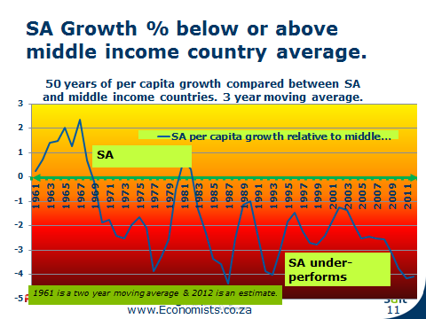

Furthermore, net loan debt is projected to reach 38.6% in 2013/14, and stabilise at just higher than 40% towards 2016. The overall efficiency in government spending is thus one area that needs tighter controls and monitoring as the increase in both the current account deficit and balance of payments will affect, for instance, retirement fund investment strategies in the future.. Forging alliances with the private sector in order to reduce this deficit should also be considered but this sector is already highly geared (see below).
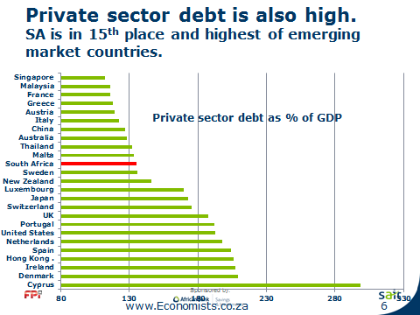

Although the budget did not outright address the growing debt, the minister said the government would continue its drive to achieve savings, eliminate wasteful expenditure, enforce stricter tax compliance and fight corruption. Control over procurement will be tightened to ensure the government gets better value for less money. Government (individuals) should be held accountable should these measures and controls not be vigilantly adhered to.
Government’s planned expenditure of R827bn for new and upgrading existing infrastructure over the next three years is considered vital but not necessarily sufficient.
Tax burden – the rich are getting fewer
In the 2011 tax year, there were only 2,8 million people registered and complying with tax laws who earned a taxable income of over R10 000 per month. There is an estimated 3,1 to 3,4 million people in this category, thus only one in ten SA adults earn a taxable income of R10 000 per month. These taxpayers pay 97% of all personal income tax (Schussler, 2013).
This is massive in anybody’s terms. Furthermore, there are only 500 individuals that earn above R5 million, and although no “wealth tax” was proposed and it seems as if these high net-worth individuals were off the hook in this budget, tax savings for persons earning R1m and more amounted to only 0,9%. Taking the current inflation rate into account, it actually means that they are actually paying 5% more tax. Various other changes in the various tax Acts (such as the increase in the dividend withholding tax and CGT inclusion rates) have resulted in these individuals being subject to higher taxes in any event. This also holds true for the proposed amendments to share schemes where it is proposed that the broad-based employee share plan contemplated in s8B of the Income Tax Act will be reviewed and possibly merged with s8C of the Income Tax Act into a single employee share scheme regime. Due to the onerous requirements imposed by s8B, these schemes are generally not used by many taxpayers. It is anticipated that combining s8C and s8B share scheme provisions could be to the detriment of high-net worth individuals.
For the rest of the SA citizens, there was no real tax relief either, in fact, taxes have increased in 2013. The total tax increased by 11% while nominal GDP is up only 9,7%, thus the real tax burden increases. Personal tax relief provided in the budget equals 2,3% while inflation is 5,6% and wage increases are over 7%. Small businesses are given slightly better rate savings of 3,5% on 550 000 – but this is also below inflation.
Companies are also under immense pressure due to high taxes. Businesses do not want to invest in South Africa due to the volatility of the labour, complex and unattractive tax legislation and the economic outlook for South Africa. South Africa cannot afford to lose foreign investment and all legislative changes should be made with these considerations in mind.
Tax review
Eighteen years into democracy, the National Treasury and SARS have exceeded all expectations with regards to tax collection and tax policy formulation. However, the current global financial crisis and growing budget deficit, together with the state infrastructure development projects, the aim of redistribution of wealth, require a critical analysis of the sustainability of the current tax policy, compared to eighteen years ago.
We therefore commend the initiative of President Zuma to follow in the footsteps of former President Mandela in establishing a commission of enquiry into tax policy. The time of this proposed review of the South African tax system to tax investigate policy reform for the future is considered ripe. An analysis of the lessons learnt over the past 18 years should inform a new strategy which can achieve a more balanced democracy as stipulated in the NDP for 2030 and beyond. SAIT expresses its willingness to assist in all aspects with this review as it believes that the findings of this review will be of key interest to taxpayers and will set the tone for future budgets.

3 SPECIFIC COMMENTS
Youth employment tax incentive and the SDZ employment incentive
The unemployment rate for individuals under the age of thirty exceeds 40%. South Africa is therefore in dire need to provide training and employment for its youth. The proposed introduction of a youth employment tax incentive to assist young people in entering the labour market, gain valuable experience and access career opportunities will go some way to address this need. We do view this incentive as a preferred alternative to the controversial youth wage subsidy.
No detailed information about the mechanics of this tax incentive have been provided, other than that it seems that entities (employers) will be able to claim a deduction or receive a tax credit if they employ persons below a certain age (presumably younger than thirty) and if those persons’ annual remuneration does exceed the income tax threshold of R63 556 (estimated at R67 111 for 2014). In our opinion the last requirement (employee’s remuneration does not exceed the tax threshold) may be to the financial disadvantage of employees as certain employers may want to maintain their employees’ annual salaries below the tax threshold in order to save taxes.

Implementation of tax incentives similar to the above is suggested for businesses in Special Economic Zones (SEZs). These entities will be entitled to a tax deduction (or credit) for each person they employ, regardless of the person’s age. Unfortunately, tighter restrictions will apply otherwise the above credit will only be allowed if an employee earns less than R60 000 a year.

Similar employment-creation tax incentives have been introduced in other countries such as the USA (New Hire Retention Credit and the Work Opportunity Tax Credit) and the BRIC countries. An investigation of employment-related tax incentives that are imposed in other countries may give a good indication of what to expect with the proposed tax legislation considered in South Africa, and it is hoped that this investigation was performed by the National Treasury.

Based on our research of the tax incentive programs in the USA and BRIC countries, it was found the critical areas to ensure that the incentives are successful and meet their intended purpose are that the administrative requirements involved in these incentives must not be significant and that the incentives must be cost effective.

From an administrative perspective, SARS should monitor this tax incentive using employer submitted PAYE information (ie. average number of full-time-equivalent employees employed per annum per business). This will provide rich longitudinal data, rather than on a snapshot view.

The South African Government estimates that the program will grant taxpayers a tax relief amounting to R500 million. Therefore the economic benefits resulting from this program must be sufficient to increase productivity to such an extent that the Government will redeem its losses in tax revenue. The cost-effectiveness for the private sector must also be considered. The tax benefits entities will receive must justify the additional costs relating to employment as well as the costs of providing individuals with the necessary skills to perform their duties. Perhaps the government should consider not limiting the tax incentive to the youth (but to all potential employees and internships as well) so that the additional intangible cost of compliance with labour regulations and the perceived risks and costs associated with growing a permanent workforce can be offset.

Overall, we believe that the tax credit incentive proposed by the Government will benefit individuals to a far greater extent than a subsidy since they are provided with job opportunities instead of a once-off allowance. Like an old Chinese proverb says: “Give a man a fish and you feed him for a day. Teach a man to fish and you feed him for a lifetime.”

Change to the taxation of trusts
The reasons for the proposed termination of the conduit principle, a core element of trust law, are not entirely clear and the fairness is also in doubt. Cognisance must be taken of the fact that there are many trusts that were legitimately created for succession planning purposes and these are now being unduly burdened and disadvantaged by the proposed changes.

VAT registration
Mention of the fact that the cumbersome VAT registration process is to receive attention is good news for new VAT vendors as we are concerned about the problems that many small businesses encounter in trying to register as vendors, either because they have to register to comply with the VAT legislation, or where they elect to register for valid business reasons. Whilst we understand the need for SARS to manage their risks related to VAT refunds, we suggest that their risk lies not so much in the registration of vendors, but rather in the actual payout of refunds.
As it is compulsory for persons to register as vendors in certain circumstances, the process of meeting this legal obligation should be made reasonably easy. In this regard, we suggest that there should not be additional verification measures introduced in the form of finger-prints, etc. when a person is attempting to merely comply with the legislation by registering as a vendor. This approach will assist businesses with getting on with business, by removing unnecessary administrative obstacles.
We also would advocate an increase in the VAT registration threshold to R5 million so as not to burden as many businesses with VAT compliance should they not regard it as being necessary to become VAT registered (for instance if they do not need to tender for government work).

VAT registration of foreign businesses
Enforcement of tax compliance associated with e commerce on the internet has up till today remained largely unresolved and is generally reliant or can be pin-pointed to geographical areas, however, in cyber space or the internet world these geographical boundaries do not exist. The underlying question is whether existing direct and indirect principles can be successfully implemented in imposing and enforcing the taxation of e commerce.
It was proposed in the budget speech that in order to curtail foreign businesses who supply goods and services essentially in cyber space from escaping the VAT net that all foreign business supplying digital goods and services in South Africa will be required to register as VAT vendors in South Africa. This line of thinking follows the current trend adopted by the European Union requiring such suppliers to register for VAT in the country where the consumer resides. The immediate problem that arises is enforcement, such as determining the location of the vendor, or where the goods or services were produced or manufactured and/or delivered, establishing what was purchased and where the purchaser is located. The legality of SARS requesting the foreign business’s list of “downloads/payments” in South Africa is also questionable.

Withholding tax on services fees paid
The withholding tax on service fees paid to offshore beneficiaries, applied at a rate of 15% (subject to the applicable treaty relief), that will be introduced as from 1 March 2014 is an unexpected announcement. It will be interesting to see how the legislature defines "service fees" or "services" to determine how far-reaching this amendment will be.

Cross issue of shares
The proposal that the anti-avoidance rules contained in section 24B(2) are to be reworked is a welcome relief to taxpayers and advisers alike as the significant adverse tax implications for BEE related transactions dealing with the cross-issues of shares will now be addressed.

Gateway Subsidiary / Treasury Company
The SARB regulations currently create an incentive for South African multinationals to use an offshore subsidiary as a treasury operation as these offshore treasuries could freely move currency without regulatory approval. These regulations thus created a disincentive to conduct the treasury operations in South Africa.
The proposal to allow South African multinationals to treat a single local subsidiary as a non-resident company for South African Reserve Bank (SARB) purposes (to essentially ensure that all its treasury operations remain in South Africa) is therefore welcomed.
The indication that these exchange control exempt entities will be entitled to use their foreign functional currency (eg US Dollars), rather than the South African Rand, as the starting point for their tax calculations is also considered as favourable as it should ease the administrative compliance burden faced by these companies.

Introduction of tax-preferred savings and investments
Although the background of introducing these preferred savings and investments is sound (see graph below), the ultimate success of these proposed instruments is rather unsure - according to the Income and Expenditure Survey (IES) 2010/2011 released on 6 November 2012 by Statistics South Africa, the average South African household expenditure increased by 69.5% over a five year period, and thus the question that should be asked is whether the average South African can afford to save - but it is hoped that these new tax free savings products will boost savings (amongst those that are able to save).
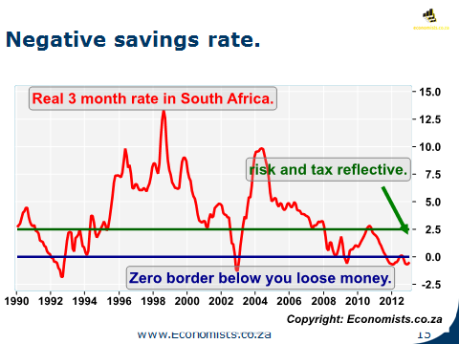
Retirement reforms
The harmonisation of the tax treatment of contributions to pension, retirement annuity and provident funds, allowing provident fund members to receive a tax deduction on their own contributions is favourably received. The roll-over of the contributions in excess of the annual caps to future years is also a positive step taken by the National Treasury.
With the level of saving by households deteriorating each year, the increase in the deductibility of contributions to pension and retirement annuity funds to 27.5% is considered prudent and should go some way to encourage greater savings among South Africans.
The proposal that would require retirement funds to transfer members’ balances into a preservation fund when they change their employer is noted. Although the reasoning behind this proposal is sound (to ensure that these funds are not used unnecessarily before retirement age so as to ensure that the individual has sufficient funds at the stage of retirement), there are certain exceptional cases (such as medical reasons – if the person does not have access to these funds at that stage, he/she might not make it to retirement age) that might make this proposal seem overly harsh. Consultation with all the stakeholders is therefore welcomed as is the fact that most of the proposals are to take effect in 2015 or later.

Increase in fuel and environmental levies
Fuel levy and RAF levy
Increases in the fuel levy and the Road Accident Fund levy will put a lot of pressure on the commuters that are already struggling in harsh economic times, especially as the exact extent of the (possible) impact of the toll fees was not mentioned in the budget.
Carbon tax and carbon emissions tax
The aim of a carbon tax is to reduce greenhouse gas emissions, not to increase government revenue. Revenue neutrality was to be achieved through spending on energy efficiency and ensuring poor households did not face higher energy bills. Whilst we agree with the introduction of the carbon tax (as South Africa is one of Africa’s largest polluters) we feel that the revenues generated by this tax and the other environmental levies should be ring-fenced. The income from this tax should be used solely for purpose for which it was introduced - reducing greenhouse gas emissions in South Africa.
The carbon emissions tax encourages consumer to buy vehicles with lower carbon emissions and it is encouraging that data shows that the average carbon emissions have been declining since the inception of this tax.
Expansion of social grants and the National Health Insurance
The SA welfare and social protection expenditure as a percentage of GDP (2012) is as follows:
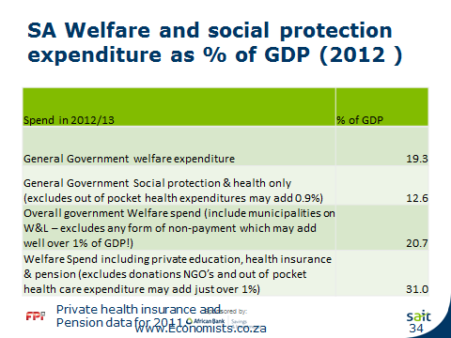

In addition to the above, municipalities and Eskom provide millions of homes with free water and electricity. Sixty per cent of government expenditure can be considered welfare expenditure.

The SA government provides 16,1 million welfare grants while South Africa has less than 5 million actual personal income tax payers. This is clearly not sustainable and alternatives need to be earnestly considered by the government.

"Alongside social assistance, access to health care is a vital element in the social wage," said Minister Gordhan. With regard to the National Health Insurance (NHI) that was briefly mentioned by the Minister in his budget speech, it is encouraging to hear that the initial phase of the NHI will not place new revenue demands on the fiscus. However, the Minister did warn that it is expected that a tax increase (an increase in the VAT rate, a surcharge on taxable income of individuals, a payroll tax on employers or a combination of these) will be required to fund the other phases of implementation. We eagerly await the discussion document to provide some clarity on these issues.

Recognising the number of South African’s that rely on and use social grants and social assistance (more than 16m people in South Africa – up from 2.5m in 1998) to support themselves and various family members, raising the most important social grants between 4% and 5% is considered the humane thing to do. However, the manner in which the grants are distributed needs urgent consideration as there have been reports that grant recipients in some regions have to queue overnight to get their grants. Furthermore, we echo the sentiments of President Zuma that South Africans should become self-sufficient by productively using the land (such as food gardens) to prevent them from relying on social grants.

Proposed Gambling Tax
Although it is indicated that the proposed gambling tax (based on gross gambling revenue of casinos would be introduced at a rate of 1% in addition to the provincial rates) is similar to gambling taxes that exist in India, the Netherlands and the United States, it is uncertain whether this would assist in discouraging excessive gambling in South Africa. Once this tax has been introduced, it is suggested that empirical research be performed to determine whether or not this is in fact the case.

Exemptions for bursaries
Government’s proposal to review the rules governing the exemption of bursaries granted by employers to employees is a welcome proposal, especially viewed in light of the country’s poor education outcomes.

Concluding comments
When South Africa’s public education spend is compared to the other BRIC countries, it is evident that South Africa outspends all of these countries.
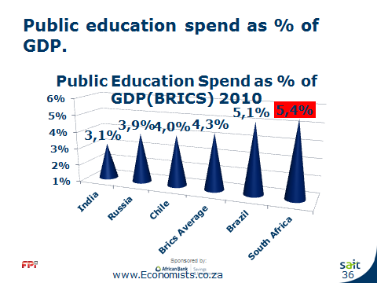

The cost per learner has also increased as can be seen below.
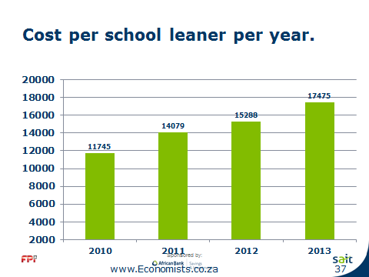

Despite large amounts being spent on education in South Africa, the Minister of Basic Education this year reported that the country has the highest rate of absenteeism within the SADC region. According to publically released statistics, 392,000 teachers were employed at public schools throughout the country in 2012, with each teacher, on average, being absent for 19 days. Furthermore, South Africa’s educational system was ranked 140th out of 144 countries in the World Economic Forum report (2012). Even Lesotho and Swaziland have a higher quality of education than South Africa.
Depriving young learners of their rights to basic education is completely unacceptable. With a skills shortage in this country, education should become the number one priority of the South African government. Education will provide employment, entrepreneurship/self-sufficiency and ultimately it will lead to a reduction in crime – three elements critical to ensuring that South Africa remains a successful and prosperous country as well as a vital player in the global arena. Every possible effort should be made to ensure that education, of the highest standard, is available to every single child/citizen of this country.
Please do not hesitate to contact us if you have any queries in this regard.
Yours sincerely,

Prof Dr Sharon Smulders
Chief Executive Head: Tax Technical Policy & Research
Cc:keith.engel@treasury.gov.za; cecil.morden@treasury.gov.za; rmoodley3@sars.gov.za; zrento@parliament.gov.za

