PORTFOLIO COMMITEE BRIEFING

The Department of Trade and Industry

PFMA audit outcomes for the 2011/12 financial year

Date of Briefing: 17 October 2012

Portfolio Committee Briefing 2011/12

CONTENTS
1. Introduction 1
2.1 Audit Opinions History 2
2.2 Key Focus Areas 3
3. Commitments by the Executive 2
4. Other Matters of Interest 3
5. Other AG reports (e.g Performance, Investigation, etc) 4

1. Introduction
This document contains a brief summary of the audit outcomes for the department of Trade and Industry and other entities in this ministerial port folio.

.
2. Vote: 36
2.1 Audit opinion history
 | Audit opinions |  |  | Findings on predetermined objectives |  |  | Findings on compliance
 | 09/10 | 10/11 | 11/12 | 09/10 | 10/11 | 11/12 | 09/10 | 10/11 | 11/12
Department of Trade and Industry |  |  |  | X | X |  | X | X | X
docproperty "Address line 1" Companies and Intellectual Property Commission |  | Q | Q | X | X | X |  | X | X
Companies Tribunal
National Gambling Board |  |  |  | X | X | X | X | X
National Consumer Commission |  |  |  |  |  |  |  |  | X
National Consumer Tribunal |  |  |  | X | X | X |  | X
National Credit Regulator |  |  |  |  |  |  |  |  | X
National Regulator for Compulsory Specifications |  |  | Q | X |  | X |  | X | X
South African Bureau of Standards
Small Enterprise Development Agency |  |  |  | X
National Lotteries Board |  |  |  | X |  |  | X | X | X
National Lotteries Distribution Trust Fund |  |  |  | X |  |  |  | X | X
Audits not conducted by the AGSA
Estate Agency Affairs Board |  |  |  |  | X |  | X | X | X
South African National Accreditation System
National Empowerment Fund
Export Credit Insurance Corporation of South Africa |  |  |  |  | X
National Metrology Institute of SA |  |  |  |  |  |  |  | X | X

AUDIT OPINION
 | CLEAN AUDIT OPINION: No findings on PDO and Compliance
 | UNQUALIFIED with findings on PDO and Compliance
Q | QUALIFIED AUDIT OPINION (with/without findings)
 | DISCLAIMER/ADVERSE AUDIT OPINION
 | NOT APPLICABLE – NEW ENTITY

  - KEY FOCUS AREAS
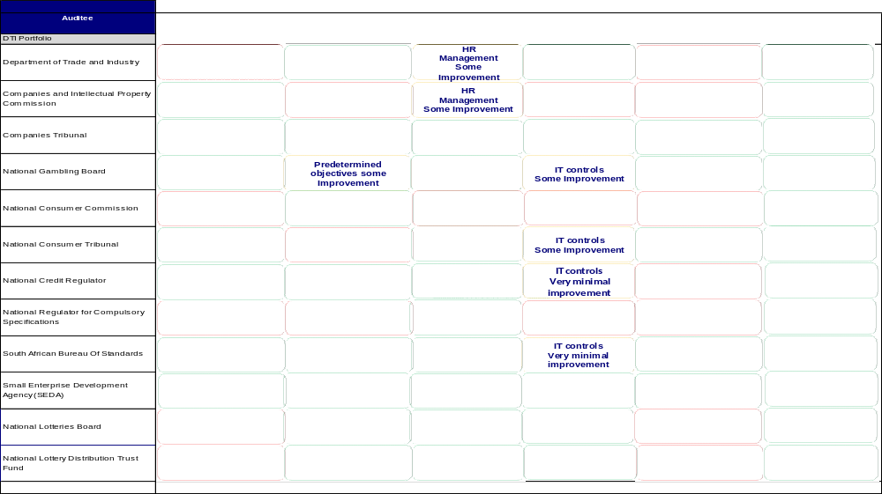
    - Supply Chain Management
Entity | Finding | Root Cause | Recommendation
Department of Trade and Industry (the dti) | - Goods and services with a transaction value below R500 000 were procured without obtaining the required price quotations, as required by Treasury Regulation (TR) 16A6.1. | - Action plans are inadequate or not implemented correctly to address prior year matters reported.  - Lack of accountability of management responsible for SCM.  - Lack of understanding of SCM legislation resulting in incorrect interpretation. | - An irregular expenditure report must be compiled monthly by the unit heads. The unit heads must declare irregular expenditure incurred or not and sign off on these reports. Internal audit must validate these reports and the CFO must report monthly to the Accounting Officer and the Audit Committee. The Audit Committee and the Accounting Officer must then report quarterly to the Executive Authority.
National Consumer Commission | - Goods and services with a transaction value of between R10 000 and R500 000 were procured without obtaining written price quotations from at least three different prospective providers as per the requirements of TR16A6.1.  - Invitation for a competitive bid was not advertised in at least the government tender bulletin, as required by Treasury Regulations 16A6.3(c).  - Invitation for a competitive bid was not advertised for a required minimum period of 21 days, as required by Treasury Regulations 16A6.3(c). | - Controls were not implemented to ensure compliance.  - No internal audit unit was in place.  - Lack of skills within finance and SCM to ensure compliance. | - Controls should be implemented to ensure compliance with SCM regulations. Appropriate action should be taken against the officials.  - Training should be done
National Regulator for Compulsory specification (NRCS) | - Goods and services with a transaction value below R500 000 were procured without obtaining the required price quotations, as required by Treasury Regulation 16A6.1.  - Sufficient appropriate audit evidence could not be obtained that goods and services of a transaction value above R500 000 were procured by means of inviting competitive, as required by Treasury Regulations 16A6.1.  - Quotations were awarded to suppliers who did not submit a declaration of past supply chain practices such as fraud, abuse of SCM system and non-performance, which is prescribed in order to comply with Treasury regulation 16A9.1.  - Quotations were awarded to suppliers whose tax matters had not been declared by the South African Revenue Services to be in order as required by Treasury Regulations 16A9.1(d) and the Preferential Procurement Regulations.  - The preference point system was not applied in all procurement of goods and services above R30 000 as required by section 2(a) of the Preferential Procurement Policy Framework Act and Treasury Regulations 16A6.3(b).  - Quotations were awarded to bidders based on preference points that were not allocated and calculated in accordance with the requirements of the Preferential Procurement Policy Framework Act and its regulations.  - Quotations were awarded to bidders who did not submit a declaration on whether they are employed by the state or connected to any person employed by the state, which is prescribed in order to comply with Treasury regulation 16A8.3.  - Sufficient appropriate audit evidence could not be obtained that all contracts were awarded in accordance with the legislative requirements due to the information not being available. | - Vacancies in key positions (CEO, CFO, SCM head and internal audit)  - Action plans are inadequate or not implemented correctly to address PY matters reported.  - Internal audit not functioning effectively to make recommendations on internal controls to Accounting Officer/Authority.  - Lack of accountability of management responsible for SCM.  - Lack of understanding of laws and regulations resulting in incorrect interpretation. | - An irregular expenditure report must be compiled monthly by the unit heads. The unit heads must declare irregular expenditure incurred or not and sign off on these reports.  - Internal audit must validate these reports and the CFO must report monthly to the Accounting Officer and the Audit Committee. The Audit Committee and the Accounting Officer must then report quarterly to the Executive Authority.  - Management should ensure that SCM policies and procedures are in line with the laws and regulations of SCM to ensure compliance.  - Key vacancies should be filled
National Lotteries Board (NLB) | - Goods and services of a transaction value above R500 000 were procured without inviting competitive bids, as required by Treasury regulation 16A.6.1.  - Goods and services with a transaction value below R500 000 were procured without obtaining the required price quotations, as required by Treasury Regulation 16A6.1. | - The current processes on supply chain management and allocation of grants are not adequately designed to prevent and detect irregular expenditure.  - Management did not adequately review and monitor compliance with applicable laws and regulations. | - Regarding procurement of goods and services, management should follow the legislative requirements rigorously, to avoid irregular expenditure, unless there are valid documented and approved reasons for deviating from the correct procedures.  - Grant allocation policies should be complied with.

    - Predetermined Objectives
Entity | Finding | Root Cause | Recommendation
Companies and Intellectual Property Commission (CIPC) | Usefulness of information  - The National Treasury Framework for managing programme performance information requires that it must be possible to validate the processes and systems that produce the indicator. A total of 66% of the indicators relevant to the selected objective, Maintenance of accurate up-to-date and relevant information, were not verifiable as it was not possible to validate some of the processes and systems that produce theses indicators. This was due to planned indicators not being reviewed for compliance against prescribed criteria before being approved.  - The National Treasury Framework for managing programme performance information requires that it must be possible to validate the processes and systems that produce the indicator. A total of 33% of the indicators relevant to the selected objective, Establish world class customer service delivery, that meets the needs of the customer and delivers consistently against a customer promise, were not verifiable as it was not possible to validate some of the processes and systems that produce theses indicators. This was due to planned indicators not being reviewed for compliance against prescribed criteria before being approved. | - Planned targets are not reviewed for compliance against prescribed criteria before being approved | - All planned indicators must be reviewed prior to the strategic plan being approved and tabled in Parliament to ensure that they comply with criteria as outlined in National Treasury’s Framework for Managing Programme Performance Information.
Companies and Intellectual Property Commission (CIPC) | Reliability of information  - I was unable to obtain sufficient, appropriate audit evidence to satisfy myself as to the validity, accuracy and completeness of the actual performance reported in the annual performance report relating to the selected objective, efficient and effective end to end operations. This was due to ineffective systems being in place that assists the entity with valid, accurate and complete reporting | - There is no performance system in place that assists management with valid, accurate and complete reporting | - Adequate reviews and checks must be performed to ensure that all disclosed information are reviewed and verified before submission for audit.  - A fully integrated performance management system that matches CIPRO's information requirements must be implemented.
National Gambling Board (NGB) | Usefulness of information  - Reported indicators and targets not consistent with planned indicators and targets  - Treasury Regulation 30.1.3(g) requires that the strategic plan should form the basis for the annual report, therefore requiring the consistency of objectives, indicators and targets between planning and reporting documents. A total of 33% of the reported targets and indicators are not consistent with the targets and indicators as per the approved strategic plan. This is due to the entity not having sufficient controls in place to ensure that changes are approved by the Executive. | - Lack of understanding of the FMPPI resulting in incorrect application or interpretation. | - The entity should ensure that it follows up on its action plans to ensure that appropriate action is taken timely to address issues noted.  - Workshops should be conducted with the National Treasury to ensure clear guidance on expectations when the strategic plan is being drafted.
National Consumer Tribunal (NCT) | Usefulness of information  - Treasury Regulation 30.1.3(g) requires that the strategic plan should form the basis for the annual report, therefore requiring the consistency of indicators and targets between planning and reporting documents. A total of 72% of the reported indicators and 56% of the reported targets are not consistent with the indicators and targets as per the approved strategic plan. This was due to the revision of the business plan during the year. | This was due to a lack of understanding of the FMPPI framework. | All changes to the strategic plan and annual performance plan must be approved by the executive authority.  Training should be done
National Regulator for Compulsory specification (NRCS) | Usefulness of information  - The National Treasury FMPPI requires that indicators should have clear unambiguous data definitions so that data is collected consistently and is easy to understand and use. A total of 33% of the indicators relevant to following goal, to maximise compliance with all the specifications and technical regulations falling under the mandate of NRCS were not well defined in that clear, unambiguous data definitions were not available to allow for data to be collected consistently. This was mainly due to the fact that targets were not suitably developed during the strategic planning process.  - Performance targets not specific.  - The National Treasury FMPPI requires that performance targets be specific in clearly identifying the nature and required level of performance. A total of 33% of the targets relevant to following two goals, to maximise compliance with all the specifications and technical regulations falling under the mandate of NRCS were not specific in clearly identifying the nature and the required level of performance. This was mainly due to the fact that targets were not suitably developed during the strategic planning process | This was due to a lack of understanding of the FMPPI framework. | - The entity should ensure that it follows up on its action plans to ensure that appropriate action is taken timely to address issues noted.  - Workshops should be conducted with the National Treasury to ensure clear guidance on expectations when the strategic plan is being drafted.  - The strategic plan must be reviewed in detail by those charged with governance
National Regulator for Compulsory specification (NRCS) | Reliability of information  - The National Treasury FMPPI requires that processes and systems which produce the indicator should be verifiable. A total of 67% of the actual reported performance relevant to the two goals, to maximise compliance with all the specifications and technical regulations falling under the mandate of National Regulator for Compulsory Specifications was not valid, accurate and complete when compared to and from the source information and evidence provided. This was due to a lack of monitoring and review for the recording of actual achievements by senior management. | - Lack of key controls in the relevant systems of collection, collation, verification and storage of actual performance information  - Lack of standard operating procedures for the recording of actual achievements by senior management. | The entity should develop a system to collect and collate information to ensure that all reported information is adequately supported by sufficient substantiating evidence.
    - Human Resources
Entity | Finding | Root Cause | Recommendation
Department of Trade and Industry (the dti) | Certain positions had been vacant for more than 12 months, this includes the CFO post. | - Actions plans to address prior year audit issues are not effective.  - Lack of process in place to ensure posts are advertised within 6 months and filled within 12 months.  - The progress of investigations were not tracked and followed up timely.  - Lack of reconciliation performed between leave taken in foreign offices and leave captured on system. | - Procedures should be put in place to ensure vacancies are filled timely.  - Investigations should be tracked and followed up to ensure timely conclusion of matters.  - Reconciliation should be performed between leave taken in foreign offices and leave actually captured.
Department of Trade and Industry (the dti) | Acting periods of certain officials exceeded the maximum period prescribed by PSR 1/VII/B5.3.
Department of Trade and Industry (the dti) | Employees were on suspension with pay for more than 30 days. The longest suspension period is 675 days.
Department of Trade and Industry (the dti) | Leave in foreign economic offices were not captured in time resulting in inaccurate leave balance.
Companies and Intellectual Property Commission (CIPC) | The vacancy rate increased from 10.29% in the 2010/11 financial year to 16.8% in the 2011/12 financial year. | - All posts were frozen until the new organisational structure is approved and in place. | - Within available funds, CIPC should address the gaps between the human resources (HR) required to perform the entity’s functions and the existing HR by means of recruitment and retention strategies to ensure adequate capacity to fulfil its mandate (service delivery).  - The organisational structure should be approved as soon as possible so vacancies can be filled with permanent staff who would take time to understand and take into consideration the real needs of CIPC.
National Lotteries Board (NLB) and National Lotteries Distribution Trust Fund (NLDTF) | - Certain key positions including that of Chief Risk Officer and Chief Information Technology Officer were not filled during the 2011/12 period. Management has taken note of these vacancies and a Chief Risk Officer has been appointed effective 2 July 2012. A Chief Technology Officer is expected to be appointed, effective 1 September 2012.  - The entity did not have the required skills to ensure adequate design and implementation of the security management controls and user access management controls. | - An organisational restructuring is currently underway. This has delayed the recruitment process.  - Policies and procedures have not been established to enable and support understanding and execution of internal control objectives and processes. | - Key positions should be filled urgently. Including the position of the security officer.

    - Information Technology Controls
Entity | Finding | Root Cause | Recommendation
Companies and Intellectual Property Commission (CIPC) | - Inadequate IT security policy | - All existing policies are currently being reviewed by management. | - The Chief Information Officer (CIO) should ensure that the network security policy is updated to include server configuration requirements and patch management processes.
Companies and Intellectual Property Commission (CIPC) | - IT management had not formally designed, approved and documented user access controls. | - Failure by management to establish Network and Persal user account management procedures as indicated in the prior year’s management report.  - Management is currently in the process of recovering the source codes for legacy systems, which needs to be rewritten prior to establishing ERMS and user account management procedures. | - While the ICT Applications Manager waits for the source code of the legacy systems to be recovered and rewritten, the network security policy should be utilised to govern user account management processes for all financial systems in use at the organisation.  - The ICT Applications Manager should then ensure that user account management procedures for all the applicable systems are formally developed, approved and implemented.
Companies and Intellectual Property Commission (CIPC) | - IT management had not formally designed change management controls. | Lack of a governance framework that prescribes good practices for ICT planning and monitoring processes. | - In the absence of an IT governance framework, the CIO should ensure that formal change management policies and procedures are developed, approved and implemented.  - The CIO with support from Director Applications and Application Maintenance Manager should utilise the formal interim ICT change management directive as a basis to develop the permanent ICT change management policy, process and structure for the management of ICT changes as intended. This document should then be distributed to the applicable stakeholders.
Companies and Intellectual Property Commission (CIPC) | - IT management had not formally designed IT service continuity controls Disaster Recovery Plan (DRP) and backup procedures. | - The draft backup procedure document is not updated because the auditee is in process of procuring a new backup solution.  - Documentation for legacy systems is not in place and the functionalities are distributed across multiple applications, therefore, the process of collecting the information required to compile a disaster recovery plan is a challenge. | - The Commissioner with support from the CIO, the Information Security Manager (ISM) and Director Infrastructure Management (DIM) must ensure that a formal DRP is developed, approved and implemented.  - Management should ensure that the draft backup procedure document is revised to suit the backup strategy / solution once it has been implemented.
Companies and Intellectual Property Commission (CIPC) | - IT management had not formally designed IT governance controls. | - The CIPC strategic plan was recently approved; as a result management had not yet developed the ICT strategy.  - Lack of project management capacity | - The CIO should develop a framework that will best suit CIPC ICT environment by using available draft guidelines of the DPSA IT governance framework. And utilise the CIPC Interim ICT Programme – Initial Gap Analysis Report and the recently approved CIPC strategic plan to formally document the ICT strategic plan. Furthermore the CIO should ensure that a formal agreement between the CIPC and DTI is documented and signed by both parties. In addition, the CIO should ensure that the ICT organisational structure makes provision for the ICT Project Manager Position and the position is filled. Thereafter the Project Manager with support from the CIO should ensure that the Information Technology (IT) project management framework is adopted and implemented for the management of ICT projects.
Companies and Intellectual Property Commission (CIPC) | - Data changes are allowed to be made to the Informix database master files through the ERMS system and these changes are logged. However the person making these changes also has the option to change their user ID. | - There is inadequate design and implementation over the access controls on the Informix and ERMS database to ensure the availability, accuracy and protection of information.  - The CIO position is vacant therefore there is no continuity and progress with identified weakness and system controls.  - The Informix system is not designed to mitigate risks and adequately handle the user requirement of CIPC. | - The Commissioner and acting CIO should ensure that the database system is upgraded to prevent and detect the weaknesses identified above. There should also be strict and limited access to this type of information.  - Management should thereafter implement mechanisms to monitor changes and access to the database.  - Management should consider obtaining a new system that adequately covers the unique user requirements of CIPC.  - The CIO position should be filled as soon as possible to ensure continuity and progress with CIPC’s IT controls.
Companies and Intellectual Property Commission (CIPC) | - It was noted that the “SACRO” account is a shared account which gives users access to the master files via ERMS to change details such as status, directors, company conversions, registration dates etc.  - The users who have changed the details cannot be traced back as the “SACRO” user account is not linked to any individual user.
Companies and Intellectual Property Commission (CIPC) | - An assessment was done on the integrity and reliability of the information maintained in the database and there were significant deficiencies identified that questioned the integrity of the information maintained on the database.
National Consumer Tribunal (NCT) | - No formal IT governance controls and no committee formally appointed (IT Governance steering committee)  - Inadequate user account management  - Formal program change/ upgrade control policies and procedures had not been designed | - Lack of IT governance committee  - IT policies does not take into account user account management and change/ upgrade procedures | - A formal IT committee should be established  - IT policies should be updated to take into account user account management and program change procedures.
National Credit Regulator (NCR) | - Lack of formal Security Policy  - No processes in place to ensure that the activities of the systems administrator are reviewed.  - No processes to ensure reviews on user’s access to financial systems are done  - No approved IT strategic plan  - No formally approved IT Governance framework  - The copies of IT continuity plan and disaster recovery plan are not kept off-site.  - No formal disaster recovery plan. | - Lack of clear policy regarding new user and maintenance of user IDs | - Management should ensure that prior year matters are implemented as contained in its action plan.  - IT Policy should be revised to ensure that the User account management matters are addressed.
National Regulator for Compulsory specification (NRCS) | - No security policies and procedures  - No IT governance controls.  - Inadequate user account management.  - Weaknesses identified in the implementation of the program change policy.  - Inadequate data centre management. | - Failure by management to address prior findings in the action plan. | - Management should ensure that prior year matters are implemented as contained in its action plan.  - Policies regarding IT governance and security should be developed.  - All IT policies should be revised to ensure that all controls are adequately addressed.
South African Bureau of standards (SABS) | - Inadequate user account management  - Lack of formal Security Policy  - N o change management controls on the system  - No formal disaster recovery plan | - Lack of clear policies and procedures on IT processes | - IT Policy should be revised and approved and compliance with the policy should be monitored.
Small Enterprise Development Agency (SEDA) | - The Client Relationship Management (CRM) system is still providing some differences for performance information. The performance information was verified using manual files.  - IT weaknesses have been identified in light of absence of IT frameworks. | - Lack of approved IT security policy and was due to management still being in the process of revising and updating the policies as the entity did not have the required skills to develop the IT security policy due to vacancies with the IT department. | - The management should ensure the IT security policy is updated and approved; a process should also be put in place to periodically review the policy. Furthermore management should ensure that the IT vacancies are filled with appropriately skilled staff.
National Lotteries Board (NLB) and National Lotteries Distribution Trust Fund (NLDTF) | - The IT security policy is in draft and has not been approved.  - There is a lack of proper user access control in GMS, Payday and Pastel. No approved processes to manage upgrades made to financial / performance information systems are in place  - The disaster recovery plan and IT continuity plans are in draft and have not been approved  - User access management internal controls deficiencies were identified. | - The position of Chief Information Technology Officer has not been filled. | - The Chief Information Technology Officer vacancy should be filled urgently.  - The newly appointed CIO should have and action plan to address all shortcomings identified.

    - Material Errors/Ommissions in AFS submitted for Audit
Entity | Finding | Root Cause | Recommendation
Department of Trade and Industry (the dti) | The financial statements submitted for auditing were not prepared in accordance with the prescribed financial reporting framework as required by section 40(1)(b) of the Public Finance Management Act. Material misstatements of contingent liability, accruals and key management personnel identified by the auditors in the submitted financial statement were subsequently corrected, resulting in the financial statements receiving an unqualified audit opinion. | - Action plans are inadequate or not implemented correctly to address prior year matters reported.  - Management did not have adequate controls to ensure that the financial statements and performance reports submitted for audit purposes are accurate and complete. | - Management should ensure that AFS are prepared regularly (monthly vs. quarterly).  - These AFS should be reviewed by the governance structures i.e. management, internal audit and audit committee.
Companies and Intellectual Property Commission (CIPC) | The financial statements submitted for auditing were not prepared in accordance with the prescribed financial reporting framework and supported by full and proper records as required by section 55(1) (a) and (b) of the PFMA. Material misstatements identified by the auditors in the submitted financial statements were not adequately corrected which resulted in the financial statements receiving a qualified audit opinion. | - Action plans are inadequate or not implemented correctly to address prior year matters reported.  - Lack of adequate information systems to support balances in the financial statements | - The AFS prepared should be adequately supported by substantiating evidence to corroborate validity, accuracy and completeness thereof.  - These AFS should be reviewed by the governance structures i.e. management, internal audit and audit committee.
National Credit Regulator | The financial statements submitted for auditing were not prepared in all material respects in accordance with the requirements of section 55(1)(b) of the PFMA. Material misstatements of disclosure items identified by the auditors were subsequently corrected, resulting in the financial statements receiving an unqualified audit opinion. | - Financials not reviewed to ensure compliance with all aspects of the accounting framework | - Financial statements should be reviewed for accuracy and completeness before submission.
National Regulator for Compulsory specification (NRCS) | The financial statements submitted for auditing were not prepared in accordance with the prescribed financial reporting framework and/or supported by full and proper records as required by section 55(1) (a) and) (b) of the PFMA. Material misstatements identified by the auditors in the submitted financial statements were not adequately corrected, which resulted in the financial statements receiving a qualified audit opinion. | - Vacancies in key positions (Chair of the Accounting Authority, CEO, CFO)  - Action plans are inadequate or not implemented correctly to address PY matters reported  - Lack of adequate review of AFS by those charged with governance (incl. Audit Committee) | - Management should ensure that AFS are prepared regularly (monthly vs. quarterly).  - These AFS should be reviewed by the governance structures i.e. management, internal audit and audit committee.  - The AFS prepared should be adequately supported by substantiating evidence to corroborate validity, accuracy and completeness thereof.  - AFS which are submitted must be the final set approved by the leadership and supported as referred to above.
National Lotteries Board (NLB) | The financial statements submitted for auditing were not prepared in all material respects in accordance with the requirements of section 55(1)(b) of the PFMA. Material misstatements of disclosure note of irregular expenditure identified by the auditors were subsequently corrected, resulting in the financial statements receiving an unqualified audit opinion. | - Financials not reviewed to ensure compliance with all aspects of the accounting framework | - Financial statements should be reviewed for accuracy and completeness before submission.  - Monthly financial statements should be compiled
National Lotteries Distribution Trust Fund (NLDTF) | The financial statements submitted for auditing were not prepared in all material respects in accordance with the requirements of section 55(1)(b) of the PFMA. Material misstatements of disclosure note of irregular expenditure, provision for allocations by Distributing Agencies and allocation of grants identified by the auditors were subsequently corrected, resulting in the financial statements receiving an unqualified audit opinion. | - Financials not reviewed to ensure compliance with all aspects of the accounting framework | - Financial statements should be reviewed for accuracy and completeness before submission.  - Monthly financial statements should be compiled
National Consumer Commission | The financial statements submitted for auditing were not prepared in all material respects in accordance with the requirements of section 55(1)(b) of the PFMA. Material misstatements of property plant and equipment, administrative expenditure, operating lease expenditure, trade and other receivables, related party transactions and the operating lease liability disclosure note identified by the auditors were subsequently corrected, resulting in the financial statements receiving an unqualified audit opinion. | - Poor understanding of what is an appropriate system, and why key controls are essential in driving a working administration.  - Internal audit was not established and the audit committee was appointed late and thus had no impact. | - Management should ensure that AFS are prepared regularly (monthly vs Quarterly).  - These AFS should be reviewed by the governance structures i.e management, internal audit and audit committee.  - The AFS prepared should be adequately supported by substantiating evidence to corroborate validity, accuracy and completeness thereof.  - AFS which are submitted must be the final set approved by the leadership and supported as referred to above.

    - Financial Health Status
Entity | Finding | Root Cause | Recommendation
Companies and Intellectual Property Commission (CIPC) | The financial statement amounts were subject to limitation misstatements that resulted in the modification of the audit opinion. The ratios relating to revenue management could therefore not be evaluated.  Furthermore the capital budget was under spent and there were material losses and impairments incurred. | - Impairments and material losses were incurred due to the nature of CIPC business.  - The capital budget was under spent due to delays experienced with the move to the new building. | - Plans to move to the new building must be finalised so the capital budget can be utilised.  - A debtor’s management system must be put in place to assist with accurate and complete reporting.
Small Enterprise Development Agency (SEDA) | The entity had a net deficit for the current financial year, i.e. 2011/12. Should this trend continue; it might pose a going concern risk in the future. | Expenditure that is in excess of the allocated revenue. | Expenditure should be curbed to be in line with the revenue allocated.

3. Commitments by the Executive
The development and implementation of an action plan to address all identified audit findings. This will be done as follows:
- The CFO’s must report monthly to the Accounting Officer’s/ Authorities on progress of the action plan, the Accounting officer/ Authority to report quarterly to the Audit committee and Portfolio Committee. The progress on the action plans must be reviewed by the Audit Committees on a quarterly basis and the progress must then be confirmed by the Audit Committee and submitted to the Minister.
- The internal audit functions must do a monthly key control assessments and submit to the Accounting Officer/ Authority. The Accounting Officer/ Authorities must submit the assessments for review to the Audit Committees and the Minister for follow up on all areas where the controls are found not to be implemented.
- Internal audit must also report monthly on the progress on the action plan, subsequent to having conducted a validation process of reported information. The progress report must also be submitted quarterly to the Audit committee and also the Minister.
- Minister will follow up quarterly on key controls assessments and the reports from the Audit Committees on audit related matters.

4. Other Matters of interest
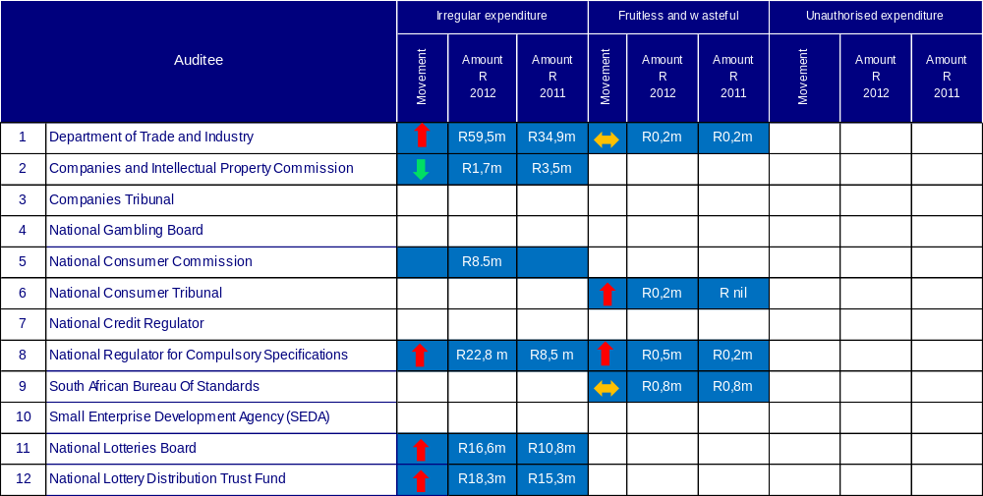
5. Other AG Reports
- Investigation:
No investigations are currently underway as undertaken by the AGSA.
- Performance Audits:
No performance audits are currently underway as undertaken by the AGSA.
- Agreed upon procedures
Two engagements were performed during the year on the royalties payable by SABS.

Qualification areas for CIPC 2010/11 – Revenue and trade receivables
Qualification areas for CIPC 2011/12 – Revenue, trade receivables and trade payables
Qualification areas for NRCS 2011/12 – Property, plant and equipment and revenue

