Portfolio Committee on International

Relations and Cooperation

Budgetary Review

And

Recommendation Report

2010/2011

Chairperson:

Hon. H T MAGAMA

Table of Contents

1. Introduction

1.1 The Committee
1.2 The Department

2. Strategic Priorities and Measurable Objectives of the Department

2.1 Strategic Priorities of the Department
2.2 Measurable Objectives of the Department

3. Analysis of Strategic and Operational Plans of the Department

4. Analysis of Expenditure Reports

5. Analysis of the Annual Report and Financial Statements of the Department

6. Consideration of Reports of Committee on Public Accounts

7. Consideration of other Sources of Information

8. Committee’s Observations

9. Conclusion

10. Recommendations

The Budgetary Review and Recommendation Report of the Portfolio Committee on International Relations and Cooperation, dated 19 October 2011

1. Introduction

  - The role of the Committee

The Portfolio Committee on International Relations and Cooperation is a committee of Parliament mandated by the sections 55 & 92 of the Constitution of South Africa to oversee and ensure accountability in the formulation and conduct of South African Foreign Policy. Consequently, the Committee conducts oversight on activities of the Department of International Relations and Cooperation (DIRCO), its policies, financial spending patterns, administrative issues, and it holds DIRCO accountable for its operations and functions. The Committee is an important mechanism to ensure oversight and conduct of South Africa’s International Relations policy, relations and cooperation.

In accordance with section 5 of the Money Bills Amendment Procedure and Related Matters Act No.9 of 2009, National Assembly, through its committees, must assess the annual performance of each national department and submit Budgetary Review and Recommendation Reports (BRRRs) for each department, for tabling in the National Assembly. These reports will be considered by the Committee on Appropriations when it is considering and reporting on Medium Term Budget Policy Statement (MTBPS) to the House.

In compiling this report, the Committee on International Relations and Cooperation as mandated by section 5 of the Money Bills Amended Procedures and Related Matters Act 2009, based the assessment of the Department in its service delivery plan as espoused in the 2010 State of the Nation Address imperatives. The Committee linked domestic priorities to the Departments Strategic Plan 2010 – 2013 and aligned the information to priorities and measurable objectives as set out in the strategic plan. The Committee examined the expenditure report as published by the National Treasury, commonly known as Section 32 Reports of the Public Finance Management Act (PFMA); reference was also made to the Auditor General’s report on the 2010 Budget Vote; the Department’s Annual Report, which contains the Departments service delivery information, reflecting its performance in 2010/11 reporting period was also considered.

  - The Legislative Mandate of the Department

The overall Mandate of the Department is to work for the realization of South Africa’s International Relations policy objectives. In terms of the provisions of the Constitution, the President of the Republic of South Africa bears the overall responsibility for the country’s foreign policy and international relations. However, the Department is entrusted with the formulation, promotion and execution of South Africa’s foreign policy and with the daily conduct of its international relations. The Minister of International Relations and Cooperation assumes overall responsibility for all aspects of South Africa’s international relations, albeit in consultation with the President. The Minister also liaises and consults with Members of the Cabinet on overlapping issues and on the priorities and programmes of other Departments that bear an international relations element. In the same breath, other Cabinet Ministers are required to consult the Minister of International Relations and Cooperation on their international role.

2. Department’s Strategic Priorities and Measurable Objectives

2.1 Strategic Plan of the Department
The Department’s strategic objectives as prioritized in its 2010-13 Strategic Plan comprise the following broad points to enable the Department to fulfill its mandate:
- Through bilateral and multilateral interactions protect and promote South African National interests and values;
- Conduct and co-ordinate South Africa’s international relations and promote its International Relations policy objectives;
- Monitor international developments and advise government on International Relations policy and related domestic matters;
- Protect South Africa’s sovereignty and territorial integrity;
- Contribute to the formulation of international law and enhance respect for the provisions thereof;
- Promote multilateralism to secure a rules based international system;
- Maintain a modern, effective and excellence driven Department;
- Provide consular services to South African nationals abroad and
- Provide a world class and uniquely South African State Protocol service.

2.2 Measurable Objectives of the Department

The Strategic plan is categorized into 6 key priority areas for the reporting year, aimed at responding to the domestic priorities as announced by government for the reporting year as follows:
- The Continued Prioritisation of the African Continent;
- Strengthening political and economic integration of SADC;
- Strengthening of South-South Relations;
- Strengthening of Relations with the formations of the North;
- Strengthening of Political and Economic Relations;
- Participation in the Global System of Governance.
During the reporting period, the thrust of the work of the Department remained anchored on these overarching priorities as confirmed by the January 2009 Cabinet Lekgotla and the 2010 SONA. In its work on these priorities, DIRCO is supported by the following activities:
- Organisational Support,;
- Rendering of Professional Services and
- Organisational Strengthening.

3. Analysis of the Department’s Prevailing Strategic and Operational Plan

During the reporting period, the department remained focused on ensuring that SA’s foreign relations contribute to an environment that is conducive to sustainable economic growth and development, and serve as a basis for addressing government’s identified urgent priorities. In support of government’s key targets, outlined in the medium term strategic framework, the department’s priority will be to pursue African development and enhanced international cooperation.

The change in 2009 of the name from the Department of Foreign Affairs to the Department of International Relations and Cooperation also signified the refocusing of the strategic emphasis for the work of the Department to respond to domestic imperatives. In response to President Zuma’s clarion call for job creation and poverty alleviation, activities underlining economic diplomacy have been prominent. Quite evidently, President Zuma has led many delegations comprising the South African business fraternity to various countries in Africa, Asia and Europe. As a democratic developmental state, South Africa has a clearly articulated socio-economic programme, which it pursues through active state interventions and supportive institutional structures.
.
In pursuing its mandate in respect of economic diplomacy, the Department continued to reflect a bias towards Africa, the Southern African Development Community (SADC), and towards support for South-South formations. It is believed that economic diplomacy in the region will support an integrated development strategy for SACU, SADC and the continent that includes investment promotion and industrial development. For this policy to succeed there must be a close partnership with government, business and labour. It has been advocated by followers of foreign policy trends that economic diplomacy will attract foreign direct investment to South Africa and Africa.

The Department’s other significant focus has been the alignment of its work in order to contribute to national priorities. It pledged to undertake a process of developing a White Paper on Foreign Policy, establishing a consultative process with relevant stakeholders in discussions on South Africa’s foreign policy. In a strategic move in response to this process, the Committee proactively conducted Outreach programs to establish what should inform foreign policy and to what extend foreign policy was being aligned to domestic priorities. The Committee benefitted from the analysis of the academia in Limpopo and Western Cape regarding foreign policy and its trends since 1994.

The Mandela era was described as the first which South African post apartheid foreign policy was articulated and shaped. South Africa was welcomed back into the family of nations, namely the African Union, United Nations and other international organizations. Statesmanship and human rights formed the pillar of our foreign policy during this period.

The Mbeki era was seen as characterized by heavy involvement of the presidency in the conduct of foreign relations. Positive outcomes identified were the projection of the African Renaissance and NEPAD; South Africa commended for being a reformist power – sponsoring decisions on debt relief for developing countries and becoming one of the initiators of the debate on the reform of international institutions. Challenges identified in this era were the foreign policy objectives which were seen as very ambitious; quiet diplomacy in Zimbabwe; unexplained voting patterns in the UN or its agencies and a very elitist approach to international relations.

The Zuma era, a call for realignment of foreign policy to domestic priorities and the emphasis on economic diplomacy have taken center stage; facilitation in Zimbabwe more pronounced; growing involvement of non state actors in the conduct of foreign policy under economic diplomacy drive and a more institutional approach to diplomacy (visibly taking the lead in international issues, eg mediation). For the Committee these analyses confirm that indeed the current trends in international relations dictate that foreign policy focus on pushing for both political and economic diplomacy in order to cater for domestic priorities and the developmental needs of the region SADC, and Africa as a whole.

3.1 Priority 1: Prioritisation / Consolidation of the African Agenda
The African Agenda continues to be the cornerstone for South Africa’s commitment to Africa. South Africa’s goals for the continent are the resolution of conflict; and the building of an environment in which socio-economic development can take place. It is the Government’s view that peace and stability constitute the necessary conditions for socio-economic development.

South Africa’s engagement with Africa rests on five key areas that constitute the overall objective of the Consolidation of the African Agenda as follows:
- African unity and integration
- New Partnership for Africa’s Development (NEPAD)
- South Africa’s development assistance
- Peace and security
- Deepening bilateral relations

a) Integration
In realization of the African agenda towards a unified Africa, political and economic integration has been the key driver. South Africa had undertaken to contribute towards deepening sustainable regional economic integration, infrastructure development and political cohesion. The Department recognized the importance of cohesion between COMESA, East African Community (EAC) and SADC. to prevail over African Union matters.
The African Diaspora would be actively engaged particularly in relation to the promotion of the African Agenda. A Diaspora summit is to be held in May 2012 to coincide with ANC Centenary celebrations.

b) New Economic Partnership for Africa’s Development (NEPAD) – The implementation of NEPAD progarams at the national level was to be a priority. These would be in conjunction with the implementation of the country’s Peer Review Report and through utilizing the Comprehensive Rural Development Programme (CRPD), as a platform for development and implementation of NEPAD and SADC programmmes. The challenge is lack of coordination amongst departments in this regard.

Regionally, South Africa would consider the implementation of NEPAD in the region in order to address development discrepancies that exist between the Member states of SADC.

Within the continental, the Department would drive for the expeditious integration of NEPAD into AU structures and processes to gain the continental ownership of NEPAD. A key aspect would be the establishment of the NEPAD Planning and Coordinating Agency, which will facilitate and coordinate the implementation of the continental and regional programmes. This process has been accomplished and Rules of procedure for NEPAD will be the next step towards its full transformation and incorporation into the AU structures.

Internationally, NEPAD has been positioned to form the core of Africa’s South South and South North relationships. This has led to a host of international commitments in support of NEPAD: the UN, the MDG, the G-8 Africa Action plan; EU Strategy for Africa; the New Africa-Asia Strategic Partnership (NAASP). The Depart undertook to ensure that these international commitments are translated into concrete actions.
This program has suffered a huge blow when it attracted limited buy-in from the US because of the US’s conditionality for support on its war on terror. There is a need to sustain political will in the continent for NEPAD to survive.

c) South African development assistance – South Africa was to continue contributing to the socio-economic development on the African continent. The key vehicle for disbursement of funds is the African Renaissance Fund. In line with the recent policy developments, there is a process underway of establishing a development agency, which will inform and direct the country’s development assistance framework. The envisaged entity will be the South African Development Partnership Agency (SADPA). Concern is still with project management capacity and clear terms of reference, governance location and structure. There will be a need for a seamless transition to avoid queries on the process. The Committee is yet to officially process the establishment of this entity once relevant parliamentary procedures have been followed.

d) Peace and security – Peace, security and stability are prerequisite for Africa’s socio-economic development. South Africa was to continue with efforts to contribute towards the operationalisation of the AU and SADC security architectures such as the African Stand-by Force and the AU and SADC Early Warning Centres. South Africa was to continue to play a major role in peace building in the Great Lakes region, promote peace and stability in East Africa, and participate in election observer missions for the AU and SADC.

Mediation has grown as an area of South Africa’s diplomatic engagement as demonstrated by involvement in Zimbabwe, Sudan and the Great Lakes. SA is performing these mediation efforts under the AU and SADC mandates. Recently SA prominently played a role in Libya.

e) Deepening bilateral relations – South Africa has increased its footprint in Africa with bilateral missions in almost all countries in Africa for trade, political and economic reasons.

Priority 2: Strengthening political and economic integration of SADC
As an integral part of the SADC region, South Africa will continue to support the promotion of peace, security, stability and prosperity in the region by participating in the SADC electoral advisory council, and by playing a leading role in SADC electoral missions. South Africa will continue to promote increased regional integration of SADC and will work to reconfigure the SADC roadmap to guide the regional integration process. Economic development, intra-trade and industrialization are key for regional integration.

Priority 3: Strengthening South-South relations
South Africa will continue to participate in forums such as the India-Brazil-South Africa Dialogue Forum, BRICS and other formations in the South. Ongoing efforts to strenghthen South-South relations have resulted in high level international engagements. These are crucial for promoting solidarity and strengthening interdependence among developing countries in addressing common socioeconomic challenges such as, poverty, education, health, population growth, and issues relating to women and children.

Priority 4: Strengthening North-South Relations
While continuing with its participation in strategic formations of the North, such as the Organisation for Economic Development,(OECD), the department will focus on trade agreements with North America, the American Free Trade Area and the EU, and will participate in new forums promoting North South cooperation.

Priority 5: Participation in global system of governance
Through its participation in international forums, notably the United Nations and its agencies, South Africa works actively towards global, political and socioeconomic stability and security within the multilateral system, promotes human rights and international dialogues and disarmament, non-proliferation and arms control, climate change and also participate in the G8 summits and meetings. The department has to ensure that it influences the outcomes of these meetings in pursuance to national interest.

Priority 6: Strengthening political and economic relations
Focus will be on strengthening relations with African countries as a key strategic objective for the country over the MTEF period. The focus will be on strengthening economic cooperation to promote South Africa’s trade, investment and tourism potential and portfolios. The Department is coordinating efforts across the national, provincial and local spheres of government, including other stakeholders, to compile terms of reference for coordinating its international work, and developing a strategy for marketing and branding SA abroad. The department promoted South Africa as the host of the 2010 FIFA World Cup in both the build up phase and during the event.

4. Analysis of Section 32 Expenditure Reports
Vote 5: Department of International Relations and Cooperation (DIRCO)
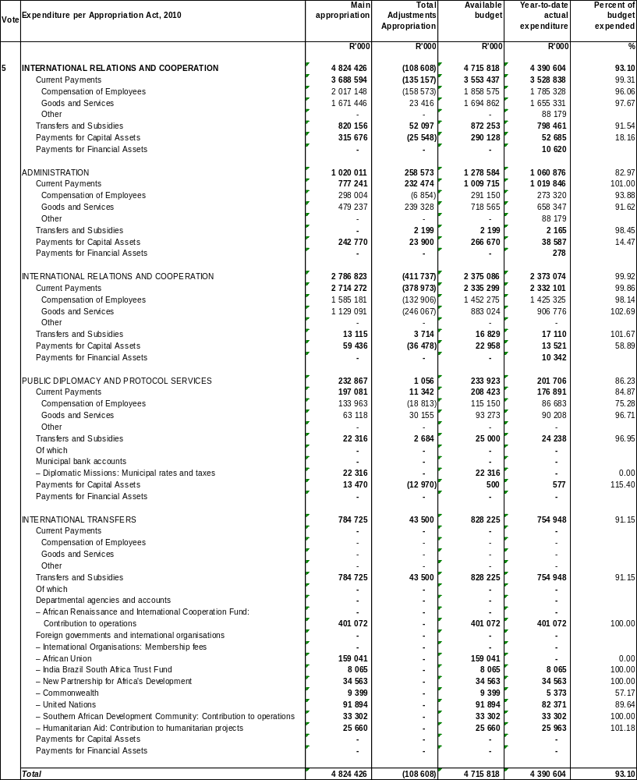Source:
As at 31 March 2011 the department spent an amount of R4.396 billion or 93.2% against the adjusted appropriation of R4.716 billion, under spending by R320.192 million or 6.8% against the adjusted appropriation at the end of the financial year. The slow spending is mainly on payments for capital assets which spent 18.2% against its adjusted appropriation. Spending in the fourth quarter increased from R2.605 million in the third quarter to R4.396, representing a 68.6% increase. Spending up to the fourth quarter is at 93.6% against the projection of R4.715 billion.
Expenditure on current payments amounted to R3.504 billion or 99.3% against the adjusted appropriation of R3.553 billion, with compensation of employees spending 96.1% and goods and services spending 97.7% against their respective appropriations. Spending against the projection for the fourth quarter is at 99.3%.
Expenditure trends per programme
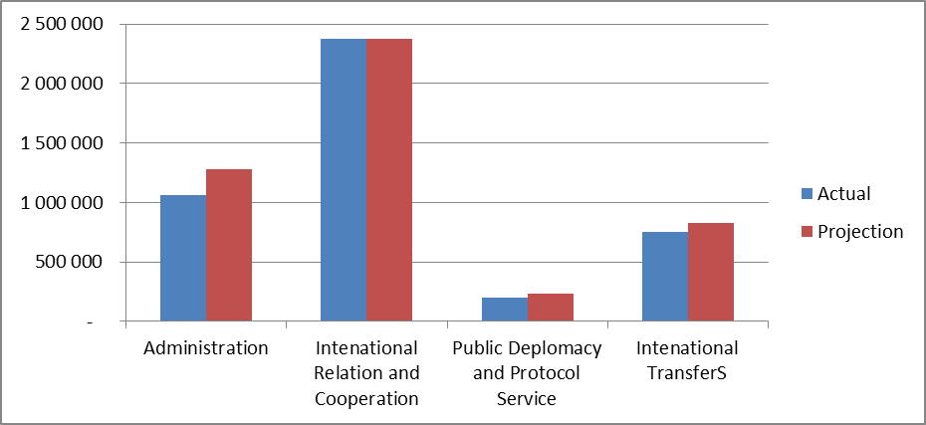
Programme 1 (Administration): Spending as at 31 March 2011 amounted to R1.061 billion or 83% against the adjusted appropriation of R1.279 billion. The slow spending is mainly on the sub programme foreign and domestic property management due to the slow spending on capital projects at the missions. Spending at the end of the fourth quarter increased from R644.904 million, representing a 64.5% increase. The missions in question are Washington (conversion and upgrade of official residence and Chancery), London (refurbishment of lifts), Nigeria(construction of Chancery and official residence).
Programme 2 (International Relations): Spending as at 31 March 2011 amounted to R2.373 billion or 99.9% against the adjusted appropriation of R2.375 billion. Spending seems to be on track in this programme; however the sub programme bilateral relations management has over spent its budget by 20.6%. Spending at the end of the fourth quarter increased from R1.732 billion, representing a 37% increase. However, it is also important to report that the department had to curtail down on missions’ activities subsequent to the adjustment estimates process in order to manage operations within the adjusted indicative baseline.
Programme 3 (Public Diplomacy): Spending as at 31 March 2011 amounted to R201.706 million or 86.2% against the adjusted appropriation of R233.923 million. Spending at the end of the fourth quarter increased from R147.673 million, representing an increase of 36.6%. The Unit was upgraded to a branch and therefore funded as a branch during the reporting period.
Programme 4 (International Transfers): Spending as at 31 March 2011 amounted to R754.948 million or 91.2% against the adjusted appropriation of R828.225 million. The under spending is attributable to savings of transfer payment due to foreign exchange gain during this financial year hence the under expenditure. Spending at the end of the fourth quarter increased from R80.571 million, representing an increase of 87%. The under-spending is attributable to unspent funds earmarked for the payment of membership and assessment contributions to the AU and the UN.
Expenditure trends by Economic classification
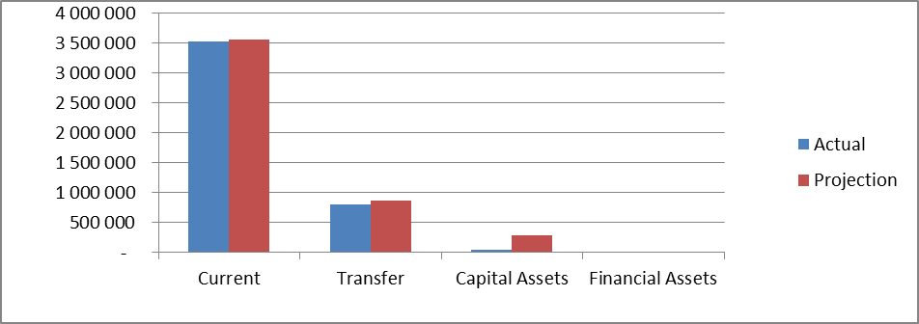
As at 31 March 2011 expenditure on current payments amounted to R3.529 billion or 99.3% against the adjusted appropriation of R3.553 billion, with compensation of employees spending 96.1% of its adjusted appropriation and goods and services spending 97.7%. Spending at the end of the fourth quarter increased from R2.447 billion, representing a 44.2% increase.
As at 31 March 2011 transfers and subsidies spent R798.461 million or 91.5% against the adjusted appropriation of R872.253 million. The under spending is attributable to savings of transfer payment due to foreign exchange gain during this financial year hence the under expenditure on Programme 4 (International Transfers).
Payments for capital assets spent R52.685 million or 18.2% against the adjusted appropriation of R290.128 million. The under spending is attributable to savings that relates to the capital projects that will be completed in the next financial year and savings on machinery & equipment which could not be acquired during this financial year.
Revenue received and deposited
Total receipts amounted to R27.733 million as at 31 March 2011, which are from financial transactions in assets and liabilities contributing R18.177 million; interest, dividends and rent on land contributing R6.041 million and sale of capital assets contributing R3.515 million.
Spending performance on earmarked funds
The department reported spending on earmarked as follows:
- spending on the Devolution of funds from Public Works stood at R2.6 million against the earmarked allocation of R70.569 million representing the under spending of R67.966 million.
- New Head Office campus (payment for capital assets) spent R149.297 million or 104% against the earmarked funds of R143.5 million, projecting to over spend by R5.797 million at the end of the financial year.

5. Analysis of the Department’s Annual Report and Financial Statements
The Portfolio Committee on International Relations and Cooperation considered and analysed the Annual Report of the Department of International Relations and Cooperation for the 2010/11 financial year.

The focus of the assessment is on the performance of the key programmes of the Department comprising of Administration, International Relations and Cooperation, Public Diplomacy and International Transfers. The Department’s performance is measured against its own set targets as identified in the Strategic Plan of 2010-2013. It is also measured against Government’s 10 key priorities identified in the President’s State of the Nation Address of May 2010 and the Government’s Medium Term Strategic Framework 2010-2015. Other key measures comprise of the moral values and principles that underpin the country’s foreign policy. The source documents for this analysis include the 2010 Estimates of National Expenditure (ENE), the 2010 State of the Nation Address, as well as the Department’s Strategic Plan 2010-2013. The analysis gives special attention to Programme Two, International Relations and Cooperation, as it is the Programme which executes the core functions of the Department. The Department’s African Renaissance and International Co-operation Fund report for 2010/11 is also assessed in this report.

5.1 Performance per Programme
5.1.1 Programme One: Administration
Main objective: The Programme is responsible for overall policy development and management of the Department.

Achievements: Consular services were rendered to South Africans affected by the following incidents: bombing in Stravropol and Moscow in Russia; the Air Afriqiyah crash in Tripoli; the unrest situations in Kyrgyzstan, Tunisia, Egypt, Libya, Cote d’ I’voire and Bahrain; flooding in parts of Australia; earthquake in Christchurch, New Zealand and earthquake in Japan. The Department completed the construction of eight staff houses in Maseru, new official residence in Namibia and a State Protocol lounge at the King Shaka International airport in Durban. Five redundant houses were disposed off in Namibia.

A total of 3754 South Africans were registered on ROSA during the reporting period. The department continued to have a proper expenditure management. It had spent 93.4% of its allocated budget by the end of the reporting period.
Two hundred and ten(210) international relations practitioners from the three spheres of Government were trained in Economic diplomacy. A White Paper on Foreign Policy has been drafted.

Challenges: However, the Auditor General has granted a financially unqualified report with findings. The report and the Internal Audit raised questions with regard to the strategic objectives of the department in some incidents not being ‘SMART’, and at times supply and chain management rules and regulations not being followed in procurement situations. Missions in Africa require use of Cashbook system due to the nature of banking transactions in countries of residence.

A currency (cashbook) system was implemented as an interim measure while mission’s Accounting System was being developed, posing possible accounting challenges in the future.

The Auditor General’s report still showed problems with capturing of data and monthly reconciliations in the missions, especially with regard to the Asset Register. Progress is still slow in filling of vacancies, resulting in low staff turnover despite the huge mandate of the department. Policy around the engagement of Locally Recruited staff in missions abroad still favours non-South Africans. Performance assessments of staff at managerial positions were not yet completed by the end of the reporting period. The Auditor General report is still highlighting the challenges of management of an entity like the African Renaissance Fund and the ascertainment of actual results in project areas.

There are difficulties in remotely managing construction projects in missions resulting in delay in completing such projects. The Consular Emergency Response Team is yet not operationalised, and it becomes a challenge dealing with complicated cases in locations where conditions of war (Anton Hammerl in Libya), serious civil unrest (Phillip Young in Afghanistan) and limited government exist (hostages Deborah Calitz and Bruno Pellizzari in Somalia).

5.1.2 Programme Two: International Relations and Cooperation
Main objective: The function of this Programme is to promote bilateral and multilateral relations and facilitate the Department’s participation in international organisations and institutions, in pursuit of South Africa’s national values and foreign policy objectives.

Achievements: The Annual report reported on the re-election of South Africa to a non permanent seat in the United Nations Security Council for a two year term 2011-2012. This coincides with SA term in the African Union Peace and Security Council; and assuming a seat as the Chairperson of the SADC Troika. All these developments provide South Africa with a unique opportunity to coordinate efforts in the three organisations with regard to the maintenance of peace and security on the continent and abroad. South Africa was appointed to form part of mediation parties mandated by SADC in Zimbabwe and Madacascar; and by the African Union in Libya and Cote d’Ivoire.

President Zuma and President Tarja Halonen of Finland have been elected as Co-chairs of a High-Level Panel on Global Sustainability (GSP), launched by the UN Secretary General in August 2010 in recognition that climate change and related factors require a bold new approach to ensure that the world can meet the MDGs and other development objectives. South Africa currently co-chairs the G20 Development Working Group with France and South Korea.

In furtherance of the spirit of ‘UBUNTU’, SA extended humanitarian assistance to several disaster hit nations including Benin, Niger, Chad, Cuba, Chile and Japan and a contribution of about R23 million was made during the previous financial year. South Africa ratified the AU Charter on Democracy, Elections and Governance. The 16th AU Assembly January 2011, endorsed appointments of Dr. Frene Ginwala to the Advisory Board on Anti Corruption for a second term, and Prof. Sloth Nelson to the African Committee on the Rights and Welfare of the Child.

In July 2010, the AU Summit endorsed President Zuma’s recommendation for prioritisation of continental cross-border infrastructure projects. South Africa submitted its 2nd Progress Report on the African Peer Review Mechanism (APRM) in January 2011. South Africa was invited to join BRIC, and participated in the 3rd BRICS Summit in April 2011. South Africa made inroads into the oil rich Gulf States and the Middle East for future cooperation prospects. Cuba assists South Africa in its efforts to provide essential services, ie health, education and decent work. A number of Cuban professionals are deployed in rural areas.

United States is the largest source of FDI with approximately 600 companies represented in South Africa. Turkey is becoming very strategic for South Africa in Europe.

Challenges: There exists a strong possibility that the G20 development agenda could be overshadowed by the current financial crisis facing Europe and the United States. Departments remain inconsistent in the identification of strategic intergovernmental bodies in which South Africans could potentially serve in order to field South Africans in relevant and strategic positions abroad.

There is insufficient commitment by some African countries to NEPAD. There is also a shortage of resources for implementation of NEPAD programmes and projects. There is inadequate representation of South Africans in both the AU and NEPAD structures. The idea of fielding Hon Nkozasana Zuma to contest for the position of the Chairperson of the African Union Commission is being mooted. There are capacity challenges also within SADC.

New cultural dynamics unique to the Gulf States need to be addressed such as challenges of sending women officials to Saudi Arabia, Gulf Royal families ranking higher than ministers protocol wise, absence of investment protection agreements with these states, making them sceptical about investing in South Africa.

The Palestinian question remains unresolved, denying the establishment of a viable Palestinian state.

The US ODA can be coming under renewed scrutiny as a result of the economic decline and the political re-alignment. Global economic difficulties will continue to challenge investment flows into South Africa. There is a slow down in trade and investment with Europe due to the financial and economic crises.
The Africa group in the United Nations Security Council do not always agree on principled positions.

5.1.3 Programme Three: Public Diplomacy and Protocol

Main objective: Among the main tasks of the Programme is to provide an effective State Protocol service as well as to “communicate an understanding of South Africa’s foreign policy goals, positions, achievements and programmes at home and abroad.” The programme has made noticeable strides in meeting its objectives.

Achievements: The events leading to COP17 have wide media coverage. Press releases are regularly held to inform the public about the positions taken at multilateral forums.. The department raised R8 million in less than a week for the campaign on Somalia famine and drought situation. The Public Diplomacy Unit has since been upgraded to a branch and capacitated with appointments this year of all director positions (5), and the majority being women.

Challenges: The public is still not fully engaged with the formulation of foreign policy and trends influential to its orientation. South Africa’s 2nd tenure in the UN Security Council is still met with criticism regarding consultation on issues and timely communication on positions taken at the UN. Capacity is still inadequate for the number of projects to be completed. The department successfully participated in the 2010 FIFA World Cup. To date, 212 officials have been trained to build capacity at the three spheres of Government.

6. Consideration of Reports of Committee on Public Accounts

Report not available for the reporting year 2010- 2011

7. Consideration of Other Sources of Information

7.1 The State-of-the-Nation address

The 2010 State of the Nation Address outlined a set of key strategic objectives to be pursued by the Department of International Relations and Cooperation during the financial year 2010/11. The list of strategic objectives was not as extensive as in the 2009 State of the Nation Address. However, there was an indication of continuity, but perhaps also a change in emphasis in 2010. For instance, whilst in 2009 it was stated that Government would ‘give impetus’ to the implementation of the New Partnership for Africa’s Development (NEPAD), in 2010 State of the Nation Address the President mentioned that Government “will focus energy on revitalising the New Partnership for Africa’s Development”. The change in emphasis can be inferred from the use of the words, ‘give impetus’ and ‘focus energy on revitalising’. The latter somewhat suggests that Government envisaged playing a central role in reinvigorating the NEPAD programme, as opposed to just giving an added focus to the initiative. Besides a renewed focus on NEPAD, the following are the key strategic objectives of Government as identified in the 2010 State of the Nation Address:

Strengthening the structures of the African Union (AU) and working for unity.
Supporting the political and economic integration of the Southern African region, through, among other things, promoting intra-regional trade and investment.
Generally promoting South Africa’s interests globally.

Enhancing an environment of peace and security throughout the African continent is a key objective for Government. Having achieved relative success in the SADC mandated facilitation role in Zimbabwe, South Africa now faces the challenging task of facilitating movement on issues where there are deadlocks. Overall South Africa should support efforts to strengthen the unity government and assist Zimbabwe towards economic recovery. The 2009 State of the Nation Address emphasised that South Africa be seized with issues pertaining to Zimbabwe until such time that free and fair elections are held in that country, which would signal the return of democracy and the rule of law. It is crucial that South Africa does not, and is not seen to be abrogating this commitment.

7.2 Report of the Auditor-General of South Africa, the Financial and Fiscal Commission

The Auditor General expressed an unmodified audit opinion on the performance of the department, with emphasis of matter on the following:
- The department incurred irregular expenditure of R526 089.00 in contravention of rules and regulations relating to supply chain management.
- The financial statements and other information which were to be included in the 2010/11 annual report were not checked for completeness and accuracy before submission for audit.
- Indicators on the performance information were not well defined and targets not specific and measurable.
- The management of the department did not report on progress made in achieving measurable objectives to the executive authority on a quarterly basis as required.
- Financial statements were submitted for auditing having not been prepared in all material aspects in accordance to all accounting standards. These were subsequently corrected.
- Employees performed remunerative work outside their employment without written permission from the relevant authority as legally required.
- Awards were made to suppliers who did not submit a declaration of past supply chain practices such as fraud.
- Not all senior managers entered into performance agreements for the current year as required.
- Employees acted in higher vacant posts for an interrupted period exceeding 12 months, and in senior management positions for periods exceeding six months contrary to regulations.
- Management did not report as required on the outcome of disciplinary proceedings related to financial misconduct.
- Leadership and accounting officer needs to improve the level of oversight responsibility on reporting and compliance with regulations at all times.
- Leadership should regularly review management reporting best practices, mentioned practices failed to detect misstatements of financial statements and performance information submitted for audit.
It may be appropriate for the department to address the concerns raised by the Auditor General and state how it aims to ensure that these problems do not recur. A report back to the Committee is crucial as this is the first time laxity of office procedures has been reported.

The African Renaissance and International Cooperation Fund (ARF):
The purpose of the ARF is to promote economic cooperation between the Republic of South Africa and other countries, by granting and/or rendering of other financial assistance in respect of post conflict development projects in such countries.

An amount of R 461, 835 million for 2010/11 was budgeted for transfers to the department’s public entity, the African Renaissance Fund.

The Auditor General has pointed out that as the ARF is a Schedule 3A public entity, it is recommended that a separate accounting system be acquired for the entity. The Auditor General made the following unmodified audit opinion on the performance of the Fund, with emphasis of matter as follows:
- In the annual performance report, the performance targets are not specific in clearly identifying the nature and required level of performance.
- The accounting officer did not report on progress made in achieving measurable objectives.
- The strategic plan for 2010-2013, for the Fund has not been submitted to Treasury as required. The department argued that by nature of the Fund’s mandate, it’s not visible to plan what assistance will be required. (How will SADPA be run without a strategy projecting its work targets?).
- Documented and implemented policies and procedures are not sufficiently monitored to ensure that the operations of the entity comply with relevant laws.
It is important for the department to iron out outstanding issues relating to proper management of the ARF before SADPA comes into place to ensure seamless transition and smooth start by the envisaged agency.
.

8. Committee’s Observations

- The change of name of the Department and the drive to align foreign policy to domestic priorities is having the necessary impetus on the department’s service delivery charter. The increased flow of FDI resulting from the international opportunities created by the department contributes to poverty alleviation and job creation.
- There is insufficient commitment by some African countries to NEPAD. This situation has an impact on the implementation of NEPAD programmes and projects. Africa is not speaking in one voice with regard to seeking international support for NEPAD programmes.
- NEPAD has been positioned to form the core of Africa’s South South and North South relationships. This has led to a number of international commitments in support of the implementation of NEPAD. (UN, EU, Asean countries, Japan through TCHAD, China-Africa forum). However, there is still a shortage of resources for supporting its programmes.
- South Africa’s contribution to peace, security and stability on the continent has grown considerably. The country has been supporting the African Union, United Nations and SADC efforts aimed at bringing peace.
- Public diplomacy program is functional, but not yet at the level where information is effectively disseminated about the activities of the Department and its execution of foreign policy is conducted. The recent staffing and elevation of the Public Diplomacy Unit to a Branch is a positive development and will begin to address the issues of communication and consultation on the conduct of foreign policy.
- The issue of continental integration is closely linked to the need for regional integration through Regional Economic Communities (RECs) as building blocs for realization of the African Economic Community. There are processes to operationalise the Tripartite Free Trade Area comprising SADC, COMESA and East African Community (ECA).This will create a conducive environment for inter-state trade and economic development in the area.
- South Africa has been re-elected to a non permanent seat in the United Nations Security Council (UNSC) for 2011-2012 term. It has taken a seat in the African Union Peace and Security Council as well as assuming a seat as a chairperson of the SADC Troika. This provides South Africa with the opportunity to coordinate efforts towards peace and stability in these three organizations.
- South Africa still faces challenges in the UN Security Council. The country’s foreign policy positions are constantly under the spotlight. The African Group in the Security Council has not been operating in a unified and effective manner. The group is not always cohesive, because of the influence of the permanent members over some elected members, alliance building is difficult.
- The department partnered with SABC and local non governmental organizations dealing with humanitarian assistance, including the Gift of the Givers, and responded in record time, in raising funds for responding to the plight of the people of Somalia in the wake of famine and drought in that country.
- In the 2007/8 annual report, the Department had mentioned a development of a draft White Paper on South Africa’s participation in International Peace Missions. In 2009/10 annual report, there is mention of a draft White Paper on South African Foreign Policy; the Committee awaits the opportunity to scrutinize both documents as soon as possible.

9. Conclusion
Overall performance by the Department in the reporting year has been satisfactory and the Committee is encouraged by the commitment the Department is contributing towards improving lives of fellow South Africans; a stable and secure continent; and creating a better world for all.

The Committee is so far satisfied that the Department has utilized its budget in accordance with its plans for 2010/11. A lot of significant achievements were reported. South Africa is highly regarded in multilateral forums because of its facilitation and mediation skills. There is an unqualified audit report with emphasis on matter, a situation which warrants undivided attention of the Accounting officer to ensure that there is no recurrence. There will always be room for improvement. The Committee regards this as work in progress and the department should make the necessary adjustments in service delivery where needed.

10. Recommendations
The Committee is of the opinion that overall the Department has performed according to the goals it had set itself for the 2010/11 reporting period. The 2010/11 budgetary allocations of the Department were generally aligned to the national strategic priorities outlined in the 2010 State of the Nation Address, as well as its strategic direction in terms of its Medium Term Expenditure Framework. The unqualified audit report with emphasis of matter, when rectified, will still be a positive indication of commitment of purpose by the Department to diligently execute its mandate.

The Committee acknowledges that in general there are challenges facing the Department which can have a bearing on its service delivery programs. In the midst of the international environment of a global meltdown, the missions abroad have to deal with decreased support for developmental assistance from cooperating partners. They have to source new export markets for South Africa’s products, while dwindling FDI means job losses and very little impact on the delivery capacity of the Department on the pronounced governmental priorities as espoused in the State of the Nation Address 2010.

The unpredictable foreign exchange portfolios, have been negatively affecting the operations of the Department, especially in the missions, where the bulk of its activities take place.

In order to further assist the Department to enhance its performance, the Committee has resolved to make the following recommendations to which progress report thereto must be presented to the Committee within three months of the publication of this report:
- In pursuit of the African Renaissance Fund activities in Africa and elsewhere, and in the context of Post Conflict Reconstruction and Development (PCRD), the department should conduct a review of its involvement on the continent to draw lessons and identify areas of focus for future engagements under the ARF or SADPA when it takes over.
- In its multilateral engagements, the department must seek concrete action on international commitments on NEPAD programmes and projects as espoused by the European Union, Asean countries, China Africa forum, Japan Africa TCHAD, the US government and the UN to mention a few.
- There must be regular physical verification of all assets globally, as well as continuous update of the Asset register to ensure its accuracy and completeness.
- A refresher workshop for middle and senior management on creation of ‘SMART’ objectives and targets; supply chain management; asset management and property management would be of benefit for future compliance with audit requirements.
- Performance contracts must be signed as required and assessments must be completed for all senior management staff to be able to fairly distribute performance dues and also to gauge the performance of this level of officers that they are able to deliver on the mandate as required.
- In the light of recent natural and man-made disasters, there is a need for a vigorous popularization campaign for ‘ROSA’, in order to be informed of the presence of South African citizens in areas of accreditation.
- Training of internal language personnel could reduce spending on secured external consultants for translation of documents and communication with foreign missions. Security of information should also be considered.
- The department should consider acquiring property for the missions as opposed to leasing for the purposes of housing staff and office accomodation.
- Policies and practice for recruitment of Locally Recruited Personnel needs to be looked at and create the same opportunities for South Africans residing in those countries abroad.
- Training on and necessary capacity on project management is essential for proper functioning of the ARF and its successor SADPA.
- The department must seize the opportunity to offer South Africa as a facilitator and mediator of choice. Mediation and facilitation experience and opportunities in conflict situations must be used to posture South Africa as a leader in this sphere. It is a tool of soft power.
- Regular consultations, engagements and lobbying of the permanent five countries in the UN Security Council crucial. Seeking a common ground with the African Group in the UN Security Council is paramount for the department’s prevalence in the Council.
- A coordination mechanism must be created between departments for identifying which strategic organizations must be targeted to field South Africans for available positions
- A facility must be created for access by all to apply for positions abroad.
- There must be feedback on the department’s response to Auditor General’s report with emphasis of matter.

Report to be considered.

Sources

- Annual Report 2010- 2011 Department of International Relations and Cooperation.
- Strategic Plan, 2010- 2013, Department of International Relations and Cooperation.
- Treasury, Vote: International Relations and Cooperation, Estimates of National Expenditure 2010.
- Zuma, J.G. 2010, State of the Nation Address at the Joint Sitting of Parliament. Cape Town.
- The African Renaissance and International Cooperation Fund Act 2000

Constitution of the Republic of South Africa 1996
Department of International Relations and Cooperation, Strategic Plan 2010/13, p6

