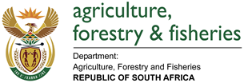
BRIEFING NOTE TO THE PORTFOLIO COMMITTEE ON AGRICULTURE FORESTRY AND FISHERIES.
SUBJECT: tariffs and subsidies in agriculture, forestry and fisheries
DATE : 18 SEPTEMBER 2012 2012

subject
Tariffs and subsidies in agriculture, forestry and fisheries products in South Africa

PURPOSE
2.1 To brief the Portfolio Committee on Agriculture Forestry and Fisheries on tariffs and subsidies in agriculture, forestry and fisheries products,
2.2 To inform the Portfolio Committee about the tight policy space available to increase import duties against subsidised imports originating from countries that we have trade agreements with, and
2.3 To get guidance from the Portfolio Committee on how DAFF should address the trade policy challenges identified in the text below.

SUMMARY
3.1 State support to South African agriculture was virtually lost during the dual processes of domestic market deregulation and trade liberalisation that took place from mid to late1990s. Deregulation of agricultural markets led to the dissolution of Marketing Control Boards that used to administer quantitative controls over imports and exports; regulate prices of agricultural commodities through state determination of ceiling and floor prices exercised in terms of the Marketing Act of 1968 by tariffs in line with the Marrakesh Agreement (Final Act establishing the WTO) of 1994.. During the process of accession to the WTO as well as conversion of the quantitative trade restrictions to deregulated marketing environment, South Africa bound its tariff rates at far lower levels than mandatory requirements imposed by the World Trade Organisation (WTO) through the Uruguay Round Agreement on Agriculture (URAA) (Annex to the Marrakesh Agreement). In summary, South Africa’s negotiated agriculture tariffs were much more bullish in contrast to our level of social and economic development at that time and levels negotiated by other WTO member states.
3.2 The URAA consists of four main portions; the Agreement on Agriculture itself; the concessions and commitments undertaken my members on market access, domestic support and export subsidies; the Agreement on Sanitary and Phytosanitary Measures; and the Ministerial Decision concerning Least-Developed and Net Food-Importing Developing countries.
3.3 Overall, the URAA provided a framework for the long-term reform of agricultural trade and encouraged the use of less trade-distorting domestic support policies. The URAA also provided for member commitments in the areas of market access, domestic support and export competition. Non-tariff border measures were to be replaced by tariffs that were aimed at providing the same level of protection and tariffs were to be lowered over a certain period. Domestic support measures that are considered to have a minimal impact on trade (“greenbox” policies) were excluded from the reduction commitments. Such policies include general government support services such as the provision of research, disease control, infrastructure support and projects aimed at increasing food security. Greenbox policies also include direct payments to producers for certain forms of “decoupled” (from production) income support and direct payments under environmental and regional assistance programmes. The URAA also requires members to reduce both the value of direct export subsidies and the quantity of subsidised agricultural exports.
3.5 A closer analysis of the data in the figure below indicates that South Africa fast-tracked the liberalisation of its (and South African Customs Union) tariff schedule during the 1990s, with the average tariff on agricultural products reaching 9.4 percent in 2004 and the average bound standing at 39.7 percent during the same period. It is important to note that the actual applied Most Favoured Nation (MFN) current rates are significantly lower than the WTO bound rates. Another important aspect to consider in the determination of available tariff policy space is the effect of South Africa’s preferential trade arrangements with a number of other individual countries and trading blocks, notably the European Union and the Southern African Development Community.
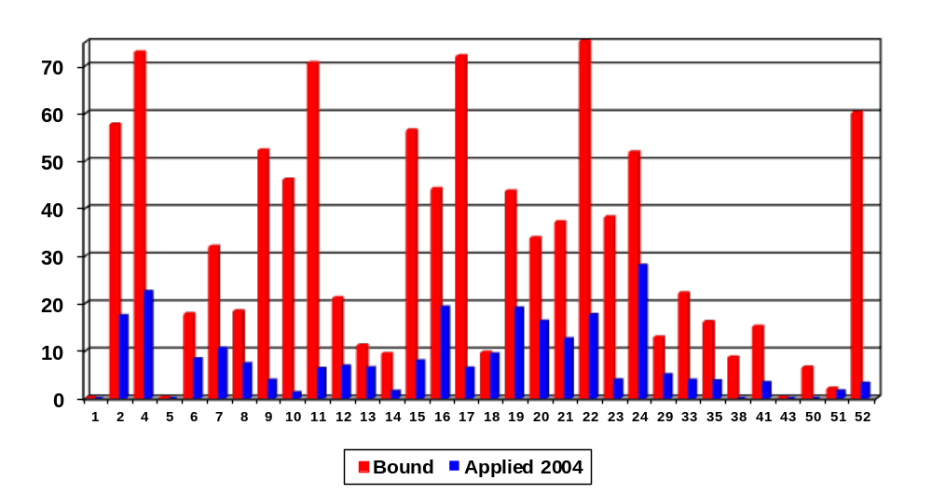

STRATEGIC FOCUS OF THE MEMORANDUM
To brief MinExco on the current tariff dispensation for agriculture, forestry and fisheries products and to further get guidance on how trade policy challenges identified in the memorandum should be addressed by the department.

discussion
5.1 Tariffs on all traded products in South Africa are determined by the International Trade Administration Commission of South Africa (ITAC). The Commission was established through an act of parliament, the International Trade Administration Act, 2002 (Act No. 71 of 2002) (Annexure A) which came into force on 1 June 2003.
5.2 The aim of the ITAC, as stated in the Act is “to foster economic growth and development in order to raise incomes and promote investment and employment in South Africa and within the Common Customs Union Area by establishing an efficient and effective system for the administration of international trade subject to the Act and the Southern African Customs Union (SACU) Agreement.” The core functions of the ITAC are: customs tariff determination and investigations; application of trade remedies (e.g. antidumping duties, countervailing duties and special safeguard measures); and the administration of import and export controls. The ITAC is therefore the only body mandated by law to deal with customs tariff determination and investigations pertaining to all products in South Africa.
5.3 South Africa has a number of formal trade agreements, including free trade agreements (FTAs) and preferential trade agreements (PTAs – have some exclusions embedded in the agreements), with a number of countries and economic blocks. Accordingly, these trade agreements are aimed at improving market access to specific countries and usually include the lowering of customs duties and other impediments to free trade. A closer examination of the South African trade regime reveals the following major trading partners: the European Union (EU), the European Free Trade Association (EFTA) and the Southern African Development Community (SADC). South Africa is also a founding member of the oldest full customs union in the world, the Southern African Customs Union (SACU). No duties apply when SACU member states (South Africa, Botswana, Lesotho, Namibia and Swaziland) trade with each other. All agricultural imports from SADC member states also enter South Africa duty free.
5.4 South Africa’s trading relationship with the EU was formalised through enactment of the Trade, Development and Cooperation Agreement (TDCA) which was implemented in 2000. The TDCA establishes preferential trade arrangement between the EU and South Africa, with the progressive introduction of a Free Trade Area (FTA). The EU is South Africa’s main trading and investment partner. The FTA aims to ensure better access to the Community market for South Africa and reciprocal access to the South African market for the EU. As a result, it plays an important role in South Africa's integration into the world economy. The Agreement covers around 90% of current bilateral trade between the two parties. The Agreement provides for the liberalisation of 95% of the EU's imports from South Africa within ten years, and 86% of South Africa's imports from the EU in twelve years. In order to protect the vulnerable sectors of both parties, certain products are excluded from the FTA and others have been only partially liberalised. For the EU, these exclusions (sensitive products) are mainly agricultural products, while for South Africa; they are industrial products, in particular certain motor vehicle products and certain textile and clothing products thus making the agricultural sector more vulnerable.
5.5 It is important to note that most import tariffs applicable to agricultural products originating from the EU are now entering South Africa at zero percent, except for sensitive products such as wheat, sugar, maize, dairy and meat. Approximately 96 percent of all agricultural imports from the EU currently enter South Africa duty-free and there appears to be very little chance of increasing import tariffs on these products. This is mainly because the TDCA included a “standstill” provision which prevented tariffs from being increased beyond the bound rate that was agreed at the start of the negotiations of the TDCA in 1996. It is important to note that tariff lines, including those for maize, wheat and sugar that are subject to tariff formulae were excluded from the standstill provision up to a certain limit. This means that for these products, there exists a bit of policy space to increase tariffs up to the limits. It is also important that in cases such as dairy products (see figure below), the duties are specific and this does not provide protection over time, it is recommended that they be converted into ad valorem duties as protection offered by specific duties get eroded over time.

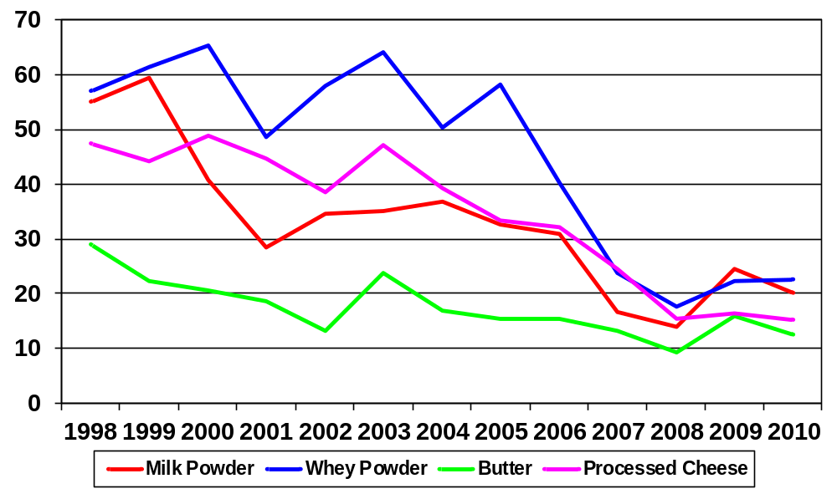

5.6 South Africa is also a party to the free trade agreement between the European Free Trade Association (EFTA) and SACU. The agreement was signed in June 2006 and entered into force in May 2008 and it covers trade in goods and lays the foundation for a further engagement of the parties with regard to intellectual property, investment, trade in services and public procurement. The agreement provides for concessions on processed agricultural products and trade in processed agricultural products is covered in Annex III to the main agreement. Trade in basic agricultural products is covered by arrangements concluded bilaterally between each EFTA state and SACU. These agreements, which form part of the instruments establishing the free trade area, are also asymmetrical; giving SACU improved preferential treatment into the EFTA markets. To date there are three agricultural agreements, namely: between Iceland and SACU, Norway and SACU, and Switzerland and SACU and most agricultural tariff lines are close to zero.
5.7 Generally, South Africa has a fairly open market and approximately 40% of all agricultural imports from all destinations enter the country free of duty. South Africa has 996 agricultural tariff lines in its tariff schedule and of these, a total of 396 lines carry a zero percent duty. The number of tariff lines carrying zero percent duties increased to 881 at the beginning of 2012 when the final stage of the TDCA was implemented. It is also important to note that the tariff lines that are subject to a formula duty (i.e. maize, wheat and sugar) are currently at zero percent or free.
5.8 The facts raised above are further supported by results from recent studies conducted by the Organization for Economic Cooperation and Development (OECD) on the level of support offered to agricultural producers in different countries. Using the producer support estimate (PSE) method to measure the extent of policy intervention by the state in the agricultural sector, the OECD found the PSE for South Africa to be 5 percent (which is mainly border measures or tariff protection). This is in comparison with 34% for the EU, 31% for OECD member states, 58% for Japan, 20% for the US, as well as 6% for China. The PSE is expressed as a percentage of gross farm receipts (a high percentage indicates high level of support and vice-versa). It is estimated that support to agriculture throughout the world, measured in terms of the PSEs, contribute about 10% depression in world prices of commodities. It can therefore be argued that the level of global support to agriculture is gradually rendering unsubsidized agricultural production unsustainable and unprofitable.
5.9 It is important to note that the trading relation between South Africa and the EU, provided for through the TDCA, is asymmetrically in favour of the EU due to the following factors: EU producers are highly subsidized; South Africa’s applied rates are generally low and the EU is already commanding a sizeable share of the South African markets in products such as dairy; protection offered by specific duties is generally low as duties do not keep trend with price and cost increases; from the foregoing, it appears that agriculture was treated as a bargaining sector by South African negotiators during the TDCA negotiations.
5.10 Following the above, and given the strategic nature of agriculture in South Africa, it becomes critical that the sector be afforded the necessary support for it to be able to fulfil its strategic mandate. Even though recent data indicates that the direct contribution of the agricultural sector to GDP has declined steadily over the past few decades, this approach however, underestimates the sector’s real contribution to GDP. The real contribution of the sector should be looked at in terms of its contribution to the economy through:
- Direct agricultural production activities plus the processing of farm-produced raw materials into food, feed, beverages and textile products. The food and beverages sector in South Africa represents about 18% of total manufacturing production whereas the manufacturing sector contributes some 19% of GDP. This represents a further contribution of approximately 3.4% of GDP. In addition, agriculture contributes to GDP directly through the purchase of inputs (both goods and services). The combined GDP contribution of the sector along with its forward and backward linkages is therefore larger than the recorded 3%;
- Agriculture generates employment to a large proportion of the economically active labour force (between 8 and 9%);
- The purchasing power of farmers’ incomes and farm workers’ wages, which are the main source of the strong linkages between agriculture and the rest of the economy.
- Earning of foreign exchange;
- The role that agriculture plays in the rural areas of South Africa, where its contribution is larger than in the whole economy;
- The livelihoods that it provides for people in the informal economy through subsistence production as well as through a wide variety of activities in the processing, distribution and retailing of food products in poor rural and urban areas; and
- The role of the sector in the stewardship of the environment (preservation of natural resources).
5.11 Over a period of time, the Department of Agriculture, Forestry and Fisheries (DAFF) raised concerns to ITAC and the Department of Trade and Industry regarding the generic application of tariffs (in the context of its implementation of trade policy) on imported products where agricultural, forestry and fisheries products were not given special attention due to the nature of the sector and also noting the fact that agricultural products in most countries are subsidized while domestic producers are not.
5.12 Following the above, the DAFF then initiated a process to develop an Agricultural Tariff Policy Framework to guide ITAC on how agriculture, forestry and fisheries products should be tariffied. Such a tariff policy framework was developed in collaboration with various industry stakeholders including ITAC and the DTI (Annexure B). The tariff policy framework was approved by the Minister for Agriculture, Forestry and Fisheries and the Minister for Trade and Industry. The policy framework now provides for tariff policy application to be considered on a case by case basis depending on the sector.
5.13 In terms of the ITA Act, requests for tariff reviews for any product (ranging from chemicals, automotive, textiles and clothing, printing, etc) can be applied for by any key player within the affected sector/industry and are only considered on merit and on a case by case basis. It is important to note that should the department or any key stakeholder within the agricultural sector desire to have all tariffs for agricultural, forestry and fisheries products reviewed, such a request will still have to be submitted to ITAC in line with the provisions of the Act with strong motivations why such an investigation or review should be undertaken.
5.14 As part of the agreement (Memorandum of Understanding attached as Annexure C), ITAC reserved a seat for a Commissioner from DAFF to represent the interests of the sector in line with the principles of the policy framework. The current commissioner representing DAFF at the ITAC is the Director: Marketing, Mr. Billy Morokolo. The standing arrangement is that whenever ITAC receives applications relating to the review of a tariff for agricultural, forestry and fisheries products, DAFF is invited to provide its comments and views for consideration by the Commission. The NAMC is also part of the bodies closely consulted by ITAC on any tariff application pertaining to agriculture, forestry and fisheries products.

CONSIDERATIONS
6.1 It should be noted that South Africa liberalized trade and deregulated its markets faster and liberalized trade ambitiously than the rest of its trading partners while the multilateral trading rule system established to reduce trade distortions got stuck in slow movement (WTO impasse on agriculture). As a result, South African producers experienced and continue to experience unfair competition from countries that delayed their processes of deregulation (subsidized producers). It was also realized that tariff dispensation as applied may not be sufficient to encourage expanded domestic production of some agricultural products. Due to its significance in the economy, the agricultural sector should enjoy more support similar to other sectors that receive preferential attention, such as the textile and automotive sectors.
6.2 The incorporation of the principles encapsulated in the agricultural tariff policy into the national industrial policy framework of the DTI provided for a differentiated policy framework that takes into account the special features of the sector i.e. food security, rural development, absorption of low-skilled labour, high labour absorption rate per million rand investment, source of raw material for downstream sectors, etc.
6.3 The implementation of policies and instruments such as a tariff policy must take a strategic approach and generate wider impact on the broader agricultural sector; must be geared towards achieving certain long term outcomes such as industry growth, competitiveness, job creation, food security, exports, etc and be linked to development policies and programmes.
6.4 Applications for tariff amendments (especially increases) by primary producers always generate a negative reaction from downstream players within the same value chain. Tariff increases on imported raw agricultural products have a potential to increase food prices which in turn bring negative welfare effects in the face of high global food prices. Low tariffs on primary products have an effect of discouraging expansion of domestic production, resulting in the crowding out of domestic producers due to cheap imports. Given the above scenario, the ITAC is expected to perform a balancing act to straddle the two divides, with producers on the one side and downstream industry players and consumers on the other side. An industry-based approach to tariff setting looking at the broader interests of the entire industry value chain is essential though a challenge.
6.5 It is also important to note that the ITAC operates under a prescribed legal framework and within the bounds of free trade agreements that South Africa has signed. Given the limited space within which tariffs may be utilised, it becomes critical that their use should form part of an integrated strategy to derive certain socioeconomic outcomes such as increasing production and competitiveness, ensuring food security, profitability, sustainability, contribution to rural development, etc. The objective must not be narrowly focussed only on domestic protection. Objectives as stipulated in government policies such as the New Growth Path (NGP), Industrial Policy Action Plan (IPAP), National Industrial Policy Framework (NIPF), etc. must be used as a basis for arguments in favour of better border protection measures.
6.6 South Africa entered into trade agreements and bound tariffs at levels that cannot be increased; there is therefore a need to utilize and simplify alternative mechanisms to protect the sector against cheap imports. These measures include tariffs, antidumping duties, countervailing duties, as well as special safeguard measures.

ORGANISATIONAL AND PERSONNEL IMPLICATIONS
None

FINANCIAL implications
None

COMMUNICATION implications
9.1 Whenever the ITAC receives applications for a new tariff line or the review of an existing tariff for agricultural, forestry and fisheries products the DAFF is invited to provide comments and recommendations for consideration by the Commission.

CONSTITUTIONAL AND OTHER LEGAL IMPLICATIONS
10.1 The legislative mandate of determining and investigating customs tariffs rests with the International Trade Administration Commission of South Africa (ITAC). The ITAC derives its mandate from the International Trade Administration Act, 2002 (Act No. 71 of 2002).

IMPLICATIONS FOR VULNERABLE GROUPS
The memorandum seeks to address trade policy issues affecting competitiveness and sustainability of producers across various value chains, including smallholder producers.

SECURITY IMPLICATIONS
None

DEPARTMENTS AND PARTIES CONSULTED, RESPONSES AND COMMENTS
None

recommendationS
14.1 The following recommendations are made:
14.1.1 Consideration should be given to the possibility of converting specific duties that exist within the agriculture, forestry and fisheries product lines into ad valorem duties in order to preserve levels of protection over time, while guarding against under-invoicing;
14.1.2 Tariffs should be used to protect all role players within a specific value chain. The current approach tends to offer protection for or to selected role players while leaving other role players within the same value chain vulnerable and this does not provide a total solution to the affected industry as a whole;
14.1.3 The processing of raw agricultural products into value added products should be promoted and the emphasis should be on exports of processed rather than raw agricultural products in order to support industrialization through agro-processing, e.g. conversion of the surplus maize into chicken, eggs, dairy products, meat and other maize based products that could be industrialized and traded locally or exported. Application of tariff policy in the sector should be geared towards deepening industrialization in SACU.
14.1.4 That for the sake of optimal application of the common customs tariff regime, SACU must determine the industries where it has common interest and ensure that they are fully protected and fully supported. Currently, SACU does not have a coherent and synchronized industrial development policy and this gap has the potential of creating regional conflict (e.g. wheat flour);
14.1.5 That South Africa should explore the possibility of renegotiating the “standstill” clause within the TDCA in order to increase the upper technical limits so as to create more policy space to increase import duties where necessary;
14.1.6 That DAFF should motivate for additional funds from the National Treasury to fund the implementation of greenbox policies such as infrastructure support, research and development in agriculture, forestry and fisheries. The department is urged to develop a motivation to NT in this regard because the policy space exists to support green box interventions in line with WTO;
14.1.7 The use of other trade remedies other than tariffs (e.g. antidumping, countervailing and special safeguard measures) should also be given consideration and promoted and be simplified in their application;
14.1.8 The Department should continue to argue for specialised treatment for the sector and motivate for enabling support policies similar to those placing the automotive and the textile sector at the forefront of economic development programs.
14.1.9 Consideration should also be given to the possibilities of introducing seasonal tariffs for specific agricultural products; and
14.1.10 South Africa and SACU should identify strategic agriculture, forestry and fisheries products and develop a long term trade and industrial support strategy to increase their growth and competitiveness within the broader policies such as IPAP and NGP.

TABLED BY:
Mr. M.E Morokolo
Director: Marketing

