
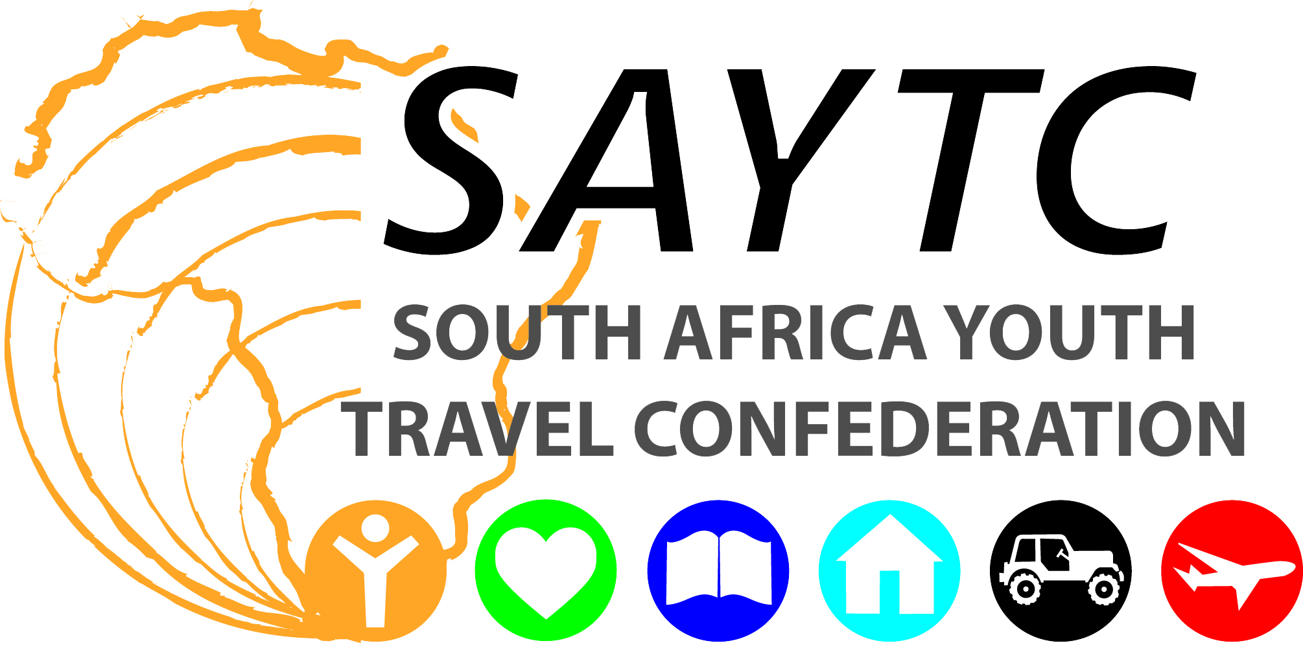

Education South Africa
Foyer A, 101, Sovereign Quay
34 Somerset Road
Green Point, 8001
CAPE TOWN
Mr Anele Kabingesi
Committee Secretary
Portfolio Committee on Higher Education and Training
3rd Floor, 90 Plein Street
Cape Town
2001
Dear Mr Kabingesi
Submission to the Portfolio Committee on Higher Education and Training on Behalf of Education South Africa and the English as a Forgeign Language Industry in South Africa
The EFL Industry in South Africa
The English as a Foreign Language (EFL) industry has been operating in South Africa for the last 18 years. The underlying philosophy of this industry is that people travel abroad to learn a language in the country in which it is spoken. So if I want to learn Russian, for example, the best place to do this would be somewhere in Russia. As an English speaking country, therefore, South Africa competes with other English-speaking destinations (UK, USA, Canada, Australia, New Zealand) in this multi-billion dollar global industry where many thousands of youth (aged 15 to 50) annually travel abroad to study another language.
There are currently around 25 EFL centres in and around Cape Town alone and possibly 40 nation-wide, although the exact number is difficult to pinpoint. I represent the largest association of EFL centres, called Education South Africa (EduSA), of which I am the chairman and I encourage you to visit our website at www.edusouthafrica.com in order to see who we are and what we do. EduSA consists of 16 member schools at present, many of which are owned by international chains.
There has been a phenomenal increase in foreign-language visitors to South Africa over the past decade, with many of them opting to stay longer than they had originally planned. It is not surprising, then, that there has been a growing need for English language centres offering English language tuition and accompanying services where one can learn English as another language.
Education South Africa
Because of this enormous growth within the English as a Foreign Language (EFL) industry, an association of quality language centres, Education South Africa or EduSA (formerly known as ELTASA) was established in 2002. The main purpose of EduSA is to represent the EFL industry in South Africa, and to allow educational centres involved with education in South Africa, whether this pertains to foreign or local clients, the opportunity to benefit from belonging to a national organization that has countrywide, regional and local interests at heart, while also providing the best possible platform for promoting South Africa as a major destination for youth travel.
Education South Africa ensures standards of quality and professionalism, affiliation to international organizations, competitive prices, accommodation choices, exciting social programmes, and the opportunity to do more than just learn a language.
Today, English language centres operate throughout South Africa. They offer courses for general, business, academic and social purposes. Courses are geared towards adult learners, but some centres do cater for younger learners as well. EduSA centres guarantee that learners will gain the maximum from their choice of South Africa as an English language learning destination.
The centres vary in location and size. Some are in city centres of Cape Town, while others are located in the more tranquil suburbs around major urban areas. They take anything from 25 to 250 students at a time.
Choices include training for Cambridge or TEFL examinations, preparation for entry into a tertiary institution, volunteering, work placement, learning English on safari and much more.
The following centres are currently members of EduSA:
- EC Cape Town
- EF International Language Schools
- Eurocentres Cape Town
- Good Hope Studies
- inlingua Training Centre
- Interlink School of Languages
- International House Cape Town
- Jeffreys Bay Language School (Jeffreys Bay, EC)
- Kurus English
- LAL South Africa
- Bay Language Institute (Port Elizabeth, EC)
- Cape English Language School
- The Cape Town School of English
- English Language School of Cape Town
- Language Teaching Centre
- South African School of English
- Language Link
- Wits Language School (Jhb, Gauteng)
- International House Johannesburg (Jhb, Gauteng)
We are constantly in the process of negotiating with additional centres and institutions regarding new membership.

Developing Key Markets
China and India have been identified as core markets as these are markets with potential and easy to access, but they will only become accessible to the EFL industry in South Africa if there is recognition of the industry by Government and the Department of Higher Education and Training in particular.
President Zuma specifically identified Brazil, India and China as key players both nationally and internationally. He also said that South Africa “will focus energy on revitalising the New Partnership for Africa’s Development, as a strategy for economic development on the continent.” Finance Minister Gordhan then further developed this notion by stating that “we operate in a global village where our fortunes are partly dependent on how well we are able to leverage off the global economy. Other countries are not standing still. Brazil, India, China and a host of other middle income countries are actively taking steps to improve their competitiveness, raise their skills.” The fact is that all of these countries need their workforce to be able to speak English in order to improve in these areas, and EFL schools worldwide contribute directly to this growth and development.

China, in particular, is a huge potential EFL market for South Africa, as it actively continues to drive the world’s economy through industrial expansion, urbanisation and modernization. They currently send thousands of students to Australia each year in order to learn English. The reason they do this is because the EFL schools in Australia are officially recognized and registered with the Department of Education there and they are viewed by the Chinese government as “official” schools. Therefore Chinese students are granted permission to travel. They also travel to other countries, but in fewer numbers, where EFL schools are recognized by and registered with the State. In South Africa, on the other hand, we have virtually no Chinese students at all and this market will remain closed for us as long as EFL schools and the industry here are not able to get official recognition as bona fide educational institutions.

Another key market for the industry at present is Brazil and some schools have up to 20% of their total student numbers made up of this nationality. This market has been growing steadily over the last five years and State recognition for the industry will give EFL schools added credibility and status in Brazil and so encourage further growth from there.

In terms of the market in Africa, we are only beginning to see this develop. Currently the largest African market is Angola, but EFL schools have received students from all of the following African nations over the last few years: DRC, Libya, Gabon, Cameroon, Mozambique, Senegal, Rwanda, Cote d’Ivoire, Sudan, Burundi and Mauritania. While not all of these countries will grow to the extent that Brazil has, there are still significant opportunities for expansion into these nations which will enhance South Africa’s ties with NEPAD, as President Zuma indicated he would like to see.
Having students from these countries attending EFL programmes in South Africa, they then go back to their countries and become unofficial ambassadors of South Africa.
Education
As we are sure you are aware, President Zuma has previously also highlighted the importance of education: “Our education and skills programmes will increase our productivity and competitiveness…”, and he also stressed our government’s commitment to five key priorities, the first of which was on his list, being education.

We have already intimated that several of the EduSA members also offer additional training to local South Africans – specifically in training teachers for this industry in South Africa - so it is clear that our sphere of influence does not end with foreign the foreign students who enter South Africa in order to come and learn English. Several EFL schools also teach additional languages to South African citizens, such as Portuguese, Spanish, German and Chinese, to name a few. Others offer services like Translation, Interpreting, Cross Cultural Training and Interpreter Training.

Further services include running Business English courses for local South African businesses, which either happens at the EFL centre or a teacher is sent to the businessperson’s place of work and does the training there. This enables those who perhaps struggle with the language of business, English, to improve their skill levels in this regard.

Many centres involve their teachers with volunteer programmes, in which they offer their time and expertise to run free classes for local children in previously disadvantaged communities in order to improve the numeracy and literacy levels of South African children.

EduSA also runs ongoing management training and equipping for the academic directors of all the member schools, so that at every stage we seek to improve the level of education, training and skills base of those involved in the industry.

There are four centres who run Cambridge-accredited teacher-training courses for EFL teachers, which means that they graduate with an internationally recognized qualification that can be used anywhere in the world. One of the major reasons for running these and other TEFL courses is so that the most talented and gifted teachers can be identified and therefore be persuaded to remain in South Africa as part of the industry here rather than go abroad in order to ply their trade. If the EFL industry can be grown and developed further in South Africa, there will be far more opportunities for these qualified teachers and attractive reasons for keeping them “at home.” This training fully supports President Zuma’s desire to see increased numbers of skilled and capable young people joining the workforce “to support growth and job creation” and will also enable us “to provide a second chance at education, for those who do not qualify for university.” As part of the education sector, the EFL industry would certainly fall into the category of private learnerships which would further contribute to President Zuma’s vision for South Africa.

However, our current situation is that none of the EFL schools or the courses on offer are recognized by the National Department of Education, the Department of Higher Education and Training (DHET) or the South African Qualifications Authority (SAQA). If the industry was formally recognized by these authorities as being part of the education sector in South Africa, and if accreditation for our courses could be attained, then we would also be able to offer these learnerships and any South African doing the courses with us would get the proper recognition and qualification towards which they have worked.
It is for this reason that we strongly believe that it is time for the DHET to recognize EFL Schools as bona fide places of education within this department and to give the industry the recognition it deserves.
As an industry we need and want to be able to compete on an equal footing with other existing Higher Education Training centres in South Africa, as well as internationally with other destinations where similar schools have full accreditation with their governments and education departments – e.g. in the UK and Australia EFL schools have full accreditation with their various governments and the main associations in those countries, English UK and English Australia, have been instrumental in managing and guiding this process. These two associations of EFL schools also currently advise their respective governments on EFL matters and are recognised and have a voice through them if needs be.
EduSA is also recognized by other big global industry associations (like GAELA – the Global Alliance of Education and Language Associations) who are also the relevant voices into various governments.
At present, though, we find that there is nothing currently within the SAQA framework that allows for EFL schools to become accredited and certified within either the ETDP or THETA SETA. What we specifically want is recognition by the DHET and so this process needs to involve them as well as Umalusi and SAQA.
The benefits for gaining this recognition are:
- Recognition as an industry and niche market for Educational Tourism in South Africa.
- Quality assurance and regulation of the industry.
- Opening up of other international markets – e.g. China, where agents may only send students to study abroad with institutions that are recognized and certified by the state, which no EFL centre is currently able to do. There are several other countries, like Spain, where this is also the case.
Recommendations
Please note that this is not a request for funding from the State, but merely an outline of how we would like to collaborate with the DHET in order to promote this industry locally and internationally and also to be able to present South Africa as a viable EFL destination for foreign students.
EFL schools in South Africa are currently at a huge disadvantage in the international industry. The reason for this is essentially two-fold:
- EFL schools in other destinations have accreditation with and are recognised by their respective governments and, in particular, their Departments of Education, which allow them to access markets to which we currently have no access.
- Due to this recognition, these schools are not required to pay VAT for the services they provide and are therefore able to offer more competitive pricing for their clients.
EduSA therefore makes the following recommendations in wokring together with the DHET:
- We recommend that we begin the process with the DHET to become recognised as proper educational institutions. Our teachers are all formally trained and the majority of them already have university degrees or college diplomas; we operate out of excellent, world-class facilities; we offer genuine tuition services and courses to our clients and we use internationally recognised course material and resources.
- EduSA should be the moderating body through which this process takes place, as member schools have in excess of 75 years cumulative experience with this market and know what the required courses, resources, teacher qualifications, etc. are that would qualify centres for accreditation.
- EduSA already has Quality Management Systems in place and can perform Quality Audits and Quality Assurances firstly by:
  - Establishing Specific Outcomes and Unit Standards which the current SAQA framework does not currently have, which is why it’s not possible to get accreditation at present.
  - Working with the DHET in order to get these officially established and in place as soon as possible.
- We suggest EduSA works with the DHET to work out the details of the process and requirements. However, this would be a brand new division within the current setup and so we want to be able to add to existing structures and procedures and not have to be required to meet existing outcomes or unit standards all of which are currently irrelevant to our sector.
Benefits to South Africa
We envisage three key areas in which South Africa as a country would benefit should our recommendations be followed:
- Increased international exposure,
- Job creation and employment, leading to economic growth and
- Quality education for both foreign and local students.
Each of these has been specifically outlined above and we specifically envisage that the main areas in which these benefits will be felt are the education sector, which is a key developing sector in the South African economy.
Conclusion
We recognise and acknowledge the assistance we currently receive from Government which enables for us to access international markets. This is already happening in conjunction with the Department of Trade and Industry which has provided funding through the South African Youth Travel Confederation (SAYTC), but there is an increased need for Government assistance in this regard, not so much in providing funding, but by allowing the industry in South Africa to become more globally competitive through the process of recognition by and accreditation with our own DHET which will give added credibility to the sector, especially in markets like China where this is an absolute pre-requisite for their government to allow students to travel for study purposes. It will also place us on a more level footing with competing destinations, like the USA, UK and Australia, where they are already recognized by their own governments and Education Departments.
Finally, we cannot express ourselves more clearly than Finance Minister Gordhan, when he said in his Budget Speech last year: “A new engagement between government, the business sector and organised labour is being forged, through which we will mobilise our creativity, our determination, our sheer grit – to build a durable, developmental, just and prosperous nation.”
Education South Africa and EFL schools across the country want to be a part of this process.
We look forward to your favourable response.
Best regards
Craig Leith
For: Education South Africa

