

Annual Performance Plan
2012/13 - 2014/15

Final - 31 January 2012

=================================

NATIONAL ENERGY REGULATOR
KULAWULA HOUSE
526 VERMEULEN STREET
ARCADIA
PRETORIA
0007
Foreword

The National Energy Regulator (NERSA) was established on 1 October 2005. In terms of the National Energy Regulator Act, 2004 (Act No. 40 of 2004), its mandate is to regulate the electricity industry in terms of the Electricity Regulation Act, 2006 (Act No. 4 of 2006), regulate the piped-gas industry in terms of the Gas Act, 2001 (Act No. 48 of 2001), and regulate the petroleum pipelines industry in terms of the Petroleum Pipelines Act, 2003 (Act No. 60 of 2003). NERSA must perform such other functions as may be assigned to it by or under these Acts.

In regulating the electricity, piped-gas and petroleum pipelines industries, NERSA adheres to the regulatory principles of transparency; neutrality; consistency and predictability; independence; accountability; integrity; and efficiency.

The Annual Performance Plan of the National Energy Regulator of South Africa (NERSA) for the period 2012/13-2014/15 is informed by the five year Strategic Plan. It reflects government’s long term plans as outlined in the medium term expenditure framework (MTEF). The Plan incorporates the Department of Energy’s contribution to the 12 outcomes of government.

Priorities which have guided the development of the Annual Performance Plan are as stated in the Strategic Plan. These pertain to the challenges South Africa faces regarding the security of supply, especially within the electricity and petroleum industries requiring therefore a focus on new electricity generation capacity as well as the completion of the construction of the new multi-product pipeline.

Energy infrastructure, especially in the electricity industry, requires major refurbishment and in certain cases replacement. The growth of the gas market in South Africa remains a challenge, given the paucity of domestic natural gas and the substantial investment cost involved for new entrants. A priority for NERSA is to facilitate infrastructure investment through predictable and transparent regulation.

The need to diversify the energy sources in this country, with the emphasis shifting towards sustainability into the future, the introduction of renewable energy, gas and independent power producers into the grid, will be a priority for the times ahead.

NERSA will also prioritise facilitation of entry of other players into the sector, particularly given the generally monopolistic nature of the electricity, piped-gas and petroleum pipelines industries, as well as balance the needs of all stakeholders.

Increasing levels of poverty and unemployment necessitate the focus on pro-poor regulation in a bid to ensure affordability and accessibility of energy to the poor.

Performance targets have been set against each strategic objective outlined in the Strategic Plan. Specific, measurable, achievable, realistic and time bound key performance indicators will ensure achievement of the strategic objectives.

Adequate resourcing of the organisation as well as the quarterly performance reviews will facilitate the assessment of the overall performance of each programme against this Annual Performance Plan.

The Energy Regulator fully endorses this Annual Performance Plan and commit to supporting its implementation. I would like to take this opportunity to acknowledge the important work that the Regulator Members, management team and staff are executing and would like to encourage a collective and innovative spirit in implementing the legislative mandate of NERSA and future strategic programmes.

Cecilia Khuzwayo
Chairperson: NERSA
Official sign-off

It is hereby certified that this Annual Performance Plan was developed by the Energy Regulator with inputs from the Executive Management of NERSA. It was prepared in line with the current Strategic Plan of NERSA and accurately reflects the performance targets which NERSA will endeavour to achieve given the resources made available in the budget for 2012/13.

Esther Viljoen Signature: ___________________________
Senior Manager: Strategic Planning and Monitoring

Busisiwe Chaunzwa Signature: ___________________________
Chief Financial Officer

Phindile Nzimande Signature: ___________________________
Chief Executive Officer (Accounting Officer)

Approved by:

Cecilia Khuzwayo Signature: ___________________________
Chairperson (on behalf of the Accounting Authority)

Contents

Topic | Page
Part A: Strategic overview
- Updated situational analysis | 2
- Revisions to legislative and other mandates | 17
- Overview of 2012 budget and MTEF estimates | 24
- NERSA Programmes and Purpose of each Programme | 26
- Link between Strategic Objectives and Programmes | 28
Part B: Programme and Sub-Programme Plans
- ELECTRICITY INDUSTRY REGULATION
  - Programme 1: Setting and/or approval of tariffs and prices
- Strategic objective annual targets for 2012/13 - 2014/15 | 30
- Programme performance indicators and annual targets for 2012/13 - 2014/15 | 32
- Quarterly targets for 2012/13 | 34
- Linkage with other macro or infrastructure plans | 36
  - Programme 2: Licensing and registration
- Strategic objective annual targets for 2012/13 - 2014/15 | 37
- Programme performance indicators and annual targets for 2012/13 - 2014/15 | 38
- Quarterly targets for 2012/13 | 39
- Linkage with other macro or infrastructure plans | 40
  - Programme 3: Compliance monitoring and enforcement
- Strategic objective annual targets for 2012/13 - 2014/15 | 41
- Programme performance indicators and annual targets for 2012/13 - 2014/15 | 42
- Quarterly targets for 2012/13 | 43
- Linkage with other macro or infrastructure plans | 44
  - Programme 4: Dispute resolution, including mediation, arbitration and handling of complaints
- Strategic objective annual targets for 2012/13 - 2014/15 | 45
- Programme performance indicators and annual targets for 2012/13 - 2014/15 | 46
- Quarterly targets for 2012/13 | 47
- Linkage with other macro or infrastructure plans | 48
  - Programme 5: Setting of rules, guidelines and codes for the regulation of the electricity industry
- Strategic objective annual targets for 2012/13 - 2014/15 | 49
- Programme performance indicators and annual targets for 2012/13 - 2014/15 | 51
- Quarterly targets for 2012/13 | 53
- Linkage with other macro or infrastructure plans | 55
  - Programme 6: Establishing NERSA as an efficient and effective regulator
- Strategic objective annual targets for 2012/13 - 2014/15 | 56
- Programme performance indicators and annual targets for 2012/13 - 2014/15 | 57
- Quarterly targets for 2012/13 | 58
- Linkage with other macro or infrastructure plans | 59
- PIPED-GAS INDUSTRY REGULATION
  - Programme 1: Setting and/or approval of tariffs and prices
- Strategic objective annual targets for 2012/13 - 2014/15 | 60
- Programme performance indicators and annual targets for 2012/13 - 2014/15 | 61
- Quarterly targets for 2012/13 | 62
- Linkage with other macro or infrastructure plans | 63
  - Programme 2: Licensing and registration
- Strategic objective annual targets for 2012/13 - 2014/15 | 64
- Programme performance indicators and annual targets for 2012/13 - 2014/15 | 66
- Quarterly targets for 2012/13 | 68
- Linkage with other macro or infrastructure plans | 70
  - Programme 3: Compliance monitoring and enforcement
- Strategic objective annual targets for 2012/13 - 2014/15 | 71
- Programme performance indicators and annual targets for 2012/13 - 2014/15 | 72
- Quarterly targets for 2012/13 | 73
- Linkage with other macro or infrastructure plans | 74
  - Programme 4: Dispute resolution, including mediation, arbitration and handling of complaints
- Strategic objective annual targets for 2012/13 - 2014/15 | 75
- Programme performance indicators and annual targets for 2012/13 - 2014/15 | 76
- Quarterly targets for 2012/13 | 77
- Linkage with other macro or infrastructure plans | 78
  - Programme 5: Setting of rules, guidelines and codes for the regulation of the piped-gas industry
- Strategic objective annual targets for 2012/13 - 2014/15 | 79
- Programme performance indicators and annual targets for 2012/13 - 2014/15 | 80
- Quarterly targets for 2012/13 | 81
- Linkage with other macro or infrastructure plans | 82
  - Programme 6: Establishing NERSA as an efficient and effective regulator
- Strategic objective annual targets for 2012/13 - 2014/15 | 83
- Programme performance indicators and annual targets for 2012/13 - 2014/15 | 84
- Quarterly targets for 2012/13 | 85
- Linkage with other macro or infrastructure plans | 86
- PETROLEUM PIPELINES INDUSTRY REGULATION
  - Programme 1: Setting and/or approval of tariffs and prices
- Strategic objective annual targets for 2012/13 - 2014/15 | 87
- Programme performance indicators and annual targets for 2012/13 - 2014/15 | 88
- Quarterly targets for 2012/13 | 89
- Linkage with other macro or infrastructure plans | 90
  - Programme 2: Licensing and registration
- Strategic objective annual targets for 2012/13 - 2014/15 | 91
- Programme performance indicators and annual targets for 2012/13 - 2014/15 | 92
- Quarterly targets for 2012/13 | 93
- Linkage with other macro or infrastructure plans | 94
  - Programme 3: Compliance monitoring and enforcement
- Strategic objective annual targets for 2012/13 - 2014/15 | 95
- Programme performance indicators and annual targets for 2012/13 - 2014/15 | 96
- Quarterly targets for 2012/13 | 97
- Linkage with other macro or infrastructure plans | 98
  - Programme 4: Dispute resolution, including mediation, arbitration and handling of complaints
- Strategic objective annual targets for 2012/13 - 2014/15 | 99
- Programme performance indicators and annual targets for 2012/13 - 2014/15 | 100
- Quarterly targets for 2012/13 | 101
- Linkage with other macro or infrastructure plans | 102
  - Programme 5: Setting of rules, guidelines and codes for the regulation of the petroleum pipelines industry
- Strategic objective annual targets for 2012/13 - 2014/15 | 103
- Programme performance indicators and annual targets for 2012/13 - 2014/15 | 104
- Quarterly targets for 2012/13 | 105
- Linkage with other macro or infrastructure plans | 106
  - Programme 6: Establishing NERSA as an efficient and effective regulator
- Strategic objective annual targets for 2012/13 - 2014/15 | 107
- Programme performance indicators and annual targets for 2012/13 - 2014/15 | 108
- Quarterly targets for 2012/13 | 109
- Linkage with other macro or infrastructure plans | 110
- CROSS-CUTTING REGULATORY
  - Programme 6: Establishing NERSA as an efficient and effective regulator
- Strategic objective annual targets for 2012/13 - 2014/15 | 111
- Programme performance indicators and annual targets for 2012/13 - 2014/15 | 112
- Quarterly targets for 2012/13 | 113
- Linkage with other macro or infrastructure plans | 114
- 0RGANISATIONAL
  - Programme 6: Establishing NERSA as an efficient and effective regulator
- Strategic objective annual targets for 2012/13 - 2014/15 | 115
- Programme performance indicators and annual targets for 2012/13 - 2014/15 | 116
- Quarterly targets for 2012/13 | 117
- Linkage with other macro or infrastructure plans | 118
Appendices
Appendix A: Strategic Risk Register | 119
Appendix B: Budget Assumptions and Parameters | 147
Appendix C: Budget for NERSA | 157
Appendix D: Funding for NERSA | 162
Appendix E: NERSA Consolidated Budget | 165
Appendix F: Notes to the NERSA Budget | 167
ELECTRICITY INDUSTRY REGULATION
Appendix G1: Consolidated Electricity Industry Regulation Budget | 182
Appendix G2: Electricity Industry Regulation Programme 1: Setting and/or approval of tariffs and prices Budget | 184
Appendix G3: Electricity Industry Regulation Programme 2: Licensing and Registration Budget | 186
Appendix G4: Electricity Industry Regulation Programme 3: Compliance monitoring and enforcement Budget | 188
Appendix G5: Electricity Industry Regulation Programme 4: Dispute resolution including mediation, arbitration and handling of complaints Budget | 190
Appendix G6: Electricity Industry Regulation Programme 5: Setting of rules, guidelines and codes for the regulation of the electricity industry Budget | 192
Appendix G7: Electricity Industry Regulation Programme 6: Establishing NERSA as an efficient and effective regulator Budget | 194
Appendix G8: Funding for the regulation of the electricity industry | 196
PIPED-GAS INDUSTRY REGULATION
Appendix H1: Consolidated Piped-Gas Industry Regulation Budget | 198
Appendix H2: Piped-Gas Industry Regulation Programme 1: Setting and/or approval of tariffs and prices Budget | 200
Appendix H3: Piped-Gas Industry Regulation Programme 2: Licensing and Registration Budget | 202
Appendix H4: Piped-Gas Industry Regulation Programme 3: Compliance monitoring and enforcement Budget | 204
Appendix H5: Piped-Gas Industry Regulation Programme 4: Dispute resolution including mediation, arbitration and handling of complaints Budget | 206
Appendix H6: Piped-Gas Industry Regulation Programme 5: Setting of rules, guidelines and codes for the regulation of the piped-gas industry Budget | 208
Appendix H7: Piped-Gas Industry Regulation Programme 6: Establishing NERSA as an efficient and effective regulator Budget | 210
Appendix H8: Funding for the regulation of the piped-gas industry | 212
PETROLEUM PIPELINES INDUSTRY REGULATION
Appendix I1: Consolidated Petroleum Pipelines Industry Regulation Budget | 214
Appendix I2: Petroleum Pipelines Industry Regulation Programme 1: Setting and/or approval of tariffs and prices Budget | 216
Appendix I3: Petroleum Pipelines Industry Regulation Programme 2: Licensing and Registration Budget | 218
Appendix I4: Petroleum Pipelines Industry Regulation Programme 3: Compliance monitoring and enforcement Budget | 220
Appendix I5: Petroleum Pipelines Industry Regulation Programme 5: Setting of rules, guidelines and codes for the regulation of the petroleum pipelines industry Budget | 222
Appendix I6: Petroleum Pipelines Industry Regulation Programme 6: Establishing NERSA as an efficient and effective regulator | 224
Appendix I7: Funding for the regulation of the petroleum pipelines industry | 226

Part A: Strategic overview

- Updated situational analysis

This Annual Performance Plan has been developed in the same period as the Strategic Plan (2012/13 – 2016/17). Therefore there are no changes in the external and internal environments that might affect performance. For the same reason the demand for services and the challenges that need to be addressed within the performance delivery and organisational environment remain the same.

For completeness, the situational analysis as reflected in the Strategic Plan (2012/13 – 2016/17) has been included.

  - Performance environment

NERSA undertook an environmental scan to assess the factors within the performance environment which would impact on the execution of its mandate. The environmental factors are considered within the context of NERSA, through the regulatory regime, facilitating economic development for:
- Security of energy supply;
- Investment in infrastructure;
- Competitive functioning of the industry; and
- Affordability and access.

With the current negotiations surrounding international agreements on climate change and biodiversity, the global community is involved in the collective responsibility and management of global ecological issues. South Africa is a signatory to the global and regional agreements and protocols on climate change.

South Africa’s is reliant on coal as the main primary energy source in electricity generation in the short to medium term. Coal is one of the major contributors to green house gas emissions. This poses a challenge to NERSA in balancing the electricity needs of the country with cleaner energy requirements at affordable costs.

The National Government’s renewed sense of urgency and focus on accelerated delivery of services is evidenced in the quantum of targets set such as, amongst others, the 100% access to electricity by 2014. This places a burden on NERSA in facilitating the achievement of the targets.

The high unemployment rate and increasing levels of poverty directly impact NERSA as determination of pro-poor tariffs is impinged upon by the inability of citizens to pay for electricity services.

Much as it is down played, talks of nationalisation within the political arena coupled with the decrease of foreign direct investment into South Africa may compromise the ability of NERSA in promoting and facilitating investments into the energy infrastructure.

Uncertainty and mixed policy messages about investment could be contributing to the potential flight of capital out of South Africa. A case in point is the decision of Sasol to invest billions of dollars in shale gas in Canada.

The fact that regulatory control in the entire supply chain of the regulated industries is limited, raise issues of NERSA’s strategic positioning as well as policy gaps. Political dialogue is necessary to influence policy changes in this regard.

The escalation of crude oil prices, as it pertains to the reliance of the energy sector on crude oil in so far as input costs are concerned exposes the energy sector volatility. This places a particular burden on NERSA in terms of promoting investment into energy infrastructure; promoting affordable access to energy; facilitating a conducive environment to the creation of competition within the industry and promoting the entry of HDIs.

The specific factors considered in the environmental scan are shown in the tables below:

Political Factors | NERSA response to the challenge
Political uncertainty (2012) | - NERSA must appropriately position itself
State led infrastructure expansion | - Ensuring a level playing field  - Create and issue rules that are designed to clearly define the roles of government, NERSA and others  - Price determination done such that Eskom could raise its credit rating  - NERSA is to highlight the implications of the state led infrastructure expansion to the policy makers
“State capitalism” | - Assist DoE in creating awareness of policy  - Proactive engagement with government
Manage interface between different policy thrusts of Government (new growth path, IPAP2) | - Make decisions that are not in conflict with the Acts  - Identify points of contribution  - Develop a position paper in this regard
Policy gaps and inconsistencies | - Thorough study of all the policies that NERSA is responsible for  - Input into policy development / review  - Highlight cost of projects, the impact and implications thereof i.e. IRP
Discussion / debate around nationalisation | - Efficiency in the operations of NERSA  - Ensure investor confidence through our regulatory activities  - Influence perception of investor risk (particularly in piped-gas)
Review of millennium goals (2014) | - Monitor targets after allocation has been done  - Reporting back through media and media coverage
Presidential review on the organs of state / creation of a “super regulator” and collapse all regulators | - Profile NERSA in the public arena  - Affirm NERSA’s effectiveness and positioning  - Monitor debate  - Influencing the discussions  - Engage with stakeholders  - Stakeholder survey  - Position NERSA as a low maintenance entity  - Highlight the importance of an independent regulator in a political environment  - Improve on current performance  - Understand regulatory environment, who are the other regulators  - Help / teach / learn from them (other regulators)  - “Do what you do, well”
Developments in the Arab world | - Get statistics on oil demands  - Proactively research and promote alternative sources of energy  - Look at the referencing of the price of gas (reference against oil price may make gas less attractive as oil price rise)

Economic factors | NERSA response to the challenge
Risk of US, EURO debt default and the impact on emerging markets | - Review of tariffs in line with developments  - Promote energy conservation  - Create public awareness
Perception of imbalance between supply and demand | - Allow primary energy cost as a pass through cost  - Develop and publish rules that will ensure that new capacity is built and commissioned on time
Inclusion of SA in the BRIC countries | - Factor in the existing BRICS agreements when setting and or approving prices  - Understand the new demand
Impact of poverty | - Focus on pro-poor regulation
Capital flight (foreign and local) | - Create regulatory certainty
Africa has 2 of the top 5 oil producing countries | - Encourage country-to-country agreements
Double dip recession | - Create focus on ‘pro-poor’ interventions
Increased consumption of energy by China | - Regulatory advocacy  - Regulate the stock piles  - Promote the introduction of renewable energy in the energy mix (taking into account its limitations)  - Increase the number of days that the coal stock piles must be
Inter-dependency of SADC on SA economy | - Create space to be able to facilitate the realisation of SADC countries’ power plans
Wave of industrial action and the impact | - Encourage entities to have better risk management interventions
Tanzania found significant amounts of Gas | - Potential of country to country agreements
Oil majors leaving SA | - Monitor the status of the oil majors in South Africa and act accordingly
Impact of environmental levies on prices | - Highlight impact of environmental levies to policy makers  - “pro-poor” regulation

Regulatory Factors | NERSA response to the challenge
Management of concurrent jurisdiction | - Concluding of MoUs and MoAs with other regulators  - Regulatory advocacy  - Co-operate and help other regulators  - Build closer relationships with other regulators
Perception of independence of the Regulator | - Communication – particularly on how decision was reached (Not only on website – more personalised)  - Structured stakeholder engagement
Consistency in policy applications by different regulators | - Harmonisation of regulatory methodologies (internally and externally)  - Regulatory advocacy  - Reviving structures such as the SA Regulators Forum
Compliance monitoring and enforcement | - Propose amendments to legislation  - MoUs with the right departments that have more “teeth”  - Work with different institutions in the country such as National Treasury, Auditor-General

Social Factors | NERSA response to the challenge
Increase in social delivery protests (consumer activism) | - Customer education  - Public consultation  - Mediation
NERSA’s Impact on poverty | - Contribute to Learnership / internship / job creation  - Inclining Block Tariffs (IBTs) and evaluation  - Review and publicise  - Assessing impact of IBTs  - Further research to include the “working poor”  - Possible money in tariff to train artisans
Resistance to energy infrastructure close to settlements | - NERSA to ensure that it is ready for expropriation
Non-technical losses | - Customer education  - Monitor non-technical losses  - Highlight legislative gaps to policy maker
Lack of skills | - Provide for industry specific skills training in the tariffs

Technological Factors | NERSA response to the challenge
Mode of transport is changing | - Monitoring and understanding the impact of technological developments on revenue streams and households  - Engaging, researching and understanding
Changes in technologies
Uncertainty / fears (Shale Gas and CNG)
Smart meters and Smart Grids
Sustainable / smart technologies to be utilized
Nuclear

Environmental Factors | NERSA response to the challenge
Growing awareness on environmental factors | - Utilising the MYPD to facilitate contributing towards the reduction of green house gas emissions
Environmental levies and Carbon tax | - Encourage and facilitate cooperation and coordination between decision making bodies  - Allowing Transnet to recover land rehabilitation costs  - Develop an integrated view going forward  - Participation in the dialogue and educate the public regarding key environmental issues and NERSA decisions
Expiry of Kyoto protocol
Lobbying against Shale Gas
Delays in issuing environmental Impact Assessments | - Draw up MOU with role players  - Monitor delays in construction  - Assist licensees in achieving infrastructure development milestones

Legal Factors | NERSA response to the challenge
Review of the Acts | - NERSA is to pro-actively participate in any development / review of applicable legislation  - Regulatory advocacy
Lack of enforcement provisions in the Acts
Ability to influence supplementary legislation
Compliance with regulatory requirements (PFMA and others)
Electricity and Gas reticulation in the constitution
Fragmentation of legislations
Challenges and Risks

The environmental scan/situational analysis of NERSA’s performance environment identified industry specific challenges and risks that have informed the formulation of the strategic objectives and the programmes as indicated in the 2012/13-2016/17 Strategic Plan and the 2012/13-2014/15 Annual Performance Plan. The identified challenges are listed below in respect of each of the three industries being regulated by NERSA as well as with respect to the cross-cutting regulatory and organisational environment.

Electricity Industry Regulation

- Challenges and risks

- Demand and supply:
- Lack of Generation Capacity to meet the demand;
- No new capacity will become available until the 4th quarter of 2012;
- Major investments still required (R14m – R35m/MW);
- Introduction of carbon taxes which will result in increase in electricity costs;
- Risks associated with the implementation of the Integrated Resource Plan (IRP2010);
- Risk mitigation for late decisions or late projects;
- Energy efficiency and Demand Side Management (EEDSM) targets not achieved (8.5TWh/3000MW in 3 years);
- Lack of maintenance of the current generation fleet;
- Increased possibility of major failures (34 GO’s postponed);
- High load factors and no cover by insurance; and
- Ageing infrastructure.

- Transport and reliability:
- Transmission system operating at maximum capacity;
- Possible interruptions due to system overload;
- Ageing infrastructure;
- Lack of system maintenance;
- Protection schemes test postponed;
- Transmission system expansion delays;
- Permits / authorisation delays;
- Limited permutations for power transfer/transportation; and
- Redundancy (N-1) compromised.

- Distribution and reticulation:
- Non optimal maintenance of the distribution infrastructure;
- Lack of funds and capability in some areas;
- Varying tariffs, services, quality between licensees;
- Customer mix variations;
- Revenue collection and non technical losses;
- Different economic growth strategies within Municipalities;
- Distribution infrastructure operating at maximum capacity;
- System overload and interruptions; and
- Ageing infrastructure.

- Access, affordability, investments
- Projected price path for MYPD3;
- Price increases still above inflation (approx 19% per annum);
- International competiveness for exporting industries is still positive;
- Local industries will be negatively affected by the increase in electricity costs;
- Affordability of services threatened (Bad debt and theft increased);
- Customisation of the IBTs;
- Renewable Energy increase (43% by 2030);
- The cost of renewable energy will be R50bn by 2016;
- Security of supply is not necessarily guaranteed by the introduction of renewable energy;
- Limited or no off-grid investments; and
- Access targets will not be met.

- Priorities / mitigation strategies:

In mitigating against these challenges and risks, the following priorities have been identified with regards to the regulation of the electricity industry:
- Finalisation and promulgation of IRP2010 implementation rules;
- Assignment of roles and responsibilities in the implementation of the IRP2010;
- Development of risk mitigation strategies;
- MYPD3 submission by Eskom and processing of the application;
- Public consultation and education planning;
- Analysis of MYPD2 results and impact;
- Customisation of the IBTs;
- Credit rating and access to funds for the new build programme;
- Compliance enforcement and monitoring;
- Accuracy of inputs and costs;
- Implementation of approved and funded projects;
- Licensing process streamlining for IPPs;
- IPP friendly evaluation process from tendering to licensing;
- Relieve demand and stress on the Eskom Balance sheet;
- Energy Efficiency and Demand Side Management;
- Facilitation of growth;
- Affordability enhancement;
- Contribution to the lessening of greenhouse gas emissions;
- Energy Conservation Scheme for emergency conditions;
- Avoiding blackouts and black starts; and
- Create space for maintenance of the generation fleet.

Piped-Gas Industry Regulation

- Constraints

- The Agreement Concerning the Mozambican Gas Pipeline between the Government of the Republic of South Africa and Sasol Limited, including Schedule One thereof (“the Agreement”) prescribes Sasol’s price setting methodology, certain tariffs, exclusivity conditions and a price capping mechanism until approximately 2014;
- Lack of alternative gas sources and investors;
- Highly compliance focused due to the Agreement;
- Supposedly ‘light handed’ tariffs and pricing but paradoxically requires more pro-active involvement;
- Creating market structure - preparing market for arrival of competition or new gas finds;
- Increasing electricity prices are rendering gas, such as Liquid Natural Gas (LNG), more attractive, especially for electricity Generation;
- Difficult to promote natural gas as a ‘greener source’ of energy with paucity of domestic gas finds;
- Chicken or egg cliché still holds true – anchor customer for LNG terminal remains elusive;
- Single largest hurdle in growing the gas market is the paucity of Natural Gas finds; and
- Currently relying on Mozambican imports. Therefore growing supply is reliant on imports and domestic exploration.

- Risks

- The lack of gas sources will result in no investments and consequently no competition;
- Insufficient gas to supply existing or future customers;
- No new gas finds;
- No investment in new pipeline infrastructure;
- Incentives to use natural gas near-exclusively for GTL at Secunda;
- Anti-competitive conduct by incumbent successfully bars entry and results in high prices and tariffs;
- Moratorium shale gas exploration – is this indefinite?
- SA misses window of low LNG prices;
- No significant uptake of LNG for electricity generation (coal remains dominant, nuclear fired generation gains in prominence);
- Open Cycle Gas Turbine (OCGT) stations not converted to Closed Cycle Gas Turbines (CCGT);
- The electricity generated through CCGT in not adjusted upwards in the IRP2010; and
- Legal challenge of maximum prices and tariff methodologies prevent NERSA from effectively subjecting Sasol Gas to economic regulation (resulting in higher prices and tariffs, deterring entry).

- Challenges

- Loss of credibility and regulatory reputation can deter development of the gas market;
- New order mining rights in terms of MPRDA, e.g. moratorium on shale gas exploration after exploration licence granted to Shell;
- Calls for nationalisation of the mines and Sasol;
- Customer education on Market Value Pricing (MVP) and fear of intimidation;
- Lack of coordination with other regulators (e.g. PASA) can cause administrative burden to new entrants;
- Mandate creep by DoE and lobbying by incumbents; and
- Lack of critical skills in economic regulation of piped-gas (specialist legal and economic skills).

- Priorities / mitigation strategies:

In mitigating against these challenges and risks, the following priorities have been identified with regards to the regulation of the piped-gas industry:
- Development of a gas market;
  - monitor trends alternative sources of supply (LNG, shale, CBM etc);
  - NERSA dialogue on impediments to gas infrastructure investment;
  - Participate in Gas Act review;
  - Combine licensing knowledge with national dialogue and advise DoE on ensuring an anchor customer for gas; and
  - Review of the Gas Act (incorporate currently unlicensed activities and clarity of infrastructure planning).
- Sending correct price signals;
  - Implement RRMs to overcome information asymmetry;
  - Market value pricing investigations;
  - Establish and implement maximum pricing methodology in terms of s21(1)(p);
  - Tariff guidelines implemented for Sasol, Transnet, Rompco; and
  - Enforce pricing provisions of the Agreement.
- Promote entry and competition;
  - Licence construction applications within statutory deadlines;
  - Licence conditions – excise undeveloped distribution areas;
  - Benchmark licence conditions;
  - Compliance framework implementation and monitoring;
  - Third Part Access enforcement and advocacy; and
  - Advocacy and coordination at exploration stage, e.g. liaising with PASA, INP.
- Create regulatory certainty;
  - Build a reputation as a credible and predictable regulator;
  - Provide incumbents and new entrants with documented decisions;
  - Advocacy and stakeholder education;
  - Facilitating entry, third party access and a clear tariff framework; and
  - Fill policy gaps by participating in any review of Gas Act and Regulations.

Petroleum Pipelines Industry Regulation

- Risks:
- Regulatory certainty
  - PASA awarded prospecting licences for shale gas to Shell, Sasol and others;
  - Cabinet decided to suspend shale gas prospecting;
  - Minister of Transport has intervened in Airports Regulator on tariffs issues. What does this say about regulatory independence and certainty?
- Inland Security of Supply;
- Line fill;
- Possible legal challenge;
- Pipeline capacity shortages would have led to shortages of supply inland. The recession “saved” the inland market from those shortages. Now recession is ending – 2011 is a tight year;
- The inland fuel demand in 2011 exceeds the pipeline capacity which will require road and rail to take up the slack. This will increase the number of trucks on the road (with the associated costs of road transport on the infrastructure) from 68 to 117 per day;
- The riskiest period therefore is up to the end of 2011;
- Transnet’s Mitigation strategy until the New Multi-Product Pipeline (NMPP) is finished is to use both old and new pipelines in parallel as well as road and rail;
- Because it is not clear who will pay the R1.1bn required to fund the line fill this has resulted in construction delay; and
- There is a risk of the NMPP being ready whilst the line fill is not, resulting in the inability to meet inland fuel demand.

- Challenges

- Big infrastructure projects: regulating for construction delays and cost escalations/ regulating market entry;
- Third party access to storage is not working as the Act intended as Oil companies are vertically integrated;
- Oil companies are investing in storage; merchant oil companies are showing interest; allocations mechanism guidelines have been published and Allocation mechanisms are trickling in;
- The construction delays are resulting in increased capital costs which will attract higher tariffs. The challenge for NERSA will be in determining prudently incurred costs;
- In terms of facilitating market entry NERSA is challenged by the fact that the Petroleum Pipelines Act is silent on competing applications;
- The issue of who bears the risk of delays in late delivery and cost over runs challenges NERSA in so far as fair allocation between customers and investors;
- The lack of unified petroleum regulation due to multiple regulators is resulting in boundary demarcation issues; timing of decisions (synchronizing); regulatory burden (e.g. different regulatory accounts) and licensees playing one off against another;
- There is an information gap due to lack of industry data. SAPIA stopped publishing RSA sales data 18 months ago;
- Whilst the filling of posts and training particularly in financial skills takes place, NERSA will be partially reliant on consultants for the foreseeable future; and
- The lack of capacity and shortage of skills both within the organisation and within the SMME sector is putting a strain on the ability of NERSA to timeously process applications.

- Priorities / mitigation strategies

In mitigating against these challenges and risks, the following priorities have been identified with regards to the regulation of the petroleum pipelines industry:
- Tariffs:
  - Setting/approval of tariffs;
  - Review of tariff methodologies (pipelines and storage and loading facilities);
  - Publication of data; and
  - Benchmarking.
- Licensing:
  - Timely decisions on applications for construction, operation, amendment of licences and revocation of licences.
- Monitoring and compliance:
  - Monitoring and inspections of licences issued; and
  - Identification of and appropriate action against unlicensed facilities
- Data collection and analysis;
- Access:
  - Common carriage and 3rd party access: monitoring facilitation and enforcement.
- Monitoring security of inland supply.

Cross-Cutting Regulatory

- Challenges:

- To manage the information asymmetry between NERSA and the licencees;
- To advise policy makers of NERSA views, policy gaps and NERSA’s mandate;
- To identify and seek remedies to weaknesses and gaps in industry legislation experienced by NERSA;
- To consult government departments and economic regulators in pursuit of NERSA’s strategic objectives. Publicize regulatory processes, frameworks and rules;
- To enhance NERSA’s credibility, legitimacy, sustainability and image through quality decisions, consistent approach, consultation and information disclosure;
- To be constantly alert to shifts in NERSA’s mandate;
- To coordinate NERSA activities with other regulators with concurrent jurisdiction;
- To keep abreast with new developments and adapting regulatory tools for increasing sophistication in the energy business;
- To assess NERSA’s processes and methodologies against best in world practices through regulatory analysis, research, benchmarking and auditing; and
- To sustain the institutional memory of the Energy Regulator.

  - Stakeholder Analysis and Engagement

NERSA is dependent on sound relationships with stakeholders based on trust and credibility. However, trust is built by keeping channels of communication open and clear, and by making sure that all publics have access to information, by consulting and listening to stakeholders and by being open, honest and transparent at all times.

The Stakeholder Analysis and Engagement will be aligned with the Integrated Communication Strategy and implemented according to the Action Plans within the Strategy. In order to understand the important stakeholders of NERSA as well as all factors impacting on the relationship between NERSA and its stakeholders, an approach was followed to segment stakeholders into specific groups:

- Normative Stakeholder Group

Normative groups provide the authority for NERSA to function and the organisation is dependent on their co-operation and goodwill. They are NERSA’s stakeholders and are critical for NERSA in the accomplishment of its mission. They have the ability to influence the course of our regulatory functions or existence. These target groups include the Portfolio Committee on Energy; all Parliamentarians and government departments such as the Ministry and Department of Energy; Ministry and Department of Public Enterprises; Ministry and Department of Finance (National Treasury); Ministry and Department of Cooperative Governments and Traditional Affairs; National Planning Commission; Work streams established by the Inter Ministerial Committee; and Auditor-General. NERSA should be actively involved in interacting with decision-makers such as Parliament and Government.

The approach in dealing with these stakeholders is to keep them informed through regular consultation and monitoring of developments within the energy industry.

- Functional Groups

Functional groups directly affect many of the day-to-day activities of NERSA. It’s most important target group is its employees because the credibility of NERSA is mainly determined by the output of its employees. Various employees interact on different levels and on a regular basis with external stakeholders and they act as the doors and windows of the organization. The better informed they are, the more efficient and credible NERSA is perceived to be. This means that well-informed, empowered and committed NERSA staff can play a very important role as ambassadors of the organization. However, this group also includes Energy Regulator Members who have an influence on the functions and policies of the organisation, as well as interact on a strategic level with government and parliamentarians. The functional groups can be divided into the following sub-groups:

- A management public such as the Executive Management and Heads of Departments;
- A specialized public, which consists mainly of Functional experts & professionals in the technical, financial, economic, customer and support services areas who communicate horizontally and across channels within the organisation;
- An administrative public, which consists of people who work mainly with administrative tasks and who communicate across organisational boundaries.

NERSA’s vision is to be a world-class leader in energy regulation. In order to achieve this vision, NERSA needs to keep their functional stakeholders informed and involved about developments within NERSA and the energy industry on a regular basis. This will ensure loyalty by staff and keep them motivated to perform effectively and efficiently.

‘An informed employee is an inspired, motivated and productive employee’.

- Public groups

Public groups are those dependent on the organisation for the rendering of a specific service and those who are affected by the decision-making of NERSA. They include the following:

- Utilities, Investors and Licencees
Eskom, Eskom Enterprises, Metro Councils Local Municipalities, Other Distributors, Transnet, PetroSA, iGas, Shell, Transnet Pipelines, Sasol Gas, All big oil companies, Sasol Oil and Engen. It is mutually beneficial to maintain a meaningful relationship by sharing needs, perceptions and values. It is important to share information on new projects, progress made on existing ones, successes and breakthroughs.

- Customers
- Industrial: they are major stakeholders of NERSA and account for 35% of the electrical energy consumed in South Africa. They play an important role in the economic growth, prosperity and development of South Africa They have a major interest in the outcome of the management and restructuring of the electricity industry NERSA needs to form close relationships with them through active involvement, engagement and participation in energy-related activities, which have a bearing on the business of energy intensive consumers;
- Commercial, agricultural, and residential (urban/rural): NERSA needs to form closer relationships with them through active involvement, engagement and participation; and
- Customer and end user forums need to be established for electricity customers as per Section 6 of the Electricity Regulation Act.

These stakeholders need to be engaged and encouraged to actively participate in the Energy Regulator’s processes by being accessible, honest and transparent at all times. This will create credibility and confidence of NERSA’s ability to effectively execute its mandate.

- Diffused groups

Diffused groups are particular types of stakeholders who are concerned about protecting the rights of other people. They include the media; non-governmental organisations; community-based organisations; special interest groups such as academic institutions; associations/organisations/Unions; and political parties. NERSA needs to form closer relationships with them through active involvement, engagement and participation.

NERSA need to engage and interact with these stakeholders as partners. In this regard, pro-active actions will be taken to respond to them and clarify to them NERSA’s role and functions

  - Organisational environment

Following is the approved NERSA Organisational Structure:
Energy Regulator

FTRM primarily responsible for Electricity Regulation

FTRM primarily responsible for Petroleum Pipelines Regulation

CEO

FTRM primarily responsible for Piped-Gas Regulation

Electricity Regulation
(ELR) (3)

Piped Gas Regulation
(GAR) (6)

Petroleum Pipelines Regulation
(PPR) (6)
Corporate Services
(COS) (2)
Human Resources
(CHO) (2)

Finance and Administration
(CFO) (2)
Special Support Units
(SSU)
CEO’s Office Operations
(COO) (6)

Electricity Infrastructure
Planning
(EIP) (10)

Electricity Pricing and Tariffs
(EPT) (16)

Electricity Regulatory
Reform
(ERR) (5)

Electricity Licensing, Compliance and Dispute Resolution (ELC) (19)

Gas Pricing and Tariffs
(GPT) (5)

Gas Licensing, Compliance and Dispute Resolution
(GLC) (8)

Petroleum Pipelines Tariffs
(PPT) (8)

Petroleum Licensing, Compliance and Dispute Resolution
(PLC) (5)

Legal Advisory Services
(LAS) (5)

Communication and Stakeholder Management
(CSM) (10)

International Coordination and partnerships
(ICP) (3)

Information Resources Management
(IRM) (12)
Human Resources
(HRD) (5)

Human Resources
(HRD) (5)

Finance and Administration
(FAD) (13)

Regulator Support
(RSU) (15)

Regulatory Analysis and Research
(RAR) (3)

Strategic Planning and Monitoring
(SPM) (3)

Internal Audit
(IAU) (5)

SLA
SLA
SLA

During 2010/11, NERSA managed to fill 93.7% of positions in the approved structure of 168 positions. The Energy Regulator approved the implementation of a revised structure from 2011/12, with a revised staff complement of 177 positions. Currently the new structure is 85% populated indicating challenges of under capacitation. The lack of specialized industry specific technical skills in both core business and support functions makes NERSA utilise consultants from time to time. NERSA is committed to resourcing the organsiational appropriately to achieve its goals.

Staff complement

The table below summarises the staff complement of NERSA.

DIVISION | DEPARTMENT | TOTAL NERSA
Electricity Regulation (ELR) | Executive | 3
Electricity Regulation (ELR) | Electricity Pricing and Tariffs (EPT) | 16
Electricity Regulation (ELR) | Electricity Licensing, Compliance and Dispute Resolution (ELC) | 19
Electricity Regulation (ELR) | Electricity Regulatory Reform (ERR) | 5
Electricity Regulation (ELR) | Electricity Infrastructure Planning (EIP) | 10
Piped-Gas Regulation (GAR) | Executive | 6
Piped-Gas Regulation (GAR) | Gas Pricing and Tariffs (GPT) | 5
Piped-Gas Regulation (GAR) | Gas Licensing, Compliance and Dispute Resolution (GAC) | 8
Petroleum Pipelines Regulation (PPR) | Executive | 6
Petroleum Pipelines Regulation (PPR) | Petroleum Pipelines Tariffs (PPT) | 8
Petroleum Pipelines Regulation (PPR) | Petroleum Licensing, Compliance and Dispute Resolution (PLC) | 5
Finance and Administration (CFO) | Executive | 2
Finance and Administration (CFO) | Finance and Administration (FAD) | 13
Human Resources (CHO) | Executive | 2
Human Resources (CHO) | Human Resources (HRD) | 5
Corporate Services (COS) | Executive | 2
Corporate Services (COS) | Legal Advisory Services (LAS) | 5
Corporate Services (COS) | Communication and Stakeholder Management (CSM) | 10
Corporate Services (COS) | International Co-ordination and Partnerships (ICP) | 3
Corporate Services (COS) | Information Resources Management (IRM) | 12
Specialised Support Units (SSU) | Internal Audit (IAU) | 5
Specialised Support Units (SSU) | Strategic Planning and Monitoring (SPM) | 3
Specialised Support Units (SSU) | Regulator Support RSU) | 15
Specialised Support Units (SSU) | CEO’s Office Operations (COO) | 6
Specialised Support Units (SSU) | Regulatory Analysis and Research (RAR) | 3
Total Number of NERSA staff |  | 177

Organisational challenges

The table below highlights the specific organisational challenges and mitigating strategies:

Organisational issues | Threat posed by the factor | Opportunity presented by the factor | NERSA response to the challenge
People | - Ability to attract and retain requisite skills  - Loss of skills within the industries  - Need for critical and scarce skills  - Growth ceiling within the organisation, there is no room for growth for certain skilled individuals  - Employees experience working / operational environment ‘hassles’ | - An opportunity exists to help employees to love their jobs and perform at an optimal level  - Development of a management, leadership style and organisational culture  - Development of key skills where possible | - Review of exit interviews -understand where skills are going to and the reasons thereof  - Develop a uniform culture (NERSA is currently conducting a culture survey)  - Encourage internal job rotations  - Review current operations model (to amend organistaional structure issues)  - Review of findings from people and or organisational surveys conducted in the past and implementing relevant recommendations
Processes | - A gap exists in our institutional memory  - Supply chain / procurement processes ‘cripple’ operations and productivity | - Regulatory processes need to be reviewed | - Develop a balance between compliance and procurement efficiencies  - Undertake a business process review exercise to streamline, automate, re-engineer, document and workshop with all users
Enabling technology | - NERSA has a culture of ‘information over-load” | - An opportunity exists to improve the current IT systems and integrate where possible | - Develop knowledge management processes and systems  - Automate and send documents electronically  - Adopt a resourcing policy model
Conducive working environment | - NERSA has poor “hygiene factors” such as lifts, safety regulations etc. |  | - Develop and implement an internal workspace enhancing strategy

- Revisions to legislative and other mandates

NERSA is the regulatory authority established in terms of the National Energy Regulator Act, 2004 (Act No. 40 of 2004) with the mandate to “undertake the functions of the National Electricity Regulator as set out in the Electricity Regulation Act, 2006 (Act No. 4 of 2006), undertake the functions of the Gas Regulator as set out in the Gas Act, 2001 (Act No. 48 of 2001), undertake the functions of the Petroleum Pipelines Regulatory Authority as set out in the Petroleum Pipelines Act, 2003 (Act No. 60 of 2003) and to perform such other functions as may be assigned to it by or under these Acts”. NERSA’s mandate is anchored on the following four primary Acts:
- National Energy Regulator Act, 2004 (Act No. 40 of 2004);
- Electricity Regulation Act, 2006 (Act No. 4 of 2006) (ERA);
- Gas Act, 2001 (Act No. 48 of 2001); and
- Petroleum Pipelines Act, 2003 (Act No. 60 of 2003).

NERSA derives its revenue by, amongst others, imposing prescribed levies on the regulated industries following a prescribed transparent procedure. In this regard, the following Acts govern the imposition of such levies:
- Gas Regulator Levies Act, 2002 (Act No. 75 of 2002);
- Petroleum Pipelines Levies Act, 2004 (Act No. 28 of 2004); and
- Section 5B of the Electricity Act, 1987 (Act No. 41 of 1987).

Apart from the mentioned legislation that anchors NERSA’s mandate and the imposition of levies, the following facilitating and all other legislation is also applicable to NERSA’s conduct of its business:
- The Public Finance Management Act, 1999 (Act No. 1 of 1999) (PFMA), which specifies the accounting of NERSA as a Section 3 Public Entity;
- The Promotion of Access to Information Act, 2000 (Act No. 2 of 2000) (PAIA), which determines the way that NERSA has to treat access to information;
- The Promotion of Administrative Justice Act, 2000 (Act No. 3 of 2000) (PAJA), which determines just administrative action of NERSA; and
- The Constitution.

Objects of the Acts

Each one of the industry-specific Acts that NERSA is deriving its mandate from has certain objects that should be achieved if NERSA carries out its functions as defined in these Acts.

The objects of the Electricity Regulation Act as stipulated in Section 2 of the Act, are to:
      - Achieve the efficient, effective, sustainable and orderly development and operation of electricity supply infrastructure in South Africa;
      - Ensure that the interests and needs of present and future electricity customers and end users are safeguarded and met, having regard to the governance, efficiency, effectiveness and long-term sustainability of the electricity supply industry within the broader context of economic energy regulation in the Republic;
      - Facilitate investment in the electricity supply industry;
      - Facilitate universal access to electricity;
      - Promote the use of diverse energy sources and energy efficiency;
      - Promote competitiveness and customer and end user choice; and
      - Facilitate a fair balance between the interests of customers and end users, licensees, investors in the electricity supply industry and the public.

The objects of the Gas Act as stipulated in Section 2 of the Act, are to:
      - Promote the efficient, effective, sustainable and orderly development and operation of gas transmission, storage, distribution, liquefaction and re-gasification facilities and the provision of efficient, effective and sustainable gas transmission, storage, distribution, liquefaction, re-gasification and trading services;
      - Facilitate investment in the gas industry;
      - Ensure the safe, efficient, economic and environmentally responsible transmission, distribution, storage, liquefaction and re-gasification of gas;
      - Promote companies in the gas industry that are owned or controlled by historically disadvantaged South Africans by means of licence conditions so as to enable them to become competitive;
      - Ensure that gas transmission, storage, distribution, trading, liquefaction and re-gasification services are provided on an equitable basis and that the interests and needs of all parties concerned are taken into consideration;
      - Promote skills development among employees in the gas industry;
      - Promote employment equity in the gas industry;
      - Promote the development of competitive markets for gas and gas services;
      - Facilitate gas trade between the Republic and other countries; and
      - Promote access to gas in an affordable and safe manner.

The objects of the Petroleum Pipelines Act as stipulated in Section 2 of the Act, are to:
      - Promote competition in the construction and operation of petroleum pipelines, loading facilities and storage facilities;
      - Promote the efficient, effective, sustainable and orderly development, operation and use of petroleum pipelines, loading facilities and storage facilities;
      - Ensure the safe, efficient, economic and environmentally responsible transport, loading and storage of petroleum;
      - Promote equitable access to petroleum pipelines, loading facilities and storage facilities;
      - Facilitate investment in the petroleum pipeline industry;
      - Provide for the security of petroleum pipelines and related infrastructure;
      - Promote companies in the petroleum pipeline industry that are owned or controlled by historically disadvantaged South Africans, by means of licence conditions to enable them to become competitive;
      - Promote the development of competitive markets for petroleum products;
      - Promote access to affordable petroleum products; and
      - Ensure an appropriate supply of petroleum to meet market requirements.

The objects of the National Energy Regulator Act as stipulated in Section 1 of the Act, is to:
      - Establish a National Energy Regulator for the regulation of the electricity, piped-gas and petroleum pipelines industries

Regulations

Electricity Industry Regulations

The Electricity Regulation Act gives the Minister of Energy the power to make Regulations in terms of which NERSA must discharge its mandate. The Minister has published the following Regulations:

- Electricity Regulations for Expropriation on behalf of a licensee;
- Electricity Regulations for compulsory norms and standard for reticulation services;
- Electricity Regulations on deviation from set or approved tariffs; and
- Revised New Generation Regulations were issued on 4 May 2011.

Piped-Gas Industry Regulations

The Gas Act gives the Minister of Energy the power to make Regulations in terms of which NERSA must discharge its mandate. The Minister published Regulations in terms of the Gas Act on 20 April 2007. These Regulations deal with, amongst others:

- third party access to transmission and storage facilities;
- expropriation procedures and timelines;
- mechanisms to promote historically disadvantaged South Africans;
- mediation and arbitration procedures; and
- price regulation principles and procedures.

Petroleum Pipelines Industry Regulations

The Petroleum Pipelines Act gives the Minister of Energy the power to make Regulations in terms of which NERSA must discharge its mandate. The Minister published the Regulations in terms of Petroleum Pipelines Act on 4 April 2008. The Regulations deal with, amongst others:

- third party access to storage facilities;
- setting of tariffs for petroleum pipelines and approval of tariffs for petroleum loading and storage facilities;
- expropriation procedures and timelines;
- mechanisms to promote historically disadvantaged South Africans; and
- mediation and arbitration procedures.

  - Policy mandates

NERSA’s mandate is further derived from written government policies developed by the Minister of Energy in terms of the Electricity Regulation Act, Gas Act and Petroleum Pipelines Act. According to the Electricity Regulation Act, Gas Act and Petroleum Pipelines Act, NERSA must make decisions that are not at variance with published government policy.

The relevant policies applicable are:
- White Paper on Energy Policy for South Africa of 1998;
- Electricity Pricing Policy (EPP) of the South African Electricity Supply Industry;
- Free Basic Electricity Policy; and
- White Paper on Renewable Energy Policy for South Africa of 2003;
- Energy Security Master Plan: Liquid fuels published by the Department of Energy in 1998 and 2007.

Section 36 of the Gas Act incorporates an Agreement between the Minister of Minerals and Energy, the Minister of Trade and Industry and Sasol Limited concerning the introduction of natural gas by pipeline from the Republic of Mozambique into South Africa (“The Agreement”). This Agreement concerns the regulatory regime applicable to one particular participant in the piped-gas industry, Sasol Limited, and binds the regulator by bestowing a special regulatory dispensation to Sasol Limited (“Sasol”) valid until to 25 March 2014 at the latest.

  - NERSA’s contribution to Government’s outcomes

Over and above the above stated policies, NERSA is also expected to contribute to Government’s twelve outcomes, which is based on Government’s Medium Term Strategic Framework (MTSF) that clearly articulates the agenda of the Government. The set of 12 outcomes were developed to reflect the desired development impacts Government seeks to achieve, given Government’s policy priorities. Each tier of government as well as public entities are required to base their own planning for the medium term expenditure framework on these priorities and outcomes. As a public entity NERSA will contribute to the following five outcomes that the Minister of Energy has committed to:

Outcome 2: A long and healthy life for all South Africans

NERSA contributes through:
- Offering advice/comment with regards to cleaner fuels;
- Driving renewable energy programmes and promoting the introduction of renewables and gas into the energy mix;
- In determining electricity pricing, NERSA has set aside 3.2c/kWh in the second Multi-Year Price Determination (MYPD2) for the Electrification Fund;
- Taking affordability into consideration when setting and or approving tariffs and prices;
- Implementing inclining block tariffs for electricity consumers; and
- Regulating in a manner which facilitates security of supply.

Outcome 4: Decent employment through inclusive economic growth

NERSA contributes through:
- Licensing and the setting and/or approving of tariffs and prices. In this manner NERSA creates pre-conditions towards the achievement of this outcome;
- Setting renewable energy selection criteria, indicating that twenty decent jobs for every megawatt produced are required;
- Promoting companies that are owned and controlled by HDIs to become competitive; and
- Ensuring the sustainability of the coal industry as a large employer and job creator through the MYPD.

Outcome 6: An efficient, competitive and responsive economic infrastructure network

NERSA contributes through:
- Monitoring compliance and undertaking technical audits leading to regulatory efficiency;
- Setting and/or approving cost reflective tariffs and prices that encourage investment;
- Facilitating 3rd party access to facilities;
- Setting rules and frameworks that facilitate the building of new infrastructure; and
- Regulating in a manner which facilitates security of supply.

Outcome 8: Sustainable human settlements and improved quality of household life

NERSA contributes through:
- Creating an environment to attract investment to facilitate gas to power projects;
- Monitoring the implementation of the Integrated Resources Plan;
- Saving of electricity (MYPD1 and MYPD2);
- Participating in the Energy Sector Technical Committee that is preparing for the hosting of United Nations Climate Change of the Parties Conference (COP17);
- Verifying 1 Terrawatt hour (TWh) combined savings from Energy Efficiency and Demand Side Management (EEDSM) projects, including municipalities and Eskom;
- Taking affordability into consideration when setting and/or approving tariffs;
- Implementing inclining block tariffs; and
- Regulating in a manner which facilitates security of supply.

Outcome 10: Environmental assets and natural resources that are well protected and continually enhanced

NERSA contributes through:
- Creating an environment to attract investment to facilitate gas to power projects;
- Monitoring the implementation of the Integrated Resources Plan;
- Saving of electricity (MYPD1 and MYPD2);
- Participating in the Energy Sector Technical Committee that is preparing for the hosting of COP17; and
- Participating in the competitive bidding process as part of its licensing mandate to introduce renewable energy, generated through independent power producers (IPPs) into the energy mix; and 1 Terrawatt hour (TWh) combined savings verified from EEDSM projects, including municipalities and Eskom.

  - Relevant court rulings

NERSA received a High Court application from Eskom on the Energy Regulator decision to award Midvaal an electricity distribution licence amendment. This pending decision by the High Court may have an impact on the contents of the Strategic Plan for the period 2012/13 – 2016/17.

  - Planned policy initiatives

Although policy formulation is outside of NERSA’s realm of authority, specific policy gaps were identified that require ongoing dialogue and strategic engagement with the Department of Energy in order to ensure that there is alignment between NERSA’s strategic direction and the Department’s policy thrusts. In some instances policy is not clear on, for instance, what security of supply requirements are and who should pay for them or build the infrastructure, but NERSA is required to consider licence and tariff applications in which such considerations play a role.

Many questions arise, such as:
- Who should ultimately pay for additional spare capacity desired by the state for strategic reasons but which cannot be commercially justified at present?
- How will the envisaged integrated infrastructure network be operated?
- To what extent can supplies be imported?
- What is the role of the Energy Regulator and/or government in facilitating investment in import facilities?

The result is that economic regulators face difficult trade-offs.

NERSA advocates the implementation of the White Paper on Energy Policy of 1998 before the principles enshrined in the policy and suite of subsequent legislation are overhauled. As the Energy Regulator we are aware that the policies of 1998 and consequent suite of legislation (Gas Act, Petroleum Pipelines Act, National Energy Regulator Act and Electricity Regulation Act) which were developed between 2001 and 2006 have been actively implemented since the establishment of NERSA in October 2005. It is only now that we are able to give private investors some certainty regarding energy infrastructure investments and the level playing field we are expected to provide. Recent private sector licence applications in the piped-gas and petroleum pipelines industries are a testimony to the success of government’s liberalisation policies.

The Electricity Regulation Act gives the mandate for competitive bidding of electricity generation capacity to the Department of Energy (DoE), following a Cabinet decision that private sector participation in the electricity industry be split 70:30 between Eskom and the private sector, with DoE procuring the plant and Eskom being the “off-taker”. The procurement by DoE took much longer than anticipated and in 2007 Cabinet decided that Eskom be designated as the single buyer of power from Independent Power Producers (IPP’s) in South Africa and that Eskom will be responsible for ensuring that adequate generation capacity is made available and that 30% of the new power generation capacity is derived from IPP’s.

Apart from the Regulations on the revised New Generation Capacity, promulgated in May 2011, no legislation or regulations have been promulgated in this regard.

The ability of NERSA to enforce compliance is constrained by a lack of policy to impose penalties in cases of non-compliance.

The energy industry lacks a single view of the regulatory authority as various energy industry supply chains are regulated by different authorities thus compromising the ability of co-ordinated regulatory oversight as a result of concurrent and/or adjacent jurisdiction.

There are developments in the three industries that are not covered by the current industry-specific Acts. For example, in the piped-gas industry there are new technological developments allowing for mobile storage of compressed natural gas that were not foreseen when the Gas Act was promulgated in 2001. Furthermore, with the experience arising from licence applications received in 2009, NERSA is aware that licensing is becoming increasingly complex, involving methodological analysis of financial, technical and legal considerations.

Experience has also shown that a review of the National Energy Regulator Act needs to be undertaken in order to ensure that the gaps that have been identified can be addressed.

- Overview of 2012 budget and Medium Term Expenditure Framework (MTEF) estimates

  - As per the requirements of the National Energy Regulator Act, 2004 (Act No. 40 of 2004), the budget for the regulation of the electricity, piped-gas and petroleum pipelines industries has been ring-fenced in order to reflect the cost of regulating each industry appropriately. The approved ring-fencing methodology is based on the following principles:

- Costs that can be directly attributable to an industry-specific regulatory function will be charged directly to that function.

- Costs that are not directly attributable to an industry-specific regulatory function, but are incurred as common costs in order to support the three industry-specific regulatory functions, will be allocated between the three industry-specific regulatory functions using the ratio proportionate to the approved staff complement attributable to the industry-specific function:
  - The current ratio is 58% for the electricity industry regulation; 21% for the petroleum pipeline industry regulation; and 21% for the piped-gas industry regulation.

- This ring-fencing methodology will be reviewed in 2014/15 years. The Energy Regulator however has the discretion to review the ratios should there be indications of actual ratio’s varying by more than 5%.

  - The total NERSA Expenditure Budget amounts to R240 315 901 for 2012/13 (2011/12: R223 021 701) with the specific budgets for regulating the three industries being as follows:
- Electricity Industry: R 137 485 425 (2011/12: R 124 667 690)
- Piped-gas Industry: R 51 194 911 (2011/12: R 50 486 314)
- Petroleum Pipelines Industry: R 51 635 565 (2011/12: R 47 867 696)

  - This expenditure budget represents an increase of 7.8% over the expenditure budget for the National Energy Regulator for the financial year 2011/12, submitted to the Minister of Energy at the end of September 2010.

  - In the 2012/13 budget the levy payable by the licensed generators for the electricity regulation industry will be effectively reduced by a refund of surplus funds which existed at 31 March 2010 to the value of R 2.3million and the refund of surplus funds that existed on 1 October 2005 of R13.4 million.

  - Taking this into account, the total amount that NERSA will have to recover through levy income is R211 926 003 for 2012/13 (2011/12: R147 408 375) with the specific amounts to be recovered for the three industries being as follows:
- Electricity Industry: R 115 548 495 (2011/12: R 73 408 045)
- Piped-gas Industry: R 47 223 647 (2011/12: R 40 496 714)
- Petroleum Pipelines Industry: R 49 153 861 (2011/12: R 33 503 616)

  - The amount to be recovered through levy income represents an increase of 43.8% over the amount that had to be recovered for the financial year 2011/12, submitted to the Minister of Energy at the end of September 2010 and approved by to the Minister of Energy in concurrence with the Minister of Finance in June 2011.

  - The expenditure estimates over the three year period 2012/13 – 2014/15 reflect an increase of 4.5% from 2012/13 to 2013/14 and 4% from 2013/14 to 2014/15.

  - Based on the statutory requirement of ring-fencing the three regulated industries budgets as well as the fact that the manner of structuring of the programmes identified in the Strategic Plan are a new initiative by NERSA, historical financial performance against each programme and a comparison of budget allocation to performance will only be reported upon from the 2013/14 financial year. A consolidated budget per programme within each regulated industry sector is attached as Appendices F2-F7, G2-G7 and H2 to H6.

- NERSA Programmes and Purpose of each Programme

  - Programme 1: Setting and/or approval of tariffs and prices

The programme purpose is to set and/or approve tariffs, prices and charges in order to ensure a fair balance between the needs of the customer and the regulated entity. While the customer needs to be protected against misuse of monopolistic powers and unnecessary price hikes, the regulated entities needs to have sufficient income to ensure that they can continue operating as a going concern and have enough revenue for the maintenance and refurbishment of infrastructure.

  - Programme 2: Licensing and registration

The programme purpose is to ensure the orderly development of the energy industry and to ensure that all activities related to all operations are licensed and registered as required by the Electricity Regulation Act, 2006 (Act No. 4 of 2006), Gas Act, 2001 (Act No. 48 of 2001) and the Petroleum pipelines Act, 2003 (Act No. 60 of 2003).

  - Programme 3: Compliance monitoring and enforcement

The programme purpose is to ensure that all licensees in the three regulated industries fully comply with their licence conditions, including those relating to health, safety, security, environmental standards and requirements as well as any other standards and requirements prescribed by the relevant industry-specific legislation. The programme will also ensure compliance with directives to govern relations between a licensee and its end users. Compliance monitoring will be done in such a way that a fair balance between the interests of all stakeholders is encouraged and maintained.

  - Programme 4: Dispute resolution, including mediation, arbitration and handling of complaints

The programme purpose is to ensure that disputes and complaints between licensees or between licencees and customers or end-users are managed effectively and settled in a manner that is appropriate. This programme will also ensure that when needed, any mediation or arbitration required will be done within prescribed procedures.

  - Programme 5: Setting of rules, guidelines and codes for the regulation of the three energy industries

The programme purpose is to ensure the setting of appropriate rules, guidelines and codes of best practices in the quest to promote uniformity and standardise practices in the regulation of the three energy industries. This will facilitate the creation of investor confidence and lessen the regulatory burden on licencees. In order to achieve orderly investor confidence in the energy industries there must be standardised practices, which are the same for all participants and NERSA must maintain and safeguard these standards. This will facilitate investment in the energy industries, as investors and developers need a sound regulatory framework to ensure that they receive the expected returns for their investment.

  - Programme 6: Establishing NERSA as an efficient and effective regulator

The programme purpose is to ensure that systems, processes, procedures and resources are in place that will put NERSA in the position to appropriately advise policy makers on any matter relating to the effective and efficient regulation of the electricity, piped-gas and petroleum pipelines industries, thereby contributing towards the broader government objectives aimed at the economic development of the country. The purpose includes the development to skills, both internally and externally in energy regulation.
- Link between Strategic Objectives and Programmes

The following table indicates the link between the strategic objectives as defined in the Strategic Plan (2012/13 – 2016/17) and the programmes as discussed above:

Strategic Objective | Programme
Regulatory environment facilitates investment in energy infrastructure | Setting and/or approval of tariffs and prices
 | Licensing and registration
 | Compliance monitoring and enforcement
 | Setting of rules, guidelines and codes for the regulation of the three energy industries
 | Establishing NERSA as an efficient and effective regulator
Energy supply is certain and secure for current and future user needs | Setting and/or approval of tariffs and prices
 | Licensing and registration
 | Compliance monitoring and enforcement
Fair competition exists within the energy industry | Setting and/or approval of tariffs and prices
Fair competition exists within the energy industry | Licensing and registration
Fair competition exists within the energy industry | Compliance monitoring and enforcement
Fair competition exists within the energy industry | Dispute resolution, including mediation, arbitration and handling of complaints
Fair competition exists within the energy industry | Setting of rules, guidelines and codes for the regulation of the three energy industries
Regulatory certainty exists within the energy industry | Setting and/or approval of tariffs and prices
Regulatory certainty exists within the energy industry | Setting of rules, guidelines and codes for the regulation of the three energy industries
Regulatory certainty exists within the energy industry | Establishing NERSA as an efficient and effective regulator
Energy is accessible and affordable for all citizens | Setting and/or approval of tariffs and prices
Energy is accessible and affordable for all citizens | Licensing and registration
Energy is accessible and affordable for all citizens | Compliance monitoring and enforcement
Energy is accessible and affordable for all citizens | Dispute resolution, including mediation, arbitration and handling of complaints
NERSA is established and positioned as a credible and reliable regulator | Dispute resolution, including mediation, arbitration and handling of complaints
 | Setting of rules, guidelines and codes for the regulation of the three energy industries
 | Establishing NERSA as an efficient and effective regulator

The link between the programmes and the indicators are shown in the section below.

Part B: Programme and Sub-Programme Plans

- ELECTRICITY INDUSTRY REGULATION

  - Electricity Industry Regulation Programme 1: Setting and/or approval of tariffs and prices

    - Strategic objective annual targets for 2012/13 - 2014/15

Programme Strategic objective |  | Audited/Actual performance | Estimated  performance  2011/12 | Medium-term targets
 |  | 2007/08 – 2010/11 | Estimated  performance  2011/12 | 2012/13 | 2013/14 | 2014/15
1. | To ensure municipalities are sustainable within the ring fenced electricity business | No performance information available | 70% of municipalities are sustainable | 80% of municipalities are sustainable | 85% of municipalities are sustainable | 90% of municipalities are sustainable
1. |  | No performance information available | 96% of tariffs applications of all licensed distributors set and approved | 100% of tariffs applications of all licensed distributors set and approved. | 100% of tariffs applications of all licensed distributors set and approved. | 100% of tariffs applications of all licensed distributors set and approved.
1. |  | No municipalities implementing the Regulatory Reporting Manual (RRM) requirements | The 6 metro municipalities implementing the Regulatory Reporting Manual (RRM) requirements | 100% of municipalities implementing the 10% RRM requirements | 100% of municipalities implementing the 15% RRM requirements | 100% of municipalities implementing the 20% RRM requirements
1. |  | Inclining Block Tariffs (IBTs) only developed as part of the second Multi-year Price Determination (MYPD 2) | 80% of licensed distributors implementing Inclining Block Tariffs (IBTs) for their residential customers | 100% of licensed distributors implementing Inclining Block Tariffs (IBTs) for their residential customers | 100% of licensed distributors implementing IBTs for their residential customers | 100% of licensed distributors implementing IBTs for their residential customers
2. | To ensure the sustainability of Eskom and the Electricity Supply Industry (ESI) | Eskom’s MYPD 2 application evaluated and implemented | - | Eskom’s application for the MYPD 3 evaluated for implementation | - | Eskom’s application for MYPD 4 evaluated for implementation
2. |  | Only to be determined in 2012/13 | Only to be determined in 2012/13 | Determine baseline from Eskom audited financial statements | Eskom achieves an interest cover ratio of 1:1 | Eskom achieves an interest cover ratio of 1.5:1
2. |  | Only to be determined in 2012/13 | Only to be determined in 2012/13 | Determine baseline from Eskom audited financial statements | Eskom achieves a Weighted Average Cost of Capital as determined in baseline | Eskom achieves a Weighted Average Cost of Capital as determined in baseline
2. |  | Only to be determined in 2012/13 | Only to be determined in 2012/13 | Determine baseline from Eskom audited financial statements | Eskom achieves a debt equity ratio as determined in baseline | Eskom achieves a debt equity ratio as determined in baseline
2. |  | MYPD 2 only implemented in 2010/11 | MYPD 2 impact analysis report submitted | MYPD 2 impact analysis report submitted | MYPD 3 monitoring report submitted. | MYPD 3 monitoring report submitted.
2. |  | Eskom’s application of adjusted retail tariffs assessed for implementation | Eskom’s application of adjusted retail tariffs assessed for implementation | Eskom’s application of adjusted retail tariffs assessed for implementation | Eskom’s application of adjusted retail tariffs assessed for implementation | Eskom’s application of adjusted retail tariffs assessed for implementation
2. |  | The free basic electricity rate for the compensation of Eskom determined | The free basic electricity rate for the compensation of Eskom determined | The free basic electricity rate for the compensation of Eskom determined | The free basic electricity rate for the compensation of Eskom determined | The free basic electricity rate for the compensation of Eskom determined

    - Programme performance indicators and annual targets for 2012/13 - 2014/15

Programme  performance indicator |  | Audited/Actual performance | Estimated  performance  2011/12 | Medium-term targets
 |  | 2007/08 – 2010/11 | Estimated  performance  2011/12 | 2012/13 | 2013/14 | 2014/15
 | % of municipalities that are sustainable within the ring fenced electricity business | No performance information available | 70% of municipalities are sustainable | 80% of municipalities are sustainable | 85% of municipalities that are sustainable | 90% of municipalities that are sustainable
 | % of tariff applications of all licensed distributors set and approved | No performance information available | 96% of tariffs applications of all licensed distributors set and approved | 100% of tariff applications of all licensed distributors set and approved | 100% of tariff applications of all licensed distributors set and approved | 100% of tariff applications of all licensed distributors set and approved
 | % RRM requirements implemented by 100% of municipalities | No municipalities implementing the Regulatory Reporting Manual (RRM) requirements | The 6 metro municipalities implementing the Regulatory Reporting Manual (RRM) requirements | 100% of municipalities implementing the 10% RRM requirements | 100% of municipalities implementing the 15% RRM requirements | 100% of municipalities implementing the20% RRM requirements
 | % of licensed distributors implementing IBTs for their residential customers | Inclining Block Tariffs (IBTs) only developed as part of the second Multi-year Price Determination (MYPD 2) | 80% of licensed distributors implementing Inclining Block Tariffs (IBTs) for their residential customers | 100% of licensed distributors implementing IBTs for their residential customers | 100% of licensed distributors implementing IBTs for their residential customers | 100% of licensed distributors implementing IBTs for their residential customers
 | Eskom’s revenue requirements and prices determined | Eskom’s MYPD 2 application evaluated and implemented | - | Fully approved revenues and prices for 2013/14 to 2015/16 financial years | - | Fully approved revenues and prices for 2016/17 to 2018/19 financial years
 | Interest cover ratio achieved by Eskom | Only to be determined in 2012/13 | Only to be determined in 2012/13 | Determine baseline from Eskom audited financial statements | Eskom achieves an interest cover ratio of 1:1 | Eskom achieves an interest cover ratio of 1.5:1
 | % weighted average cost of capital achieved by Eskom | Only to be determined in 2012/13 | Only to be determined in 2012/13 | Determine baseline from Eskom audited financial statements | Eskom achieves a weighted average cost of capital of --- % (Note: The % will be determined in line with the baseline) | Eskom achieves a weighted average cost of capital of --- % (Note: The % will be determined in line with the baseline)
 | Debt: Equity ratio achieved by Eskom | Only to be determined in 2012/13 | Only to be determined in 2012/13 | Determine baseline from Eskom audited financial statements | Eskom achieves a debt equity ratio of X (Note: The ratio will be determined in line with the baseline) | Eskom achieves a debt equity ratio of X (Note: The ratio will be determined in line with the baseline)
 | The impact of Eskom’s revenue and price determinations analysed | MYPD 2 only implemented in 2010/11 | MYPD 2 impact analysis report submitted | MYPD 2 impact analysis report submitted | MYPD 3 monitoring report submitted. | MYPD 3 monitoring report submitted.
 | Eskom’s retail tariffs assessed for implementation | Eskom’s application of adjusted retail tariffs assessed for implementation | Eskom’s application of adjusted retail tariffs assessed for implementation | Eskom’s application of adjusted retail tariffs assessed for implementation | Eskom’s application of adjusted retail tariffs assessed for implementation | Eskom’s application of adjusted retail tariffs assessed for implementation
 | The FBE rate for the compensation of Eskom approved on time for implementation in line with the legal requirements. | The free basic electricity rate for the compensation of Eskom determined | The free basic electricity rate for the compensation of Eskom determined | The free basic electricity rate for the compensation of Eskom determined | The free basic electricity rate for the compensation of Eskom determined | The free basic electricity rate for the compensation of Eskom determined

    - Quarterly targets for 2012/13

Performance indicator |  | Reporting period (Quarterly, Biannual, Annual) | Annual target  2012/13 | Quarterly targets
 |  | Reporting period (Quarterly, Biannual, Annual) | Annual target  2012/13 | 1st | 2nd | 3rd | 4th
 | % of municipalities that are sustainable within the ring fenced electricity business | Annual | 80% of municipalities are sustainable | 80% of municipalities are sustainable | 80% of municipalities are sustainable | 80% of municipalities are sustainable | 80% of municipalities are sustainable
 | % of tariff applications of all licensed distributors set and approved | Annual | 100% of tariff applications of all licensed distributors set and approved | 100% of tariff applications of all licensed distributors set and approved | 100% of tariff applications of all licensed distributors set and approved | 100% of tariff applications of all licensed distributors set and approved | 100% of tariff applications of all licensed distributors set and approved
 | % RRM requirements implemented by 100% of municipalities | Annual | 100% of municipalities implementing the 10% RRM requirements | 10% of municipalities implementing 10% of RRM requirements | 30% of municipalities implementing 10% of RRM requirements | 75% of municipalities implementing 10% of RRM requirements | 100% of municipalities implementing 10% of RRM requirements
 | % of licensed distributors implementing IBTs for their residential customers | Annual | 100% of licensed distributors implementing IBTs for their residential customers | 100% of licensed distributors implementing IBTs for their residential customers | 100% of licensed distributors implementing IBTs for their residential customers | 100% of licensed distributors implementing IBTs for their residential customers | 100% of licensed distributors implementing IBTs for their residential customers
 | Eskom’s revenue requirements and prices determined | Annual | Fully approved revenues and prices for 2013/14 to 2015/16 financial years | 50% of the analysis of the Eskom MYPD 3 application completed | Eskom’s MYPD 3 application review process completed. | - | -
 | Interest cover ratio achieved by Eskom | Annual | Determine baseline from Eskom audited financial statements | - | - | Determine baseline from Eskom audited financial statements | -
 | % Weighted Average Cost of Capital achieved by Eskom | Annual | Determine baseline from Eskom audited financial statements | - | - | Determine baseline from Eskom audited financial statements | -
 | Debt: Equity ratio achieved by Eskom | Annual | Determine baseline from Eskom audited financial statements | - | - | Determine baseline from Eskom audited financial statements | -
 | The impact of Eskom’s revenue and price determinations analysed | Annual | MYPD 2 impact analysis report submitted | MYPD 2 impact analysis report submitted | - | - | -
 | Eskom’s retail tariffs assessed for implementation | Annual | Eskom’s application of adjusted retail tariffs assessed for implementation | - | - | Eskom’s application of adjusted retail tariffs assessed for implementation | -
 | The Free Basic Electricity (FBE) rate for the compensation of Eskom approved on time for implementation in line with the legal requirements. | Annual | The free basic electricity rate for the compensation of Eskom determined | The free basic electricity rate for the compensation of Eskom determined | - | - | -

    - Linkage with other macro or infrastructure plans

Government’s developmental objectives and its strategy to expand infrastructure rely upon a secure supply of electricity. Electricity is a necessary precondition to social and economic development. The successful supply of electricity at an appropriate price is one of NERSA’s objectives; a necessary precondition to obtain security of supply.

This programme also links directly to the build programme of generation capacity as the tariffs and prices that are set and/or approved must ensure an environment conducive for the licencees securing the necessary capital in order to embark / continue with this programme – another precondition for security of supply going into the future.

  - Electricity Industry Regulation Programme 2: Licensing and registration

    - Strategic objective annual targets for 2012/13 - 2014/15

Programme Strategic objective |  | Audited/Actual performance | Estimated  performance  2011/12 | Medium-term targets
 |  | 2007/08 – 2010/11 | Estimated  performance  2011/12 | 2012/13 | 2013/14 | 2014/15
 | To control entry and ensure orderly development of the Electricity industry | 100% of licence applications processed within statutory time frames | 100% of licence applications processed within statutory time frames | 100% of licence applications processed within statutory time frames | 100% of licence applications processed within statutory time frames | 100% of licence applications processed within statutory time frames

    - Programme performance indicators and annual targets for 2012/13 - 2014/15

Programme  performance indicator |  | Audited/Actual performance | Estimated  performance  2011/12 | Medium-term targets
 |  | 2007/08 – 2010/11 | Estimated  performance  2011/12 | 2012/13 | 2013/14 | 2014/15
 | % of licence applications processed within statutory time frames | 100% of licence applications processed within statutory time frames | 100% of licence applications processed within statutory time frames | 100% of licence applications processed within statutory time frames | 100% of licence applications processed within statutory time frames | 100% of licence applications processed within statutory time frames

    - Quarterly targets for 2012/13

Performance indicator |  | Reporting period (Quarterly, Biannual, Annual) | Annual target  2012/13 | Quarterly targets
 |  | Reporting period (Quarterly, Biannual, Annual) | Annual target  2012/13 | 1st | 2nd | 3rd | 4th
 | % of licence applications processed within statutory time frames | Quarterly | 100% of licence applications processed within statutory time frames | 100% of licence applications processed within statutory time frames (120 days) | 100% of licence applications processed within statutory time frames (120 days) | 100% of licence applications processed within statutory time frames (120 days) | 100% of licence applications processed within statutory time frames (120 days)

    - Linkage with other macro or infrastructure plans

Government’s developmental objectives and its strategy to expand infrastructure rely upon a secure supply of electricity. Electricity is a necessary precondition to social and economic development. The licensing of electricity infrastructure across the value chain is one of NERSA’s objectives; a necessary precondition to obtain security of supply.

The licensing of the Independent Power Producers will also fit in with the macro and infrastructure plans as the move towards renewable energy sources has been identified as a priority in order to assure sustainability of the industry into the future. To this end, NERSA is participating in the competitive bidding process led by Government.

  - Electricity Industry Regulation Programme 3: Compliance monitoring and enforcement

    - Strategic objective annual targets for 2012/13 - 2014/15

Programme Strategic objective |  | Audited/Actual performance | Estimated  performance  2011/12 | Medium-term targets
 |  | 2007/08 – 2010/11 | Estimated  performance  2011/12 | 2012/13 | 2013/14 | 2014/15
 | To enforce compliance to the quality and reliability level of electricity supply | Audit 10 selected licensees per annum to check their level of compliance with licence conditions | Audit 10 selected licensees per annum to check their level of compliance with licence conditions | Audit 10 selected licensees per annum to check their level of compliance with licence conditions | Audit 10 selected licensees per annum to check their level of compliance with licence conditions | Audit 10 selected licensees per annum to check their level of compliance with licence conditions
 |  | 100% of corrective action plans implemented through re-enforcement from previous non-compliant licensees | 100% of corrective action plans implemented through re-enforcement from previous non-compliant licensees | 100% of corrective action plans implemented through re-enforcement from previous non-compliant licensees | 100% of corrective action plans implemented through re-enforcement from previous non-compliant licensees | 100% of corrective action plans implemented through re-enforcement from previous non-compliant licensees
 | To ensure efficient operation of the licensed activities | No performance information available | To be determined in 2012/13 | 100% compliance to 80% of prescribed conditions for previously audited licensees | 100% compliance to 80% of prescribed conditions for 10 audited licensees | 100% compliance to 80% of prescribed conditions for 10 audited licensees

    - Programme performance indicators and annual targets for 2012/13 - 2014/15

Programme  performance indicator |  | Audited/Actual performance | Estimated  performance  2011/12 | Medium-term targets
 |  | 2007/08 – 2010/11 | Estimated  performance  2011/12 | 2012/13 | 2013/14 | 2014/15
 | Number of licencees selected per annum to check their level of compliance with licence conditions | Audit 10 selected licensees per annum to check their level of compliance with licence conditions | Audit 10 selected licensees per annum to check their level of compliance with licence conditions | 10 licensees selected per annum to check their level of compliance with licence conditions through an audit | 10 licensees selected per annum to check their level of compliance with licence conditions through an audit | 10 licensees selected per annum to check their level of compliance with licence conditions through an audit
 | % of corrective action plans implemented through re-enforcement from previous non-compliant licensees | 100% of corrective action plans implemented through re-enforcement from previous non-compliant licensees | 100% of corrective action plans implemented through re-enforcement from previous non-compliant licensees | 100% of corrective action plans implemented through re-enforcement from previous non-compliant licensees | 100% of corrective action plans implemented through re-enforcement from previous non-compliant licensees | 100% of corrective action plans implemented through re-enforcement from previous non-compliant licensees
 | % of compliance by selected licencees with 80% of prescribed conditions | No performance information available | To be determined in 2012/13 | 100% compliance to 80% of prescribed conditions for previously audited licensees | 100% compliance to 80% of prescribed conditions for 10 audited licensees | 100% compliance to 80% of prescribed conditions for 10 audited licensees

    - Quarterly targets for 2012/13

Performance indicator |  | Reporting period (Quarterly, Biannual, Annual) | Annual target  2012/13 | Quarterly targets
 |  | Reporting period (Quarterly, Biannual, Annual) | Annual target  2012/13 | 1st | 2nd | 3rd | 4th
 | Number of selected licensees per annum to check their level of compliance with licence conditions | Quarterly | 10 licensees selected per annum to check their level of compliance with licence conditions through an audit | Development of Compliance Monitoring Framework | 5 of the 10 selected licensees audited using the Compliance Monitoring Framework | Remaining 5 of the 10 selected licensees audited using the Compliance Monitoring Framework | 10 licensees audited to check their level of compliance with licence conditions
 | % of corrective action plans implemented through re-enforcement from previous non-compliant licensees | Quarterly | 100% of corrective action plans implemented through re-enforcement from previous non-compliant licensees | 25% of corrective action plans implemented through re-enforcement from previous non-compliant licensees | 50% of corrective action plans implemented through re-enforcement from previous non-compliant licensees | 75% of corrective action plans implemented through re-enforcement from previous non-compliant licensees | 100% of corrective action plans implemented through re-enforcement from previous non-compliant licensees
 | % of compliance by selected licencees with 80% of prescribed conditions | Quarterly | 100% compliance to 80% of prescribed conditions for 10 audited licensees | 25% compliance to 80% of prescribed conditions for 10 audited licensees | 50% compliance to 80% of prescribed conditions for 10 audited licensees | 75% compliance to 80% of prescribed conditions for 10 audited licensees | 100% compliance to 80% of prescribed conditions for 10 audited licensees

    - Linkage with other macro or infrastructure plans

Government’s developmental objectives and its strategy to expand infrastructure rely upon a secure supply of electricity. Electricity is a necessary precondition to social and economic development. The monitoring of compliance to licence conditions is one of NERSA’s objectives; a necessary concurrent activity to obtain security of supply.

  - Electricity Industry Regulation Programme 4: Dispute resolution, including mediation, arbitration and handling of complaints

    - Strategic objective annual targets for 2012/13 - 2014/15

Programme Strategic objective |  | Audited/Actual performance | Estimated  performance  2011/12 | Medium-term targets
 |  | 2007/08 – 2010/11 | Estimated  performance  2011/12 | 2012/13 | 2013/14 | 2014/15
 | To create a fair balance between the needs of all stakeholders | 100% of complaints processed within statutory timelines | 100% of complaints processed within statutory timelines | 100% of complaints processed within statutory timelines | 100% of complaints processed within statutory timelines | 100% of complaints processed within statutory timelines

    - Programme performance indicators and annual targets for 2012/13 - 2014/15

Programme  performance indicator |  | Audited/Actual performance | Estimated  performance  2011/12 | Medium-term targets
 |  | 2007/08 – 2010/11 | Estimated  performance  2011/12 | 2012/13 | 2013/14 | 2014/15
 | % of complaints processed within statutory timelines | 100% of complaints processed within statutory timelines | 100% of complaints processed within statutory timelines | 100% of complaints processed within statutory timelines | 100% of complaints processed within statutory timelines | 100% of complaints processed within statutory timelines

    - Quarterly targets for 2012/13

Performance indicator |  | Reporting period (Quarterly, Biannual, Annual) | Annual target  2012/13 | Quarterly targets
 |  | Reporting period (Quarterly, Biannual, Annual) | Annual target  2012/13 | 1st | 2nd | 3rd | 4th
 | % of complaints processed within statutory timelines | Quarterly | 100% of complaints processed within statutory timelines | 100% of complaints processed within statutory timelines | 100% of complaints processed within statutory timelines | 100% of complaints processed within statutory timelines | 100% of complaints processed within statutory timelines

    - Linkage with other macro or infrastructure plans

Government’s developmental objectives and its strategy to expand infrastructure rely upon a secure supply of electricity. Electricity is a necessary precondition to social and economic development. The resolution of disputes is one of NERSA’s objectives; a necessary concurrent activity to obtain security of supply.

  - Electricity Industry Regulation Programme 5: Setting of rules, guidelines and codes for the regulation of the electricity industry

    - Strategic objective annual targets for 2012/13 - 2014/15

Programme Strategic objective |  | Audited/Actual performance | Estimated  performance  2011/12 | Medium-term targets
 |  | 2007/08 – 2010/11 | Estimated  performance  2011/12 | 2012/13 | 2013/14 | 2014/15
 | To ensure non- discriminatory access to the electricity infrastructure | 100% attendance and chairing of the Grid Code Advisory Committee’s quarterly meetings | 100% attendance and chairing of the Grid Code Advisory Committee’s quarterly meetings | 100% attendance and chairing of the Grid Code Advisory Committee’s quarterly meetings – thus enabling Independent Power Producers (IPPs) to constructively participate at all meetings including the Industry Expert Team workgroup sessions | 100% attendance and chairing of the Grid Code Advisory Committee’s quarterly meetings – thus enabling IPPs to constructively participate at all meetings including the Industry Expert Team workgroup sessions | 100% attendance and chairing of the Grid Code Advisory Committee’s quarterly meetings – thus enabling IPPs to constructively participate at all meetings including the Industry Expert Team workgroup sessions
 |  | Introduction of IPPs only to start in 2011/12 | 100% completion of applications received from IPPs relating to fair and equitable access to electricity infrastructure requiring amendment of the Grid code processed within set timelines | 100% completion of applications received from IPPs relating to fair and equitable access to electricity infrastructure requiring amendment of the Grid code processed within set timelines. | 100% completion of applications received from IPPs relating to fair and equitable access to electricity infrastructure requiring amendment of the Grid code processed within set timelines. | 100% completion of applications received from IPPs relating to fair and equitable access to electricity infrastructure requiring amendment of the Grid code processed within set timelines.
 | To facilitate investment in the ESI | 100% of transmission development plans evaluated | 100% of transmission development plans evaluated | 100% of transmission development plans evaluated | 100% of transmission development plans evaluated | 100% of transmission development plans evaluated
 |  | Integrated Resource Plan (IRP) only promulgated on 2011 | Identify the rules relating to the IRP to be published | 100% of rules relating to IRP developed and published through a consultation process within the required time frame | 100% of IRP rules reviewed and published through a consultation process within the required time frame | 100% of IRP rules reviewed and published through a consultation process within the required time frame
 |  | Only applicable from 2011/12 onwards | Identify the Energy Efficiency and Demand Side Management (EEDSM) rules to be developed | Development and publication of rules (standard offer programme) for the implementation of EEDSM through a consultation process within the required time frame | Review and publication of rules (standard offer programme) for the implementation of EEDSM through a consultation process within the required time frame | Review and publication of rules (standard offer programme) for the implementation of EEDSM through a consultation process within the required time frame
 |  | Renewable Energy Feed-In Tariffs and Co-Generation Feed-In Tariffs developed | Renewable Energy Feed-In Tariffs and Co-Generation Feed-In Tariffs reviewed | Development and publication of renewable energy and co-generation rules through a consultation process within the required time frame | Review and publication of renewable energy and co-generation rules through a consultation process within the required time frame | Review and publication of renewable energy and co-generation rules through a consultation process within the required time frame

    - Programme performance indicators and annual targets for 2012/13 - 2014/15

Programme  performance indicator |  | Audited/Actual performance | Estimated  performance  2011/12 | Medium-term targets
 |  | 2007/08 – 2010/11 | Estimated  performance  2011/12 | 2012/13 | 2013/14 | 2014/15
 | % attendance and chairing of the Grid Code Advisory Committee’s quarterly meetings – thus enabling IPPs to constructively participate at all meetings including the Industry Expert Team workgroup sessions | 100% attendance and chairing of the Grid Code Advisory Committee’s quarterly meetings | 100% attendance and chairing of the Grid Code Advisory Committee’s quarterly meetings | 100% attendance and chairing of the Grid Code Advisory Committee’s quarterly meetings – thus enabling IPPs to constructively participate at all meetings including the Industry Expert Team workgroup sessions | 100% attendance and chairing of the Grid Code Advisory Committee’s quarterly meetings – thus enabling IPPs to constructively participate at all meetings including the Industry Expert Team workgroup sessions | 100% attendance and chairing of the Grid Code Advisory Committee’s quarterly meetings – thus enabling IPPs to constructively participate at all meetings including the Industry Expert Team workgroup sessions
 | % completion of applications received from IPPs relating to fair and equitable access to electricity infrastructure requiring amendment of the Grid code processed within set timelines. | Introduction of IPPs only to start in 2011/12 | 100% completion of applications received from IPPs relating to fair and equitable access to electricity infrastructure requiring amendment of the Grid code processed within set timelines | 100% completion of applications received from IPPs relating to fair and equitable access to electricity infrastructure requiring amendment of the Grid code processed within set timelines. | 100% completion of applications received from IPPs relating to fair and equitable access to electricity infrastructure requiring amendment of the Grid code processed within set timelines. | 100% completion of applications received from IPPs relating to fair and equitable access to electricity infrastructure requiring amendment of the Grid code processed within set timelines.
 | % of transmission development plans evaluated | 100% of transmission development plans evaluated | 100% of transmission development plans evaluated | 100% of transmission development plans evaluated | 100% of transmission development plans evaluated | 100% of transmission development plans evaluated
 | % of rules developed relating to IRP and publicised through a consultation process within the required time frame | Integrated Resource Plan (IRP) only promulgated on 2011 | Identify the rules relating to the IRP to be published | 100% of rules developed relating to IRP and publicised through a consultation process within the required time frame | 100% of IRP rules reviewed and publicised through a consultation process within the required time frame | 100% of IRP rules reviewed and publicised through a consultation process within the required time frame
5 | % development and publication of rules (standard offer programme) for the implementation of EEDSM through a consultation process within the required time frame | Only applicable from 2011/12 onwards | Identify the Energy Efficiency and Demand Side Management (EEDSM) rules to be developed | 100% development and publication of rules (standard offer programme) for the implementation of EEDSM through a consultation process within the required time frame | 100% review and publication of rules (standard offer programme) for the implementation of EEDSM through a consultation process within the required time frame | 100% review and publication of rules (standard offer programme) for the implementation of EEDSM through a consultation process within the required time frame
6 | % development and publication of renewable energy rules through a consultation process within the required time frame | Renewable Energy Feed-In Tariffs and Co-Generation Feed-In Tariffs developed | Renewable Energy Feed-In Tariffs and Co-Generation Feed-In Tariffs reviewed | 100% development and publication of renewable energy rules through a consultation process within the required time frame | 100% review and publication of renewable energy rules through a consultation process within the required time frame | 100% review and publication of renewable energy rules through a consultation process within the required time frame
7 | % development and publication of co-generation rules through a consultation process within the required time frame |  |  | 100% development and publication co-generation rules through a consultation process within the required time frame | 100% review and publication co-generation rules through a consultation process within the required time frame | 100% review and publication co-generation rules through a consultation process within the required time frame

    - Quarterly targets for 2012/13

Performance indicator |  | Reporting period (Quarterly, Biannual, Annual) | Annual target  2012/13 | Quarterly targets
 |  | Reporting period (Quarterly, Biannual, Annual) | Annual target  2012/13 | 1st | 2nd | 3rd | 4th
 | % attendance and chairing of the Grid Code Advisory Committee’s quarterly meetings – thus enabling IPPs to constructively participate at all meetings including the Industry Expert Team workgroup sessions | Annual | 100% attendance and chairing of Grid Code Advisory Committee’s quarterly meetings – thus enabling IPPs to constructively participate at all meetings including the Industry Expert Team workgroup sessions | Attend and chair 1 meeting per quarter | Attend and chair 1 meeting per quarter | Attend and chair 1 meeting per quarter | Attend and chair 1 meeting per quarter
 | % completion of applications received from IPPs relating to fair and equitable access to electricity infrastructure requiring amendment of the Grid code processed within set timelines. | Quarterly | 100% completion of applications received from IPPs relating to fair and equitable access to electricity infrastructure requiring amendment of the Grid code processed within set timelines. | 100% applications received processed. | 100% applications received processed. | 100% applications received processed. | 100% applications received processed.
 | % of transmission development plans evaluated | Quarterly | 100% Transmission Development Plans evaluated. | 100% Transmission Development Plans received and evaluated. | 100% Transmission Development Plans received and evaluated. | 100% Transmission Development Plans received and evaluated. | 100% Transmission Development Plans received and evaluated.
 | % of rules developed relating to IRP and publicised through a consultation process within the required time frame | Quarterly | 100% of rules developed relating to IRP and publicised within the required time frame | 100% IRP rules developed. | 100% IRP rules published through a Consultation Paper. | 100% stakeholder comments on IRP rules evaluated. | 100% of final approved IRP rules published
 | % development and publication of rules (standard offer programme) for the implementation of EEDSM through a consultation process within the required time frame | Quarterly | 100% development and publication of rules (standard offer programme) for the implementation of EEDSM through a consultation process within the required time frame | 100% development of rules (standard offer programme) for the implementation of EEDSM. | 100% EEDSM rules (standard offer programme) published through a Consultation Paper. | 100% stakeholder comments EEDSM rules (standard offer programme) evaluated | 100% of final approved EEDSM rules (standard offer programme) published
 | % development and publication of renewable energy rules through a consultation process within the required time frame | Quarterly | 100% development and publication of renewable energy rules through a consultation process within the required time frame | 100% development of renewable energy rules. | 100% renewable energy rules published through a Consultation Paper. | 100% stakeholder comments on renewable energy rules evaluated | 100% of final approved renewable energy rules published.
 | % development and publication of co-generation rules through a consultation process within the required time frame | Quarterly | 100% development and publication co-generation rules through a consultation process within the required time frame | 100% development of co-generation rules. | 100% co-generation rules published through a Consultation Paper. | 100% stakeholder comments on co-generation rules evaluated | 100% of final approved co-generation rules published.

    - Linkage with other macro or infrastructure plans

Government’s developmental objectives and its strategy to expand infrastructure rely upon a secure supply of electricity. Electricity is a necessary precondition to social and economic development. The setting of rules, guidelines and codes is one of NERSA’s objectives; a necessary concurrent activity to obtain security of supply.

  - Electricity Industry Regulation Programme 6: Establishing NERSA as an efficient and effective regulator

    - Strategic objective annual targets for 2012/13 - 2014/15

Programme Strategic objective |  | Audited/Actual performance | Estimated  performance  2011/12 | Medium-term targets
 |  | 2007/08 – 2010/11 | Estimated  performance  2011/12 | 2012/13 | 2013/14 | 2014/15
 | To facilitate the effectiveness of NERSA in the electricity industry | Minister of Energy to give effect to legislation in 2011/12 | Minister of Energy to give effect to legislation | 10 end user forums established in alignment with compliance issues | 10 end user forums established in alignment with compliance issues | 10 end user forums established in alignment with compliance issues

    - Programme performance indicators and annual targets for 2012/13 - 2014/15

Programme  performance indicator |  | Audited/Actual performance | Estimated  performance  2011/12 | Medium-term targets
 |  | 2007/08 – 2010/11 | Estimated  performance  2011/12 | 2012/13 | 2013/14 | 2014/15
 | Number of end-user forums established | Minister of Energy to give effect to legislation in 2011/12 | Minister of Energy to give effect to legislation | 10 end user forums established in alignment with compliance issues | 10 end user forums established in alignment with compliance issues | 10 end user forums established in alignment with compliance issues

    - Quarterly targets for 2012/13

Performance indicator |  | Reporting period (Quarterly, Biannual, Annual) | Annual target  2012/13 | Quarterly targets
 |  | Reporting period (Quarterly, Biannual, Annual) | Annual target  2012/13 | 1st | 2nd | 3rd | 4th
 | Number of end-user forums established | Quarterly | 10 end user forums established in alignment with compliance issues | 2 end user forums established in alignment with compliance issues | Additional 3 end user forums established in alignment with compliance issues | Additional 2 end user forums established in alignment with compliance issues | Additional 3 end user forums established in alignment with compliance issues

    - Linkage with other macro or infrastructure plans

Government’s developmental objectives and its strategy to expand infrastructure rely upon a secure supply of electricity. Electricity is a necessary precondition to social and economic development. The establishment of NERSA as an efficient and effective regulator is one of NERSA’s objectives; a necessary concurrent activity to obtain security of supply.

- PIPED-GAS INDUSTRY REGULATION

  - Piped-Gas Industry Regulation Programme 1: Setting and/or approval of tariffs and prices

    - Strategic objective annual targets for 2012/13 - 2014/15

Programme Strategic objective |  | Audited/Actual performance | Estimated  performance  2011/12 | Medium-term targets
 |  | 2007/08 – 2010/11 | Estimated  performance  2011/12 | 2012/13 | 2013/14 | 2014/15
 | To approve prices in line with the published price methodology | NERSA did not have a methodology to approve maximum prices for gas | Develop a methodology to approve maximum prices of gas | 80% of maximum prices approved within 90 days from the date of publishing the price application | 90% of maximum prices approved within 90 days from the date of publishing the price application | 100% of maximum prices approved within 90 days from the date of publishing the price application
 | To approve and monitor tariffs in line with the published tariff guidelines | Developed guidelines for transmission and storage tariffs | Approve Transnet tariff for 2011 and 2012 within 120 days from the date of publication of the tariff application | 80% of transmission and storage tariffs approved within 90 days from the date of publishing the tariff application | 90% of transmission and storage tariffs approved within 90 days the date of publishing the tariff application | 100% of transmission and storage tariffs approved within 90 days the date of publishing the tariff application
 | To implement pricing provisions of schedule 1 to the Agreement and the piped-gas regulations | Developed the Report on Sasol Gas compliance with all pricing provisions in terms of Schedule One to the Agreement and piped-gas regulations to be completed within 150 days after receiving the information | Report on Sasol Gas compliance with all pricing provisions in terms of Schedule One to the Agreement to be approved within 150 days after receiving the information | Report on Sasol Gas compliance with all pricing provisions in terms of Schedule One to the Agreement to be completed within 120 days after receiving the information | Report on Sasol Gas compliance with all pricing provisions in terms of Schedule One to the Agreement to be completed within 90 days after receiving the information | -
 |  |  |  | Calculate aggregate prices of gas for each province within 4 months after receiving the information | Calculate aggregate prices of gas for each province within 4 months after receiving the information | Calculate aggregate prices of gas for each province within 4 months after receiving the information

    - Programme performance indicators and annual targets for 2012/13 - 2014/15

Programme  performance indicator |  | Audited/Actual performance | Estimated  performance  2011/12 | Medium-term targets
 |  | 2007/08 – 2010/11 | Estimated  performance  2011/12 | 2012/13 | 2013/14 | 2014/15
 | % of maximum prices approved within 90 days from the date of publishing the price application | NERSA did not have a methodology to approve maximum prices for gas | Develop a methodology to approve maximum prices of gas | 80% of maximum prices approved within 90 days from the date of publishing the price application | 90% of maximum prices approved within 90 days from the date of publishing the price application | 100% of maximum prices approved within 90 days from the date of publishing the price application
 | % of transmission and storage tariffs approved within 90 days from the date of publishing the tariff application | Developed guidelines for transmission and storage tariffs | Approve Transnet tariff for 2011 and 2012 within 120 days from the date of publication of the tariff application | 80% of transmission and storage tariffs approved within 90 days from the date of publishing the tariff application | 90% of transmission and storage tariffs approved within 90 days the date of publishing the tariff application | 100% of transmission and storage tariffs approved within 90 days the date of publishing the tariff application
 | Number of days for completing the calculation of prices and for providing a report on Sasol Gas compliance with all pricing provisions of Schedule One | Report on Sasol Gas compliance with all pricing provisions in terms of Schedule One to the Agreement and piped-gas regulations to be approved within 150 days after receiving the information | Report on Sasol Gas compliance with all pricing provisions in terms of Schedule One to the Agreement to be completed within 150 days after receiving the information | Report on Sasol Gas compliance with all pricing provisions in terms of Schedule One to the Agreement to be completed within 120 days after receiving the information | Report on Sasol Gas compliance with all pricing provisions in terms of Schedule One to the Agreement to be completed within 90 days after receiving the information | -
 | Number of days for completing the calculation of aggregate prices of gas for each province | Report on Sasol Gas compliance with all pricing provisions in terms of Schedule One to the Agreement and piped-gas regulations to be completed within 150 days after receiving the information | Report on Sasol Gas compliance with all pricing provisions in terms of Schedule One to the Agreement to be completed within 150 days after receiving the information | Calculate aggregate prices of gas for each province within 120 days after receiving the information | Calculate aggregate prices of gas for each province within 120 days after receiving the information | Calculate aggregate prices of gas for each province within 120 days after receiving the information
    - Quarterly targets for 2012/13

Performance indicator |  | Reporting period (Quarterly, Biannual, Annual) | Annual target  2012/13 | Quarterly targets
 |  | Reporting period (Quarterly, Biannual, Annual) | Annual target  2012/13 | 1st | 2nd | 3rd | 4th
 | % of maximum prices approved within 90 days from the date of publishing the price application | Annual | 80% of maximum prices approved within 90 days from the date of publishing the price application | 20% of maximum prices approved within 90 days from the date of publishing the price application | 40% of maximum prices approved within 90 days from the date of publishing the price application | 60% of maximum prices approved within 90 days from the date of publishing the price application | 80% of maximum prices approved within 90 days from the date of publishing the price application
 | % of transmission and storage tariffs approved within 90 days from the date of publishing the tariff application | Annual | 80% of transmission and storage tariffs approved within 90 days from the date of publishing the tariff application | 20% of transmission and storage tariffs approved within 90 days from the date of publishing the tariff application | 40% of transmission and storage tariffs approved within 90 days from the date of publishing the tariff application | 60% of transmission and storage tariffs approved within 90 days from the date of publishing the tariff application | 80% of transmission and storage tariffs approved within 90 days from the date of publishing the tariff application
 | Number of days for completing the calculation of prices and for providing a report on Sasol Gas compliance with all pricing provisions of Schedule One to the Agreement | Annual | Report on Sasol Gas compliance with all pricing provisions of Schedule One to the Agreement to be completed within 120 days after receiving the information | Report on Sasol Gas compliance with all pricing provisions of Schedule One to the Agreement to be completed within 120 days after receiving the information | Report on Sasol Gas compliance with all pricing provisions of Schedule One to the Agreement to be completed within 120 days after receiving the information | Report on Sasol Gas compliance with all pricing provisions of Schedule One to the Agreement to be completed within 120 days after receiving the information | Report on Sasol Gas compliance with all pricing provisions of Schedule One to the Agreement to be completed within 120 days after receiving the information
 | Number of days for completing the calculation of aggregate prices of gas for each province | Annual | Report on Sasol Gas compliance with all pricing provisions in terms of Schedule One to the Agreement to be completed within 150 days after receiving the information | Calculate aggregate prices of gas for each province within 120 days after receiving the information | Calculate aggregate prices of gas for each province within 120 days after receiving the information | Calculate aggregate prices of gas for each province within 120 days after receiving the information | Calculate aggregate prices of gas for each province within 120 days after receiving the information

    - Linkage with other macro or infrastructure plans

Government’s developmental objectives and its strategy to expand infrastructure rely upon a secure supply of energy. Energy is a necessary precondition to social and economic development. The successful supply of piped-gas at an appropriate price is one of NERSA’s objectives; a necessary precondition to obtain security of supply.

This will also assist in obtaining investor confidence; a necessary precondition to ensure the growth of the gas market.

  - Piped-Gas Industry Regulation Programme 2: Licensing and registration

    - Strategic objective annual targets for 2012/13 - 2014/15

Programme Strategic objective |  | Audited/Actual performance | Estimated  performance  2011/12 | Medium-term targets
 |  | 2007/08 – 2010/11 | Estimated  performance  2011/12 | 2012/13 | 2013/14 | 2014/15
 | To process all licence applications within the statutory deadlines | 90% of licence applications were processed within the statutory deadlines in 2010 | To process at least 95% of all license applications within statutory deadlines | 97% of all licences processed within statutory deadlines | 98% of all licences processed within statutory deadlines | 100% of all licences processed within statutory deadlines
 |  | 14 days to implement licensing decision | 14 days to implement licensing decision | 13 days to implement licensing decision | 12 days to implement licensing decision | 10 days to implement licensing decision
 | To register gas imports and production | 10 operations engaged in the production and importation of gas were registered in 2010 | No investigations to take place – registration of applications will continue | 20% of the industry will be investigated to identify unregistered imports and production | An additional 30% of the industry will be investigated to identify unregistered imports and production | An additional 40% of the industry will be investigated to identify unregistered imports and production
 | To register gas imports and production | All applications were processed within 120 days | All applications are processed within 90 days | All applications are processed within 60 days | All applications are processed within 45 days | All applications are processed within 30 days
 | To develop the non financial reporting requirements on the RRM | Only the financial requirements of RRMs were developed | RRM non financial requirements currently not developed | Approved non financial reporting RRM requirements | - | -
 | To propose an implementation strategy for the gas to power component of IRP2010 | IRP2010 was only published in 2011 | There is no implementation strategy for gas to power component of the IRP2010 | Approved implementation strategy | Annual Report on Implementation of strategy | Annual Report on Implementation of strategy
 | To propose to the policy maker implementation strategy for Liquefies Natural Gas (LNG) | No implementation strategy exists for LNG | Research and gathering of necessary information | Draft strategy and outputs of consultation with relevant stakeholders | Approved strategy | Strategy Implementation report
 | To research alternative gas sources from specifically compressed natural gas (CNG), Shale gas, coal bed methane gas and underground coal gasification (UCG) | Desktop research was conducted on developments in gas industry, including continued explorations for Shale gas and production of CNG and UCG | To increase research initiatives with emphasis on CNG, Shale gas and UCG | Approved research study on the results of gas exploration activities in South Africa and Mozambique | Approved expanded research report into CNG, Shale Gas and UCG explorations in other foreign countries likely to export to South Africa | Approved evaluation report including advice on necessary interventions/improvements on availability and state of infrastructure necessary for sustainable transmission and distribution of CNG, Shale gas and UCG

    - Programme performance indicators and annual targets for 2012/13 - 2014/15

Programme  performance indicator |  | Audited/Actual performance | Estimated  performance  2011/12 | Medium-term targets
 |  | 2007/08 – 2010/11 | Estimated  performance  2011/12 | 2012/13 | 2013/14 | 2014/15
 | % of all licences processed within statutory deadlines | 90% of all licences processed within statutory deadlines | To process at least 95% of all license applications within statutory deadlines | 97% of all licences processed within statutory deadlines | 98% of all licences processed within statutory deadlines | 100% of all licences processed within statutory deadlines
 | Number of days of implementing licensing decision | 14 days to implement licensing decision | 14 days to implement licensing decision | 13 days to implement licensing decision | 12 days to implement licensing decision | 10 days to implement licensing decision
 | % of gas industry investigated to identify unregistered import and production activities | 10 operations engaged in the production and importation of gas were registered in 2010 | No investigations to take place – registration of applications will continue | 20% of the industry will be investigated to identify unregistered imports and production activities | An additional 30% of the industry will be investigated to identify unregistered imports and production activities | An additional 40% of the industry will be investigated to identify unregistered imports and production activities
 | Number of days taken to process registration application | All applications were processed within 120 days | All applications are processed within 90 days | All applications are processed within 60 days | All applications are processed within 45 days | All applications are processed within 30 days
 | To develop the non financial reporting requirements on the RRM | Only the financial requirements of RRMs were developed | RRM non financial requirements currently not developed | Approved non financial reporting RRM requirements | - | -
 | Approved implementation strategy for the gas to power component of IRP2010 | IRP2010 only published in 2011 | Research on international practices/developments regarding gas to power projects | Draft strategy and engage in consultations with stakeholders | Strategy proposed to policy makers | Approved strategy
 | Approved  implementation strategy for LNG | No implementation strategy exists for LNG | Research and gathering of necessary information | Draft strategy and engage in consultations with stakeholders | Strategy proposed to policy makers | Approved strategy
 | Approved research report on alternative gas sources from specifically compressed natural gas, Shale gas, coal bed methane gas and underground coal gasification | Desktop research was conducted on developments in gas industry, including continued explorations for Shale gas and production of CNG and UCG | To increase research initiatives with emphasis on CNG, Shale gas and UCG | Conduct one research study on the results of gas exploration activities in South Africa and Mozambique | Expand the research into CNG, Shale Gas and UCG explorations in other foreign countries likely to export to South Africa | Evaluate availability and state of infrastructure necessary for sustainable transmission and distribution of CNG, Shale gas and UCG and advice on necessary interventions/improvements

    - Quarterly targets for 2012/13

Performance indicator |  | Reporting period (Quarterly, Biannual, Annual) | Annual target  2012/13 | Quarterly targets
 |  | Reporting period (Quarterly, Biannual, Annual) | Annual target  2012/13 | 1st | 2nd | 3rd | 4th
 | % of all licences processed within statutory deadlines | Annual | 97% of all licences processed within statutory deadlines | 97% applications processed within statutory deadlines | 97% applications processed within statutory deadlines | 97% applications processed within statutory deadlines | 97% applications processed within statutory deadlines
 | Number of days of implementing licensing decision | Annual | 13 days to implement licensing decision | 13 days to implement licensing decision | 13 days to implement licensing decision | 13 days to implement licensing decision | 13 days to implement licensing decision
 | % of gas industry investigated to identify unregistered import and production | Quarterly | 20% of the industry will be investigated to identify unregistered imports and production activities | 5% of gas industry investigated | An additional 5% of gas industry investigated | An additional 5% of gas industry investigated | An additional 5% of gas industry investigated
 | Number of days taken to process registration application | Annual | 100% of all applications are processed within 60 days | 60 days | 60 days | 60 days | 60 days
 | To develop the non financial reporting requirements on the RRM | Annual | Approved non financial reporting RRM requirements | Draft non financial reporting RRM requirements developed | Stakeholder consultation | Implementation of stakeholder comments | Approved non financial reporting RRM requirements
 | Approved implementation strategy for the gas to power component of IRP2010 | Annual | Draft strategy and engage in consultation with stakeholders | Draft strategy | Public consultation process | Strategy to be approved | Approved implementation strategy proposed
 | Approved  implementation strategy for LNG | Annual | Draft strategy and engage in consultation with stakeholders | Draft strategy | Public consultation process | Strategy to be approved | Approved implementation strategy proposed
 | Approved research report on alternative gas sources from specifically compressed natural gas, Shale gas, coal bed methane gas and underground coal gasification | Annual | Conduct one research study on the results of gas exploration activities in South Africa and Mozambique | Gather information on exploration activities | Verify accuracy and analyse information | Produce research report | Consideration of report by the Piped-Gas Subcommittee

    - Linkage with other macro or infrastructure plans

Government’s developmental objectives and its strategy to expand infrastructure rely upon a secure supply of energy. Energy is a necessary precondition to social and economic development. The licensing and registration of piped-gas activities is one of NERSA’s objectives; a necessary precondition to obtain security of supply.

This will also assist in obtaining investor confidence; a necessary precondition to ensure the growth of the gas market.
  - Piped-Gas Industry Regulation Programme 3: Compliance Monitoring and Enforcement

    - Strategic objective annual targets for 2012/13 - 2014/15

Programme Strategic objective |  | Audited/Actual performance | Estimated  performance  2011/12 | Medium-term targets
 |  | 2007/08 – 2010/11 | Estimated  performance  2011/12 | 2012/13 | 2013/14 | 2014/15
 | To monitor the supply of 120m GJ p.a. from Mozambique to South Africa in terms of Schedule One of the Agreement | Gas supply reached 120 MGJ for the first time since first gas (26 March 2004) | Assessment of monthly volume balance reports | Assessed 12 monthly volume balance reports | Assessed12 monthly volume balance reports and enforce corrective measures where discrepancies are identified | Assessed 12 monthly volume balance reports, correct discrepancies and publish on website
 |  | No audits on the ROMPCO pipeline conducted | Conduct 2 audits on the ROMPCO pipeline | Conduct 2 audits on the ROMPCO pipeline | Conduct 2 audits on the ROMPCO pipeline to include meters on 50% of other transmission pipelines | Conduct 2 audits on the ROMPCO pipeline to include meters on 100% of other transmission pipelines
 | To enforce licence conditions with regard to competitive prices and conditions | Only to commence during 2011/12 | Initiate investigations on prices and competitiveness of environment | 3 investigations conducted and non-compliance notices issued (if and when necessary) | 4 investigations conducted and non-compliance notices issued (if and when necessary) | 4 investigations conducted and non-compliance notices issued (if and when necessary)
 | To analyse compliance to the RRM | Compliance can only be measured from 2011/12 | Quarterly Compliance reports | Quarterly Compliance reports | Quarterly Compliance reports | Quarterly Compliance reports
 | To determine and publish uncommitted capacity in transmission pipelines and storage facilities | Available uncommitted capacity has never been published | Formulate guidelines/criteria for determination and publishing of uncommitted capacity | Published audit or evaluation report of uncommitted capacity in the Lilly pipeline | Published audit or evaluation report of uncommitted capacity in 50% of transmission and storage facilities | Published audit or evaluation report of uncommitted capacity in 100% of transmission and storage facilities

    - Programme performance indicators and annual targets for 2012/13 - 2014/15

Programme  performance indicator |  | Audited/Actual performance | Estimated  performance  2011/12 | Medium-term targets
 |  | 2007/08 – 2010/11 | Estimated  performance  2011/12 | 2012/13 | 2013/14 | 2014/15
 | Number of monthly volume balance reports assessed | Gas supply reached 120 MGJ for the first time since first gas (26 March 2004) | Assess all 12 monthly volume balance reports | Assess all 12 monthly volume balance reports | Assess all 12 monthly volume balance reports | Assess all 12 monthly volume balance reports
 | Number of audits on the ROMPCO pipeline conducted | No audits on the ROMPCO pipeline conducted | Conduct 2 audits on the ROMPCO pipeline | Conduct 2 audits on the ROMPCO pipeline | Conduct 2 audits on the ROMPCO pipeline to include meters on 50% of other transmission pipelines | Conduct 2 audits on the ROMPCO pipeline to include meters on 100% of other transmission pipelines
 | Number of investigations conducted and non-compliance notices issued | Investigations were conducted on price competitiveness | Initiate investigations on prices and competitiveness of environment | 3 investigations conducted and non-compliance notices issued (if and when necessary) | 4 investigations conducted and non-compliance notices issued (if and when necessary) | 4 investigations conducted and non-compliance notices issued (if and when necessary)
 | Quarterly monitoring reports of RRM Compliance | Compliance can only be measured from 2011/12 | Quarterly Compliance reports | Quarterly Compliance reports | Quarterly Compliance reports | Quarterly Compliance reports
 | Published reports on uncommitted capacity in transmission pipelines and storage facilities | Available uncommitted capacity has never been published | Formulate guidelines/criteria for determination and publishing of uncommitted capacity | Published audit or evaluation report of uncommitted capacity in teh Lilly pipeline | Published audit or evaluation report of uncommitted capacity in 50% of transmission and storage facilities | Published audit or evaluation report of uncommitted capacity in 100% of transmission and storage facilities

    - Quarterly targets for 2012/13

Performance indicator |  | Reporting period (Quarterly, Biannual, Annual) | Annual target  2012/13 | Quarterly targets
 |  | Reporting period (Quarterly, Biannual, Annual) | Annual target  2012/13 | 1st | 2nd | 3rd | 4th
 | Number of monthly volume balance reports assessed | Quarterly | Assess all 12 monthly volume balance reports | 3 monthly volume balance reports | Additional 3 monthly volume balance reports | Additional 3 monthly volume balance reports | Additional 3 monthly volume balance reports
 | Number of audits on the ROMPCO pipeline conducted | Quarterly | To conduct 2 audits on ROMPCO pipeline | - | 1 audit on South African side of pipeline | 1 audit on Mozambican side of pipeline | -
 | Number of investigations conducted and non-compliance notices issued | Quarterly | 3 investigations conducted and non-compliance notices issued (if and when necessary) | - | Conduct 1 investigation and issue non-compliance notice (if and when necessary) | Conduct 1 investigation and issue non-compliance notice (if and when necessary) | Conduct 1 investigation and issue non-compliance notice (if and when necessary)
 | Quarterly monitoring reports of RRM Compliance | Quarterly | Quarterly RRM Compliance report | Approved quarterly RRM Compliance report | Approved quarterly RRM Compliance report | Approved quarterly RRM Compliance report | Approved quarterly RRM Compliance report
 | Published reports on uncommitted capacity in transmission pipelines and storage facilities | Quarterly | Report on uncommitted capacity in the Lilly pipeline | - | - | - | Conduct an audit and publish the results of available of uncommitted capacity in the Lilly pipeline

    - Linkage with other macro or infrastructure plans

Government’s developmental objectives and its strategy to expand infrastructure rely upon a secure supply of energy. Energy is a necessary precondition to social and economic development. The monitoring of compliance to licence conditions by piped-gas licencees is one of NERSA’s objectives; a necessary concurrent activity to obtaining security of supply.

  - Piped-Gas Industry Regulation Programme 4: Dispute Resolution including mediation, arbitration and the handling of complaints

    - Strategic objective annual targets for 2012/13 - 2014/15

Programme Strategic objective |  | Audited/Actual performance | Estimated  performance  2011/12 | Medium-term targets
 |  | 2007/08 – 2010/11 | Estimated  performance  2011/12 | 2012/13 | 2013/14 | 2014/15
 | To ensure fairness and equity in the piped-gas market | No complaints received during this period | Investigate all complaints | 50% of received complaint investigations completed within 4 months | 70% of received complaint investigations completed within 4 months | 90% of received complaint investigations completed within 4 months
 | To ensure fairness and equity in the piped-gas market | No initiated investigations have been conducted between this period | Initiate 2 investigations | 50% of initiated investigations completed within 4 months | 70% of initiated investigations completed within 4 months | 90% of initiated investigations completed within 4 months

    - Programme performance indicators and annual targets for 2012/13 - 2014/15

Programme  performance indicator |  | Audited/Actual performance | Estimated  performance  2011/12 | Medium-term targets
 |  | 2007/08 – 2010/11 | Estimated  performance  2011/12 | 2012/13 | 2013/14 | 2014/15
 | % of all received complaint investigations completed within 4 months | No complaints received during this period | Investigate all complaints | 50% of received complaint investigations completed within 4 months | 70% of received complaint investigations completed within 4 months | 90% of received complaint investigations completed within 4 months
 | % of all initiated complaints completed within 4 months | No initiated investigations have been conducted between this period | Initiate 2 investigations | 50% of initiated investigations completed within 4 months | 70% of initiated investigations completed within 4 months | 90% of initiated investigations completed within 4 months

    - Quarterly targets for 2012/13

Performance indicator |  | Reporting period (Quarterly, Biannual, Annual) | Annual target  2012/13 | Quarterly targets
 |  | Reporting period (Quarterly, Biannual, Annual) | Annual target  2012/13 | 1st | 2nd | 3rd | 4th
 | % of all received complaint investigations completed within 4 months | Annual | 50% of received complaint investigations completed within 4 months | 50% of received complaint investigations completed within 4 months | 50% of received complaint investigations completed within 4 months | 50% of received complaint investigations completed within 4 months | 50% of received complaint investigations completed within 4 months
 | % of all initiated complaints completed within 4 months | Annual | 50% of initiated investigations completed within 4 months | 50% of initiated investigations completed within 4 months | 50% of initiated investigations completed within 4 months | 50% of initiated investigations completed within 4 months | 50% of initiated investigations completed within 4 months

    - Linkage with other macro or infrastructure plans

Government’s developmental objectives and its strategy to expand infrastructure rely upon a secure supply of energy. Energy is a necessary precondition to social and economic development. The resolution of disputes in the piped-gas industry is one of NERSA’s objectives; a necessary concurrent activity to obtaining security of supply.

This will also assist in obtaining investor confidence; a necessary precondition to ensure the growth of the gas market
  - Piped-Gas Programme 5: Setting of rules, guidelines and codes for regulation

    - Strategic objective annual targets for 2012/13 - 2014/15

Programme Strategic objective |  | Audited/Actual performance | Estimated  performance  2011/12 | Medium-term targets
 |  | 2007/08 – 2010/11 | Estimated  performance  2011/12 | 2012/13 | 2013/14 | 2014/15
 | To provide stakeholder education and information sharing | Stakeholder workshops held | 4 stakeholder workshops | 4 stakeholder workshops | 5 stakeholder workshops | 6 stakeholder workshops
 | To develop; align to relevant legislation; and implement an HDI scorecard | Scorecard not yet developed | Collect all outstanding information on the promotion of HDI’s by licensees | Development of scorecard and consult with stakeholders | Approved implementation strategy proposed to policy makers | Implement HDI scorecard

    - Programme performance indicators and annual targets for 2012/13-2014/15

Programme  performance indicator |  | Audited/Actual performance | Estimated  performance  2011/12 | Medium-term targets
 |  | 2007-2010 | Estimated  performance  2011/12 | 2012/13 | 2013/14 | 2014/15
 | Number of stakeholder workshops held | Stakeholder workshops held | 4 stakeholder workshops | 4 stakeholder workshops | 5 stakeholder workshops | 6 stakeholder workshops
 | Developed, approved and implemented HDI scorecard | Scorecard not yet developed | Collect all outstanding information on the promotion of HDI’s by licensees | Develop scorecard and consult with stakeholders | Approved implementation strategy proposed to policy makers | Implement HDI scorecard

    - Quarterly targets for 2012/13

Performance indicator |  | Reporting period (Quarterly, Biannual, Annual) | Annual target  2012/13 | Quarterly targets
 |  | Reporting period (Quarterly, Biannual, Annual) | Annual target  2012/13 | 1st | 2nd | 3rd | 4th
 | Number of stakeholder workshops held | Quarterly | 4 stakeholder workshops | 1 stakeholder workshop | 1 stakeholder workshop | 1 stakeholder workshop | 1 stakeholder workshop
 | Developed, approved and implemented HDI scorecard | Annual | Develop scorecard and consult with stakeholders | Formulate draft score card | Draft score approved for public consultation | Public consultation process | Approved scorecard

    - Linkage with other macro or infrastructure plans

Government’s developmental objectives and its strategy to expand infrastructure rely upon a secure supply of energy. Energy is a necessary precondition to social and economic development. The setting of rules, guidelines and codes for the piped-gas industry is one of NERSA’s objectives; a necessary concurrent activity to obtaining security of supply
  - Piped-Gas Industry Regulation Programme 6: Establishing NERSA as an efficient and effective regulator

    - Strategic objective annual targets for 2012/13 - 2014/15

Programme Strategic objective |  | Audited/Actual performance | Estimated  performance  2011/12 | Medium-term targets
 |  | 2007/08 – 2010/11 | Estimated  performance  2011/12 | 2012/13 | 2013/14 | 2014/15
 | To propose regulations and legislative review and to submit approved comments on draft legislative amendments to the policy makers | Participated in the drafting of the Gas Amendment Bill | Consolidate information on impediments to investments in gas infrastructure and make proposals to DoE on solutions for incorporation into Gas Amendment Bill | Legislative benchmark conducted and proposed amendments submitted to the policy maker | Legislative benchmark conducted and proposed amendments submitted to the policy maker | Legislative benchmark conducted and proposed amendments submitted to the policy maker
 |  | Approved comments on draft legislative amendments submitted to the policy makers (as and when required) | Approved comments on draft legislative amendments submitted to the policy makers (as and when required) | Approved comments on draft legislative amendments submitted to the policy makers (as and when required) | Approved comments on draft legislative amendments submitted to the policy makers (as and when required) | Approved comments on draft legislative amendments submitted to the policy makers (as and when required)
 | To promote understanding of Energy Regulator decisions to stakeholders | No regulatory advocacy | Engage in regulatory advocacy | Conduct 1 stakeholder workshop | Conduct 2 stakeholder workshops | Conduct 3 stakeholder workshops

    - Programme performance indicators and annual targets for 2012/13-2014/15

Programme  performance indicator |  | Audited/Actual performance | Estimated  performance  2011/12 | Medium-term targets
 |  | 2007-2010 | Estimated  performance  2011/12 | 2012/13 | 2013/14 | 2014/15
 | Proposed amendments to existing legislation submitted to the policy maker | Participated in the drafting of the Gas Amendment Bill | Consolidate information on impediments to investments in gas infrastructure and make proposals to DoE on solutions for incorporation into Gas Amendment Bill | Legislative benchmark conducted and proposed amendments submitted to the policy maker | Legislative benchmark conducted and proposed amendments submitted to the policy maker | Legislative benchmark conducted and proposed amendments submitted to the policy maker
 | Approved comments on draft legislative amendments (as and when required) | Approved comments on draft legislative amendments submitted to the policy makers | Approved comments on draft legislative amendments submitted to the policy makers (as and when required) | Approved comments on draft legislative amendments submitted to the policy makers (as and when required) | Approved comments on draft legislative amendments submitted to the policy makers (as and when required) | Approved comments on draft legislative amendments submitted to the policy makers (as and when required)
 | Number of stakeholder workshops | No regulatory advocacy | Engage in regulatory advocacy | Conduct 1 stakeholder workshop | Conduct 2 stakeholder workshops | Conduct 3 stakeholder workshops

    - Quarterly targets for 2012/13

Performance indicator |  | Reporting period (Quarterly, Biannual, Annual) | Annual target  2012/13 | Quarterly targets
 |  | Reporting period (Quarterly, Biannual, Annual) | Annual target  2012/13 | 1st | 2nd | 3rd | 4th
 | Proposed amendments to existing legislation submitted to the policy maker | Annual | Legislative benchmark conducted and proposed amendments submitted to the policy maker | Conduct legislative benchmark study | Draft proposed amendments to existing legislation developed | Approved proposed amendments to existing legislation | Proposed amendments to existing legislation submitted to the policy maker
 | Approved comments on draft legislative amendments (as and when required) | Annual | Approved comments on draft legislative amendments submitted to the policy makers (as and when required) | Approved comments on draft legislative amendments submitted to the policy makers (as and when required) | Approved comments on draft legislative amendments submitted to the policy makers (as and when required) | Approved comments on draft legislative amendments submitted to the policy makers (as and when required) | Approved comments on draft legislative amendments submitted to the policy makers (as and when required)
 | Number of stakeholder workshops | Biannual | Conduct 1 stakeholder workshop | - | - | - | 1 stakeholder workshop

    - Linkage with other macro or infrastructure plans

Government’s developmental objectives and its strategy to expand infrastructure rely upon a secure supply of energy. Energy is a necessary precondition to social and economic development. The establishment of NERSA as an effective and efficient regulator is one of NERSA’s objectives; a necessary concurrent activity to obtaining security of supply.

- PETROLEUM PIPELINES INDUSTRY

  - Petroleum Pipelines Industry Regulation Programme 1: Setting and/or approval of tariffs and prices

    - Strategic objective annual targets for 2012/13 - 2014/15

Programme Strategic objective |  | Audited/Actual performance | Estimated  performance  2011/12 | Medium-term targets
 |  | 2007/08 – 2010/11 | Estimated  performance  2011/12 | 2012/13 | 2013/14 | 2014/15
 | To set and approve tariffs in accordance / in line with published methodology | Transnet pipeline tariffs approved | Transnet pipeline tariffs approved | Decision on Transnet pipeline tariffs application | Decision on Transnet pipeline tariffs application | Decision on Transnet pipeline tariffs application
 |  | No other pipeline applied for tariff approval | No other pipeline applied for tariff approval | Investigation and prioritisation of other pipelines for tariff setting | Decision on one other pipeline tariffs application | Decision on two (2) other pipeline tariffs applications
 | To set and approve tariffs that facilitate affordability and accessibility whilst balancing the economic interests of all stakeholders | One storage and loading facility tariff approved | Storage and loading facilities tariffs approved for 20% of facilities | Storage and loading facilities tariffs approved for 30% of facilities | Storage and loading facilities tariffs approved for 40% of facilities | Storage and loading facilities tariffs approved for 50% of facilities
 |  | No financial reports from RRM phase 1 licensees yet | Approved RRM phase 1 licensees (X3) Regulatory Financial Reports | Approved RRM phase 1 licensees (X3) Regulatory Financial Reports | Approved RRM phase 1 licensees (X3) Regulatory Financial Reports | Approved RRM phase 1 licensees (X3) Regulatory Financial Reports
 |  | Phase 2 of RRM only to be implemented in 2012/13 | Phase 2 of RRM only to be implemented in 2012/13 | Approved RRM phase 2 licensee (X1) Implementation Plan (IP) and Cost Allocation Matrix | Approved RRM phase 2 licensees (X1) Regulatory Financial Reports | Approved RRM phase 2 licensees (X1) Regulatory Financial Reports

    - Programme performance indicators and annual targets for 2012/13 - 2014/15

Programme  performance indicator |  | Audited/Actual performance | Estimated  performance  2011/12 | Medium-term targets
 |  | 2007/08 – 2010/11 | Estimated  performance  2011/12 | 2012/13 | 2013/14 | 2014/15
 | Pipeline tariffs set | Transnet pipeline tariffs approved | Transnet pipeline tariffs approved | Decision on Transnet pipeline tariffs application | Decision on Transnet pipeline tariffs application | Decision on Transnet pipeline tariffs application
 | Pipeline tariffs set | No other pipeline applied for tariff approval | No other pipeline applied for tariff approval | Investigation and prioritisation of other pipelines for tariff setting | Decision on one (1) other pipeline tariffs application | Decision on two (2) other pipeline tariffs applications
 | Percentage of storage and loading facilities tariff applications approved | One storage and loading facility tariff approved | Storage and loading facilities tariffs approved for 20% of facilities | Storage and loading facilities tariffs approved for 30% of facilities | Storage and loading facilities tariffs approved for 40% of facilities | Storage and loading facilities tariffs approved for 50% of facilities
 | Approved financial reports from phase 1 RRM licensees | No financial reports from RRM phase 1 licensees yet | Approved RRM phase 1 licensees (X3) Regulatory Financial Reports | Approved RRM phase 1 licensees (X3) Regulatory Financial Reports | Approved RRM phase 1 licensees (X3) Regulatory Financial Reports | Approved RRM phase 1 licensees (X3) Regulatory Financial Reports
 | Progress reports on phase 2 RRM licensees | Phase 2 of RRM only to be implemented in 2012/13 | Phase 2 of RRM only to be implemented in 2012/13 | Approved RRM phase 2 licensee (X1) Implementation Plan (IP) and Cost Allocation Matrix | Approved RRM phase 2 licensees (X1) Regulatory Financial Reports | Approved RRM phase 2 licensees (X1) Regulatory Financial Reports

    - Quarterly targets for 2012/13

Performance indicator |  | Reporting period (Quarterly, Biannual, Annual) | Annual target  2012/13 | Quarterly targets
 |  | Reporting period (Quarterly, Biannual, Annual) | Annual target  2012/13 | 1st | 2nd | 3rd | 4th
 | Pipeline tariffs set | Annual | Decision on Transnet pipeline tariffs application | - | - | Publication of application | Approval of Transnet pipeline tariffs
 | Pipeline tariffs set | Annual | Investigation and prioritisation of other pipelines for tariff setting | Approved Terms of Reference | Conduct study on other pipelines for tariff setting | Draft report on other pipelines for tariff setting | Final report on other pipelines for tariff setting
 | Percentage of storage and loading facilities tariff applications approved | Quarterly | 30% of storage and loading facilities tariff applications approved | 7.5% of storage and loading facilities tariff applications approved | An additional 7.5% of storage and loading facilities tariff applications approved | An additional 7.5% of storage and loading facilities tariff applications approved | An additional 7.5% of storage and loading facilities tariff applications approved
 | Approved financial reports from phase 1 RRM licensees | Biannually | Approved RRM phase 1 licensees (X3) Regulatory Financial Reports | Approval of full year RFR | - | Approval of half yearly RFR | -
 | Progress reports on phase 2 RRM licensees | Quarterly | Approved RRM phase 2 licensee (X1) Implementation Plan (IP) and Cost Allocation Matrix (CAM) | - | Approval of IP | - | Approval of CAM

    - Linkage with other macro or infrastructure plans

Government’s developmental objectives and its strategy to expand infrastructure rely upon a secure supply of petroleum products to the inland market. Petroleum products are a necessary precondition to social and economic development. The successful supply of petroleum products by pipeline and storage at an appropriate tariff is one of NERSA’s objectives; a necessary precondition to obtain security of supply.

  - Petroleum Pipelines Industry Regulation Programme 2: Licensing and registration

    - Strategic objective annual targets for 2012/13 - 2014/15

Programme Strategic objective |  | Audited/Actual performance | Estimated  performance  2011/12 | Medium-term targets
 |  | 2007/08 – 2010/11 | Estimated  performance  2011/12 | 2012/13 | 2013/14 | 2014/15
 | To decide on licence applications for pipelines, loading and storage facilities within the statutory deadlines | 80% licences approved within statutory deadlines | 80% licences approved within statutory deadlines | 100% licences approved within statutory deadlines | 100% licences approved within statutory deadlines | 100% licences approved within statutory deadlines
 | To decrease the number of unlicensed activities | No suspected unlicensed facilities investigated | 3 suspected unlicensed facilities investigated | 5 suspected unlicensed facilities investigated | 5 suspected unlicensed facilities investigated | 5 suspected unlicensed facilities investigated

    - Programme performance indicators and annual targets for 2012/13 - 2014/15

Programme  performance indicator |  | Audited/Actual performance | Estimated  performance  2011/12 | Medium-term targets
 |  | 2007-2010 | Estimated  performance  2011/12 | 2012/13 | 2013/14 | 2014/15
 | % of licences approved within statutory deadlines | 80% licences approved within statutory deadlines | 80% licences approved within statutory deadlines | 100% licences approved within statutory deadlines | 100% licences approved within statutory deadlines | 100% licences approved within statutory deadlines
 | Number of suspected unlicensed facilities investigated | No suspected unlicensed facilities investigated | 3 suspected unlicensed facilities investigated | 5 suspected unlicensed facilities investigated | 5 suspected unlicensed facilities investigated | 5 suspected unlicensed facilities investigated

    - Quarterly targets for 2012/13

Performance indicator |  | Reporting period (Quarterly, Biannual, Annual) | Annual target  2012/13 | Quarterly targets
 |  | Reporting period (Quarterly, Biannual, Annual) | Annual target  2012/13 | 1st | 2nd | 3rd | 4th
 | % of licences approved within statutory deadlines | Quarterly | 100% licences approved within statutory deadlines | 100% licences approved within statutory deadlines | 100% licences approved within statutory deadlines | 100% licences approved within statutory deadlines | 100% licences approved within statutory deadlines
 | Number of suspected unlicensed facilities investigated | Quarterly | 5 suspected unlicensed facilities investigated | 1 suspected unlicensed facilities investigated | 1 suspected unlicensed facilities investigated | 2 suspected unlicensed facilities investigated | 1 suspected unlicensed facilities investigated

    - Linkage with other macro or infrastructure plans

Government’s developmental objectives and its strategy to expand infrastructure rely upon a secure supply of petroleum products to the inland market. Petroleum products are a necessary precondition to social and economic development. The licensing of petroleum pipelines and storage facilities is one of NERSA’s objectives; a necessary precondition to obtain security of supply.

  - Petroleum Pipelines Industry Regulation Programme 3: Compliance monitoring and enforcement

    - Strategic objective annual targets for 2012/13 - 2014/15

Programme Strategic objective |  | Audited/Actual performance | Estimated  performance  2011/12 | Medium-term targets
 |  | 2007/08 – 2010/11 | Estimated  performance  2011/12 | 2012/13 | 2013/14 | 2014/15
 | To monitor and enforce compliance with construction licence conditions | 75% of reports analysed and ready for noting within 60 days | 80% of reports analysed and ready for noting within 60 days | 85% of reports analysed and ready for noting within 60 days | 90% of reports analysed and ready for noting within 60 days | 95% of reports analysed and ready for noting within 60 days
 | To monitor compliance to HDSA ownership levels requirements within the petroleum pipelines industry | No licencees had to provide this information as yet | 0% of licensees HDSA submissions analysed and ready for noting within 60 days | 50% of licensees HDSA submissions analysed and ready for noting within 60 days | 70% of licensees HDSA submissions analysed and ready for noting within 60 days | 90% of licensees HDSA submissions analysed and ready for noting within 60 days
 | To monitor compliance to third party access legislation requirements | No licencees had to provide this information as yet | 0% | 3rd party compliance status for 50% of licensees reported on | 3rd party compliance status for 70% of licensees reported on | 3rd party compliance status for 90% of licensees reported on
 | To investigate compliance to common carrier rules | 0% of common carriers investigated | 0% of common carriers investigated | 30% of common carriers investigated | 40% of common carriers investigated | 50% of common carriers investigated

    - Programme performance indicators and annual targets for 2012/13 - 2014/15

Programme  performance indicator |  | Audited/Actual performance | Estimated  performance  2011/12 | Medium-term targets
 |  | 2007/08 – 2010/11 | Estimated  performance  2011/12 | 2012/13 | 2013/14 | 2014/15
 | % of reports analysed and ready for noting within 60 days | 75% of reports analysed and ready for noting within 60 days | 80% of reports analysed and ready for noting within 60 days | 85% of reports analysed and ready for noting within 60 days | 90% of reports analysed and ready for noting within 60 days | 95% of reports analysed and ready for noting within 60 days
 | % of licensees HDSA submissions analysed and ready for noting within 60 days | No licencees had to provide this information as yet | 40% of licensees HDSA submissions analysed and ready for noting within 60 days | 50% of licensees HDSA submissions analysed and ready for noting within 60 days | 70% of licensees HDSA submissions analysed and ready for noting within 60 days | 90% of licensees HDSA submissions analysed and ready for noting within 60 days
 | % of licensees whose 3rd party compliance status are reported on | No licencees had to provide this information as yet | 0% | 3rd party compliance status for 50% of licensees reported on | 3rd party compliance status for 70% of licensees reported on | 3rd party compliance status for 90% of licensees reported on
 | % of common carriers investigated | 0% of common carriers investigated | 0% of common carriers investigated | 30% of common carriers investigated | 40% of common carriers investigated | 50% of common carriers investigated

    - Quarterly targets for 2012/13

Performance indicator |  | Reporting period (Quarterly, Biannual, Annual) | Annual target  2012/13 | Quarterly targets
 |  | Reporting period (Quarterly, Biannual, Annual) | Annual target  2012/13 | 1st | 2nd | 3rd | 4th
 | % of reports analysed and ready for noting within 60 days | Quarterly | 85% of reports analysed and ready for noting within 60 days | 25% of reports analysed and ready for noting within 60 days | Additional 20% of reports analysed and ready for noting within 60 days | Additional 20% of reports analysed and ready for noting within 60 days | 85% of reports analysed and ready for noting within 60 days
 | % of licensees HDSA submissions analysed and ready for noting within 60 days | Quarterly | 50% of licensees HDSA submissions analysed and ready for noting within 60 days | 10% of licensees HDSA submissions analysed and ready for noting within 60 days | Additional 10% of licensees HDSA submissions analysed and ready for noting within 60 days | Additional 15% of licensees HDSA submissions analysed and ready for noting within 60 days | Additional 15% of licensees HDSA submissions analysed and ready for noting within 60 days
 | % of licensees whose 3rd party compliance status are reported on | Quarterly | 3rd party compliance status for 50% of licensees reported on | 3rd party compliance status for 10% of licensees reported on | 3rd party compliance status for an additional 10% of licensees reported on | 3rd party compliance status for an additional 15% of licensees reported on | 3rd party compliance status for an additional 15% of licensees reported on
 | % of common carriers investigated | Quarterly | 30% of common carriers investigated | - | 10% of common carriers investigated | Additional 10% of common carriers investigated | Additional 10% of common carriers investigated

    - Linkage with other macro or infrastructure plans

Government’s developmental objectives and its strategy to expand infrastructure rely upon a secure supply of petroleum products to the inland market. Petroleum products are a necessary precondition to social and economic development. The monitoring of compliance to license conditions by the petroleum pipelines and storage licencees is one of NERSA’s objectives; a necessary concurrent activity to obtain security of supply.

  - Petroleum Pipelines Industry Regulation Programme 4: Dispute resolution including mediation, arbitration and the handling of complaints

    - Strategic objective annual targets for 2012/13 - 2014/15

Programme Strategic objective |  | Audited/Actual performance | Estimated  performance  2011/12 | Medium-term targets
 |  | 2007/08 – 2010/11 | Estimated  performance  2011/12 | 2012/13 | 2013/14 | 2014/15
 | To investigate complaints regarding non-compliance with legislation | No complaints received | 100% of complaints received investigated and concluded within 60 days | 100% of complaints received investigated and concluded within 60 days | 100% of complaints received investigated and concluded within 60 days | 100% of complaints received investigated and concluded within 60 days

    - Programme performance indicators and annual targets for 2012/13 - 2014/15

Programme  performance indicator |  | Audited/Actual performance | Estimated  performance  2011/12 | Medium-term targets
 |  | 2007/08 – 2010/11 | Estimated  performance  2011/12 | 2012/13 | 2013/14 | 2014/15
 | % of complaints received investigated and concluded within 60 days | No complaints received | 100% of complaints received investigated and concluded within 60 days | 100% of complaints received investigated and concluded within 60 days | 100% of complaints received investigated and concluded within 60 days | 100% of complaints received investigated and concluded within 60 days

    - Quarterly targets for 2012/13

Performance indicator |  | Reporting period (Quarterly, Biannual, Annual) | Annual target  2012/13 | Quarterly targets
 |  | Reporting period (Quarterly, Biannual, Annual) | Annual target  2012/13 | 1st | 2nd | 3rd | 4th
 | % of complaints received investigated and concluded within 60 days | Annually | 100% of complaints received investigated and concluded within 60 days | 100% of complaints received investigated and concluded within 60 days | 100% of complaints received investigated and concluded within 60 days | 100% of complaints received investigated and concluded within 60 days | 100% of complaints received investigated and concluded within 60 days

    - Linkage with other macro or infrastructure plans

Government’s developmental objectives and its strategy to expand infrastructure rely upon a secure supply of petroleum products to the inland market. Petroleum products are a necessary precondition to social and economic development. The resolution of disputes in the petroleum pipelines industry is one of NERSA’s objectives; a necessary concurrent activity to obtain security of supply.

  - Petroleum Pipelines Industry Regulation Programme 5: Setting of rules, guidelines and codes for the regulation of the three industries

    - Strategic objective annual targets for 2012/13 - 2014/15

Programme Strategic objective |  | Audited/Actual performance | Estimated  performance  2011/12 | Medium-term targets
 |  | 2007/08 – 2010/11 | Estimated  performance  2011/12 | 2012/13 | 2013/14 | 2014/15
 | To publish licensing guidelines | No guidelines published | No guidelines published | Publication of first version of guidelines | - | Review of guidelines
 | To publish tariff methodologies and guidelines and amend as and when required | Published tariff guidelines for storage facilities | Review annual tariff guidelines for storage facilities | Review annual tariff guidelines for storage facilities | Review annual tariff guidelines for storage facilities | Review annual tariff guidelines for storage facilities
 |  | Published Petroleum pipelines tariff methodology | - | - | - | 3 year review of the Petroleum pipelines tariff methodology
 |  | Only applicable in 2012/13 | Only applicable in 2012/13 | Investigate guidelines for the Starting Regulatory Asset Base (SRAB) of storage facilities | Approved guidelines to determine the SRAB of storage facilities | -

    - Programme performance indicators and annual targets for 2012/13 - 2014/15

Programme  performance indicator |  | Audited/Actual performance | Estimated  performance  2011/12 | Medium-term targets
 |  | 2007/08 – 2010/11 | Estimated  performance  2011/12 | 2012/13 | 2013/14 | 2014/15
 | Approved licensing guidelines published | No guidelines published | No guidelines published | Publication of first version of guidelines | - | Review of guidelines
 | Published tariff guidelines for storage facilities | Published tariff guidelines for storage facilities | Review annual tariff guidelines for storage facilities | Review annual tariff guidelines for storage facilities | Review annual tariff guidelines for storage facilities | Review annual tariff guidelines for storage facilities
 | Published Petroleum pipelines tariff methodology | Published Petroleum pipelines tariff methodology | - | - | - | 3 year review of the Petroleum pipelines tariff methodology
 | Approved guidelines to determine the SRAB of storage facilities | Only applicable in 2012/13 | Only applicable in 2012/13 | Investigate guidelines for the Starting Regulatory Asset Base (SRAB) of storage facilities | Approved guidelines to determine the SRAB of storage facilities | -

    - Quarterly targets for 2012/13

Performance indicator |  | Reporting period (Quarterly, Biannual, Annual) | Annual target  2012/13 | Quarterly targets
 |  | Reporting period (Quarterly, Biannual, Annual) | Annual target  2012/13 | 1st | 2nd | 3rd | 4th
 | Approved licensing guidelines published | Annually | 1st version of licensing guidelines published | 1st draft of licensing guidelines developed | 2nd draft of licensing guidelines developed | Approved licensing guidelines | Published 1st version of licensing guidelines
 | Published tariff guidelines for storage facilities | Annually | Review annual tariff guidelines for storage facilities | - | Research report on the annual tariff guidelines for storage facilities | Publish report for public comment | Decision on the review of the tariff guidelines for storage facilities
 | Published Petroleum pipelines tariff methodology | - | No target in 2012/13 | - | - | - | -
 | Approved guidelines to determine the SRAB of storage facilities | Annually | Investigate guidelines for the SRAB of storage facilities | Approved ToR | Conduct research | Conduct research | Publish report for public comment

    - Linkage with other macro or infrastructure plans

Government’s developmental objectives and its strategy to expand infrastructure rely upon a secure supply of petroleum products to the inland market. Petroleum products are a necessary precondition to social and economic development. The setting of rules, guidelines and codes for the petroleum pipelines industry is one of NERSA’s objectives; a necessary concurrent activity to obtain security of supply.

  - Petroleum Pipelines Industry Regulation Programme 6: Establishing NERSA as an efficient and effective regulator

    - Strategic objective annual targets for 2012/13 - 2014/15

Programme Strategic objective |  | Audited/Actual performance | Estimated  performance  2011/12 | Medium-term targets
 |  | 2007/08 – 2010/11 | Estimated  performance  2011/12 | 2012/13 | 2013/14 | 2014/15
 | To investigate the bottlenecks in the petroleum pipelines infrastructure in Durban | No investigations conducted | Terms of Reference finalised and DoE consulted | Infrastructure investigated and reported on | - | -
 | To maintain, update and report on inland supply forecast model - 6 monthly report | Inland supply forecast model developed | Petroleum Pipelines Subcommittee to consider the report on the inland supply forecast | Petroleum Pipelines Subcommittee to consider the report on the inland supply forecast | Petroleum Pipelines Subcommittee to consider the report on the inland supply forecast | Petroleum Pipelines Subcommittee to consider the report on the inland supply forecast
 | To review legislation affecting the petroleum industry and recommend changes (where appropriate) | No review undertaken | Report on outcome of review and make recommendations | Report on outcome of review and make recommendations | Report on outcome of review and make recommendations | -
 | To publish relevant industry data | No storage tariffs approved | Publish storage tariffs | Publish storage tariffs | Publish storage tariffs | Publish storage tariffs
 | To publish relevant industry data | No benchmark study on storage tariffs | No benchmark study on storage tariffs | - | Conduct a benchmark study on storage tariffs | -
 | To publish relevant industry data | Limited financial and tariff information published on NERSA website | Publication of financial and tariff information on NERSA website | Publication of financial and tariff information on NERSA website | Publication of financial and tariff information on NERSA website | Publication of financial and tariff information on NERSA website

    - Programme performance indicators and annual targets for 2012/13 - 2014/15

Programme  performance indicator |  | Audited/Actual performance | Estimated  performance  2011/12 | Medium-term targets
 |  | 2007/08 – 2010/11 | Estimated  performance  2011/12 | 2012/13 | 2013/14 | 2014/15
 | Infrastructure investigated and reported on in Durban | No investigations conducted | Terms of Reference finalised and DoE consulted | Infrastructure investigated and reported on | - | -
 | Report on the inland supply forecast | Inland supply forecast model developed | Petroleum Pipelines Subcommittee to consider the report on the inland supply forecast | Petroleum Pipelines Subcommittee to consider the report on the inland supply forecast | Petroleum Pipelines Subcommittee to consider the report on the inland supply forecast | Petroleum Pipelines Subcommittee to consider the report on the inland supply forecast
 | Report on the review of legislation for the petroleum pipelines industry | No review undertaken | Report on the review of legislation for the petroleum pipelines industry | Report on the review of legislation for the petroleum pipelines industry | Report on the review of legislation for the petroleum pipelines industry | -
 | Published storage tariffs | No storage tariffs approved | Publish storage tariffs | Publish storage tariffs | Publish storage tariffs | Publish storage tariffs
 | Benchmark study on storage tariffs | No benchmark study on storage tariffs | No benchmark study on storage tariffs | - | Conduct a benchmark study on storage tariffs | -
 | Publication of financial and tariff information | Limited financial and tariff information published on NERSA website | Publication of financial and tariff information on NERSA website | Publication of financial and tariff information on NERSA website | Publication of financial and tariff information on NERSA website | Publication of financial and tariff information on NERSA website

    - Quarterly targets for 2012/13

Performance indicator |  | Reporting period (Quarterly, Biannual, Annual) | Annual target  2012/13 | Quarterly targets
 |  | Reporting period (Quarterly, Biannual, Annual) | Annual target  2012/13 | 1st | 2nd | 3rd | 4th
 | Infrastructure investigated and reported on in Durban | Quarterly | Infrastructure investigated and reported on | - | Draft Report on infrastructure investigated in Durban | - | Final Report on infrastructure investigated in Durban
 | Report on the inland supply forecast | Biannual | Petroleum Pipelines Subcommittee to consider the report on the inland supply forecast | Request information from data sources and update model | Petroleum Pipelines Subcommittee to consider the report on the inland supply forecast | Request information from data sources and update model | Petroleum Pipelines Subcommittee to consider the report on the inland supply forecast
 | Report on the review of legislation for the petroleum pipelines industry | Annual | Annual Report on the review of legislation for the petroleum pipelines industry | Review of legislation for the petroleum pipelines industry | Review of legislation for the petroleum pipelines industry | Review of legislation for the petroleum pipelines industry | Report on the review of legislation for the petroleum pipelines industry
 | Published storage tariffs | Annual | Published storage tariff | - | - | Publish storage tariffs | -
 | Benchmark study on storage tariffs | - | No target in 2012/13 | - | - | - | -
 | Publication of financial and tariff information | Biannual | Publication of financial and tariff information on NERSA website | Data collection from sources and updating of financial and tariff information | Publication of financial and tariff information | Data collection from sources and updating of financial and tariff information | Publication of financial and tariff information

    - Linkage with other macro or infrastructure plans

Government’s developmental objectives and its strategy to expand infrastructure rely upon a secure supply of petroleum products to the inland market. Petroleum products are a necessary precondition to social and economic development. The establishment of NERSA as an effective and efficient regulator is one of NERSA’s objectives; a necessary concurrent activity to obtain security of supply.

- CROSS-CUTTING REGULATORY

  - Cross-Cutting Programme 6: Establishing NERSA as an efficient and effective regulator

    - Strategic objective annual targets for 2012/13 - 2014/15

Programme Strategic objective |  | Audited/Actual performance | Estimated  performance  2011/12 | Medium-term targets
 |  | 2007/08 – 2010/11 | Estimated  performance  2011/12 | 2012/13 | 2013/14 | 2014/15
1. | To benchmark regulatory decisions against international best practice | To commence in 2012/13 | To commence in 2012/13 | Benchmark report on regulatory decisions by category | Benchmark report on regulatory decisions by category | Benchmark report on regulatory decisions by category
2. | To determine the impact of regulatory decisions | To commence in 2012/13 | To commence in 2012/13 | Impact assessment report | Impact assessment report | Impact assessment report
3. | To develop the research agenda for the organisation on other new sources of energy | To commence in 2012/13 | To commence in 2012/13 | Research agenda | Research reports | Research reports
4. | To harmonise regulatory processes within the organisation | To commence in 2011/12 | Business Process Analysis of all regulatory processes to be undertaken | Harmonised regulatory processes | - | -
5. | To empower stakeholders with relevant energy industry knowledge and information | Quarterly newsletters published | Quarterly newsletters published | Quarterly newsletters published | Quarterly newsletters published | Quarterly newsletters published
5. |  | Stakeholder engagement and education programmes undertaken | Stakeholder engagement and education programmes undertaken | Undertake 20 stakeholder engagement and education programmes | Undertake 25 stakeholder engagement and education programmes | Undertake 30 stakeholder engagement and education programmes
6. | To influence energy sector policy development and amendments to legislation | Approved comments on draft policy amendments | Participate in the amendment of the Gas Act, Electricity Regulation Act and National Energy Regulator Act | Approved proposals / comments on policy changes (if and when necessary) | Approved proposals / comments on policy changes (if and when necessary) | Approved proposals / comments on policy changes (if and when necessary)

    - Programme performance indicators and annual targets for 2012/13 - 2014/15

Programme  performance indicator |  | Audited/Actual performance | Estimated  performance  2011/12 | Medium-term targets
 |  | 2007/08 – 2010/11 | Estimated  performance  2011/12 | 2012/13 | 2013/14 | 2014/15
 | Benchmark report on regulatory decisions by category | To commence in 2012/13 | To commence in 2012/13 | Benchmark report on regulatory decisions by category | Benchmark report on regulatory decisions by category | Benchmark report on regulatory decisions by category
 | Report on the impact of regulatory decisions | To commence in 2012/13 | To commence in 2012/13 | Impact assessment report | Impact assessment report | Impact assessment report
 | Research reports on new sources of energy | To commence in 2012/13 | To commence in 2012/13 | Research agenda | Research reports | Research reports
 | Harmonised regulatory processes | To commence in 2011/12 | Business Process Analysis of all regulatory processes to be undertaken | Harmonised regulatory processes | - | -
 | Published quarterly newsletters | Quarterly newsletters published | Quarterly newsletters published | Quarterly newsletters published | Quarterly newsletters published | Quarterly newsletters published
 | Number of stakeholder engagement and education programmes conducted | Stakeholder engagement and education programmes undertaken | Stakeholder engagement and education programmes undertaken | Undertake 20 stakeholder engagement and education programmes | Undertake 25 stakeholder engagement and education programmes | Undertake 30 stakeholder engagement and education programmes
 | Approved proposals / comments on policy changes | Approved comments on draft policy amendments | Participate in the amendment of the Gas Act, Electricity Regulation Act and National Energy Regulator Act | Approved proposals / comments on policy changes (if and when necessary) | Approved proposals / comments on policy changes (if and when necessary) | Approved proposals / comments on policy changes (if and when necessary)

    - Quarterly targets for 2012/13

Performance indicator |  | Reporting period (Quarterly, Biannual, Annual) | Annual target  2012/13 | Quarterly targets
 |  | Reporting period (Quarterly, Biannual, Annual) | Annual target  2012/13 | 1st | 2nd | 3rd | 4th
 | Benchmark report on regulatory decisions by category | Annually | Benchmark report on regulatory decisions by category | Identification of world-class regulators to benchmark regulatory decisions against | Obtaining copies of decisions from identified regulators | Benchmark NERSA decisions against decisions from other regulators | Report on NERSA performance against international best practice on regulatory decisions
 | Report on the impact of regulatory decisions | Annually | Impact assessment report | Development of Terms of Reference | Appointment of consultant | Impact assessment conducted | Approved report on impact assessment of regulatory decisions
 | Research reports on new sources of energy | Annually | Research agenda | Desktop study to determine priorities | Desktop study to determine priorities | Draft research agenda | Approved research agenda
 | Harmonised regulatory processes | Annually | Harmonised regulatory processes | Assessment of recommendations from business process analysis study | Develop implementation plan based on recommendations | Implement the harmonization of regulatory processes | Report on harmonization of regulatory processes
 | Published quarterly newsletters | Quarterly | Quarterly newsletters published | Quarterly newsletter published | Quarterly newsletter published | Quarterly newsletter published | Quarterly newsletter published
 | Number of stakeholder engagement and education programmes conducted | Quarterly | Undertake 20 stakeholder engagement and education programmes | Conduct 5 stakeholder engagement and education programmes | Conduct and additional 5 stakeholder engagement and education programmes | Conduct and additional 5 stakeholder engagement and education programmes | Conduct and additional 5 stakeholder engagement and education programmes
 | Approved proposals / comments on policy changes | Annually | Approved proposals / comments on policy changes (if and when necessary) | Determine any required amendment to policy | Draft proposed amendments to policy | Approve proposed amendments to policy | Provide the proposed amendments to policy to the policy maker

    - Linkage with other macro or infrastructure plans

Government’s developmental objectives and its strategy to expand infrastructure rely upon a secure supply of energy. Energy is a necessary precondition to social and economic development. The establishment of NERSA as an effective and efficient regulator is one of NERSA’s objectives; a necessary concurrent activity to obtain security of supply.

- ORGANISATIONAL

  - Organisational Programme 6: Establishing NERSA as an efficient and effective regulator

    - Strategic objective annual targets for 2012/13 - 2014/15

Programme Strategic objective |  | Audited/Actual performance | Estimated  performance  2011/12 | Medium-term targets
 |  | 2007/08 – 2010/11 | Estimated  performance  2011/12 | 2012/13 | 2013/14 | 2014/15
1. | To create an efficient and effective world class organisation | 69% successful implementation of the business plan | 73% successful implementation of the business plan | 78% successful implementation of the business plan | 83% successful implementation of the business plan | 88% successful implementation of the business plan
1. |  | To be determined in 2012/13 | To be determined in 2012/13 | --% of targets met (Note: baseline to be determined in 2012/13) | --% of targets met (Note: Based on baseline to be determined in 2012/13) | --% of targets met (Note: Based on baseline to be determined in 2012/13)
2. | To establish NERSA as an employer of choice | 95% staff retention | 95% staff retention | 95% staff retention | 95% staff retention | 95% staff retention
2. | To establish NERSA as an employer of choice | 87% of organisational structure filled | 90% of organisational structure filled | 95% of organisational structure filled | 95% of organisational structure filled | 95% of organisational structure filled
2. | To establish NERSA as an employer of choice | 50% of staff undergoing training and development | 60% of staff undergoing training and development | 70% of staff undergoing training and development | 80% of staff undergoing training and development | 85% of staff undergoing training and development
3. | To position and promote the good image of NERSA | Baseline to be determined in 2011/12 | Baseline to be determined in 2011/12 | --% customer satisfaction (Note: this target will be dependent on the baseline) | --% customer satisfaction (Note: this target will be dependent on the baseline) | --% customer satisfaction (Note: this target will be dependent on the baseline)
4. | To improve the effectiveness of the financial processes, systems and procedures | Unqualified audit | Unqualified audit | Unqualified audit | Unqualified audit | Unqualified audit
4. |  | 75% of creditors paid within 30 days after all relevant documentation have been received | 80% of creditors paid within 30 days after all relevant documentation have been received | 90% of creditors paid within 30 days after all relevant documentation have been received | 95% of creditors paid within 30 days after all relevant documentation have been received | 100% of creditors paid within 30 days after all relevant documentation have been received
    - Programme performance indicators and annual targets for 2012/13-2014/15

Programme  performance indicator |  | Audited/Actual performance | Estimated  performance  2011/12 | Medium-term targets
 |  | 2007-2010 | Estimated  performance  2011/12 | 2012/13 | 2013/14 | 2014/15
 | % successful implementation of the annual business plan | 69% successful implementation of the business plan | 73% successful implementation of the business plan | 78% successful implementation of the business plan | 83% successful implementation of the business plan | 88% successful implementation of the business plan
 | % of targets in the Annual Performance Plan met | To be determined in 2012/13 | To be determined in 2012/13 | --% of targets met (Note: baseline to be determined in 2012/13) | --% of targets met (Note: Based on baseline to be determined in 2012/13) | --% of targets met (Note: Based on baseline to be determined in 2012/13)
 | % of staff retention | 95% staff retention | 96% staff retention | 98% staff retention | 98% staff retention | 98% staff retention
 | % of organisational structure filled | 87% of organisational structure filled | 100% of organisational structure filled | 100% of organisational structure filled | 100% of organisational structure filled | 100% of organisational structure filled
 | % of staff undergoing training and development | 50% of staff undergoing training and development | 60% of staff undergoing training and development | 70% of staff undergoing training and development | 80% of staff undergoing training and development | 85% of staff undergoing training and development
 | Level of (%) customer satisfaction | Baseline to be determined in 2011/12 | Baseline to be determined in 2011/12 | --% customer satisfaction (Note: this target will be dependent on the baseline) | --% customer satisfaction (Note: this target will be dependent on the baseline) | --% customer satisfaction (Note: this target will be dependent on the baseline)
 | Result of annual audit | Unqualified audit | Unqualified audit | Unqualified audit | Unqualified audit | Unqualified audit
 | % of creditors paid within 30 days after all relevant documentation have been received | 75% of creditors paid within 30 days after all relevant documentation have been received | 80% of creditors paid within 30 days after all relevant documentation have been received | 90% of creditors paid within 30 days after all relevant documentation have been received | 95% of creditors paid within 30 days after all relevant documentation have been received | 100% of creditors paid within 30 days after all relevant documentation have been received

    - Quarterly targets for 2012/13

Performance indicator |  | Reporting period (Quarterly, Biannual, Annual) | Annual target  2012/13 | Quarterly targets
 |  | Reporting period (Quarterly, Biannual, Annual) | Annual target  2012/13 | 1st | 2nd | 3rd | 4th
 | % successful implementation of the annual business plan | Annually | 78% successful implementation of the business plan | 78% successful implementation of the business plan | 78% successful implementation of the business plan | 78% successful implementation of the business plan | 78% successful implementation of the business plan
 | % of targets in the Annual Performance Plan met | Annually | --% of targets met (Note: baseline to be determined in 2012/13) | --% of targets met (Note: baseline to be determined in 2012/13) | --% of targets met (Note: baseline to be determined in 2012/13) | --% of targets met (Note: baseline to be determined in 2012/13) | --% of targets met (Note: baseline to be determined in 2012/13)
 | % of staff retention | Quarterly | 95% staff retention | 95% staff retention | 95% staff retention | 95% staff retention | 95% staff retention
 | % of organisational structure filled | Quarterly | 95% of organisational structure filled | 95% of organisational structure filled | 95% of organisational structure filled | 95% of organisational structure filled | 95% of organisational structure filled
 | % of staff undergoing training and development | Quarterly | 70% of staff undergoing training and development | 10% of staff undergoing training and development | An additional 20% of staff undergoing training and development | An additional 20% of staff undergoing training and development | An additional 20% of staff undergoing training and development
 | Level of (%) customer satisfaction | Annually | --% customer satisfaction (Note: this target will be dependent on the baseline) | 1.5% increase in level of customer satisfaction from baseline | An additional 1.5% increase in level of customer satisfaction from baseline | An additional 1.5% increase in level of customer satisfaction from baseline | An additional 1.5% increase in level of customer satisfaction from baseline
 | Result of annual audit | Annually | Unqualified audit | - | Unqualified audit | - | -
 | % of creditors paid within 30 days after all relevant documentation have been received | Quarterly | 80% of creditors paid within 30 days after all relevant documentation have been received | 80% of creditors paid within 30 days after all relevant documentation have been received | 80% of creditors paid within 30 days after all relevant documentation have been received | 80% of creditors paid within 30 days after all relevant documentation have been received | 80% of creditors paid within 30 days after all relevant documentation have been received

    - Linkage with other macro or infrastructure plans

Government’s developmental objectives and its strategy to expand infrastructure rely upon a secure supply of energy. Energy is a necessary precondition to social and economic development. The establishment of NERSA as an effective and efficient regulator is one of NERSA’s objectives; a necessary concurrent activity to obtaining security of supply.

Appendix A: Strategic Risk Register
NERSA STRATEGIC RISK REGISTER

- BACKGROUND

  - NERSA is a Public Entity as per the Public Finance Management Act, 1999 (Act No. 1 of 1999) (PFMA), and therefore has to comply with the requirements of this Act.

  - As part of complying with the requirements of the PFMA, the Energy Regulator approved a Risk Management Policy for the organisation.

  - As part of the requirements of the approved Risk Management Policy, a complete risk identification and ranking exercise is conducted every three years in order to determine and rank the risks facing the organisation. This risk identification is carried out as part of the strategic planning process within the organisation. Risk are identified at different levels namely:

    - Electricity Industry Risks;
    - Piped-Gas Industry Risks;
    - Petroleum Pipelines Industry Risks;
    - Cross-Cutting Risks; and
    - Organisational Risks (which includes fraud and information technology risks).

  - The ranking of the risks based on the impact that the occurrence of the risk would have on the organisation as well as the likelihood of the risk happening, are done taking all current strategies to mitigate against the occurrence of the identified risks into account.

  - Once the risks have been identified and ranked, the risk appetite (the broad-based amount of risk an organisation is willing to accept in pursuit of its mission or vision) and risk tolerance (the acceptable variation relative to the achievement of objectives) for every risk is determined. In line with the risk appetite and risk tolerance, additional strategies to mitigate against the occurrence of the risks, are identified. In line with the recommendations from the King III report on good governance, primary risk owners, as well as secondary risk owners (assurance providers) are also identified.

  - In the two years in between the new risk identification and ranking, a confirmation of the strategic risk register is undertaken.

  - The top ten (10) risks facing the organisation are:
      - Compliance with Legislation, Regulations and Rules by NERSA;
      - Independence of Energy Regulator;
      - Leadership and Management of NERSA;
      - Remuneration of NERSA employees;
      - Electricity Generation Reserve margins;
      - NERSA Business Continuity and Disaster Recovery;
      - Electricity Distribution Infrastructure Maintenance;
      - NERSA Image;
      - NERSA Talent Management (Recruitment, Development, Retention, Deployment and Separation); and
      - NERSA Operations Model, Integration and TBNS Implementation (Governance Structure and Clarity)
- STRATEGIC RISK REGISTER

  - Electricity Industry Risks
No | Risk | Description | Risk Factors | Cause | Current Mitigating Strategies in place | Additional Mitigating strategies to put in place (Priorities) | Primary Risk Owner | Secondary Risk Owner | Tolerance | Appetite
1 | Reserve margins  - Funding for the required capex  - Attracting IPPs  - Clear Regulatory Framework for third party entry  - Long run marginal cost of electricity  - Integration of renewable energy resources | Low reserve margins may lead to shortage of supply, load shedding and a total system collapse | Delays in establishment of new generation capacity | Demand increase exceeding capacity increase | Electricity infrastructure analysis and Integrated Resource Plan | Development of a clear regulatory framework | EM (ELR) | HOD (EIP) | Treat | Moderate
 |  |  |  |  |  | Development of regulatory framework for unsolicited bids
1 |  |  | Availability of funds to Eskom | Demand increase exceeding capacity increase | Accelerated DSM and EE | Revised EEDSM rules
 |  |  |  |  |  | Developing selection criteria for the REFIT programme
 |  |  |  |  |  | Develop process for connection and integration of renewable energy generation
 |  |  |  |  | Power purchasing strategies | Finalising CRM rules
1 |  |  | High demand growth | Long lead times to establish new capacity | Power purchasing strategies | Developing a generic REFIT Power Purchase Agreement
1 |  |  | Non-availability of generation capacity e.g. partial load losses and maintenance slippage | Delays in the build program and REFIT programme | Cost Recovery mechanism in place | Implementation of the revised DSM and EE framework
 |  |  |  |  |  | Annual audits of the EEDSM fund
 |  |  |  |  |  | Annual review of the EEDSM Rules
1 |  |  | Barriers to entry of new players in power generation | Inadequate (central) planning of generation and transmission | Cost Recovery mechanism in place | Promotion of the DSM and EE implementation
 |  |  |  | Lack of explicit regulations | Cost Recovery mechanism in place | Strategies to maintain generation plant performance
 |  |  |  | Lack of independent power purchaser (ISMO). | Cost Recovery mechanism in place | Implement independent system and market operator (ISMO) to purchase power independent from Eskom
1 |  |  | Operation of the system beyond design capabilities | Implementation of new generation Regulations |  | Developing PCP rules
1 |  |  | Reduced planned maintenance to improve availability | Slow procurement of Renewable Energy Generation |  | Overseeing the DoE’s and Eskom’s competitive bidding programmes
2 | Distribution infrastructure maintenance  - Reliability of electricity supply;  - Access to electricity  - Cost of electricity | The backlog in distribution infrastructure maintenance results in plant failure, power interruptions and limits access to electricity | Inappropriate licence conditions which leads to ineffective regulation | Inadequate monitoring and enforcement of procedures, processes, systems and budgets as required by license conditions | New electricity legislation provides detailed and advanced license conditions. | Monitoring implementation of Distribution Maintenance Summit resolutions | EM (ELR) | HOD (ELC) | Treat | Moderate
2 |  |  | Technical skills of distributors |  | Regulatory frameworks for electricity developed. | Monitoring implementation of loadshedding report recommendations
2 |  |  | Distribution performance not measured and managed |  | Current licence conditions contain international best practices and are regularly reviewed. | Requesting the Minister of Energy to prescribe manner in which licence conditions are amended
2 |  |  | Slow implementation of EDI Restructuring |  | Independent technical audits | Ensuring that licensees form and fund customer fora
2 |  |  | Managing increasingly complex networks |  | Stakeholder involvement takes place during standards development. | Measurement and reporting of distributor performance  Establishing KPIs for Municipal reporting in terms of the ERA
2 |  |  | Misuse of electricity generated revenue
3 | Primary energy cost  - Access to Information  - Coal, Oil and water Prices  - Contracting with suppliers  - Management and planning | Rising cost in primary energy putting pressure on future energy prices | Procured coal energy content | Shortages at contracted mines | Multi-Year Price Determination | Enhance information gathering | EM (ELR) | HOD (ELC) | Treat | Moderate
3 |  |  | Decreasing local coal reserves | Inadequate coal transport infrastructure
3 |  |  | Development of new water supply infrastructure | International oil prices
3 |  |  | International pressure to diversify away from coal as a primary energy source | Poor quality of coal | Multi-Year Price Determination | Implementing MYPD rules
 |  |  |  | Inadequate planning resulting in poor management of stock piles | Multi-Year Price Determination | Obtaining RRM implementation plans from Eskom
4 | Determination of electricity prices and tariffs  - Access to information  - Appropriate price path  - International pricing framework | Incorrect determination of prices and tariffs which may result in windfall profits for licensees; unaffordable prices; financial sustainability of the industry; and diminished investor appetite | Inappropriate tariff methodology for electricity industry | Incorrect calculations by licensees and / or NERSA | The Multi-Year Price Determination allows for "re-opening" to correct any over or under-recovery. | Implementing the Pricing policy | EM (ELR) | HOD (EPT) | Treat | Moderate
 |  |  |  |  |  | Developing MYPD tariff methodology
4 |  |  | Perception that IPPs may not be allowed to recover all costs | Information asymmetry | A more robust pricing methodology is being introduced for Metros and preparations are going ahead for REDs. | Developing wholesale, retail and network tariffs
 |  |  |  |  |  | Developing a tariff methodology for electricity
 |  |  |  | Inadequate ring-fencing | International best practice methodology for determining Eskom revenue requirement. | Enforcement of compliance with regards to Regulatory Reporting Manuals
 |  |  |  |  | Benchmarking methodology implemented for municipal tariffs. | Implementing RoR tariff methodology for Metros
 |  |  |  |  | Development of the RRM | Enforcement of compliance with regards to submission of information
 |  |  |  |  | Stakeholder participation in determining tariffs structures and levels for Eskom
5 | Restructuring electricity industry  - Definition and understanding of a buyer model  - Apportioning of the 70/30 new generation capacity  - Finalisation of the restructuring legislation  - Separation of the Systems Operator from Eskom | Regulatory uncertainty caused by Government’s restructuring initiatives leads to inaction by the industry and the Energy Regulator | Legal mandate for restructuring Electricity Distribution | Delay in finalisation of legal framework for restructuring of industry |  | New Generation Regulations provides a framework for the Single Buyer | EM (ELR) | HOD (ERR) | Treat | Moderate
 |  |  |  |  |  | Implementation of New Generation Regulations
5 |  |  | Conflicting views on a single buyer model that takes due regard of the country’s requirements | Provision in Constitution |  | Fast track the ring-fencing of the electricity divisions within municipalities
5 |  |  | Conflicting views on the role of Eskom delay in the implementation of the Independent systems operator | Multiplicity of Municipal infrastructure legislation |  | Continued participation in restructuring fora
 |  |  |  | Large number of municipalities
 |  |  |  | 70:30 policy for new generation capacity
6 | Energy Efficiency and Demand Side Management | Electricity shortages due to inefficient use of electricity | Inadequate customer education programmes | Lack of public awareness campaigns | EEDSM funding from Eskom’s MYPD2 price increase | EEDSM Policy framework and Standard Offer programme | EM(ELR) | HOD (ELC) | Treat | Moderate
 |  |  |  | Lack of EE incentives
6 | Energy Efficiency and Demand Side Management | Electricity shortages due to inefficient use of electricity | Low price of electricity | Lack of enabling legislation | Energy Efficiency Regulations | Review electricity distribution licence conditions that will ensure implementation of action required
6 | Energy Efficiency and Demand Side Management | Electricity shortages due to inefficient use of electricity | Energy wasting | Lack of efficient EEDSM funding mechanism | Energy Efficiency Regulations | Implement EEDSM policy framework and NERSA rules

  - Piped-Gas Industry Risks
No | Risk | Description | Risk Factors | Cause | Current Mitigating Strategies in place | Additional Mitigating strategies to put in place (Priorities) | Primary Risk Owner | Secondary Risk Owner | Tolerance | Appetite
1 | Inadequate natural gas | Insufficient reserves and investment in the infrastructure to support the growing demand of natural gas | Inadequate infrastructure to transport gas | Insufficient investment into gas market to develop possible new gas fields |  | Provide regulatory certainty to new entrants via documented decisions | EM(GAR) | HOD(GLC) / HOD (GPT) | Treat | Moderate
1 | Inadequate natural gas |  | Inadequate monitoring of developments in the gas industry |  |  | Monitor Certified Proven Sasol Reserves by using legal instruments available
 |  |  |  | Lack of infrastructure planning |  | Act on trends and activities regarding new developments such as CNG, CMG, LNG, landfill projects and etc through licensing activities
 |  |  |  |  |  | Conduct research on new sources of gas and gas to power projects
 |  |  |  |  |  | Facilitate fuel purchase agreement between Eskom and gas suppliers
2 | Inadequate competition in the gas industry | The piped-gas industry comprises of one supplier and few other industry players | Industry relying on a single supplier |  |  | Licence conditions to provide limited exclusivity where applicable | EM (GAR) | HOD (GLC) / HOD (GPT) | Treat | Moderate
 |  |  |  |  |  | Advocacy or communication by the Energy Regulator
 |  |  |  |  |  | Flexible or appropriate licence conditions to suit the new entrants and that provide limited exclusivity period where applicable
 |  |  |  |  |  | Enforce third party access
3 | Piped-gas licences and compliance monitoring framework | Inadequate licence conditions and compliance monitoring framework | Incorrect / Inappropriate licence conditions | insufficient resources to collect facts and evidence to develop effective licence conditions | Current licence conditions contain international best practices and is regularly reviewed | Benchmarking of regulatory practices with international best practice | EM(GAR) | HOD(GLC) | Treat | Moderate
3 | Piped-gas licences and compliance monitoring framework |  | Possible amendments to licence conditions as more learning / information becomes available | Imbalance of information between the licence holders and the regulator (information asymmetry) | Licence conditions updated on a regular basis when required | Enforcement of compliance with regards to submission of information
3 | Piped-gas licences and compliance monitoring framework |  | Inadequate monitoring of procedures, processes, systems and budgets as required by license conditions and Agreement Concerning the Mozambican Gas Pipeline between the Government of the Republic of South Africa and Sasol Limited, including Schedule One thereof |  | Stakeholder involvement
 |  |  |  |  | Compliance department in place
4 | Determination of maximum prices for all classes of customers | Incorrect determination of prices which may result in windfall profits for licensees; unaffordable prices; financial sustainability of the industry; and diminished investor appetite | Inappropriate pricing methodology for piped-gas industry | Information asymmetry | Development of the RRM | Develop a maximum pricing methodology | EM(GAR) | HOD(GPT) | Treat | Moderate
 |  |  |  |  |  | Enforcement of compliance with regards to Regulatory Reporting Manuals
 |  |  |  |  |  | Consistent decisions
 |  |  |  |  |  | Enforcement of compliance with regards to submission of information
5 | Planning of piped-gas capacity and infrastructure policy | Inadequate planning of energy capacity and infrastructure policy may lead to lack of infrastructure to transport to customer | Promotion of competition and development of energy market | Current order of supply allows Sasol to utilise all its reserves | Licensing process | Enforce licence conditions relating to obligation to supply | EM(GAR) | HOD (GLC) | Treat | Moderate
 |  |  |  | Lack of investment into the infrastructure | Licensing process | Interact with the DoE on competitive bidding for gas infrastructure projects to be added to the Gas Act
 |  |  |  | Lack of infrastructure planning | Licensing process | Interact with the DoE to facilitate fuel procurement project contracts
 |  |  |  | Policies favouring Sasol
6 | Elements for commercial project | Not having all the elements necessary for a commercial project may lead to the project not being undertaken | Promotion of competition and development of energy market | Absence of anchor customer | Approved tariff methodology and price path for piped-gas | Provide regulatory certainty to new entrants via documented decisions | EM(GAR) | HOD(GPT) | Treat | Moderate
 |  |  |  |  |  | Cooperate with electricity planning e.g. regarding Open Cycle Gas Turbines (OCGT)
6 | Elements for commercial project |  | Inappropriate tariff methodology for piped-gas industry | Lack of investment into the infrastructure | Approved tariff methodology and price path for piped-gas | Enforce maximum prices assisted by implementation of RRMs
 |  |  |  |  |  | Enforce non-discrimination and non-cross-subsidisation clauses
7 | Evaluating competing licence applications | NERSA may in future be faced with the evaluation of more than one competing piped-gas licence application. These will have to be evaluated and the licence granted to the most deserving applicant | Decision being taken on review | Lack of openness and transparency | Developed evaluation criteria for licence applications | Approve the evaluation criteria developed for licence applications | EM (GAR) | HOD (GLC) | Treat | Moderate
 |  |  |  | Lack of independence of the Energy Regulator | Energy Regulator and Subcommittee meetings open to the public | Define criteria for assessing licence application
 |  |  |  | Lack of consistency in decision making | Public consultation process | Ensure consistency in Energy Regulator decisions

  - Petroleum Pipelines Industry Risks
No | Risk | Description | Risk Factors | Cause | Current Mitigating Strategies in place | Additional Mitigating strategies to put in place (Priorities) | Primary Risk Owner | Secondary Risk Owner | Tolerance | Appetite
1 | Imports receiving: Durban wharf and storage capacity | Inadequate wharf and storage capacity may lead to shortage of supply |  | Decommissioning of berth 5 | Berth 6 has been commissioned and this is no longer a risk. | Engage NPA and DoE | EM(PPR) | HOD (PLC) | Treat | Moderate
 |  |  |  |  |  | Process licence applications asap
 |  |  |  |  |  | Facilitate EIA processing
2 | Construction / commissioning of new pipeline capacity | Delayed commissioning | Construction delays | Long lead times | Currently Transnet Pipelines, DoE and oil companies are holding meetings to plan petroleum supplies | Monitor construction of new pipelines closely and act when appropriate | EM (PPR) | HOD (PLC) | Treat | Moderate
 |  |  |  | Global demand increase in construction
 |  |  |  | Inadequate financial plans for infrastructure expansion |  | Increase consultation with relevant departments
3 | Continuity of operations of DJP | DJP failure will lead to the inland market experiencing petroleum product shortages |  | Ageing infrastructure | Currently Transnet Pipelines, DoE and oil companies are holding meetings to plan petroleum supplies | Investigate and monitor | EM(PPR) | HOD (PLC) | Treat | Moderate
 |  |  |  | Poorly maintained infrastructure | Government published draft Strategic Stocks Regulations | Security of Supply Model to monitor product flow from the coast to the inland
4 | Inland refinery operations | Non-optimal operations by inland refineries may impact on security of supply |  | Advent of new fuel specifications |  | Monitor and amend licences rapidly in emergency | EM(PPR) | HOD (PLC) | Treat | Moderate
5 | Insufficient Infrastructure | Inland market experiencing petroleum product shortages due to insufficient infrastructure |  | Demand growth in the inland market with no new investment in infrastructure | Security of Supply Model | Monitor the industry and by licensing new infrastructure construction (allocation of licenses on a accountable way) | EM(PPR) | HOD (PLC) | Treat | Moderate
 |  |  |  |  |  | Warn Minister in advance
6 | Determination of prices and tariffs | Incorrect determination of prices and tariffs which may result in windfall profits for licensees; unaffordable prices; financial sustainability of the industry; and diminished investor appetite  Benefit of higher tariffs can flow to unintended people | Inappropriate / incomplete tariff applications for petroleum pipelines facilities (storage and loading facilities still outstanding) | Incorrect calculations by licensees and / or NERSA | Approved tariff methodologies for (a) petroleum pipelines and (b) storage facilities | Enforcement of compliance with regards to Regulatory Reporting Manuals | EM(PPR) | HOD (PPT) | Treat | Moderate
6 | Determination of prices and tariffs |  | Setting tariffs not conducive to investment | Information asymmetry | Comment on draft Regulations if the opportunity arises | Consistent decisions
6 | Determination of prices and tariffs |  | Department of Energy (DoE) changing regulations pertaining to tariff setting for the industry. | Inadequate ring-fencing | Development of the RRM and MIRTA | Enforcement of compliance with regards to submission of information
 |  |  |  | Historic economic policy | Development of the RRM and MIRTA | Consultation with and information provided to government departments and stakeholders
 |  |  |  | Transnet Limited in discussions with DoE regarding changing the regulations | Development of the RRM and MIRTA | Try to ensure that the DoE follows a public participative approach if changes to the regulations are decided upon
7 | Petroleum pipeline licences and compliance monitoring framework | Inappropriate licence conditions and compliance monitoring framework which may lead to ineffective regulation | Inappropriate licence conditions due to insufficient time/resources and collection of facts and evidence | Short time NERSA has been regulating the petroleum pipeline industry | Current licence conditions contain international best practices and is regularly reviewed | Benchmarking of regulatory practices with international best practice | EM(PPR) | HOD (PLC) | Treat | Moderate
7 |  |  | Possible amendments to licence conditions as more learning / information becomes available | Imbalance of information between the licence holders and the regulator (information asymmetry) | Licence conditions updated on a regular basis when required | Enforcement of compliance with regards to submission of information
7 |  |  | Ineffective processes and transparency / fair play to manage access to current infrastructure |  | Stakeholder involvement takes place during standards development
7 |  |  | Inadequate monitoring of procedures, processes, systems and budgets as required by license conditions |  | Compliance department in place for petroleum pipelines
7 |  |  | Ageing and poorly maintained infrastructure
7 |  |  | Inadequate compliance monitoring framework
8 | Evaluating competing licence applications | NERSA may in future be faced with the evaluation of more than one competing petroleum pipelines licence application. These will have to be evaluated and the licence granted to the most deserving applicant | Decision being taken on review | Lack of openness and transparency | Energy Regulator and Subcommittee meetings open to the public | Approve the evaluation criteria developed for licence applications | EM (PPT) | HOD (PLC) | Treat | Moderate
 |  |  |  | Lack of independence of the Energy Regulator | Public consultation process | Define minimum requirements for licences
 |  |  |  | Lack of consistency in decision making | Public consultation process | Review of Energy Regulator decisions to ensure consistency
 |  |  |  |  |  | Recommend amendment of the Petroleum Pipelines Act to allow for competitive bidding

  - Cross-Cutting Risks
No | Risk | Description | Risk Factors | Cause | Current Mitigating Strategies in place | Additional Mitigating strategies to put in place (Priorities) | Primary Risk Owner | Secondary Risk Owner | Tolerance | Appetite
1 | Independence of Energy Regulator | Failure to act independently from stakeholders may lead to investor and customer uncertainty in regulated industries as well as the Energy Regulator not being taken seriously | Mandate creep | Interference by Government | National Energy Regulator Act | Signing of MOUs with regulators with concurrent jurisdiction | Chair of Energy Regulator | EM (COS) | Treat | Moderate
 |  |  |  | Regulatory capture by licensees | Regular communication with all stakeholders
 |  |  |  | Getting swayed by populist politics | Some MOU's with Government Departments and other regulators in place
2 | Regulatory Capture of NERSA | Regulatory capture or corruption of NERSA by but not limited to regulated entities may lead to decisions that may not stand the test of independence and fairness when taken on review |  |  | Code of conduct | Cooling off period included in conditions of service | Chair of Energy Regulator | General Counsel | Treat | Moderate
 |  |  |  |  | Declaration of interest
 |  |  |  |  |  | Awareness workshops
3 | Compliance with Legislation, Regulations and Rules | Non-compliance with Legislation, Regulations and Rules by NERSA will mean that NERSA is acting ultra vires which can threaten NERSA's existence in future | Compliance with umbrella legislation in National Energy Regulator Act | Different interpretations of the Acts between NERSA and stakeholders | Appointment of Compliance Officer | Full-time Compliance Officer position in proposed new structure | CEO | SM (COO) | Treat | Moderate
3 | Compliance with Legislation, Regulations and Rules |  | Compliance with Sectoral Legislation (Electricity Regulation Act, Gas Act and Petroleum Pipelines Act) | There is concurrent jurisdiction in terms of legislation | Some MOU's with Government Departments and other regulators in place
3 | Compliance with Legislation, Regulations and Rules |  | Compliance with levies Legislation (Section 5B of the Electricity Act, Gas Regulator Levies Act, Petroleum Pipeline Levies Act) | Under performance by the Energy Regulator and staff
3 | Compliance with Legislation, Regulations and Rules |  | Compliance with facilitating Legislation (PFMA, PAIA, PAJA) | Conflict between policy and legislation
3 | Compliance with Legislation, Regulations and Rules |  | Government policy on expanding access to affordable energy | Agreements between Government and licensees that supersede the Act e.g. Schedule One of the Agreement between the Minister of Minerals and Energy, Minister of Trade and Industry and Sasol Limited
3 | Compliance with Legislation, Regulations and Rules |  | Requirement of legislation to open access networks
3 | Compliance with Legislation, Regulations and Rules |  | Carbon Credits
3 | Compliance with Legislation, Regulations and Rules |  | Requirement of legislation to third party access
3 | Compliance with Legislation, Regulations and Rules |  | Achieving universal access to energy by 2012
3 | Compliance with Legislation, Regulations and Rules |  | Clarity of roles and responsibilities of compliance officer
3 | Compliance with Legislation, Regulations and Rules |  | Conflicting legislation may result in non-compliance or non-delivery on mandate e.g. MFMA, MSA, Electricity Regulation Amendment Act
4 | Clarity of role of Energy Regulator by industry stakeholders | Possible reduction of Energy Regulator's role | National Energy Bill | Signals by Government on Regulations (piped-gas and petroleum pipelines) | Regular interaction with relevant stakeholders | Memorandums of Understanding with Government Department, other Regulators and other organisations where concurrent jurisdiction exist | Chairperson of Energy Regulator | EM (COS) | Treat | Moderate
4 | Clarity of role of Energy Regulator by industry stakeholders | Possible reduction of Energy Regulator's role | Mandate creep |  | Comments made on proposed legislation impacting on the role of the Regulator
5 | Adequacy of internal regulatory systems processes and procedures | Inadequate and / or non-existence of relevant internal regulatory systems and procedures may lead to ineffective regulation | Internal systems processes and procedures not developed and sustained | Inadequate understanding of the regulated industries and regulatory systems processes and procedures needed | Establishment of the Regulatory Analysis and Research Unit who will ensure audits of regulatory processes as well as international benchmarking | Auditing of regulatory systems, processes and procedures | CEO | SM (RAR) | Treat | Moderate
6 | Regulation of unlicensed activities | Due to shortcomings in the three industry Acts being administered by NERSA, unlicensed activities cannot be regulated, even if they were supposed to have been licensed. | Unlicensed activities can do what they want and the Regulator can do nothing to prevent it | Inadequate legislation regarding unlicensed activities |  | Lobby with Legislature to amend the three industry Acts | Chair of Energy Regulator | EM (COS) | Tolerate | Moderate
7 | Stakeholder / Shareholder relations | Inadequate stakeholder and shareholder relationship management may damage the credibility of NERSA in the eyes of the stakeholders and shareholders | Maintain credibility to the public, investors and stakeholders | Poor management of stakeholder relationship | International exposure of regulator members and staff |  | Chairperson of Energy Regulator | EM (COS) | Tolerate | Moderate
7 | Stakeholder / Shareholder relations |  | Public Private Partnerships form part of Government policy to ensure delivery | Reactive response by Energy Regulator | RERA
7 | Stakeholder / Shareholder relations |  | Different interpretations of the Acts between NERSA and stakeholders | Internal processes taking too long | AFUR
7 | Stakeholder / Shareholder relations |  | Inadequate networking with international regulators | Inadequate communication strategy | Participation in CIGRE regulation study committee
7 | Stakeholder / Shareholder relations |  | Development of National Energy Bill by Government | Failure to timeously react to gaps identified | International partnerships with Norway and NARUC
7 | Stakeholder / Shareholder relations |  | International Co-ordination and Partnerships | Allowing different interpretations of the Acts without managing it | Stakeholder Communication Strategy in place
7 | Stakeholder / Shareholder relations |  | Reputation of NERSA | Inadequate consultation processes | Public participation processes
7 | Stakeholder / Shareholder relations |  | Stakeholders considering NERSA as irrelevant | Inadequate consultation processes | Regular interaction with shareholders

  - Organisational Risks
No | Risk | Description | Risk Factors | Cause | Current Mitigating Strategies in place | Additional Mitigating strategies to put in place (Priorities) | Primary Risk Owner | Secondary Risk Owner | Tolerance | Appetite
1 | Leadership and Management | Lack of leadership and management development may lead to NERSA not meeting its objectives or not motivating and retaining staff | Low staff morale | Lack of shared vision and commitment by managers | Management and Leadership training | Executive Mentoring and Coaching | CEO | SM (COO) | Treat | Moderate
1 | Leadership and Management |  | Inadequate implementation of Performance Management System Policy | Improper implementation of Performance Management System Policy, and Disciplinary Code | Revised Organisational Structure
 |  |  |  |  | Performance Contracts and Personal Development Plans
 |  |  |  |  | Disciplinary Code and Grievance Procedure
2 | Remuneration | Inability to attract, develop, motivate and retain experienced regulatory staff | Inability to attract, develop, motivate and retain experienced staff | Salaries not being market related | Implementation of market related salaries | Development of a remuneration policy and model | CHO | HOD (HRD) | Treat | Moderate
 |  |  |  |  | Performance measurement criteria and related bonuses are in place
2 | Remuneration |  | Performance management
2 | Remuneration |  | Remuneration of employees
3 | Business Continuity and Disaster Recovery | Outdated business continuity plan which may lead to failure to continue with critical business activities in case of a disaster | Testing and updating of Business Continuity Plan not taking place | New Business Continuity Plan that has not as yet been tested | Disaster Recovery Plan developed | Approval of Business Continuity Management Policy and Operating Procedures | SM (SPM) | HOD (IRM) | Treat | Moderate
3 | Business Continuity and Disaster Recovery |  | Business Continuity plan not aligned with Disaster Recovery Plan and not including force majeure and other disruptions | New Business Continuity Plan that has not as yet been tested | Business Continuity Plan Crises Management Plan and Emergency Response Plan developed | Annual testing and updating of Business Continuity Plan
 |  |  |  |  | Failure to uphold the Regulatory Principles
4 | NERSA Image | Failure to create and uphold a good image of NERSA will lead to a loss in reputation and the integrity of the Energy Regulator being questioned. | Loss of integrity and respect for the Energy Regulator | Lack of professional conduct by NERSA employees and members of Energy Regulator | Campaign to create awareness of the NERSA values | Promote the image of NERSA through communication with internal and external stakeholders | EM (COS) | HOD (CSM) | Treat | Moderate
4 | NERSA Image |  | Credibility of the Energy Regulator being questioned | Failure to live NERSA values | Developed integrated communication strategy | Increase public awareness of NERSA
4 | NERSA Image |  | Decisions of the Energy Regulator not questioned as being unlawful | Failure to uphold the Regulatory Principles | Developed integrated communication strategy | Develop a mechanism to enforce the living of the NERSA values
5 | Talent Management (Recruitment, Development, Retention, Deployment and Separation) | Inadequate development, motivation and retention of experienced staff | Inadequate knowledge within NERSA on energy sector regulation | Inadequate training | Training in accordance with PDP &WSP | Implementation of dual career path and scarcity premium policies | CHO | HOD (HRD) | Treat | Moderate
 |  |  |  |  | Performance management system in place | Revision of the Training and Development Policy
 |  |  |  |  | Implementation of Employee Welness Programme
 |  |  |  |  | Internal capacity building on industry and regulatory matters
 |  |  |  |  | Continuous recruitment of required skills
 |  |  |  |  | Implementation of approved organisational structure
 |  |  |  |  | International exposure of regulator members and staff
 |  |  |  |  | Information sharing
 |  |  |  |  | Targeted recruitment
6 | Operations Model, Integration and TBNS Implementation (Governance Structure and Clarity) | The implementation of an appropriate governance structure and operations model is necessary to ensure the effective operations of the Energy Regulator | Implementation of the Operations Model | Failure to finalise the operations model | The Energy Regulator approved the operations model | Implementation of revised Operations Model | CEO | SM (RSU) / SM (COO) / SM (SPM) | Treat | Moderate
6 |  |  | Lack of timely decision making by Energy Regulator | Failure to finalise the operations model | A code of conduct for the regulator is in place | Code of Conduct is to be reviewed annually
 |  |  |  |  | The Schedule of NERSA meetings for all Energy Regulator and Sub-committee meetings is in place | Consultation, review and approval of plan prior to financial year-end.
 |  |  |  |  | Participation of regulator members in regulator memorandums in the preparation and submission | Operating procedures on supporting Energy Regulator and its Subcommittees to be reviewed..
 |  |  |  |  | Deadlines for submissions are set allowing sufficient time to study documentation | Review Terms of Reference of Subcommittees annually
 |  |  |  |  | Revised structure of Energy Regulator Subcommittees approved | Review delegation of authority annually
 |  |  |  |  | Approved TBNS Policy in place | Re-launch TBNS Policy within NERSA
7 | Planning, Implementation, Monitoring, Evaluation and Reporting | Inadequate processes in implementation and monitoring of Energy Regulator decisions may lead to some decisions not implemented or implemented incorrectly | Inappropriate Planning | Inadequate internal processes | Debriefing sessions are conducted after each Energy Regulator and Subcommittee meeting | Implement electronic decision tracking system | CEO | SM (SPM) / SM (RSU) | Treat | Moderate
7 |  |  | Failure to implement or delayed implementation | Inadequate internal processes | All action items are considered and monitored by EXCO for implementation purposes
7 |  |  | Inadequate performance monitoring and evaluation | Inadequate internal processes | REC receives progress reports on implementation of Energy Regulator meetings | Revisit applicable operating procedures and ensure that all gaps are filled and they are still relevant and valid
7 |  |  | Inadequate reporting
8 | Policies, Procedures, Systems and Processes | Absence of and non-compliance to policies and procedures may lead to ineffective governance of NERSA | Non-compliance to financial processes (procedures), human resources policies and procedures, including the PFMA | Lack of or inadequate training/induction/familiarization with developed or revised Policies, Procedures, Systems and Processes | Training/induction on Policies, Procedures, Systems and Processes | Adherence to policies and procedures made part of Performance Contracts | CHO / CFO / SM (RSU) | HOD:HR /  HOD:FAD /  EM (COS) | Treat | Moderate
8 | Policies, Procedures, Systems and Processes | Failure to regularly update the CGH may lead to NERSA staff members not being aware of latest approved policies and procedures | Inadequate adherence to procurement policies and procedures | Inadequate knowledge of PFMA | ORC taking responsibility for the monitoring of the implementation of audit findings | Declaration signed by everybody after long leave that they have read policies / procedures and understand
8 | Policies, Procedures, Systems and Processes |  | Inadequate information management policies and procedures | Failure to implement approved procedures | Compliance officer performing PFMA compliance reviews | The CGH will from henceforth be reviewed at least once a year
8 | Policies, Procedures, Systems and Processes |  | Supporting the Energy Regulator and its Subcommittees | Coordinators of CGH not always aware of policy changes | Corporate governance handbook which includes all NERSA policies is in place
8 | Policies, Procedures, Systems and Processes |  | Rules of meetings of the Energy Regulator | Failure to implement approved procedures | Procurement policy is currently in place and is being reviewed
8 | Policies, Procedures, Systems and Processes |  | Improper management of leave | Failure to implement approved procedures | Delegation of authority framework in place
8 | Policies, Procedures, Systems and Processes |  | Dispute resolution | Failure to implement approved procedures | Tender committee in place
8 | Policies, Procedures, Systems and Processes |  | Customer complaints | Failure to implement approved procedures | Detailed procurement process in place e.g. requisition, approval, order, receipt, recording and payment
 |  |  |  |  | Approval of the position of a procurement manager
 |  |  |  |  | Information management policy in place
 |  |  |  |  | Information officer appointed
9 | Supply Chain Management | Inadequate Supply Chain Management policies and procedures may lead to NERSA incurring irregular expenditure as well as possible procurement fraud | Supply Chain Management Policy not in line with relevant legislation | Failure to update the Supply Chain Management Policy regularly in line with Treasure Regulation amendments | Procurement policy is currently in place and is being reviewed | Procurement process is being developed for urgent services required/utilized within NERSA | CFO | HOD (FAD) | Treat | Moderate
9 | Supply Chain Management |  | Inadequate adherence to procurement policies and procedures |  | Delegation of authority framework in place | Finalisation of Supply Chain Management Procedures
9 | Supply Chain Management |  | Non-establishment of a Supply Chain Management Unit | Ineffective supply chain management practices | Tender committee in place | Development of an integrated Demand Plan
9 | Supply Chain Management |  | Non-existence of a suppliers database | Ineffective supply chain management practices | Detailed procurement process in place e.g. requisition, approval, order, receipt, recording and payment | Development of SLA between SCM Unit and rest of organisation
9 | Supply Chain Management |  | Delegation of authority | Ineffective supply chain management practices | Approval of the position of a procurement manager
9 | Supply Chain Management |  | Contracts with suppliers | Ineffective supply chain management practices | Project leaders taking responsibility for the monitoring and management of contracted services
9 | Supply Chain Management |  | Lack of management or monitoring of contracts for services procured | Ineffective supply chain management practices | Legal Advisory Services Department is involved in drafting of contracts
9 | Supply Chain Management |  | Ineffective structure of the Tender Committee (BAC?)
10 | Budget and Financial Management | Inadequate development and adherence to policies and procedures relating to budgeting and financial management may lead to inappropriate budgeting and spending in NERSA | Non-compliance to financial processes, policies and procedures, including the PFMA | Budget and financial management not part of managers' performance contracts | Internal audit review of financial compliance | At contracting stage, managers should have a KPA on budget management | CFO | HOD (FAD) | Treat | Moderate
10 | Budget and Financial Management |  | Insufficient debtors and creditors policies and procedures |  | ORC taking responsibility for the monitoring of the implementation of audit findings | Training in financial management for non-financial managers
10 | Budget and Financial Management |  | Cash-flow management |  | Compliance officer performing PFMA compliance reviews
10 | Budget and Financial Management |  | Projectised budgeting |  | Corporate governance handbook which includes all NERSA policies is in place
10 | Budget and Financial Management |  | Budget management through commitment ledgers |  | Staff debtors sign acknowledgement of debt
10 | Budget and Financial Management |  | Inadequate resources within Finance and Administration to allow for adequate and accurate financial reporting |  | Creditor payments addressed by the procurement policy
 |  |  |  |  | Payment dates are negotiated with suppliers
10 | Budget and Financial Management |  | Maintenance of documentation |  | Submission to the Ministers of Minerals and Energy and Finance re: the approval of a cash flow mitigation reserve based on three months employment estimated expenditure (R19 million)
11 | Technology Platforms Solutions and Equipment | Inappropriate or inadequate technology platforms solutions and equipment may lead to ineffective data capture and analysis and delayed or incorrect decision making due to a lack of information | Inappropriate and incomplete Management Information System | Non-integration of all information technology systems | As part of the implementation of the Regulatory Reporting Manuals, a Regulatory Reporting System was developed | Finalisation of the ICT Strategy | EM (COS) | HOD (IRM) | Treat | Moderate
11 | Technology Platforms Solutions and Equipment |  | Delayed or incorrect decision making | Failure to understand needs of organisation | Draft ICT Strategy | Implementation of Regulatory Reporting System
11 | Technology Platforms Solutions and Equipment |  | Ineffective utilization of time of specialists in organisation | Outdated ICT related policies and procedures | ICT Steering Committee | Develop demand plan for acquisition of IT equipment
12 | Information management | Insufficient information management may lead to ineffective and inefficient decision-making | Lack of buy in on IT initiatives to add value to the business | Disaster Recovery Plan not implemented | A backup and recovery strategy has been developed and implemented | Implementation of disaster recovery plan (see point 9 below) | EM (COS) | HOD (IRM) | Treat | Moderate
12 | Information management |  | Inadequate IT resources to support business requirements | Failure to enforce information collection licence conditions | IDMS training provided as part of induction to all new NERSA employees | Review and finalization of the information policy and procedures
12 | Information management |  | Loss of data due to system crashes | Lack of buy in on IT initiatives | Refresher courses in IDMS offered on a regular basis | Develop and implement IT Handbook consisting of a number of IT related policies
12 | Information management |  | Information reliability | Lack of buy in on IT initiatives | Information management policy in place
12 | Information management |  | IT Infrastructure | Lack of buy in on IT initiatives | Information officer appointed
12 | Information management |  | Information security
12 | Information management |  | Loss of documentation and business records due to inadequate usage of IDMS
12 | Information management |  | Physical security access
12 | Information management |  | Inadequate information management policies and procedures
12 | Information management |  | Information collection
12 | Information management |  | Lack of a proper Management Information System
13 | Internal Communication | Ineffective communication within NERSA may result in messages that are inconsistent with authorised responsibilities or established performance measures. This influence service delivery and staff morale |  | Failure by managers to communicate with staff | All EMs and HODs commit themselves to communicating with their direct reports continuously and as relevantly as possible | Communication policy being developed | CEO | Manco | Treat | Moderate
 |  |  |  |  | Weekly news bulletin | Initiatives to motivate and encourage staff to attend monthly together meetings such as attendance register, motivational speakers and drumming are being introduced
 |  |  |  |  | Regular MANCO and EXCO meetings
 |  |  |  |  | Monthly staff get togethers
 |  |  |  |  | Quarterly reviews of divisional performance
14 | Drafting and Writing/Presentation (Communication) Skills | Lack of drafting skills may delay decision making and could also result in incorrect recording | Delayed decision making by the Energy Regulator | English is not the home language of most of the staff employed by NERSA | Position of Language Editor part of new Organisational Structure | Plain English Writing course for all NESRA staff | CHO | HOD (HRD) | Treat | Moderate
14 | Drafting and Writing/Presentation (Communication) Skills |  | Incorrect decisions made by the Energy Regulator
14 | Drafting and Writing/Presentation (Communication) Skills |  | Negative impact on the image of the NERSA
15 | Consultation and Engagement | Failure to consult and engage with staff before decisions affecting them are made may lead to low staff morale and performance | Involvement of staff in decision making | Failure to consult with staff | Regular meetings with union office bearers | Facilitated workshop between management and union office bearers to develop rules of engagement | CHO | Manco | Treat | Moderate
15 | Consultation and Engagement |  | Implementation of recognition agreement | Absence of rules of engagement between management and Union
 |  |  |  | Interpretation of the recognition agreement

Appendix B: Budget Assumptions and Parameters

NERSA BUDGET PLANNING ASSUMPTIONS AND PARAMETERS

The planning assumptions and parameters that are to be utilised in preparing the NERSA 2012/13 budget and forecasts for 2013/14 and 2014/15 are provided below. These factors are based on the information received from Bureau for Economic Research.

- Economic Factors

 | 2010/11 | 2011/12 | 2012/13 | 2013/14 | 2014/15
Eskom price increase | 24.8% | 25.8% | 25.9% | *** | ***
 | 2010 | 2011 | 2012 | 2013 | 2014
Inflation rate – CPI | 4.3 | 5.2 | 5.9 | 5.4 | 6.2
Exchange Rate of the Rand (R/USD) | 7.32 | 6.92 | 7.26 | 8.03 | 8.45
Interest Rates | 9.90 | 9.06 | 10.36 | 12.25 | 12.50
Gross Domestic Product | 2.8 | 3.8 | 3.7 | 3.8 | 4.0

*** Eskom price increase is as per the second Multi-Year Price Determination (MYPD 2). Figures for 2013/14 and 2014/15 will become available once MYPD3 has been concluded.

  - Inflation rate

Consumer inflation (CPI) continued to accelerate in the first half of 2011, reaching 5% year-on-year in June. The year-on-year rate for headline inflation has already increased by 1.8 percentage points from the low of 3.2% reached in September 2010. Looking forward, it is expected that the higher commodity and electricity prices will start to impact a broader range of prices as companies start to pass on higher input costs to a greater extent. Factors that are likely to compound the pass-through include indications for another year of above-inflation wage increases and the fact that the Rand is likely to lose ground in 2012. However, in 2013 a relatively lower inflation is expected, although the upward trend continues, mainly on the account of base effects (see figure 1).

Figure 1: Consumer Price Inflation
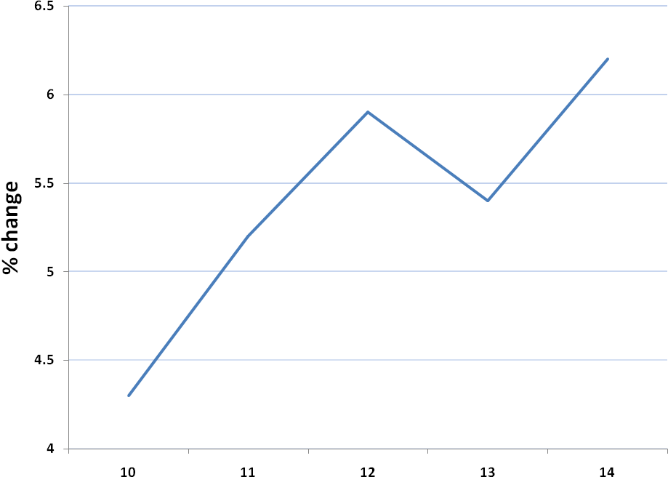.
Source: Bureau for Economic Research

  - Exchange rate of the Rand

The Rand exchange rate strengthened to an average of R6.77 against the US dollar during the second quarter (Q2) of 2011 after averaging R7.00 in the first quarter (Q1) of 2011. The robust performance continued in the early stages of the third quarter (Q3) with the currency remaining around the R6.75 level.

The sustained strength of the Rand was mainly due to robust foreign appetite for investing in SA bonds and equities. The currency has also been boosted by a relatively weak US dollar, robust commodity prices and indications of more sustained direct investment flows.

Most of the factors that supported the Rand during 2011 Q2 are expected to remain in place over the short term, ensuring that the currency remains supported for the rest of 2011. In light of the Rand remaining stronger than expected against the US Dollar in Q2 and no signs of imminent change in direction, there is consensus that the rand will on average remain below R7/US dollar until the end of 2011.

Going into 2012, more pronounced rand weakness (see Figure 2) is expected once financial markets start to price in the prospect of a growing number of developed countries increasing interest rates.

Figure 2: Rand/US Dollar Exchange Rate
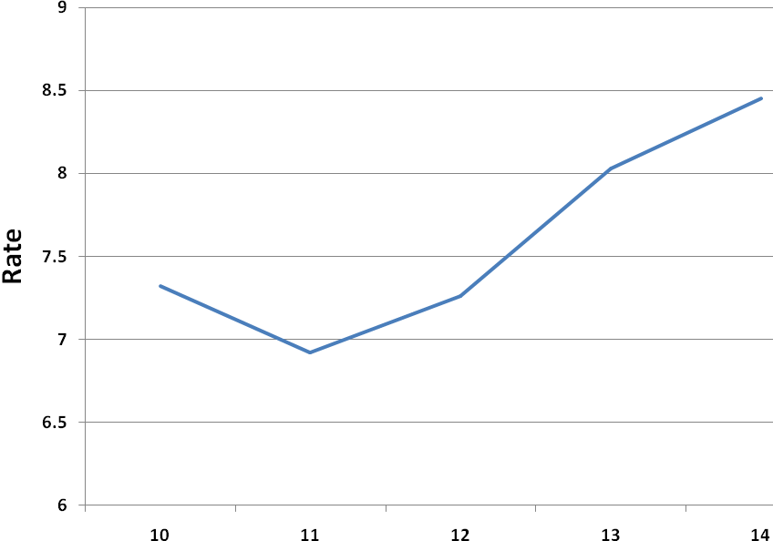
Source: Bureau for Economic Research

  - Interest rates

The SA policy interest rate (repurchase rate) has remained unchanged at 5.5% since November 2010 with the prime rate stable at 9.0%. The South African Reserve Bank kept the repurchase rate on hold following the January, March, May and July 2011 Monetary Policy Committee (MPC) meetings.

While a number of factors can be highlighted to justify the SARB keeping the interest rates unchanged so far, there are arguments in favour of starting the monetary tightening cycle before the end of 2011. According to the BER, interest rates should start rising in November 2011 (see Figure 3). This is informed by the view that core inflation (which excludes volatile items) is expected to reach in excess of 5% by mid-2012 and remain around 5% through 2012.

Figure 3: Prime Rate
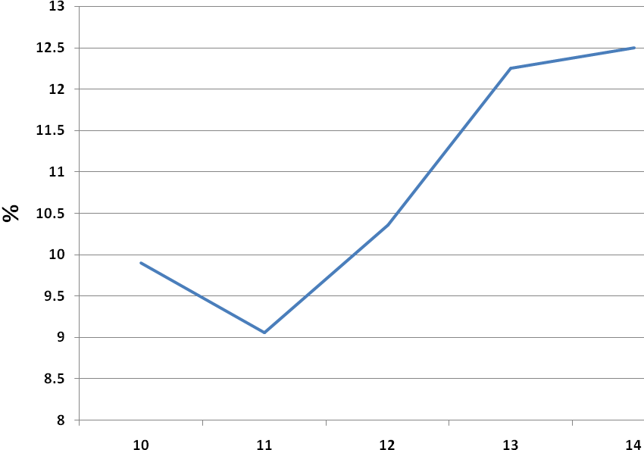
Source: Bureau for Economic Research

  - Gross Domestic Product (GDP)

Economic activity in South Africa gained further traction in the first quarter of 2011 when real gross domestic product expanded at an annualised rate of 4.8% - marking the seventh quarter of uninterrupted growth since the start of the recovery in the third quarter of 2009. The increase was attributed to a stronger pace of increase in real value added by the secondary and tertiary sectors.

The actual data already released for 2011’s second quarter suggests that GDP growth moderated from the robust 4.8% recorded in the first quarter. However, better-than-expected first quarter outcomes for household consumption and fixed investments have resulted in an improved forecast for 2011 as a whole. The BER expects GDP to average 3.8% for 2011 (see Figure 4) and ease slightly to 3.7% on the account of base effects and slower growth in disposable income.

Figure 4: Gross Domestic Product
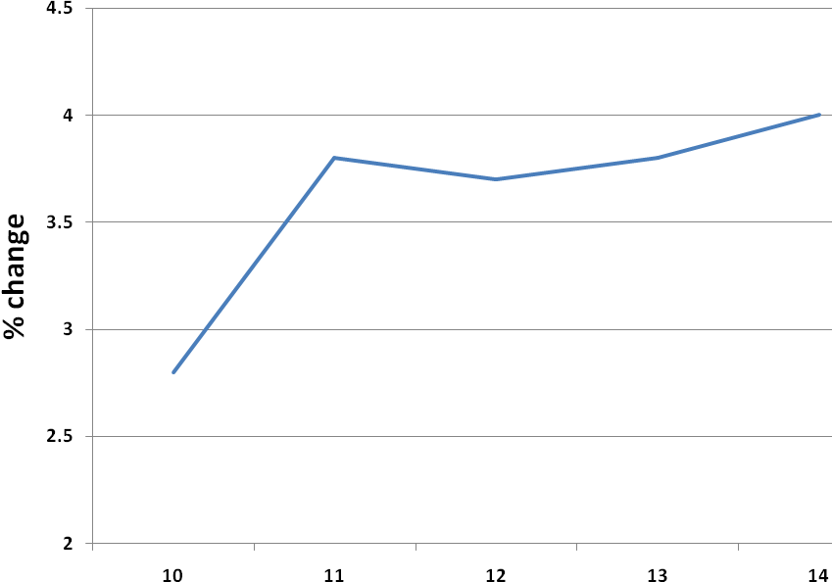
Source: Bureau for Economic Research

  - Industry volumes and growth

 | FY2009/10 | FY2010/11  Actual | FY2011/12 | FY2012/13 | 2013/14 | 2014/15
Net electricity sent out from licensed power stations (MWh) (Note 1) | 236 710 139 | 238 935 714 | 256 800 000 | 258 465 000 | 261 601 000 | 268 073 000
Electricity volume growth % | 0.19% | 0.94% | 7.48% | 0.65% | 1.21% | 2.47%
Piped-gas volume delivered at inlet flange of licensed pipelines (GJ) (Note 2) | 157 365 ,440 | 146 101 585 | 141 000 000 | 135 000 000 | 135 000 000 | 135 000 000
Piped-gas volume growth % | 24.10%% | (7.16%) | (3.49%) | (4.26%) | 0% | 0%
Petroleum volumes delivered at inlet flange of licensed pipelines (kl) (Note 3) | 17 993 390 | 17 990 221 | 17 590 283 | 18 020 000 | 18 120 000 | 18 627 000
Petroleum pipelines volume growth % | (1.55%) | (0.02%) | (2.22%) | 2.44% | 0.55% | 2.80%

Note 1

The energy sent out numbers arrived at were based on the Eskom’s projected volumes for the 2012/2013 to 2014/2015 financial years.

Note 2

For the 2010/2011 financial year the volumes were above 141 million gigajoules, at 146 million gigajoules. They are expected to increase slightly. The capacity of the pipeline, following improvements, is at 147 million gigajoules, but volumes will not be increased to that extent immediately.

Note 3

The volumes for the 2012/2013 financial years are based on Transnet’s projected volumes for the 2012/2013 to 2014/2015 financial years.

Regulatory Factors

These industry specific and cross-cutting regulatory factors are likely to influence the regulatory programmes and projects of the Energy Regulator.

Industry | Factors
Electricity | - The third Multi-Year Price Determination application  - Security of supply remain high on the national agenda  - Compliance enforcement to improve supply reliability  - Implementation of accelerated DSMEE plan and cogeneration framework  - Licensing of IPP 2011 generation plant  - Energy conservation program  - Impact of formation of ISMO  - Delay in Regulations (Electricity Regulation Act)  - Municipal maintenance and refurbishment
Piped-gas | - Monitoring of the SASOL Agreement  - Monitoring gas transmission and storage pipeline tariffs  - Possibility of additional piped-gas transmission pipelines being built  - Possible electricity plant (for gas power station and piped-gas market in the Cape region)  - Coal bed methane projects (RSA and Botswana)  - Additional natural gas fields in Mozambique  - Possibility of an additional CTL Plant  - Paucity of domestic gas finds  - Implementation of the maximum price methodology for approval of maximum prices
Petroleum pipelines | - Security of supply is a priority  - Additional storage (to meet the Energy Bill/Act and Energy Master Plan requirements)  - Construction of the New Multi-Product Pipeline (NMPP) – 24” pipeline  - Tariff structure  - The proposed 450,000 bbl/day Coega refinery  - Change in focus from licensing to compliance  - Tariff models for pipelines, loading and storage facilities
Cross –cutting regulatory | - NERSA is a regulatory body driven by skilled and competent staff. There have been real cost increases to this category of workers in South Africa  - Regulatory practices are moving towards world class practices  - Scope for rigorous technical and financial due diligence of licensees  - Need to benchmark the operations and performance of Energy Regulator  - Regulatory impact assessments to ensure that the value of regulation exceeds the cost of regulation  - Limited scope to draw on skilled and trained resources in a global context  - Benefits from regulating the industries far outweigh the cost of regulating the industries  - Energy bill

- Salary projections

 | 2007/08 | 2008/09 | 2009/10 | 2010/11 | 2011/12 | 2012/13
Projected Salary Increase Percentage* | 8.5% | 8.5% | 10.2% | 4.9% | 5.7% | 7.9%
Projected bonus percentage as a function of total employment cost | 12.5% | 14.0% | 17.0% | 17.0% | 17.0% | 17.0%
Performance linked pay progression | 3% | 3% | 3% | 3% | 2% | 2%

As NERSA is a knowledge-based institution, the retention of staff is a priority and therefore it is important that the salary market for the skills necessary is understood and taken into account.

* An additional allowance for 2% has been budgeted for to cater for a margin of error in projections and provide for possible settlements. The above estimated salary increases (CPI + 2%) is based on the BER focus as per table 1 above.

- Budgeting Principles

- The budget is aimed at achieving the NERSA policy objectives of staff development and moving towards becoming a world-class Energy Regulator.
- The budget is linked to projects and programmes in the Strategic Plan and Business Plan.
- Expense items are justified based on legal requirements, NERSA policies and regulatory mandate.
- Costs that can be directly attributable to an industry-specific regulatory function are charged directly to that function.
- Costs that are not directly attributable to an industry-specific regulatory function, but are incurred as common costs in order to support the three industry-specific regulatory functions, are allocated between the three industry-specific regulatory functions using the ratio proportionate to the approved staff complement attributable to the industry-specific function:
  - The current ratio is 58% for the electricity industry regulation; 21% for the petroleum pipeline industry regulation; and 21% for the piped-gas industry regulation.

- A cash-flow risk mitigation reserve is held by the Energy Regulator to overcome timing differences between the start of the financial year and the start of levy payment by the industries. The reserve target is 3 months employment cost for the electricity, piped-gas and petroleum pipelines industry and 4.5% of the annual operating expenditure budget less employment costs.

- The funding requirement from each industry is determined for each year to cover the following: total expenditure allocated to the regulation of the industry (operating plus capital) minus funds rolled forward from the funding for the previous year plus the cash-flow reserve for the industry.

- Employment costs are budgeted at full staff compliment and based on the projected salary increase.

- Higher level trend analysis

 | 2007/08  R ’000 | 2008/09  R’000 | 2009/10  R ’000 | 2010/11  R’000
Levies received
Actual | 137 193 | 110 030 | 127 028 | 155 197
Budget | 138 761 | 112 875 | 133 361 | 159 727
% Variance – (Under)/Over | (1.2%) | (2.5%) | (4.7%) | (2.8%)
Operating Expenditure
Actual | 104 720 | 119 730 | 143 818 | 163 718
Budget | 134 471 | 144 893 | 173 329 | 177 159
% Variance – (Under)/Over | (22.1%) | (17.4%) | (20.5%) | (7.6%)
Capital Expenditure
Actual | 4 547 | 990 | 5 456 | 9 999
Budget | 4 290 | 4 647 | 6 669 | 8 518
% Variance – (Under)/Over | 6% | (78.7%) | (18.2%) | 17.4%

- Analysis of direct versus common costs – 2012/13 budget year

 | Electricity | Piped-Gas | Petroleum Pipelines
Direct Costs | 39.8% | 41.5% | 42.2%
Direct Costs | R54 547 804 | R21 203 117 | R21 787 272
Common Costs | 60.2% | 58.5% | 57.8%
Common Costs | R82 484 036 | R29 864 904 | R29 864 909

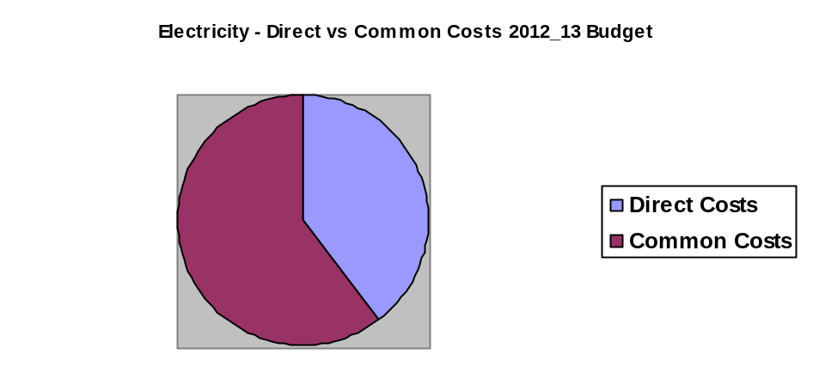

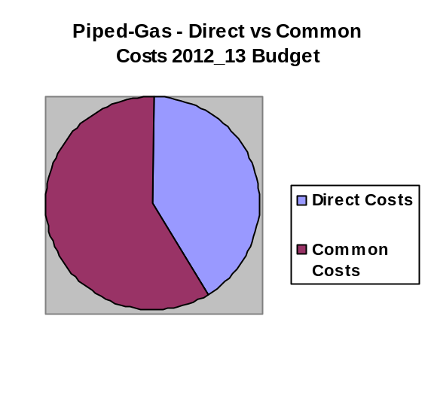

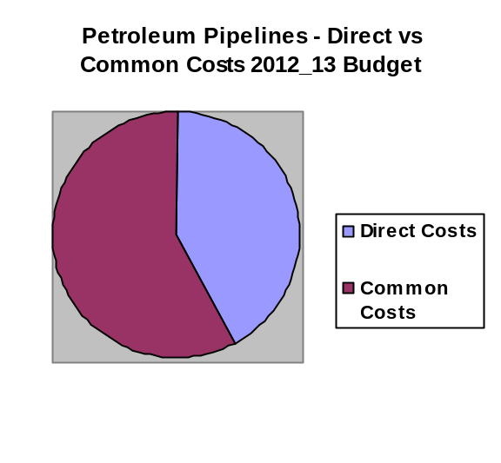

Appendix C: Budget for NERSA

In order to guide its budgeting process the Energy Regulator has adopted budgeting assumptions and parameters which seek to contain costs in line with government economic objectives, especially inflation targeting and the general direction in which the regulated industries are moving in economic terms. The budgeting assumptions and parameters are attached as Appendix B.

The total NERSA estimated Expenditure Budget for 2012/13 amounts to R 240 315 901 (2011/2012: R223 021 701). The specific budgets for the three regulated industries are as follows (the approved budgets for 2011/12 are in parenthesis):

- Electricity Industry R 137 485 425 (2011/2012: R 124 667 690)
- Piped-Gas industry R 51 194 911 (2011/2012: R 50 486 314)
- Petroleum Pipelines R 51 635 565 (2011/2012: R 47 867 696)

TOTAL R 240 315 901 (2011/2012: R 223 021 701)

As documented in the budgeting assumptions and parameters (Appendix B), a Cash Flow Mitigation Reserve is held by the Energy Regulator to overcome timing differences between the start of the financial year and the start of levy payment by the industries. The Cash Flow Mitigation Reserve carried forward from the previous years will be R32.1 million at the end of 2012/13 in line with the principles on which the calculation of the Cash Flow Mitigation Reserve are based (refer Note 5 of Appendix F).

The NERSA expenditure budget has increased by 7.8% when compared to that of the 2011/12 financial year.

Significant changes in budgeted items are as follows:

Significant Increases

The budget for temporary staff has increased by 90.8%. The increase is due to more temporary staff being needed to handle the organisational work load with the reduction of work performed by consultants.

The current organisational structure does not fully support operations of certain divisions e.g. Electricity, Petroleum Pipelines, Finance etc. This budget item also caters for employees who are, among other reasons, on extended or maternity leave.

Due to compliance regulatory demands it is anticipated that temporary staff personnel will be critical while motivations to increase staff complements are being considered by the Energy Regulator.

The budget item includes the following:

- Human Resources Department for maternity and extended leave – 4 months leave at an average salary of R450 000 per annum x 6 people = R 900 000
- Electricity and Petroleum Pipelines divisional requirements – Average salary of R 310 000 per annum x 7 people
- Finance and Administration division – Average salary of R 200 000 per annum x 3 people

Employee wellness The budget has increased by 54.2% due to the increased structure from 168 to 177, increased awareness of the programme and increased declaration of life threatening illnesses which will result in the increased utilisation of the programme. The breakdown of the expenditure is as follows:

- Employee Wellness and Assistance Programme: R1 000 000
- Participation in Discovery/ 702 “Walk the Talk” R 150 000
- Full day Sports Day: R 440 000

Catering and Entertainment The budget has increased by 45.9%. This increase is mainly attributable to more public hearings planned including MYPD 3 for the financial year, stakeholder meetings and Energy Regulator meetings. MYPD 3 costs have been allocated to the electricity division in line with ring fencing methodology.

This budget covers for catering where there are meetings for longer periods and morning meeting including Energy Regulator and Subcommittee meetings, public hearings and stakeholder workshops. This also includes a provision for the year end function.

Learnership programme has increased by 26% as a results of introduction of internship programme which will implemented within the organisation and for this goal to be achieved 15 graduates will be recruited.

Water, electricity, rates and taxes increased by 23.9%. This increase has been necessitated mainly by the increase electricity tariff.

Currently NERSA is paying an amount of R 36 767 on a monthly basis for rates and taxes. After taking budget assumptions into consideration it comes to R 46 000 per month and R 552 000 per annum.

NERSA also pays a levy to Arcadia City improvement at an average cost of R 10 437 per month and R 137 770 per annum, after factoring budget assumptions.

Electricity and water usage is estimated at around R 119 371 per month and around R139 750 during the winter season. The total is R 119 371 x 9 months and R 139 750 x3 months = R1 493 589 per annum.

Legal fees budget has increased by 20% due to current court cases which may overlap to the next financial year. It is also anticipated that more senior counsel will be required in the current financial year.

This budget caters for any potential litigation for and against NERSA, legal opinions on the core regulatory business of NERSA on the request of the NERSA staff and the Energy Regulator. It also includes fees required to engage external legal counsel on the processes of NERSA, contractual issues and reviews of reports.

Performance bonuses have increased by 14.8%. This is due to the increased salaries as well as the increase in staff complement. NERSA requires optimum performance from its staff members and rewards the achievement of such performance. It therefore provides for bonuses to be paid for performance that exceeds the expected level of outputs. The amounts budgeted for the bonuses in 2012/13 are an estimate of the bonus quantum.

This amount will be refined by management through a formula that lays a basis for the calculation of the amount payable and is in line with approved budget parameters and assumptions.

Significant Decreases

Travel Costs – Regulator reduced by 55.8% due to less travel planned for the coming financial period for various activities such as seminars, conferences and training courses locally and overseas.

Study fees reduced by 38.3% due to the decline in study request by staff members and this trend is expected to continue to the next financial period.

Capital expenditure decreased by 27.5%. This is due to the majority capital replacements completed in the previous year. In the CAPEX budget of the following items:

- Furniture and Equipment decreased by 93.8% due to the replacement of the lifts, installation of the bio matrix system, replacement of air conditioning engines and furniture which were budgeted for in the previous period.

- Computer hardware has decreased by 88.8% due to the replacement of laptops and upgrading of networks and improvement of the teleconference system which took place in the previous period.

- Building improvements has however increased due to energy saving initiatives to the building, establishment of wellness centre, revamping of bathrooms and the replacement of the standby generator to the building.

The breakdown of the above is as follows:

- Energy saving plan – replace geysers, air conditions etc – R 3 125 000
- Replacement of standby generators – R 1 500 000
- Establishment of wellness centre – R 850 000
- General building improvement – R 750 000
- Refurbishment of bathrooms – R 500 000
- CRM Software – R 500 000
- Replacement of computer hardware – R 476 000
- Additional workstations – R 300 000
- SCM software – R 250 000
- Replacement of motor vehicle – R 230 000
- Replacement of servers – R 200 000

To give effect to section 13(2) and (3) of National Energy Regulator Act, 2004 (Act No.40 of 2004), the Energy Regulator has approved the following ring fencing principles:
- Costs that can be directly attributable to an industry-specific regulatory function will be charged directly to that function.
- Costs that are not directly attributable to an industry-specific regulatory function, but are incurred as common costs in order to support the three industry-specific regulatory functions, will be allocated between the three industry-specific regulatory functions using the ratio proportionate to the approved staff complement attributable to the industry-specific function:
  - The current ratio is 58% for the electricity industry regulation; 21% for the petroleum pipeline industry regulation; and 21% for the piped-gas industry regulation.
- This ring fencing methodology will be reviewed in three years. The Energy Regulator however has the discretion to review the ratios should there be indications of actual ratio’s varying by more than 5%

Four different income and expenditure budgets have been produced for NERSA:

- Consolidated income and expenditure budget with forecast for NERSA (2012/13 – 2014/15) (Appendix E)
- Electricity regulation income and expenditure budget with forecast (2012/13 – 2014/15) (Appendix G1)
- Piped-gas regulation income and expenditure budget with forecast (2012/13 – 2014/15) (Appendix H1)
- Petroleum pipelines regulation income and expenditure budget with forecast (2012/13 – 2014/15) (Appendix I1).

Apart from this, within each of the regulated industries, income and expenditure budgets have also been produced for the six programmes that NERSA has adopted. See Appendices G2 – G7, H2 – H7 and I2 – I6 in this regard.

Appendix D: Funding for NERSA
In terms of the National Energy Regulator Act, NERSA will be funded through money appropriated by Parliament; levies imposed by or under separate legislation; charges for dispute resolution and other services rendered in terms of the Act; and licences. However, it suffices to say that the most prudent form of funding for all three industries is through levies.

For electricity it is further provided that its funding will include donations or contributions received from any person or entity and interest received on investment, as provided for in section 5B of the Electricity Act, (Act No. 47 of 1987) since charges for disputes and other services and licence fees are excluded for the electricity industry.

Levies from the petroleum pipelines industry and piped-gas industry are imposed in terms of the Petroleum Pipelines Levies Act, 2004 (Act No. 28 of 2004) and the Gas Regulator Levies Act, 2002 (Act No. 75 of 2002) respectively.

Under Section 5B of the Electricity Act (which has not been repealed with the operationalisation of the Electricity Regulation Act, 2006 (Act No. 4 of 2006)), the Minister of Energy prescribes the electricity levies by Notice in the Government Gazette.

Under the Petroleum Pipeline Levies Act and the Gas Regulator Levies Act, the Energy Regulator first publishes the intended levies for the public to make representations, considers the representation and submits a report to the Minister of Energy on the representations and how the representations affected the levies. After the approval by the Minister of Energy in concurrence with the Minister of Finance, the Energy Regulator publishes a Notice in the Government Gazette of the approved levies for thirty days before the piped-gas and petroleum pipelines industries start paying the levies.

With regard to the electricity industry, the budget for regulating this industry will use the variable of net kilowatt-hour generated to determine the relative percentage contribution of each generation licensee to the levy as prescribed by Section 5B of the Electricity Act.

In order to calculate the levies the energy production figures for the previous calendar year for every electricity generator are used. From the energy production figures the net energy that has been sent out by every generator is calculated (the difference between the gross energy produced and the amount of energy used during the generation process). The unit for this figure is kilowatt-hour. The levy is determined by dividing the budget for the electricity industry by the total amount of energy sent out. This provides a figure measured in cents per kilowatt-hour. In order to determine the amount that every generator has to pay to the Energy Regulator, the proportional contribution of every generator to the total amount of energy sent out during the year is calculated. The electricity budget is then divided between the generators in the same proportion.

In the 2012/13 budget the levy payable by the licensed generators for the electricity regulation industry will be effectively reduced by a refund of surplus funds which existed at 31 March 2011 to the value of R13.4 million and the refund of surplus funds that existed on 1 October 2005 of R2.3 million and interest receivable from the bank of R 2.4 million.

The levy rate payable by licensed generators of electricity is estimated at 0.04471 cents per kWh based on recovering R115.5 million through an estimated net generation of 258 465 GWh (1GWh = 1 million kWh) for the 2012/13 financial year. This is a 56% increase in the levy of the 2011/12 financial year (Refer Appendix F8). The increase is due to a significant reduction in the surplus which will be refunded to the industry as well as the interest receivable from banks. The refund of surplus funds reduced from R 46.5 million to R 15.8 million in the current year. Adding back the amounts for the two financial periods results in an increase of the levy by 9.6%.

With regard to the piped-gas industry, the budget for regulating this industry will use the variable of gigajoules entered into the system to determine the relative percentage contribution of each pipeline licensee to the levy.

For piped-gas, the levy is payable by the holders of the title to gas as it enters the system licensed by NERSA and is based on gigajoules. The budgeted amount for piped-gas for 2012/13 amounts to R47.2 million. The projected volume of gas for 2012/13 amounts to 135 million GJ, giving a levy rate of 0.3489 cents/GJ. This is a 22% increase in the levy of the 2011/12 financial year (Refer Appendix G8). The increase is due to significant reduction in the surplus which will be refunded to the industry, interest receivable from banks as well as reduction of projected volume by 6 million GJ from previous period. The refund of surplus funds reduced from R 8.6 million to R 380 000 in the current year. Adding back the two amounts for the two financial periods results in an increase of the levy of 5.9%.

With regard to the petroleum pipelines industry, the budget for regulating this industry will use the variable of litres entered in the system to determine the relative percentage contribution of each owner of petroleum to the levy.

For petroleum pipelines, the levy is payable by the holders of the title to the petroleum product as it enters the system licensed by NERSA and is based on litres. The budgeted amount for petroleum pipelines for 2012/13 amounts to R49.2 million. It is estimated that the total volume of petroleum products transported by pipeline would amount to approximately 18.0 billion litres per annum, so the levy would be R0.02728 per litre. This is a 43% increase in the levy of the 2012/13 financial year (Refer Appendix H7). The increase is due to significant reduction in the surplus which will be refunded to the industry as well as the interest receivable from banks. The refund of surplus funds reduced from R 13.0 million to R 380 000 in the current year. Adding back the two amounts for the two financial periods results in the increase of the levy by 5.3%.

As mentioned, for both piped-gas and petroleum pipelines, the holder of the title to the product must pay the levy. However, the piped-gas transmission licensee is vertically integrated and therefore is also the holder to the title of the piped-gas. On the other hand, the petroleum pipelines licensee is not vertically integrated and is not the holder of the title to the petroleum. This means that the petroleum pipeline levies will have to be collected from a number of importers and refiners.

Appendix E: NERSA Consolidated Budget
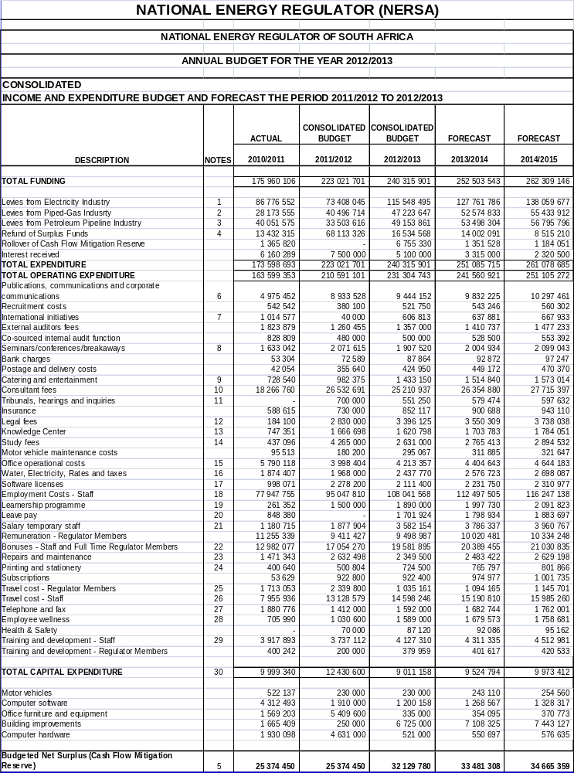

Appendix F: Notes to the NERSA Budget

EXPLANATORY NOTES TO THE BUDGET INCOME AND EXPENDITURE

OVERVIEW

Income

Funding is obtained by charging levies to the relevant industries and rolling forward the cash flow mitigation reserve from the previous years. In addition to this, interest receivable from the banks which is allocated to the three industries in terms ring fencing methodology and a refund of surplus funds as at 31 March 2011 has been calculated and included in the funding portion of the 2012/13 budget, which has an effect of reducing levies.

Total funding for the 2012/13 budget is 7.8% more than the 2011/12 budget. The calculation of this increase includes refunds to the industries, rollover of cash flow mitigation reserve and interest receivable for the current year and previous years.

The forecasted budget and funding for the 2013/14 year and the 2014/15 year increases by 4.5 % and 4.0% respectively.

The industry levies for 2012/13 will change as follows compared to the previous year:

Industry Levies | % increase with refunds and interest added back | % increase without refunds and interest
Electricity industry | 10.3% | 57.4%
Piped-gas industry | 1.4% | 16.6%
Petroleum pipelines industry | 7.9% | 46.7%

In calculating the changes in the levies both interest receivable and refund of surplus has been added back to ensure equitable comparison between the two financial years.

Expenditure

The total expenditure budget (including capital expenditure) for 2012/13 has increased by R17.3 million compared to the 2011/12 budget. The increase is mainly due to the provision for salary increases, legal fees, water and electricity and for building improvements. The Energy Regulator is focusing on compliance issues and will be auditing and assisting some licensees to ensure compliance with the licence conditions.

The budgets to regulate each of the industries have changed as follows compared to the previous year (2011/12):

 | % increase on previous year
Electricity industry | 10.3%
Piped-gas industry | 1.4%
Petroleum pipelines industry | 7.9%

INCOME

- Levies from Electricity Industry

The electricity levies with refunds from the electricity industry and interest receivable from the banks have increased by 10.3% from R124.7 million to R137.5 million. However the increase of levies without refunds from the electricity industry and interest receivable from the banks added back is only 57.4%, from R 73.4 million to R 115.5 million. This increase is mainly attributable to the reduction of the refund to the industry from R 46.5 million to R15.8 million in the current year.

The levies from the generators of electricity are in terms of section 5B of Electricity Act, 1987 (Act No.41 of 1987) and are based on estimated generation for the 2012 year and the NERSA electricity expenditure budget for 2012/13. The calculated levy is based on gross energy sent out less own use. The generation licensees range from Eskom being the largest generator at about 99% of total electricity generated to the municipalities and private generators. The levy calculation is given in Appendix F8, and further elaborated on in Appendix C of the Annual Performance Plan.

- Levies from Piped-Gas Industry

The piped-gas levies with refunds and interest receivable from piped-gas levies have increased by 1.4% from R50.5 million to R51.2 million. However when the refunds from the piped-gas industry and interest receivable from the banks are excluded it results in an increase of levies by 16.6% from R 40.5 million to R 47.2 million. This increase is mainly attributable to the decrease in the refunds to the industry from R 8.6 million to R 380 000 as well as a decrease in estimated volumes from 141 million gigajoules to 135 million gigajoules in the 2012/13 financial year.

The piped-gas levies are in terms of section 2 of the Gas Levies Act, 2002 (Act No. 75 of 2002) and are based on the estimated gas transported through the Mozambique gas pipeline and the Lilly pipeline. Sasol is the holder of the title to the gas and therefore is liable for the levy. The energy volume of gas is measured in gigajoules/annum. The levy calculation is given in Appendix G8, and further elaborated on in Appendix C of the Annual Performance Plan.

- Levies from the Petroleum Pipelines Industry

The petroleum pipelines levies with refunds and interest receivable have increased by 7.9% from R47.9 million to R51.6 million. However when the refunds from the petroleum pipelines industry and interest receivable from the banks are excluded it results in an increase of levies by 46.7% from R 33.5 million to R 49.2 million. This increase is mainly attributable to the decrease in the refund to the industry from R 13 million to R 380 000 in the 2012/13 financial year

The petroleum pipelines levy is in terms of the Petroleum Pipelines Levies Act, 2004 (Act No. 28 of 2004) and is based on the throughput of petroleum, measured in litres, delivered by importers, refiners and producers to inlet flanges of petroleum pipelines. This levy is paid by the holder of the title to the petroleum product, which in this case are the oil companies. The levy will thus be based on how many litres of petroleum an oil company has put through a petroleum pipeline. The levy calculation is given in Appendix H7, and further elaborated on in Appendix G8, and further elaborated on in Appendix C of the Annual Performance Plan.

- Refund of Surplus Funds

On 28 February 2008, the minister approved that surpluses of R 40 296 945 that existed during the National Electricity Regulator era, must be returned to the electricity industry over a period of three years as a reduction in the income budget needed in order to meet the expenditure budget of the electricity industry.

The Energy Regulator has implemented the above decision and the balance of R26.9 million surplus will continue to be refunded as follows:

2012/13 | R13 432 315
2013/14 | R13 432 315
 | R26 864 630

As at 31 March 2011 NERSA reported a surplus of R127.2 million in its Annual Financial Statements. The surplus that has to be refunded to the industries in the form of reduced levies is as follows:
 | Electricity Industry  (R) | Piped-Gas Industry  (R) | Petroleum Pipelines Industry  (R) | Total  (R)
2011/12 | 46 459 646 | 8 639 600 | 13 014 081 | 68 113 327
2012/13 | 15 774 866 | 379 851 | 379 851 | 16 524 570
2013/14 | 13 432 314 | 0 | 0 | 13 432 314
Approved commitments | 1 985 009 | 529 336 | 794 003 | 3 308 348
Cash Flow Mitigation Reserve | 15 317 988 | 4 301 726 | 6 203 999 | 25 823
Total accumulated reserves | 92 959 825 | 13 850 513 | 20 391 934 | 127 202 272

- Cash Flow Mitigation Reserve

Based on the historical background in the approval of the budget and the payment of levies to NERSA, a Cash Flow Mitigation Reserve has become a necessity for NERSA to be able to fulfill its financial obligations should there be a delay in the approval of the budget and/or delays in the payment of levies by the regulated entities. Hence the Energy Regulator made a decision that a provision be made in the budget for cash flow risks. This decision was approved by the Minister of Finance on 29 February 2008.

The Cash Flow Mitigation Reserve comprises the following principles:

- Three months of employment cost expenditure in terms of the electricity, piped-gas and petroleum pipeline industries
- 4.5% of the annual operating expenditure of NERSA net of employment costs.

The 2012/13 Cumulative Cash Flow Mitigation Reserve is as follows:
 | R
Electricity Industry | 18 831 799
Piped-Gas Industry | 6 450 715
Petroleum Pipelines Industry | 6 847 266
Total | 32 129 780

EXPENDITURE

- Publication, Communications & Corporate Communications.

There is an overall increase of 5.7%. The increase is due to more advertising for public hearings including MYPD 3 as compared to the previous year. The increase in this budget item is contained mainly in advertising, profiling of NERSA in the media and stakeholder management. This is through advertisements in magazines, newspapers and radio stations.

In order to comply with all the requirements of the duly approved Supply Chain Management Policy in line with National Treasury Regulations, NERSA must advertise all bids above R500 000. This has resulted in the increase in advertising costs for the financial year as reflected below.

The publication, communications and corporate communications budget is broken down into the following significant items:

 | R’000
Advertising and stakeholder management | 2 634
Printing of the Annual Report | 410
Corporate gifts and promotional material | 370
NERSA newsletter  Electricity supply statistics  Piped Gas Publications  Profiling NERSA in the Media | 200  180  180  868
Exhibitions  Call for tenders  Customer Education Brochures, Campaigns and Corporate Material  Sponsorship  Vacant positions advertisement  Municipality Electricity Tariff Booklet | 390  1 186  380  525  750  200
Further explanations for the above budget items are as follows:

- Corporate gifts and promotional materials
There has been a decrease in the above budget item in comparison 2011/12. Executive Corporate gifts refer to high quality gifts such as:
- Memo pads with calculators
- Metal pens
- Business Cards holders
- Globe Desk Sets
Other corporate gifts under this budget item are:
- Corporate wear for staff
- Year-end function
- Secretary’s Day
- Boss’s Day
- Women’s Day

Promotional materials are mainly for mass distribution during marketing activities and include items such as:
- Pens
- Lanyards
- Caps
- Squeeze Bottles

- Newsletter

The actual amount for the newsletter as per the contract is R38 262.96 per edition x 4 = R153 051.84 and the increase is after taking budget assumptions into consideration.

- Profiling of NERSA

There are no actuals for the 2010/11 financial year as it was removed from budget. The budgeted amount is as follows:

  - Placing of advertorials in high profile magazines targeting executives and decision makers such as Sawubona, Leadership, Equinox and Black Business Quarterly. The budget is to place advertorials in 6 magazines @ R40 000.00 = R240 000.00

  - R1 000 000 is budgeted for buying slots in electronic media (particularly SABC and Community radio) for interviews about NERSA’s role and mandate. Radio advertisements will also be considered but are very expensive – this amount can only run radio advert for a maximum of two weeks.

- Sponsorship

The amount is based on estimated requests of 30 @ R20 000.00 each. In the past year before the sponsorship policy was approved, NERSA normally received requests ranging from 50 to 80.

- International Initiatives

NERSA endeavours to establish mutually beneficial partnerships with cooperating partners. In the spirit of the New Partnership for Africa’s Development (NEPAD) and the African Union (AU), the NERSA is involved in a number of national, regional and international regulatory initiatives.

NERSA is a member of the Regional Electricity Regulators Association (RERA) of Southern Africa/SADC at regional level. At the continental level, NERSA is a member of the African Forum for Utility Regulators (AFUR).

The establishment of these regulatory associations and NERSA’s involvement in them is in line with national imperatives, international trends and best practice whereby organisations in a given industry or sector come together to share experience and collectively deal with and influence issues as well as developments that impact on the industry or sector.

This line item was severely under budgeted during 2011/12. For 2012/13, ICP intends to undertake the following activities which are detailed below: The increase from R40, 000. 00 to R606 812.00 is due to the following:
  - Economic Regulators Conference which was not covered under International Initiatives in 2011. An amount of R100 000.00 was provided for under Conferences and Seminars for 2011 which will be used for this Conference in 2011/12. The estimated costs for hosting the South African Economic Regulators Forum for 2012/13:
  - International Speakers Travel (Business Travel for I person): R60, 000.00
  - International Speakers Hotel Accommodation (4 star accommodation for 1 person): R1750 x 5 days= R8 750
  - International Speakers per diem: US 215 X 5 days x R7.50: R8 062.50
  - Venue Hire for +/- 200 participants x 2 days: R100 000.00
  - Transport and Logistics(Publicity, Call for papers, conference folders, cocktail function): R150 000.00
  - Conference Publication: R150 000.00

Total: R476 812.50

  - International Corporation and Partnerships (ICP) days which will be hosted by the ICP Department - this will include catering for NERSA staff and fees to be paid to the identified speakers. The cost for hosting two ICP days will consist of catering at R100 x 150 members of staff amounting to R30 000. 00 plus R10 000.00 budgeted for fees to be paid to identified speakers for the two ICP days.

Total: R40 000.00

  - International Relations and Protocol Training which will be offered to NERSA staff members at the Department of International Relations and Co-operation. The budgeted amount covers transport and catering for staff members. It is envisaged that this will cost R30 000. 00 for 50 members of staff

Total: R30 000.00

  - International Related Activities – this activity relates to the hosting of foreign delegations at NERSA, which may include site visits. Catering is provided for visiting delegations at NERSA, in addition to dinner offered outside NERSA. Costs in this regard are estimated at 4 dinners hosted by NERSA for visiting delegations @R250 per for 20 people, amounting to R20 000.00.

Additionally, delegations will normally request copies of presentations and background material such as South African Legislation on memory sticks or computer discs. Costs in this regard are budgeted at R150 x 50 memory sticks amounting to R7 500.00. These memory sticks and discs will be purchased by ICP and are separate from the corporate gifts which are provided by the CSM department.

Lastly transport costs for site visits as part of delegation visits, such as to ESKOM Simmerpan. This is budgeted at R7 500.00 per round trip from NERSA, thus four trips amount to R30 000.00. The total cost under International related activities is therefore R57 500.00, which is rounded off to R60 000.00.

Total: R60 000.00

ADDITIONAL INFORMATION:

- The attendance of the four Exco meeting and Subcommittee meetings for RERA and AFUR have been included under travel budget,
- Membership subscriptions to RERA (R550 000) and AFUR (R 233 100) are budgeted for separately under Subscriptions.

- Seminars, Conferences and Breakaways

There is an overall decrease of 7.9% in this expenditure compared to the 2011/12 budget. The seminars, conferences and breakaways budget comprises departmental, divisional, management committee, REC and Energy Regulator strategic planning sessions and breakaways.

Departments attend breakaway sessions at outside premises for team building purposes at least once a year. Each division hold their strategic planning sessions in preparation for the organisational strategic planning for the following financial year. Attendance at these sessions is by all personnel who are involved in different projects.

- Catering and Entertainment

The budget has increased by 45.9%. This increase is mainly attributable to more public hearings planned including MYPD 3 for the financial year, stakeholder meetings and Energy Regulator meetings. MYPD 3 costs have been allocated to electricity division in line with ring fencing methodology.

This budget covers for catering where there are meetings for longer periods and morning meeting including Energy Regulator and Subcommittee meetings, public hearings and stakeholder workshops. This also includes a provision for the year end function.

- Consultant Fees

The budget reflects a 5.0% decrease as compared to the 2011/12 budget.

The use of consultants is unavoidable due to the technical nature of the regulatory work which needs to be performed coupled with the fact that in most instances the projects undertaken are groundbreaking initiatives where similar work has not yet been performed.

The consultant fees incurred for cross cutting regulatory and organisational purposes have been allocated to the three industries as per the approved NERSA ring-fencing methodology; consultant fees directly attributable to an industry are allocated to that industry.

Most of the consultants fees are reflected in the NERSA Strategic Plan (2012/2013 – 2013/14) and Annual Performance Plans. Some of the main drivers of the consultant budget are listed below.

Electricity Regulation - Significant consultant fees

The following are the projects where significant consulting fees are required:

  - A contingency fee for electricity regulation projects – R2 500 000
- Outsourcing of D Forms data collection and verification – R 950 000

Piped-Gas Regulation – Significant consultant fees

The following are the projects where significant consulting fees are required:

- Assessment of gas demand in the market – R 800 0000
- Analysis of exploration activities – R 400 000
- Piped-Gas market research survey – R 400 000
- Regulatory Reporting Manual implementation – R 600 000
- GIS information service support – R 500 000
- Licensee Management system – R 250 000

Petroleum Pipelines Regulation – Significant consultant fees

The following are the projects where significant consulting fees are required:

- Accounting specialist – R1 700 000
- NMPP Construction/ procurement cost – R1 000 000
- Decommissioning of the DJP – R700 000
- Petroleum pipelines market research survey – R 500 000
- Licensee Management system – R 250 000

Cross Cutting Regulatory Significant consultant fees

The following are the projects where significant consulting fees are required:

- Share points support – R 5 00 000
- Disaster Recovery Site Maintenance – R 550 000
- Regularity special projects – R 700 000
- Business Process Analysis – R 1 000 000
- Regulatory Reporting Manual implementation – R2 764 554
- Facilitation of learnership programme – R 1 375 000
- Labour and Industrial Relations assistance – R 830 000

Organisational Significant consultant fees

- CRM Implementation – R 500 000
- Support to NERSA departments and the Office of the CEO – R 746 250
- IT outsource contract – R1 104 000
- Projects commissioned by the Energy Regulator – R 500 000

- Tribunals, Hearings and Enquiries

The budget has decreased by 21.3%. This is mainly due to the anticipated reduction in the number of regulated industries public hearing that will be held outside NERSA premises. These public hearings are held outside NERSA’s premises due to the huge public interest.

- Legal Fees

The budget has increased by 20%; this is due to current court cases which may overlap to the next financial year. It is also anticipated that more senior counsel will be required in the current financial year.

This budget caters for any potential litigation for and against NERSA, legal opinions on the core regulatory business of NERSA on the request of the NERSA staff and the Energy Regulator. It also includes fees required to engage external legal counsel on the processes of NERSA, contractual issues and reviews of reports.

- Knowledge Centre

NERSA houses an internal library that provides journals, newspapers, magazines and other publications. The costs pertaining to the Knowledge Centre has decreased by 2.8% mainly due to reduction in knowledge materials required by user departments.

It is vital in NERSA’s role as a Regulatory Authority and Knowledge Institution to keep abreast with the required areas of expertise and one of the ways of doing so is through obtaining the correct literature. Most of the literature required is international publications, which are paid for in foreign currencies.

- Study Fees

This expenditure has decreased by 38.3%. This is due to the decline in study request by staff members despite an increase in allowances from R15 000 to R50 000 per employee per annum. This trend is expected to continue into the next financial year.

- Office Operational Costs

This expenditure item has increased by 5.4%. This budget item includes operational lease agreements for photocopy machines, fax machines, printers and maintenance costs. These are based on a current contract. NERSA has an obligation to pay for such equipment and services rendered.

- Monthly charge for the above machines are anticipated at R267 617.60 and R 3 211 411.20 for the year under review.

- Included on the above vote is a monthly payment for Multi-choice for DSTV subscriptions R 30 000.00.

- There is also maintenance for copiers, fax and printers with Canon and Gestener which is charged at prices ranging from R 0.150528 to R 0.263424 per copy on faxing machines, and R 0.0672 per copy on printing machines. The number of copies ranges from month to month depending on the number of meetings held during that month. The average cost per month is R 105 000 x 12 months equals R 1 260 000.

- Water, Electricity, Rates and Taxes

This expenditure item has increased by 23.9%. This increase has been necessitated mainly by the increased electricity tariff.

- Currently NERSA is paying an amount of R 36 767 on a monthly basis for rates and taxes and after taking budget assumptions into consideration it amounts to R 46 000 per month and R 552 000 per annum.

- NERSA also pays a levy to Arcadia City improvement at an average cost of R 10 437 per month and R 137 770 per annum, after factoring in budget assumptions.

- Electricity and water usage is estimated at around R 119 371 per month and around R139 750 during the winter season. Total is R 119 371 x 9 months and R 139 750 x 3 months = R1 493 589 per annum.

- Software Licences

This relates to 23 software programmes that are currently used by NERSA and annual renewals licences are necessary to comply with user agreements.

- Employment Costs – Staff

Employment costs are based on the approved staff complement and have increased by 13.7% after taking into account the inflation linked salary increases, cellphone allowances and the pay progression. The salary increase projections are 7.9%(CPI+2%) as per budget assumptions and parameter and the balance of increase relates to increase in staff structure from 168 to 177. Salaries on vacant positions are based median rates.

- Learnership Programme

The Republic of South Africa is trying to address the skills shortage, unemployment, prospects of work and labour mobility, productivity in the workplace, competitiveness of employers, promotion of self-employment and delivery of social services introduced the Skills Development Act 97 of 1998.
The Act gives a framework to implement national, sector and workplace strategies to develop and improve the skills of the South African workforce; to integrate those strategies within the National Qualifications Framework as contemplated in the South African Qualifications Authority Act of 1995 and to provide for Learnership that leads to recognised occupational qualifications.

In trying to achieve the National Qualification Framework the Sectors of Education and Trainings (SETA’s) were developed and introduced.

These cater for the establishment of learnership and approval of workplace skills plans among other duties. Though NERSA is exempted from contributing to the National Skills Fund as prescribed by the National Skills Levy Act, the organisation still carries an obligation of Skills Development. In the NERSA Workplace Skills Plan of 2006, one of the areas that need to be addressed is the implementation of learnership within the organisation.

The organisation has taken a stand in ensuring that a learnership and internship programme is implemented within the organisation and for this goal to be achieved an amount of R 1.9 million has been budgeted and it will be utilised as follows:
- Learnership - 12 Learners at a stipend of R 5 000 per month for 12 months amounting to R 720 000 and,
- Internship – 15 Graduates at a stipend of R 6 500 per month for 12 months amounting to R 1 170 000.

- Leave pay

Leave pay has been calculated on the basis of leave days that are due to staff members. The leave pay budget was based on leave policy which allows only five days to be carried over to the next financial period and any excess leave days are continually forfeited.

- Employment Costs – Temporary Staff

The budget for temporary staff has increased by 90.8%. The increase is due to more temporary staff needed to handle the organisational work load with the reduction of work performed by consultants.

The current organisational structure does not fully support operations of certain divisions such as Electricity, Petroleum Pipelines and Finance. This budget item also caters for employees who are amongst other reasons on extended or maternity leave.

Due to compliance regulatory demands it is anticipated that temporary staff personnel will be critical while motivations to increase staff complements are being considered by the Energy Regulator.

The budget item includes the following:

- Human Resources Department for maternity and extended leave – 4 months leave at an average salary of R450 000 per annum x 6 people = R 900 000
- Electricity and Petroleum Pipelines divisional requirements – Average salary of R 310 000 per annum x 7 people
- Finance and Administration division – Average salary of R 200 000 per annum x 3 people

- Bonuses

Performance bonuses have increased by 14.8%. This is mainly due to the increased salaries as well as the increase in staff complement. NERSA requires optimum performance from its staff members and rewards achievement of such performance. It therefore provides for bonuses to be paid for performance that exceeds the expected level of output. The amounts budgeted for the bonuses in 2012/13 are an estimate of the bonus quantum.

This amount will be refined by management through a formula that lays a basis for the calculation of the amount payable and is in line with approved budget parameters and assumption.

- Repairs and Maintenance

The repairs and maintenance budget has decreased by 10.8%. This is due to the decrease in the new contracts values with various maintenance and consumable suppliers. Furthermore, an improved security equipment and air conditioners will be installed which will results in the reduction of general repairs and maintenance.

- Printing and Stationery

This budget item has increased by 44.7%. The increase is mainly due to increased utilisation of printing materials as a result of more meetings and participants anticipated in the coming year as well as envisaged increase costs in printing paper. This increase reflects the current expenditures.

Currently stationery is expensed and only accounted for as inventory at year end. An average expenditure per month for the past few moth R23 200.00 and it amount to R 278 400.00.

Cartridges are used mostly for printers where we do not have maintenance contracts. The usage is as follows R900.00 per black cartridge for 10 machines 4 times a year. The machine also uses other 3 colours at R 750 for ten machines 2 times a year. Total for cartridges only is R 81 000.00.

This expense will hopefully not increase and we will endeavour to keep it at that level. This will be done by buying from a cheaper supplier without compromising quality.
- Travel Costs – Regulator Members

This budget will cater for local and international travel for seminars and conferences as well as public hearings for Regulator Members. The budget with regard to travelling costs for Regulator Members has decreased by 55.8% due to less travel planned for the coming financial period for various activities such as seminars, conferences and training courses locally and overseas. The reduction is also related to less inductions anticipated in the coming year.

- Travel Costs – Staff

Travel costs attributable to staff has increased by 11.2%. This is mainly due to project related travel and mainly for conducting site visits, customer awareness campaigns, RRM implementation and monitoring, compliance audits, AFUR and RERA related activities, public hearings and attending exhibitions and training.

- Telephone and Faxes

This budget item has increased by 12.8%. This cost is regarding landlines lines and data lines. The control of this function is centralised and this encourages costs control. The costs also include Premicell which reduces call costs from landline to cell phone, to cell to cell. The average calls per month are R 62 000 which is R 744 000 per annum. The Premicells cost amounted to R29 000 which is R348 000 per annum.

- Employee Wellness

The budget has increased by 54.2% due to the increased staff structure from 168 to 177, increased awareness of the programme and increased declaration of life threatening illnesses which will result in the increased utilisation of the programme. The breakdown of the expenditure is as follows:

- Employee Wellness and Assistance Programme: R1 000 000
- Participation in the Discovery 702 “Walk the Talk”: R 150 000.00
- Full day Sports Day: R 440 000.00

- Training and development – Staff

In line with the Skills and Development Act, specialised training interventions within the energy sector have become necessary with the venture into the new regulated industries. The training budget is based on the skills requirements within the organisation. The personal development plans of individuals are consolidated to give a view of the amount of training necessary and the estimated related costs.

The training budget has increased by 10.4%. This is based on a 4% of the salary budget and the increase is in line with the increased staff compliment.

- CAPEX

This expenditure item provides for capital expenditure for the acquisition of computer software and hardware, to carry out both the administrative and regulatory functions of NERSA. Computer hardware such as servers and personal computers are required to replace existing equipment that has become obsolete and needs to be issued to new employees as a result of the increase in staff members. Building improvement is important to ensure that NERSA complies with the OSH Act and is also energy efficient.

The capital budget has decreased by 27.5%. This is due to the majority capital replacements completed in the previous year. The CAPEX budget includes the following items:

- Furniture and Equipment decreased by 93.8% This is due to the replacement of the lifts, installation of the bio matrix system, replacement of air conditioning engines and furniture which were budgeted for in the previous period.

- Computer hardware has decreased by 88.8%, this due to the replacement of laptops and upgrading of networks and improvement of the teleconference system which took place in the previous period.

- Building improvements has however increased due to energy saving initiatives to the building, establishment of wellness centre, revamping of bathrooms and the replacement of the standby generator to the building.

The breakdown of the above is as follows:

- Energy saving plan – replace geysers, air conditioning etc – R 3 125 000
- Replacement of standby generators – R 1 500 000
- Establishment of wellness centre – R 850 000
- General building improvements – R 750 000
- Refurbishment of bathrooms – R 500 000
- CRM Software – R 500 000
- Replacement of computer hardware – R 476 000
- Additional workstation – R 300 000
- SCM software – R 250 000
- Replacement of motor vehicle – R 230 000
- Replacement of servers – R 200 000

Electricity Industry Regulation

Appendix G1: Consolidated Electricity Industry Regulation Budget

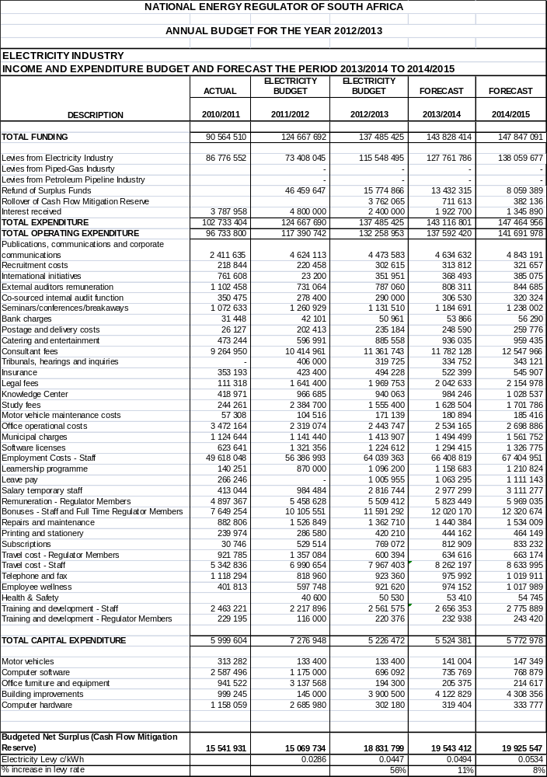

Electricity Industry Regulation

Appendix G2: Electricity Industry Regulation Programme 1: Setting and/or approval of prices and tariffs Budget
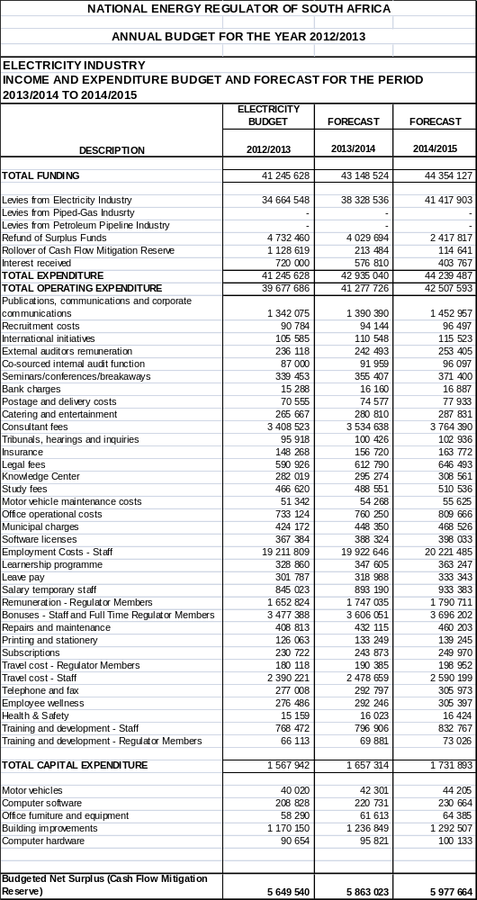

Electricity Industry Regulation

Appendix G3: Electricity Industry Regulation Programme 2: Licensing and Registration Budget

Electricity Industry Regulation

Appendix G4: Electricity Industry Regulation Programme 3: Compliance monitoring and enforcement Budget
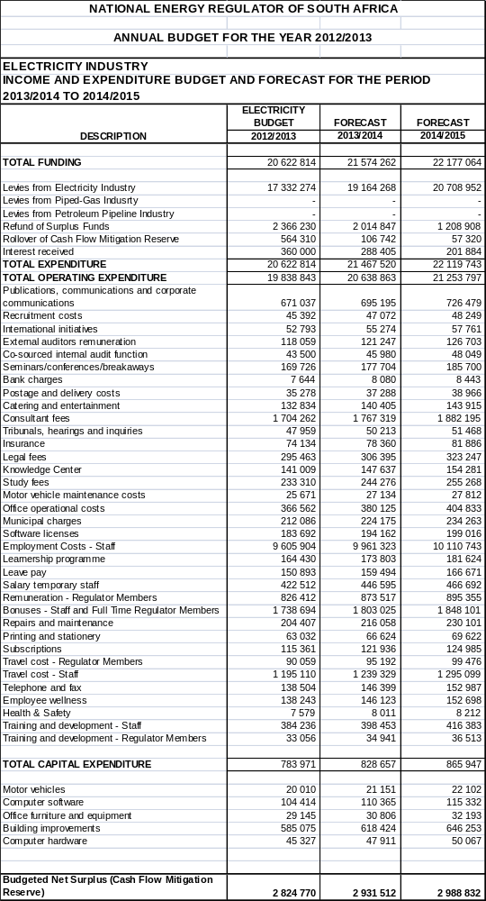

Electricity Industry Regulation

Appendix G5: Electricity Industry Regulation Programme 4: Dispute resolution including mediation, arbitration and the handling of complaints Budget
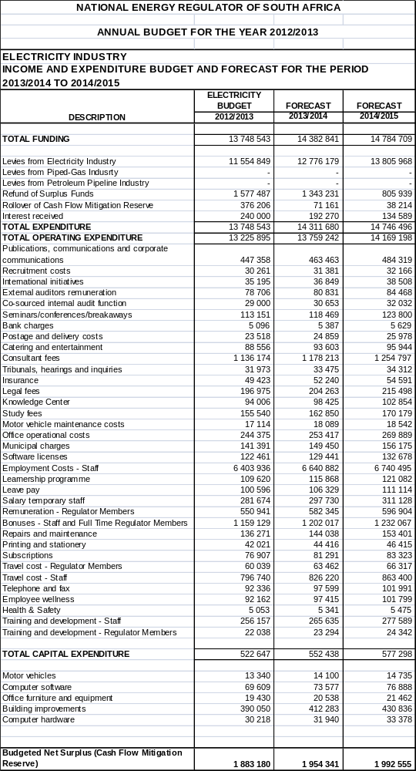

Electricity Industry Regulation

Appendix G6: Electricity Industry Regulation Programme 5: Setting of Rules, guidelines and codes for the regulation of the electricity industry Budget

Electricity Industry Regulation

Appendix G7: Electricity Industry Regulation Programme 6: Establishing NERSA as an efficient and effective regulator Budget
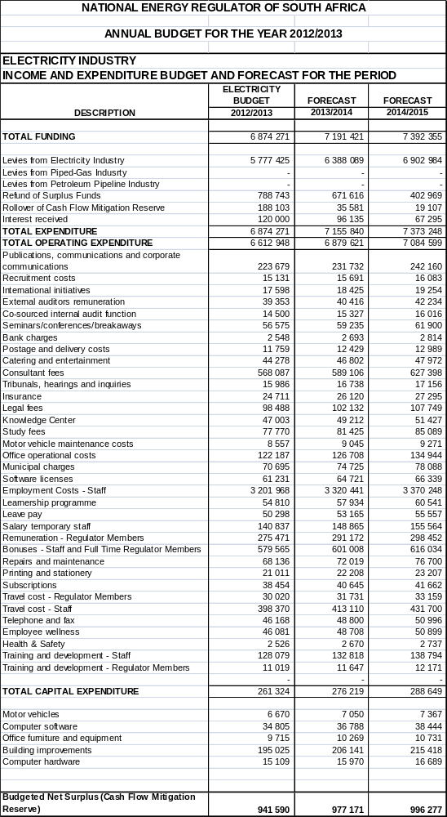

Electricity Industry Regulation

Appendix G8: Funding for the regulation of the electricity industry
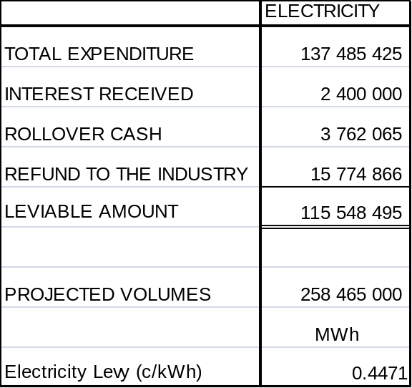

Piped-Gas Industry Regulation

Appendix H1: Consolidated Piped-Gas Industry Regulation Budget

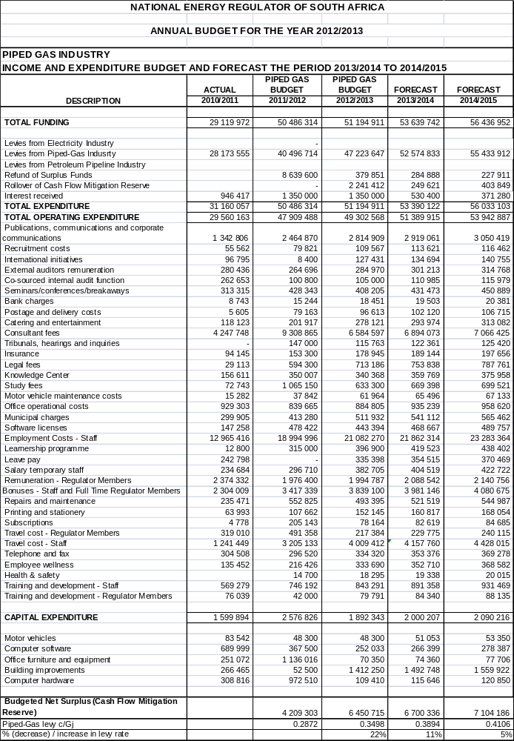

Piped-Gas Industry Regulation

Appendix H2: Piped-Gas Industry Regulation Programme 1: Setting and/or approval of prices and tariffs Budget
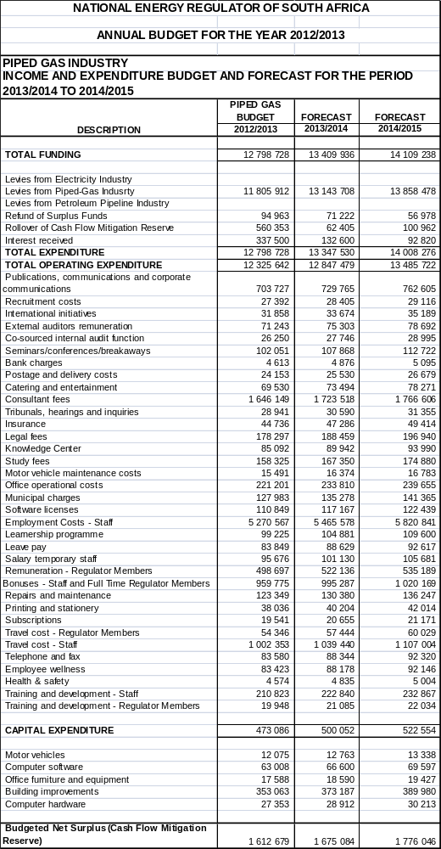

Piped-Gas Industry Regulation

Appendix H3: Piped-Gas Industry Regulation Programme 2: Licensing and Registration Budget
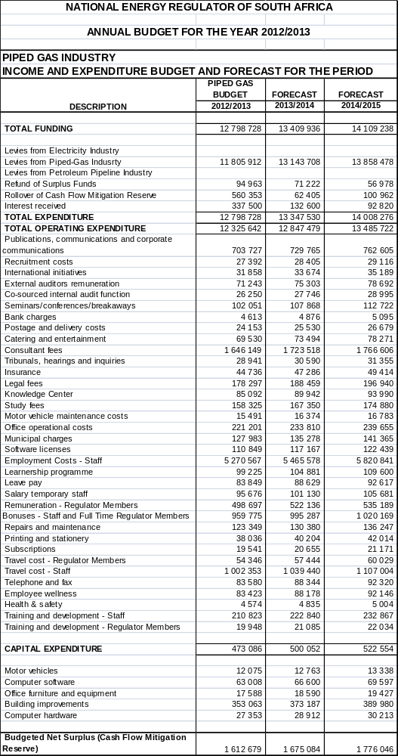

Piped-Gas Industry Regulation

Appendix H4: Piped-Gas Industry Regulation Programme 3: Compliance monitoring and enforcement Budget
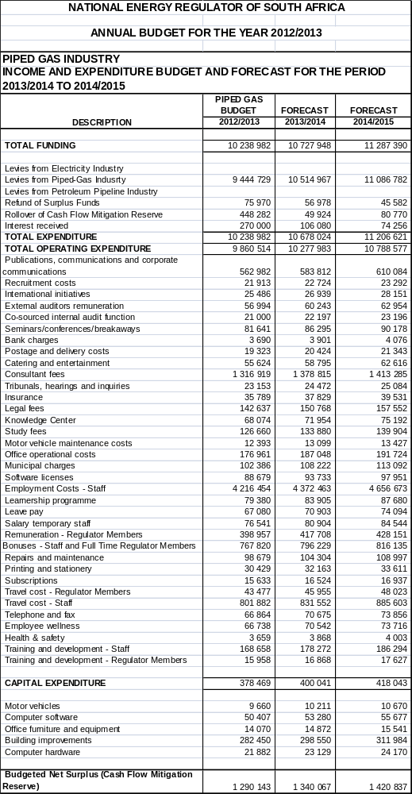

Piped-Gas Industry Regulation

Appendix H5: Piped-Gas Industry Regulation Programme 4: Dispute resolution including mediation, arbitration and the handling of complaints Budget
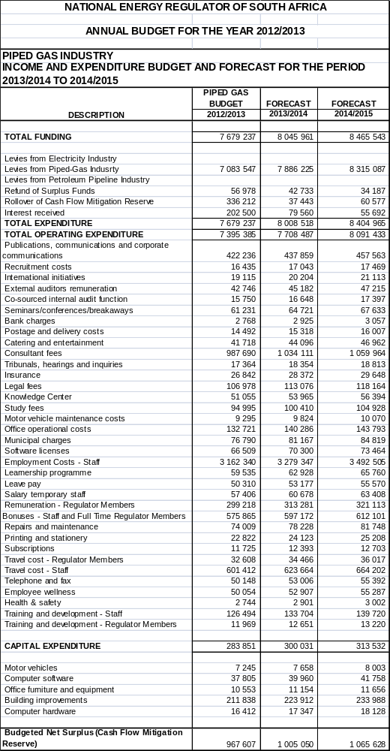

Piped-Gas Industry Regulation

Appendix H6: Piped-Gas Industry Regulation Programme 5: Setting of Rules, guidelines and codes for the regulation of the piped-gas industry Budget
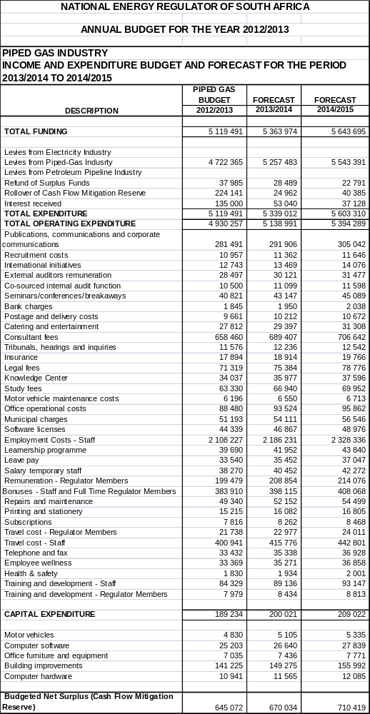

Piped-Gas Industry Regulation

Appendix H7: Piped-Gas Industry Regulation Programme 6: Establishing NERSA as an efficient and effective regulator Budget
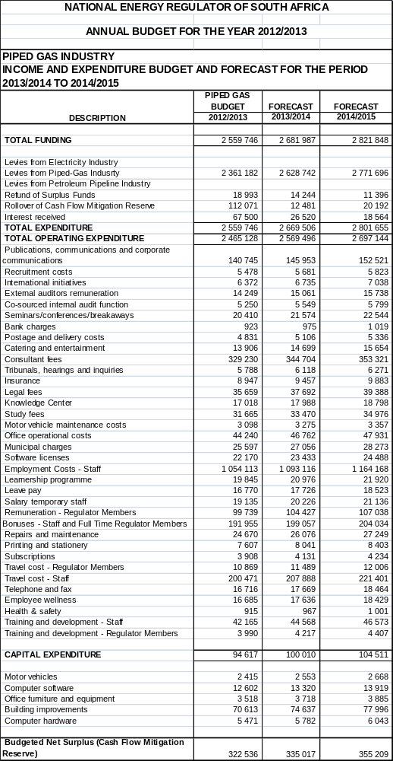

Piped-Gas Industry Regulation

Appendix H8: Funding for the regulation of the piped-gas industry
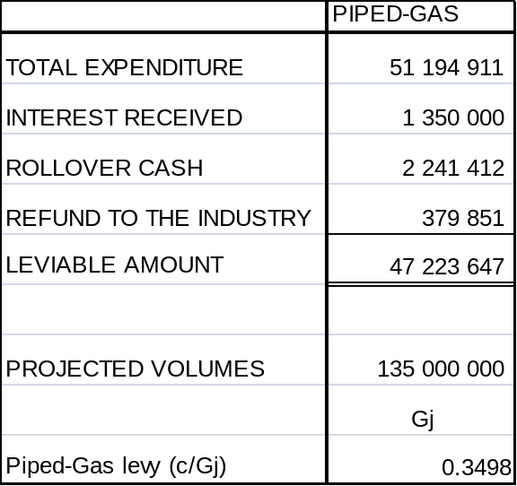

Petroleum Pipelines Industry Regulation

Appendix I1: Consolidated Petroleum Pipelines Industry Regulation Budget

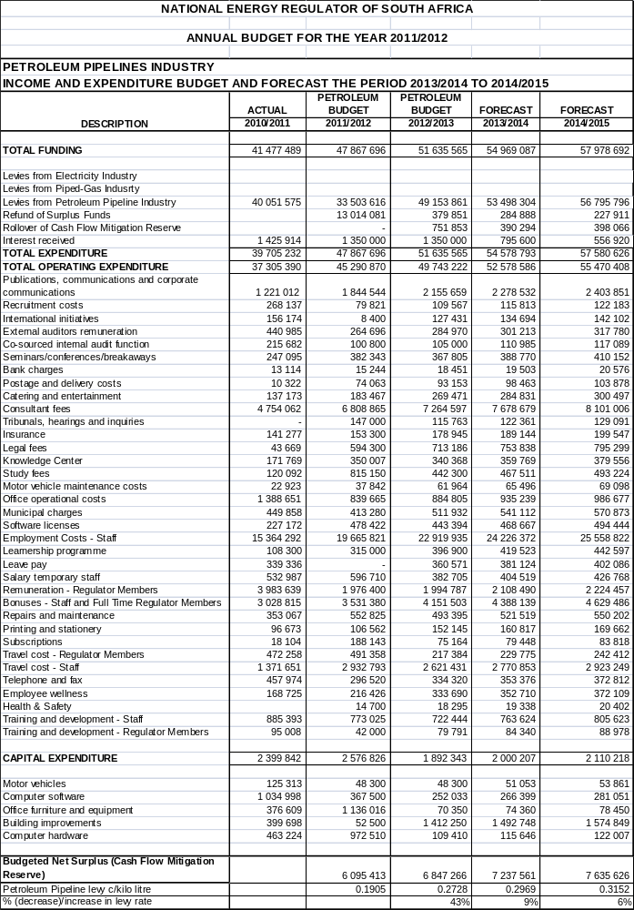

Petroleum Pipelines Industry Regulation

Appendix I2: Petroleum Pipelines Industry Regulation Programme 1: Setting and/or approval of prices and tariffs Budget
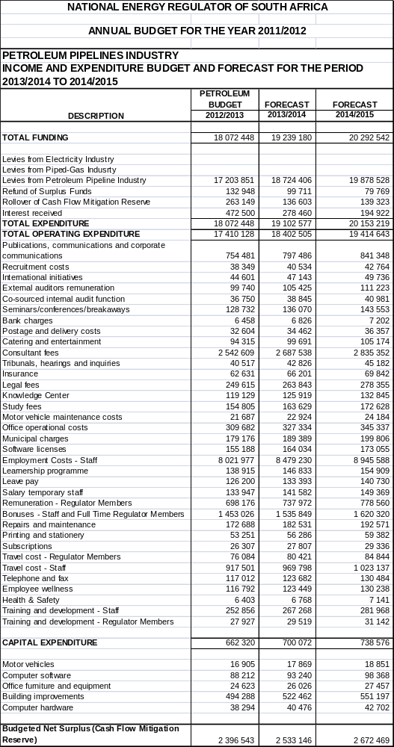

Petroleum Pipelines Industry Regulation

Appendix I3: Petroleum Pipelines Industry Regulation Programme 2: Licensing and Registration Budget

Petroleum Pipelines Industry Regulation

Appendix I4: Petroleum Pipelines Industry Regulation Programme 3: Compliance monitoring and enforcement Budget
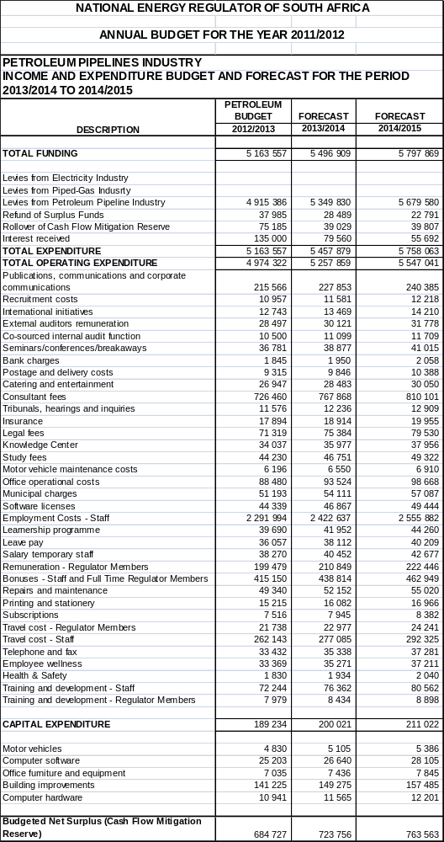

Petroleum Pipelines Industry Regulation

Appendix I5: Petroleum Pipelines Industry Regulation Programme 5: Setting of Rules, guidelines and codes for the regulation of the petroleum pipelines industry Budget

Petroleum Pipelines Industry Regulation

Appendix I6: Petroleum Pipelines Industry Regulation Programme 6: Establishing NERSA as an efficient and effective regulator Budget

Petroleum Pipelines Industry Regulation

Appendix I7: Funding for the regulation of the petroleum pipelines industry



