

SOUTH AFRICA

BRIEFING TO THE PORTFOLIO COMMITTEE ON CORRECTIONAL SERVICES

AUDIT OUTCOMES 2010/11

DEPARTMENT OF CORRECTIONAL SERVICES

11 OCTOBER 2011



CONTENTS

PART 1

1 Introduction 3

2 Background 3

3 Areas of Concern 6

4 Audit Report History 8

PART 2

5 Reported items 9

PART 1

1. Introduction
The purpose of this briefing note is to provide an insight by the Auditor-General into the issues resulting in the qualified audit opinion on the financial statements of the Department of Correctional Services for the 2010/11 financial year.

Our overall conclusion leads us to believe that in general terms the department has reached a level of maturity in terms of financial management which requires it to focus on improving the current systems of internal control, especially as far as assets management is concerned and also on the implementation of adequate financial reporting systems as well as adequate implementation of policies and procedures.

2. Background

2.1 Mission
The mission of the department is to contribute to maintaining and protecting a just, peaceful and safe society, by enforcing decisions and sentences of courts in the manner prescribed in legislation, by detaining inmates in safe custody while ensuring their human dignity and by promoting the rehabilitation, social responsibility and human development of all offenders.

The activities of the department are organised under the following seven programmes of which the key outputs can be found in the annual report 2010/2011:
PROGRAMME: PAGE No.:
- Programme A : Administration page 25 - 46
- Programme B : Security page 47 - 49
- Programme C : Corrections page 50 - 55
- Programme D : Care page 56 - 62
- Programme E : Development page 63 - 69
- Programme 6 : Social re-integration page 70 - 76
- Programme 7 : Facilities page 77 - 79
  - Accounting Basis

The department is required to account on the Modified Cash Basis of Accounting and must prepare its financial statements in terms of the National Treasury Template for National and Provincial Departments.

The department utilises the following accounting systems i.e. BAS; PERSAL and LOGIS to record its transactions and activities during the financial year.

  - Departmental Budget

The department has been tasked with a budget of R15,427,465,000 during the year under review. The following table sets out the funding of the programmes in relation to the total appropriated funds for the department:

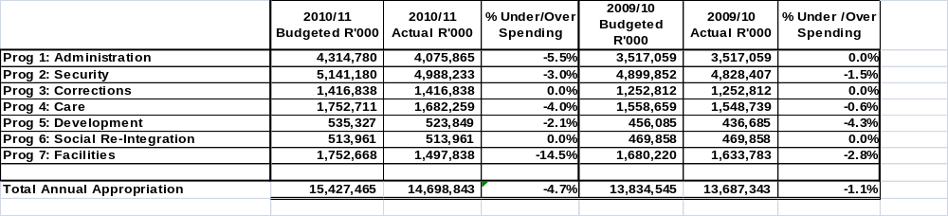

  - Staff Establishment

    - Staff Establishment per programme

As is evident from the tables below, the department experiences vacancy levels in excess of 10% in the majority of the programmes and acknowledges that this is a major impediment to the acceleration of service delivery and economic growth.

The table below depicts the personnel numbers and vacancy rates:

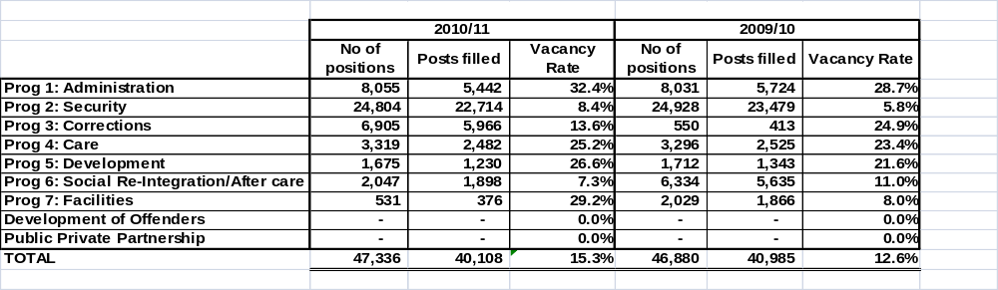

    - Staff Establishment per level

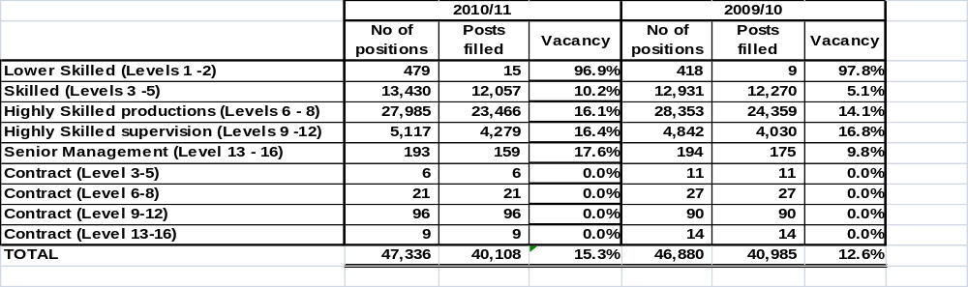

- Areas of Concern

The internal control deficiencies that resulted in the modification of the audit opinion expressed on the annual financial statements of the department can be categorised into the following areas:

3.1 Leadership

- Oversight responsibility regarding financial and performance reporting and compliance as well as related internal controls was not fully exercised.
- Effective human resource management was not implemented to ensure that adequate and sufficiently skilled resources were in place, especially as far as asset management was concerned.
- The development and implementation of action plans to address internal control deficiencies were not effectively monitored.
- An effective IT governance framework was not established to support and enable the business, deliver value and improve performance.

3.2 Financial and performance management

- The financial statements and other information to be included in the annual report were not sufficiently reviewed for completeness and accuracy prior to submission for auditing.
- Requested information was not always made available and supplied without any significant delay.
- Regular, accurate and complete financial and performance reports, which were supported and evidenced by reliable information, were not always prepared.
- There was a lack of proper record keeping in a timely manner to ensure that complete, relevant and accurate information was accessible and available to support financial and performance reporting.
- The regular review and monitoring of compliance with applicable laws and regulations were not always in place.
3.3 Governance
- Controls were not carefully selected and appropriately developed to mitigate risks over financial and performance reporting. Ongoing monitoring and supervision were not always undertaken to enable an assessment of the effectiveness of internal control over financial and performance reporting.
- Actions were not always taken to address risks relating to the achievement of complete and accurate financial and performance reporting.

  - Other Factors
- Capacity or people related issues (high vacancy levels and lack of relevant skills)
- Vacancy levels in critical occupations (table 4.3.1, page 201) , e.g. nurses (26%),
- Vacancy levels in financial and related professionals posts (56.4%),
- Vacancy levels in social work and related professionals(38.1%),
- Vacancy levels Psychologists and vocational counsellors(51.3%).

  - System related matters (inadequate financial reporting systems and inadequate business processes)
- LOGIS system could not ensure that assets movements between departmental stores do not cause duplications in additions and disposals of assets.
- Lack of independent system reviews by management caused shortcomings in the internal controls.

4. Audit Report History

A qualified audit report was issued for 2010/11:

Legend:

Q = Qualification
E = Emphasis of matter
MR = Matters were reported on in the management report, but not included in the final audit report

Report paragraph | 10/11 | 09/10 | 08/09 | 07/08 | 06/07
Asset management | Q | Q | Q | Q | Q
Receivables | MR | MR | MR | MR | Q
Medical aid expenditure | MR | MR | MR | MR | Q

PART 2

5. Reporting items

5.1 Current year’s Qualification – Movable tangible capital assets

Additions and disposals of movable tangible capital assets
In terms of Chapter 9 of the Departmental Reporting Framework guide non-cash additions represent the fair value of all assets received in kind or donated (non-cash items) from sources outside government during the 2010-11 financial year, and items transferred from another government department without payment. Furthermore, this guide states that the disposals indicate the cost amount as reflected in the asset register for all assets transferred to another government department or donated to another entity outside government. Included in disclosure notes 30.2 and 30.3 to the financial statements, non-cash additions stated at R306.9 million and disposals stated at R290.5 million, are materially overstated by internal transfers of movable tangible capital assets between departmental stores. This is the result of the accounting system (Logis) used by the department being unable to account separately for internal transfers.

5.2 Emphasis of matter

Unauthorised expenditure

As disclosed in note 9 to the financial statements, unauthorised expenditure of R483 million was incurred by the department as a result of implementing Public Service Co-ordinating Bargaining Council (PSCBC) Resolution No. 1 of 2007 on the improvement in salaries and other conditions of service for the 2007-08 to 2010-11 financial years. At the date of this report, this expenditure was still awaiting authorisation by Parliament.

Material losses

As disclosed in note 6.1 to the financial statements, the department incurred material losses of R3 387 000. This was mainly as a result of significant losses in state vehicles amounting to R2 922 000, claims amounting to R218 000 as well as from other sources amounting to R247 000.

Material underspending of the budget
As disclosed in the appropriation statement, the department materially underspent its total budget (vote). As at 31 March 2011, the underspending amounted to R728 622 000. This underspending was mainly due to the following:
- Compensation of employees: Savings as a result of lower than anticipated expenditure due to appointments that did not materialise before the financial year-end as well as vacancies resulting from natural attrition.

- Goods and services: The net underspending was mainly due to the late finalisation of the State Information Technology Agency (SITA) service level agreements for information technology projects for the financial year, which ultimately resulted in the delayed finalisation of payments.

- Buildings and other fixed structures: The net underspending was mainly due to lower than anticipated expenditure that arose from the slow progress and, as reported by the Department, poor workmanship by Department of Public Works (DPW) contractors, delays in DPW tender processes and appointment of contractors as well as a delay in the approval of a site valuation.

5.3 Non compliance with applicable legislations

Strategic planning

The accounting officer did not ensure that the institution had and maintained effective, efficient and transparent systems of financial and risk management and internal control, as required by section 38(1)(a) of the PFMA. Departmental systems to collate and report performance information were not adequate.

Expenditure management
- In certain cases expenditure was incurred without the approval of a delegated official as per the requirements of section 44 of the PFMA and Treasury Regulations (TR) 8.2.1 and 8.2.2.
- Payments due to creditors were not always settled within 30 days from receipt of an invoice as per the requirements of section 38(1)(f) of the PFMA and TR 8.2.3.
Procurement and contracts
- In some cases awards were made to suppliers who did not declare their employment by the department, their connection with a person employed by the department or their relationship with persons involved in the evaluation and/or adjudication of the bids, as per the requirements of Practice Note 7 of 2009-10.
- Some of the department’s employees performed remunerative work outside their employment in the department without written permission from the relevant authority, as per the requirements of section 30 of the Public Service Act of South Africa, 1994 (Act No. 103 of 1994).
- The prospective supplier list for procuring goods and services through quotations was not updated at least quarterly to include new suppliers that qualify for listing and prospective suppliers were not invited to apply for such listing at least once a year, as per the requirements of National Treasury Practice Note 8 of 2007-08.
  - Performance Information

Non compliance with regulatory requirements

- Adequate explanations for major variances between the planned and the actual reported targets for the corrections, security and social reintegration programmes were not provided, as required by the National Treasury guidelines.
- There was no link between indicators and targets in the strategic plan.
- For the selected programmes (corrections, security and social reintegration), a large portion of the planned and reported targets were not:
- specific in clearly identifying the nature and the required level of performance (24%);
- measurable in identifying the required performance (30%); and
- time bound in specifying the time period or deadline for delivery (100%).

  - Governance Issues

    - Audit committee
The appointment, functions and composition of the Audit Committee is in terms of Section 77 of the Public Finance Management Act, 1999 (Act No 1 of 1999) (PFMA), as amended.
The committee met at least five times in a year as required by the PFMA. The audit committee report (page 100-101 of the annual report) refers to their compliance with their audit committee charter and concluded that, based on the various reports of Internal Auditors, the Audit report on the Annual financial Statements and the management report of the Auditor- General South Africa, the existing control environment requires improvement in order to provide a reasonable assurance that the organisation’s goals and objectives are being achieved.

    - Internal Audit
An internal audit function is established in accordance with Section 38 (1)(a)(ii) of the PFMA, as amended. In our opinion the function is under-resourced and therefore cannot operate optimally given its current resources and budget, in order to address the all the risks pertinent to the department in its audit, especially at the regional level.

5.6 Other Important Information

Investigations
According to the Departmental Investigation Unit (DIU), investigations on the following cases that relate to fraud and theft were still ongoing at the reporting date:
- Fraudulent payments on Persal by utilising other officials’ user names amounting to R1 843 953.
- Theft of state money for purchasing seeds amounting to R2 800 000 at agricultural section.
- Different cases on procurement irregularities, including failing to declare business with the department and non-compliance with the procurement directives.
- Subsistence and travelling (S&T) fraud, including inflated kilometres travelled and fraudulent S&T claims.
- Cases of irregular as well as fruitless and wasteful expenditure.

Investigations completed during the financial year
According to the Departmental Investigation Unit (DIU), investigations on the following cases that relates to fraud and irregularities were completed during the year under review:
- Fraudulent payment to own account amounting to R500 000.
- Different cases of procurement irregularities, including failing to declare business with the department, colluding with suppliers tendering to do business with the department, and non-compliance with the procurement directives.
- Subsistence and travelling (S&T) fraud, including inflated kilometres travelled and fraudulent S&T claims.
Performance audits
A performance audit was conducted during the year under review on the department’s use of consultants. The management report was issued in July 2010 for management comments. However, at the date of the audit report no management comments had been received.

