ANNEXURE D

PAIA AMENDMENTS: POWERS, FUNCTIONS AND DUTIES OF THE REGULATOR IN TERMS OF PAIA

1. Current proposals in the PPI Bill in respect of the powers and duties of the Information Regulator in terms of PAIA

1.1 The PPI Bill provides as follows:
a) Clause 35(c) provides for the establishment of a juristic person to be known as the Information Regulator which must perform its functions and exercise its powers in accordance with the PPI Bill and the PAIA.
b) Clauses 36(c), 37(1), 38(1)(a), 38(5), 41(1), 42, 43(1)(g)(ii), 43(1)(g)(iv) and 43(5) furthermore, provide for various aspects of the way in which these functions and responsibilities of the Regulator in terms of PAIA should be executed.
c) Of these, clauses 43(1)(g)(iv) and 43(5) are of particular importance:
i) Clause 43(1)(g)(iv) of the PPI Bill provides the Regulator with the power to exercise the powers conferred upon the Regulator by the PPI Bill in matters relating to access to information as provided in PAIA.
ii) Clause 43 (5) provides that the powers and duties of the Regulator in terms of the Promotion of Access to Information Act are set out in Part 5 of that Act.

1.2 The proposed consequential amendments of PAIA in the Schedule to the PPI Bill, as introduced, provide for –
  - the substitution of the words ‘Human Rights Commission’ for ‘Information (Protection) Regulator’ in Part 5 of PAIA; and
  - the removal of the provisions in PAIA that allow ‘personal requesters’ access to their personal information, and the insertion of these provisions in the PPI Bill.

1.3 The effect of these amendments is to –
- provide the Regulator with the powers currently exercised by the Human Rights Commission in terms of Part 5 of PAIA; and
- make all the powers and duties of the Regulator in terms of the PPI Bill applicable to requests for access to personal information by a data subject in terms of clause 22 of the Bill.

1.4 The powers, duties and functions of the Regulator acquired in terms of Part 5 of PAIA, among others, specifically include education and training, monitoring and supervision, consultation and mediation, research and reporting to Parliament, development of legislation and assistance to those wishing to exercise a right contemplated in the Act. Most of these powers are also found in clause 43 of the PPI Bill. However, Part 5 of PAIA does not contain a dispute resolution procedure comparable to the procedure referred to in clause 43 of the PPI Bill.

1.5 As stated above, the object of the current proposed consequential amendments to PAIA is to ensure that, as a first step, all the existing responsibilities of the Human Rights Commission in terms of PAIA would be assigned to the Regulator.

1.6 It has, however, always been the understanding that the Regulator would, in due course, be assigned comprehensive powers in terms of both PAIA and PPI (see discussion of the SALRC’s recommendations in par 4.7 below). The ambit of the research that led to the development of the PPI Bill did not, however, include an in-depth review of PAIA’s dispute resolution procedures. It was envisaged that the Regulator, in his capacity as champion of PAIA, would, in due course, exercise its powers under section 83(3)(a) of PAIA to conduct a full review of PAIA. At that stage recommendations, providing for the specific requirements and qualifications as to the manner in which these powers, referred to only as a general principle in clause 43(1)(g)(iv) of the PPI Bill, would be implemented. This position would be in accordance with the example in New Zealand where the first privacy Bill made provision for the establishment of a Privacy Commissioner, but provided for this Commissioner, as a first task, to investigate the powers and duties it had to exercise and to oversee the drafting of the necessary legislation in this regard.

1.7 Section 83(3)(a) of PAIA reads as follows:

(3) The Human Rights Commission (Regulator) may –
(a) make recommendations for –
(i) the development, improvement, modernisation, reform or amendment of this Act or other legislation or common law having a bearing on access to information held by public and private bodies, respectively; and
(ii) ………

2. Submissions to Parliament

2.1 The point has been made in various written and oral submissions to Parliament that PAIA currently lacks a method for resolving disputes about access to information other than application to court, a remedy that is out of reach of the majority of information requesters. It has been submitted that Parliament has to seize the current opportunity to ensure that the Regulator is granted easily enforceable powers of dispute resolution over disputes in respect of the PAIA since this would greatly increase access to justice for individuals and would help to promote the purpose of PAIA – greater transparency in both public and private bodies.

2.2 A concern has been raised, furthermore, that transferring the powers of the SAHRC to the Regulator would actually weaken the protection of access, especially since the Regulator does not have enough enforcement powers and the Regulator would, furthermore, be consumed by PPI demands from corporate giants, the medical industry, etc.

3. Powers of dispute resolution of the Regulator in terms of PAIA: Options for discussion

3.1 The current position regarding the process to deal with disputes arising from requests to access information in terms of PAIA is set out below. See Schedule D1 (public and private bodies).

3.2 Different options have been identified, should a decision be taken to grant enforceable powers of dispute resolution over disputes in respect of PAIA, to the Regulator. The feasibility of the options should be evaluated against, among others, the need to promote transparency, the need to introduce a dispute resolution process that is accessible, not time consuming and that is fairly uncomplicated.

3.3 Two additional issues should also be briefly highlighted:

a) Firstly, it should be recognised that the nature of disputes under PAIA differ from those that may possibly arise from the application of the PPI Bill. The majority of PAIA disputes arise from requests for access to records. The question whether access to a record should have been granted or not lies at the core of dispute resolution in terms of PAIA which requires a finding that, based on the grounds for refusal stipulated in PAIA and the content of the record in question, access to a that record should have been granted or not. PPI disputes, among others, entail complaints relating to the interference with personal information by responsible parties. Dispute resolution will be based on whether personal information was processed in accordance with the conditions for lawful processing or not.

b) Secondly, internal appeals are not applicable in respect of private bodies because the head of the private body, who is the person that considers the request for access to a record can not, at the same time, be the relevant authority who is tasked with considering the internal appeal. Furthermore, the wide ambit of the definition of “private body” (which may also include a natural person), presents a stumbling block in creating an internal appeal system which is similar to internal appeals in respect of certain public bodies.

3.4 There are two options for the possible amendment of PAIA. The first option would be to mirror the powers of complaints handling of the Regulator in terms of the PPI Bill in PAIA. The second would be to make provision for a new procedure of complaints handling of the Regulator in terms of PAIA.

3.5 Once a decision has been taken regarding which option to choose a further determination would have to be made as to which of the following variations of the option should apply:
a) Should internal appeals be retained for public bodies? The complaints handling procedure would then be in addition to the internal appeals;
b) Should the internal appeals structure for public bodies be replaced by the compulsory complaint handling procedures of the Regulator, which will then be applicable to both public and private bodies?
c) Should the internal appeals system be retained, but operate alongside the complaints handling procedure, with both systems on a voluntary basis. A complainant would therefore be able to choose to make use of either the internal appeals system or the complaints handling procedure of the Regulator or may approach the courts directly.

Option 1: The mirroring of the powers of complaints handling of the Regulator in terms of PPI Bill in PAIA. See Schedule D2 (flowchart) and D3 (draft amendments).

3.6 The proposed amendments aim to make those powers that the Regulator will exercise in respect of disputes arising under the PPI Bill applicable to the resolution of disputes in terms of PAIA. In so far as the international position is concerned it should be noted that the enforcement procedures in the UK Data Privacy Act, 1998 are, in principle, the same as the ones found in the UK Freedom of Information Act, 2000. However, the new powers of the Information Commissioner to issue fines are reserved for the Privacy Act. See Schedule D4 for a summary of the position in the United Kingdom.

Option 2: Providing new powers of complaints handling of the Regulator in terms of PAIA
See Schedule D5 (flowchart) and D6 (draft amendment)

3.7 The nature of PAIA and PPI disputes differs and it may, therefore, be unnecessary to provide the Regulator with powers that mirror the powers that it will exercise in terms of the PPI Bill. In terms of this approach the current powers and functions of the relevant authority with regard to internal appeals will now be exercised by the Regulator (only, or, as well).

3.8 Once a decision has been made regarding the option to be used, the following variations need to be considered:

Variation 1: Retention of internal appeals
See Schedule D7 (flowchart)

3.9 The proposed amendments will aim to─

(a) retain compulsory internal appeals to relevant authorities of certain public bodies (i.e. any department of state or administration in the national or provincial sphere of government or any municipality in the local sphere of government) and to include a procedure in terms of which an aggrieved party should approach the Information Regulator before he or she is allowed to approach the court for appropriate relief; and

(b) require that aggrieved parties who are not subject to the compulsory internal appeal process, but who have direct access to the court in terms of section 78 of PAIA should also approach the Information Regulator before they are allowed to approach the court for appropriate relief.

3.10 Concerns raised are as follows:
(a) Inserting an application procedure to the Regulator between the internal appeal procedure and applications to court extends the process that must be followed by certain requesters to have their disputes resolved. Providing the Regulator with extensive powers may bring about an unnecessary delay in resolving disputes arising from PAIA, especially, in view thereof that requesters who are subject to the compulsory internal appeal process will have to overcome an additional hurdle with the view to having their disputes resolved;

(b) Disputes in terms of PPI are to be resolved by High Courts while disputes arising from PAIA can be resolved by a Magistrates’ Court;

(c) The proposed amendments to the PPI Bill aim, among others, to provide the Regulator with power to make regulations. The question is raised whether the Regulator should be given the same power in respect of PAIA regulations;

(d) The provisions of section 76(3) may require consequential amendment of PPI Bill to ensure that appeal fees that are payable must accrue to the Regulator.

Variation 2: Replacing internal appeals with compulsory appeals (public and private bodies) directly to Regulator
See Schedule D7 (flowchart)

3.11 The proposed amendments aim to─

(a) replace compulsory internal appeals to relevant authorities of certain public bodies (i.e. any department of state or administration in the national or provincial sphere of government or any municipality in the local sphere of government) with compulsory appeals directly to Information Regulator; and

(b) require that aggrieved parties who are not subject to the compulsory internal appeal process, but who have direct access to the court in terms of section 78 of PAIA should also be required to appeal to the Regulator before they are allowed to approach the court for appropriate relief.

3.12 Concerns raised are as follows:

(a) Replacing national, provincial and local relevant authorities with one entity (the Regulator) may impact negatively on access;

(b) Disputes in terms of PPI are to be resolved by High Courts while disputes arising from PAIA can be resolved by a Magistrate’s Court;

(c) The proposed amendments to the PPI Bill aim, among others, to provide the Regulator with the power to make regulations. The question is raised whether the Regulator should be given the same power in respect of PAIA regulations;

(d) The provisions of section 76(3) may require consequential amendment of the PPI Bill to ensure that appeal fees that are payable must accrue to the Regulator.

Variation 3: Voluntary system

See Schedule D7 (flowchart)

3.13 The last variation may be to retain the internal appeals system, but operating alongside the complaints handling procedure, with both systems on a voluntary basis. A complainant would, therefore, be able to choose to make use of either the internal appeals system or the complaints handling procedure of the Regulator or may approach the courts directly.

3.14 The concern may be raised that a voluntary system may lead to forum shopping. However, it will reduce chances of undue delay and address the problem identified above regarding access.

Internal appeals

3.15 In order to make a decision regarding the variation to be chosen it is necessary to take a closer look at internal appeals.

3.16 Sections 74 to 77 of PAIA deal with internal appeals by requesters or third parties who are aggrieved by the decisions of information officers of certain public bodies (ie any department of state or administration in the national or provincial sphere of government or any municipality in the local sphere of government).

3.17 Sections 78 to 82 deal with applications by requesters or third parties who are aggrieved by decisions of information officers, relevant authorities or heads of private bodies. They are required to approach a court directly for appropriate relief.

3.18 Internal appeals are compulsory procedures in terms of which requesters or third parties may take decisions of information officers in public bodies on appeal to relevant authorities. In the national sphere of government the Minister responsible for the public body concerned is the relevant authority.

3.19 Internal appeals in terms of PAIA can be compared to the complaints that may be lodged, in terms of the PPI Bill, with an independent adjudicator (public and private bodies) where a code of conduct exists. However, the PPI procedure is not compulsory in nature.

3.20 In theory, internal appeals present a speedy and relatively inexpensive and uncomplicated procedure in terms of which an aggrieved party can request that the decision by an information officer can be reconsidered. A requester or third party may only approach a court for appropriate relief after the internal appeal procedure has been exhausted. The procedure can, therefore, be seen as a sifting mechanism which reduces the number of cases that eventually end up in court. It also presents the further advantage that it effectively precludes an information officer from approaching a court for appropriate relief if such information officer does not agree with the decision of his or her relevant authority.

3.21 In practice it has, however, been found that private body requesters, who are not subject to a compulsory internal appeal procedure, are able to settle their disputes in court quicker than public body requesters.

3.22 Internationally, many access to information statutes require dissatisfied requesters to complain first to the body making the original decision. See table below for an exposition of the procedures followed in 5 different jurisdictions.

 |  | Independent  Review Body |  | Judicial  Review Body
Jurisdiction | Internal  Review | Ombudsman | Information  Commissioner | Tribunal | Courts
Australia | # | # |  | #
Canada | # | # |  |  | #
Ireland | # |  | #
New Zealand |  | # |  |  | #
United States of America | # |  |  |  | #
United Kingdom | # |  | # | # | #

3.23 It may be difficult to justify the replacement of internal appeals by way of consequential amendments. It would seem as though it is rather the compulsory nature of the internal appeal procedure that will have to be taken into consideration when a decision is made with regard to the proposed role of the Regulator in respect of the settlement of disputes arising from requests for access to records in terms of PAIA.

4. Technical concerns raised

4.1 In discussing the possible options above, two concerns need to be addressed:

a) The question has been posed whether the newly proposed consequential amendments to PAIA have been consulted properly; and
b) Secondly, whether the newly proposed amendments to PAIA would not amount to substantive amendments, in which case it could not be included in the consequential amendments set out in the Schedule to the Bill, but would have to be dealt with in separate amending legislation.

- Consultation

4.2 In the Constitutional Court cases of Doctors for Life International v Speaker of the National Assembly ao 2006(6) SA 416 (CC) and Matatiele Municipality ao v President of the Republic of South Africa ao 2007(1) BCLR 47(CC) the following points, amongst others, were made:
    - Section 59 of the Constitution, inter alia, prescribes that the National Assembly must facilitate public involvement in the legislative and other processes of the Assembly and its committees;
    - Facilitation of public involvement in the legislative process means taking steps to ensure that the public participate in the legislative process;
    - Parliament must be given a significant measure of discretion in determining how best to fulfill the duty to facilitate public involvement;
    - The standard of reasonableness must be used as a yardstick to test the conduct of Parliament;
    - Reasonableness is an objective standard which is sensitive to the facts and circumstances of each case. The right to political participation can be realised in many ways;
    - Ultimately, Parliament must determine in each case what methods of facilitating public participation would be appropriate; and
    - The objective in involving the public in the law-making process is to ensure that the legislators are aware of the concerns of the public. If legislators are aware of those concerns, this will promote the legitimacy, and thus the acceptance, of the legislation.

4.3 The Justice Portfolio Committee on its own, and through its Technical Committee, has held public hearings, received oral and written submissions, invited interested parties to appear before it to give evidence, and accepted representations from interested persons and institutions through open access at all times to committee meetings and deliberations. The current discussion has, in fact, been necessitated by this process.

4.4 In terms of the Constitutional Court cases the Portfolio Committee, in exercising its discretion regarding its duty to facilitate public involvement, would also be able to take into account the extensive public consultation process by the SALRC that took place over a period of seven years and also included interaction with the SAHRC on various levels.

4.5 The recommendations by the SALRC in its Report on Privacy and Data Protection (2009) were, amongst others, that the Information Protection Regulator should have supervisory powers in respect of both the PPI Bill and PAIA (see par 4.2.222 and para 7.2.135—7.2.157 of the Report).

4.6. The SALRC’s detailed recommendation is that -
A statutory regulatory authority should, therefore -
- Administer both the access to information as well as privacy and information protection legislation;
- Be responsible for both promotion, publicity, education, advice, assistance, monitoring, and reporting to Parliament and for enforcement of rights and dispute-resolution;
- Be specifically empowered to resolve disputes under provisions of both PAIA and privacy legislation;
- Be accessible as a dispute-resolution mechanism intermediate between internal appeal against decisions of public or private bodies and recourse to the courts; and
- Be empowered to make binding orders to resolve disputes.

(See para 7.2.191(e) of the Report).

4.7 In its submission to the Review of Chapter 9 and Associated Institutions Committee (Kader Asmal Committee) the SAHRC (as it then was) specifically referred to the consultations between the two bodies and indicated its support for the recommendations of the SALRC. It stated as follows:
It is recommended that the legislation for the establishment of the office of the information commissioner will be effected by means of amendments to PAIA and its inclusion in the current draft Bill on the protection of personal information (“POPIA” or “the Bill”)…………These amendments of PAIA and proposals for POPIA (as per draft Bill on the Protection of Personal Information compiled by the South African Law Reform Commission) are intended to facilitate the establishment and operation of the office of the information commissioner.

The fact that the newly appointed SAHRC was granted the opportunity to submit further, and as it turned out, different proposals to the Technical Committee is further testimony of the comprehensive nature of the consultation process.

(b) Should the proposed amendment of PAIA, resulting in the granting of specific powers of dispute resolution to the Regulator in terms of PAIA, be regarded as consequential amendments

4.8 Substantive amendments are the main provisions that establish the substantive rules.

4.9 Consequential amendments are amendments to existing legislation that are necessitated by the main substantive provisions in the amending or newly formulated legislation in order to ensure coherence or to avoid conflicts or discrepancies between two pieces of legislation.

4.10 Consequential amendments should be as a result of the main substantive amendments and not be a radical and additional provision which makes a major legal change.

4.11 The question in par (b) above has been discussed informally with the State Law Advisers who provided invaluable information and insight which made developed argument possible.

4.12 In considering the question whether amendments to PAIA, making provision for the creation of a dispute resolution procedure (for matters dealt with in PAIA) that will to a certain extent mirror the dispute resolution process set out in the PPI Bill, could, in general, be seen as consequential amendments and, more specifically, whether they would give effect to clause 43(1)(g)(iv) of the PPI Bill, the State Law Advisers highlighted the following points:

a) To provide the Information Regulator with such powers would amount to a major legislative change to the PAIA (a radical and additional provision). It would not be consequential upon any of the provisions of the PPI Bill. It could, therefore, be possible to argue that it will not be possible to include same in a Schedule to the Bill.

b) Clause 43(1)(iv)(g) does not change this position since the PPI Bill does not clarify what the interface is between the PAIA and the Bill. The internal appeals processes in the PAIA differ completely from the complaints driven dispute resolution process in the PPI Bill. Substantive amendments to the PAIA would be necessary to clarify the change to the approach envisaged in the provisions of the Bill and clarity as to where the Bill’s dispute resolution fits in within the PAIA processes.

c) Clause 43(1)(g)(iv) would, in the absence of a further substantive amendment to PAIA, find application only with regard to Part 5 of PAIA which provides for the functions of the SAHRC.

4.13 During the discussions two cases, the Court of Appeal case of Inco Europe Ltd v First Choice Distribution [1999] 1 All ER 820, and the subsequent House of Lords case, Inco Europe Ltd v First Choice Distribution [2000] 2 All ER 109 (enclosed herewith as Schedules D8 and D9) were sited as authority. Both courts concluded that the removal through an amendment of the Supreme Court Act, 1981 of a right of appeal from a decision whether or not to stay litigation covered by an arbitration clause, would not be consequential upon anything contained in the amending Act, the Arbitration Act, 1996. It would be a radical and additional provision.

4.14 It is submitted that the facts in these two cases can be distinguished from the current situation under discussion.

4.15 The UK jurisdictions, referred to above, did not only consider the literal construction of the amended 1981 Act. The courts indicated that the amending Act, the Arbitration Act, 1996, is the operative provision which contains the expression of the parliamentary will and intention as to what changes in the law Parliament wishes to make. The statutory intention disclosed by the 1996 Act should, therefore, be determined. In order to do this, they considered the development of the status of arbitration clauses in the English law since the Arbitration Act,1950; examined the international obligations of the UK in this regard; interrogated the government reports that gave rise to the Act of 1996; and evaluated the statutory context of the amendment.

4.16 No motivation for the amendments could be found during this investigation. None of the reports and consultation papers contained any criticism of the existing right of appeal, no one suggested this right should be abolished or restricted. Nor was there any suggestion or indication that any concern had been expressed to the committee or the Departments on this matter, or regarding any of the other clauses in the Bill which as enacted contain no restrictions on appeals from court decisions. Accordingly, against this background, as a matter of construing the phrase ”consequential amendments”, the conclusion was that it would be impossible to regard the amendments as being consequential on anything contained in the 1996 Act. It would be a radical and additional provision.

4.17 Thornton at 132 confirms this approach followed. He states ……”the impact of proposed law on existing law (must) be investigated and the extent to which existing laws need to be repealed or altered, either to achieve the objects of the proposals or as a consequence of those objects, must be set out”.

4.18 A review of examples of consequential amendments in South African law also indicates that their detail varies and in some instances may be considered substantive in nature. The only qualification is that consequential amendments should be necessitated by the main substantive amendments. See for example the Constitution Consequential Amendments Act 201 of 1993.

4.19 Taking into consideration the principles as set out above in evaluating whether the proposed amendment to PAIA will qualify as a consequential amendment, the following will have to be determined:
a) Will the proposed amendment aim to give effect to the objects of the PPI Bill (will it be consequential to the substantive provisions of the PPI Bill); and
b) Will the envisaged amendment amount to a radical, major legislative change to the status quo.

4.20 Currently, clause 43 of the PPI Bill provides as follows:

43.(1) The powers and duties of the Regulator in terms of this Act are –
(g) in general to –
(i)….
(ii) exercise and perform such other functions, powers and duties as are conferred or imposed on the Regulator by or under this Act or any other legislation;
(iii)….
(iv) exercise the powers conferred upon the Regulator by this Act in matters relating to the access of information as provided by the Promotion of Access to Information Act.
(2)-(4)……..

- The powers and duties of the Regulator in terms of the Promotion of Access to Information Act are set out in Part 5 of that Act.

4.21 Clauses 43(1)(g)(ii), 43(5) and items 6 and 7 of the Schedule to the PPI Bill should be read together and clearly refer to the access to information duties of the Regulator to be provided for under PAIA.

4.22 Clause 43(1)(g)(iv), however, is not clear and may be subjected to two different interpretations. It may refer to the powers and duties of the Regulator in terms of the PPI Bill, in general, to -

a) exercise the powers conferred upon the Regulator by the PPI Bill in respect of the protection of personal information (therefore the powers mainly set out in clause 43), mutatis mutandis in matters (therefore disputes relating to access of information), provided for by the Promotion of Access to Information Act; or, alternatively,
b) exercise the powers conferred upon the Regulator by the PPI Bill in those matters relating to the access of information as referred to in the PPI Bill (therefore the powers provided for in clause 43(5)), in the manner as provided for by the Promotion of Access to Information Act.

4.23 Neither of the two interpretations is unrealistic, and both would require substantive amendments, of some sort, to PAIA in order to achieve the objects of the proposals of the PPI Bill or as a consequence of those objects. It may seem necessary to clarify Parliament’s intention with clause 43(1)(g)(iv). The Legislature would then be able to exercise its discretion to proceed with the proposed amendment of PAIA in order to ensure that PAIA is in line with the statutory framework to be introduced by the PPI Bill.

4.24 In exercising the discretion the Legislature could keep in mind that the interpretation reflected in par 4.22(a) is consistent with –

a) SALRC recommendations in its report, which has been the genesis for the PPI Bill;
b) Submissions by interested parties to Parliament;
c) Other provisions of the PPI Bill for example clause 35(c).
d) The fact that there is already a link between the Human Rights Commission Act and the PAIA to the extent that the SAHRC may exercise its powers regarding dispute resolution derived from its principal Act (“additional powers”) also in access to information matters. However, the provisions of the two pieces of legislation do not clarify how the SAHRC’s additional powers fit in within the PAIA process. The proposed amendment set out in par 4.22(a) will, therefore, not present a drastic and radical departure from the current position. Since there is also already uncertainty regarding the dispute resolution processes (SAHRC Act) and the internal appeal process (PAIA) in access to information disputes, the opportunity to clarify the interface between PPI and PAIA may also assist in resolving this problem.

5. Conclusion

5.1 The following two options have been identified to define the Regulator’s role as far as disputes arising from PAIA are concerned:

a) Mirroring of the complaints handling powers of the Regulator in terms of the PPI Bill in the PAIA; and
b) New procedure to make provision for the complaints handling powers of the Regulator in terms of PAIA.

5.2 In exercising a decision regarding the two abovementioned options the following variations of these options should be considered:
(a) The retention of the existing position in PAIA regarding internal appeals and the introduction of powers of complaints handling of the Regulator.
(b) Replacing internal appeals with the requirement that all aggrieved requesters or third parties should approach the Regulator first before they approach the court for appropriate relief.
(c) Providing parties with the choice to use the existing position in PAIA regarding internal appeals, or to approach the Regulator before approaching the court for appropriate relief, or to approach the court directly, if necessary.

5.3 All the options should be evaluated against the following factors –

a) Current proposals set out in the Bill makes provision for the Regulator, after it has been established, to conduct an extensive investigation into the PAIA enforcement process and then to make certain recommendations with regard to the amendment of that Act.

b) There seems to be a need to amend clause 43(1)(g)(iv) in order to more clearly determine its statutory intention.

c) It would seem as though proper consultation has taken place regarding the powers of complaints handling of the Regulator in terms of PAIA.

6. Final note: Protection of Information Bill

6.1 The Protection of Information Bill is currently being debated in Parliament. It may be important for the Technical Committee to take note of the proposed clause 28 in this Bill which reads as follows and provides, in essence, that the Bill is subject to the PAIA:

Request for classified information in terms of Promotion of Access to Information Act
28. (1) A request for access to a classified record that is made in terms of the Promotion of Access to Information Act must be dealt with in terms of that Act.
(2) A head of an organ of state considering a request for a record which contains classified information must consider the classification and may declassify such information.
(3) If the head of an organ of state decides to grant access to the requested record then he or she must declassify the classified information before releasing the information.
(4) If the refusal to grant access to a classified record is taken on appeal in terms of the Promotion of Access to Information Act, 2000, the relevant appeal authority must consider the classification and may declassify such information.

6.2 The appeals referred to are contained in clause 25 of the Bill that provides for an appeal to the Minister of the organ of State in question. The POI Bill is therefore in line with the PAIA. This means that the dispute resolution provisions of PAIA will be applicable to such a request for classified information if it is refused.

6.3 Should the internal appeals process be adjusted in terms of any of the options referred to above, it may have the effect that the Information Regulator will be “the relevant appeal authority” referred to in clause 28(4). If it is decided that the Regulator should not be the “relevant appeal authority” it would be necessary for the POI Bill (clause 28) to be amended accordingly.
Schedule D1
Promotion of Access to Information Act, 2000
Request for access: Public or Private body
Current position
Requester: requests access to general or personal information
s18 or s50

Information officer (IO): Public body
Head: Private body (HPB)

(No 3rd party involved)
3rd party involved

21 Days

30 Days
30 Days

Request for access granted
s25(2) or s56(2)
Notice to 3rd party
s47(2) or s71(2)
Request refused:
IO notifies requester s25(3)
HPB notifies requester s56(3)

21 Days
Matter settled
3rd party makes representations re refusal; or written consent iro disclosure
s48(1) or s72(1)

Decision by IO or HPB

Request granted: IO or HPB notifies requester and 3rd party s49(1) or s73(3)
Request refused: IO or HPB notifies requester
s49(1) or s73(3)
30 Days
30 Days

Internal Appeal Procedure
Requester aggrieved by IO decision
s74(1), 75(1)
3rd party aggrieved by IO decision
S74(2), 75(1)
Requester aggrieved by IO decision
S74(1), 75(1)

60 Days
60 Days

30 Days

Internal appeal
s75(1)

IO of public body
Submits internal appeal with reasons to relevant authority
S75(4)

10 Work Days

Relevant authority

30 Days
30 Days

Requester makes written representations
s76(8) & (9)
3rd Party makes written representations
s76(2) & (5)

21 Days
21 Days

Relevant authority
Confirm or substitute new decision of IO
s77(2)

30 Days

Requester or 3rd party aggrieved by decision on internal appeal
s77(5)
Requester or 3rd party aggrieved by decision of HPB
s78(2) or (3)

180 Days
180 Days

Applications to court
Requester or 3rd party applies for appropriate relief ito sect 82

Decision on application
Confirm, amend or set aside decision
Require action to be taken or to refrain from taking action
Grant interdict, interim/specific relief, declaratory order or compensation

Matter settled

Schedule D2
Variation 1: Option 1
Promotion of Access to Information Act, 2000
Request for access: Public or Private body
Regulator’s powers as in PPI Bill mirrored in PAIA

Requester or 3rd party aggrieved by decision on internal appeal

Requester or 3rd party aggrieved by decision of HPB

Complaint to Regulator
Within 60/180 days

Pre-investigation by Regulator
Advise complainant of intent to conduct investigation
Advise relevant authority to submit written response

Investigation by Regulator
Investigate alleged failure to comply with PAIA
Act as conciliator
Take such further action as is contemplated in cl79(a), (b) and (c) of PPI

Regulator to take no action
After investigating Regulator may decide to take no action
or require no further action iro complaint
Inform complainant

Settlement of complaint
If possible then Regulator may secure settlement between parties

Information notice

Enforcement notice
Confirming, amending or setting aside original decision
Requiring action to be taken or to refrain from taking action

Applications to court

Schedule D3

Variation 1: Option 1
“PART 4
APPEALS AGAINST DECISIONS AND COMPLAINTS TO REGULATOR(SS74-82)

“CHAPTER 1A
COMPLAINTS TO REGULATOR

Complaints
77A. (1) A requester or third party referred to in section 74 may only submit a complaint to the Regulator in terms of this section after that requester or third party has exhausted the internal appeal procedure against a decision of the information officer of a public body provided for in section 74.
(2) A requester–
(a) that has been unsuccessful in an internal appeal to the relevant authority of a public body;
(b) aggrieved by a decision of the relevant authority of a public body to disallow the late lodging of an internal appeal in terms of section 75(2);
(c) aggrieved by a decision of the information officer of a public body referred to in paragraph (b) of the definition of ’public body’ in section 1–
(i) to refuse a request for access; or
(ii) taken in terms of section 22, 26(1) or 29(3);or
(d) aggrieved by a decision of the head of a private body–
(i) to refuse a request for access; or
(ii) taken in terms of section 54, 57(1) or 60,
may, within 60/180 days of the decision, submit a complaint, alleging that the decision was not in compliance with this Act, to the Regulator in the prescribed manner and form for appropriate relief.
(3) A third party─
(a) that has been unsuccessful in an internal appeal to the relevant authority of a public body;
(b) aggrieved by a decision of the information officer of a public body referred to in paragraph (b) of the definition of ‘public body’ in section 1 to grant a request for access; or
(c) aggrieved by a decision of the head of a private body in relation to a request for access to a record of that body,
may within 60/180 days of the decision, submit a complaint, alleging that the decision was not in compliance with this Act, to the Regulator in the prescribed manner and form for appropriate relief.

Modes of complaints to Regulator
77B. (1) A complaint to the Regulator must be made in writing.
(2) The Regulator must give such reasonable assistance as is necessary in the circumstances to enable a person, who wishes to make a complaint to the Regulator, to put the complaint in writing.

Investigation by Regulator
77C. (1) The Regulator, after receipt of a complaint made in terms of section 77A, must –
(a) investigate the complaint in the prescribed manner;
(b) act, where appropriate, as conciliator in relation to such complaint; and
(c) take such further action as is contemplated by this Chapter.
(2) The Regulator must as soon as is reasonably practicable after receipt of a complaint, advise the complainant and the information officer, relevant authority or head of a private body, as the case may be, to whom the complaint relates of the course of action that the Regulator proposes to adopt under subsection (1).

Regulator may decide to take no action on complaint
77D. (1) The Regulator, after investigating a complaint received in terms of section 77A, may decide to take no action or, as the case may be, require no further action in respect of the complaint if, in the Regulator’s opinion—
(a) the complaint has not been submitted within the period referred to in section 77A(2) and there are no reasonable grounds to condone the late submission;
(b) the complaint is frivolous or vexatious or is not made in good faith; or
(c) it appears to the Regulator that, having regard to all the circumstances of the case, any further action is unnecessary or inappropriate.
(2) In any case where the Regulator decides to take no action, or no further action, on a complaint, the Regulator must inform the complainant of that decision and the reasons for it.

Pre-investigation proceedings of Regulator
77E. Before proceeding to investigate any matter in terms of this Chapter, the Regulator must, in the prescribed manner, inform—
(a) the complainant of the Regulator’s intention to conduct the investigation; and
(b) the relevant authority, the information officer or the head of the private body, as the case may be, to whom the complaint relates of the—
(i) details of the complaint; and
(ii) right of the relevant authority, the information officer or the head of the private body to submit to the Regulator, within a reasonable period, a written response in relation to the complaint.

Settlement of complaints
77F. If it appears from a complaint, or any written response made in relation to a complaint under section 77E(b)(ii), that it may be possible to secure a settlement between the parties concerned, the Regulator may, without investigating the complaint or, as the case may be, investigating the complaint further, in the prescribed manner, use its best endeavours to secure such a settlement.

Investigation proceedings of Regulator
77G. (1) For the purposes of the investigation of a complaint the Regulator has powers similar to those of the High Court in terms of section 80 relating to the disclosure of records to it and non-disclosure of records by it.
(2) Section 79(a), (b) and (c) of the Protection of Personal Information Act apply to the investigation of complaints in terms of this Chapter.

Assessment
77H. (1) The Regulator, on its own initiative, or at the request by or on behalf of an information officer or head of a private body or any other person must make an assessment in the manner prescribed of whether a public or private body generally complies with the provisions of this Act.
(2) The Regulator must make the assessment if it appears to be appropriate, unless, where the assessment is made on request, the Regulator has not been supplied with such information as it may reasonably require in order to—
(a) satisfy itself as to the identity of the person making the request; and
(b) enable it to identify the action in question.
(3) The matters to which the Regulator may have regard in determining whether it is appropriate to make an assessment include—
(a) the extent to which the request appears to it to raise a matter of substance, and if the assessment is made on request—
(b) any undue delay in making the request; and
(c) whether or not the person making the request is entitled to make an application in terms of section 22 or 23 of the Protection of Personal Information Act, xx, in respect of the personal information in question.
(4) If the Regulator has received a request under this section it must notify the person referred to in subsection (1)—
(a) whether it has made an assessment as a result of the request; and
(b) to the extent that it considers appropriate, having regard in particular to any authorisation from section 22 or 23 of the Protection of Personal Information Act, xx, applying in relation to the personal information concerned, of any view formed or action taken as a result of the request.

Information Notice
77I. (1) For the purposes of the investigation of a complaint the Regulator may serve the information officer, relevant authority or head of a private body with an information notice requiring said party to furnish the Regulator, within a specified period, in a form specified in the notice, with the information specified in the notice.
(2) An information notice in terms of sub-section (1) must be accompanied by –
(a) reasons for the issuing of the notice; and
(b) particulars of the right to appeal conferred by section 78.
(3) Section 88(3) to (9) of the Protection of Personal Information Act applies to the serving of an information notice in terms of this Chapter.

Enforcement Notice
77J. (1) The Regulator, after investigating a complaint, may serve the information officer, relevant authority of a public body or the head of a private body with an enforcement notice –
(a) confirming, amending or setting aside the decision which is the subject of the complaint;
(b) requiring the said officer, authority or head to take such action or to refrain from taking such action as the Regulator has specified in the notice; or
(c) granting interim relief or a declaratory order.
(2) A notice in terms of subsection (1) must be accompanied by –
(a) reasons for the notice;
(b) particulars of the right to make an application to court conferred by Chapter 2 of this Part.
(3) Section 90(3) to (5) of the Protection of Personal Information Act applies to the serving of an enforcement notice in terms of this Chapter.

CHAPTER 2
APPLICATIONS TO COURT (ss 78-82)
Applications regarding decisions of information officers or relevant authorities of public bodies or heads of private bodies Regulator

78. (1) A requester or third party referred to in section 74 77A may only apply to a court for appropriate relief in terms of section 82 after that requester or third party has exhausted the internal appeal application procedure against a decision of the information officer or relevant authority of a public body or head of a private body provided for in section 74 77A.
(2) A requester─
(a) that has been unsuccessful in an internal appeal to the relevant authority of a public body application to the Regulator; or
(b) aggrieved by a decision of the relevant authority of a public body Regulator to disallow the late lodging of an internal appeal in terms of section 75(2) 77D(2)(a);
(c) aggrieved by a decision of the information officer of a public body referred to in paragraph (b) of the definition of 'public body' in section 1─
(i) to refuse a request for access; or
(ii) taken in terms of section 22, 26(1) or 29(3); or
(d) aggrieved by a decision of the head of a private body─
(i) to refuse a request for access; or
(ii) taken in terms of section 54, 57(1) or 60,
may, by way of an application, within 30 180 days apply to a court for appropriate relief in terms of section 82.
(3) A third party─
(a) that has been unsuccessful in an internal appeal to the relevant authority of a public body application to the Regulator;
(b) aggrieved by a decision of the information officer of a public body referred to in paragraph (b) of the definition of 'public body' in section 1 to grant a request for access; or
(c) aggrieved by a decision of the head of a private body in relation to a request for access to a record of that body,
may, by way of an application, within 30 180 days apply to a court for appropriate relief in terms of section 82.
(4) An information officer or relevant authority of a public body or the head of a private body, as the case may be, aggrieved by a decision of the Regulator in terms of section 77I or 77J may, by way of an application, within 180 days apply to a court for appropriate relief in terms of section 82.

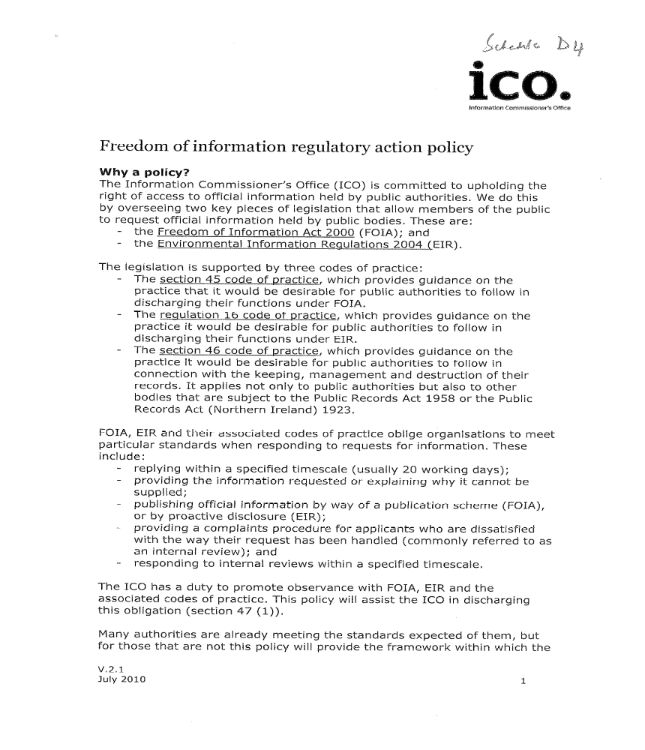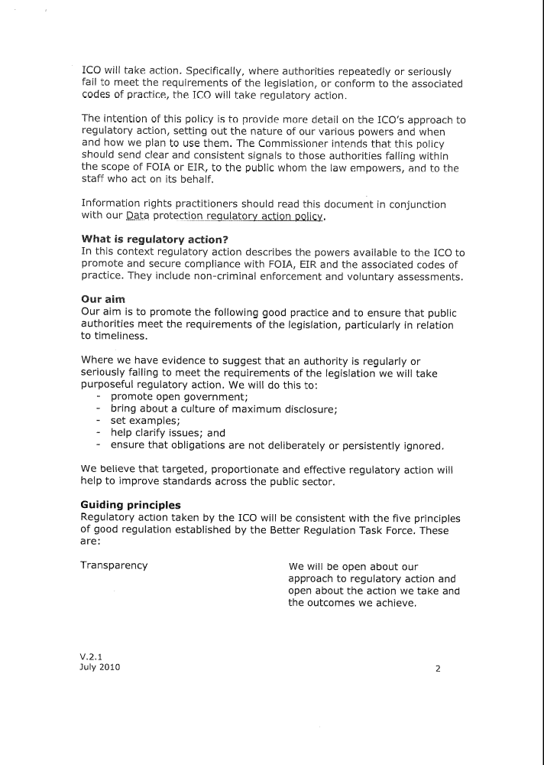

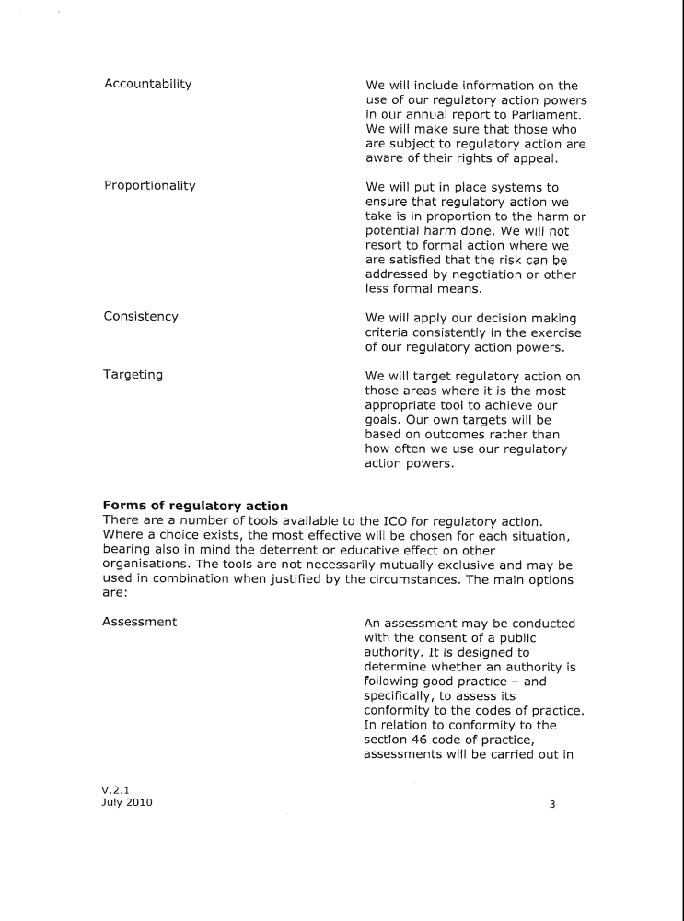

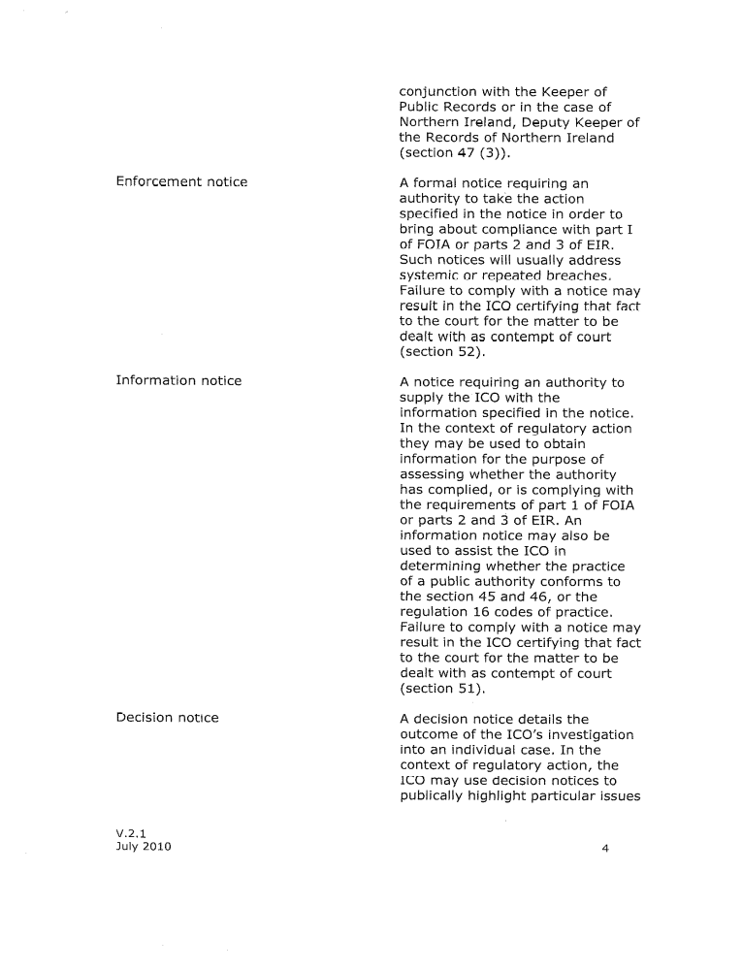

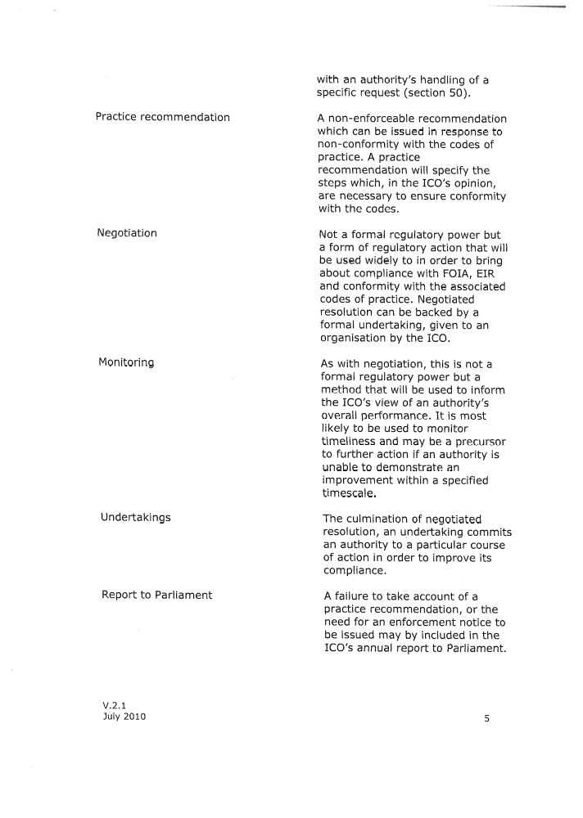

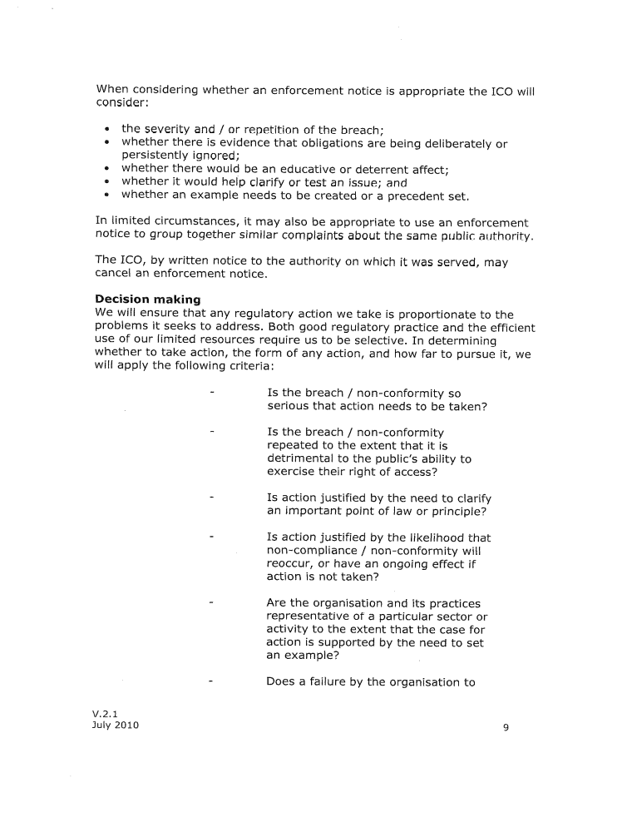

Schedule D5

Option 2: Variation 1
Promotion of Access to Information Act, 2000
Request for access: Public or Private body
Complaints handling by Regulator in terms of PAIA
Requester or 3rd party aggrieved by decision of IO or HPB

60 Days

Appeal to Regulator

IO or HPB
Submits reasons to Regulator
s75(4)

10 Work Days

Regulator

30 Days
30 Days

Requester makes written representations
s76(8) & (9)
3rd Party makes written representations
s76(2) & (5)

21 Days
21 Days

Regulator
Confirm or substitute new decision by IO or HPB s77(2)

30 Days
30 Days
30 Days

3rd party aggrieved by decision of Regulator
s78(3)
Requester aggrieved by decision of Regulator
s78(2)
IO or HPB aggrieved by decision of Regulator
s78(4)

180 Days
180 Days
180 Days

Applications to court

Schedule D6

Option 2: Variation 1
“PART 4
APPEALS AGAINST DECISIONS AND APPLICATIONS TO REGULATOR(SS74-82)

“CHAPTER 1A
APPLICATIONS TO REGULATOR

Applications to Regulator regarding decisions of information officers or relevant authorities of public bodies or heads of private bodies
77A. (1) A requester or third party referred to in section 74 may only submit an application to the Regulator in terms of this section after that requester or third party has exhausted the internal appeal procedure against a decision of the information officer of a public body provided for in section 74.
(2) A requester–
(a) that has been unsuccessful in an internal appeal to the relevant authority of a public body;
(b) aggrieved by a decision of the relevant authority of a public body to disallow the late lodging of an internal appeal in terms of section 75(2);
(c) aggrieved by a decision of the information officer of a public body referred to in paragraph (b) of the definition of ’public body’ in section 1–
(i) to refuse a request for access; or
(ii) taken in terms of section 22, 26(1) or 29(3);or
(d) aggrieved by a decision of the head of a private body–
(i) to refuse a request for access; or
(ii) taken in terms of section 54, 57(1) or 60,
may apply to the Regulator, alleging that the decision was not in compliance with this Act, in the prescribed manner and form for appropriate relief.
(3) A third party─
(a) that has been unsuccessful in an internal appeal to the relevant authority of a public body;
(b) aggrieved by a decision of the information officer of a public body referred to in paragraph (b) of the definition of ‘public body’ in section 1 to grant a request for access; or
(c) aggrieved by a decision of the head of a private body in relation to a request for access to a record of that body,
may apply to the Regulator, alleging that the decision was not in compliance with this Act, in the prescribed manner and form for appropriate relief.

Manner of application and fees
77B. (1) An application─
(a) must be submitted to the Regulator in the prescribed form─
(i) within 60 days; or
(ii) if notice to a third party is required by section 49(1)(b) or 73(1)(b), within 30 days after notice is given to the appellant of the decision appealed against or, if notice to the appellant is not required, after the decision was taken,
and a copy of the application must, at the same time, be delivered or sent to the information officer or relevant authority of the public body or head of the private body concerned;
(b) must identify the subject of the application and state the reasons for the application and may include any other relevant information known to the applicant;
(c) if, in addition to a written reply, the applicant wishes to be informed of the decision on the application in any other manner, must state that manner and provide the necessary particulars to be so informed;
(d) if applicable, must be accompanied by the prescribed application fee referred to in subsection (3); and
(e) must specify a postal address or fax number.
(2) (a) If an application is submitted after the expiry of the period referred to in subsection (1)(a), the Regulator must, upon good cause shown, allow the late submission of the application.
(b) The Regulator must, if it disallows the late submission of the application, give notice of that decision to the person that submitted the application.
(3) (a) A requester submitting an application against the refusal of his or her request for access must pay the prescribed application fee (if any).
(b) If the prescribed application fee is payable in respect of an application, the decision on the application may be deferred until the fee is paid.
(4) As soon as reasonably possible, but in any event within 10 working days after receipt of the copy of the application in accordance with subsection (1), the information officer or relevant authority of the public body or head of the private body concerned must submit to the Regulator─
(a) his or her reasons for the decision concerned; and
(b) if the application is against the refusal or granting of a request for access, the name, postal address, phone and fax number and electronic mail address, whichever is available, of any third party that must be notified in terms of section 47(1) or 71(1) of the request.

Notice to and representations by other interested persons

77C. (1) If the Regulator is considering an application against the refusal of a request for access to a record contemplated in section 34(1), 35(1), 36(1), 37(1), 43(1), 63(1), 64(1), 65(1) or 69(1), the Regulator must inform the third party to whom or which the record relates of the application, unless all necessary steps to locate the third party have been unsuccessful.

(2) The Regulator must inform a third party in terms of subsection (1)─

(a) as soon as reasonably possible, but in any event within 30 days after the receipt of the application; and

(b) by the fastest means reasonably possible.

(3) When informing a third party in terms of subsection (1), the Regulator must─

(a) state that it is considering an application against the refusal of a request for access to a record contemplated in section 34(1), 35(1), 36(1), 37(1), 43(1), 63(1), 64(1), 65(1) or 69(1), as the case may be, and describe the content of the record and the provisions of section 34(1), 35(1), 36(1), 37(1), 43(1), 63(1), 64(1), 65(1) or 69(1), as the case may be;

(b) furnish the name of the applicant;

(c) in any case where the Regulator believes that the provisions of section 46 or 70 might apply, describe those provisions, specify which of the circumstances referred to in section 46(a) or 70(a) in the opinion of the Regulator might apply and state the reasons why it is of the opinion that section 46 or 70 might apply; and

(d) state that the third party may, within 21 days after the third party is informed, make written representations why the request for access should not be granted.

(4) If a third party is informed orally of an application in terms of subsection (1), the Regulator must, on request, give a written notice stating the matters referred to in subsection (3) to the third party.

(5) A third party that is informed of an application in terms of subsection (1), may within 21 days after the third party has been informed, make written representations to the Regulator why the request for access should not be granted.

(6) A third party that obtains knowledge about an application other than in terms of subsection (1) may─

(a) make written or oral representations to the Regulator why the request for access should be refused; or

(b) give written consent for the disclosure of the record to the requester concerned.

(7) If the Regulator is considering an application against the granting of a request for access, the Regulator must give notice of the application to the requester concerned.

(8) The Regulator must─

(a) notify the requester concerned in terms of subsection (7) as soon as reasonably possible, but in any event within 30 days after the receipt of the application; and

(b) state in that notice that the requester may within 21 days after notice is given, make written representations why that request should be granted.

(9) A requester to whom or which notice is given in terms of subsection (7) may within 21 days after that notice is given, make written representations to the Regulator why the request for access should be granted.

Procedure of Regulator

77D. (1) The Regulator may, after receipt of the application and any written responses referred to in sections 77B(4) and 77C, hear oral representations made by the parties referred to in sections 77B(4) and 77C and must permit such parties to be assisted by a legal representative or other adviser.

(2) The Regulator must make a finding as soon as reasonably possible, but in any event within 30 days after receipt of the application referred to in section 77A.

(3) (a) The Regulator must keep a record of all applications received by it and a record of all its proceedings and findings which records must be open to inspection by the public at the premises and during the normal office hours of the Regulator.

(b) The Regulator must, when requested by any person and upon payment of the prescribed fee, if any, provide such person with a copy of or extract from such record.

Disclosure of records to, and non-disclosure by, Regulator

77E. The provisions of section 80 apply with the necessary changes to the Regulator when considering an application.

Decision on application and notice thereof

77F. (1) The decision on an application must be made with due regard to─

(a) the particulars stated in the application in terms of section 77B(1)(b);

(b) any reasons submitted by the information officer, relevant authority or head in terms of section 77B(4)(a);

(c) any representations made in terms of section 77C(5), (6) or (9); and

(d) if a third party cannot be located as contemplated in section 77C(1), the fact that the third party did not have the opportunity to make representations in terms of section 77C(5) why the application should be dismissed.

(2) When deciding on the application the Regulator may─

(a) decide to take no action in respect of the application if, in the Regulator’s opinion─

(i) the application has not been submitted within the period referred to in section 77B(1) and there are no reasonable grounds to condone the late submission;

(ii) the application is frivolous or vexatious or is not made in good faith; or

(iii) it appears to the Regulator that, having regard to all the circumstances of the case, any further action is unnecessary or inappropriate;

(b) confirm the decision which forms the subject of the application or substitute a new decision for it; or

(c) require the information officer, relevant authority or head to take such action or to refrain from taking such action as the Regulator has specified.

(3) The Regulator must, immediately after the decision on an application─

(a) give notice of the decision to the information officer, relevant authority or the head;

(b) give notice of the decision to─

(i) the appellant;

(ii) every third party informed as required by section 77C(1); and

(iii) the requester notified as required by section 77C(7); and

(c) if reasonably possible, inform the applicant about the decision in any other manner stated in terms of section 75(1)(d).

(4) The notice in terms of─

(a) subsection (3)(a) must state─

(i) adequate reasons for the decision, including the provision of this Act relied upon;

(ii) that the information officer, relevant authority or head may lodge an application with a court against the decision on application within 180 days, after notice is given, and the procedure for lodging the application; and

(iii) if the Regulator decided that a request for access should be granted, that access to the record must be given after the expiry of the applicable period for lodging an application with a court against the decision on application referred to in subparagraph (ii), unless that application is lodged before the end of that applicable period; and

(b) subsection (3)(b) must─

(i) state adequate reasons for the decision, including the provision of this Act relied upon;

(ii) exclude, from such reasons, any reference to the content of the record;

(iii) state that the applicant, third party or requester, as the case may be, may lodge an application with a court against the decision on application within 180 days, after notice is given, and the procedure for lodging the application; and

(iv) state, if the Regulator decided that a request for access should be granted, that access to the record will be given after the expiry of the applicable period for lodging an application with a court against the decision on application referred to in subparagraph (iii), unless that application is lodged before the end of that applicable period.

(5) If the Regulator decided that a request for access should be granted the information officer, relevant authority or head must, after the expiry of the period referred to in subsection (4)(a)(ii) and (b)(iii), give the requester access to the record concerned, unless an application with a court is lodged against the decision on application before the end of the period contemplated in subsection (4)(a)(ii) and (b)(iii) for lodging that application.

CHAPTER2
APPLICATIONS TO COURT (ss 78-82)

Applications regarding decisions of information officers or relevant authorities of public bodies or heads of private bodies Regulator
78. (1) A requester or third party referred to in section 74 77A may only apply to a court for appropriate relief in terms of section 82 after that requester or third party has exhausted the internal appeal application procedure against a decision of the information officer or relevant authority of a public body or head of a private body provided for in section 74 77A.
(2) A requester─
(a) that has been unsuccessful in an internal appeal to the relevant authority of a public body application to the Regulator; or
(b) aggrieved by a decision of the relevant authority of a public body Regulator to disallow the late lodging of an internal appeal in terms of section 75(2) 77D(2)(a);
(c) aggrieved by a decision of the information officer of a public body referred to in paragraph (b) of the definition of 'public body' in section 1─
(i) to refuse a request for access; or
(ii) taken in terms of section 22, 26(1) or 29(3); or
(d) aggrieved by a decision of the head of a private body─
(i) to refuse a request for access; or
(ii) taken in terms of section 54, 57(1) or 60,
may, by way of an application, within 30 180 days apply to a court for appropriate relief in terms of section 82.
(3) A third party─
(a) that has been unsuccessful in an internal appeal to the relevant authority of a public body application to the Regulator;
(b) aggrieved by a decision of the information officer of a public body referred to in paragraph (b) of the definition of 'public body' in section 1 to grant a request for access; or
(c) aggrieved by a decision of the head of a private body in relation to a request for access to a record of that body,
may, by way of an application, within 30 180 days apply to a court for appropriate relief in terms of section 82.
(4) An information officer or relevant authority of a public body or the head of a private body, as the case may be, aggrieved by a decision of the Regulator in terms of section 77F(2)(b) or (c) may, by way of an application, within 180 days apply to a court for appropriate relief in terms of section 82.

Transitional provision

82A. The provisions of this Act that─

(a) have been amended by; and

(b) relate to a request for access that has been submitted to an information officer or head before the implementation of,

section XX of the Protection of Personal Information Act, 2011, remain in force and all proceedings that have been or will be instituted as a result of a request referred to in paragraph (b) must be continued and concluded in all respects as if section XX of the Protection of Personal Information Act, 2011, had not been passed.

Schedule D7
Promotion of Access to Information Act, 2000
Three variations of two options

Variation 1: Internal appeals and aggrieved parties to approach Regulator before turning to court

Requester or 3rd party aggrieved by decision of IO

Requester or 3rd party aggrieved by decision of HPB

Internal appeal

Complaint to Regulator

Application to court

Variation 2: Aggrieved parties to approach Regulator before turning to court

Requester or 3rd party aggrieved by decision of IO or HPB

Complaint to Regulator

Application to court

Variation 3: Aggrieved parties exercise choice
Requester or 3rd party aggrieved by decision of IO or HPB

Internal appeal
Complaint to Regulator

Application to court

Schedule D8

[Home] [Databases] [World Law] [Multidatabase Search] [Help] [Feedback]

England and Wales Court of Appeal (Civil Division) Decisions
You are here: BAILII >> Databases >> England and Wales Court of Appeal (Civil Division) Decisions >> Inco Europe Ltd & Anor v First Choice Distribution (A Firm) & Ors [1998] EWCA Civ 1461 (30 September 1998)
URL: http://www.bailii.org/ew/cases/EWCA/Civ/1998/1461.html
Cite as: [1998] EWCA Civ 1461

[New search] [Printable RTF version] [Help]

LTA 98/5685/1
IN THE SUPREME COURT OF JUDICATURE
COURT OF APPEAL (CIVIL DIVISION)

Royal Courts of Justice
Wednesday, 30th September 1998

Before:

LORD JUSTICE HOBHOUSE
LORD JUSTICE THORPE
LORD JUSTICE MUMMERY

- - - - - - - -

INCO EUROPE LIMITED
INCO ALLOYS LIMITED
INCO LIMITED
(A company incorporated under the laws of Canada )
Plaintiffs

-v-

FIRST CHOICE DISTRIBUTION (A FIRM)
LOGISTICS PLANNING SERVICES LIMITED
STEINWEG (HANDELSVEEM BV)
(A company incorporated in the laws of the Netherlands)
SMEETS FERRY BV
(A company incorporated in the laws of the Netherlands )

Defendants

- - - - - - - -

(Transcript of the Handed Down Judgment of Smith Bernal Reporting Limited, 180 Fleet Street, London, EC4A 2HD. Telephone No: 0171-421 4040. Shorthand Writers to the Court.)

- - - - - - - -

MR. A. GHAFFAR (instructed by Messrs Holman, Fenwick & Willan) appeared for the Appellants/Applicants.

MR. M. HALLIWELL (instructed by Messrs Hill Dickinson) appeared on behalf of the Respondent.

- - - - - - - -
J U D G M E N T
(As approved by the Court )

Crown Copyright

HOBHOUSE LJ:
By a writ issued out of the Manchester District Registry of the High Court on 24th June 1997, the Plaintiffs in this action, Inco Europe Ltd and Inco Alloys Ltd, made a claim for damages in respect of the loss of a consignment of nickel cathodes being carried from Rotterdam to Hereford. One of the Defendants' named in the writ was Steinweg (Handlesveem BV). Steinweg made an application under s.9 of the Arbitration Act 1996 for the stay of the action against them on the ground that it was brought in respect of a matter which the Plaintiffs had agreed to refer to arbitration. The application was heard by HHJ Hegarty QC. He refused to grant the stay, holding that the arbitration agreement was "null and void or inoperative". (p.21 of the transcript) Steinweg seek to appeal from that decision. The Judge refused leave to do so. Steinweg have accordingly applied to this Court for leave to appeal.
It is a matter of credit to Mr Ghaffar, counsel for Steinweg, that he identified a problem which had previously been overlooked. He drew to the attention of the Judge, and has drawn to our attention, that it appears that s.107 of the 1996 Act and paragraph 37 of the Third Schedule to that Act have removed the jurisdiction of the Court of Appeal to entertain any appeal from a decision of a lower court or judge under s.9. Judge Hegarty refused leave to appeal on the basis that there is no jurisdiction and Mr Justice Tuckey in February of this year in a similar case ( Wealands v CLC Contractors ), having also had his attention drawn to the point, refused leave on the same basis. In neither instance was the matter the subject of developed argument such as has taken place before us.
By contrast, in the case Halki Shipping v Sopex Oils [1998] 2 AER 23 (decided in December of last year), the Court of Appeal assumed that it did have jurisdiction to entertain an appeal from a s.9 decision. The point of jurisdiction was not raised. Leave to appeal to the House of Lords was subsequently given. This would have provided the opportunity for an authoritative decision upon the question of jurisdiction but the appeal was withdrawn by consent before it could be heard.
The application for leave to appeal was referred to the full Court. It has been listed before us as an application with the appeal to follow if leave is granted. We have heard full argument both on the jurisdiction question and upon the merits of the appeal, should it be permissible. The first thing we have to decide is whether or not the Court of Appeal has a jurisdiction to entertain the application and appeal.

Jurisdiction:
The point for the Plaintiffs can be very simply stated. The Third Schedule of the 1996 Act amended a large number of earlier statutes. One was the Supreme Court Act 1981. S.18(1) was amended so as to read -
"No appeal shall lie to the Court of Appeal -
....
(g) except as provided in Part I of the Arbitration Act 1996 from any decision of the High Court under that Part;
...."
The 1996 Act, either in s.9 or elsewhere in Part I, makes no express provision for there to be any right of appeal from a decision under s.9 to the Court of Appeal. It is therefore submitted that under the amended s.18(1)(g) no appeal lies to the Court of Appeal. The argument of the Plaintiffs' is thus straightforward. The effect of the amendment is that unless an express right of appeal is given, as is found (albeit qualified) in other provisions of Part I of the 1996 Act, no appeal is to lie. This submission does not lose any of its force by its brevity. Indeed it is a submission which must be accepted unless some convincing answer arising within the permitted canons of statutory construction can be made to it.
A number of arguments have been advanced on behalf of Steinweg. The argument which needs to be considered is that which arises from an examination and consideration of the provisions of the 1996 Act itself. Mr Ghaffar submits that when this task is undertaken it will be seen that what might be termed the literal construction of the amended 1981 Act does not accord with the statutory intention disclosed by the 1996 Act and that the better view is that the intention of the 1996 Act is that the previously existing right of appeal (with leave) to the Court of Appeal in respect of decisions on applications for the stay of litigation has not been taken away by the 1996 Act.
In general terms, it is undoubtedly correct that the effect of an amendment to a statute should be ascertained by construing the amended statute. Thus, what is to be looked at is the amended statute itself as if it were a free-standing piece of legislation and its meaning and effect ascertained by an examination of the language of that statute.
However in certain circumstances it may be necessary to look at the amending statute as well. This involves no infringement of the principles of statutory interpretation: indeed it is an affirmation of them. The expression of the relevant parliamentary intention is the amending Act. It is the amending Act which is the operative provision and which alters the law from that which it had been before. It is the expression of the parliamentary will as to what changes in the law Parliament wishes to make. In the present case this approach is further justified by the reference in the amended 1981 Act back to the 1996 Act and by the terms of the 1996 Act itself.
As I stated earlier in this judgment the amending provision is s.107(1). The heading is "Consequential Amendments and Repeals". Sub-section (1) provides:
"The enactments specified in Schedule 3 are amended in accordance with that Schedule, the amendments being consequential on the provisions of this Act."
Schedule 3 is entitled "Consequential Amendments". It is therefore a legitimate consideration to ask whether an amendment abolishing a right of appeal from a decision refusing or allowing a stay of an action could properly be described as consequential upon the provisions of the 1996 Act.
Before amendment, paragraph (g) of s.18(1) of The Supreme Court Act had read -
"Except as provided by the Arbitration Act 1979, from any decision of the High Court -
(i) on an appeal under s.1 of that Act, on a question of law arising out of an arbitration award; or
(ii) under s.2 of that Act on any question of law arising in the course of a reference.""
The 1979 Act is the Arbitration Act which radically amended the statutory scheme of judicial review of arbitration awards by the courts. It abolished the appeal by way of case stated and 'error of law on the face of the award' as a ground for setting aside an award. It substituted a system of reasoned awards open to only very carefully limited rights of appeal to the courts. As part of this scheme, special limitations were introduced upon rights of appeal to the Court of Appeal. It was these which were referred to in the unamended paragraph (g). Questions of the stay of litigation were dealt with in a different Act, the Arbitration Act 1996, which contained no special restrictions on rights of appeal to the Court of Appeal.
The status of arbitration clauses in English law has been gradually developed over the last century and a half. It has also been the subject of international conventions. At the time of the passing of the Arbitration Act 1950, the relevant international agreement requiring states to recognise and give effect to arbitration clauses was the League of Nations Protocol of 24th September 1923 and its corollary, the Geneva Convention on the Execution of Foreign Arbitral Awards dated 26th September 1927. This Protocol and Convention were scheduled to the 1950 Act. The stay of litigation where there had been a submission to arbitration was dealt with in s.4 of that Act. Sub-section (1) dealt with domestic arbitrations which did not come within the scope of the Protocol, in which case the court had a discretion whether or not to grant the stay. Sub-section (2) provided for the mandatory recognition and enforcement of arbitration agreements falling within the scope of the Protocol and therefore the stay of any legal proceedings in respect of a matter agreed to be referred unless the court was "satisfied that the agreement or arbitration has become inoperative or cannot proceed or that there is not in fact any dispute between the parties with regard to the matter agreed to be referred."
In June 1958 the United Nations Conference on International Commercial Arbitration adopted a fresh convention on the Recognition and Enforcement of Foreign Arbitral Awards, the New York Convention. The United Kingdom subscribed to and ratified that Convention as did very many other states. The Arbitration Act of 1975 was enacted to give effect to that Convention. The obligation of the United Kingdom was to recognise and give effect to arbitration agreements to which an individual who was a national or habitually resident in a state other than the United Kingdom, or an entity incorporated in or with its central control and management in such a state, was a party. Similarly it was the obligation of the United Kingdom to recognise and give effect to arbitration awards involving one or more such parties. The scheme was mandatory, subject to certain safeguards. The safeguard in respect of the obligation to stay litigation was set out in s.1(1) of the 1975 Act the wording of which has in the material respect been repeated in s.9(4) of the 1996 Act.
"On an application under this section, the court shall grant a stay unless satisfied that the arbitration agreement is null and void, inoperative, or incapable of being performed."
Thus, the feature of the New York Convention and its implementation in the law of the United Kingdom by the Arbitration Act 1975 was the combination of the obligation to recognise arbitration agreements with the obligation to enforce awards; being an international convention, its subject matter was arbitration agreements or awards which were not exclusively domestic. The New York Convention remains a convention by which the United Kingdom is bound. It was no part of the intention of the 1996 Act to detract from the obligations of the United Kingdom under that Convention or to resile from it. It is clearly the intention of the 1996 Act to continue to give effect to the New York Convention (and the provisions of the 1975 Act). The provisions for the enforcement of foreign awards are contained in Part III of the 1996 Act. The provisions for the stay of litigation are contained in sections 9-11 in Part I of the Act. No material change was made in s.9 itself; it repeats, as of general application, the same provisions and criteria as had previously been in s.1 of the 1975 Act. The new modifications of those provisions for purely domestic agreements are contained in ss.85 and 86 in Part II of the Act.
The preamble to the 1996 Act stated that it was -
"An Act to restate and improve the law relating to arbitration pursuant to an arbitration agreement; to make other provision relating to arbitration and arbitration awards; and for connected purposes."
The genesis of the Act was a Department of Trade and Industry consultation paper of February 1994 which had attached to it a draft arbitration bill. A draft bill was also attached to the Report of a Departmental Advisory Committee of very considerable distinction chaired by the then Lord Justice Saville. In paragraphs 50 and following of the Report, the Committee explained that their proposals had in mind (among other things) the treaty obligations of the United Kingdom and Article 8 of the UNCITRAL model law. The Report discloses no intention to restrict rights of appeal to the Court of Appeal on questions relating to the stay of litigation. This is in contrast to other parts of their proposals which, in a development of the policy underlying the 1979 Act, revised and extended the limitations on the scope for interference by the court with the arbitral process or the finality of awards whether by appeal or otherwise. In that context it further limited the scope for appeals beyond the level of the Commercial Court. The draft bill did not deal with consequential amendments to other Acts of Parliament. This was clearly regarded as a technical matter to be covered by Parliamentary draftsmen.
The bill as introduced corresponded, for present purposes, to the Act which received the Royal Assent. The bill included what became s.107 and the Third Schedule. There were no material changes in s.9 between the February 1994 draft and the bill as enacted. A Supplementary Report was produced by the Departmental Advisory Committee in January 1997. The purpose of this Report was to identify and explain any changes that had been introduced since February 1996. There were some changes but none which are material for present purposes or which would support an intention to remove any right of appeal in respect of the grant or refusal of a stay of litigation. Neither the Supplementary Report nor the Parliamentary Debates provide any support in any relevant respect for any statutory intention other than to give effect to the original Report of the Departmental Advisory Committee.
It is therefore the case that, if the effect of s.107 and the Third Schedule has been to abolish a right of appeal which previously existed in relation to the 1975 Act, it is an intention which either has never come to the notice of or has not been thought worthy of comment by those most intimately concerned with the drafting of and the bringing into effect of this highly important measure to update the law of arbitration of this country. If, nevertheless, it is right to conclude that such was Parliament's intention, discrepancies of treatment become apparent. There is no additional restriction on the right of appeal or the jurisdiction of the Court of Appeal under Parts II and III of the 1996 Act. Part II includes s.85 which modifies the provisions of s.9 in relation to purely domestic arbitration agreements. It contains no restriction on the right of appeal. The same applies to Part III which includes a re-enactment of the provisions of the 1975 Act for the enforcement of awards covered by the Geneva and New York Conventions. There is no discernable reason why the re-enactment of the United Kingdom's obligation to recognise and enforce arbitration agreements as required by in particular the New York Convention, should be treated differently or should be within the exclusive jurisdiction of a lower court which may, under s.105 of the 1996 Act, be a county court.
The fulfillment of the international obligations of the United Kingdom under the New York Convention is a matter of importance. Further, the issues to which any application for a stay may give rise are also of substance. An application for a stay may require the court to try, and decide, questions of who were the parties to an alleged agreement, what were the terms of that agreement and whether that agreement was valid and subsisting. The decision given by the court on those questions may affect questions of liability as well as of procedure. If they affect liability, they will ultimately be capable of appeal when a judgment on liability has been given. Thus the exclusion of a right of appeal, particularly when, as in s.9, questions of discretion cannot arise, serves no rational purpose save, possibly, a desire for 'sudden death' solutions which finds no support from the Report which gave rise to this Act or any other part of the statutory context of s.9.
Accordingly, as a matter of construing the phrase "consequential amendments", the conclusion to which one is driven is that a removal of a right of appeal (with leave) from a decision whether or not to stay litigation covered by an arbitration clause would not be consequential upon anything contained in the 1996 Act. It would be a radical and additional provision. In my judgment such a change in the pre-existing law is not achieved by wording such as that used in s.107 of the 1996 Act. In my judgment the effect is that the amendment to s.18(1) of the 1981 Act must be understood as giving effect to the exclusions (and restrictions) on the right of appeal to the Court of Appeal laid down in Part I of the 1996 Act and no more. Thus, as is self-evident from the wording of the amendment, it is necessary to look at the provisions in Part I of the 1996 Act to ascertain to what extent the right of appeal to the Court of Appeal is excluded. If some provision of Part I does not exclude it, the right of appeal remains.
There is nothing in s.9 which excludes the jurisdiction of the Court of Appeal. The same applies to sections 10 and 11, 13, 28, 64 and 65, 72 and 74. It is not necessary to go through all these sections. Like for s.9, it is a reasonable inference from the language, the statutory scheme and the enactments being replaced, that the existing rights of appeal and the restrictions upon them are not being changed. These sections are to be contrasted with a whole raft of sections which do limit rights of appeal. A number of these confine the right of appeal to where the lower court has itself given leave to appeal; in other instances there are rights of appeal which only exist if the lower court grants a certificate that a point of law of general public importance is involved. All these provisions, in their various forms, are designed (in succession to and development from the 1979 Act) to reduce to an acceptable minimum the interference of courts with the conduct of arbitrations and the finality of awards. It is recognised that, in the interests of justice and a healthy arbitral system, there should be some limited scope for recourse to the courts. But it is also recognised, particularly in response to international commercial opinion, that the parties having chosen their tribunal should not be able to evade the decisions of that tribunal or obstruct or delay them save within carefully confined and controlled circumstances.
This logic and policy does not apply to the separate question of the fulfillment by the United Kingdom of its obligations under the New York Convention. As explained previously, these have a different character and arise at a different stage. The construction of s.107 which I prefer does not give rise to anomaly. It involves a coherent distinction between the differing provisions of various sections in Part I of the Act. It gives effect to the stated intention only to make consequential amendments. It enables the issues which are liable to arise under s.9 to be finally resolved in an appropriate and just manner consistent with the Report which preceded the introduction of the bill.
In my judgment the simple reading of the amended 1981 Act for which the Plaintiffs contend and which was understandably accepted by Judge Hegarty and Mr Justice Tuckey is not correct. There is a jurisdiction of the Court of Appeal to hear appeals from decisions of a judge or court under s.9 of the 1996 Act and there is a right of an aggrieved party to apply to the judge or to the Court of Appeal for leave to appeal and a power of that judge or this Court to grant leave.
Having concluded that there is jurisdiction to grant this application for leave it is necessary to consider whether it is an application which should be granted. For reasons which will become apparent when I turn, as I now do, to the merits of the appeal, I consider that leave to appeal should be granted.

The Appeal:
It appears that the relevant consignment of nickel cathodes was packed in 52 drums. The origin of these was the Steinweg warehouse in Rotterdam. They were loaded by Steinweg onto a trailer which was then taken across the Channel to Felixstowe and there picked up by, it is said, the first Defendants, First Choice Distribution. The driver went via the first Defendant's premises where the trailer was unhitched and, the Plaintiffs allege, left unguarded so that it and its load were stolen.
Steinweg and Inco Europe were well known to each other. The latter was a dealer in non-ferrous metals traded on the London Metal Exchange. Steinweg had an approved LME warehouse for metals being traded on the exchange. It was under these circumstances that Steinweg received their instructions in respect of this and two similar consignments on 23rd December from a Miss Janet Povey of Inco Europe. By her fax of that date, confirming her telephone call, she requested Steinweg to "please arrange" the delivery of the three lots of nickel cathodes to Inco Alloys Hereford. On 30th December Steinweg faxed her at Inco Europe -
"We herewith confirm having loaded above mentioned parcel today, 30.12.1996 for delivery to Inco Alloys, Hereford via Felixstowe on 02/03.01.1997.
Trailer numbers SM 72, SM 53, SM 114"
A CMR consignment note was made out. It is in the form prescribed by Article 6 of the CMR Convention. Box 1 is for the name, address and country of the sender. That was filled in with the name and address of Steinweg. Box 2 is for the name, address and country of the consignee and that was filled in with the name and address of Inco Alloys at Hereford. The place of delivery and dispatch were respectively filled in as Hereford and Rotterdam. Steinweg also filled in box 22 confirming their status as sender. Boxes 16-18 and 23 are to be filled in by the carrier. They have not been completed in the only copy of the CMR consignment note which has been produced in the action. Only box 23 has been filled in, acknowledging receipt of the parcel in good order and condition by the carrier with an illegible signature on behalf of the carrier. It is not suggested that that signature was a signature by or on behalf of Steinweg. (It also appears to include a different trailer number but no-one has founded any argument upon that discrepancy.) In due course Steinweg rendered an invoice to Inco Europe for the warehouse rent, the sealing of drums, palletising, customs documentation and "truckfreight".
It was the evidence that Inco Europe had dealt with Steinweg on a regular basis for at least about three years before this transaction. Steinweg's invoices have on the reverse a clause printed in four languages; the English version includes -
"Storage activities are subject to the filed Storage Conditions at Amsterdam-Rotterdam; ship brokers activities are subject to the filed General Dutch Shipbrokers' Conditions, latest version; forwarding activities are subject to the filed FENEX-conditions; stevedoring activities are subject to ... "
The FENEX general conditions are the conditions of the Netherlands Association for Forwarding and Logistics and are apparently widely used in the Netherlands. They are printed in English (and other languages). They are clearly intended to be governed by Dutch law. They are in most respects typical of the standard conditions of Freight Forwarders. The role of a forwarder is well-recognised in international trade. It is to act as the agent of a goods owner in making all the necessary arrangements for the carriage of goods by others from one place or country to another. Article 1 of the FENEX conditions deals with applicability and provides:
"Article 1
1. These general conditions shall apply to any form of service which the forwarder shall carry out. Within the framework of these general conditions the term forwarder must not be understood exclusively to mean the forwarder as contemplated in Book 8 of the Dutch Civil Code.
2. With respect to the operations and activities, such as those of shipbrokers, stevedores, carriers, insurance agents, warehousing and superintending firms etc. which are carried out by the forwarder, the conditions customary in the particular trade, or the conditions stipulated to be applicable, will also be applicable.
3. The forwarder may at any time declare applicable the conditions stipulated by third parties with whom he has made contracts for the purpose of carrying out the orders given to him.
4. The forwarder may have his orders and/or the work connected therewith carried out by third parties or the servants of third parties. In so far as such third parties or their servants bear statutory liability towards the forwarder's principal, it is stipulated on their behalf that in doing the work for which the forwarder employs them they shall be regarded as solely in the employ of the forwarders. All the provisions (inter alia) regarding non-liability and limitation of liability and also regarding indemnification of the forwarder, as described herein shall apply to such persons."
Similarly Article 7 (Performance of the Contract) provides that:
"If the principal has not given any specific instructions in his order, the mode and route of transport shall be at the forwarder's option and he may at all times accept the documents customarily used by the firms with which he contracts for the purpose of carrying out his orders."
Under "Liability", Article 11 includes the provision:
"8. The forwarder, who is not a carrier, even in the event all-in or fixed rates, as the case may be, have been agreed, shall be liable under the present conditions and not as a carrier."
The tenor of these clauses is therefore that the forwarder is primarily an agent carrying out the duties of an agent including making contracts on behalf of his principal and is not, other things being equal, acting as a carrier but if he does act as a carrier, he is liable as a carrier (Article 16.1). Article 23 includes an arbitration clause under the auspices of FENEX. It expressly provides:
"The arbitrators shall make the award equitably as good men and true, subject to their liability to observe the applicable imperative legal stipulations, including the provisions of international transport treaties."
The Plaintiffs' claim against Steinweg in the action is for damages for breach of contract as the first CMR carrier, that is to say, the person or entity with whom the actual contract of carriage was made. The Plaintiffs say that it was Inco Europe who made that contract with Steinweg on 23rd December. Inco Alloys claim under the CMR consignment note as the consignee of the goods who is by Article 13.1 "entitled to enforce in his own name against the carrier any right arising from the contract of carriage", that is to say as a person entitled to enforce the contract of carriage between the sender and the carrier evidenced by the CMR consignment note.
Steinweg say that whatever contractual relationship they had with Inco Europe was on the terms of the FENEX conditions as referred to on the back of their invoices; these conditions include an arbitration clause. Therefore, they say, they are entitled to a stay under s.9 of the 1996 Act of the claim that is made against them by Inco Europe and by Inco Alloys through Inco Europe.
In a structured judgment Judge Hegarty held that the arbitration clause was incorporated in the contractual relationship between Inco Europe and Steinweg and that it was also binding upon Inco Alloys. He also held that as a matter of construction the claim made in the action fell within the matters agreed to be referred to FENEX arbitration in accordance with the arbitration clause. Therefore he concluded that, unless the Plaintiffs were entitled to rely upon subsection (4) of s.9 of the Act, Steinweg were entitled to a stay of the action against them. He recognised that the burden of proof and persuasion was upon the Plaintiffs to satisfy him that the arbitration agreement was, in the circumstances, null and void or inoperative. He however held that because the Plaintiffs were making a contractual claim under CMR against Steinweg, the arbitration clause must be held to be void and invalid because it did not expressly provide that the arbitration tribunal should apply the CMR Convention in accordance with the requirements of Articles 33 and 41 of CMR. He applied Bofors-UVA v Skandia Transport [1982] 1 Lloyds 410. The requirement in the arbitration clause that the arbitrators should observe "the applicable imperative legal stipulations including the provisions of international transport treaties" did not in his judgment suffice for this purpose. For good measure he also held that the Plaintiffs had a good arguable case that Steinweg were the first carriers of this consignment under CMR.
It can be commented at the outset that there is a certain circularity in the reasoning which the Judge adopted. The Plaintiffs allege that Steinweg was the first carrier under CMR. Therefore any arbitrator must be required to apply CMR. This arbitration clause does not necessarily require the arbitrators to do so. Therefore the arbitration clause is void under CMR and cannot be relied upon in support of an application for a stay under the New York Convention and s.9 of the 1996 Act. This gives rise to an absurdity. If Steinweg dispute, as they do and are patently entitled to dispute, that they were ever in the position of carrier under CMR in relation to the relevant consignment and, if the question whether or not they were a CMR carrier is among the matters which the parties have agreed to refer to FENEX arbitration, as the Judge has held they did, it begs the question to require the arbitrators to apply CMR. Whether or not CMR is applicable is one of the matters which the arbitrators have got to decide at the outset. Indeed, the way in which it has been put in the FENEX arbitration clause may be thought to be appropriate: the arbitrators are required to observe any applicable international convention.
The nearest that the Judge's judgment comes to recognising the circularity of his reasoning is that he seems to proceed on the basis that he is not required to find whether Steinweg was a CMR carrier or was, in respect of this particular consignment bound by CMR, but only to examine whether the Plaintiffs had a good arguable case. However this again begs a question: why is it not enough for Steinweg to show that they have a good arguable case that the arbitration clause is valid? Indeed, it is the preferable view that the arbitration clause must be observed and the New York Convention obligation given effect to unless it is actually proved that the arbitration clause is null and void. The Judge's reasoning therefore cannot be supported and it confirms that it is right to be surprised by the result at which he arrived.
It is convenient to approach the Judge's conclusions in the reverse order to that which he adopted. He concluded that the Plaintiffs had a good arguable case that Steinweg was the first CMR carrier, that is to say that Steinweg made a contract of carriage with Inco Europe. There was no evidence to support that conclusion or the conclusion that the Plaintiffs had shown even an arguable case to that effect. The fax of 23rd December was a typical fax of instruction by a goods owner to a forwarder. It requested Steinweg to arrange the consignment of the relevant goods. The use of the word "arrange" is not conclusive but it is indicative. The fax does not come anywhere near showing that the employment of Steinweg was as carrier or that Steinweg was accepting the obligations of carrier as opposed to of forwarder. The next document upon which the Judge relied was the CMR consignment note.
This was wholly contradictory of the Plaintiffs' case. Steinweg was named as the sender not as the carrier. The sender is the antithesis of the carrier: the sender is the person who makes the contract of carriage with the carrier. The consignment note contains no evidence whatsoever that Steinweg was the contracting carrier for any purpose, let alone for the purposes of CMR. The consignment note confirms the role of Steinweg as the person from whose possession or custody the goods were delivered to the carrier and, in relation to the carriage, as a forwarder or other agent of whomever it was that owned the goods at that time.
Finally, the Judge relied upon the invoice which referred to "truckfreight". This document is neutral. It is as consistent with Steinweg being a forwarder as with its being a carrier. As a forwarder and consignor Steinweg would be liable for the freight to the carrier and would be entitled to charge Inco Europe for that sum, which is what occurred.
The Judge should not have concluded that the Plaintiffs had a good arguable case against Steinweg that Steinweg was a contracting carrier. He should have concluded that the Plaintiffs had not provided any basis for their allegation that Steinweg was the carrier and that the evidence which the Plaintiffs relied on showed no more than that Steinweg were forwarders. This shows that the whole basis upon which the Judge arrived at his conclusion was fundamentally mistaken.
The next point (in reverse order) which the Judge had to address was whether or not the arbitration clause offended against CMR. In my judgment he arrived at the wrong conclusion on this point as well. The FENEX clause required the arbitrators to observe the applicable imperative legal stipulations "including the provisions of international transport treaties". The effect of his conclusion is that the Convention can never be satisfied by a multi-purpose arbitration clause. It was not suggested that there was any ambiguity about the reference to the international convention (treaty) which was compulsorily applicable where the substantive contract was a contract for the international carriage of goods by road. The applicable convention was the CMR Convention. It is that to which the clause necessarily referred. Similarly there was no ambiguity about the requirement in the arbitration clause that the arbitrators should observe the applicable convention. It contained an express requirement that they should do so. The Bofors case is clearly to be distinguished. In that case there was no reference of any kind to any convention. Bingham J said:
"[The Convention] seems to require a provision which would ordinarily, I think, be taken to mean an express provision that the tribunal shall apply the Convention and I can really see no justification in the language, or indeed in the general purpose of the provision, for watering down what seems on the face of it to be fairly plain."
But the Judge's analysis in this connection was further mistaken since the relevant question was whether a contract of carriage had been made on 23rd December between Inco Europe and Steinweg. That was the relevant allegation. It was an issue which the parties had agreed would be decided by FENEX arbitration. It was an issue which was antecedent to any question of the application of the CMR Convention. The Judge's reasoning in relation to the CMR Convention provided no basis for nullifying the effect of or refusing to enforce that arbitration agreement.
Therefore in my judgment the Judge's conclusion on the merits of the Plaintiff's response to the application of Steinweg for a stay of the action under s.9 was wrong. The Judge should have held that Steinweg were entitled to the stay of the action against them. The appeal should be allowed accordingly.

THORPE LJ:
I agree.
MUMMERY LJ:
I also agree.

Order: Appeal allowed with costs in the Court of Appeal and below; application for leave to appeal to House of Lords refused; all further legal proceedings and actions be stayed save that the defendant Steinweg have liberty to apply to set aside default judgment.

BAILII: Copyright Policy | Disclaimers | Privacy Policy | Feedback | Donate to BAILII
URL: http://www.bailii.org/ew/cases/EWCA/Civ/1998/1461.html
Schedule D9

 | [Home] [Databases] [World Law] [Multidatabase Search] [Help] [Feedback] | 
 | United Kingdom House of Lords Decisions
You are here: BAILII >> Databases >> United Kingdom House of Lords Decisions >> Inco Europe Ltd and Others v. First Choice Distribution (A Firm) and Others [2000] UKHL 15; [2000] 1 WLR 586 (9th March, 2000)
URL: http://www.bailii.org/uk/cases/UKHL/2000/15.html
Cite as: [2000] CLC 1015, (2000) 2 TCLR 487, [2000] 1 All ER (Comm) 674, [2000] 2 All ER 109, [2000] 1 WLR 586, [2000] 1 Lloyd's Rep 467, [2000] UKHL 15, 74 Con LR 55, [2000] BLR 259

[New search] [Help]

JISCBAILII_CASE_ENGLISH_LEGAL_SYSTEM

Inco Europe Ltd and Others v. First Choice Distribution (A Firm) and Others [2000] UKHL 15; [2000] 1 WLR 586 (9th March, 2000)

HOUSE OF LORDS
Lord Nicholls of Birkenhead Lord Jauncey of Tullichettle Lord Steyn Lord Clyde Lord Millett

OPINIONS OF THE LORDS OF APPEAL FOR JUDGMENT

IN THE CAUSE
INCO EUROPE LTD. AND OTHERS
(APPELLANTS)
v.
FIRST CHOICE DISTRIBUTION (A FIRM) AND OTHERS
(RESPONDENTS)
ON 9 MARCH 2000
LORD NICHOLLS OF BIRKENHEAD
My Lords,
Section 9 of the Arbitration Act 1996 empowers the court to stay legal proceedings brought against a party to an arbitration agreement in respect of a matter which under the agreement is to be referred to arbitration. The issue on this appeal is whether an appeal lies to the Court of Appeal from a decision of the first instance court made under section 9. Section 9 is silent on the point.
The circumstances in which this question has arisen are set out in the judgment of Hobhouse L.J. in the Court of Appeal, reported at [1999] 1 All E.R. 820, 822. Nothing turns on the particular facts, so I can be appropriately economical in my rehearsal of them. On 24 June 1997 the plaintiffs issued a writ in the Manchester District Registry of the High Court claiming damages in respect of the loss of a consignment of nickel cathodes being carried from Rotterdam to Hereford. One of the defendants, Steinweg (Handelsveem B.V.), made an application for an order under section 9 of the Arbitration Act 1996 staying the legal proceedings, on the ground that the proceedings had been brought in respect of a matter the parties had agreed by their contract to refer to arbitration in the Netherlands. His Honour Judge Hegarty Q.C., sitting as a judge of the High Court, dismissed the application. He held that the arbitration agreement was 'null and void, or inoperative'. In order to appeal against this interlocutory order Steinweg needed permission to appeal. Steinweg sought permission from the judge, but this was refused. Steinweg renewed its application to the Court of Appeal. One of the questions the Court of Appeal had to consider was whether it had any jurisdiction to entertain the appeal. The doubt arose from a provision in section 18 of the Supreme Court Act 1981. The material part of section 18(1), as amended by the 1996 Act, reads:
'No appeal shall lie to the Court of Appeal -
. . .
(g) except as provided by Part I of the Arbitration Act 1996, from any decision of the High Court under that Part;'
Inco's case was an extremely simple one. Judge Hegarty's decision was a decision of the High Court under Part I of the Act of 1996. The saving exception does not apply, because nowhere in section 9, or indeed anywhere else in Part I, is there provision for an appeal from a decision of the court under section 9. Ergo, so the argument runs, the decision sought to be appealed falls four-square within section 18(1)(g): no appeal lies to the Court of Appeal.
If section 18(1)(g) as amended by the Act of 1996 is read literally and in isolation from its context, this argument is unanswerable. However, the Court of Appeal, comprising Hobhouse, Thorpe and Mummery L.JJ., rejected the submission. Hobhouse L.J. examined with care the development of the status of arbitration clauses in English law, the genesis of the Act of 1996 and the statutory context of the amendment. The amendment made by the Act of 1996 to section 18(1)(g) of the Act of 1981 was made by section 107 of the Act of 1996. Section 107 was concerned with 'consequential' amendments. The conclusion of Hobhouse L.J., at page 826e, was that a removal of the pre-existing right of appeal (with leave) from a decision whether or not to stay litigation covered by an arbitration clause would not be consequential upon anything contained in the Act of 1996. It would, he said, be a radical and additional provision. He continued:
'In my judgment such a change in the pre-existing law is not achieved by wording such as that used in section 107 of the 1996 Act. In my judgment the effect is that the amendment to section 18(1) of the 1981 Act must be understood as giving effect to the exclusions (and restrictions) on the right of appeal to the Court of Appeal laid down in Part I of the 1996 Act and no more. Thus, as is self-evident from the wording of the amendment, it is necessary to look at the provisions in Part I of the 1996 Act to ascertain to what extent the right of appeal to the Court of Appeal is excluded. If some provision of Part I does not exclude it, the right of appeal remains.'
Thorpe and Mummery L.JJ. agreed. The Court of Appeal granted permission to appeal from the decision of Judge Hegarty. Having considered the substantive grounds of appeal, the court then allowed the appeal and stayed further proceedings in the action brought by the plaintiffs against Steinweg.
Before this House is an appeal by the plaintiffs on the jurisdictional point. The plaintiffs do not seek to challenge the decision of the Court of Appeal if, contrary to their submissions, the Court of Appeal had jurisdiction to hear the appeal.
In my view the decision of the Court of Appeal was correct. Several features make it plain beyond a peradventure that on this occasion Homer, in the person of the draftsman of Schedule 3 to the Act of 1996, nodded. Something went awry in the drafting of paragraph 37(2) of Schedule 3. Paragraph 37(2) is the paragraph which set out the amendment made to section 18(1)(g) of the Act of 1981. Moreover, what paragraph 37(2) was seeking to do, but on a literal reading of the language failed to achieve, is also abundantly plain.
The starting point is to consider what was the purpose of section 18(1)(g) of the Act of 1981 as originally enacted. Sections 15 to 18 of the Act of 1981 are the statutory provisions regarding the jurisdiction of the Court of Appeal. Section 16 is the basic source of the Court of Appeal's jurisdiction to hear appeals from decisions of the High Court. Section 16(1) provides that 'subject as otherwise provided by this or any other Act' the Court of Appeal 'shall have jurisdiction to hear and determine appeals from any judgment or order of the High Court'. Section 18 is concerned with restrictions on appeals to the Court of Appeal. As originally enacted, the relevant part of section 18(1)(g) read:
'(1) No appeal shall lie to the Court of Appeal -
. . .
(g) except as provided by the Arbitration Act 1979, from any decision of the High Court -
(i) on an appeal under section 1 of that Act on a question of law arising out of an arbitration award; or
(ii) under section 2 of that Act on a question of law arising in the course of a reference;'
As paragraph (g) indicates, sections 1 and 2 of the Act of 1979 enabled the High Court to make decisions on questions of law arising out of arbitration awards or in the course of references to arbitration. These two sections contained restrictions on appeals to the Court of Appeal in respect of certain decisions. For instance, section 1(7) excluded an appeal to the Court of Appeal unless the High Court or the Court of Appeal gave leave and the High Court certified that the decision raised a point of law of general public importance. Thus, and this is the first feature to note regarding section 18(1)(g) in its original form, the phrase 'except as provided by the Arbitration Act 1979' did not mean 'except as enabled by the Arbitration Act 1979'. The Arbitration Act 1979 did not contain provisions empowering the Court of Appeal to hear appeals from decisions of the High Court on arbitration matters. As already noted, the source of the statutory power enabling the Court of Appeal to hear such appeals lies elsewhere, in the Act of 1981 itself. Rather, in this context the word 'provided' meant envisaged, or permitted. In more legalistic language, the phrase meant 'except in accordance with the provisions of the Arbitration Act 1979', those provisions being restrictions on appeal.
A second feature should also be noted. Section 18(1)(g) did not impose additional restrictions on the right to appeal to the Court of Appeal from decisions of the High Court mentioned in sub-paragraphs (i) and (ii) of section 18(1)(g). Section 18(1)(g) merely brought forward into section 18(1) restrictions on rights of appeal already expressed in the relevant sections of the Act of 1979. Presumably it was thought convenient and desirable that these restrictions, set out in another statute, should be expressly mentioned in Part II of the Act of 1981, concerned as it is with the jurisdiction of the Court of Appeal.
I now turn to the Act of 1996. Many sections in Part I provide for applications to the court. Some of them restrict appeals from decisions of the court. Typical is section 12, which concerns the power of the court to extend time for beginning arbitral proceedings. Section 12(6) provides that the 'leave of the court is required for any appeal from a decision of the court under this section'. The 'court' means the High Court or a county court (section 105). Other sections are wholly silent about appeals. Section 9 is such a section.
I derive two impressions from these sections. First, the draftsman was well aware that the source of any right to appeal lay elsewhere. Nowhere do the sections create a right of appeal. References to appeals are confined to restricting a right whose existence is assumed. Second, when the draftsman wished to limit the right of appeal he said so. In section after section in Part I, restrictions similar to the restriction in section 12(6) are set out expressly. In some sections, such as section 32, the restriction on appeals is even more tightly framed. This style of drafting points strongly to the conclusion that where a section is silent about an appeal from a decision of the court, no restriction was intended. The draftsman must have intended that, save to the extent that an appeal was expressly circumscribed, parties to court decisions under the various sections would be able to exercise whatever rights of appeal were available to them from sources outside the Act itself.
This, then, is the scheme of the Act of 1996, so far as appeals are concerned. The absence, from section 9 and other sections, of restrictions on appeal is not surprising. The principal purpose of the Act, as recited in its preamble, was to restate and improve the law relating to arbitration pursuant to an arbitration agreement. Its genesis was several reports of a Departmental Advisory Committee on Arbitration Law. In its report of June 1989 the committee concluded that current statute law was not serving business well, but advised against adopting the United Nations Commission on International Trade Law (UNCITRAL) model law on international commercial arbitration. The committee recommended that, instead, there should be a new and improved Arbitration Act, not limited to the subject matter of the model law. In February 1994 the Department of Trade and Industry published a consultation document and a draft Bill. In July 1995 the Department published a further consultation paper and a revised draft Bill. In February 1996 the departmental advisory committee, in a further report, discussed the Bill introduced into Parliament in December 1995 and recommended some changes. The committee published a supplementary report in January 1997. These reports and consultation papers commented in detail on each clause of the Bill or draft Bill and drew attention to changes in the law. For instance, the report of February 1996 noted that under clause 12 leave to appeal from a court decision would require the leave of that court: see paragraph 74. None of these reports and consultation papers contained any criticism of the existing right of appeal against court decisions on stay applications. None of them suggested this right should be abolished or restricted. Nor was there any suggestion or indication that any concern had been expressed to the committee or the Department on this matter, or regarding any of the other clauses in the Bill which as enacted contain no restrictions on appeals from court decisions.
Mr. Kendrick Q.C. placed some reliance on section 1(c) of the Act of 1996. The provisions of Part I are founded on three principles and are to be construed accordingly. The third principle is that in matters governed by Part I the court should not intervene except as provided in that Part. I do not think section 1(c) assists the plaintiffs. Section 9 does not empower the court to intervene in the arbitral process. When a stay application is made under section 9 court proceedings are already on foot. The question raised by the stay application is whether those existing legal proceedings shall be stayed or permitted to continue. Further, section 1(c) does not touch upon the question of appeals from court decisions. Section 1(c) is concerned with a different question: whether the court should intervene at all. Section 1(c) throws no light on the present question.
Against this background one comes to section 107. Section 107 bears the heading 'Consequential amendments and repeals'. Section 107(1) provides that the enactments specified in Schedule 3 are amended in accordance with that Schedule, 'the amendments being consequential on the provisions of this Act'. Schedule 3 contains 62 paragraphs of consequential statutory amendments. One of the consequential amendments necessitated by the Act of 1996 was an amendment to section 18(1)(g) of the Act of 1981. The Act of 1996 repealed the Act of 1979, and Part I of the Act of 1996 contained its own restrictions on appeals to the Court of Appeal in certain cases. The consequential amendment called for was replacement of the existing section 18(1)(g) by a new paragraph (g) which carried forward into section 18(1) the restrictions on appeals set out in Part I of the Act of 1996. As drafted and enacted, the new paragraph (g), read literally, went much wider than this. The new paragraph (g) carried these restrictions into section 18(1). Unfortunately, the new paragraph (g), read literally, also made a major legislative change which was not consequential on any provision of the Act of 1996. By including within its scope every court decision under Part I, the new paragraph abolished an appeal to the Court of Appeal from all court decisions made under Part I of the Act save for decisions made under sections containing restrictions on such an appeal. This abolition, moreover, was achieved by a paradoxical drafting technique: when the draftsman intended to restrict the right of appeal, he did so expressly, but when taking the more far-reaching step of wholly excluding a right of appeal he said nothing about this in the section. Instead, on the literal reading of the new paragraph (g), the abolition was effected by an obscure provision, supposedly no more than consequential, in one of the schedules to the Act.
I am left in no doubt that, for once, the draftsman slipped up. The sole object of paragraph 37(2) in Schedule 3 was to amend section 18(1)(g) by substituting a new paragraph (g) that would serve the same purpose regarding the Act of 1996 as the original paragraph (g) had served regarding the Act of 1979. The language used was not apt to achieve this result. Given that the intended object of paragraph 37(2) is so plain, the paragraph should be read in a manner which gives effect to the parliamentary intention. Thus the new section 18(1)(g), substituted by paragraph 37(2), should be read as confined to decisions of the High Court under sections of Part I which make provision regarding an appeal from such decisions. In other words, 'from any decision of the High Court under that Part' is to be read as meaning 'from any decision of the High Court under a section in that Part which provides for an appeal from such decision'.
I freely acknowledge that this interpretation of section 18(1)(g) involves reading words into the paragraph. It has long been established that the role of the courts in construing legislation is not confined to resolving ambiguities in statutory language. The court must be able to correct obvious drafting errors. In suitable cases, in discharging its interpretative function the court will add words, or omit words or substitute words. Some notable instances are given in Professor Sir Rupert Cross' admirable opuscule, Statutory Interpretation, 3rd ed., pp. 93-105. He comments, at page 103:
'In omitting or inserting words the judge is not really engaged in a hypothetical reconstruction of the intentions of the drafter or the legislature, but is simply making as much sense as he can of the text of the statutory provision read in its appropriate context and within the limits of the judicial role.'
This power is confined to plain cases of drafting mistakes. The courts are ever mindful that their constitutional role in this field is interpretative. They must abstain from any course which might have the appearance of judicial legislation. A statute is expressed in language approved and enacted by the legislature. So the courts exercise considerable caution before adding or omitting or substituting words. Before interpreting a statute in this way the court must be abundantly sure of three matters: (1) the intended purpose of the statute or provision in question; (2) that by inadvertence the draftsman and Parliament failed to give effect to that purpose in the provision in question; and (3) the substance of the provision Parliament would have made, although not necessarily the precise words Parliament would have used, had the error in the Bill been noticed. The third of these conditions is of crucial importance. Otherwise any attempt to determine the meaning of the enactment would cross the boundary between construction and legislation: see Lord Diplock in Jones v. Wrotham Park Settled Estates [1980] A.C. 74, 105. In the present case these three conditions are fulfilled.
Sometimes, even when these conditions are met, the court may find itself inhibited from interpreting the statutory provision in accordance with what it is satisfied was the underlying intention of Parliament. The alteration in language may be too far-reaching. In Western Bank Ltd. v. Schindler [1977] Ch. 1, 18, Scarman L.J. observed that the insertion must not be too big, or too much at variance with the language used by the legislature. Or the subject matter may call for a strict interpretation of the statutory language, as in penal legislation. None of these considerations apply in the present case. Here, the court is able to give effect to a construction of the statute which accords with the intention of the legislature.
For these reasons, which are substantially the same as those of the Court of Appeal, I would dismiss this appeal.
LORD JAUNCEY OF TULLICHETTLE
My Lords,
I have had the advantage of reading in draft the speech of my noble and learned friend Lord Nicholls of Birkenhead. For the reasons he has given I would also dismiss the appeal.
LORD STEYN
My Lords,
I have had the advantage of reading in draft the speech of my noble and learned friend Lord Nicholls of Birkenhead. For the reasons he has given I would also dismiss the appeal.
LORD CLYDE
My Lords,
I have had the advantage of reading in draft the speech of my noble and learned friend, Lord Nicholls of Birkenhead. I agree with it, and for the reasons he gives I too would dismiss the appeal.
LORD MILLETT
My Lords,
I have had the advantage of reading in draft the speech of my noble and learned friend, Lord Nicholls of Birkenhead. I agree with it, and for the reasons he gives I too would dismiss the appeal.

© 2000 Crown Copyright

BAILII: Copyright Policy | Disclaimers | Privacy Policy | Feedback | Donate to BAILII
URL: http://www.bailii.org/uk/cases/UKHL/2000/15.html

The proposed draft reflects Variation 1 (Internal appeals are retained, in respect of certain public bodies, and complaints handling by Regulator will be in addition to the internal appeals.) of Option 1 (The Regulator’s PPI powers are mirrored in respect of complaints handling in terms of PAIA). Variation 2 (Internal appeals replaced by complaints handling by Regulator in respect of both public and private bodies) will require minor amendments to the above draft, namely, the omission of, for example, cl77A(1), (2)(a) and (b), (3)(a), cl77E(b) and cl77I(1) and the omission of provisions dealing with internal appeals and the amendment of section 78(1). Variation 3 (Complainant may choose to use internal appeal, complain to Regulator or approach court for appropriate relief) will require minor amendments to the above draft, namely, the omission of, for example, cl77A(1), (2)(a) and (b), (3)(a), cl77E(b) and cl77I(1) and sections 74(1) and 78(1). Additional Note: Implementation of any of the three variations referred to above, may require consequential amendments to, among others, sections 1, 21, 22(3), 25(2) and (3), 26(3), 29(9), 32, 49(3) and (4), 54(3), 56(2) and (3), 57(3), 73(3) and (4) and 84.
Assessments, if approved as a function to be exercised by the Regulator in terms of PAIA, could be introduced on a voluntary basis.
Proposed amendment aims to clarify meaning of clause and to harmonise with clause 43(1)(b)(v).
The proposed draft reflects Variation 1 (Internal appeals are retained, in respect of certain public bodies, and complaints handling by Regulator will be in addition to the internal appeals.) of Option 2 (New procedure of complaints handling by Regulator). Variation 2 (Internal appeals replaced by complaints handling by Regulator in respect of both public and private bodies) will require minor amendments to the above draft, namely, the omission of, for example, cl77A(1), (2)(a) and (b), (3)(a), cl77F(2)(c) and (5)(a), section 78(1) and the omission of provisions dealing with internal appeals. Variation 3 (Complainant may choose to use internal appeal, complain to Regulator or approach court for appropriate relief) will require minor amendments to the above draft, namely, the omission of, for example, cl77A(1), (2)(a) and (b), (3)(a), cl77F(2)(c) and (5)(a) and sections 74(1) and 78(1). Additional Note: Implementation of any of the three variations referred to above, may require consequential amendments to, among others, sections 1, 21, 22(3), 25(2) and (3), 26(3), 29(9), 32, 49(3) and (4), 54(3), 56(2) and (3), 57(3), 73(3) and (4) and 84.

