NATIONAL PROGRESS REPORT
Client: | NATIONAL DEPARTMENT OF PUBLIC WORKS
Programmes: | ERADICATION OF MUD SCHOOLS AND OTHER INAPPROPRIATE STRUCTURES 2008 – 2011 (R2.7 billion National Programme)  IDT MUD SCHOOLS ERADICATION PROGRAMME 2007-09
Report Up to: | 30 January 2011
Appendix 2

1. EXECUTIVE SUMMARY

Background
- In February 2007 the Independent Development Trust developed a concept paper, proposal and implementation plan to eliminate the Mud Schools in the country; IDT Board of Trustees approved the organisation’s leadership and participation in this programme.
- At its next meeting in May 2007, the Board approved a budget of R150 million to kick-start A programme to Eradicate the Mud Schools and Inappropriate Structures.
- Eradication of Mud Schools and Inappropriate Structures was adopted as a Presidential Lead programme in the first quarter of 2007 and designated as an Apex Priority Project in the 2008 State of the Nation Address.
- In 2007 the IDT concept paper enabled the Department of Public Works to successfully bid for funding for this programme. In this business plan submitted to National Treasury the IDT is the preferred and designated National Implementation Agency for the programme
- In the last quarter of 2007, National Treasury allocated R 2.7 billion to the Programme over the 2008-11 MTEF period; this budget was confirmed in the 2008 National Budget Vote.
- This budget was allocated to the Department of Education with specific allocations for provinces according to need
- The Public Works MINMEC and HOD Forum endorsed IDT as the National Implementation Agency for the programme.
- Given the complementarity of mandate in this programme, the Ministers of Public Works and Education convened joint MINMEC and HOD meetings to provide leadership so as to ensure the effectively delivery of the programme.
- The accountability for the Eradication of Mud Schools and Undesirable Structures remains with the Department of Education.
Performance Summary
- Treasury-Funded Programme (R2.7 billion):
- 67 Projects have been identified by 5 Provincial Departments of Education (DoE) for implementation by IDT, as follows:

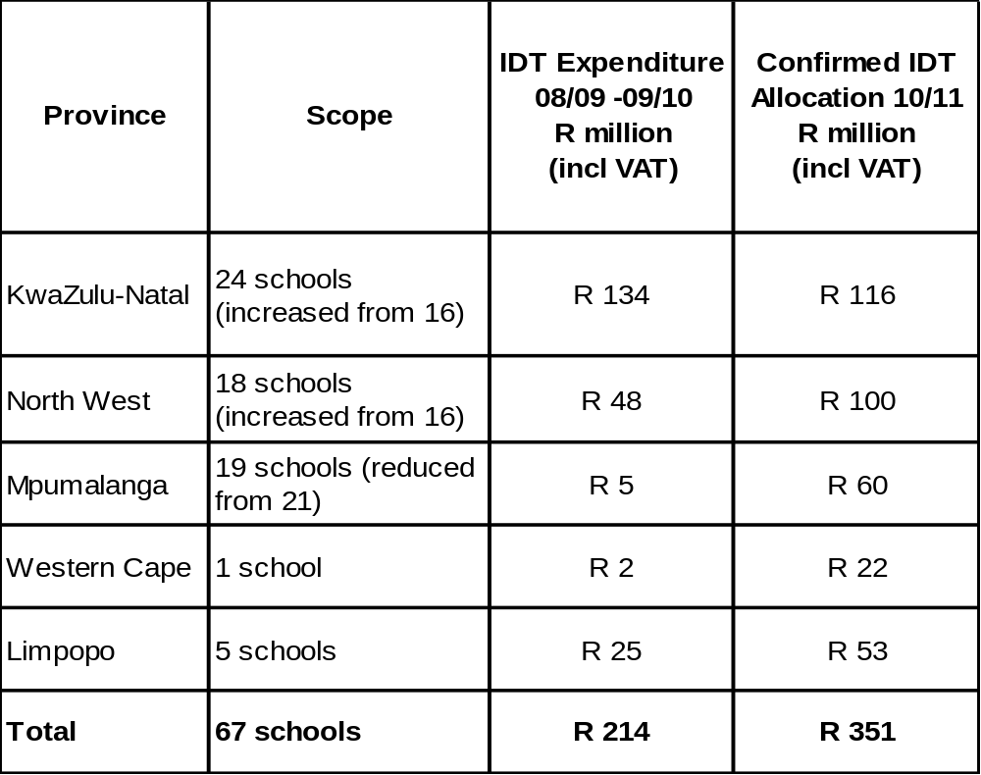
- In KwaZulu-Natal 10 projects have been handed over to DoE (7 schools are at final handover and 3 at practical completion). 12 projects are currently under construction and 1 project is at tender stage. One project is on hold pending a decision on the site location by DoE.
- In the Mpumalnaga programme the DoE has stopped the construction of 1 of the 21 schools originally identified by DoE for inclusion in the programme due to changes in infrastructure plans. Of the remaining 20 schools, 10 projects have achieved Practical Completion and construction is currently proceeding on 6 projects (including 1 project that has handed over the completed classrooms only). Decisions from the client are awaited for up to 6 montrhs on land purchases and project scope changes that are negatively affecting the progress of 9 projects.
- In the North West Province 1 project has reached Final Handover and 3 projects have achieved practical completion, with Final Handover not being possible at one project (Ipokeng) as it is awaiting an electrical connection. Construction is proceeding at 4 other projects and 10 projects that were previously on hold are at tender stage. The one remaining project is on hold.
- In Limpopo, 1 project has been completed and 4 projects have started construction.
- Construction at the Western Cape school, Klapmuts PS, is being funded jointly by DoE and IDT. Currently the project is proceeding to plan.
- In the Northern Cape and Free State no programmes were implemented by DoE during 2008/09 and 2009/10 and none are planned currently for 2010/11.
- In the 2009/10 financial year, the IDT was engaged by 5 provinces with a budget allocation to the total value of R204.5m out of a total of R800m allocated for 2009/10. The current allocation for 2010/11 is R351 million. IDT has been appointed as Implementing Agency for KwaZulu-Natal, North West, Mpumalanga, Western Cape and Limpopo.
- In the Gauteng and Eastern Cape Provinces, DPW is the Implementing Institution for the programme. IDT is however an implementing agent for a substantial school infrastructure programme in the EC funded under the normal infrastructure allocation.
- Cumulative expenditure as at 30 January 2011 in the programmes where the IDT has appointed as implementing agent amounted to R395,846,665 (including VAT).
- A total of 2,166 job opportunities have been created to date in this programme.

- IDT-Funded Programme (R150 million):

- 39 projects were included under this programme, 19 schools building projects and 20 toilet construction projects.
- 28 projects have reached final handover stage with final accounts complete and final payment processes are in progress. 7 projects in Northern Cape are completing final snags to achieve practical completion stage.
- In Western Cape the construction of Klapmuts school is being co-funded with IDT (progress is summarised under Treasury Funded Programme. Final payments utilising IDT’s funds are in progress.
- In the Northern Cape the 3 projects that have been on hold following termination of the contractor will now be re-tendered.
- 21 female contractors have been appointed by the programme.
- To compliment the schools construction, value-add projects have been completed. These have provided school furniture to 14 schools, IT laboratories to 7 schools. Implementation of wastewater treatment to 4 schools. Solar power installations in 2 schools.
- Cumulative expenditure as at 30 January 2011 was R 147,480,591
- A total of 1,728 job opportunities have been created to date in this programme.

2. IMPLEMENTATION STRATEGY
The following developmental principles are intrinsic to the implementation of these programmes:
- Expanded Public Works Programme Principles
- Innovative Construction Methodologies
- Women Contractor Development
- Contractor Development

3. TREASURY-FUNDED PROGRAMME (R2.7 BILLION)

3.1 PROGRESS

3.1.1 KWAZULU-NATAL
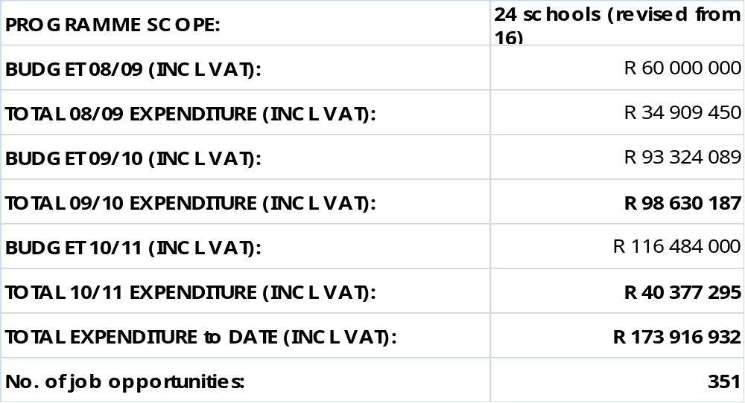

No. | PROJECT NAME | STATUS | % Constr Compl | Issues/ Problems & Action Plan | Planned Handover Date
1. | Ekuweleni PS | Final Handover | 100% |  | 30 April 09 (Actual Final)
2. | KwaNdaba PS | Final Handover | 100% |  | 30 April 09 (Actual Final)
3. | Ntunjeni PS | Final Handover | 100% |  | 22 May 09  (Actual Final)
4. | Mary Help Mission | Final Handover | 100% |  | 21 June 10 (Actual Final)
5. | Amaphisi HS | Final Handover | 100% |  | 4 June 10 (Actual Final)
6. | Amandlakhe CPS | Final Handover | 100% |  | 4 Dec 09 (Actual Final)
7. | Vusukukhanya PS | Construction (finishes/ external works) | 94% |  | 28 Feb 11  (revised from 2 May 10)
8. | Mlozana | Construction  (roofing & Finishes) | 68% | Contractor has financial problems which are causing progress delays | 31 Mar 11  (revised from 29 July 10)
9. | Zwelibanzi J.S | Construction (superstructure – classrooms & toilets, Finishes – Admin block) | 70% | Contractor performance has improved | 31 Mar 11 (revised from 31 May 10)
10. | Zwelinzima S.S | Construction (Fencing/ superstructure) | 70% | Engineers have completed an investigation on a crack and remedial action id planned | 31 Mar 11 (revised from 8 Aug 10)
11. | Brandwood J.S | Practical Completion | 95% | Construction complete, final account and closeout report in progress | 21 July 10  (Actual Practical)
12. | Zwelonke J.S | Final Handover | 100% |  | 22 Jul 10 (Actual Final)
13.1 | Entsikeni S.S - Phase 1 | Construction (finishes) | 87% |  | 31 Mar 11  (revised from 19 Aug 10)
13.2 | Entsikeni S.S - Phase 2 | Construction (superstructure) | 60% | Site handed over to contractor on 4th November 10 | 4 Apr 11
14. | Tonjeni S.S | Practical Completion | 95% |  | 26 Feb 10  (Actual practical)
15. | MT Sheba J.S | Practical Completion | 95% | Final Handover expected 15 Dec 10 | 24 Jun 10 (Actual Practical)
16. | Mdombolo PS | On hold |  | DoE have approved construction of an access road within BoQ.  Design has been started but project on hold until decision has been made on site location
17 | Riverdale P School | Construction (superstructure) | 35% |  | 4 Oct 11
18 | Gloucester Junior Secondary | Construction (superstructure) | 35% |  | 4 Oct 11
19 | Zamuxolo Primary School | Construction (superstructure) | 12% |  | 5 May 11
20 | Mpolweni Secondary | Construction (superstructure) | 5% |  | 5 Oct 11
21 | Fountain Junior Secondary | Construction (superstructure) | 20% |  | 29 Nov 11
22 | Ntsongo Junior Secondary | Construction (superstructure) | 10% |  | 29 Sep 11
23 | Washbank Junior Secondary | Procurement (adjudication) |  | Original tender process cancelled due to tender irregularities.
24 | Nguse Junior Secondary | Site clearance | 5% |  | 6 Jun 11

SUMMARY OF PROGRESS TO DATE:
- 7 projects are at final handover stage and 3 projects at practical completion.
- 12 projects are at construction stage and 1 project is on hold at the request of DoE.
- 1 project is at tender adjudication stage.
- Additional scope has been added to the Entsikeni SS project which will be completed as a second project phase, the contractor for this phase has been appointed
- Service Delivery Agreement (SDA) – the SDA has been finalized between the KZN DoE and IDT only, with KZN DPW’s involvement based on a separate standing SLA with KZN DoE.

KEY CHALLENGES
- Slow progress of 2 projects – performance of the contractors has now improved following close monitoring and support.

3.1.2 LIMPOPO
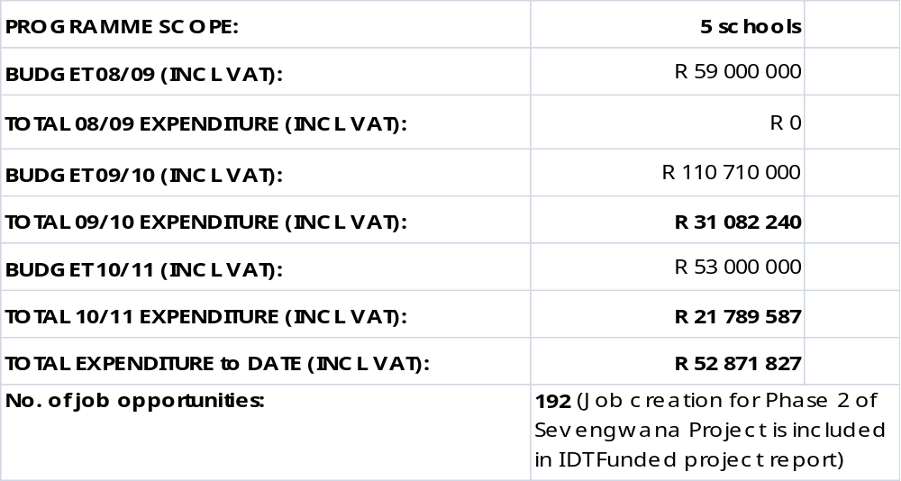
No. | PROJECT NAME | STATUS | % Constr Compl | Issues/ Problems & Action Plan | Planned Handover Date
1. | Sevengwana HS | Final Handover | 100% |  | 11 Sep 09 (Actual Final)
2. | Photo PS | Construction (superstructure) | 45% |  | 18 Jul 11
3. | Makoma PS | Construction (superstructure) | 40% |  | 18 Jul 11
4. | Matsepe PS | Foundation level | 10% | Contractor is now on schedule following delays in finalising coordinates | 18 Jul 11
5. | Xirhulurhulu PS | Construction (superstructure) | 35% |  | 18 Jul 11

SUMMARY OF PROGRESS TO DATE:
- Phase 2 of Sevengwana High School has been completed and handed over to DoE (Phase 1 is included in the IDT Funded programme).
- 4 projects are at construction stage
- The Provincial Implementing Agency (PIA) agreement has been finalized.

KEY CHALLENGES:
- None

3.1.3 MPUMALANGA

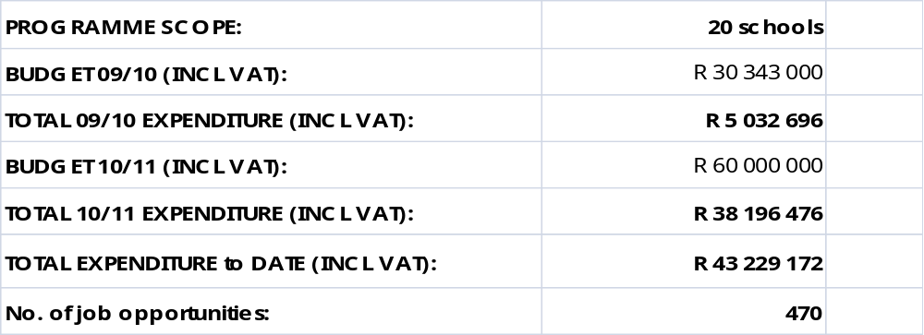
No. | PROJECT NAME | STATUS | % Constr Compl | Issues/ Problems & Action Plan | Planned Practical Handover Date
1. | Sakhisizwe P. School | Practical Completion | 95% | Practical Completion was delayed due to late payment of contractor. | 30 Sep 10 (Actual) (original 5 Aug 10)
2. | Twfelhoek P. School | Construction – Foundation stage | 20% | Project has been stopped at the request of DoE due to changes in DoE infrastructure plans.
3. | Blesbokspruit P. School | Construction (finishes) | 94% | Delay in completion due to late funding transfer from DoE. Extension of time approved | 29 Jan 11 (original planned date was 7 Aug 10)
4. | Madola P. School | Construction (finishes) | 94% | As Blesbokspruit PS | 20 Jan 11 (original planned date was 31 Aug 10)
5. | Hlobisa P. School | Practical Completion | 95% | The school Principal has requested additional work and a VO is being prepared for approval | 15 Nov 10 (Actual) (planned date was 19 Aug 10)
6. | Norden P School | Practical Completion (not taken) | 95% | Location change has resulted in change in scope of work (removal of tree stumps). VO approval awaited from DoE/DPW for 6 months | 21 Jan 11  (original planned date was 15 Sept 10)
7. | Kalkoenskrans P School | Practical Completion | 95% |  | 10 Oct 10 – Actual  (original 20 Sept 10)
8. | Ntabambomvu P School | Practical Completion | 95% | VO approval awaited from DoE for 5 months | 28 Oct 10 –Actual (original 22 Jun 10)
9. | Sitanani P School | Practical Completion | 95% | VO approval awaited from DoE for 4 months | 15 Oct - Actual  (original 15 Jul 10)
10. | Emzwele P School | Construction – Foundation stage | 5% | Project on hold. DoE and land owner are currently negotiating purchase of the land. | 22 Jun 10  (to be revised)
11. | Klipstapel P. School | Practical Completion | 95% |  | 25 Oct 10 – Actual (original 6 Aug 10)
12. | Baarjiesbult P School | Practical Completion | 95% |  | 14 Sept 10 –Actual
13. | The Brook P School | Construction (finishes) | 94% |  | 15 Jan 11 - (original planned date was 30 Jul 10)
14. | Swelihle P. School | Practical Completion | 95% |  | 25 Oct 10 – Actual (original 7 Aug 10)
15. | Bazenzele P. School | Construction (finishes) | 90% | As Blesbokspruit PS | 25 Jan 11 (original planned date was 21 Sep 10)
16. | Isidwala P.  School | Site Handover 21 Apr 10 | 0% | Project on hold. DoE and land owner are currently negotiating purchase of the land.
17. | Dumisani P. School | Site Handover 21 Apr 10 | 0% | As Isidwala
18. | Khangela P School | Practical Completion | 95% |  | 26 Oct 10 – Actual (original date was 20 Sep 10)
19. | Esigangeni P. School | Construction (foundations) | 50% | Project on hold pending client decision on scope | 3 Dec 10 (to be revised – original planned date was 21 Sep 10 )
20. | Versatilles P School | Practical Completion | 95% |  | 23 Sep 10 –Actual (original planned date was 20 Sep 10)
21a. | Sizimisele P School (Phase 1) | Partial Practical Completion achieved on 8 Nov 10 | 95% | Classrooms have reached practical completion | 8 Feb 11  (original planned date was 30 Jul 10)
21b. | Sizimisele P School (Phase 2) |  | 0% | The project was advertised and was put on hold by the Client Department at tender adjudication stage due to budget constraints. Awaiting the approval of budget from client department

SUMMARY OF PROGRESS TO DATE:
- PIA agreement has been concluded.
- 10 projects are at Practical Completion
- 6 projects are currently under construction including 1 that has achieved partial Practical Completion.
- 3 projects are on hold pending DoE securing purchase of land or right to the use of the land.
- 1 project is on hold pending client decision on revised project scope
- 1 project has been stopped by DoE (contractor has completed some work on this project).
- 1 project (Phase 2 of the Sizimisele PS) is on hold awaiting budget approval

KEY CHALLENGES:
- Decisions from the client on land purchases and scope changes (including approval of variation orders for 6 projects) are not forthcoming despite continued engagement from IDT’s regional office.

3.1.4 NORTH WEST
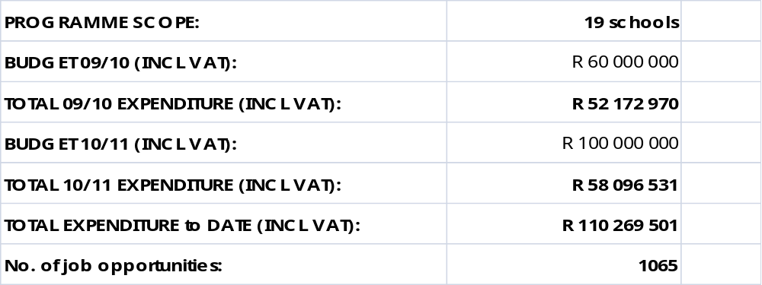

No. | PROJECT NAME | STATUS | % Constr Compl | Issues/ Problems & Action Plan | Planned Handover Date
1. | Ipokeng P. School | Practical Completion | 95% | Final Handover delayed by ESKOM connection | 12 Oct 09 (Actual Practical)
2. | Mmanotshe Moduane H. School | Construction (superstructure) | 58% |  | 1 Feb 11
3. | Batshabeng P. School | Tender stage - on hold | 0%
4. | Nozizwe P. School | Final Handover | 100% |  | 9 Jul 10  (Actual Practical)
5. | Kakanyo P. School | Practical Completion | 95% |  | 15 Sep 10  - Actual (original planned date was from 22 Jul 10)
6. | Gaeonale P. School | Tender stage | 0% | Appointment expected Jan 11
7. | Dingake P. School | Tender stage | 0% | Appointment expected Jan 11
8. | Letsopa P. School | Practical Completion | 95% |  | 26 Oct 10 - Actual (original planned date was 10 Nov 10)
9. | Gatelapele S. School | Tender stage | 0% | Appointment expected Jan 11
10. | Ooskraal I. School | Site Establishment | 0%
11. | Matloding P. School | Tender stage | 0% | Appointment expected Jan 11
12. | Ikalafeng P. School | Tender stage | 0% | Appointment expected Jan 11
13. | Gaegane P. School | Tender stage | 0% | Appointment expected Jan 11
14. | Tshwaraganang P. School | Tender stage | 0% | Appointment expected Jan 11
15. | Ithuseng P. School | Tender stage | 0% | Appointment expected Jan 11
16. | Ragogang P. School | Tender stage | 0% | Appointment expected Jan 11
17. | Madibogo Batlhaping PS | Construction (superstructure) | 64% |  | 21 Mar 11
18. | Lilian Lehetla Special School | Construction (superstructure) | 40% |  | 22 Apr 11
19. | Phatshima PS | Tender stage | 0% | Appointment expected Jan 11

SUMMARY OF PROGRESS TO DATE:
- 1 project has reached Final Handover and 3 projects have reached Practical completion
- Construction at 4 other projects is underway. The project manager and contractor at one project have been put on terms due to poor performance.
- Adjudication of tenders and appointment of contractors for 10 projects is underway and 1 project is currently on hold.

KEY CHALLENGES:
- None.

3.1.5 FREE STATE

IDT were not appointed as Implementing Agent for the 2008/09 programme (R1.8m which was allocated to minor repairs).
IDT assisted DoE with planning for 2009/10, for which a draft Approach Plan was developed. Free State DoE have now confirmed that no budget is available for the programme for 2009/10 and 2010/11.

3.1.6 WESTERN CAPE
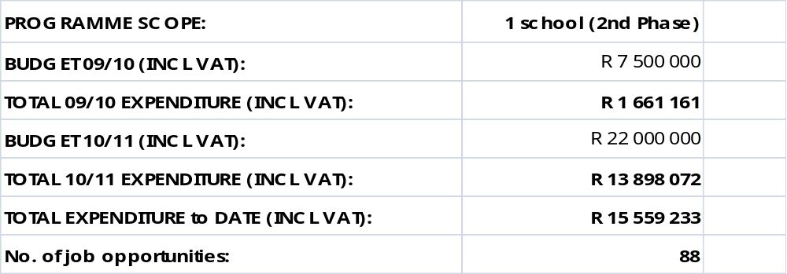
No. | PROJECT NAME | STATUS | % Constr Compl | Issues/  Problems & Action Plans | Planned Handover Date
1. | Klapmuts PS | Construction (Superstructure) | 90% |  | 30 Mar 11

SUMMARY OF PROGRESS TO DATE:
- Construction on target.
KEY CHALLENGES:
- None
3.1.7 NORTHERN CAPE

- No funds were available for 2008/09 for this programme.
- IDT assisted Northern Cape DoE with planning for 2009/10, for which a draft Approach Plan was developed, however Northern Cape DoE have now confirmed that no budget is available for the programme for 2009/10 and 2010/11.

4. IDT-FUNDED PROGRAMME (R150 MILLION)

4.1 PROGRESS

4.1.1 KWAZULU-NATAL

PROGRAMME SCOPE: 4 schools
BUDGET (EXCL VAT): R 34 million (Revised to: R33.8m)
CURRENT EXPENDITURE (EXCL. VAT): R 31,351,027
No. of job opportunities: 115

No. | PROJECT NAME | STATUS | %  ConstrCompl | Issues/  Problems & Action Plans | Planned Handover Date
1. | Ndwakazana CS (Amajuba) | Final Handover | 100% | All payments completed | 21 Aug 09  (Actual final delivery)
2. | St Faith PS (Port Shepstone) | Final Handover | 100% | All payments completed | 17 June 09 (Actual Final Delivery)
3. | Mangeni PS (Sisonke) | Final Handover | 100% | All payments completed | 24 June 09 (Actual Final Delivery)
4. | Ezibindini PS (Vryheid) | Final Handover | 100% | All payments completed | 21 Aug 09  (Actual Final Delivery)

PROGRESS TO DATE:
- All 4 projects have been handed over to the client, final delivery has been achieved and final payments made.
- Final closeout reports are in progress.

KEY CHALLENGES
- None

4.1.2 EASTERN CAPE REGION

PROGRAMME SCOPE: 5 schools
BUDGET (EXCL. VAT): R 34 million (Revised to R 33.8m)
CURRENT EXPENDITURE EXCL VAT): R 31,377,691
No. of job opportunities: 160

No. | PROJECT NAME | STATUS | % ConstrComp | Issues/  Problems & Action Plans | Planned Handover Date
1. | Mngomanzi SSS (Amatole) | Final Handover | 100% | Final payments are in progress | 18 Dec 09  (Actual Final)
2. | Tembeni (Amatole) | Final Handover | 100% | Final payments are in progress | 11 Mar 10 (Actual Final)
3. | Gcinubuzwe (Chris Hani) | Final Handover | 100% | Final payments are in progress | 26 Feb 10 (Actual Final)
4. | Dalisoka SPS (OR Tambo) | Final Handover | 100% | Final payments are in progress | 30 Sept 08 (Actual Final)
5. | Pelandaba SPS (OR Tambo) -replaced Meyisi | Final Handover | 100% | Final payments are in progress | 12 Jan 10  (Actual Final)

PROGRESS TO DATE:
- All 5 projects are at final handover stage, final accounts have been paid and consultants’ fee payments are in progress.
KEY CHALLENGES:
- Submission of Closeout reports – these are being followed up with the Principal Agent.

4.1.3 LIMPOPO

PROGRAMME SCOPE: 1 school
BUDGET (EXCL. VAT): R 24.25 million (Revised to: R22.5m)
CURRENT EXPENDITURE (EXCL VAT): R 20,483,009
No. of job opportunities: 1002

No. | PROJECT NAME | STATUS | % Constr Compl | Issues/  Problems & Action Plans | Planned Handover Date
1. | Sevengwana HS (Mopani) | Final Handover | 100% | All payments completed.  Closeout Report drafted | 11 Sept 09 (Actual Final Handover)

PROGRESS TO DATE:
- Phase 1 of project (IDT funded) and Phase 2 (DoE funded) are now at Final Handover
- The closeout report has been drafted.

KEY CHALLENGES:
- None

4.1.4 MPUMALANGA

PROGRAMME SCOPE: 5 schools
BUDGET (EXCL. VAT): R 19.5 million (Revised to: R21.13)
CURRENT EXPENDITURE (EXCL. VAT): R 18,906,303
No. of job opportunities: 154

No. | PROJECT NAME | STATUS | % ConstrCompl | Issues/  Problems & Action Plans | Planned Handover Date
1. | Sibahle PS  (Gert Sibande) | Final Handover | 100% | Final payments are in progress | 30 May 09 (Actual  Final)
2. | Lamlile CS  (Gert Sibande) | Final Handover | 100% | Final payments are in progress | 26 June 09 (Actual)  Final)
3. | Retsebile PS  (Gert Sibande) | Final Handover | 100% | Final payments are in progress | 26 June 09 (Actual)  Final)
4. | Van Standerdam PS (Gert Sibande) | Final Handover | 100% | Final payments are in progress | 26 June 09 (Actual)  Final)
5. | Memezile HS (Ehlanzeni) | Final Handover | 100% | Final payments are in progress | 4 Mar 10 (Actual Final)

PROGRESS TO DATE:
- All 5 projects are at final handover stage and final fee accounts are being processed.

KEY CHALLENGES:
- Submission of Closeout reports – these are being followed up with the Principal Agent.

4.1.5 NORTH WEST

PROGRAMME SCOPE: 3 schools (reduced from 4 schools)
BUDGET (EXCL. VAT): R 19.5 million (Revised to: R20m)
CURRENT EXPENDITURE (EXCL. VAT): R 19,266,399
No. people employed: 147

No. | PROJECT NAME | STATUS | % ConstrCompl | Issues/  Problems & Action Plans | Planned Handover Date
1. | Langa La Sembo PS (Bojanala) | Final Handover | 100% | Final payments are in progress | 28 Aug 09  (Actual Practical)
2. | Marope PS (Bophirima) | Final Handover | 100% | Final payments are in progress | 17 July 09  (Actual Practical)
3. | Kelesedi PS (Southern) | Final Handover | 100% | Final payments are in progress | 30 July 09  (Actual Practical)

PROGRESS TO DATE:
- All 3 projects are at Final Handover stage. Final accounts have been approved and final fee payments are in progress.

KEY CHALLENGES:
- Finalisation of Closeout Reports. This is being followed up with the Principal Agent.

4.1.6 FREE STATE

PROGRAMME SCOPE: 10 schools (toilet blocks)
BUDGET (EXCL. VAT): R 5 million (Revised to: R 5.2m)
CURRENT EXPENDITURE (EXCL. VAT): R 4,751,535
No. people employed: 96

No. | PROJECT NAME | STATUS | % Constr Compl | Issues/  Problems & Action Plans | Planned Handover Date
1. | Sekgompepe PS | Final Handover | 100% | All payments completed | 20 May 09 (Actual Final Handover)
2. | Namahadi PS | Final Handover | 100% | All payments completed | 20 May 09 (Actual Final Handover)
3. | Bolata IS | Final Handover | 100% | All payments completed | 28 May 09 (Actual Final Handover)
4. | Koos Mota IS | Final Handover | 100% | All payments completed | 20 May 09 (Actual Final Handover)
5. | Tseseng PS | Final Handover | 100% | All payments completed | 20 May 09 (Actual Final Handover)
6. | Thibella IS | Final Handover | 100% | All payments completed | 20 May 09 (Actual Final Handover)
7. | Mpophomo CFS | Final Handover | 100% | All payments completed | 21 August 09 (Actual Final Handover)
8. | Glen Ash CFS | Final Handover | 100% | All payments completed | 21 August 09  (Actual Final Handover)
9. | Ntsu SS | Final Handover | 100% | All payments completed | 20 May 09 (Actual Final Handover)
10. | Phaphama PS | Final Handover | 100% | All payments completed | 20 May 09 (Actual Final Handover)

PROGRESS TO DATE:
- All 10 Projects at Final Account stage
- All payments have been completed.

KEY CHALLENGES:
- Finalisation of Closeout Reports. This is being followed up with the Principal Agent.

4.1.7 WESTERN CAPE

PROGRAMME SCOPE: 1 school (1st Phase)
BUDGET (EXCL. VAT): R 5 million
CURRENT EXPENDITURE (EXCL. VAT): R 4,182,595
No. people employed: 0 (included in DoE funded project report)

No. | PROJECT NAME | STATUS | % Constr Compl | Issues/  Problems & Action Plans | Planned Handover Date
1. | Klapmuts PS | Construction stage (superstructure) | 100% |  | N/A for Phase 1

PROGRESS TO DATE:
- Phase 1 of the construction is complete, final payments are being processed.
KEY CHALLENGES:
- None

4.1.8 NORTHERN CAPE

PROGRAMME SCOPE: 10 schools (toilets only) - revised.
BUDGET (EXCL. VAT): R 5 million (Revised to: R5.3m)
CURRENT EXPENDITURE EXCL VAT) : R 3,855,474
No. people employed: 54

No. | PROJECT NAME | STATUS | % Constr Compl | Issues/  Problems & Action Plans | Planned Handover Date
 | TT Lekalake PS | Practical Completion (not taken – snags to complete) | 95% | New contractor appointed (original contractor terminated) | 30 Mar 11
 | Rusfontein PS | Pre-tender stage | 0% | Re-tendering following termination of contractor
 | Oreeditse PS | Pre-tender stage | 0% | Re-tendering following termination of contractor
 | Gato – lwa – Tlou PS | Pre-tender stage | 0% | Re-tendering following termination of contractor
 | Itekeleng PS | Practical Completion (not taken – snags to complete) | 95% | New contractor appointed (original contractor terminated) | 30 Mar 11
 | Gahohuwe PS | Practical Completion (not taken – snags to complete) | 95% |  | 30 Mar 11
 | Rearata PS | Practical Completion (not taken – snags to complete) | 95% |  | 30 Mar 11
 | Oarabile PS | Practical Completion (not taken – snags to complete) | 95% |  | 30 Mar 11
 | Nametsagang HS | Practical Completion (not taken – snags to complete) | 95% |  | 30 Mar 11
 | Ikakanyeng SS | Practical Completion (not taken – snags to complete) | 95% |  | 30 Mar 11

PROGRESS TO DATE:
- 7 projects require snag lists to be completed before practical Completion is achieved.
- The tender process for the remaining 3 schools has now been initiated following approval of additional funds. The original contractor for these schools was terminated for poor performance.

KEY CHALLENGES:
- PIA finalisation – PIA agreement has been misplaced by DPW on following signing by DoE (3 PIA agreements have to date been sent to DoE). It has now been agreed that the PIA agreement will be between DoE and IDT only and a new agreement is being drafted by IDT.

4.1.9 NATIONAL

PROGRAMME SCOPE: (i) Project Management Services
(ii) School Furniture (14 schools)
(iii) IT Laboratory installation at schools (7 schools)
- Wastewater treatment at schools (4 schools)
- Solar Power installation at schools (2 schools)

BUDGET (EXCL. VAT): R 13,833,276
CURRENT EXPENDITURE (EXCL VAT) : R 13,306,558

No. | PROJECT NAME | STATUS | % Compl | Issues/  Problems & Action Plans | Planned Completion Date
1. | Project Management Services | Project complete. Final Report received | 100% |  | 4 May 09 (Actual)
2. | School Furniture | Complete | 100% |  | 30 Nov 09 (Actual)
3 | IT Laboratories | Installation complete | 100% |  | 30 April 10  (Actual)
4. | Wastewater Treatment  (N. Cape) | 3 of 4 installations complete | 100% |  | 30 May10 (Actual)
5 | Solar Power | Installation at 2 schools complete | 95% |  | 30 Apr 10 (Actual)

PROGRESS TO DATE:
- The furniture has been supplied and installed at all the schools in the North West, Kwa-Zulu Natal, Eastern Cape and Mpumalanga provinces.
- The service provider has completed the installation of computer systems at the schools in the North West and Eastern Cape provinces.
- Installation and commissioning of waste water treatment plants has been completed at all 4 schools and regular water testing of the water indicates that the plants are operating satisfactorily.
- Solar power installations have been completed - the delivery of materials was delayed 4 months to November 2009.

KEY CHALLENGES:
- None
- N
5. CHALLENGES EXPERIENCED AND ACTIONS TAKEN BY IDT

ENTAL TARGETS

5.1 Challenges
- Major delays were experienced with regards to approval of projects by provincial Departments of Education. This resulted in construction on the majority of IDT Funded projects only starting after April 2008.

- Approval of provincial agreements for the IDT Funded Programme has been a challenge with 3 agreements still outstanding in Mpumalanga, Northern Cape and Eastern Cape.

Capacity of emerging contractors: lesson learned has been that working with the small contractors that were used in most of these projects does require more extensive hands-on support than what is normally provided in the normal delivery institutional arrangements. Going forward, this is addressed by the IDT in-house contractor development programme.

- Non-payment or late transfer of programme funds from provincial departments has been experienced in many provinces involved in the Treasury-funded programme. This has had a profound affect on the rate of infrastructure delivery, particularly in projects involving small contractors who are unable to self-finance projects for extensive periods.

- In Mpumalanga current projects have delayed or put on hold pending decisions and/or action from the provincial DoE.

5.2 Actions Taken to Address Challenges

The following actions have been taken to avoid future occurrences of the foregoing challenges:-

- Project approvals: Provincial Departments of Education and Public Works were proactively engaged to kick-off initiation and programme planning.
- Provincial agreements: Programme Implementation Agreements were pro-actively prepared and forwarded to DPW where funding allocations were confirmed. DoE was engaged by the IDT to confirm allocation of funding to the programme.
- Capacity of service providers: The IDT in partnership with the NEF commissioned an emerging contractor support programme. Furthermore, the IDT has instituted a women focused contractor development programme supporting 45 women contractors over a three year period.
- Continuous engagement with provincial clients to raise and address challenges such as payment transfers and slow decision-making.

  - Conclusion

The following developmental principles are intrinsic to the implementation of these programmes:

- Expanded Public Works Programme Principles.
- Innovative Construction Methodologies.
- Women Contractor Development.
- Emerging Contractor Support Programme.

The conclusion of a multi year co-operation agreement with DPW re-enforced by the DPW drive to reclaim its mandate would go a long way in institutionalising early planning and speedy delivery.

Compiled by: David Gadd, Programme Manager: Portfolio Management Services

