15-Nov-10

Portfolio Committee on Economic Development 16th November, (National Assembly),
[Public Hearings on Small and Medium Enterprises (SMEs) access to funding],
Committee Room E249, Second Floor, National Assembly Wing, 09:30

SME’s need funding to buy assets: land, buildings, plant and equipment and for working capital to pay for salaries, goods and services during production. A business plan is required The SME must offer personal guarantees. NOT EASY TO ACCESS LOANS.

There are (say) five million unemployed families in SA. That is 35% of the total 14.2M unemployed. [SA Institute of Race Relations [CT Nov 15 2010]]. A small enterprise can be a one–family show like me.

Let’s take the worst scenario that in the next ten years none of these find formal jobs. Nevertheless these 5M families must be able to make a decent life for themselves. This is best done in villages and towns where there is land enough to be self-sufficient and where they can build good houses,. Access to a modern village is needed with schools and clinics and from where they can take temporary jobs or simply work the land as www.sacprif.org.

The secret of farming is to use the productive power of nature. For example, a pair of rabbits produce 800 progeny a year worth R24 000. A hand-raised Angora goat will yield ultra-fine fibre worth R136 000 each year. Two hundred square metres of arable land is all that is needed to grow food for a family of four, working for less than two weeks a year. The sun is powerful:

“If we convert the energy gained from harvested plants into kilowatt hours and compare it with the energy expended for that harvest, the result is startling: for fifty harvested energy units the American farmer invests 250 fuel energy units, the Chinese farmer only a single of human energy.

"This means simply that the primitive countryman of the east works at an efficiency rate of 5000 per cent and the USA farmer equipped with the most advanced technical aids, at an efficiency rate of only 20 per cent" Felix Paturi NATURE, MOTHER OF INVENTION Themes and Hudson, 1976

DECENT RURAL LIFE-1.2Ha
120sqm house: 3year development period, phased. Use the clay and rocks for building and grow the rest. Small capital cost. Don’t chase cash crops. Rear rabbits, angora goats, fruit.
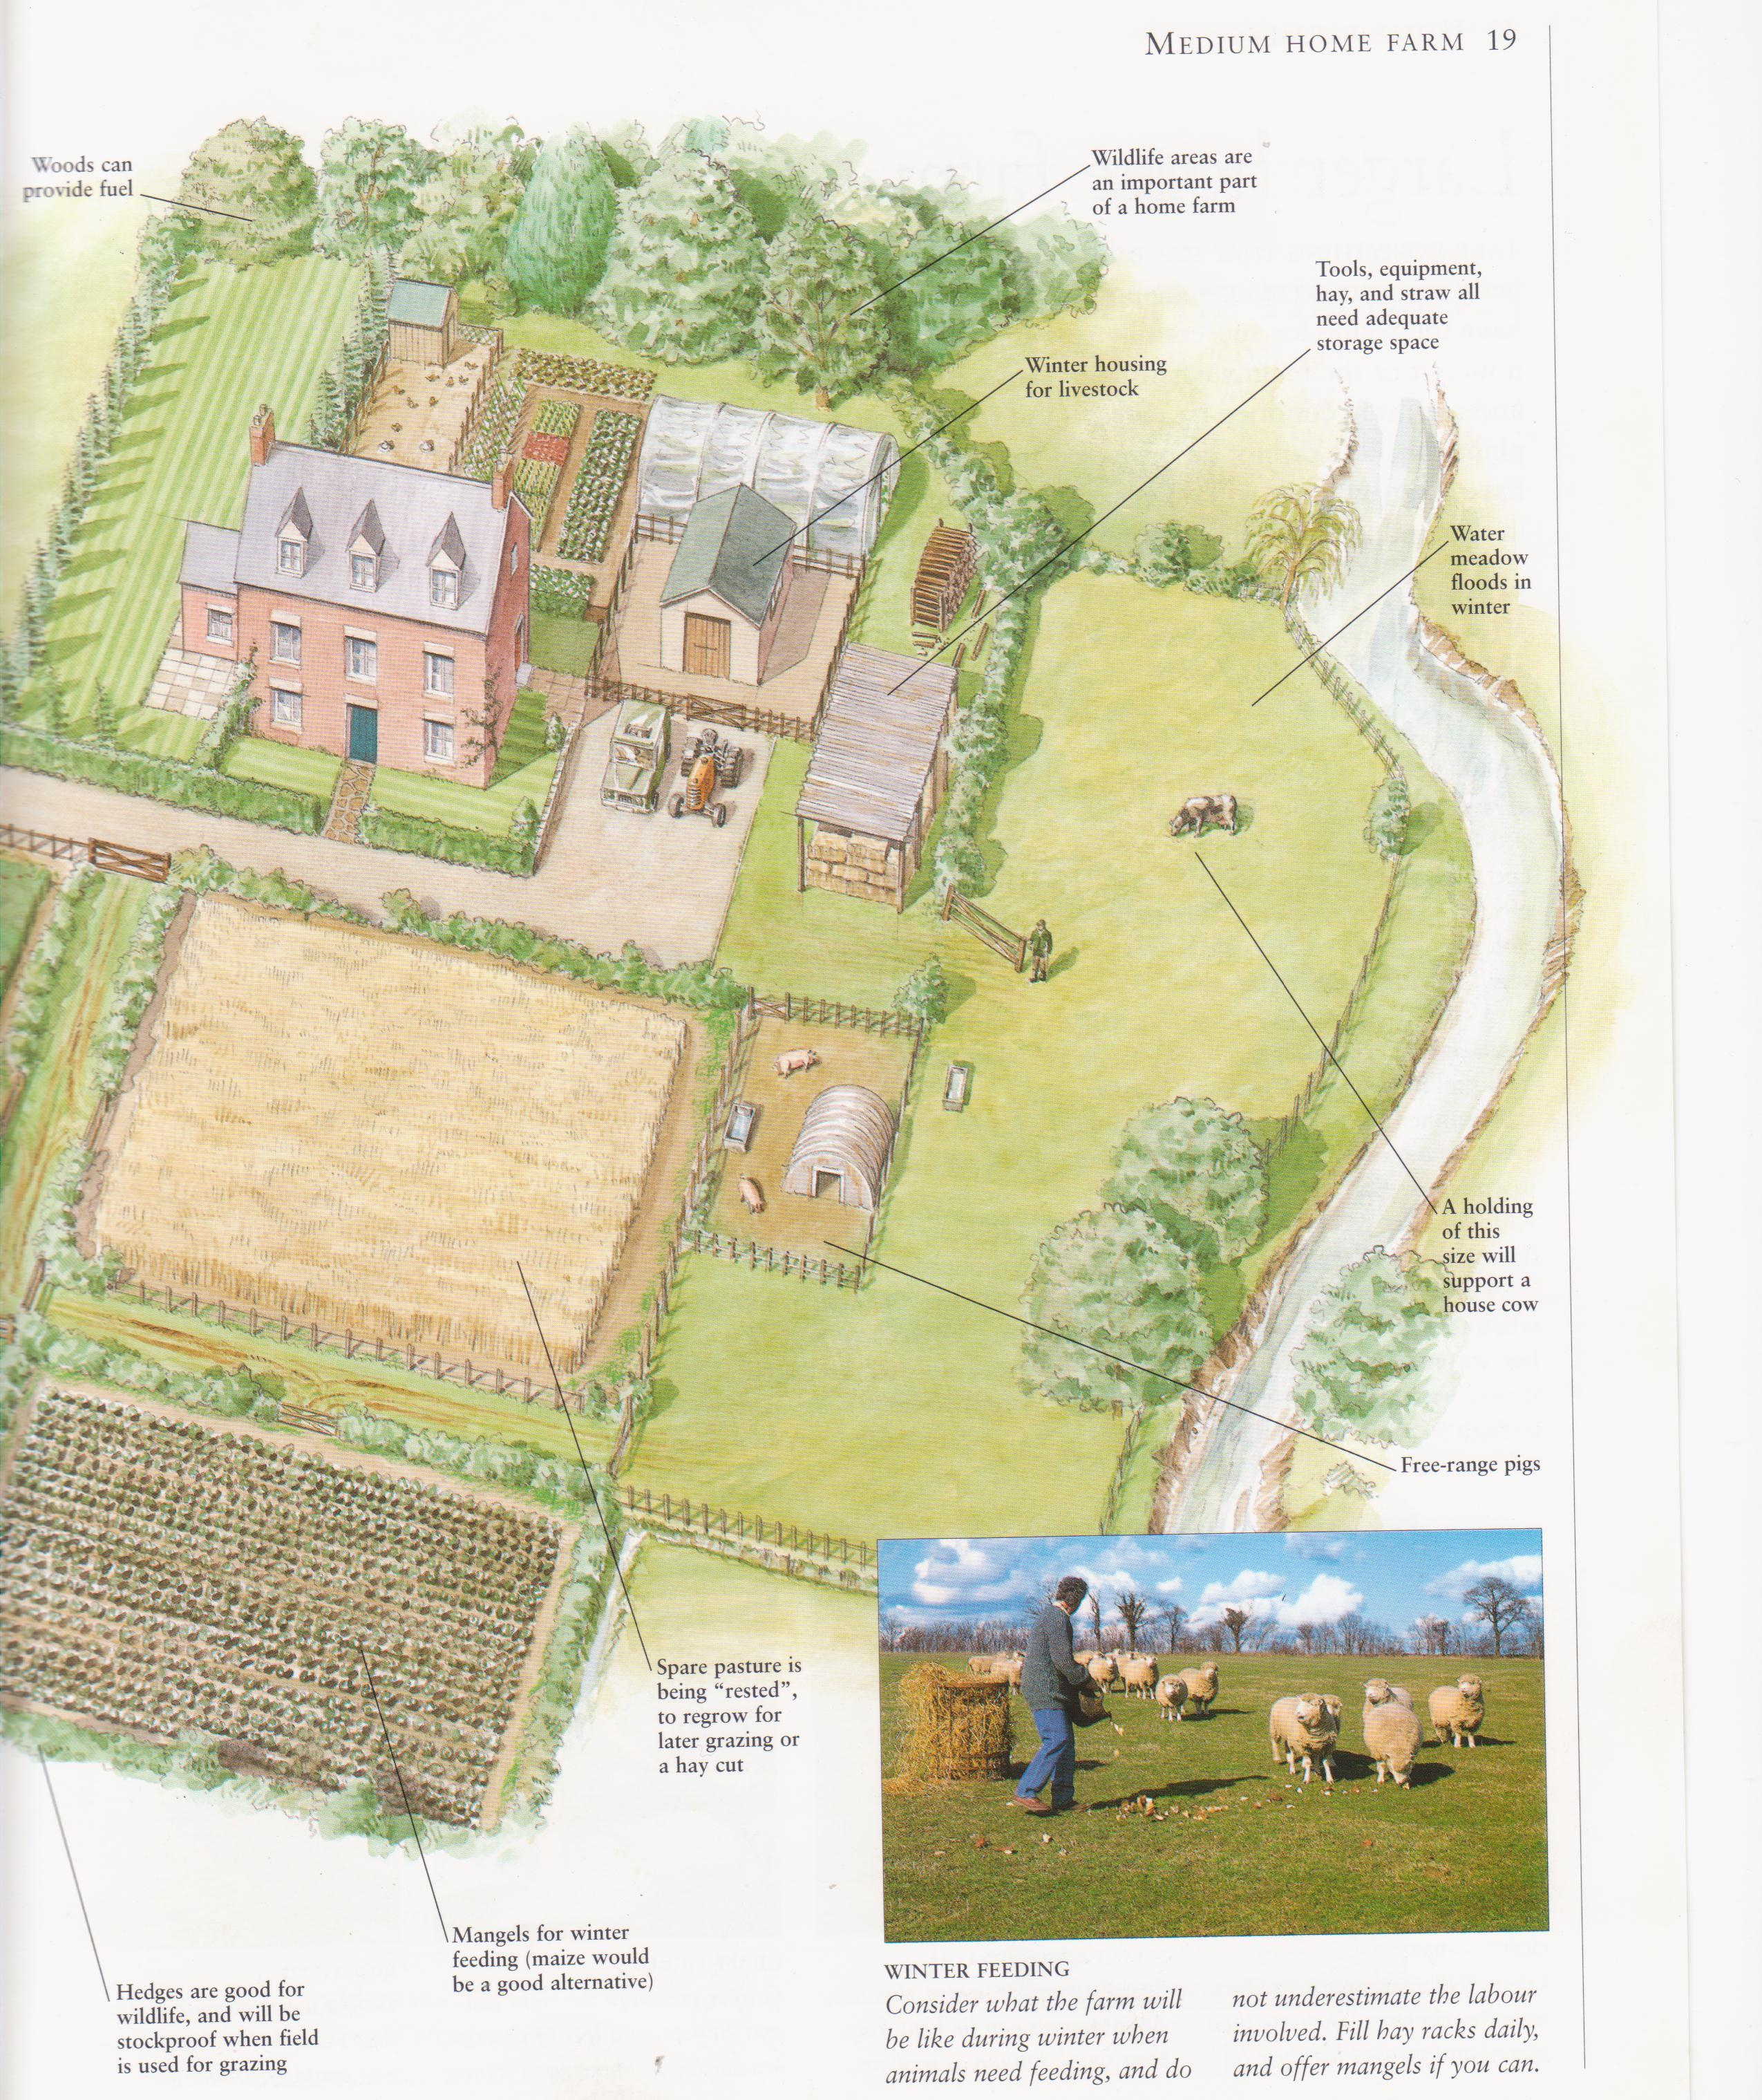

Where is the land? 27M hectares of unused arable land in SA [Frost and Sullivan].

What is its cost? ± R500 000 average for urban plot. Small holdings more.

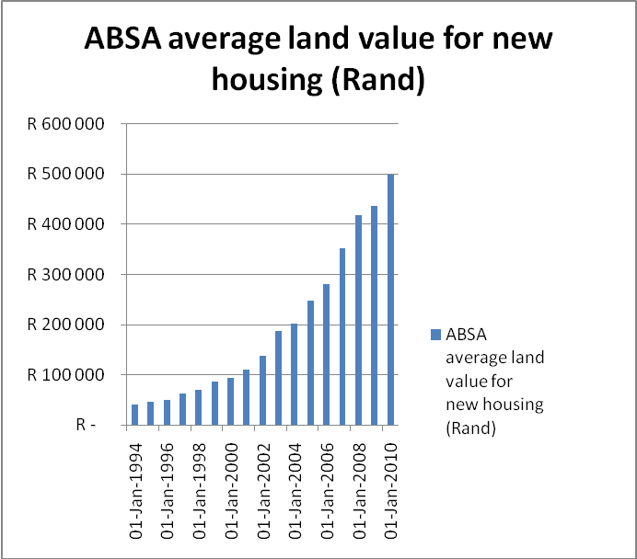

Why does land have any entry cost, any price? God gave the land just to his people not those who can afford it.

What has gone wrong?

Metaphorically land is a treasure box which had no production cost, cannot be replaced, does not depreciate or become obsolescent and, if we each just make the effort to open the lid, will yield all the material essentials and luxuries one can ever imagine.

But to open the lid we have to get to the box and in South Africa that is more difficult than anywhere else in the world. According to the Economist House Price Indicator, a conservative proxy for land prices, South African land prices have risen 4.6 times in the last thirteen years.

We know this because where land costs are contained, such as in Hong Kong where there are no land prices because land is leased, the GDP is five times that of South Africa’s [R186 180 vs R37 306 at R7=$1,
Economist Pocket World of Figures 2009].

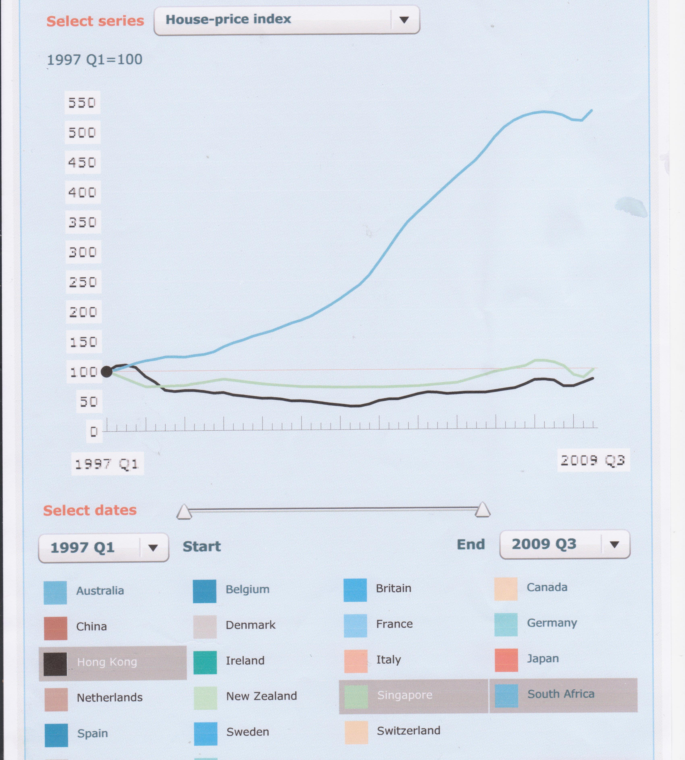

THEREFORE The first law of economic growth [by Meakin]:
“GDP is stifled when taxes are levied on property, capital, and employment and trade because these costs all rise. It will flourish under a land rent as the single tax, as they then all fall.”

HOW TO MAKE LAND AFFORDABLE THROUGHOUT SA?

Persuade Minister Gordhan to gradually replace Income Tax Acts and VAT with a single tax on land, like Rates and Taxes.

WHAT TO DO IMMIEDIATELY?

Expropriate 5M Ha of the 27m arable “unused” land? After announcing the relief of Income Taxes and VAT

WHERE IS THIS USED

Ethiopia, Botswana, Mozambique use similar methods but

Joshua Nkomo, one time deputy President of Zimbabwe, put the land question beautifully:-

“We don't believe in trading land or selling land - no. And in any government that I lead, you can be certain those practices must go. That does not mean we will be taking people's land. It means that other people who haven't got money will have a chance to use land, which is the common property of everybody.

“And if they have to pay some rates or rents, that will go to a general fund of the people. In this way citizens can use as much land as they want. Our system is this: once you use land, that land belongs to you. But you have not bought it. You cannot sell it to someone. The land belongs to the people, but everything on that land is yours.”

CONSTITUTION

The Constitution demands that “the state must take reasonable legislative and other measures, within its available resources, to foster conditions which enable citizens to gain access to land on an equitable basis.”
To legal counsel
Fostering conditions can easily mean changing to a new land pricing system,
Equitable means that gaining access to raw land must be affordable to everyone and that means vacant land must become free of any entry, or capital cost.
Within its available resources means taking some administrative action like changing the tax rates which really do not cost anything. [Remember in 2008 that Minister Manuel reduced corporate rates to 28% on the grounds that would help job creation.

THEORY oF NIL CAPITAL COST of RAW LAND

No capital cost means reducing the p/e ratio of land prices from ±240 to 1 months rent by capturing [taxing]
the entire land rent and simultaneously repealing VAT and the Income Tax Acts, both personal and corporate.

This is sometimes described as nationalising land rents, not the land, whilst simultaneously privatising all work, savings and business. As Ricardo noted, land rents are not man-made and are therefore the ultimate tax instrument, returning to the community those values which nature and society generate through public infrastructure and the growth of settlements.

