

HUMAN RIGHTS OFFICE

SUBMISSION TO THE CONSTITUTIONAL REVIEW COMMITTEE

For further information regarding the submission or any queries, please contact:

Theodore Kamwimbi / Johnlyn Tromp

Projects Abroad Human Rights Office

Main Road, Rondebosch

Tel: 021 685 1998

Mobile: 072 024 7310

Email: humanrights@projects-abroad.org

Web: http://www.volunteer-human-rights.org/

31 May 2010
Ms Pat Jayiya
Committee Secretary
Constitutional Review Committee
Cape Town, 8000

By email: lpjayiya@parliament.gov.za

Dear Madam

Delivery of health care services, sufficient water and social security in South Africa and Challenges Pertaining Thereto

CONTENTS

1 Introduction
1.1 Aims and objectives of report
1.2 Method of research
1.3 Drafting history and International context
1.4 Relevant case-law
2 Problems arising in fulfilling ESRs
2.1 Separation of Powers
2.2 Civil/Political Rights and ESRs – priority issues
3. Specific problems observed in communities and recommendations
3.1 Health care
3.2 Social security
3.3 Water
4 Main recommendations
4.1 South African Human Rights Commission Recommendations
4.1.1 Health care
4.1.2 Water
4.1.3 Social security
4.2 Establishing a human rights-based approach
4.3 Structural Interdicts and the South African Human Rights Commission – A way forward with Judiciary enforcement
5. Conclusion
6. Bibliography
7. Acknowledgements

1. Introduction
”I was in the waiting room at the Blikkiesdorp Health Clinic in the morning with my grandchild awaiting treatment. There was a man there as well who was stabbed awaiting treatment. I was worried for my grandchild and tried to shield him from the sight. The man died there waiting to get treated. He died there waiting in front of my grandchild. After this time, I never returned to the Blikkiesdorp Health Clinic and have no choice but to go to Observatory Hospital.” – Woman surveyed at Blikkeisdorp, Delft - May 2010
”We live in a society in which there are great disparities in wealth. Millions of people are living in deplorable conditions and in great poverty. There is a high level of unemployment, inadequate social security, and many do not have access to clean water or to adequate health services. These conditions already existed when the Constitution was adopted and a commitment to address them, and to transform our society into one in which there will be human dignity, freedom and equality, lies at the heart of our new constitutional order. For as long as these conditions continue to exist that aspiration will have a hollow ring.”
The purpose of the 1996 South African Constitution was to be transformative in moving from the past atrocities to the new democratic dispensation. The incorporation of civil and political rights was paramount in attaining this goal – eradicating discrimination and inequality would empower the black and coloured majority who previously faced political suppression.
Equally important was the incorporation of economic and social rights which is given effect in the 1996 South African Constitution under Chapter 2 of the Bill of Rights. However, 14 years into democracy, rights to housing, health care, food, water, social security and basic education are still elusive for many. The overall purpose of incorporating these rights was to end economic and social injustice. Establishing what exactly these rights entail and mean has been difficult on a judiciary, executive and legislative level. This has led to ongoing difficulties with enforcement resulting in what we consider an inadequate fulfilment of economic and social (hereinafter referred to as ’ESR’) rights.
This submission is in part investigatory in nature, depicting the conditions and realities which the members of the Lavender Hill, Delft, and Diep River communities face in the access of water, health care, and social assistance as guaranteed under Section 27 of the Bill of Rights. In order to supplement our quantitative and qualitative research, this paper aims to substantiate elements of its arguments and independent research within an academic context. It is without question that the fulfilment of ESRs has been a much discussed and explored topic, thus it only seeks to focus on three of the above-mentioned ESRs.
When considering the challenges associated with fulfilling ESRs, there are two core problems of focus, which this paper will review and consider in detail. The first obstacle can be the challenges associated with the ‘separation of powers’ within the newly formed democratic state of South Africa. For the purpose of this paper, we shall consider that the rule of law requires the three major functions of state, the legislative, the executive and judicial to be exercised by independent bodies. Despite the bodies functioning independently, there needs to be mutual co-operation in order to deliver an effective service. This will entail the challenges the judiciary has faced with vagueness in establishing a ’minimum core’ of what the conditions and thresholds are for finding an infringement of an ESR. We shall consider these challenges in section 2.1 below, as well as reviewing how they have emerged within relevant case-law to date (section 1.4).
Secondly, a strong perception exists of civil/political rights as a bundle of rights that are given higher priority over ESRs. Contesting this perception is paramount to attaining the fulfilment of ESRs.
The above represents the problems with fulfilling ESRs. Following from this we will turn to discussing the specific problems observed in communities along with recommendations for their solution. Afterwards we will provide our main recommendations (section 4) which will entail an objective review of the past and current findings of the South African Human Rights Commission (SAHRC). These will not only provide an insightful guide of past challenges, but also help to understand the role of the SAHRC and how it can help to eradicate social and economic injustice in South Africa.
1.1 Aims and Objectives of this report
- To critically review the South African Constitution of 1996 with respect to Chapter 2 (Bill of Rights), Section 27
- To conduct surveys on the conditions in Lavender Hill, Diep River and Delft in relation to the fulfilment and enjoyment of:
  - The right to access to water;
  - The right to access to health care and;
  - The right to access to social assistance.
- To understand if there is a correlation between the actual progression or lack of progressive realisation of the said rights and the socio-economic circumstances of people living in the surveyed areas
- To highlight the key obstacles/issues facing the people living in the surveyed areas
- Propose recommendations on tackling the obstacles by
  - Recognising the academic concerns relating to the judicial aspects of enforcing these rights.
  - Recognising proposals presented by the South African Human Rights Commission.
  - Recognising the testimonies and concerns raised by the members of these communities.

1.2 Method of research
In the interest of compiling an effective report, we found it imperative to steer away from relying solely on the academic perspective, and aim to highlight the realities of Lavender Hill, Diep River and Delft. This required conducting a total of 108 surveys in these communities on the access to water, health care and social assistance. Whilst the academic perspectives enriches our knowledge in comprehending the challenges facing governmental policy and judiciary involvement, the ground research carried out at these communities reveal the practical problems in fully realising ESR. This chosen method of research serves to strengthen our arguments, and enable new issues and solutions to surface, directly from the South African population.
In our selection, we were interested in focusing on three communities which represented three different levels of income. In our surveys, Diep River, Lavender Hill and Delft represent the service conditions in an upper-middle class, lower-middle class and lower class community respectively. This serves as a useful indication of the level and quality of service delivery in these areas with respect to the level of income. These locations were also chosen in light of demonstrating the variation of service delivery across different racial groups.
For the purpose of this paper, we took a combined approach to the empirical research, using both quantitative and qualitative approaches. We took this approach in order to ensure that we had sufficient data to conduct an effective analysis, but at the same time, not restrain our research to the issues we had already identified and outlined. The benefit of this approach is apparent in responses such as complaints about long waiting times and staff shortages. The preference for the combined approach has allowed us to gain greater insight and understanding into the reasons for dissatisfaction, instead of relying on unadorned statistics on dissatisfaction levels.
While this approach has given us access to case studies/examples, there are limitations to our approach. For example, not every interviewee felt comfortable answering all of the highly personal and sensitive questions, such as ‘what is your race’, and ‘what is your residency type’. In some cases it was clear that people were uncomfortable in sharing their need to access social assistance, considering it failing on their behalf.
In these circumstances, we have aimed to show a balanced view of the people who did give us sufficient information, whilst observing some of the challenges and issues through the qualitative approach. This can mean, however, that certain portions of our statistics are not as ideal in nature as we would wish.
It is important to consider that the use of qualitative data is an inductive approach, and therefore the analysis does reflect the design of our inquiry. For the purpose of this study, our approach was to focus upon areas where the units of analysis would potentially be more predisposed to requiring social assistance or using public health care. By selecting historically disadvantaged areas (Lavender Hill and Delft) and newly developed areas that were occupied by previously disadvantaged individuals currently receiving limited NGO assistance, we were able to have greater insight into the challenges associated with the delivery of ESRs than if our selection had included wealthy areas where neither social assistance, water, nor access to public healthcare are required.
1.3 Drafting History and International Context
It is important to look at the origin of Section 27 due to the relative uniqueness of its inclusion in a constitution. This uniqueness can be attributed to two main factors: the drafting of a constitution that incorporated elements of international agreements in the era following the UN Declaration of Human Rights, and the heritage of the African National Congress (ANC)’s promises of such rights during the apartheid era. This history should allow us to consider whether the modern realisation of these rights lives up to the spirit and purpose in which they were intended.

On 2nd February 1990, President F.W. De Klerk made a landmark speech unbanning the ANC and promising a new Bill of Rights, mentioning in the same speech programs to increase access to basic resources for all. In November of the same year, the ANC released a draft Bill of Rights for public discussion, containing the key provisions of Section 27 as justiciable rights. The 1993 Interim Constitution of South Africa, negotiated during the years 1991-1994 by the Convention for a Democratic South Africa (CODESA) and the Constitutional Court, was silent on the issue of ESRs, and it was left to the Constitutional Assembly, formed after the 1994 elections, to draft the full constitution.

The Assembly was bound by a two-thirds majority rule for adoption of text, creating difficulties in establishing ESRs as strong as those in the Freedom Charter (see below) or 1990 draft Bill of Rights. This was largely due to conflict between those holding optimalist and minimalist legal opinions. Briefly, the minimalist argument suggested that given the potential difficulties in enforcing secondary rights (broadly, positive rights involving resources), their inclusion might undermine more basic rights. This was due to a fear that if separation of powers or resource issues prevented ESRs from being enforced, precedents would be set that would weaken other constitutional rights. The SAHRC lobbied strongly for robust, justiciable ESRs in Section 27 as part of a wider national NGO effort, while the more minimalist Law Commission argued for the right to protection against infringement of ESRs as more realistic. The "flexible" compromise found reduced the strength of Section 27 provisions by introducing the phrase "progressive realisation" and using deliberately vague language on what constituted "reasonableness". This ambiguity had difficult implications, as we shall later examine in Section 1.4.
The constitution was signed into law on 10th December 1996. The final text of Section 27 states the following:
1: Everyone has the right to have access to a. health care services, including reproductive health care;
b. sufficient food and water; and
c. social security, including, if they are unable to support themselves and their dependants, appropriate social assistance.
2: The state must take reasonable legislative and other measures, within its available resources, to achieve the progressive realisation of each of these rights.
3: No one may be refused emergency medical treatment.
Sections 7(2) and 8(1) reinforce these rights by stating, respectively:
The state must respect, protect, promote and fulfil the rights in the Bill of Rights.
The Bill of Rights applies to all law, and binds the legislature, the executive, the judiciary and all organs of state.
This, along with section 3(2) of the founding provisions which states that all citizens are equally entitled to the rights enshrined in the Constitution, reaffirms the duty of the state to provide ESRs without exception.
To understand the context of Section 27, we must look at how international obligations on ESRs affected the drafting and application of it, one of the only constitutions to be drafted in consideration of the Universal Declaration of Human Rights and the post- Second World War international liberal consensus. There are three primary international conventions affecting South Africa’s obligations pertaining to ESRs.
Firstly, the Universal Declaration of Human Rights provides in Article 25:
“Everyone has the right to a standard of living adequate for the health and well-being of himself and of his family, including food, clothing, housing and medical care and necessary social services, and the right to security in the event of unemployment, sickness, disability, widowhood, old age or other lack of livelihood in circumstances beyond his control.”
Although this Declaration, owing to its very nature, is not justiciable or binding, after the signature of the Declaration by South Africa, and following apartheid, the SAHRC felt that this language should be reflected in the Constitution, and so is an important interpretative source. The Declaration is also an important foundation for further UN conventions on ESRs. These include the 1966 International Covenant on Economic, Social and Cultural Rights, signed (though not ratified) by South Africa on 3rd October 1994, which includes Articles 9:
The States Parties to the present Covenant recognize the right of everyone to social security, including social insurance.
Art. 11.i:
The States Parties to the present Covenant recognize the right of everyone to an adequate standard of living for himself and his family, including adequate food, clothing and housing, and to the continuous improvement of living conditions. The States Parties will take appropriate steps to ensure the realization of this right, recognizing to this effect the essential importance of international co-operation based on free consent.
Art. 12.i:
The States Parties to the present Covenant recognize the right of everyone to the enjoyment of the highest attainable standard of physical and mental health.
These provisions, while deliberately left open in terms of their applications, are comfortably incorporated by Sections 26 and 27 of the Bill of Rights. The phrase “continuous improvement” from the ICESCR parallels the “progressive realisation” phrase in Section 27.ii, although there has been legal debate on the discrepancy between the use of “appropriate” in the ICESCR and “reasonable” in Section 27. This incorporation makes the South African Constitution groundbreaking in that it attempts to absorb international human rights at a national level, and so questions of enforceability are to some extent test cases.
It should be noted that the provisions in the ICESCR are monitored by the UN Committee for Economic, Social and Cultural Rights (CESCR), whose general comments are “authoritative if not legally binding.” To date, 21 general comments have been issued, including 19: The right to social security (2008), 15, the right to water (2002, and 14, the right to the highest standard of health (2000). On a less formal level, the guidelines set out at conventions such as the Maastricht Guidelines of 1997, the Limburg principles of 1986 and the Bangalore Declaration of 1995 all provide interpretations on the implementation of ESRs.
However, as Brand notes, for these developments, the absence of case law from other domestic jurisdictions is “problematic”, and the CESCR does not have an individual complaints mechanism, thus interpretations the committee gives to the provisions are not developed in the context of concrete disputes. The absence of actual enforcement of norms developed by commission’s means little attention has been devoted to separation of powers issues that arise at domestic level in the enforcement of court orders with respect to ESR. These dilute the usefulness of international norms as interpretive sources for socio economic rights at a domestic level.
Finally, the strength of the international obligations is demonstrated by section 39.i of the Bill of Rights, stating that
“1. When interpreting the Bill of Rights, a court, tribunal or forum [ ...]
b. must consider international law; and
c. may consider foreign law.”
The South African Constitutional Court has since ruled that these provisions include treaties not ratified by South Africa and decisions from European and American regional systems.

For example, legal rulings that could be considered by South African courts include the German constitutional court's ruling in the Milk and Butterfat case, 1965, which insulated state action on basic resource rights against freedom of competition claims, or the Canadian Eldridge vs British Columbia (Attorney General) 1997 case ruling on equality of treatment under state healthcare provision. Statutes such as The European Social Charter 1961, and the Additional Protocol to the American Convention of Human Rights in the area of economic, social and cultural rights are other foreign law instruments that may feasibly be considered when adjudicating on Section 27 rights.
On a regional level South Africa is party to The African Charter 1981, ratified by South Africa 9th July 1996. Article 16.i closely mirrors the earlier provision of the ICESCR:
Every individual shall have the right to enjoy the best attainable state of physical and mental health.
Note that both the African Charter and the ICESCR were signed by South Africa before the constitution was finalised, and so to some extent the inclusion of Section 27 was an incorporation of previous commitments.
Given the considerable influence of international law in the drafting of and rulings on Section 27 rights, it is important to note that they derive heritage from South Africa itself, and the long-standing social-democratic policies of the ANC. They can be considered to have their roots in the 1955 Freedom Charter in the clause entitled: There Shall be Houses, Security and Comfort! including the phrases:
All people shall have the right to live where they choose, be decently housed, and to bring up their families in comfort and security;
...food plentiful and no-one shall go hungry;
A preventive health scheme shall be run by the state;
Free medical care and hospitalisation shall be provided for all, with special care for mothers and young children;
The aged, the orphans, the disabled and the sick shall be cared for by the state
These provisions did not enter the Constitution in their original form, having been softened from a political manifesto to a realistic Bill of Rights. Nevertheless, when considering the context of Section 27, we must see these historical promises as the most powerful native South African influence on the rights provided. We will further examine how well the promises have been fulfilled.

1.4 Relevant Case-Law
The primary purpose of this section is to highlight the three leading cases which explicitly make reference to Section 27.
The cases will be reviewed in chronological order, with discussion of the implications and challenges each individual case presents, in consideration of the idea that “a constitution that pretends to guarantee rights which cannot be judicially enforced should not be considered a serious legal document.”

Soobramoney v Minister of Health, Kwa Zulu-Natal in 1998 (hereafter “Soobramoney”).
In consideration of the facts, the claimant was suffering from both ischaemic heart and cerobro-vascular disease which constituted a terminal condition. He was also in the final stages of chronic renal failure and thus required dialysis two or three times a week to stay alive. Due to a lack of resources at Addington Hospital, medical criteria prioritized patients whose conditions could be remedied by dialysis over those whose conditions are irreversible. A reversible condition was determined as someone was eligible for kidney transplant. To be eligible for a kidney transplant, the patient must be ‘free of significant vascular or cardiac disease.’ Soobramoney was thus determined ineligible for kidney transplant and refused access to the dialysis programme.
The claimant brought his case to the South African Constitutional Court (SACC) arguing that when read together with the right to life in S.11, the State was obliged to provide ongoing renal dialysis. The court dismissed his claim on the basis that the situation was not an emergency calling for immediate remedial treatment but rather a deteriorating, ongoing state of affairs due to Soobramoney’s failing renal functions.
Soobramoney is relevant as the court also considered the claim under S.27(1)(a) – the right of access to healthcare services, within available resources; and S.27(2) – the state must take reasonable legislative and other measures, within its available resources, to achieve the progressive realization of the right.
The court accepted that since the State does not have the economic resources to provide sophisticated health care to all those who need it, the available resources were allocated in a rational manner and there was found to be no constitutional violation.
Soobramoney highlights two key challenges: First, the difficulties associated with the separation of powers which results in limited implementation/realization of socio economic rights (see section 2.1). Secondly, the challenges associated with fulfilling ESRs as a result of an inability to meet funding and adequate resource requirements.
The Constitutional Court acknowledged that ESRs “must at the very minimum…be negatively protected from proper invasion…the state is obliged to take reasonable legislative and other measures, within its available resources, to achieve the progressive realization of [the] rights.” How this obligation is translated practically in the lives of South Africans has yet to be defined clearly by the law or the courts. The surveys we conducted reveal the difficulties of realizing these rights uniformly across society (see section 3).
The Government of the Republic of South Africa v Grootboom (hereafter “Grootboom”).
In consideration of the facts, a group of indigent people brought an action under S. 26. The group was living in appalling circumstances and decided to move out, subsequently occupying someone else’s land. They were then evicted and left homeless.
The court found the measures of the provincial government to provide systematic housing over a period of time unreasonable; particularly considering the absence of contingent provisions for temporary shelters for the homeless and destitute. The court thus focused on the reasonableness of the programme of the legislative and executive authorities and the manner in which the programme is implemented rather than mere rationality and good faith as seen in Soobramoney. Grootboom states that “the court is willing to enforce a socio-economic right even in the face of budgetary constraints.”
This ruling reflects a positive component to the negative duty on the State to protect citizens against invasion. A clear example of a negative violation of the right to housing in international jurisprudence is “the creation of homelessness by forcibly evicting squatters without providing alternate accommodation.” Thus in this case, the court chose to take a purposive approach to the doctrine of the separation of powers whereby the court is allowed discretion to evaluate the reasonableness of the implementation of socio-economic rights. Legislation invariably has to be supported by appropriate policy through the Executive branch which is then interpreted by the Judiciary, resulting in a system of accountability. Courts thus can require the state to give an account of its progress in implementing socio-economic rights, requiring the state to justify its choice of means of implementing such rights to the public.
Several European constitutions expressly involve provisions which require the state to fulfil the role of providing a just socio-economic political system. In this manner judicial decisions have been seen to directly impact the development of legislative policy through constitutional interpretation and implementation.
It should also be noted that unlike Soobramoney, where an individual was demanding treatment, the persons in Grootboom were a ‘vulnerable group’ needing very rudimentary housing assistance. Therefore, it could be that the budgetary adjustments were justified in Grootboom as the court could see a clear way to assist the group unlike in the case of Soobramoney.
Subsequently, although Grootboom laid a foundation for judicial evaluation on the principles of reasonableness, progressive realization and the availability of resources, it raises key questions, that as yet, this paper considers un-answered:
- Principally, what structures are implemented to bridge the gap between the existing policies and provisions on socio-economic rights with the stark reality of how socio-economic rights are actually distributed within society?
- In other words, is there a balance between the goals and means? Are judicial decisions being made in a vacuum or does a clear framework exist for the implementation of socio-economic rights?
- What must be reassessed for the constitutional promise of the progressive realisation of socio-economic rights to be actualized for all South Africans?
Treatment Action Campaign and Others v Minister of Health and Others (hereafter “TAC”).
In TAC Botha J ruled that the state had to provide the drug nevirapine to all pregnant women by virtue of a health plan. The Constitutional Court rejected a phased implementation programme suggested by the State because it would be discriminatory and cause inequality by denying access to those who found themselves out of the scope of the implementation sites. It was held that when a policy does not satisfy the needs of a “significant segment of society” it falls short of its constitutional obligations and is no longer reasonable.
The state appealed stating this finding constituted a violation of the doctrine of the separation of powers and this was subsequently unanimously rejected by the Courts; illustrating that the Court will hold the government to its constitutional obligations. The Court further held that the judiciary will be obligated to make orders which alter policy in the case that the provisions of the Constitution are being infringed. Thus it would not equate to a violation of the doctrine of the separation of powers since it operates within the South African constitutional paradigm.
Although this case demonstrates a more assertive front from the SACC in the implementation of ESRs, it also hints at an emerging trend. In both TAC and Grootboom the applicants were either an organization or a large group of people. Does this mean that an individual filing a claim for the implementation of their constitutional rights will nearly always be rejected by the Courts? There is still significant uncertainty as to the threshold requirements needed to appear successfully in court with a S.27 claim.
What then becomes of those who do not have the means or ability to access such organizations or to organize themselves? Are socio-economic rights then a collective right versus an individual right? The individual appears to be disregarded in the interest of the nation. Our survey results (see section 3.2) demonstrate a marked divide between those able to access and act upon their ESRs and those who are not able to.
Apart from these three foundational cases, two other cases worth citing are Khosa and Others v Minister of Social Development and Others (hereafter “Khosa”) and Mazibuko and Others v The City of Johannesburg and Others (hereafter “Mazibuko”).
In Khosa the court found that the impugned legislation excluded permanent residents from the scheme for social security. The exclusion was found to limit their rights in a manner which affected their dignity and equality, both founding and fundamental values of the Constitution.
Permanent residents were also deemed to be a ‘vulnerable’ group of people to which the state had the duty to provide assistance. Furthermore, the court provided some structure on how to determine the reasonableness of a particular provision. They stated judicial evaluation of a provision should begin with outlining the purpose of the provision and then a consideration of the impact of exclusion from the provision. Thus again we see the judiciary taking a more purposive approach to the interpretation and implementation of constitutional rights.
In Mazibuko, the claimants filed a claim under Section 27(1) after the state limited the dispensing of water per household in an attempt to reduce the amount of unaccounted and wasted water usage. The new provision allowed each household 6 cubic meters of water, after which more water could be purchased using water credits. The court held this limitation to be unconstitutional as it constituted a gross deprivation, particularly to the impoverished claimants.
Mazibuko demonstrates that a fundamental right will be interpreted by the judiciary in conjunction with the values of the Constitution, thereby establishing whether the positive law entrenches the particular fundamental right or not.
The purpose of reviewing the relevant case law to date is two fold, one it demonstrates that South Africa is progressive in that cases relating to the realisation of ESRs have been brought to the SACC and ruled on, however, it also serves to demonstrate how very few cases have been brought to the courts. The outcomes of these cases can also be so vastly variable. Although this paper recognises the importance of the SACC to rule on a case by case basis, we recognise that currently there is a lack of clarity/true consistency to their approach, which could suggest that the SACC operates within a vacuous framework of ESRs, a challenge which academics argue is related to issues arising from the separation of powers, and the inability of the courts/government to take accountability for the understanding of the ‘minimum core’ of rights.
2. Problems arising in fulfilling ESRs
In this section we provide a critical discussion of the obstacles facing the fulfilment of ESRs. We find it imperative to discuss not only the importance of our recommendations, but also to highlight the status quo. We will first discuss the issue of the doctrine of separation of powers and second address the priority issues associated with civil/political rights and ESRs.
2.1 Separation of Powers
The South African Government is based on the principle of the division of powers among three branches. The judiciary thus has the role of interpreting and enforcing laws, but is not entitled to make executive decisions. The judges are trained to apply legal principles, not to evaluate the complex polycentric question of social policy. There is an ongoing debate as to whether they have the relevant competency to evaluate the decision-making.
The problem resulting from this strict division of labour is inefficiency in the application of laws. If the judiciary is on one hand entitled to ensure that laws are enforced, it cannot on the other hand, overtake the role of the executive and force it to change a policy. The application of a law requires the Court to direct the way in which the government distributes the state's resources, especially if the law is vague in itself (see below paragraph). However, by doing this, the Court is acting outside of its judicial function. The Court is bound by section 7(2) of the Constitution to ensure that the Bill of Rights be protected and fulfilled. Because the ESRs are positive rights, the government is obliged to do as much as it can to make sure these rights are fulfilled. However, if the Courts do not intervene in the enforcement of policy, the result is a lack of guideline on how to establish the right to water, health care or social assistance. If the Court does not provide any thresholds or basic requirement to succeed to adequately provide ESRs, Section 27 will remain as it is, i.e. a general statement on every citizen's right to water, education, health care and accommodation. In other words, it must also make sure that the ESRs are protected and fulfilled.
Ultimately, the Courts only act on a case-by-case basis, releasing a judgment on how much water should be allocated to a certain group, after the Court determines that their right to water has been violated. Even if the Courts set a precise threshold in specific situations, they do not permanently define the rights of Section 27. Restricting the reach of the judiciary thus creates a problem on the application of any policy, and especially on the enforcement of ESRs. This problem is further increased by the vague terms used to define ESRs.
The restriction on the judiciary also causes government inefficiency, and makes the interpretation and fulfilment of the ESRs more difficult. “Everyone has the right to have access to [...] sufficient food and water”. What amounts of food and water are “sufficient”? The rights described in section 27 are unique and meant to ensure that ESRs be respected. But how can they be meaningfully adjudicated or enforced if they remain vague? If they do remain vague, a branch has to be responsible for interpreting the terms of the ESRs. However, once again, the judiciary cannot possibly do it, without acting as the executive. The judiciary has never set a minimum-core obligation of the ESRs - it rejected the obligations identified by the General Comment 15 regarding the right to water. In the Treatment Action Campaign case, the Court was also urged to adopt a minimum-core obligation, but refused to do so as it considers its only responsibility to be that of ensuring that the measures taken by the state to progressively implement ESRs are reasonable. Therefore, instead of defining a clear threshold for Section 27, the Court conducts a “reasonableness review”, i.e. it looks at the means used by the government to implement the ESRs and judges if they are adequate to facilitate their realization. In other words, the Court simply checks if the government does what is required to fulfill a right that remains undefined. It verifies that the governmental programs are well-defined and well-implemented, it can also request an account of the progress made in implementing these measures. If the vagueness persists because no branch of the government is responsible for clarifying Section 27, the ESRs implementation remains very limited. Instead, the contents should be specified first, before the methods of realizing the rights are evaluated by the Courts. The governmental system in South Africa creates a deadlock where it is now impossible to state who is responsible for specifying the content of the ESRs. The objective pursued when including the right to water, healthcare, education, water and social assistance has not yet been achieved; and even its progressive realization is at a standstill because of the constraints on the system. Unfortunately, the “inclusion of constitutional rights related to housing, healthcare, education, and other social necessities has not resulted in a nation that satisfies all of its citizens' social welfare needs.”
2.2 Civil/Political and ESRs – Priority issues
In the opinion of Louise Arbour, former UN High Commissioner for Human Rights, “[ESR] rights are not entitlements but aspirations, expectations […] they will be fulfilled by market-driven, merit-based initiatives.” Arbour argued that a prioritization or hierarchy of rights exists between civil/political rights and ESR, where the former seem to take priority. The existence of an International Covenant on Civil and Political Rights and an International Covenant on Economic, Social and Cultural Rights as opposed to “a single treaty guaranteeing all human rights” suggests that ESRs are substantially different and subsequently cause a separation of rights. A common misconception has been to prioritize civil/political rights and believe “the realization of economic, social and cultural rights will automatically flow from the enjoyment of those rights.” The latter was confirmed during our surveys. A few of the members of the communities we visited were of the opinion that though post-apartheid saw the political empowerment of the previously disadvantaged in theory, it neglected the restoration of economic conditions that were once sustained and enjoyed by these communities. Additionally, the only individuals who would have an interest in bringing forward an ESR violation to court are those who have fallen within the poverty bracket. These are people who are not capable of affording private health care and private homes with fully functioning taps, nor are earning enough to support themselves and their family – thus not requiring any social assistance. Therefore, rights enjoyed are relative to one’s society, and dedication to political liberty is often perceived as an enjoyment that only the economically satisfied classes can afford to enjoy, hence in this emerging democracy it is more important than ever to recognise the equality of ESRs with civil/political rights.
ESRs need to be regarded as equally significant and important as civil/political rights. There appear to be higher chances of success in bringing a successful Section 27 claim to court if it was to be linked with another right (for instance, section 9 of the Bill of Rights on Equality). This emphasises the unequal status between civil/political rights and ESR. Infringements of ESRs should not be adjacent to an infringement to a civil/political right. It is thus important to realise that “[t]he full realization of human rights is never achieved as a mere by-product, or fortuitous consequence, of some other developments, no matter how positive.”
3. Specific Problems observed in communities and recommendations
To gain an understanding of the challenges associated with the delivery of health care services, sufficient water and social security in South Africa, this paper took the decision to conduct field work among various communities within the surrounding area of Cape Town. We conducted quantitative data analysis through a series of specific questions. In addition to the specific quantitative data analysis that was conducted, the survey used allowed for subjects to provide additional commentary in a more qualitative manner. Through extensive review of this commentary, we found that wider reaching problems emerged, and that these problems were more acute in specific geographic areas.
To better understand the circumstances in which these complaints arose, a short introduction of the specific areas with their unique characteristics will follow.
As a brief history and overview, Delft is a township on the outskirts of Cape Town, South Africa. Delft was established in 1989. It was established to be one of Cape Town's first mixed race townships including 'coloured' and 'black' residents. In 2000, it had a population between 25 000 and 92 000 inhabitants.
According to the 2001 census, Delft is currently 73% Coloured and 25% Black African with almost no Whites and 1% Indians. The majority of residents have not finished their matric. Official unemployment levels are at about 43% (although unofficially, this might be much higher).
Lavender Hill’s housing was constructed between 1972 and 1974 as a housing estate during the apartheid era. Lavender Hill still faces many challenges, the combination of government housing and informal residences makes it an interesting area of study, particularly when trying to understand issues with water and social assistance.
We considered Diep River to be an area of greater economic stability. This area has a greater proportional of private housing, and the surrounding infrastructure reflects the stable income nature of the area (for example there are Malls, Supermarkets and several car dealerships in these areas). These three suburbs serve as representatives for areas with different populas. In order to provide an interesting analysis, we consider the socio-economic rights in isolation, as opposed to the locations, which provide an insightful comparison.
These three suburbs serve as representatives for areas with different populas. In order to provide an interesting analysis, we consider the socio-economic rights in isolation, as opposed to the locations, which provide an insightful comparison.
3.1 Health care
The biggest problem mentioned by a majority of the respondents is long waiting hours in poor conditions. As a result of a shortage of staff (doctors as well as nurses), one doctor may care for up to 25 patients at any one time. They then may have to wait considerable hours before they are treated. Furthermore, the patients did not feel they received sufficient information on how long they may have to wait for, which compounds the patients’ frustration and dissatisfaction.
Another issue that arose, as reflected in the commentary, was the travel distance from some people’s houses to a hospital or doctor. Especially for those suffering from acute diseases it is a huge burden to travel for more than an hour for treatment. Furthermore, as per the above complaints, they then have to wait further prior to being treated.
As an area, Diep River was chosen in order to represent a more affluent area of society, and provide a point of comparison with historically socially disadvantaged areas, such as Lavender Hill and Delft. It is interesting to note that in Diep River, although a more affluent area, several of the issues and challenges faced were reflective of those in socially disadvantaged areas, such as long waiting hours and staff shortages; 30% of coloured people and 20% of white people in Diep River felt that treatment from staff was not satisfactory. The majority of people in Diep River did feel they were treated with respect during their treatment, but interestingly when considering general satisfaction with healthcare in Diep River, 36% of coloured people, 40% of black people and 25% of white people were not satisfied with health care. It is interesting to note, that in terms of residency type, those who lived in private housing and those who lived in government housing had a comparable percentage of dissatisfaction with the South African Healthcare system (approximately 40% across the two types).
Diep River showed a different type of approach to health care than the alternative areas, as several interviewees in Diep River were able to overcome the challenges associated with healthcare by accessing medical aid or private healthcare through their employers. In Diep River, the surveyed made comments such as “I feel grateful I can access medical aid“ , “I had the fortune of private healthcare” and “I feel sorry for people who have to go to public hospitals“. This provides an interesting point of comparison with the Tsunami area where, as a percentage, more people requiring access to health care came from informal housing than any other type of residency.
When reviewing the responses from the Diep River surveys, very few if any residents were refused health care. This directly contrasts with the Lavender Hill area, where 50% of people living in government housing were refused medical treatment.
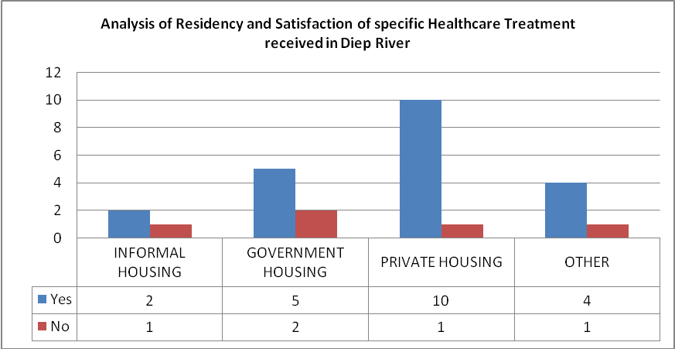

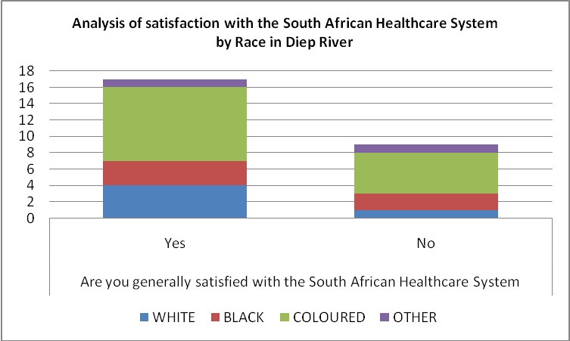

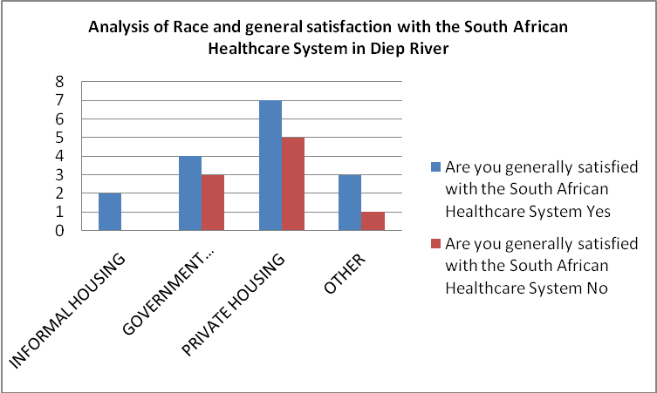
3.2 Social Security
In Diep River, the majority of the population surveyed required Grants for Older People. This is reflective of Diep River being an area of affluence in that a) people may live considerably longer in these areas, and b) many of the people interviewed of a younger age did not require social assistance at all (60% of those interviewed did not require social assistance.) In comparison to Lavender Hill, the majority of people who did require social assistance, most frequently required disability and child support grants.

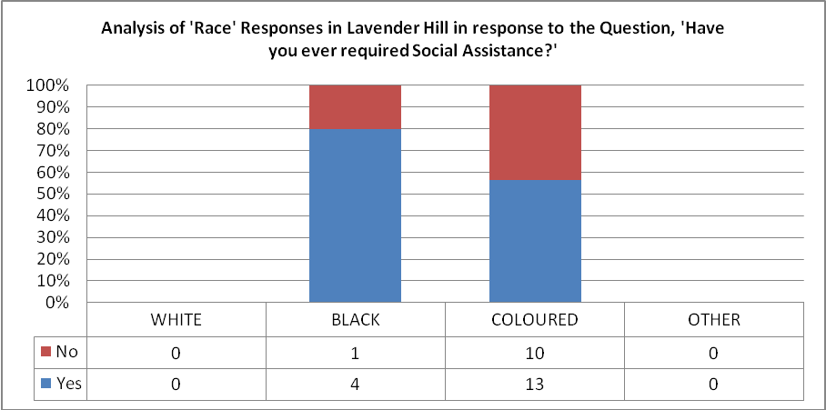
In Delft, the most popular Grant applied for was Child Support Grants. In Delft we also noted that females applied for social assistance by a considerable majority compared to their male counterparts. In Blikkiesdorp, it is particularly acute with 88% of the respondees who needed social assistance being female.
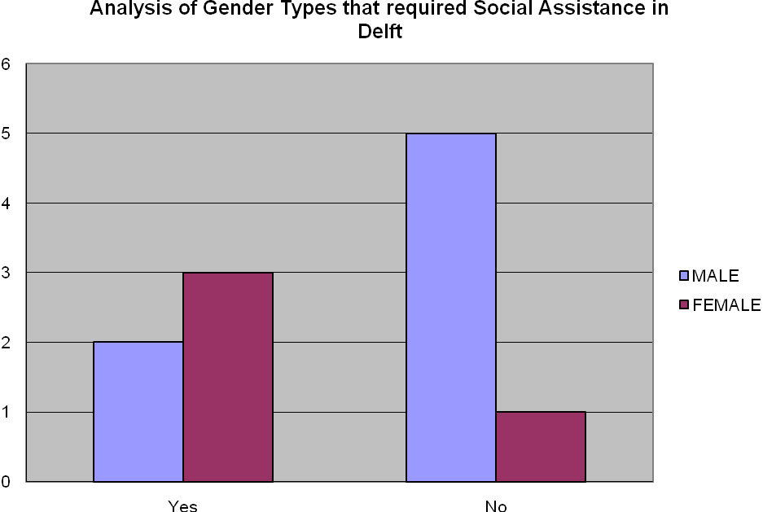

It is interesting to note that in Diep River, only 30% of coloured people had encountered problems obtaining social assistance vs 100% of black people surveyed. This is a reverse of the situation in Lavender Hill, where more coloured people than black people encountered issues.
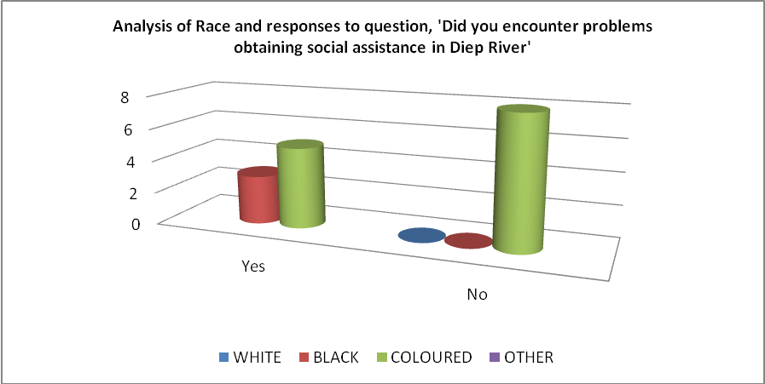
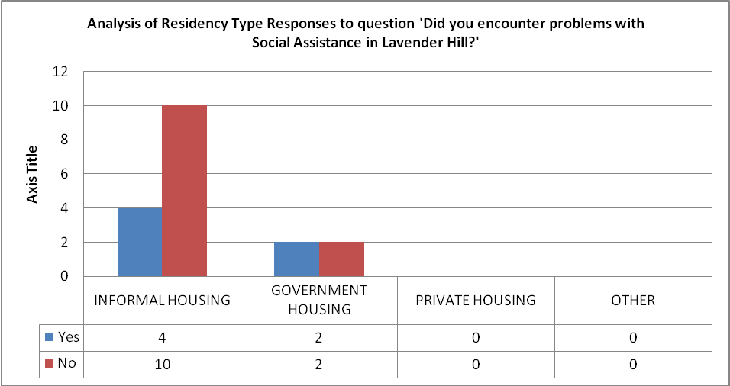
In Lavender Hill, many of those interviewed reported that they suffered from severe asthma, which hindered their ability to work. They applied for a disablity grant but the motion was denied without further explanation. This demonstrates an important example of how in some socially disadvantaged areas, people were not receiving the access to social assistance as required, and as suggested within section 27 of the South African constitution.
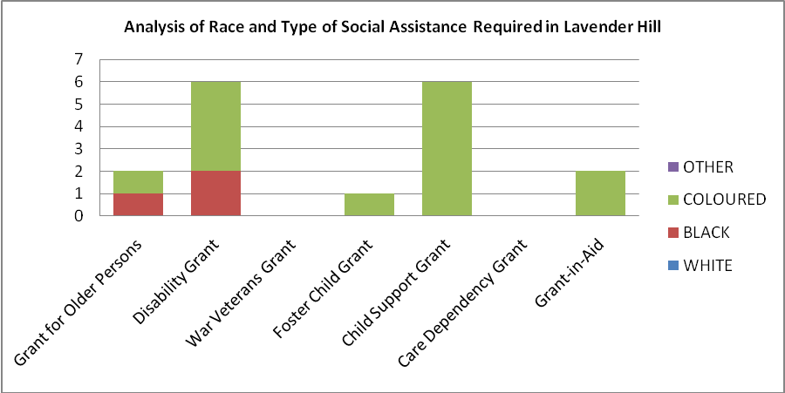

This argument is further extended if one considers that the area of Tsunami in Delft, where over 80% of the population is dissatisfied with social assistance in South Africa. Similarly, in Blikkiesdorp, 78% of respondents surveyed were dissatisfied, and of this population, all of the respondents had experienced some kind of delay in receiving social assistance. This is of notable importance, when compared with only 50% of the population in Diep River who experienced delay.

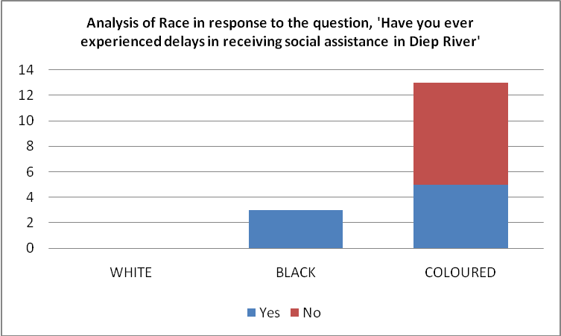
In Blikkiesdorp and Lavender Hill, it was particularly noted that many of those polled had to deal with administrative barriers such as documents which had been completed incorrectly by the responsible doctor or not having a postal address to provide. Furthermore, once the grants were approved, delays of up to 6 months could occur before the funding was received, this was particularly visible in areas such as Blikkiesdorp. In this area, respondents highlighted that a shortage of staff had an adverse effect on the processing of each case, resulting in long waiting hours if paper work required review or assistance.

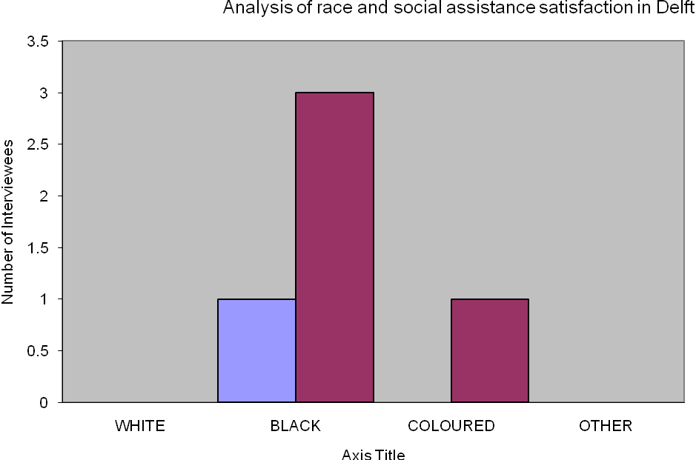
One of the biggest complaints from areas such as Blikkiesdorp and Lavender Hill was the lack of communication once people had attempted to apply for funding. In Lavender Hill, people went as far to say that, in their experience, “people’s grants were stopped without informing them.”
One of the key aspects to note in relation to social assistance, is the similarity across the three areas in relation to two key issues, firstly the inadequacy of the financial assistance gained from grants, and secondly, we received overwhelming feedback that people did not apply for grants, because they felt that grants were overly difficult to obtain.
Money received was felt to be sufficient in order to successfully alleviate the key issues pertaining to the requirement for social assistance. For example, even in Diep River, an area considered to be of stable economic conditions/good income, a coloured female commented that “more money is needed”. In Blikkiesdorp, respondents were more explicit about their financial concerns, articulating that “My pension is not enough, R 1080, which runs out before my next payment” and that “the R250 per child, support grant is inadequate.”
Many of the communities interviewed were reluctant to complete surveys associated with social assistance, or felt unable to successfully apply for social assistance in South Africa. Although this cannot accurately be reflected in the quantitative data, we received specific feedback in both Blikkiesdorp, Lavender Hill and Diep River, such as “I didn't apply for a grant because I don't think I will get help/it will take a long time/government will not care.” (Quotation from a female in Blikkisdorp). In Diep River, a respondent commented that he had “given up on the government, they don’t help. They only help people with jobs”, a direct contradiction of the objective of social assistance.
3.3 Water
In order to better understand people’s access to water, and their experience in obtaining water, we conducted a large quantitiative and qualitative survey across Lavender Hill, and the two particular regions of Delft, Tsunami and Blikkiesdorp. Due to time constraints associated with conducting our research, we did not effectively cover the Diep River area. The Diep River area data (from social assistance and healthcare data collated) reflected that most of the populas in this area lived in private or government housing (86% of those interviewed were from private or government housing in the social assistance survey). Therefore, for the purpose of our reseach (and objective to understand the challenges associated with the delivery of water as an ESR, we focused heavily on the areas considered more underprivileged).
In Lavender Hill, an area considered more affluent and established than Delft, 40% of people were able to obtain their water from a household connection. Where residents were able to obtain water through household connections, the majority of respondees lived in government housing. In the area of Blikkisdorp, the situation regarding water was reflective of the challenges in Lavender Hill. In this area, more than 45% of people used public taps, and only 29% of the population were able to obtain a household connection. Where respondents answered that they used public taps, it reflected the fact that they resided in informal housing.

Analyis of the Delft Area

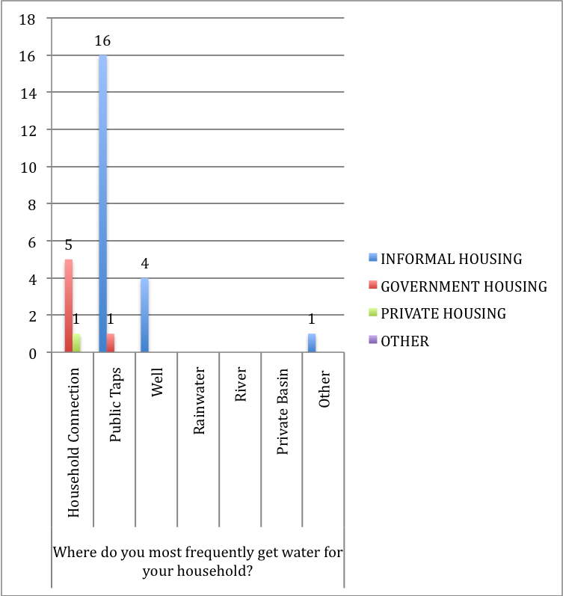

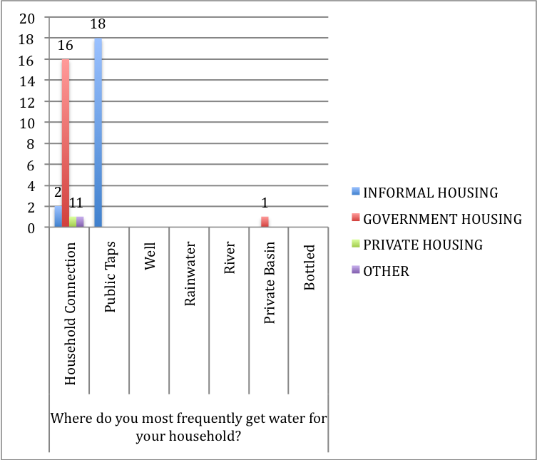

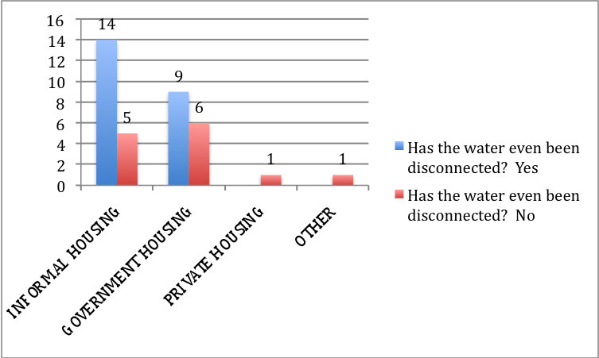
Analysis above shows the Lavender Hill Area specifically.
The ability to access water through a convenient and safe connection was more challenging in the Tsunami area of Delft. In this area, 100% of people that used wells lived in informal housing.
Even if the area was able to access water in a safe and efficient manner, it was disappointing to note that over 74% of people in informal housing, and 60% government housing have had their water disconnected. In the area of Tsunami, the statistics were of a similar proportion to Lavender Hill, where over 71% of people living in informal housing have had their water disconnected, while 100% of people living in government housing had faced this challenge as well.

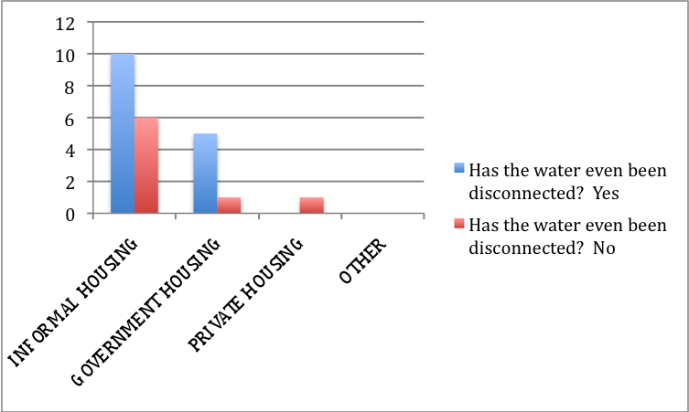

Analysis above shows the type of residency and ‘disconnection experience’ in the Delft area.
One of the distinct comparisons between Lavender Hill and Delft was that in Lavender Hill, more than half of people living in informal housing felt that they did not gotten enough water for their needs, while in Delft, even in government housing, a majority of people from this residency type felt they did not get enough water for their needs.

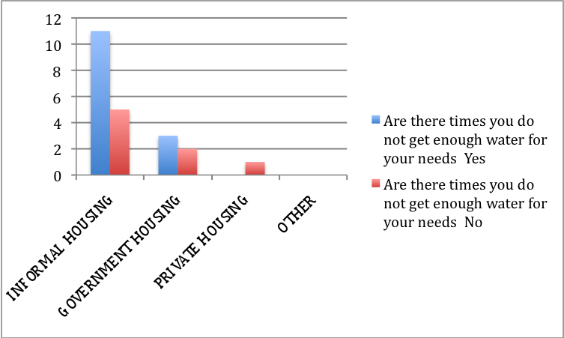

In terms of commentary, the biggest issue addressed by the residents of Lavender Hill were the high costs that arise due to leaking pipes and delays in fixing them. One respondent's debts grew to 18,808 Rand which resulted in a disconnection of their water as they were forced to miss a few payments. Another problem mentioned by a few of the surveyed was the lack of numerous communal taps, which affect not only their daily lives, in that they must spend a lot of time collecting water but also, the security of the whole neighborhood in the event of an emergency such as a fire.
A topic closely connected to the access to water is the state of the sanitary facilities. Complaints include both the quality and the quantity of toilet installations. In the informal settlement of Lavender Hill the communal sanitary facilities consist of obsolete toilets with a bucket system which are mostly situated in unhygienic conditions. In two specific cases bacterial diseases such as diarrhea were found to exist due to the above circumstaces.
4. Main recommendations
On the basis of our findings from the surveys and analysis of the problems in fulfilling ESRs, we have recommendations calling primarily for the further involvement of the SAHRC. We believe, in consideration of the strong constitutional mandate of the SAHRC, it is through the Commission that most change to the current system can be initiated.
4.1 South African Human Rights Commission Recommendations
In this section we take a critical perspective on the SAHRC and base our information on the 2002/03 and 2008/9 SAHRC reports on health, water and social security. We are seeking to conduct a comparative study of these two reports to highlight the recommendations but also raise the ongoing challenges of implementing them. It is highly important to understand that the 2008/09 SAHRC report is currently unpublished and subject to review, changes and approval by the Commissioners.

4.1.1 Health care
The SAHRC report of 2002/03 contains a several recommendations associated with healthcare and treatment in South Africa. In the report, the key issues are classified in several different categories, such as HIV, District Health System, Monitoring and Evaluation, Children's Health, Hospitals and clinics, Administration and Management Systems, Budgetary measures. In comparison, the new, not yet published, 7th report of 2008/09 also provides a set of recommendations, structured around 3 main points: the progressive realization of the right to access to health care, the access to information, and the social exclusion. While these appear to be ‘revised’ headings, it is clear that the heart of the problem remains the same, namely HIV prevention and treatment, children and maternal health.
The 5th report's recommendations are broad and not linked to any clear program or determined targets. The 7th report provides more strategic plans; it calls, for example, for greater clarity in the setting of a target for reducing child mortality. That being said, many of its recommendations still remain, in this paper’s opinion, far too broad. For example, the report recommends that the national TB Control Programme be strengthened, it does not provide any further, precise recommendations, similarly, when the report states that ''sufficient funding must be sourced for tertiary health care facilities as well as primary health care facilities'', no exact targets are suggested. In addition, no clear numbers are provided as to the number of health professionals with special training that will be needed in the health care system due to the increase of the population.
All in all, the final section ''from strategic planning to implementation'' appears to be in part a repetition of some of the recommendations of the 5th report. While this may indicate that the problems (by their very nature) have not changed, it is disappointing that there is not a revised approach to some of the previously recognised and understood challenges; The 7th report, as the previous one, fails to provide tangible concrete and precise recommendations. Its recommendations are broad and linked to general problems rather than specific issues. Moreover, the SAHRC addresses its recommendations to the government, without mentioning the actual steps it is going to take to improve health care in South Africa.
The gaps in the reports reflect the problems we witnessed during our surveying of Diep River, Delft and Lavender Hill. The percentage of dissatisfaction in the low income population will not decrease if the SAHRC continues its involvement in the improvement of the South African health care system.

4.1.2 Water
We will assess the implementation of the constitutional right to water, not by comparing conflicting statistics over the past years, but by comparing the challenges and recommendations addressed in the SAHRC 5th and 7th report. This method is used due to the lack of reliable data to assess the progressive realisation of the constitutional right to water. Statistics provided by the governmental organization, Water Service National Information System, differ to those provided by civil society organisations. The basic conclusion which can be drawn from the government reports is that there has been a significant improvement in water service delivery over the last two decades.

The SAHRC is “ the national institution to support constitutional democracy through the promotion and protection of human rights.” In order to fulfil these obligations it has a wide mandate which encompasses civil, political, economic and social rights. It is supposed to be provided with information on measures of the progressive realisation of ESRs by the relevant organs of state. On the basis of these as well as outside information it submits annual reports to the Portfolio Committee on Justice and Constitutional Development on the challenges in the implementation process and gives recommendations for its acceleration. Therefore it is relevant to seek the comparison of the key results of these findings in order to analyse the realisation of the ESRs.

Recommendations of the SAHRC's 5th Report
The recommendations of the South African Human Rights Commission's 5th annual report released in 2003 only concentrate on policies that are already in place.
They focus chiefly on improving the access conditions for the most economically disadvantaged parts of the population. In order to achieve this priority issue they promote different measures:
1) Monitoring
One measure that incorporates and controls all the others is the implementation of monitoring bodies at local level to control and ensure the enforcement of policies and laws. Therefore the collaboration between the three different spheres of government is required as it is the duty of provincial and national government to monitor the performance of local government.
Where the provided framework is too methodically inefficient to observe the present status properly the government will not be required to account for its actions and the results thereof.
2) Governmental support on policy and financial level
As the national government is required to provide the framework to ensure the realisation of the right the DWAF is asked to support the provincial departments and municipalities at policy level. The responsibility to ensure the delivery of water to the communities lies within the local government.
Regarding the water and sanitation infrastructure the DWAF is challenged to provided a guideline on how to remedy dysfunctional facilities. Similar, not further defined, recommendations ( requirement of a guideline) are addressed upon the Free Basic Water Policy.
Additional to the support on policy level the financial aid is the next step as most enhancements in the sector of economic and social rights depend on financial investment.
3) Water and Sanitation Infrastructure
To provide specifically poor households with adequate sanitation facilities. Moreover the maintenance of these installations has to be ensured.
The same claims apply concerning the water infrastructure. The supply with more communal taps and improvement of both the pipe and the water quality (just to mention concerns regarding the priority group of the disadvantaged and vulnerable) requires financial support.

Recommendations of the SAHRC's 7th report
In contrast to the above recommendations which mainly focus on improvement of basic resource allocation, the 7th report recommendations move on to rather secondary concerns such as environmental impact, discrimination issues and more more cost-benefit considerations. From this one might conclude that the primary concerns of the report are likely to have been addressed successful. However, our survey appears to contradict the 7th assumption. Recommendations made in the 5th SAHRC report highlight the necessity to focus on the economically disadvantaged groups of society.
Our surveys showed that the quality of both the water and the pipes in the townships were not as sufficient as stated in the government reports. Contaminated drinking water and leaking taps were the major concerns expressed in this areas by many of those interviewed. We are concerned that the focus of 7th report has prematurely moved on to secondary concerns while primary concern of good quality drinking water has been sidelined. We feel it is worth repeating and reinforcing the necessity of addressing this primary concern. Progressive realisation means both ensuring the supply of basic services and constant improvement above this minimum level. None of these issues should be neglected.

The role of the SAHRC
In order to promote awareness of human rights and thus to fulfil its basic obligation the SAHRC has to enhance its means of awareness-raising. Only citizens that are aware of their rights are enabled to recognise violations of their rights and liberties. The following example regarding the right of sufficient water illustrates this principle.

Indigent Policy
If a household fails to register that it is indigent it will not be provided with Free Basic Services. Thus the onus of proof lies within each household. The ones unaware of this obligation are being disadvantaged unjustly. Even though the actual delivery of the service lies within the responsibility of the municipalities and consequently only in the indirect duty of the Commission another part falls in their field of duties: the promotion of the duty to register indigent. If the SAHRC fails the very basic level of its duties (promotion and education) the ones that are based on it (indemnity if necessary by legal remedies and thus change of the status quo) will not be fulfilled either.

The SAHRC and the government
When discussing the implementation of the ESRs, it is crucial to keep in mind the tension that exists between between full cost-recovery policies and more progressive social policies. Any decisions made regarding the ESR, whether executive, legislative or judiciary is linked to financial cost. Therefore many of the gains that have been made have come about via litigation rather than efforts on part of the state. The government has been reactive rather than proactive. This goes the against the spirit of the law as enshrined in the Bill of Rights :

“Other organs of state, through legislative and other measures, must assist and protect these institutions to ensure the independence, impartiality, dignity and effectiveness of these institutions.”

De facto this close cooperation is not implemented satisfactorily. Frequently the parliament neglected to respond to the SAHRC reports or enquires. To name one example: in the Socio-Economic hearings in March 2009 a lack of response from state organs led to a postponement in two occasions. As it is a criminal offence to frustrate the work of the SAHRC the use of legal remedies is a possible measure which has not been used so far. This is another example of the government's reactive instead of proactive attitude. The SAHRC does not seem to be changing the governments behaviour with its available means; it has the power to enforce claims by suing either the state, individuals or private persons. It is supposed to provide a cost-free and accelerated option for citizen to claim their rights. Yet of 10,000 complaints only 30 were brought to court.
For instance, sanitation is a persistent problem we have observed in the communities. Access to sufficient sanitation is not an explicit constitutional right. However, reading the above right together with the right to living in an environment not harmful to health and well-being one can conclude that these rights can not be fulfilled without a basic sanitation service. According to the DWEA , there is a Free Basic Sanitation policy available for implementation. Due to a lack of awareness of this policy the municipalities are not implementing it. This is an issue where the SAHRC could organize an official complaint on the government's ineffective measures in preserving sanitation.
In the past the SAHRC has proved many times that is in an important institution in its contribution to strengthening democracy and promoting human rights.
Its basic function as promoter of a human rights culture in the form of awareness-raising is the fundamental measure it is tasked with. Only a citizen who knows his rights will realise its violation. Only pursuing the matter further will cause change.
Its lack of executive authority to enforce their decisions or recommendations is a hurdle in fulfilling the responsibilities. However, the broad mandate and the strong measures provided have not been exhausted yet, and we strongly urge they should be in future. If a state department does not respond and take its responsibilities serious the SAHRC should use its powers in order to act on human rights violations and achieve change.
4.1.3 Social security
Where it cannot be denied that much work has been done in the development and realization of the Right to Social Security, many challenges that were faced in the past still exist nowadays. To further this argument this chapter will give an overview of the development in the challenges faced and recommendations given by the SAHRC to progressively realize the Right to Social Security in the past decade. This will entail a critical overview of the SAHRC’s 5th and 7th report. The overview will be structured according to the issues and he comparison will be made thereof.

Maladministration
From the SAHRC’s 5th Report of 2003 it was held that the delivery of social assistance was not efficient. This as result of lack of documentation as barriers to accessing grants, administrative problems, poor conditions that prevailed at pay points, as well as corruption and maladministration.
The requirement of valid identification and birth certificate documentation has affected access to grants. This is due to the fact some children did not hold birth certificates, whilst some adults did not have the appropriate identity documents. The disability grant posed the most problems, given the medical assessment required for payment of the grant. This meant to a large extent that they were unable to apply for and be awarded a grant.
Administration problems include people traveling long distances to local welfare offices; waiting hours before being attended to; and grants that were suspended or terminated with no reason given and without proper procedures being followed. This resulted in the Department of Social Development being subject to a number of legal actions instituted against it by affected persons.
In the 2010 7th report of the SAHRC the argument continued that the problems of inefficiency, incompetence and poor service which had plagued the Department of Social Development’s delivery of social grants were merely transferred to the South African Social Security Agency. One telling piece of evidence from the Belhar Community Health Forum is as follows: “Our Social Security Agency boasts of a world class service but our community people have to sleep overnight at their doorsteps to attend to the next day and in most cases actually wasted their time going to these agencies. There are no visible notices to indicate which services are rendered on which days to inform our communities.”
The 2010 7th report also stated that “for those able to access social security infrastructure, the intensive administrative demands and means testing reduces the social security process to an undignified, cumbersome and discretionary experience leading to unintended or incorrect conclusions or exclusions and sometime non-transparent behavior by officials.”
It becomes clear that during the last decade only little has changed concerning the administrative challenges that have been identified. Moreover, it is these administrative problems that limit the people of actually gaining access to a grant, for which they do have a right to. Since these problems do appear in both reports it is clear that the challenge has been identified as such, yet it also implies that the challenge is yet to be faced with a proper and effective solution. To accomplish this, closer monitoring and a more active approach to overcome this challenge should be undertaken by the SAHRC.
Labour orientated Social Security
Already in the 2003 5th report by the SAHRC it was found that many people were excluded from the Right to Social Security. Reason for this exclusion was found to be that social security is labour orientated. Coverage is extended to the only to the formal labour force, and those not in formal employment do not qualify for social assistance. People with no social protection can fall easily into a poverty trap if they are not catered for by social assistance systems.
It was concluded there had been a lack of emphasis on protection, promotion and fulfilment of the right to social insurance. The most vulnerable and marginalized people in South Africa were either unemployed or atypically employed and therefore not covered by the occupational based social insurance schemes. Where joblessness had increased 15% to 30% from 1995 to 2003, there was a rapid fall in real incomes from work, which pushed more people into the informal sector and casual labour and unemployment. These groups of people were denied access to social security.
In the SAHRC’s 2010 7th report the argument was raised again stating the Unemployment Insurance Fund has only a narrow reach in South Africa. It was stated that “conventional programs that are based on the needs of urbanized wage-earning workers cannot be easily adopted to meet the needs of the large poor (rural) populations in developing countries. Similarly, conventional programs are often not suited for meeting the needs of large numbers of people who are working in the informal sector.”
The consistency in which the SAHRC keeps approaching the social security for the (un)employed points out that only little has changed in the attitude towards this challenge. Therefore many people still fall out of the scope of social security and therefore are denied access to social security as a whole. Although the SAHRC clearly states where the problem is to be found and how it is to be solved, we find that the SAHRC is passive in achieving the implementation of the recommendations it has made.
Availability of grants for vulnerable groups
From the 5th report by the SAHRC 2003 it was found that the State should embark on effective awareness campaigns and inform the public about all the available grants. The application project should be simplified. The Department of Social Development in partnership with the Department of Health should introduce a comprehensive program that will address income as well as health care needs.
The argument was strengthened referring to the Taylor Report which took under consideration the Grootboom judgment and recommended that social security policies and programs must be reasonable both in their conception and their implementation. It stated that therefore, vulnerable communities must be given priority by the government and their needs must be addressed effectively.
This argument was repeated in the 2010 7th Report by the SAHRC, for the report stated that development of the policy, legislation and strategies which promote the rights of vulnerable groups (such as older persons, persons with disabilities, child-headed households, care-givers and many others) should be given priority. The 2010 7th Report further states that The South African government appears to have interpreted its responsibility to ensure the realization of the right to social security in terms of expanding eligibility for specific social grants rather than undertaking a broader programmatic effort to ensure that the poor have the maximum possible opportunities. Even in terms of social grants, improving access and availability has largely been facilitated and motivated through legal action rather than proactive efforts by government to ensure the progressive realization of the right. On balance it is reasonable to assert that a rights-based approach has not truly informed policy or practice in social security arena.
Pro-active attitude
Already in the SAHRC’s 5th Report of 2003 it was stated that there is a cost to not acting on or not addressing social needs in South Africa. In the long run, intervention conducted sooner may be more prudent both economically and fiscally, despite any fiscal impact in the short run. As argued in the Report, “the negative social externalities generated by a lack of state action [causes] the society … or the affected communities [to] bear the costs” (Taylor, 2002, p. 44-45). This was found to be an undesirable outcome from the political and social point of views.
The 7th Report by the SAHRC furthers the argument by examination of paragraph 68 of the Committee on Economic, Social and Cultural Rights, General Comment 19. This Paragraph states in part that a national strategy and plan of action to realize the right to social security should (in part) “…set targets or goals to be achieved and the time-frame for their achievement, together with corresponding benchmarks and indicators, against which they should be continuously monitored; and contain mechanisms for obtaining financial and human resources.”
Furthermore Paragraph 76 of General Comment 19 (CESCR) underlines that: “in the following five years, the states parties will use these national benchmarks to help their implementation of the right to social security. Thereafter, in the subsequent reporting process, states parties and the Committee will consider whether or not the benchmarks have been achieved, and the reasons for any difficulties that may have been encountered.
It is concluded that the National Department of Social Development should undertake the process of developing a comprehensive Roadmap for social security. The Roadmap should clearly articulate how the constitutional right to social security will be progressively realised. In its Annual Report the Department of Social Development should be required to clearly map out the measures taken, and is planning to take, toward achieving the progressive realization to the right to social security. These must be linked with solid plans or achievements in terms of programmatic roll-out.
It becomes clear from both the 5th and the 7th report that there is a consistency in the recommendation to the government to create clear and prudent measures which are to be implemented in the government policies and strategies addressing the realization of the right to social security. Whereas it becomes clear that the government has not been able to do so in the last decade, this implies that the SAHRC has been lacking in her responsibility to move the government to creating such policies and strategies.
The Basic Income Grant (BIG)
In the 5th report of 2003 the SAHRC identified a high rate of poverty and argued that for the first time about the introduction of a BIG, which could assist the poorest of the poor who are excluded from social security and social assistance to begin escape poverty and have some form of income. It furthered its argument stating from the Taylor Report that the BIG would not only wide the current social welfare provisioning of the State, but would also target the unemployed, thus ensuring that no individual fall through gaps in the system.
Since the 7th Report by the SAHRC stated that the social grant aimed at temporarily assisting those in utter destitution, Social Relief of Distress (SROD), was identified as the most mismanaged and unevenly applied social grant of all, the argument for creating a Basic Income Grant seems to still apply nowadays. Especially because the report further stated that only very small numbers of people in desperate need have been able to access this grant.
Where many concrete challenges have been identified and recommendations made to face these challenges we have found that many challenges still exist nowadays. Most of these challenges limit the accessibility and availability of grants especially to those people in dire need of it. This does not only become clear from our surveys, but from a comparison of the reports of the SAHRC as well.
It is not surprising to see from that point that there is a strong trend in recommendations to the government to move away from a reactive approach to the social security system, but instead to move to a pro-active approach in the realization of the right to social security. It has been strongly recommended that policies and strategies focus on creating concrete and clear plans, which are to be measured over time to evaluate their progress.
The SAHRC should take on a pro-active attitude as well, to assure these plans not only come into existence, but are also implemented over the course of time. From the mandate given to the SAHRC the means necessary are there to make sure government bodies follow these recommendations and an important role for the SAHRC will be to monitor these government bodies in fulfilling these recommendations.
In the end it is important to note that the question why many of the challenges faced in the past are still in existence may even further the argument as stated above. For it is only likely that this question will remain unanswered, unless concrete strategies and policies will be created to prove and show measures are being taken and the right to social security is progressively realised for all. Again it should be emphasized that not only the government should take a pro-active stance in this matter, but it will be a necessity as well for the SAHRC to step up to their mandate to fulfill their task to a full extent.

4.2 Establishing a human rights-based approach
“A human rights-based approach is not only about expanding people’s choices and capabilities but above all about the empowerment of people to decide what this process of expansion should look like.”

As a result of the priority issues between civil/political rights and ESRs discussed above along with observations made by the members of the communities, it is the purpose of this recommendation to place ESRs on equal footing with civil/political rights.

There are two main areas where a human rights-based approach needs to be introduced: governmental and community level. Firstly, a human rights-based approach needs to be adopted towards the designing of governmental policy. It will assist in disciplining government to take into account potential ESRs implications. Even during the implementation process of any governmental policy (in particular those relating to water, housing, social assistance, food, electricity, and/or health care) being executed by departments it becomes necessary to incorporate such an approach. Widening the government’s perspective on policy considerations to include ESRs would significantly mitigate any further inefficiency and prohibit ESR infringements.

Secondly, a human rights-based approach also entails empowering people with knowledge of their ESRs. One recurring response we received during our surveys was that people living in highly difficult economic conditions had not applied for any social assistance benefits. One observation that can be made from this is that there is not much awareness of these grants and opportunities available. This calls for more direct involvement in outreach into communities.

The method of incorporating this recommendation requires the participation of the SAHRC. They possess the constitutional mandate and relevant competences to ensure the government takes serious consideration of ESRs. The SAHRC also possesses legal personality, to the extent that it can initiate cases against the government if there are grounds to do so. It is recommended that the government ensure that any strategies and/or policies overlapping with social and economic matters in South Africa are screened by SAHRC in order to ensure compliance with ESRs.
4.3 Structural Interdicts and The South African Human Rights Commission – A way forward with Judicial enforcement

Mitra Ebadolahi is of the opinion that judiciary remedies – declaratory relief, prohibitory interdicts and mandatory orders – are ineffective in the fufillment of ESRs. Structural interdicts essentially demands ”the violator to rectify the breach of fundametal rights under court supervision.” The use of structural interdicts has been used by the courts before in non-ESR cases – prisoner rights, welfare benefits, housing and evictions and children’s rights. Therefore, extending the usage of structural interdicts to ESRs cases would be desireable. Ebadolahi drew on the findings of Iain Currie and Johan de Waal in implementing this approach to judiciary remedy.

Firstly, the court declares that the government has infringed the constitutional rights of an individual or group ”or otherwise failed to comply with its constitutional obligations.” Secondly, ”the court mandates government compliance with constitutional responsibilities.” Thirdly, the government is given a deadline to submit a deatiled report stipulating its strategy to rectify the constitutional violations. This ensures the separation of powers principle is held in tact, as the judiciary will leave it up to the government reconsider their initial stategy. Fourthly, the court will evaluate whether or not the infringement has been rectified. Lastly, the court would issue a final order on whether or not compliance has been achieved. If the government then later fails to stick to its plan then it would be held in contempt of court. As mentioned earlier, these applicants fall within the poverty bracket and are vulnerable. Expecting the applicant to go through the judicial system again due to the inefficiencies of the government is far too burdensome. This could be extremely disadvantageous to the applicant who now has to deal with brining contempt proceedings. That is why judicial supervision cannot be done alone by the courts and requires the involvement of the SAHRC. Ebadolah states:

”The proposal is as follows: When a court decides that a structural interdict is the appropriate remedy in an ESR case, it should order government actors to formulate a plan for future compliance with the SAHRC’s assistance. The SAHRC would thus help government actors craft an action plan that adequately remedies the rights violations identified in the declaratory portion of the court order. In this way, the SAHRC may alleviate institutional competence concerns; if courts are confident that the Commission and the appropriate arm of government will work together to find a concrete, viable solution, then judges can simply focus on accurately identifying a rights violation.”

The SAHRC thus has the capacity and ability to share the burden of the court’s supervision in ensuring the government follows through on compliance. The SAHRC can assist the government in preparing the detailed report before evaluation by the court. Involving the SAHRC in the monitoring process of judicial enforcement has been done before an ESR case. In the Grootboom case, the court” assigned the Human Rights Commission […] to monitor and report on the status of the changes.” The judge stated:

“Counsel for the [South African Human Rights] Commission indicated during argument that the Commission had the duty and was prepared to monitor and report on the compliance by the state of its section 26 obligations. In the circumstances, the Commission will monitor and, if necessary, report in terms of these powers on the efforts made by the state to comply with its section 26 obligations in accordance with this judgment.”

Therefore, a precedent has already been set and should be used as the guiding principle for future cases. The SAHRC can act as the mediator between the judiciary and government – thereby “various government branches and State organs would work together to create meaningful plans of action, progressively realizing ESRs.”

A common criticism of rejecting this recommendation is that the SAHRC lacks the competence and legitimacy to handle with overseeing the government’s strategy to rectify the constitutional infringement. However, the Human Rights Commission Act 1994 (HRCA) and the 1996 Constitution give the SAHRC the mandate to monitor and promote human rights and the power to issue proceedings. Secondly, initiating this recommendation with regards to investing in the SAHRC would be perceived as costly. However, the government is required to assist the SAHRC with respects to fulfilling its duties and this extends to ensuring the SAHRC is financially independent as well. Thirdly, the recommendation might threat the independence of the SAHRC - in particular with regards to appointing Commissioners and deciding the budget. However, this is mitigated by the preservation of the independence of the SAHRC, which is safeguarded in section 4 (1) of the HRCA.

5. Conclusion
The objective of this paper was to gain an understanding of Section 27 of the South African Constitution. This unique section, reflective of a new democracy in a developing nation, aims to uphold ESRs on an equal footing as civil and political rights. Our study aimed to understand not only the realities of these rights, and whether they were being realised in areas such as Delft, Lavender Hill and Diep River. Through our quantitative and qualitative research we have gained greater insight into the South African people’s ability to access water, healthcare and social assistance. As a generalisation, there are satisfied people among these communities, but it is clear that many inequalities, disparities and struggles still exist, from not enough social assistance to truly alleviate the problem, to core areas of the community frequently having their water disconnected.
Our study aimed to show the challenges that were being experienced in the day to day lives of South Africans, and reflect upon the challenges associated with the true realisation and delivery of these rights due to issues that tend to be beyond the reach of the ordinary citizen. Challenges such as the separation of powers, funding and resource allocation by government organisations and limited ability to take real legal action are challenges that the judiciary and government must seek to overcome if they are to truly tackle and deliver Section 27 in the manner it was perceived to be written in. Challenges associated with the prioritization between civil/political rights and ESRs require government to re-evaluate the manner they approach strategies.

In order to further our understanding, this paper aimed to provide a summary of the findings of the 5th SAHRC Report, as well as the Taylor Report. It is clear that while these reports recognised several pertinent issues, the comments we saw on the ground reflected no clear change in certain issues (such as staff shortages, long delays etc). This paper calls upon the duty of the SAHRC to take real, definitive and community action in order to hold the government to account for the ‘progressive realisation’ of ESRs. During the final writings of this paper, the team working on this, had the great fortune of being able to review the 2010 unpublished 7th report from the SAHRC. This team is of the conclusion that overall there are some excellent and fantastic insights within the paper that allude and demonstrate real, genuine awareness of the challenges and issues South Africa faces in being able to truly deliver ESRs. It is our opinion that the SAHRC can do much more than what its already doing. They have a real duty to the people of South Africa to see these actions fulfilled.
In order to fully appreciate whether these recommendations have advanced the socio economic rights of the people of South Africa, it is our hope to conduct a new round of surveys and research, two years on from the release of the SAHRC 7th report to monitor on whether changes have been made.
6. Bibliography
African Charter www.umn.edu/humanrts/instree/z1afchar.htm Accessed 25/05/2010

Algotsson, Emma,Tumai Murombo. ''Chapter 3 Legal and Policy Framework 1. Constitutional Rights 1.3. Core minimum obligations''. [10]. Water Supply and Sanitation in South Africa, Environmental Rights and Municipal Accountability. 2009. Print.

Arbour, Louise. "Economic And Social Justice For Societies in Transition." Second Annual Transitional Justice Lecture. New York University School of Law Center for Human Rights and Global Justice and the International Center for Transitional Justice, New York. 25 Oct. 2006. Lecture.

Bilchitz, David. [20]. Poverty and Fundamental Rights – the Justification and Enforcement of Socio-Economic Rights. July 2007. Print.

Brand, Danie, and Christof Heyns. The Socio-economic Rights in South Africa. Pretoria:: Pretoria University Law, 2005. Print.
Cathrine Musuva, Promoting the Effectiveness of Democracy Protection Institutions in Southern Africa, EISA Reasearch Report 41, 2009
Chaskalson, Matthew. Constitutional Law of South Africa. Kenwyn: Juta, 2007. Print.
Choma Hako. “Constitutional enforcement of socio-economic rights: South African Case Study” US-China Law Review 55th ser. 6.6 (2009): 41-54. Print.

Christiansen, Eric C. ''I.Protecting Social Welfare rights in South Africa: Two Preliminary Questions. B.Why South Africa? 3.Court-imposed Limits''. [385]. ''III.Constitutional Rights Enforcement As a Tool For Social Justice A.The Constitutional Meaning of Persistent Socio-economic Inequality''. [389-390]. Using Constitutional Adjudication to Remedy Socio-Economic Injustice. Diss. UCLA, 2008. Print.

City of Johannesburg and Others v Mazibuko and Others 2009 (8) BCLR 791 (SCA). Electronic

Committee of Inquiry into a Comprehensive System of Social Security for South Africa, Transforming the present – Protecting the Future, Consolidated Report, 2002. Print

Constitution of the Republic of South Africa, Act 108 of 1996

Craven, Matthew C. R. The International Covenant on Economic, Social, and Cultural Rights: a Perspective on Its Development. Oxford: Clarendon, 1995. Print.
Currie, Iain and Johan De Waal. The Bill of Rights Handbook. Wetton: Juta & Company Ltd, 2008. Print.

Davis Denis M, Cheadle H and Hayson N Fundamental Rights in the Constitution: Commentary and Cases (Juta 1997). Print.

Davis, Denis M. ''2. The adjudication of social and economic rights within the South African Constitution: The early steps'' [681]. Socioeconomic rights: Do they deliver the goods?. International Journal of Constitutional Law, July/October 2008. Oxfordjournals. Web. 22 May 2010. <http://icon.oxfordjournals.org/cgi/reprint/6/3-4/687>.

Devenish, G.E., A Commentary on the South African Bill of Rights, 367.

Dlamini, C. R. M. Human Rights in Africa: Which Way South Africa? Durban: Butterworth, 1995. Print

Ebadolahi, Mitra. ''II. Theoritical and Practical Problems with Judicial enforcement of socio-economi rights (A) Vagueness Problem''. [1582, 1586]. Using Structural Interdicts and the South African Human Rights Comission to Achieve Judicial Enforcement of Economic and Social Rights in South Africa. Diss. New York University School of Law, 2008. HeinOnline - SplashPage. 2008. Web. 23 May 2010. <http://heinonline.org>.

Freedom Charter, 1955 http://www.anc.org.za/ancdocs/history/charter.html Accesssed 25/05/2010
International Covenant on Civil and Political Rights of 16 December 1966

Kalie Pauw and Liberty Mncube, Development Policy Research Unit (DPRU), University of Cape Town, Expanding the Social Security Net in South Africa: Opportunities, Challenges and Constraints, International Poverty Centre, United Nations Development Programme, 2007

Khosa and Others v Minister of Social Development and Others 2004 (6) BCLR 569 (CC)

Mashavha v The State President of the Republic of South Africa and Others, Transvaal High Court case number 17220/02 and Constitutional Court case number 67/03

Mashishi v The Minister of Social Development and Others, Transvaal High Court case number 4239/03

Mazibuko Case. The Supreme Court of Appeal - Republic of South Africa. 25 Mar. 2009. Web.

Mrs. B.E.E. Molewa, MP (Minister of Social Development), Strategic Plan 2010/11 – 2012/13, SASSA

Oliver, M.P. et al., Social Security Law, General Principles, Butterworths 1999
Pieterse, M., Possibilities and Pitfalls in the Domestic Enforcement of Social Rights: Contemplating the South African Experience, Human Rights Quarterly, John Hopkins University Press 2004

PPP Research Project, Draft report on accessing funds from government department:
www.idasa.org.za/bis/docs/whats%20available%20%20a%20guide%20to%20government%20grants.htm (accessed September 2003)

Sibuye and Others v The Member of the Executive Committee for Health and Welfare in Limpopo and the Minister of Social Development and Others, Transvaal High Court case number 17713/03
Soobramoney v Minister of Health (Kwazulu-Natal) (CCT32/97) [1997] ZACC 17 (27 November 1997). See Chief Justice Chaskalson P. Para. 8

South African Human Rights Commission, Economic and Social Rights Report Series 2002/2003; 21 June 2004 – 5th Report

South African Human Rights Commission, Economic and Social Rights Report Series 2007/2010 UNPUBLISHED 7th Report – subject to review, changes and approval by the commissioners.

South Africa's Water Law and Policy Framework, Implications for the Right to Water, IELRC Working Paper, 2007-03

The History of the Constitution http://www.constitutionalcourt.org.za/site/theconstitution/history.htm Accessed 25/05/2010

Treatment Action Campaign and Others v Minister of Health and Others, 2002 (5) SA 703 (CC) 2002 10 BCLR 1075 (CC)

Water and Sanitation in South Africa, LHR Publication Series (1/2009)

UN committee for Economic, Social and Cultural Rights http://www2.ohchr.org/english/bodies/cescr/comments.htm Accessed 26/05/10

UN Committee on Economic, Social and Cultural Rights, General Comment 7 ‘The Right to Adequate Housing (Art 11(1) of the Covenant): Forced Evictions’ UN Doc E/C (1997), para 17.

Universal Declaration of Human Rights, 1948 www.un.org/en/documents/udhr Accessed 25/05/2010
7. Acknowledgements
We would like to extend our thanks to all the people who have assisted in carrying out this report. A special thanks to: ProjectsAbroad, Professor Pierre De Vos, Cameron Jacob, Kader Asmal, Elinor Hampson-Jones, Fred Maynard, Louise Murray, Shanaz Khan, Lisa Hahn, Shalini Thomas, Isabelle Sokolnicka, Jos van der Linden, Peter Fairman, Lyndon Metembo, Maxima Aylwin, Zoe Lambert, Jennifer Morgan, Jennifer Jones, Ryanne van Dormolen, Marlene Grubbe Egerup, Artur Caracciolo, Maria Petrides, Jawad Ahmad, Theodore Kamwimbi and Johnlyn Tromp.

Soobramoney v Minister of Health (Kwazulu-Natal) (CCT32/97) [1997] ZACC 17 (27 November 1997). See Chief Justice Chaskalson P. Para. 8
Constitution of the Republic of South Africa, Act 108 of 1996
South Africa has also signed the International Convention on Economic Social and Cultural Rights of 1966.
Constitutional Law of South Africa 2nd edition, Woolman, Roux and Bishop, Juta and co, 2009 2-27
Dlamini, C. R. M. Human Rights in Africa: Which Way South Africa? Durban: Butterworth, 1995. Print p 107
The History of the Constitution http://www.constitutionalcourt.org.za/site/theconstitution/history.htm Accessed 25/05/2010
Dlamini, C. R. M. Human Rights in Africa: Which Way South Africa? Durban: Butterworth, 1995. Print p. 108
Dlamini, C. R. M. Human Rights in Africa: Which Way South Africa? Durban: Butterworth, 1995. Print p. 109
Dlamini, C. R. M. Human Rights in Africa: Which Way South Africa? Durban: Butterworth, 1995. Print p. 108
Dlamini, C. R. M. Human Rights in Africa: Which Way South Africa? Durban: Butterworth, 1995. Print p. 107
Constitution of South Africa, Act 108 of 1996
Universal Declaration of Human Rights, 1948 www.un.org/en/documents/udhr Accessed 25/05/2010
Dlamini, C. R. M. Human Rights in Africa: Which Way South Africa? Durban: Butterworth, 1995. Print p. 107
Brand, Danie, and Christof Heyns. The Socio-economic Rights in South Africa. Pretoria:: Pretoria University Law, 2005. Print. p. 7
UN committee for Economic, Social and Cultural Rights http://www2.ohchr.org/english/law/cescr.htm Accessed 25/05/2010
Brand, Danie, and Christof Heyns. The Socio-economic Rights in South Africa. Pretoria:: Pretoria University Law, 2005. Print. p. 4
Craven, Matthew C. R. The International Covenant on Economic, Social, and Cultural Rights: a Perspective on Its Development. Oxford: Clarendon, 1995. Print
UN committee for Economic, Social and Cultural Rights http://www2.ohchr.org/english/bodies/cescr/comments.htm Accessed 26/05/10
Brand, Danie, and Christof Heyns. The Socio-economic Rights in South Africa. Pretoria:: Pretoria University Law, 2005. Print. p 7
Brand, Danie, and Christof Heyns. The Socio-economic Rights in South Africa. Pretoria: Pretoria University Law, 2005. Print. Page 7
The Republic of South Africa 1996 Constituion, section 39 of the Bill of Rights
Pieterse, M., Possibilities and Pitfalls in the Domestic Enforcement of Social Rights: Contemplating the South African Experience, Human Rights Quarterly, 2004 The Johns Hopkins University Press. Page 888
18 BVerffGE 315 1965
1997 151 DLR
Brand, Danie, and Christof Heyns. The Socio-economic Rights in South Africa. Pretoria: Pretoria University Law, 2005. Print. Page 6
Brand, Danie, and Christof Heyns. The Socio-economic Rights in South Africa. Pretoria:: Pretoria University Law, 2005. Print. Page 7
African Charter www.umn.edu/humanrts/instree/z1afchar.htm Accessed 25/05/2010
Freedom Charter, 1955, http://www.anc.org.za/ancdocs/history/charter.html
Choma Hako. “Constitutional enforcement of socio-economic rights: South African Case Study” US-China Law Review 55th ser. 6.6 (2009): 41-54. Print.
Soobramoney v Minister of Health, Kwa Zulu-Natal, 1998 (1) SA 765 (CC) 1997 12 BCLR 1696 (CC).
Choma Hako. “Constitutional enforcement of socio-economic rights: South African Case Study” US-China Law Review 55th ser. 6.6 (2009): 41-54. Print.
The Government of the Republic of South Africa v Grootboom, 2001 (1) SA 46 (CC).
Davis D, Cheadle H and Hayson N Fundamental Rights in the Constitution: Commentary and Cases (Juta 1997)
UN Committee on Economic, Social and Cultural Rights, General Comment 7 ‘The Right to Adequate Housing (Art 11(1) of the Covenant): Forced Evictions’ UN Doc E/C (1997), para 17.
Currie, Iain and Johan De Waal. The Bill of Rights Handbook. Wetton: Juta & Company Ltd, 2008. 577.
Choma Hako. “Constitutional enforcement of socio-economic rights: South African Case Study” US-China Law Review 55th ser. 6.6 (2009): 41-54. Print.
Treatment Action Campaign and Others v Minister of Health and Others, 2002 (5) SA 703 (CC) 2002 10 BCLR 1075 (CC)
Devenish, G.E., A Commentary on the South African Bill of Rights, 367
More discussion on the doctrine of the separation of powers can be found at 3.1.1.
2004 (6) BCLR 569 (CC)
2009 (8) BCLR 791 (SCA)
Ebadolahi, Mitra. Using Structural Interdicts and the South African Human Rights Commission to achieve Judicial Enforcement of Economic and Social Rights in South Africa. [p.1582].
Currie, Iain, Johan De Waal. The Bill of Rights handbook. [p.567]
The South African Constitution and Bill of Rights, 1996. Section 27(1)(b).
Comment of the UN Human Rights Committee on Social and Economic rights regarding the right to water and States Parties' obligations in relation to this right. Identifies the obligation: “to ensure access to the minimum essential amount of water that is sufficient and safe for personal and domestic uses to prevent diseases;to ensure physical access to water facilities or services that provide sufficient, safe and regular water; that have a sufficient number of water outlets to avoid prohibitive waiting times and that are at a reasonable distance from the household; and to take measures to prevent, treat and control diseases linked to water, particularly ensuring access to adequate sanitation.” ( Algotsson, Emma,Tumai Murombo. Water Supply and Sanitation in South Africa, Environmental Rights and Municipal Accountability. 2009. [Chapter 3. 1.2.] ).
Currie, Iain, Johan De Waal. The Bill of Rights handbook. [note 11]
Ebadolahi, Mitra. Using Structural Interdicts and the South African Human Rights Commission to achieve Judicial Enforcement of Economic and Social Rights in South Africa. [p.1586]
Christiansen, Eric C. “Using Constitutional Adjudication to Remedy Socio-economic Injustice: Comparative Lesson from South Africa”. [p.389-390]
Arbour, Louise. "Economic And Social Justice For Societies in Transition." Second Annual Transitional Justice Lecture. New York University School of Law Center for Human Rights and Global Justice and the International Center for Transitional Justice, New York. 25 Oct. 2006. Lecture. P. 2
International Covenant on Civil and Political Rights of 16 December 1966
International Covenant on Economic, Social and Cultural Rights of 16 December 1966
Arbour, Louise. "Economic And Social Justice For Societies in Transition." Second Annual Transitional Justice Lecture. New York University School of Law Center for Human Rights and Global Justice and the International Center for Transitional Justice, New York. 25 Oct. 2006. Lecture. P. 4
Arbour, Louise. "Economic And Social Justice For Societies in Transition." Second Annual Transitional Justice Lecture. New York University School of Law Center for Human Rights and Global Justice and the International Center for Transitional Justice, New York. 25 Oct. 2006. Lecture. P. 6
See section 3.2 below
In the case of Khosa v. Minister of Social Development 2004 (6) SA 505 (CC) (S. Afr.) the court found that denying social welfare benefits to non-citizens violated rights to equality and social security. In the TAC case the initial government policy was seen as discriminatory. Further highlighting the requirement of a civil/political right to bring an ESR violation claim.
Arbour, Louise. "Economic And Social Justice For Societies in Transition." Second Annual Transitional Justice Lecture. New York University School of Law Center for Human Rights and Global Justice and the International Center for Transitional Justice, New York. 25 Oct. 2006. Lecture. p. 6
Ward. "City of Cape Town." City of Cape Town Official Website - Local Government Services. Web. 31 May 2010. http://www.capetown.gov.za/en/stats/2001census/Documents/Delft.htm
Currently unpublished and embargoed. It has still not been approved by the Commissioners yet.
We are grateful to Cameron Jacobs for providing us with this unpublished report.
South African Human Rights Commission, 7th report 2008/2009, unpublished
http://www.dwaf.gov.za/dir_ws/wsnis/default.asp?nStn=wsnisindex; http://www.info.gov.za/otherdocs/2007/developmentindicator/household.pdf
South African Human Rights Commission, http://www.sahrc.org.za/, published 2010, 31.05.2010
South African Human Rights Commission, 7th report 2008/2009, unpublished
South African Human Rights Commission, 5th report 2002/2003, p 52
South African Human Rights Commission, 7th report 2008/2009, unpublished
South Africa's Water Law and Policy Framework, Implications for the Right to Water, IELRC Working Paper, 2007-03, p8 ff
Constitution of South Africa, Bill of Rights, Chapter 9, Section 181 (3)
Promoting the Effectiveness of Democracy Protection Institutions in Southern Africa, Cathrine Musuva, EISA Reasearch Report 41, 2009, p 30
Promoting the Effectiveness of Democracy Protection Institutions in Southern Africa, Cathrine Musuva, EISA Reasearch Report 41, 2009, p 25
Bill of rights, Section 24 (a)
South African Human Rights Commission, 7th report 2008/2009, unpublished
A Human Rights-based Approach to Development Programming in UNDP – http://www.undp.org/governance/docs/HR_Pub_Missinglink.pdf
Section 184, Chapter 9 of the Constitution of the Republic of South Africa, Act 108 of 1996: 184. Functions of South African Human Rights Commission - The South African Human Rights Commission must - promote respect for human rights and a culture of human rights; - promote the protection, development and attainment of human rights; and - monitor and assess the observance of human rights in the Republic. - The South African Human Rights Commission has the powers, as regulated by national legislation, necessary to perform its functions, including the power - to investigate and to report on the observance of human rights; - to take steps to secure appropriate redress where human rights have been violated; - to carry out research; and - to educate. - Each year, the South African Human Rights Commission must require relevant organs of state to provide the Commission with information on the measures that they have taken towards the realisation of the rights in the Bill of Rights concerning housing, health care, food, water, social security, education and the environment. - The South African Human Rights Commission has the additional powers and functions prescribed by national legislation.
The Human Rights Commission Act 54 of 1994 s. 7(1)(e).
Mitra Ebadolahi is currently a 2009-10 Hugo Grotius LL.M. Scholar at the New York University School of Law. “Ebadolahi received her J.D., cum laude, from New York University School of Law in 2008. http://www.law.nyu.edu/llmjsd/llmscholars/hugogrotiusscholars/index.htm
Ebadolahii, Mita. “Using Structural Interdicts And The South African Human Rights Commission to Achieve Judicial Enforcement of Economic And Social Rights in South Africa.” 83 N.Y.U.L. Rev. 1565 2008. p. 1590.
Currie & de Waal, Remedies in The Bill of Rights Handbook (Ian Currie & Johan de Waal eds., 5th ed. 2005) at 217-19
Mitra Ebadolahii makes references to these cases in her article: ” Using Structural Interdicts And The South African Human Rights Commission to Achieve Judicial Enforcement of Economic And Social Rights in South Africa.”
See Strydom v Minister of Corr. Servs. & Others 1999 (3) BCLR 342 (W) 23, 1998 SACLR LEXIS 50.
Ngxuza & Others v Permanent Sec'y, Dep't of Welfare, E. Cape, & Another 2001 (2) SA 609 (E), Magidimisi v Premier of the E. Cape & Others 2006 JDR 0346
City of Cape Town v Rudolph & Others 2004 (5) SA 39 (C)
Centre for Child Law & Others v Member of Exec. Council for Educ., Gauteng, & Others 2008 (1) SA 223 (T)
Currie & de Waal, Remedies in The Bill of Rights Handbook (Ian Currie & Johan de Waal eds., 5th ed. 2005) at 217-19
Ebadolahi, Mita. “Using Structural Interdicts And The South African Human Rights Commission to Achieve Judicial Enforcement of Economic And Social Rights in South Africa.” 83 N.Y.U.L. Rev. 1565 2008. p. 1591
Ebadolahi, Mita. “Using Structural Interdicts And The South African Human Rights Commission to Achieve Judicial Enforcement of Economic And Social Rights in South Africa.” 83 N.Y.U.L. Rev. 1565 2008. p. 1591
Ebadolahi, Mita. “Using Structural Interdicts And The South African Human Rights Commission to Achieve Judicial Enforcement of Economic And Social Rights in South Africa.” 83 N.Y.U.L. Rev. 1565 2008. p. 1591. Richard Moultrie, ‘A Structural Interdict as the Appropriate Remedy for the Constitutional Infringement 7-8 (Dec. 2006) – unpublished manuscript from the Legal Resource Centre’s Constitutional Litigation Unit.
Ebadolahi, Mita. “Using Structural Interdicts And The South African Human Rights Commission to Achieve Judicial Enforcement of Economic And Social Rights in South Africa.” 83 N.Y.U.L. Rev. 1565 2008. p. 1591
Currie & de Waal, Remedies in The Bill of Rights Handbook (Ian Currie & Johan de Waal eds., 5th ed. 2005) at 218
See 3.1.3
Ebadolahi, Mita. “Using Structural Interdicts And The South African Human Rights Commission to Achieve Judicial Enforcement of Economic And Social Rights in South Africa.” 83 N.Y.U.L. Rev. 1565 2008. p. 1597
Ebadolahi, Mita. “Using Structural Interdicts And The South African Human Rights Commission to Achieve Judicial Enforcement of Economic And Social Rights in South Africa.” 83 N.Y.U.L. Rev. 1565 2008. p. 1598
Ebadolahi, Mita. “Using Structural Interdicts And The South African Human Rights Commission to Achieve Judicial Enforcement of Economic And Social Rights in South Africa.” 83 N.Y.U.L. Rev. 1565 2008. p. 1602-3
Ebadolah, Mita. “Using Structural Interdicts And The South African Human Rights Commission to Achieve Judicial Enforcement of Economic And Social Rights in South Africa.” 83 N.Y.U.L. Rev. 1565 2008. p. 1603
Eric C. Christiansen. “Using Constitutional Adjudication to Remedy Socio-Economic Injustice: Comparative Lesson from South Africa.” 13 UCLA J. Int’l. L. & For. Aff. 369 (2008). P. 383
Government of the Republic of South Africa and Others v Grootboom and Others (CCT11/00) [2000] ZACC 19; 2001 (1) SA 46; 2000 (11) BCLR 1169; (4 October 2000). See para. 97
Ebadolah, Mita. “Using Structural Interdicts And The South African Human Rights Commission to Achieve Judicial Enforcement of Economic And Social Rights in South Africa.” 83 N.Y.U.L. Rev. 1565 2008. p. 1603
Ebadolah, Mita. “Using Structural Interdicts And The South African Human Rights Commission to Achieve Judicial Enforcement of Economic And Social Rights in South Africa.” 83 N.Y.U.L. Rev. 1565 2008. p. 1603-4
Human Rights Commission Act 54 of 1994 (HRCA)
Human Rights Commission Act 54 of 1994 (HRCA) S. 4(3) All organs of state shall afford the Commission such assistance as may be reasonably required for the protection of the independence, impartiality and dignity of the Commission.
New National Party v Government of the Republic of South Africa and Others (CCT9/99) [1999] ZACC 5; 1999 (3) SA 191; 1999 (5) BCLR 489 (13 April 1999) at para 98
Ebadolah, Mita. “Using Structural Interdicts And The South African Human Rights Commission to Achieve Judicial Enforcement of Economic And Social Rights in South Africa.” 83 N.Y.U.L. Rev. 1565 2008. p. 1605
4. (1) A member of the Commission or a member of the staff of the Commission shall serve impartially and independently and exercise or perform his or her powers, duties and functions in good faith and without fear, favour, bias or prejudice and subject only to the Constitution and the law. (2) No organ of state and no member or employee of an organ of state nor any other person shall interfere with, hinder or obstruct the Commission, any member thereof or a person appointed under section 5(1) or 16(1) or (6) in the exercise or performance of its, his or her powers, duties and functions. (3) All organs of state shall afford the Commission such assistance as may be reasonably required for the protection of the independence, impartiality and dignity of the Commission. (4) No person shall conduct an investigation or render assistance with regard thereto in respect of a matter in which he or she has any pecuniary or any other interest which might preclude him or her from exercising or performing his or her powers, duties and functions in a fair, unbiased and proper manner. (5) If any person fails to disclose an interest contemplated in subsection (4) and conducts or renders assistance with regard to an investigation, while having an interest so contemplated in the matter being investigated, the Commission may take such steps as it deems necessary to ensure a fair, unbiased and proper investigation.

