REPORT

ELRC – TEACHER LAPTOP INITIATIVE

05 October 2010



TABLE OF CONTENTS

1. INTRODUCTION 3

2. Background 4

3. accredited suppliers 5
3.1 Process and Requirements 5
3.2 Provisionally Accredited Suppliers 5
3.3 Products on offer 6

4. partners 7
4.1 Strategic Partners 7
4.2 Intel 7
4.3 Implementing Partner – Dimensions Data 7
4.4 Software included in Packages

5. PROCESS AND PurchasE 8

6. ROLLOUT 9
6.1 National Rollout Launch 9
6.2 Provincial Rollout Launches 9

7. Treasury recommendations 10
7.1 Legal Entities 10
7.2 TLI Association 10

8. TRaining & Development

9. Information sources 11
9.1 wEBSITES 11
9.2 RaDIO INTERVIEWS 11
9.3 LAUNCHES 11
9.4 WORKSHOPS 12
9.5 OTHER 12

10. finance 12
10.1 iNterest rAtes 12
10.2 affordability tests 12
10.3 Blacklisted teachers 12

11. recommendations 12
11.1 Term Of credit 12
11.2 insurance 13
11.3 WIFI 13
12. CONCLUSION 13

13 aNNEXTURE 1 frequently asked questions 14

14. ANNEXTURE 2 Training Strategy

15. ANNEXTURE 3 Pricing Structure 35
DATE: 05 October 2010

1. INTRODUCTION

The Teacher Laptop Initiatve (TLI), managed by the Education Labour Relations Council (ELRC), addresses South Africa’s need for a quality education system and forms part of the cohesive plan by the Department of Basic Education (DBE) and other stakeholders in education to improve the overall quality of education by making resources available to learners and educators in the public education sector.

In line with its mandate to serve the needs of the public education sector, the ELRC, in consultation with the DBE and the combined teacher unions, (CTU-SADTU and CTU-ITU) established a special task team to drive this initiative forward.

Guided by Government Gazette (GG) 32207 of May 2009, the ELRC investigated models to provide simple and the most cost effective solutions for educators to obtain their own laptop computers.

The packages needed to consist of appropriate hardware with prescribed minimum specifications, school administration, national curriculum and other software, as well as Internet connectivity, insurance, and finance, as per requirements of GG 32207.

The packages further need to be based on the following criteria as determined by the TLI Task Team:

Table 1.1

Task Team CRITERIA –TLI
1 | ONE-STOP-SHOP approach (Total Bundle Approach)
2 | Consortium must be lead by Laptop Manufacturer/ Connectivity Supplier
3 | Direct guarantees for full 5 years by manufacturer/ connectivity supplier (repair/replacement)
4 | Must include all specified software
5 | Provide GOOD/BETTER/BEST offerings where the total may not exceed R390 per month
6 | Connectivity must be “Top-up” not open
7 | Stop order fixed for 5 years

2. Background

Consultative research has indicated that existing offers in the market consisting of bundles as specified in GG 32207 were way in excess of the maximum R390 pm. In this regard the decision to approach laptop manufacturers and connectivity suppliers only, was taken in order to negotiate the best possible prices.

Further it was realised that other services needed to be included in the monthly bundle as specified by GG 32207. In addition to the hardware, packages needed to include:
- Insurance;
- Finance; and
- Connectivity.

Laptop Manufacturers/Connectivity Suppliers were thus asked to lead consortiums that include the services as specified by GG 32207.

The Task Team issued a Request for Information (RFI) for the TLI at the briefing meeting held on 15 May 2009.

The ELRC received 16 RFIs by 28 May 2009 that was screened on 3 June 2009 at the Special Task Team meeting attended by the educator trade unions.

Six RFIs were received by distributors who were not invited to the briefing session on 15 May 2009 for laptop manufacturers and Internet connectivity providers. These submissions were taken into consideration, however.

Providers were made aware that once the administrative processes for the RFIs were completed, shortlisted providers would be contacted to make a presentation of their proposed hardware to the Principals of the ELRC.

These meetings were held on 18 and 19 June 2009.

Reasons for Public engagement process v/s Public Tender

Public Engagement | Tender Process
1. Direct Access: The Task Team was able to engage directly with the Laptop manufacturers and connectivity suppliers, thus getting prices at a lower market rate. | 1. We would have received tenders from everyone from ICT brokers to retailers.
2. Warranty: The market offers between 12 and 24 months warranty, the process allowed the Task Team to negotiate a five-year warranty for all laptops. | 2. Would have received the standard warranty period of 12 to 24 months, which would have meant additional maintenance costs for teachers.
3. New Entrants: Public engagement ensures that the process remains open for other suppliers to enter thus improving the competition. | 3. Fixed number of companies for the duration of the agreement and no flexibility to review specifications, pricing and offerings that could benefit teachers due to changed market conditions.
4. Software Imaging: The software is preloaded by the laptop manufacturer. | 4. The teacher would have had to load it on their own without having the expertise, which could damage the laptop.
5. Software Package: The teacher buys prescribed specs of software at much reduced prices of nearly 60% less versus the retail price. | 5. The teacher would have bought the same software at a very high price.
6. Reinvestment: The TLI Task Team managed to get Strategic Partners to reinvest training and development funds in the initiative | 6. There would have been no funding for training from the suppliers.

3. accredited suppliers

3.1 Process and Requirements

It is important to note that the process is not closed to any supplier. Any supplier meeting the requirements as set out in GG32207 and the Criteria as determined by the ELRC TLI Task Team (Table 1.1) can qualify as an accredited provider.

Annexure A 17-19 of GG32207 states that only accredited suppliers will qualify for the stop order facility. This means that only when an educator purchases a laptop package from an accredited supplier, he/she will qualify for the stop order.

The teacher engages in a contract directly with the supplier and with no other participating entity (DBE, ELRC, TUs, etc). Although the teacher may purchase a laptop from any outlet in order to qualify for the subsidy (R130 pm), the teacher will not receive this allowance if the laptop does not meet all the specifications as stipulated in the GG 32207. The teacher is thus free to buy from either accredited or non-accredited supplier, subject to a non-accredited supplier meeting the requirements as specified in the Gazette.

3.2 Provisionally Accredited Suppliers

The ELRC has put tremendous effort into the accreditation process with the aim to qualify and accredit suppliers to the Teacher Laptop Initiative that will receive a stop order deduction code.

In this regard twelve provisionally accredited suppliers (Table 3.1) were identified based on the criteria as set in GG 32207 and criteria set out by Task Team (Table 1.1). The twelve provisionally accredited consortia/suppliers for participation in the first phase of the TLI are:

Table 3.1
provisionally* accredited SUPPLIERS
1 | Dell/Laptitude
2 | Hewlett-Packard
3 | Lenovo
4 | MTN
5 | Pinnacle Technologies
6 | Sahara Systems
7 | Telkom
8 | Mustek
9 | Vodacom
10 | LG
11 | Cell C
12 | Fujitsu
3.3 Products on offer

Table 3.2
LAPTOPS
1 | Acer
2 | Dell
3 | Compaq
4 | HP
5 | Sahara
6 | Lenovo
7 | Proline
8 | Fujitsu
9 | Mecer
10 | Toshiba
11 | Samsung
12 | LG
13 | Sony
To Submit
1 | Panasonic
2 | AppleMac
3 | Gigabite

Table 3.3
Connectivity
1 | MTN
2 | Vodacom
3 | Cell C
4 | Telkom
5 | Iburst
6 | Neotel
To Submit
1 | MWeb

Table 3.4
insurance
1 | Santam
2 | IUM
3 | GaurdRisk (EuroGuard)
4 | Others

Table 3.4
finance
1 | African Bank
2 | ABSA
3 | First Rand Group (RMB)
4 | Ithala Bank
5 | IBM
6 | Rentworks Africa
7 | First Equity Finance
8 | Others

4. partners

4.1 STRATEGIC PARTNERS

It is imperative that teachers be properly trained and coached to empower them to utilize the laptops and the applications to its fullest capacity and ultimately ensure quality learning and teaching. To this extent the following strategic partners to the initiative are reinvesting time and resources towards the training and development of teachers in ICT and Computer Literacy.

The strategic partners to the initiative are the software suppliers Microsoft, Symantec and Adobe, as well as Cisco Systems, Intel, HP, Mindset and SchoolNet who are reinvesting in the initiative towards professional development of teachers. These companies are considered strategic partners as they are not simply supplying software and/or technology but investing time, support, resources and service in the Initiative.

The TLI Task team received a number of enquiries from various organisations that want to become strategic partners. HP has been accepted as a strategic partner and will therefore participate in the various Training & Development initiatives, including contributing resources to ensure that the initiative is a success.

The Task Team will continue to evaluate requests from companies that want to become strategic partners.

4.2 Intel

In addition to their tremendous contributions towards training and development, Intel has been testing all products with Intel processors to ensure that all hardware as proposed by the various consortia, meet the minimum requirements as stipulated in GG32207. Intel is also supplying the Intel SkooolTM software.

4.3 IMPLEMENTING PARTNER - Dimension Data

Attempts to ensure no fraud or corruption takes place is managed by taking a centralised approach. This is done through a central registry or the Central Process and Records Database that will be used by all the service providers to register the laptop packages purchased by educators and have been developed and will be hosted by Dimension Data. All licences for the Microsoft software will be supplied and managed by Dimension Data as one of Microsoft’s largest global partners. In addition, Dimension Data will supply and manage the Adobe licences for the teacher package.

4.4 Software INCLUDED IN PACKAGES

Table 4.1

Software to be preloaded on all laptops
Microsoft
1 | Microsoft Windows 7 Pro operating system
2 | Microsoft Office Enterprise software
3 | Microsoft Digital Literacy Curriculum and the Partners in Learning Teacher Training Model
4 | Microsoft Live@Edu email address activated against individual PERSAL numbers
Symantec
5 | Symantec Digital Security software
Adobe
6 | Adobe Digital Schools Collection
7 | Adobe Presenter Package
Intel
8 | Intel Skoool (School) training materials
Other
9 | Connectivity Software
10 | Policy Materials

5. PROCESS AND PurchasE

The rollout of the TLI will be taking place in cohorts specific to the size and funds available to the individual Provincial Education Departments (PEDs). Government Gazette (GG) 32207 specifies that the PEDs will implement the allowance on a preference list of teachers based on seniority.

The following process applies when a laptop is purchased:

- The PED identifies and informs teachers who qualify for the TLI.
- A written notification from the PED is issued to the teacher.
- The teacher approaches any accredited supplier at an authorised outlet as identified by the supplier. This will be indicated on and or the consortium can be contacted in this regard.
- The teacher has the choice of comparing the different packages offered by different suppliers.
- The notification letter is presented to the accredited service provider.
- The legitimacy of the letter and the identity of the teacher are validated on the Central Registry.
- Once the teacher chooses a package that will suit his/her needs the teacher and accredited service provider enter into an agreement.
- The service provider issues the teacher with a certificate of purchase that contains all the information of the package. Everything from serial numbers to connectivity is captured. The certificate is accompanied by a unique number that will be verified on the Central Registry.
- The teacher will be required to sign a Code of Conduct.
- The certificate serves as proof of purchase and will be used to activate the teacher's email account. It will further be forwarded to the PED to enable the allowance and the monthly stop order for the repayments

6. ROLLOUT

The official rollout of the Teacher Laptop Initiative (TLI) has been preceded by months of intense deliberations and careful planning to finally arrive at a moment where ICT integration in public schools across the country, becomes a reality.

6.1 NATIONAL ROLLOUT

The National Rollout Launch of the TLI took place on the 15th July 2010 at the Lotus Gardens Primary School in Pretoria West. The rollout launch had a key focus on training and development, particularly ICT, computer literacy and pedagogy as well as brief demonstrations on connectivity (Email and internet) to illustrate the different ways that ICT can be incorporated in the classroom. The wide range of products that teachers can choose from was also displayed at the rollout launch.

The Deputy Minister of Basic Education, Mr Enver Surty, MP, delivered the keynote address. The President of SADTU, Mr Thobile Ntola, as well as the President of NAPTOSA, Mr Ezra Ramasehla on behalf of the Combined Trade Union – ITU, also addressed the meeting. Other prominent stakeholders who attended the rollout launch included the leadership of the educator trade unions, SADTU; SAOU; NATU; NAPTOSA and PEU as well as members of the 12 consortia and the strategic partners to the initiative.

6.2 PROVINCIAL ROLLOUT LAUNCHES

In addition to the National Rollout Launch, the ELRC is currently facilitating provincial launches in support of the Provincial Education Departments and the Teacher Trade Unions.
All these launches are attended by the MEC and HOD of Education in the Provinces, Teacher Trade Unions leaders and local teachers in the province.

Kwazulu-Natal: The Roll out launch was held on 26 July 2010 at Adams College in Amazintoti.

Mpumalanga: The Roll out Launch was held on 02 October 2010 at Sitintile High School in Kanyamazane (.i.e. Mbombela / Nelspruit).
This was the first launch held as an open day to attract more teachers to the event by holding it on a Saturday for longer hours. The feedback from the teachers was good and very positive.

Gauteng: The Roll out launch for Gauteng Province is tentatively scheduled for 23 October 2010.

Limpopo: The Roll out launch for Limpopo has been tentatively scheduled for 14 October 2010.

Western Cape: The Roll out launch for the Western Cape has been confirmed for 30 October 2010.

Other Provinces: Two other Provincial Education departments have also requested to host rollout launches namely Free State and North West. The Project Manager is in discussion with these provinces to finalise the launch dates and venues.

Launch Review

The TLI Task team has been considering holding the launches as TLI open day for some time to ensure greater teacher attendance. With the success of the TLI open day launch in Mpumalanga, all launches will now be held as an open day.
.

7. TREASURY recommendations

7.1 Legal Entities / FSB Accredited Partners

Emanating from a meeting held with Mr. Sphiwe Ndlovu (National Treasury), Acting DDG, Mr S Padayachee (DBE), and Mr M Govender (ELRC) on 3 March 2010, the following recommendations was made by National Treasury.

7.1.1 Treasury Regulations Chapter 23.3.3[a]) states the conditions under which stop order codes can be given and specifies which organisations can qualify. The entity that will be issued the stop order code, must comply with section 23.

7.1.2 That the 12 consortiums create an association that will act as a single body with a joint objective. This body will represent all the accredited suppliers and will function in accordance with a Code of Conduct.

Table 7.1

 | provisionally accredited PROVIDERS | LEGAL ENTITY * | NOMINATED FSB ACCREDITED PARTNER **
1 | Dell/Laptitude | Laptitude Solutions (Pty) Ltd. | Hyphen Technologies (Pty) Ltd
2 | Hewlett-Packard | Hewlett Packard SA (Pty) Ltd | Hewlett Packard Financial Services Holding Company Ltd
3 | Lenovo | Lenovo (South Africa) (Pty)Ltd | First Equity Risk Management Services (Pty) Ltd
4 | MTN | MTN Service Provider (Pty) Ltd | MTN Service Provider (Pty) Ltd
5 | Pinnacle Technologies | Pinnacle Technology Holding Ltd | African Bank Limited
6 | Sahara Systems | Sahara Systems (Pty) Ltd | Merchant West Holdings (PTY) LTD
7 | Telkom | Telkom SA Limited | ABSA Bank Limited
8 | Mustek | Mustek Limited | Rentworks (Pty) Ltd
9 | Vodacom | Vodacom Service Provider Company (Pty) Ltd | Vodacom Service Provider Company (Pty) Ltd
10 | LG | LG Electronics SA (Pty) Ltd | The Standard Bank of SA Ltd
11 | Cell C | Cell C (Pty) Ltd | The Standard Bank of SA Ltd
12 | Fujitsu | Fujitsu Technology Solutions (Pty) Ltd | SA Credit Company (Pty) Ltd

7.2 TLI ASSOCIATION

Emanating from recommendations made by National Treasury, the ELRC is in the process of converting the Memorandum of Understanding (MOU – Appendix 1) into an Article of Association for the Consortiums to create a TLI Association.

8. TRAinning & Development

Training & Development is a very important component of the Teacher Laptop Initiative. The TLI Task Team established a National Training and Development Committee to ensure that there is a forum that specifically focus on all Training related matters of the initiative.

The Training and Development Committee comprises of representatives from Microsoft, Symantec, Intel, Adobe, Cisco, HP, SchoolNet, Mindset, Trade Unions and the department of Basic Education. Most members of the committee are involved in training on a daily basis within their respective organisations and the ICT industry.
Their involvement in this process ensures that the Task Team leverage their experience, knowledge and resources for the benefit of the teachers.

The Training and Development committee has developed a training and development strategy for the TLI, which was accepted by the TLI Task Team.

The objective of the committee is to drive computer literacy and ICT programs for the initiative, thus ensuring that teachers get the knowledge and expertise to use their newly acquired laptops and become competent in using them as teaching tools. The committee is looking at various training delivery models to ensure that all teachers are reached, as well as the suitability of the model for the relevant module. The evaluation process will also take into account the urban and rural components of our country.

Macmillan publishers requested to become involved in the Training and Development component of the TLI and contribute 2000 Laptop books. The National Training Committee asked Macmillan to provide it with a full proposal which includes their objectives and resources that they are willing to contribute to the initiative.

9. INFORMATION sources

The TLI Task team has been looking at various methods to ensure that we provide information to the teachers and the general public through various sources like websites, print advertisements, radio interviews, and telephone enquiries.

  - Websites

The Task Team initiated the creation of a TLI website which is continuously reviewed to ensure that it serves the needs of teachers.
The teacher trade unions are encouraged to create links of their websites on the TLI website to ensure that their members and the general public can gain access to the relevant information on the initiative.
FAQ: A list of frequently asked questions has been developed through the phone calls received from teachers regarding the TLI. This has been posted on the website and will be updated regularly to ensure that they remain current.

  - Call Centre

The Task Team is in the process of finalising the contact centre that teachers could access to get information from about the TLI.
It’s been structured in a way that ensures that the teachers to get to use too much of their airtime from their mobiles phones to find information about. The teachers will SMS the provided contact number and the call centre agent will than call the teacher back within 24 to 48 hours pending on volumes of calls. This will therefore result the teacher only incurring the costs of the sms and not the telephone line and therefore allowing him to ask all the questioned been relaxed.
The plan is to have this up and running before the end of November 2010.

  - Radio Interviews

SA FM
Jozi
Legwalagwala

  - Launches

The national and provincial launches provide an awareness and information to the people in that particular area and province, and seeks to ensure that the, information is been filtered down to the educators. The exhibitions of the laptops at the launches also allow teachers to make informed decisions about the laptops.

  - Workshops

The HR Manager’s meeting co-ordinated by the department of Basic Education, was used to inform the HR Managers in the provincial education departments about the initiative. There will be another session with the Provincial HR Managers to workshop them on the central registry and offer support on challenges experienced since the roll out, as part of the review process.

  - Other
It has become evident that the electronic sources of communication are not adequate to communicate to teachers. The Task Team is looking at sending circulars to provincial education departments, who then have to distribute it to all teachers, to ensure that the teacher who do not have access to computers and / or internet have all the information on the TLI.

10. FINANCE

  - Interest Rates

The TLI Task Team is very committed to continuously look at ways of ensuring that the whole TLI offerings are the cheapest in the market place based on what the teacher will actually be getting. The TLI Task wanted to achieve a very low interest rate for the teacher laptop offerings however the consortiums submissions were a bit higher than expected. The Task Team is currently in discussion with both Private and Public sector finance institutions to find substantially reduced rates for teachers on the offerings to bring them to acceptable levels.

  - Affordability Tests

In terms of the process to acquire a laptop, every a teacher will have to go through an affordability test. Some teachers may fail this test not because they are blacklisted, but because of many financial commitments.

  - Black listed teachers

The Task Team wants to ensure that black listed teachers also have access to the TLI. The Task Team has engaged with the consortiums and financial institutions to determine how the black listed teachers can gain access to credit. If this objective is not realised, it would mean that 40% of teachers will not be able to participate in the initiative. However it’s important to know that while the Task Team is engaging the finance houses the affected teachers could still buy it the offerings cash.

11. pOSSIBLE fUTURE cONSIDERATIONS

  - Term of Credit

The credit term for the laptop needs to be revised to three years, and the five years should be an option and not the default term period.

  - Insurance

Insurance pricing needs to be reviewed and standardised for the different categories of pricing or there should be a maximum price for insurance.

  - WIFI

The TLI Task Team propose that we start investing to turn schools into internet free zones to ensure that teachers do not use their connectivity airtime while at school, thus ensuring increased internet access for teachers for lessons preparation.

12. CONCLUSION

The collective quest of all stakeholders in education to address the many challenges facing our education system, is taking off in earnest through the teacher laptop initiative. ICT integration in the classroom is an extremely positive addition to the learning environment, as it brings rich and diverse resources into the classroom. This in turn leads to the formation of a more dynamic and productive learning environment. The central aim of the TLI is to add value to the learning and teaching process and to support the delivery of the curriculum in public schools.

All the relevant information regarding the TLI and the different options offered to teachers is available on the TLI website at: www.teacher-laptop.co.za. A frequently asked questions page can also be accessed on the website to answer questions that teachers might have.


Best regards

Mahalingum Govender
__________________________________

General Secretary and Accounting Officer
Education Labour Relations Council (elrc)

Direct Tel: +27 12 663 0432
Direct Fax: +27 12 663 9599

Cell: +27 82 889 7443

Frequently Asked Questions (FAQs)

1. Question
"To many of us, it looks as if the laptops are overpriced and would end up costing in the region of R15 000 if taken over the 5 year period."

Answer
It is imperative to note that the monthly costs are not only for the laptop, but that it is the total costs for the complete packages.

The packages include the following:

- Connectivity (250Mb – 1Gig per month - usually worth about R140 to R290 p/m is included in the monthly package cost.)
- Software: Office Enterprise, Adobe Digital Schools Collection and Presenter Package, Symantec Anti Virus to the total value of R15 000+. The ELRC TLI Task Team has managed to get all this for a total cost of only R668 and is covered in the monthly package cost.
- Insurance
- 5 year carry in warrantee
- Finance costs

The ELRC TLI Task Team had negotiated low prices exclusively for teachers, directly with Laptop Manufacturers and Connectivity Suppliers

If any teacher can find a laptop with the above included for cheaper than any offering by one of the accredited suppliers, they should contact the ELRC and bring the matter to our attention, as suppliers have guaranteed the exclusivity of their offerings for teachers.

2. Question
Who qualifies and who is eligible for the laptop subsidy?

Answer
Every public school-based educator employed in terms of the Employment of Educators Act and who occupies a permanent post on the establishment of the school would be eligible to qualify to participate in the initiative.

The rollout of the TLI will be taking place in cohorts specific to the size and funds available to the Individual Provincial Education Departments (PEDs). Government Gazette (GG) 32207 specifies that the PEDs will implement the allowance on a preference list of teachers based on seniority. Our reference to “qualifying teachers” thus means “the first batch of teachers that the Provincial Department will issue letters to, to inform them that they qualify.” This letter needs to be presented to purchase the laptop.

3. Question
Where do I purchase my laptop? Who are the providers?

Answer
In line with its mandate to serve the needs of the public education sector, the ELRC, in consultation with the DBE and the Combined Teacher’s Unions (CTU-SADTU and CTU-ITU) identified 12 accredited suppliers for the TLI, based on the requirements as set in Government Gazette 32207 and the criteria as determined by the ELRC TLI Task Team. As the teacher will be contracting directly with the supplier, it is important to note that these suppliers were identified through public engagement and not a tender.

The 12 provisionally accredited consortia/suppliers participating in the first phase of the TLI are: Dell/Laptitude; Fujitsu; Hewlett-Packard; Lenovo; MTN, Pinnacle Technologies Holdings Limited; Sahara Systems; Telkom / Mustek; Vodacom, LG and Cell C.

The provisionally accredited service providers have identified outlets or “one-stop shops” where a teacher may purchase the complete package (including the finance agreement). The provisionally accredited service providers have a “good, better, best” range of packages where the maximum all-inclusive monthly repayment will not exceed R390.00. The TLI website (www.teacher-laptop.co.za) and the suppliers directly, can be consulted in this regard.

The process is not closed to any supplier. Any supplier meeting the requirements as set out in GG32207 and the Criteria as determined by the ELRC TLI Task Team can qualify as an accredited provider. Annexure A 17-19 of GG32207 do however states that only accredited suppliers will qualify for the stop order facility.
The teacher is free to buy from any supplier of his/her choice. Only those buying from accredited suppliers qualify for stop order facilities from their salaries.

4. Question
How much will I get as a subsidy?

Answer
The subsidy is R130.00 per month (taxable). The “package” will vary according to the make of laptop, the specifications of the laptop, connectivity, insurance etc. The packages will vary in price from approximately R250.00 per month to R390.00 per month. Teachers will have to pay the difference between the R130.00 and the cost of the package. It is imperative to note that the monthly costs are not only for the laptop, but that it is the total costs for the complete packages.

5. Question
How do I get the laptop? What must I do?

Answer
The purchasing of the laptop is a matter between the individual teacher and the service provider. It is up to the educator to decide where to purchase the laptop according to the directives of his/her provincial education department. Each province will determine their own roll-out programme, which may include issues such as the granting of subsidies according to seniority, availability of funds etc.

Educators should not rush out and buy laptops, but rather wait until their provincial education department informs them of them qualifying.

The following process applies when a laptop is purchased:
1. The PED identifies and informs teachers who qualify for the TLI.
2. A written notification from the PED is issued to the teacher.
3. The teacher approaches any accredited supplier at an authorised outlet as identified by the supplier. This will be indicated on and or the consortium can be contacted in this regard.
4. The teacher has the choice of comparing the different packages offered by different suppliers.
5. The notification letter is presented to the accredited service provider.
6. The legitimacy of the letter and the identity of the teacher is validated on the Central Registry.
7. Once the teacher chooses a package that will suit his/her needs the teacher and accredited service provider enter into an agreement.
8. The service provider issues the teacher with a certificate of purchase that contains all the information of the package. Everything from serial numbers to connectivity is captured. The certificate is accompanied by a unique number that will be verified on the Central Registry.
9. The teacher will be required to sign a Code of Conduct.
10. The certificate serves as proof of purchase and will be used to activate the teacher's email account. It will further be forwarded to the PED to enable the allowance and the monthly stop order for the repayments

6. Question
Can I buy the laptop cash and will I still qualify for the subsidy?

Answer
Yes. If a teacher buys a laptop cash and it complies with the specifications as per Government Gazette 32207, from an ELRC accredited provider, the teacher will still qualify for the allowance.

One should note however that there would still be monthly costs involved relating to insurance and connectivity, as these are some of the prerequisites determined by the Gazette.

7. Question
I have never used a laptop before, will I be offered training?

Answer
Yes. It is imperative that teachers be properly trained and coached to empower them to utilize the laptops and the accompanying applications to its fullest capacity and ultimately ensure quality learning and teaching in the classroom.
To this extent the strategic partners to the initiative are reinvesting time and resources towards the training and development of teachers in ICT and Computer Literacy. A training and Development Committee had been established and together with our strategic partners, a Training and Development strategy had been formulated.
The strategic partners to the initiative are the software suppliers Microsoft, Symantec and Adobe, as well as Cisco Systems, Intel, SchoolNet and Mindset who are reinvesting in the initiative towards the professional development and training of teachers.

8. Question
At the end of 5 years, and the laptop agreements have been repaid, are you are not left with an outdated machine?

As with all technology there is bound to be hardware that is outdated, it will be up to teachers to update hardware through recommended suppliers, as it becomes necessary.

9. Question
Is there a continuous upgrading of hardware and software built into the agreement?
Answer The upgrading of hardware of software were not build into the purchase because it would have made the laptops unaffordable however a five year warranty has been negotiated including insurance cover. However the department will provide a process to provide its own curriculum software upgrades in need.
- Question
Why are senior teachers who can afford laptops, have been targeted to receive the 1st tranche of machines? Who decided this and who decides which teachers make it onto the list?
Answer Teachers were selected by seniority. This was seen as a way to reward teachers for having been in service for a long period of time. This is not to say that newly qualified teachers will not be eligible as well. The lists of teachers were compiled by Provincial Departments of Education and are also informed by teachers’ credit commitments.
11. Question Why is there no open source-software available to teachers buying these laptops when we the use of open source products happens to be a government initiative?
Answer The tender process was open to everyone. None of the Consortiums submitted any open source products in their proposals for this initiative. Microsoft SA has not only partnered with various consortia and submitted proposal for their offerings, however has also reinvested funds earned through this initiative for teacher training.
12. Question
In some rural communities there is no 2 G or 3 G connectivity available, how would the teacher laptop include connectivity in cases such as these?

Answer
The TLI Task team is currently engaging the connectivity suppliers in an effort to get them to agree to invest in connectivity infrastructure in rural areas. Should this be achieved it will benefit the teachers and communities in those areas.

13. Question
Are licenses provided for the software loaded on the computers?

Answer
The licenses have been directly negotiated with the software providers to ensure that teachers get them for better price than anyone in the market place. When the teacher purchases the laptop they will be provided with a certificate which will include information about the licenses, laptop serial number, etc. The good prices negotiated with software providers included the commitment to manage the legality of licenses which is managed through the central registry developed by Di-data.

14. Question
Will Microsoft licenses be provided?

Answer
Microsoft is a TLI Strategic partner and therefore all laptops will be supplied with Microsoft software meeting all the license provisions and will be treated like other licenses.

15. Question
Some teachers have already purchased their own laptops either through their own personal funding or SGB funded programmes; would these teachers still be eligible to receive the software available in the this initiative?

Answer
The enterprise software is been paid for by teachers participating in the TLI project and pre-loaded by the consortiums. It will therefore not be possible to supply enterprise software at no cost including the logistics to distribute it to teachers around the country. However it could be possible to provide the curriculum software but the costs associate with the logistics could be prohibitive.

ANNEXURE A1 – TRAINING AND DEVELOPMENT STRATEGY

Teacher Laptop Initiative - Teacher Professional Development Strategy
13 September 2010

Contents
- Introduction
- Alignment with national policy
- Teacher training sub-committee for Teacher Laptop Initiative
- Training model and strategy
- Training requirements
- Awareness
- Teacher professional development learning pathway
- Potential estimated budget
- Course overviews and content being pre-loaded onto the teachers’ laptops

- Introduction
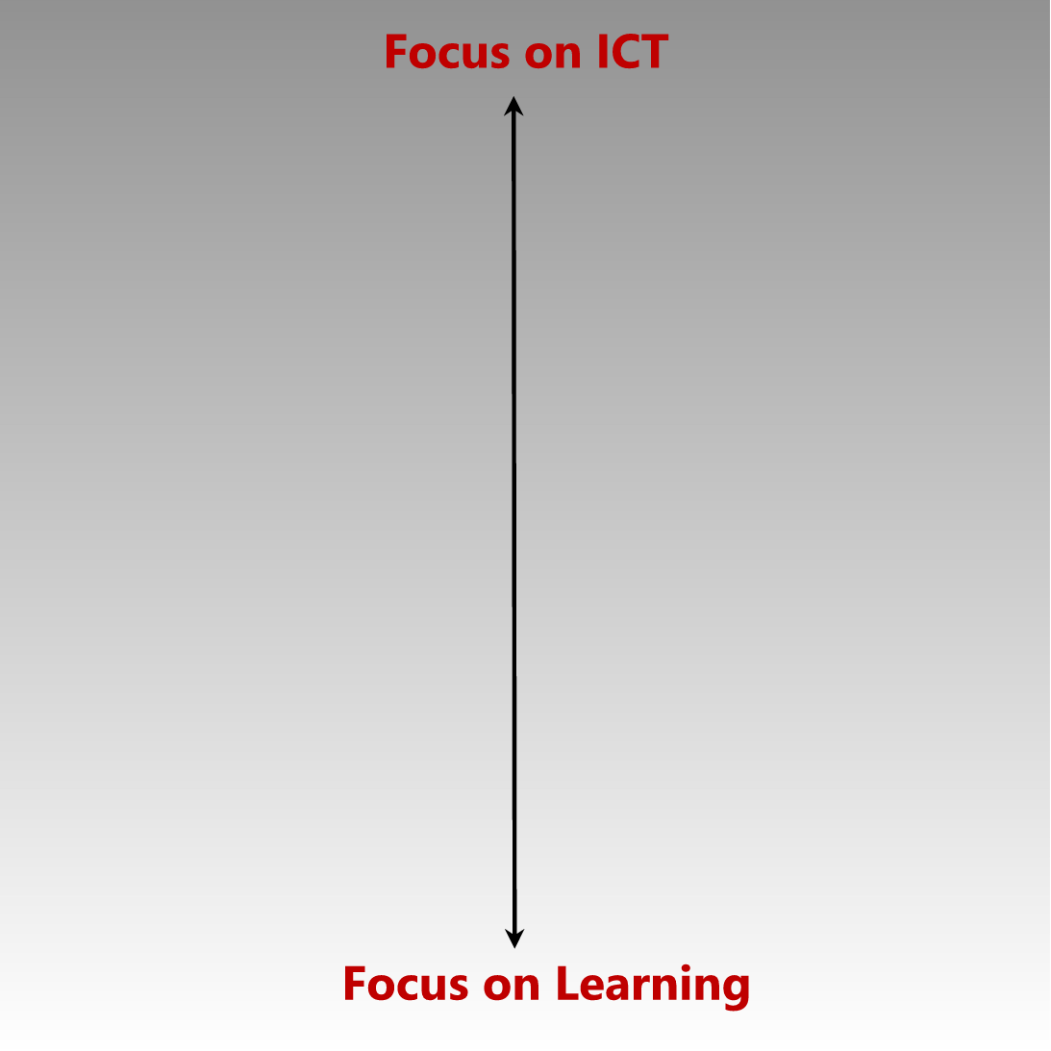
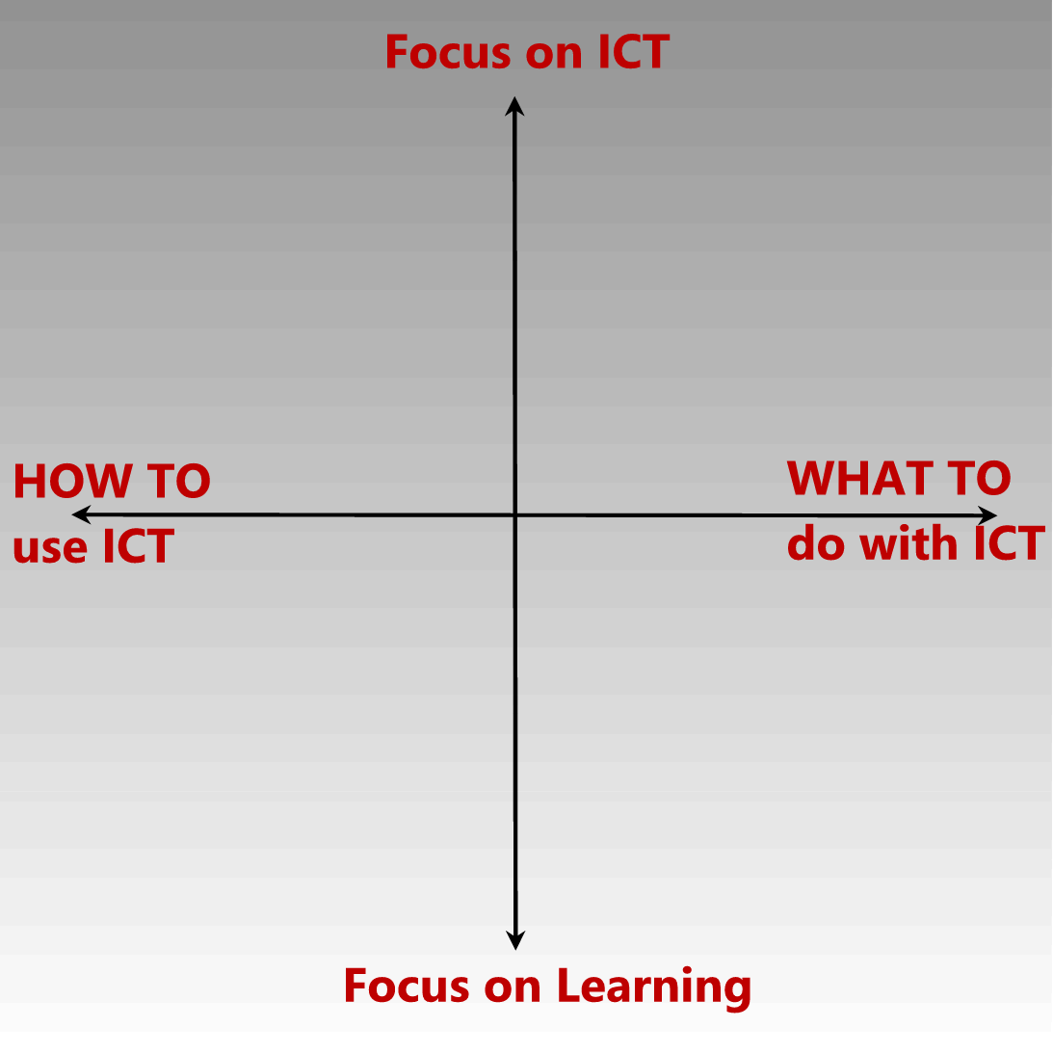
The purpose of this document is to outline an approach for teachers to receive training and ongoing teacher professional development on how they can maximize the use of their laptops for teaching and learning. This approach aims to support the Department of Basic Education’s Quality Learning and Teaching Campaign.
ICT Literacy
No Integration
Learning ICT Skills in Context
Teacher Development in ICT integration

ICT integration has many dimensions and stands the risk of being misunderstood on the same colossal scale that “computer literacy” is. Let us examine teacher development in ICT integration in 2 dimensions. The first dimension is the extent to which ICT skills are being taught as opposed to being used. The second dimension is the extent to which the focus on the planned activity IN THE CLASSROOM is focused on the ICT outcomes as opposed to the curriculum outcomes.

In the resulting grid we can distinguish between activities that focus on how ICT is used in various situations (on the right hand side) and activities that focus on meaningful learning contexts (in the bottom half). Initial courses for new users offer teacher-related scenarios in which teachers can explore teaching and learning contexts using ICT. Advanced courses for experienced users explore ways in which ICTs can create change in teaching and learning contexts; integrating ICT to enhance learning.

The activities in the top left corner are one dimensional in that they focus only on how to use ICT. These activities should be avoided as they ignore the basic principle of learning in meaningful contexts. Because teachers are often trained in courses without context such as ICDL, they often model that kind of training when asked to teach “computer literacy”. Planners worldwide typically make the error of considering teaching ICT skills to be sufficient for teachers to be able to use ICT in the classroom.

- Alignment with national policy

The e-Education White Paper outlines a strategy for ICT integration to enhance teaching and learning. Both the White Paper and the resulting DoE Guidelines for Teacher Training and Professional Development in ICT make reference to a hierarchy of stages that teachers would typically progress through as they adopt ICT and become more proficient with time.
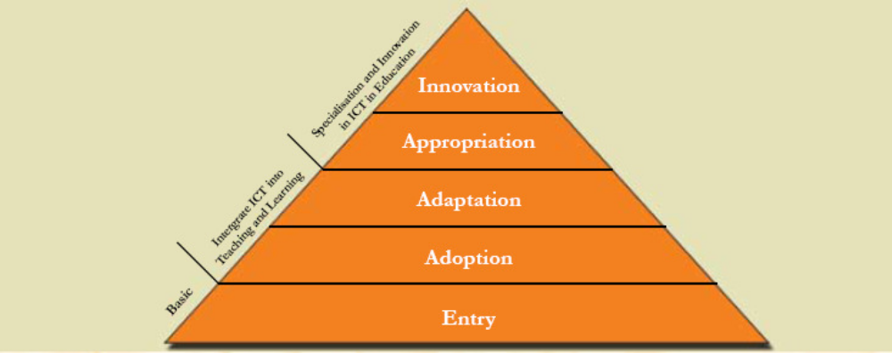

- Teacher Professional Development sub-committee for Teacher Laptop Initiative
A task team has been formally established to plan and manage implementation of teacher professional development in support of effective use of the teacher laptops. This team comprises the Department of Basic Education, the Teacher Unions and ELRC, and the strategic consortia partners.

Name | Organization
Haroon Mohamed - Director Teacher Development | Department of Basic Education
T. Mataboge | Department of Basic Education
Masivuye Sangoni | Department of Basic Education
Janet Thomson | SchoolNet SA
Omashani Naidoo | SchoolNet SA
Wally Smith | NAPTOSA
Madzena Mndi | NAPTOSA
David Mawela | SADTU
Deon Lerm | SAOU
Angela Schaerer | Microsoft
Reza Bardien | Microsoft
Parthy Chetty | Intel
Hannes Steyn | Intel
Alfie Hamid | Cisco
Simon Bromfield | Adobe
Sakkie Kilian | Symantec
Dylan Busa | Mindset
Xolani Hlongwane | HP

- Training model and strategy

Phase 1: Advocacy sessions

2-3 hour advocacy sessions incorporated into the launch event in each of the provinces, to promote and demonstrate the value of the initiative including the following:
- Overview of the Teacher Laptop Initiative – who qualifies, costs and subsidy available for teachers, what is included in the consortium offerings, teacher training, how to order a laptop (and potentially make this process available at the sessions).
- Demo of software, curriculum content and training included
- Value of a teacher laptop - how the laptop with the resources and content will support teacher administration and enhance teaching and learning
Facilitators: SchoolNet personnel and SchoolNet trainers; DBE representatives; Union representatives
Audience: teachers who are considering buying a laptop through the Teacher Laptop Initiative
Approximate timing: following the launch on 15 July to September 2010

Phase 2: Orientation/introductory session

A one (1) day of optional face-to-face training using existing experienced trainers, introducing all interested teachers who have purchased a laptop through the TLI, to the operation of the laptop and navigation through resources and content available on the laptop. These will be run in each of the provinces when there is a critical mass of teachers, based on the information provided through the DiData Central Registry. This course information will be provided in print and downloadable format as an alternative option to attending the course.

Facilitators: Facilitator training sessions to be run by authorised training providers (SchoolNet SA)
Audience: teachers who have bought a laptop through the Teacher Laptop Initiative
Approximate timing: January 2011 onwards once teachers have received laptops

Phase 3: Depth Scale Model - ongoing teacher professional development

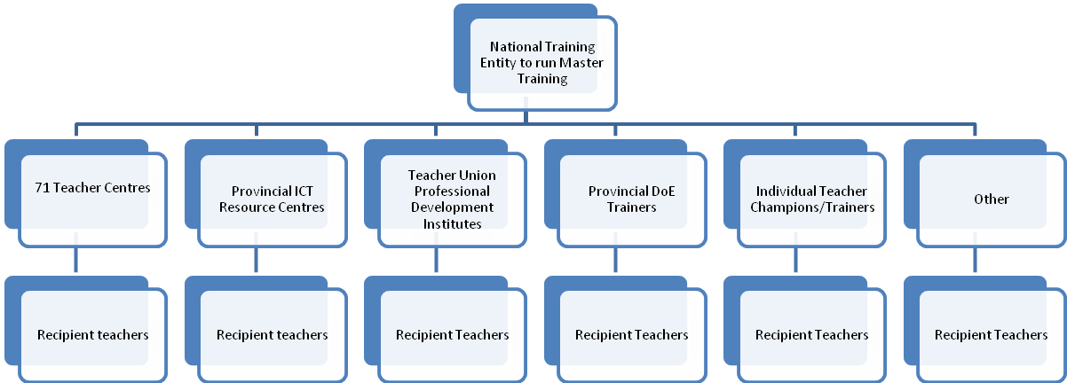
- SchoolNet SA will create a critical mass of national facilitators in order to scale continuous training. The national facilitators will be selected from current provincial trainers; trainers from provincial ICT Resources or Teacher Centres; trainers from Unions; champion teachers in provinces
- Cisco Master training will need to be conducted by accredited Universities.
- Facilitators need to pass training certification in order to conduct training, to maintain standards.
- Training will happen at either a teacher centre, union office or school depending on proximity and critical mass of teachers
- Teachers to maintain minimum standards set out for training to be recognised towards teacher professional development point system
- Recommend that facilitators train in pairs until they are confident enough to train alone
- Pair experienced facilitators with newly recruited facilitators
- Training to be mandatory for principals with laptops because there should be management buy-in and support
- Focus teacher training on novice teachers while also providing intermediate level training
- Monitoring and evaluation of trained teachers – facilitators and teachers complete evaluation reports
- Certificates for teachers attending training who have met all requirements

Facilitators: Facilitators from institutions/organisations outlined above
Audience: ongoing teacher professional development
Approximate timing: January 2011 onwards

All training initiatives will be supported by programming broadcast on Mindset Learn (available on Dstv, TopTV and Sentech Vivid). This support will be of the following nature:
- General awareness building and communication about the initiative (keeping up momentum throughout the life of the initiative)
- Provision of some types of training
- Support to teachers between formal training events
- Examples of best practice from “expert” teachers
- Broadcast of recorded training sessions as “refreshers”

Mindset is able to make this platform available at no charge (excluding video production and media ingest costs) for a period of 12 months ending in July 2011, after which time a review will take place.

- Training requirements

- Teachers to bring laptops (which will already include course curriculum, software and connectivity)
- Teacher registration and attendance
- Data projector
- Sufficient desks and chairs
- Connectivity
- Sufficient plug points
- Refreshments

- Awareness

Use marketing avenues to communicate training sessions
- Mindset Learn on Dstv, TopTV and Sentech Vivid
- Websites – Thutong, ELRC, SACE, consortia websites, union websites
- District circulars/memos
- National and regional newspapers
- Teacher email addresses from Windows Live ID
- Union publications
- Payslips printed by Persal
- Conferences – e-Schools Conference, Education Week, NEPAD conference, Networking Academy Safari

- Potential estimated budget
The ELRC will set up a separate bank account to receive any donations or reinvestment monies from partners, all of which will contribute towards the execution of the Teacher Professional Development programme. The amount of combined reinvestment funds totals approximately R121 per teacher. The estimated cost of training is based on a rate of R150 per teacher per day. The average course duration is three days.

- Teacher professional development learning pathway
The Teacher Laptop Initiative will focus on the Entry, Adoption and Adaptation levels of the national policy. Courses primarily at the Novice and Intermediate levels will therefore be offered to teachers as part of the Teacher Laptop Initiative.
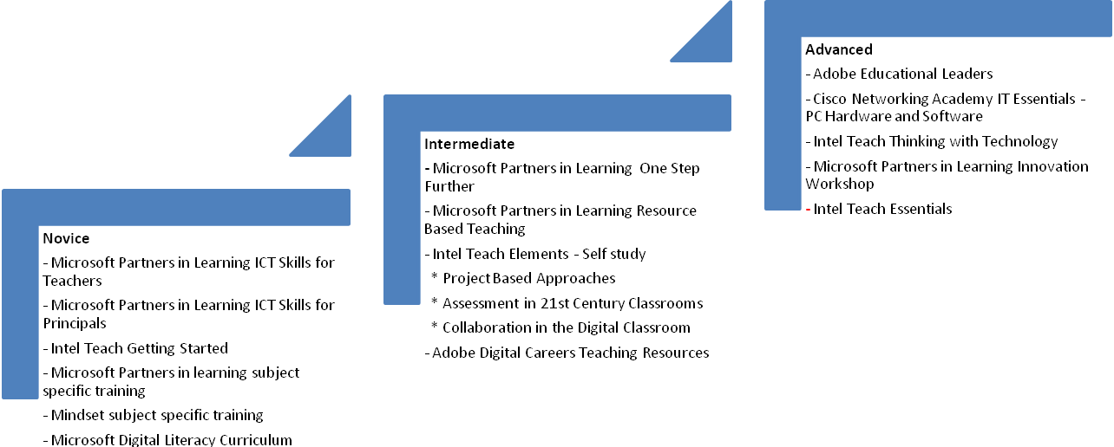

ANNEXURE A2 – TRAINING AND DEVELOPMENT content

Teacher Laptop Initiative
Information Booklet (in progress)
Contents should include
- Help Desk contact details
- Contact details for vendors
- Contact details for training providers
- Q & A - inserted below
- What the TLI package includes
- Insurance and finer details of it
- What does the warranty cover and how long is it
- How to activate Live ID
- Brief Course content outlines
Orientation Workshop (1 day) Programme
- Accessing the Internet
- Accessing the Live ID tools
- Accessing the Professional development courses
  - Microsoft –ICT Skills for Teachers or ICT Skills for Principals
  - Intel Teach- Elements (Project based Approaches, Assessing 21st century skills, assessing collaboration)
  - Adobe Digital School
  - Mindset
  - Cisco Networking Academies
- Basic Troubleshooting
- Laptop Support Contact Details
- Appendices (Professional Development Course Profiles)

General Teacher Laptop Call Centre Information
Professional Development Course Profiles
Microsoft ICT Skills for Teachers/ Principals
ANNEXURE A3 – TRAINING AND DEVELOPMENT objectives and measurables

Programme 1. Teacher Laptop INITIATIVE

Programme 1.1 tli Training & development

Responsible: TLI Project Manager / General Secretary

Purpose: To outline the training programme designed to ensure that teachers benefiting from the TLI Project are trained to be competent to use their laptops to optimum levels for the benefit of both the teacher and learner. This is to avoid a situation where laptops get purchased and remain unused or used to a minimum level.

1.1.1 Strategic Objectives

Strategic Objective | Key Measurable Objective
To ensure that :  - TLI task team has the correct partners to assist with the training initiative especially content, funding, etc.  - All training is of high quality and properly quality controlled.  - Funding is secured for the orientation programmes and training of all approved teachers in the computer literacy and intermediary training.  - Funding is secured for identification of potential Facilitators and their training.  - Facilitators are well trained to train teachers on the two levels of training and orientation programme.  - All approved teachers who require computer literacy are trained  - All teachers who bought laptops and are computer literate are trained in the intermediary ICT course. | - Resources identified and matched with contributions.  - Consultant employed to review quality & relevance of material that was provided.  - Funds secured for the implementation of orientation and training of all computer literate teachers.  - Adequate funds secured for identification of potential facilitators. The teachers functioned efficiently with their laptops and delivered quality education.  - All facilitators trained on the orientation programmes and the two levels of training  - All approved teachers who required computer literacy training trained.  - All approved teachers who had basic understanding and usage of laptops trained.
- To identify teachers and train them to be technical trainers who will assist with trouble shooting system problems and / or hardware. | - Teachers were identified and trained on the technical aspect of the hardware and technical system.

1.1.2 Analysis of constraints and measures to overcome them

Risks / Constraints | Impact/Effect on Business | Control Measures
- The interest of teachers to be trained.  - The teachers not arriving for training due to various reasons.  - Trainer not arriving for training due to an emergency, etc. | - Unable to correctly utilise their laptops effectively thus impacting on the quality of education delivered  - Wasted resources that could have been diverted and create a delay in reaping the benefits of quality education.  - Wasted resources that could have been diverted and delay in reaping the benefits of quality education. | Market the training and its importance through the advocacy sessions & trade unions.  Follow up with participants a day or two before the training day to serve as reminder.  The Training co-ordinator will liaise with trainers and delegates the two days before and get feedback on training day to track the initiative operationally.
- Informal channels of communication created by delegates who have attended training session and giving the others who still need to attend negative feedback. | - This may result in spreading of confusion among teachers and possibly make delegates due to attend training to become reluctant to attend. This will result in them not been able to optimise the usage of their laptops. | The training committee through the training co-ordinator needs to continuously communicate with teachers through the advocacy programme to clear confusion and continuously answer questions.
- Other teacher interventions that could make teachers to prioritise them instead of the TLI training. | - Effects of not getting all learners to be exposed to alternative learning methods – use of new technology, impacting quality of education. | Liaise with DoBE to include the TLI program into the DoBE annual departmental calendar.

1.1.3 Summary budget

2.3.3 OPERATIONAL PLAN FOR 20010/11

1st Quarter 01 April 2010 – 30 June 2010

Objective | Key Performance  Indicator | Target | Performance Result | Reason for Variance
Secure value adding partners to the training committee. | Partners contributing training resources like content, facilities, etc. | 100%
Secure funding | Ensure all reinvestments funds are received as per agreement and source additional funding required. | 50% of annual funding required
Provide advocacy sessions to provincial education department staff dealing with teachers especially the different departments within HR. | Provide sessions to all 9 provincial education departments | 100%
Train master trainers who are going to train teachers who buys laptops in this quarter on computer literacy and intermediary | Training of 50 master trainers | 100%
Provide orientation and train all approved teachers who buy laptops in this quarter on computer literacy and intermediary | Training of all teachers who purchased laptops especially based on the projected numbers of 32067. | 100%

2nd Quarter – July 2010 – September 2010

Operational Objective | Key Performance  Indicator | Target | Performance Result | Reason for Variance
Secure funding |  | 100%
Train facilitators who are going to train teachers on the computer literacy and ICT intermediary | Training of 70 facilitators | Within quarter
Provide orientation and train all approved teachers who buy laptops in this quarter on computer literacy and intermediary | Training of all teachers who purchase laptops - projected number of teachers is 32067 per quarter | 100%
Training of technical facilitators | Training of 150 facilitators | 100%

3rd Quarter – October 2010 to December 2010

Operational Objective | Key Performance  Indicator | Target | Performance Result | Reason for Variance
Train facilitators who are going to train teachers on computer literacy and ICT intermediary | Train 50 facilitators | 100%
Provide orientation and train all approved teachers who buy laptops in this quarter on computer literacy and intermediary | Training of all teachers who purchased laptops - projected number of teachers is 32067 per quarter | 100% Within quarter
Training of technical facilitators | Train 150 facilitators | 100%
Assessment of all trained teachers & provide quarterly reports to TLI Task team and ensure quality of material | Assess the competency of all trained teachers for the quarter to ensure that they are competent | 100%

4th Quarter – January 2011 to March 2011

Operational Objective | Key Performance  Indicator | Target | Performance Result | Reason for Variance
Provide orientation and train all approved teachers who buy laptops in this quarter on computer literacy and intermediary | Train all teachers who actually buy laptops as per the projected number of teachers is 32067 per quarter | 100%
Assessment of all trained teachers & provide quarterly reports to TLI Task team | Assess the competency of all trained teachers for the quarter | 100%

TLI PRICING STRUCTURE

ANNEXURE B

Approved Package Name | Predefined | Option 1 | Option 2 | Option 3
Laptop Specifications
Supplier/Consortium Name | Yes
Laptop Make | Yes | Mecer | Mecer | Mecer
Laptop Model | Yes | M748S | M748S | W765CQ
Laptop CPU Type, Make, Model and Speed | Yes | Intel Celeron T3100 1.9GHz | Intel Pentium T4500 2.3GHz | Intel Core i5-430M 2.26GHz
Laptop Memory Type and Size | Yes | DDR3-1333, 1GB | DDR3-1333, 2GB | DDR3-1333, 2GB
Laptop Cache | Yes | 1024KB | 1024KB | 3MB
Screen Type And Size | Yes | 14.1 inch WXGA TFT | 14.1 inch WXGA TFT | 15.6 inch 16x9 HD TFT
Hard Drive Type and Size | Yes | 250GB SATA | 250GB SATA | 320GB SATA
RW/DVD Drive | Yes | Super-Multi DVD R/W | Super-Multi DVD R/W | Super-Multi DVD R/W
Network Interfice Card (NIC) Specifications | Yes | Intel | Intel | Intel
Wireless LAN connection | Yes | 802.11 B/G | 802.11 B/G | 802.11 B/G/N
Ethernet LAN connection | Yes | 10/100TX Ethernet | 10/100TX Ethernet | Gigabit Ethernet
Voice-Fax Modem | Yes | Yes | Yes | Yes
Speakers | Yes | Yes | Yes | Yes
Microphone | Yes | Yes | Yes | Yes
USB ports | Yes | 3 x USB2.0 | 3 x USB2.0 | 3 x USB2.0
Battery Specifications | Yes | 6-Cell Li-ION | 6-Cell Li-ION | 6-Cell Li-ION
Operating System | Yes | Windows 7 Pro PPP | Windows 7 Pro PPP | Windows 7 Pro PPP
USB Flash Memory Stick | Yes | 4GB | 4GB | 4GB
Carry Bag | Yes | Yes | Yes | Yes
Hardware Value (Rands) | Yes | 4,110 | 4,428 | 5,306
Harware Serial Number | No
OEM PPP SKU Number | No

Warranty
3-Year Warranty | Yes | Yes | Yes | Yes
2-year Additional Warranty | Yes | Yes | Yes | Yes
Warranty Conditions | Yes | Carry into Branch | Carry into Branch | Carry into Branch
Warranty Exclusions | Yes | Force Majeur (Accidental) | Force Majeur (Accidental) | Force Majeur (Accidental)
Warranty Limitations | Yes | 1-Year for Battery | 1-Year for Battery | 1-Year for Battery
Warranty Number | No
Connectivity
3G Modem Type, Make, Model and Speed | Yes | Mecer 3.75G HSPA 7.2Mbps USB Mecer WM81, 3.75 | Mecer 3.75G HSPA 7.2Mbps USB Mecer WM81, 3.75 | Mecer 3.75G HSPA 7.2Mbps USB Mecer WM81, 3.75
Connectivity Service Provider | Yes | MTN | MTN | MTN
Data Package Name | Yes | T-Dat One | T-Dat One | T-Dat One
Data Quantity (Mb) | Yes | 150MB | 150MB | 150MB
Modem Connectivity Device Value (Rands) | Yes | 450 | 450 | 450
Package Value (Rands) | Yes | 540 | 540 | 540
Additional ‘top up’ cost per Mb of bandwidth | Yes | R 1.50 | R 1.50 | R 1.50
If any/all items are free when signing a contract, please specify | Yes | - | - | -
Up-front costs (equipment, installation, etc) | Yes | - | - | -
All additional costs (clearly specified) | Yes | - | - | -
Modem Serial Number: | No
SIM Number | No
PUK Number | No
Software
Productivity 1 | Yes | Microsoft Office Enterprise 2007/10 | Microsoft Office Enterprise 2007/10 | Microsoft Office Enterprise 2007/10

Insurance
Name of Insurance Company | No
Name of Underwriter | No
Insurance Reference Number | No
Total Insured Package Value (Rands) | Yes | R 4,100.00 | R 4,400.00 | R 5, 200.00
Total Monthly Premium over 5 years | Yes | R 1,435.00 | R 1,540.00 | R1,820.00
Finance
Financial Institution Name | No
Laptop Product | Yes | R 6,646.00 | R 7,657.00 | R 8,324.00
Required Accessories | Yes | R -
Data/Connectivity Cost (Monthly) | Yes | R 77.00 | R 77.00 | R 77.00
Insurance (Monthly) | Yes | R 23.92 | R 25.67 | R 30.33
Insurance (Total) | Yes | R 1,435.00 | R 1,540.00 | R 1,820.00
Software Microsoft (all including OS and Office and other) | Yes | R 298.00 | R 298.00 | R 298.00
Software Symantech (all) | Yes | R 220.00 | R 220.00 | R 220.00
Software Adobe (all) | Yes | R150.00 | R 150.00 | R 150.00
Software Other 1 | Yes | R -
Software Other 2 | Yes | R -
Software Other 3 | Yes | R -
Software Other 4 | Yes | R -
Software Other 5 | Yes | R -
Interest (Rands) | Yes | R 3,416.00 | R 3,888.00 | R 4,200.00
Interest (%) | Yes
VAT | Yes | R 2,453.00 | R 2,703.00 | R 2,868.00
TOTAL COST | Yes | R 19,974.00 | R 2,010.00 | R 23,354.00
Overview (Monthly Cost Year 1) | Yes | R 332.90 | R 366.83 | R 389.23
Government Subsidy (Monthly Cost) | Yes | R 130.00 | R 130.00 | R 130.00
Payment Terms - Months (Fixed to 60) | Static | 60 | 60 | 60
Teacher Total Monthly Payment | Yes | R 202.90 | R 236.83 | R 259.23
Amount Financed | Yes | R -

DoE. 2004. White Paper on e-Education – Transforming learning and teaching through Information and Communication Technology. Government Gazette, Vol. 470, No. 26734. Pretoria
DoE, 2007. The Guidelines for Teacher Training and Professional Development in ICT, Pretoria

