
Siyadiliva Nomakanjani!

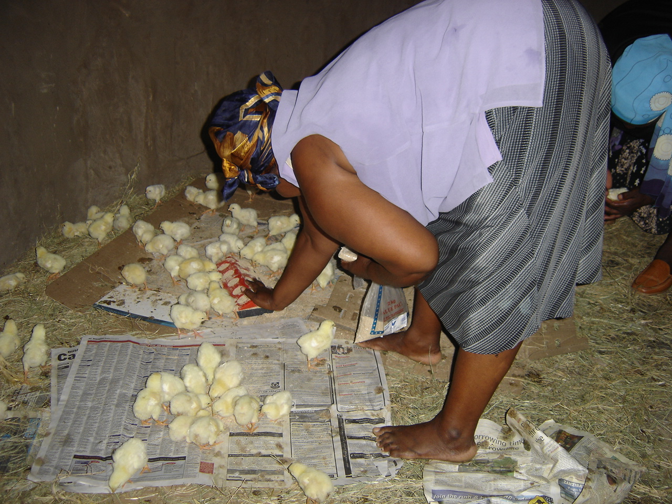
TRANSFORMATION OF THE AGRICULTURAL SECTOR
AGRICULTURAL PORTFOLIO SUBMISSION
“Transformation is not about changing policy, but about changing people”
Wanyuka Consultants CC
P O Box 8
LIONS RIVER
3260
Tel: 033- 234 4511
Fax:033- 234 4494
Faxmail: 0866 717 458
Email: susan@wanyuka.co.za

1. INTRODUCTION

My career began in the business world with a fiery entrepreneurial spirit, which led to my becoming a Financial Director of a successful multi-million rand construction company while still in my early twenties. Farming had been incubated in my bloodline though, hence the inevitable purchase of a commercial farm. Following on from this, I delved into the world of education and rural development. During the apartheid years I registered an independent school on our farm in Zululand where our own seven children sat alongside the local rural Zulu children until they graduated with matric.

A combination of my business, education and development skills attracted attention and I was approached by the Department of Agriculture to write a training course for the youth. Following that, groups of youth would visit the farm and live there for three weeks while I trained them in farming and business skills on behalf of the Department. This led to me travelling far and wide in the Province of KwaZulu Natal in order to live within a community group that was to be trained.

This introduction should set me aside from the academic world (of which I am a part still) and enhance my credibility as a researcher who fully comprehends the agricultural status quo amongst the new and emergent farmer today.

Hence – I will not be delivering statistics, graphs or academic language material. My focus is on people. Neither policy not transformation would exist without people. Implementation of transformation policy needs people to make it happen but it also needs people to receive it willingly and with the required knowledge and skills to be successful. I am here to tell you about what I encounter at grass roots level with the deep hope that someone might eventually heed the cry of the new farmer and make a difference!

2. FARMING IS BUSINESS

Land allocation policy has focused on re-settling and settling of previously disadvantaged and displaced people. The selection criteria for these beneficiaries, be they land claim or LRAD recipients, have had absolutely no reference to business skills. It is now reported that up to 90% of new land beneficiary projects have failed. Unless we have urgent intervention in this sector, we are facing disaster.

Traditionally, land was never owned in tribal Africa – it was granted to an individual to utilize under the auspices of the Inkhosi and his headmen, just as it is in the Tribal Trustlands today. Commercial trading as we know it was not a factor and certainly the global village did not play a part in trade and markets.

The sedentary lifestyle which farming generally represented in the past has been replaced with gruelling production deadlines, meticulous application to budgets, cash flows and profit margins. We seriously need to ask ourselves and thereafter define what access to land should represent in this scenario.

3. DEVELOPMENT BANK PAPER

During 2008, I wrote a paper entitled “Ensuring Water and Food Security in South Africa” for the Development Bank Knowledge Week. Despite the forum being well attended by strategic persons, I have not seen change in any of the challenges highlighted there. Topics covered in that paper, of which I have included a copy with this submission:
- Commercial farming challenges
- Tribal Trustlands
- Problems and Aspirations common to emergent, re-settled and Tribal Trustland farmers
- Focus, Inhibitions and Aspirations of Rural Farmers
- Paradigm Shifts
- A study of Rural Co-operatives, including formation and registration of their legal entity, Funding, Business skills, Access to Supplies and Markets and Social dynamics
- Recommendations

I do not have time today to repeat what is written in that document.

4. PRE AND POST SETTLEMENT SUPPORT

Our Constitution provides for an individual to have access to land. It also provides for the protection of the dignity of the individual. If we are to safeguard our Constitutional rights and aspirations and guarantee transformation within the agricultural and land sector, we would focus on the person who is to be given access to land and ensure that he/she is equipped to be successful at farming.

The criteria for successfully claiming land was to have been previously dispossessed of that land. The criteria for acquiring land through LRAD require only being previously disadvantaged as a Black person and having “some own equity, which could include sweat”. There is not a Needs Analysis conducted where the business skills levels of beneficiaries would be tabled and demonstrated.

I have trained thousands of new and emergent farmers from subsistence level to large land project owners and the challenges encountered are consistent across the board. The groups that I work with range in number from fifteen to 30 and sometimes even more as people bring their friends and neighbours when they find the course material enjoyable and interesting. Literacy levels are a major challenge as course participants range from being totally illiterate to semi-literate to a very small minority who are reasonably literate. Literacy means the ability to read and write NOT the ability to do business projections and calculations. Circumstances have pressurised me into purchasing a panel van to accommodate the materials needed to assist these adult learners.

Just imagine – arriving at a location or training venue to teach business and finding that not a single person knows how to operate a calculator, has never done basic maths and has no idea how to work with percentages. Added to that, I have never experienced a group of 30 learners that has had more than three people who have operated a bank account. Now I am entrusted with making them business literate within a five day period and thereafter expect them to be proficient in producing budgets, cash flows and most importantly how to calculate percentages with a purpose of gauging inputs, adding a percentage for profit and assessing the selling price of produce. There has been the rare participant who has understood what is required but the majority struggle.

The general trend is to place produce in plastic bowls and sell it for an estimated price with no knowledge of inputs and hence no generation of profit or even enough finance to cover expenditure.

Operating within the current constraints and status quo will never see the new farmer arising triumphant. Education requires constant reinforcement and practise, so any new material not only needs to be processed, it needs to be practised.

The training directorate is an integral part of post-settlement support but cannot cover the spectrum requiring attention. By the time training reaches some projects (some of these own hundreds or thousands of hectares of land), the electricity has been cut off due to the beneficiaries of that land not understanding that a contract with Eskom means paying line charges even when no consumption has occurred, no agriculture is happening as there is no money for seed or any other input.

The main problem, as researched by Stellenbosch University is that those people in place to train or teach agriculture, have never done business. The agricultural technicians (extension service) have not done business. How do they advise or teach the new farmers? I have also trained Extension officers for the Department of Agriculture and have been alarmed at their lack of business knowledge. With regards to their technical support and assistance, it is a different matter.

Most group or social cohesion disputes involve finance. With the promotion of co-operatives, this has introduced a new focus on group cohesion or the lack thereof. If all members of a co-operative understood the intricate elements of business, this would bring about a spirit of unity to achieve a common vision. Through all the years of involvement with these communities, I have not encountered a single person who is even aware of what bankruptcy is and the implications thereof – like having their assets sold on a liquidation sale!

5. FOOD SAFETY AND SECURITY

I have personally had a paradigm shift from thinking that commercial agriculture is the answer to our food problems. Food security needs to be achieved through households and communities growing their own produce. The one household, one garden project was supposed to have been launched. I have not witnessed any progress in this regard and every person involved in agriculture needs to be skilled! I will not dwell on the depressing statistics – all of us who are involved in agriculture should be aware of our dire problem and the threat that is posed to our food security in this country. Policy will not change this. Owning more land will not change this. Political elbowing will not change this. Transformation will not happen without people changing!

To secure our food production, post-settlement support should include mechanisation. Apparently the mechanisation programme has been launched and we now wait patiently to see if the grass root farmer will benefit. I was with a group near Osizweni (around Newcastle/Madadeni), teaching them Veggie farming when an older man who was attending the course arrived late one morning. He was complaining about his very sore shoulders and back – he had been pulling the plough himself! So we see the demonstration of the willingness to make progress but the lack of support is crippling.

6. RECOMMENDATIONS

6.1 If the Constitution states that an individual has the right to access to land – should that be agricultural land? Agricultural land should only be given to screened applicants who demonstrate the required skills and passion for working the land as a business. This will engineer transformation within the sector. Emotion generated by this subject is detrimental to our progress. Otherwise access to land should be only on a small scale as in the Tribal Trustland areas where households and communities could engage in subsistence farming to ensure household food security, but of course having title to that land which Tribal Trustland residents do not have.

6.2 If there is going to be no distinction in household access to land, these beneficiaries should also be vibrantly supported and trained. I was present at the Agriseta roadshow this year where one of the top executives made the announcement that not every person who holds a spade in his hand will get training! They are now allegedly only looking at projects that are showing success. How does a person who has been denied education in the past, become successful with no training and support? Every person who is prepared to work with a spade should be afforded the privilege of training. This is where food security begins.

6.3 A further compounding problem is that FET training for new farmers is being given over to technicians and agricultural college graduates. Yet again the crucial experience of business is non-existent.

6.4 Every new project should be assigned a “business mentor” to assist the management in setting up record keeping structures and making business decisions. This process is lengthy and the acceptance of mentoring should be mandatory – not a choice. Many project members refuse to accept this and resent the “intrusion”.

6.5 The Agribee charter and the pending Agriculture and Land Green Paper will do nothing towards improving the situation unless appropriate screening is done and skills transferred. Hand-outs will never be a profitable trade for this.

6.6 Social cohesion is an ongoing problem with power struggles and jealousy causing division and disintegration. The Besters project near Ladysmith is an example of this. Once a vibrant project, it has become an embarrassment. Capacity building, conflict resolution and business knowledge is lacking in that group.

6.7 A paradigm shift is needed with urgent intervention. It will not be beneficial to the crisis we are facing in failed projects to have the Agriseta unit standard qualification in agriculture take up to three years to achieve! Further to that, a new mind is needed where the business trainer and mentor has to be innovative in assisting the project members to utilise the resources at their disposal to be successful instead of trying to do it all according to the academic textbook. The photograph on the cover of this submission document is typical of this principle – where chickens were grown up in a hut that was available and sold for a handsome profit. There was no finance to build proper poultry houses and have all the correct equipment. The grass roof was the perfect insulator and chickens were allowed out for a period during the day making them the perfect free range birds.

Finally, this submission can be summarised – no transformation will occur unless we deal with people. As we transform their lives by imparting the necessary skills, we empower them with dignity and self worth – the qualities that were stripped from them during the years of apartheid rule and tribal trustland governance. Business minds, gender equality and access to land for the right reason will build our country and ensure that food remains plentiful and cost effective.

Every revolution in history has been instigated by hunger – recently across our own border in Mozambique. Are we going to continue with our political arm-wrestling or are we going to put our heads and expertise to work in building agriculture?

Author: Susan Pletts

