DEPARTMENT OF HUMAN SETTLEMENTS
HLAMDA ANNUAL REPORT
2009/10



CHIEF DIRECTORATE: HOUSING EQUITY
TABLE OF CONTENTS TABLE OF CONTENTS

- Introduction……………………………………………………………4
- Objectives of HLAMDA……………………………………………....4
- Required information…………………………………………...…....4
- Explanation of codes used………………………...…..……………5
- Compliance………………. ………………………………………….6
- The Analysis ……………………………...………………………….7
6.1 Total applications received per bank……………………………..7
6.2 Total applications received per race………………………….......9
6.3 Consolidation of applications received per race……………....10
6.4 Total applications received per income category……………...11
6.5 Consolidation of applications received per income…………...12
- Total applications approved per bank……………………….......14
7.1 Individual banks’ applications approved per race…………….16
7.2 Consolidation of approved applications per race……………..17
- Total applications declined ……………………………..............18
8.1 Total applications declined per race…………………………...20
8.2 Consolidation of declined applications per race………………21
8.3 Reasons for declined applications……………………………...22
- Total applications received per province………………............23
9.1 Allocation of applications per province…………………………24
- Lending patterns……………………………. ……………………26
10.1 Income lending patterns…………………………………………26
- Performance ratings……………………………………………….27
- Conclusion………………………………………………………….28
- Recommendations…………………………………………………28

1. INTRODUCTION
All financial institutions have an obligation to disclose the required home loans information on annual basis in terms of the Home Loan and Mortgage Disclosure Act (HLAMDA) 63 of 2000. HLAMDA was implemented with effect from 2007.

2. OBJECTIVES OF HLAMDA
The main purpose of HLAMDA is to promote fair lending practices, which require disclosure by financial institutions of information regarding the provision of home loans and thereby eliminate discriminatory lending patterns. The country has evolved in a positive way since 1994 hence the discrimination under this Act is not only racial but per income as well as geographical areas.
The analysis of the information provided has enabled the department to make informed decisions in identifying problem areas in order to respond appropriately.

3. REQUIRED INFORMATION
According to HLAMDA, the following information needs to be disclosed by the financial institutions:
- Total number and amount of completed applications received;
- Total number and amount of applications declined and reasons thereof;
- Total number and amount of loans approved; and
- Other information as may be prescribed.
All the above information must be disclosed in terms of:
- Categories of borrowers, and
- Geographic areas.
The communication between the financial sector, in particular the banks, has improved. The engagements are now more focused. Whilst it is noted that the banks’ systems are not yet fully accommodative to the requirements of HLAMDA, but the banks have responded positively to this challenge despite the costs involved. However, it must be mentioned that not all the affected financial services providers have complied and the department will soon communicate this message.
The Act itself creates certain impracticalities hence the need for review. The departmental reporting format is not perfect. In some areas, it creates a challenge that affects the reporting by financial institutions. This matter is receiving attention.
- EXPLANATION OF CODES USED

Reason/ s (if declined )

ID Description

01A : Low repayment capacity
02A : Unacceptable credit record
03A : Irregular Income
04A : Accepted security requirements not met
05A : Required repayment period exceeds the period to retirement
age
06A : Nature or relationship between joint applicants not conclusive to
meeting repayment obligations
07A : Other (specify)

5. COMPLIANCE
The following financial institutions complied with Section 3 of HLAMDA for the year ending March 2010:
NO | BANK | FINANCIAL YEAR
1 | ABSA | 2008
2 | Albaraka | 2008
3 | Bank of Athens | 2008/09
4 | First Rand Bank | 2008/09
5 | Imperial Bank | 2008
6 | Investec | 2008/09
7 | Ithala | 2008/09
8 | MEEG | 2008
9 | Mercantile | 2008
10 | Nedbank | 2008
11 | S.A Home Loans | 2008
12 | Sanlam | 2008
13 | Standard | 2008
14 | Teba | 2008/09
15 | VBS Mutual | 2008/09
TOTAL | 15

6. THE ANALYSIS

The purpose of this report is to present the information submitted to the department and the compliance thereof by the financial institutions. This means that this report is not intended to compare the financial institutions against each other but rather to the compliance of the Act.
  - TOTAL APPLICATIONS RECEIVED PER BANK

Table 1: Total applications received per bank
NUMBER | BANK | Number | Value | %
1 | ABSA | 462,075 | * | 41.96
2 | FRB | 249 152 | 123 043 597 870 | 22.63
3 | Std Bank | 260 142 | * | 23.62
4 | Nedbank | 65 535 | 36 096 496 752 | 5.95
5 | Investec | 11 521 | 65 331 461 288 | 1.05
6 | Ithala | 4 117 | 1 375 856 254 | 0.37
7 | Teba | 3412 | 150 948 818 | 0.31
8 | Albaraka | 502 | * | 0.05
9 | Mercantile | 365 | 1 113 738 160 | 0.03
10 | Bank of Athens | 49 | 59 945 000 | 0.01
11 | VBS Mutual Bank | 49 | 15 053 000 | 0.01
12 | Sanlam | 8550 | 5 635 033 385 | 0.78
13 | S.A Home Loans | 34 241 | 16 861 668 717 | 3.10
14 | MEEG | 484 | 130 525 553 | 0.04
15 | Imperial Bank | 963 | 171 758 661 | 0.09
 | TOTAL | 1 101 157 | 249 986 083 458 | 100
* implies that the Bank did not provide the information or that the information provided created discrepancies and therefore could not be used in the analyses

Graph 1: Total applications received

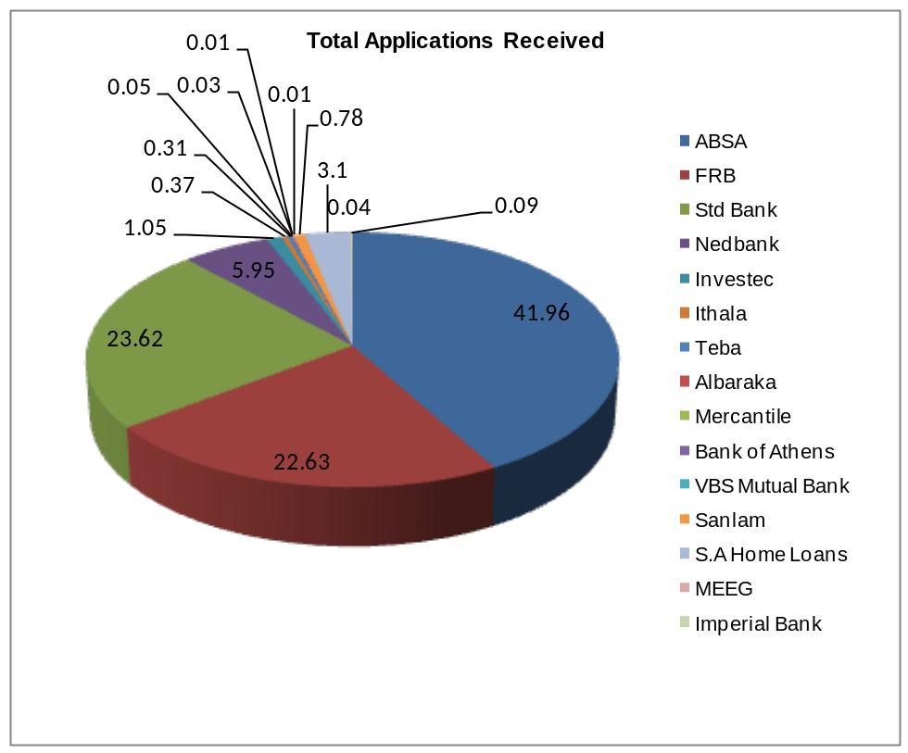

6.2 TOTAL APPLICATIONS RECEIVED PER RACE

Table 2: Applications Approved as per Race
BANK | African | Coloured | White | Indian | Other | Unknown
ABSA | 180 245 | 25 104 | 183 950 | 27 762 | 864 | 50 150
FRB | 101 084 | 24 693 | 101 447 | 1 533 | 20 395 | *
Std Bank | 132 024 | 27 746 | 83 835 | 15 524 | 866 | 147
Nedbank | 14 225 | 14 357 | 18 823 | * | 18 130 | *
Investec | 1 225 | 237 | 5 510 | 587 | 62 | 3 900
Ithala | 3 659 | 38 | 152 | 225 | 43 | *
Teba * | * | * | * | * | * | *
Albaraka | 3 | 73 | 4 | 413 | 5 | 4
Mercantile | 6 | 7 | 344 | 8 | * | *
Bank of Athens | 3 | 1 | 42 | 3 | * | *
VBS Mutual Bank | 40 | * | 8 | 1 | * | *
Sanlam * | * | * | * | * | * | *
S.A Home Loans | 4 201 | 3 102 | 10 444 | 2 377 | 14 117 | *
MEEG | 384 | 65 | 31 | 3 | 1 | *
Imperial Bank | 111 | 44 | 676 | 132 | * | *
TOTAL | 437 210 | 95 467 | 405 266 | 48 568 | 54 543 | 54 197

* implies that the Bank did not provide the information or that the information provided created discrepancies and therefore could not be used in the analyses

6.3 CONSOLIDATION OF APPLICATIONS RECEIVED PER RACE

Table 3 (below) is a summary of all applications received per racial categories.

Table 3 : Consolidation of Applications Received per Race
RACE | Number | %
African | 437 210 | 39.92
Coloured | 95 467 | 8.72
White | 405 266 | 37.00
Indian | 48 568 | 4.43
Other | 54 543 | 4.98
Unknown | 54 197 | 4.95
Total | 1 095 251 | 100

Graph 2: Total Applications Received by Banks

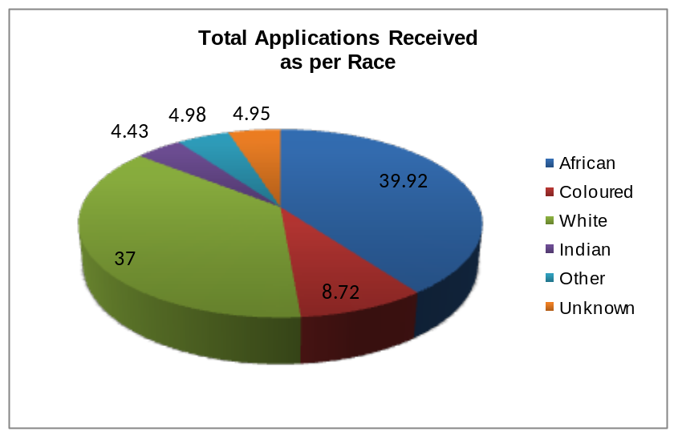

The difference in the number of applications received for Africans and Whites is minimal. Due to the discrepancy in the information received, the grand totals do not balance (R1 101 157 vs R1 095 251). Some of the financial institutions did not comply with Section 3 of HLAMDA and the departmental Compliance Manual.

6.4 TOTAL APPLICATIONS RECEIVED PER INCOME CATEGORY

Table 4 presents the classification of applications received per income category.

Table 4 : Applications Received per Income Category
BANK | R0-R3500 | R3501-R5500 | R5501-R7500 | R7501-R10000 | R10001-R15000 | R15001 and + | Unknown
ABSA | 37414 | 13 584 | 17232 | 28869 | 63 411 | 301565 | *
FRB | 18446 | 8 025 | 10253 | 17 012 | 35 333 | 160071 | 12
Std Bank * | * | * | * | * | * | * | *
Nedbank | 348 | 1 286 | 1 966 | 3 570 | 7 471 | 35 525 | 18 369
Investec | 6 | 4 | 11 | 34 | 67 | 7 153 | 4 246
Ithala | 210 | 143 | 222 | 406 | 1141 | 1995 | *
Teba * | * | * | * | * | * | * | *
Albaraka | 131 | 17 | 21 | 33 | 67 | 227 | 6
Mercantile | * | 1 | 6 | 2 | 23 | 333 | *
Bank of Athens | * | * | * | * | 5 | 44 | *
VBS Mutual Bank | * | * | 5 | 9 | 19 | 16 | *
Sanlam * | * | * | * | * | * | * | *
S.A Home Loans | 16 | 51 | 855 | 1 856 | 5 278 | 26 185 | *
MEEG | * | 21 | 41 | 91 | 210 | 121 | *
Imperial Bank | * | * | * | * | 5 | 744 | 214
TOTAL | 56571 | 23 132 | 30612 | 51882 | 113030 | 533979 | 22 847

* implies that the Bank did not provide the information or that the information provided created discrepancies and therefore could not be used in the analyses

6.5 CONSOLIDATION OF APPLICATIONS RECEIVED PER INCOME CATEGORY

Table 5 :Total Applications Received as per Income category
Income Range | Number | %
R0-R3500 | 56 571 | 6.71
R3501-R5500 | 23 132 | 2.74
R5501-R7500 | 30 783 | 3.65
R7501-R10000 | 51 882 | 6.16
R10001-R15000 | 113 030 | 13.41
R15001 and + | 544 642 | 64.62
Unknown | 22 847 | 2.71
Total | 842 887 | 100

Graph 3: Total Applications Received as per Income Category
of Applicants

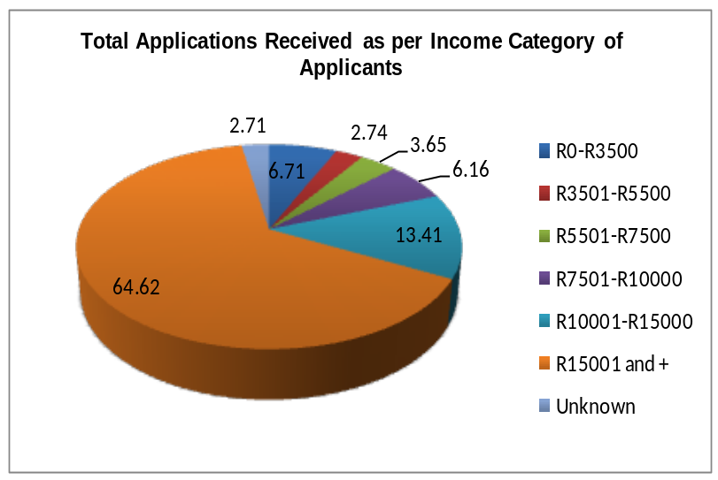

* implies that the Bank did not provide the information or that the information provided discrepancies and therefore could not be used in the analyses

Sections 6.3 and 6.4 confirm that the majority of home loan applications came from the upper end of the income (64.62%). The challenges facing the low and middle income categories are also confirmed by this analysis.

The breakdown of information per income category does not balance due to inconsistency in the figures for income categories R5501-R7500 and in excess of R15000 and above. The major disappointment is with poor quality of data provided by one of the biggest banks, the Standard Bank of South Africa Limited.

- TOTAL APPLICATIONS APPROVED PER BANK

Table 6: Total applications approved per bank

NO | BANK | Number | Value | %
1 | ABSA | 21 498 | * | 12.83
2 | FRB | 24 772 | 26 568 374 366 | 14.78
3 | Std Bank | 73 969 | 109 093 | 44.14
4 | Nedbank | 29 768 | 16 396 132 071 | 17.76
5 | Investec | 9 282 | 54 072 197 092 | 5.54
6 | Ithala | 324 | 244 745 277 | 0.19
7 | Teba |  | 0 | 0.36
8 | Albaraka | 115 | 5 238 397 250 | 0.07
9 | Mercantile | 67 | * | 0.04
10 | Bank of Athens | 7 | 8 080 000 | 0.01
11 | VBS Mutual Bank | 41 | 12 465 000 | 0.02
12 | Sanlam | 2 775 | 343 991 597 | 1.66
13 | S.A Home Loans | 3 537 | 1 767 907 863 | 2.11
14 | MEEG | 72 | 20 517 953 | 0.04
15 | Imperial Bank | 745 | 974 368 192 | 0.45
 | TOTAL | 167 581 | 105 647 285 754 | 100

* implies that the Bank did not provide the information or that the information provided discrepancies and therefore could not be used in the analyses

Graph 4: Total Applications Approved by Banks

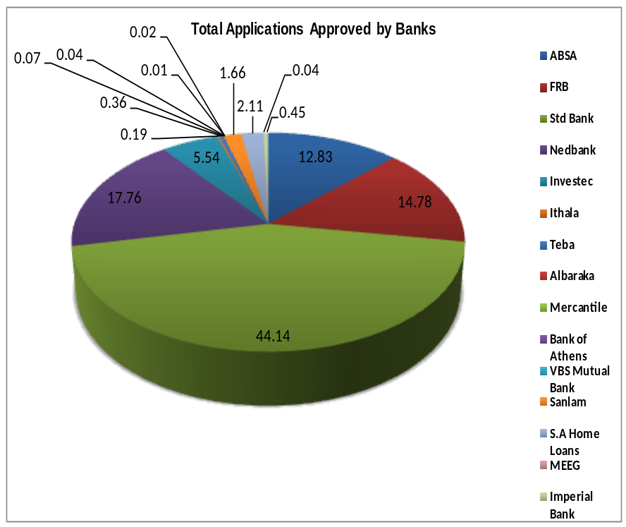

Even though Standard Bank had the highest percentage of the approval rate, this achievement cannot go unchallenged. The quality of data provided by the bank was not credible. The spread of the approval rate is in line with the size of individual banks.

7.1 INDIVIDUAL BANKS’APPLICATIONS APPROVED PER RACE

Table 7: Applications Approved per Race

BANK | African | Coloured | White | Indian | Other | Unknown
ABSA | 6 318 | 867 | 8 851 | 893 | 50 | 4 519
FRB | 6 695 | 1 773 | 13 665 | 218 | 2 421 | *
Std Bank | 30 074 | 8 273 | 29 672 | 5 504 | 322 | 124
Nedbank | 4 734 | 4 831 | 9 975 | * | 10228 | *
Investec | 900 | 199 | 4 508 | 485 | 46 | 3 144
Ithala | 275 | 5 | 9 | 8 | 27 | *
Teba * | * | * | * | * | * | *
Albaraka * | * | * | * | * | * | *
Mercantile | 1 | * | 66 | * | * | *
Bank of Athens * | * | * | * | * | * | *
VBS Mutual Bank | 33 | * | 8 | * | * | *
Sanlam * | * | * | * | * | * | *
S.A Home Loans | 443 | 380 | 1 415 | 295 | 1 004 | *
MEEG | 65 | 6 | * | 1 | * | *
Imperial Bank | 87 | 39 | 511 | 108 | * | *
TOTAL | 49 625 | 16 373 | 68 680 | 7 512 | 14098 | 7 787

* implies that the Bank did not provide the information or that the information provided discrepancies and therefore could not be used in the analyses

7.2 CONSOLIDATION OF APPROVED APPLICATIONS PER RACE

Table 8 : Applications Approved as per Race
RACE | Number | %
African | 49 625 | 30.25
Coloured | 16 373 | 9.98
White | 68 680 | 41.86
Indian | 7 512 | 4.58
Other | 14 098 | 8.59
Unknown | 7 787 | 4.74
Total | 164 075 | 100

Graph 5: Total Applications Approved by Banks as per Race
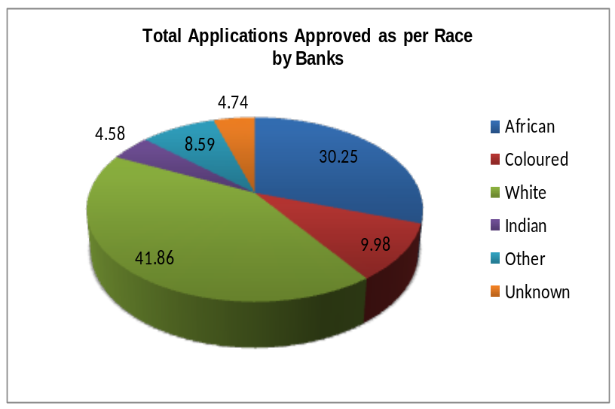

Sections 7.1 and 7.2 represent the most important home loans information required by HLAMDA. Tables 7 and 8 indicate that the highest approval rate was in favour of the “White” followed by “Black”. The “unknown” figures reflected by ABSA and Investec are a cause for concern.

- TOTAL APPLICATIONS DECLINED

Table 9: Total applications declined

Number | BANK | Number | Value | %
1 | ABSA | 135 926 | * | 29.32
2 | FRB | 126 536 | 57 908 830 963 | 27.29
3 | Std Bank | 156 281 | * | 33.71
4 | Nedbank | 30 110 | 16 584 504 725 | 6.49
5 | Investec | 328 | 3 356 039 353 | 0.07
6 | Ithala | 3 075 | 1 027 627 036 | 0.66
7 | Teba | 2211 | 106 240 736 | 0.48
8 | Albaraka | 56 | 10 609 500 | 0.01
9 | Mercantile | 23 | * | 0.01
10 | Bank of Athens | 2 | 1 490 000 | 0.00
11 | VBS Mutual Bank | 8 | 2 588 000 | 0.00
12 | Sanlam | 2 929 | 1 851 996 252 | 0.63
13 | S.A Home Loans | 6 071 | 3 233 728 726 | 1.31
14 | MEEG | 91 | 31 336 000 | 0.02
15 | Imperial Bank | 26 | 42 406 000 | 0.01
 | TOTAL | 463 673 | 84 157 397 291 | 100

Graph 6: Total Applications Declined by Banks

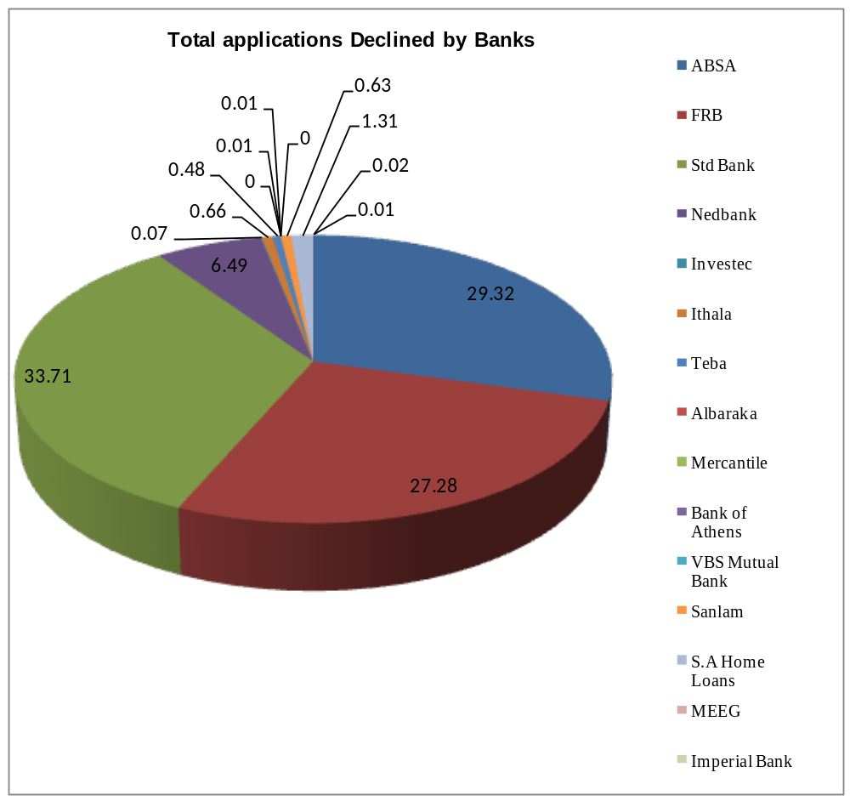

8.1 TOTAL APPLICATIONS DECLINED PER RACE

Table 10: Applications declined as per Race
BANK | African | Coloured | White | Indian | Other | Unknown
ABSA | 73 444 | 6 995 | 42 046 | 5 971 | 186 | 7 284
FRB | 64 955 | 14 055 | 39 042 | 781 | 7 703 | *
Std Bank | 90 290 | 17 242 | 7 752 | 40 572 | 425 | 25
Nedbank | 8 201 | 9 151 | 7 040 | * | 5 718 | *
Investec | 41 | 5 | 112 | 14 | 3 | 153
Ithala | 2 720 | 32 | 116 | 200 | 7 | *
Teba * | * | * | * | * | * | *
Albaraka * | * | * | * | * | * | *
Mercantile | 3 | * | 20 | * | * | *
Bank of Athens * | * | * | * | * | * | *
VBS Mutual Bank | 7 | * | * | 1 | * | *
Sanlam * | * | * | * | * | * | *
S.A Home Loans | 977 | 648 | 1 632 | 400 | 2 414 | *
MEEG | 69 | 12 | 8 | 2 | * | *
Imperial Bank | 8 | 1 | 16 | 1 | * | *
TOTAL | 240 15 | 48 141 | 97 784 | 47 942 | 16 56 | 7 462
* implies that the Bank did not provide the information or that the information provided discrepancies and therefore could not be used in the analyses

8.2 CONSOLIDATION OF DECLINED APPLICATIONS PER RACE

Table 11 : Applications Declined as per Race
RACE | Number | %
African | 240 715 | 52.50
Coloured | 48 141 | 10.50
White | 97 784 | 21.33
Indian | 47 942 | 10.46
Other | 16 456 | 3.59
Unknown | 7 462 | 1.62
Total | 458 500 | 100

Graph 7: Total Applications Declined by Banks as per Race
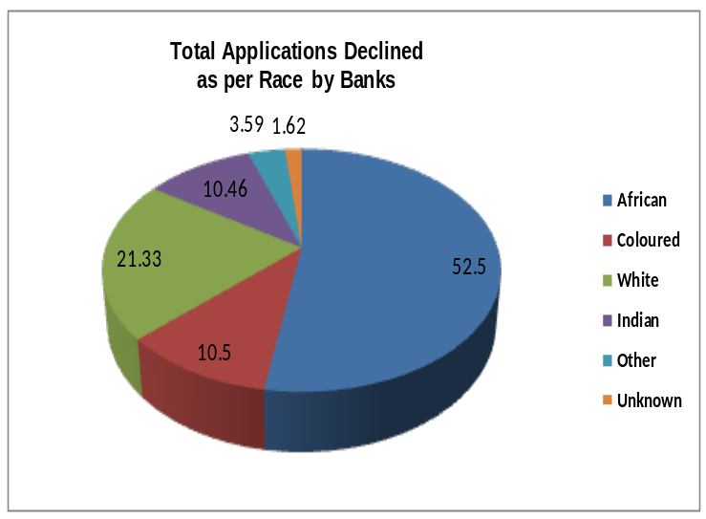

The highest percentage of declined applications came from Africans (Black). 52.50% Of home loan applications from Black people were declined. The difference of 5173 (463 673 – 458 500) in the number of declined applications is based on the quality of data submitted by individual banks.

  - REASONS FOR DECLINED APPLICATIONS

The following reasons were provided by Financial Institutions:

Table 12: Reasons for declined applications

NO | BANK | Reasons for Decline | No | BANK | Reasons for Decline
1 | ABSA | 01A, 02A, 07A | 9 | Mercantile | *
2 | FRB | * | 10 | Bank of Athens | *
3 | Std Bank | * | 11 | VBS Mutual Bank | 01A
4 | Nedbank | 01A, 02A,07A,04A | 12 | Sanlam | 01A, 02A, 07A
5 | Investec | 01A, 02A,07A,04A | 13 | S.A Home Loans | 01A, 02A, 03A, 07A
6 | Ithala | 01A, 02A, 07A | 14 | MEEG | 02A, 05A, 07A
7 | Teba | * | 15 | Imperial Bank | 01A, 02A, 05A, 07A
8 | Albaraka | 01A,02A,03A,06A,07A,

* implies that the Bank did not provide the information or that the information provided discrepancies and therefore could not be used in the analyses

Whilst some of the banks did not provide the reasons for declining the home loan applications, but 60% of those who complied provided the following reasons:

- Low repayment capacity,
- Unacceptable credit record, and
- Other (specify).

9. TOTAL APPLICATIONS RECEIVED PER PROVINCE

Table 13 : Total Applications Received as Per Province
BANK | E Cape | Free  State | Gauteng | KZN | Limpopo | MP | NW | NC | WC | Unknown
ABSA | 20934 | 12561 | 119249 | 34390 | 9152 | 15313 | 13214 | 4997 | 52695 | 26001
FRB | 16227 | 10812 | 116575 | 31487 | 5723 | 11089 | 9522 | 4108 | 43609 | 0
Std Bank | 10827 | 6329 | 153585 | 28165 | 3983 | 6677 | 6899 | 1062 | 42033 | 1474
Nedbank | 2775 | 3882 | 16516 | 3284 | 512 | 1889 | 1034 | 1258 | 32660 | 1717
Investec | 332 | 59 | 6349 | 902 | 41 | 82 | 52 | 11 | 2512 | 1181
Ithala * | * | * | * | * | * | * | * | * | * | *
Teba | 22 | 347 | 660 | 3 | 2 | 680 | 1697 | * | * | 1
Albaraka | 1 | 1 | 139 | 130 | 3 | 6 | 3 | * | 62 | 10
Merc | * | 28 | 255 | 20 | * | 8 | 1 | 1 | 52 | *
Bank of Athens | * | * | 39 | 2 | 1 | * | 1 | * | 6 | *
VBS | * | * | * | * | 49 | * | * | * | * | *
Sanlam * | * | * | * | * | * | * | * | * | * | *
S.A Home Loans | 2303 | 1343 | 14271 | 6219 | 524 | 1639 | 1078 | 487 | 6377 | *
MEEG | 192 | 33 | 102 | 40 | 17 | 10 | 8 | 28 | 51 | 3
Imperial Bank | 106 | 85 | 330 | 185 | 12 | 20 | 19 | 11 | 195 | *
TOTAL | 53 719 | 35 480 | 428 070 | 104827 | 20019 | 37 413 | 33 528 | 11 963 | 180252 | 30 387

* implies that the Bank did not provide the information or that the information provided discrepancies and therefore could not be used in the analyses

9.1 ALLOCATION OF APPLICATIONS PER PROVINCE

Table 14 :Total Applications Received as per Province
Province | Number | %
Eastern Cape | 53 719 | 5.74
Free State | 35 480 | 3.79
Gauteng | 428 070 | 45.75
KZN | 104 827 | 11.20
Limpopo | 20019 | 2.14
Mpumalanga | 37 413 | 4
North West | 33 528 | 3.58
Northern Cape | 11 963 | 1.28
Western Cape | 180 252 | 19.26
Unknown | 30 387 | 3.26
Total | 935 658 | 100

Graph 8: Total applications received per Province

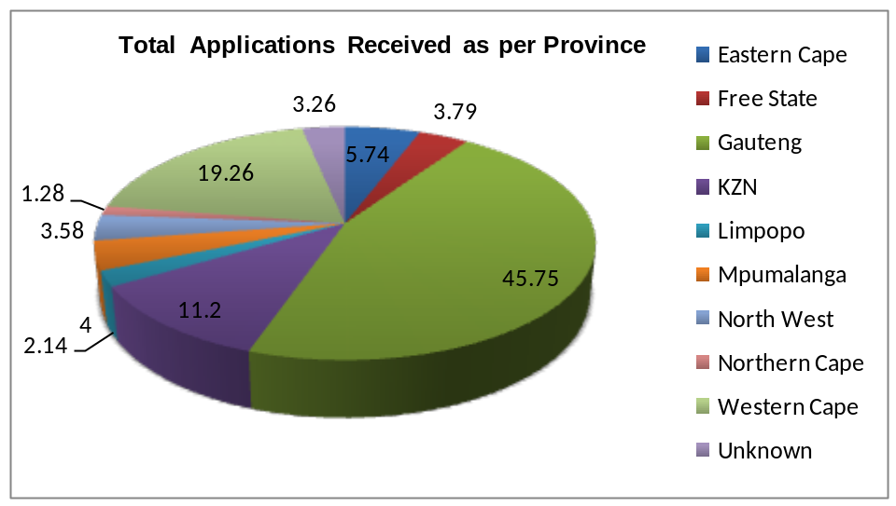

Among the nine (9) provinces in South Africa, the Gauteng province being the economic hub, received more home loan applications followed by Western Cape. This is reflected as 45.75% and 1926% of the total number of applications received respectively. Kwa Zulu Natal came third with 11.20%.

The distortion in the figures which did not balance was highlighted. Some of the banks created their own categories in addition to the template provided while one financial institution even reported figures for legal entities and information in foreign countries. This misreporting leads to the conclusion that in certain cases, the reported data was a “cut and paste” exercise from the information that is sent to the National Credit Regulator. The big four (4) banks were amongst the culprits of the above practice.

10. LENDING PATTERNS

HLAMDA was implemented retrospectively in 2007. This posed a huge challenge for the financial institutions to comply as their systems were not ready. Some opted for Ministerial exemption which was available.

In order to have a convincing trend, one needs credible data for at least three (3) years. In the absence of racial discrimination complaints received by the department, one could not conclude in favour of any racial discrimination by the financial institutions. However, lending discrimination on the basis of income is evident.

10.1 INCOME LENDING PATTERNS

The following lending patterns have been observed:

10.1.1 Almost no applications were received in the lower income category (R0 – R3500).
10.1.2 Less applications were received from the affordable market (R3501 – R15000).
10.1.3 Most applications came from the upper end of the market (above 15 000).

The observed lending pattern is also in terms of geographic areas. There were
fewer applications received from rural areas and more from urban areas. This is being supported by the number of home loan applications received and approved in Gauteng province in comparison to more rural provinces such as Limpopo.

11. PERFORMANCE RATINGS

The financial institutions were rated on the quality of information submitted. This included the correctness of figures provided per category and whether all categories added up to the gross figure.

Table 15: PERFORMANCE RATINGS

NO | BANK | PERFORMANCE  RATINGS  1 - 5
1 | ABSA | 2
2 | Albaraka | 2
3 | Bank of Athens | 4
4 | First Rand Bank | 3
5 | Imperial Bank | 2
6 | Investec | 4
7 | Ithala | 4
8 | MEEG | 2
9 | Mercantile | 4
10 | Nedbank | 3
11 | S.A Home Loans | 3
12 | Sanlam | 2
13 | Standard | 2
14 | Teba | 2
15 | VBS Mutual | 4
TOTAL | 15

12. CONCLUSION

12.1 The financial institutions received 1.1 million home loan applications with a total value of R250 billion.

12.2 Out of 1.1 million applications received, 164 075 (15%) were approved and
458 500 (42%) were declined.

12.3 The banks approved home loans to the value of R106 billion and declined applications worth R84 billion.

  - The quality of information submitted by all financial institutions was far from being perfect. The use of “Other and Unknown” categories contributed negatively to the credibility of information provided. In some cases, the required information was no provided. The same trend also applied to previous financial years.

  - Nedbank reported the same figure of applications received for 2007 and 2008 financial years. This is highly impossible.

12.6 On the positive side, data from small financial institutions was reasonable.

13. RECOMMENDATIONS

The following recommendations are made in compliance to Section 5(1) (g) of HLAMDA:

13.1 The departmental reporting Compliance Manual needs to be reviewed in order to be more strategic in reporting.

13.2 As an interim measure, financial institutions must be allowed to have their HLAMDA performance audited in a separate schedule and not in their financial statements as required by Section 2(4) of the Act. The wording in the Act falls outside the scope of the auditors. Should HLAMDA information be included in the financial statements, this might result in qualified financial statements.

13.3 HLAMDA as well as its Regulations needs to be reviewed as some of the requirements are not practical such as the expected comments from the Auditors.

13.4 The department should continue with its engagements with the National Credit Regulator with the purpose of developing a national data repository. The success of a national data repository system will ease the burden of double reporting by financial institutions.

