

Lower – Level Organisation Structure



CORPORATE SERVICES BUSINESS UNIT

EXECUTIVE HEAD
CORPORATE SERVICES
MR
.
SP NKOSI
(
ACTING
)
PERSONAL ASSISTANT
CORPORATE SERVICES
VACANT
ADMINISTRATIVE OFFICER
CORPORATE SERVICES
VACANT
DEPUTY MANAGER
HUMAN RESOURCES
MR
.
PA THOKWANA
MANAGER
MARKETING AND COMMUNICATIONS
MR
.
SP NKOSI
(
ACTING
)
MANAGER
LEGAL SERVICES
ADV
.
Z FENI
MANAGER
STRATEGY
&
POLICY COORDINATION
VACANT
CHIEF EXECUTIVE OFFICER
MR
.
LC SWEPU
(
ACTING
)
DEPUTY CEO
MR
.
LC SWEPU
HUMAN RESOURCES

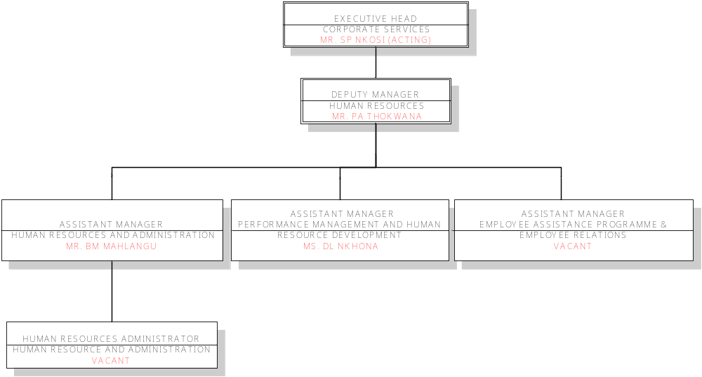

MARKETING AND COMMUNICATIONS

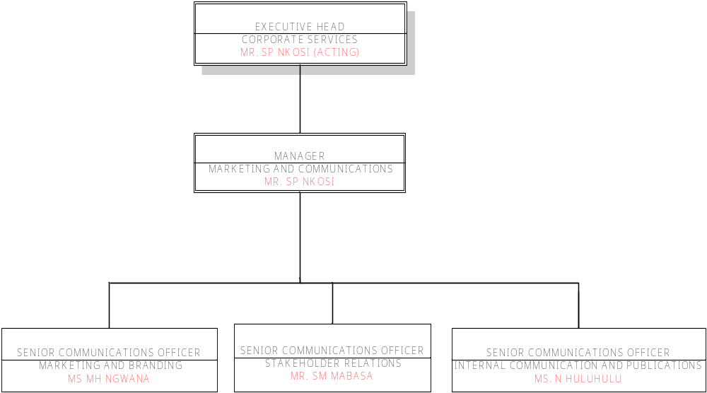

LEGAL SERVICES

ADMINISTRATOR
LEGAL SERVICES
MS BS MOETI
(
CONTRACT
)
MANAGER
LEGAL SERVICES
ADV .
.
Z FENI
EXECUTIVE HEAD
CORPORATE SERVICES
MR
.
SP NKOSI
(
ACTING
)
DEPUTY MANAGER
LEGAL SERVICES
ADV
.
L
.
ADEBOLA
SECRETARY
LEGAL SERVICES
VACANT

STRATEGY AND POLICY COORDINATION

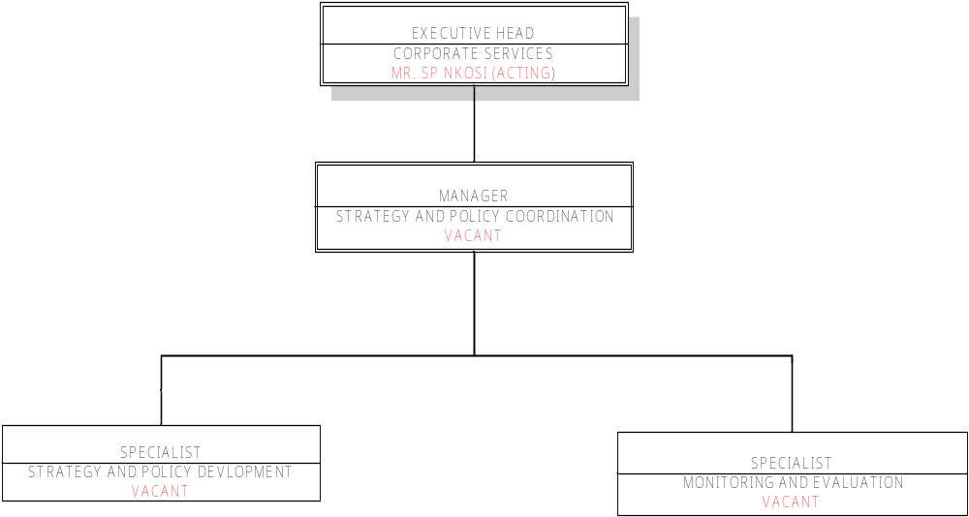

FINANCE AND SUPPLY CHAIN MANAGEMENT BUSINESS UNIT

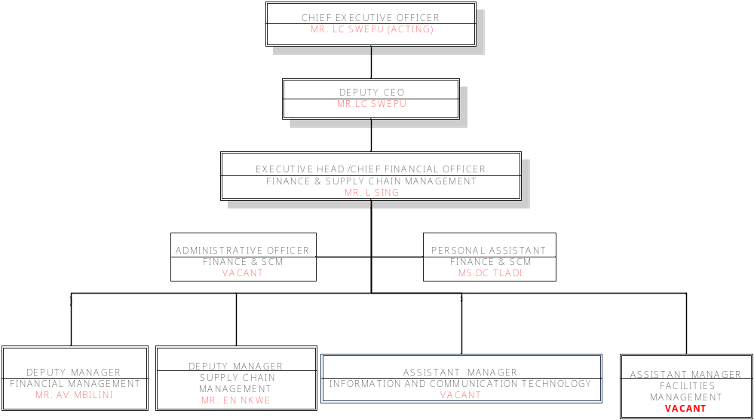
FINANCIAL MANAGEMENT

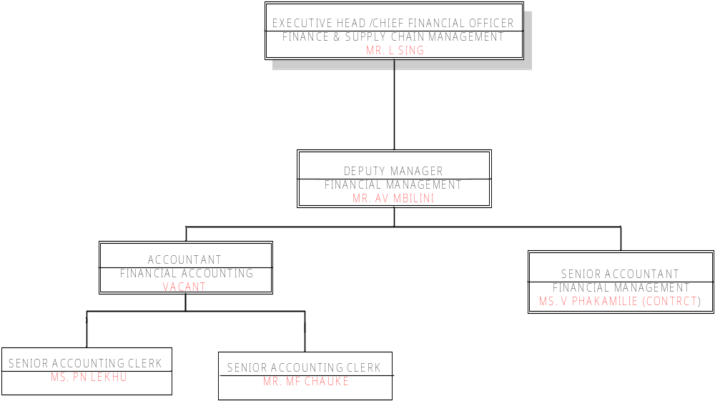

SUPPLY CHAIN MANAGEMENT

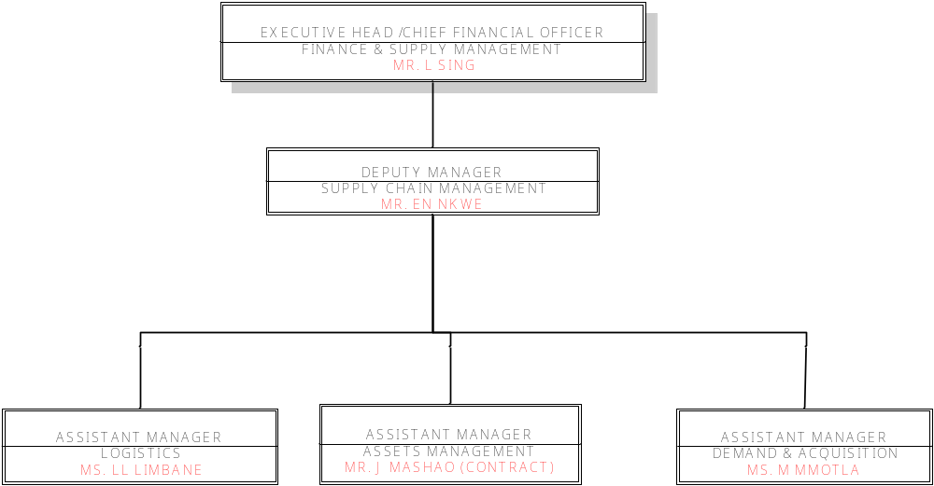

INFORMATION AND COMMUNICATIONS TECHNOLOGY

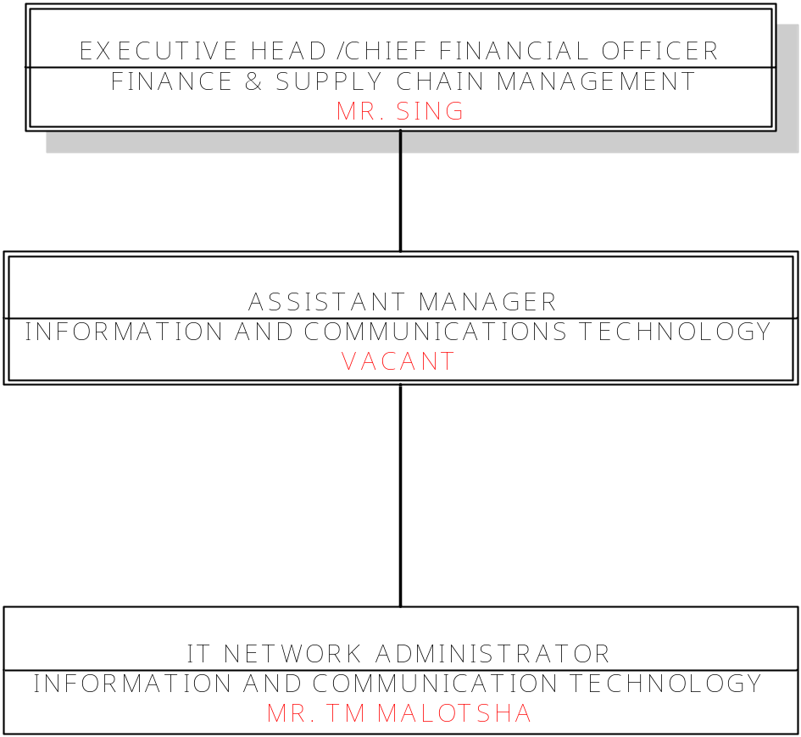

FACILITIES MANAGEMENT

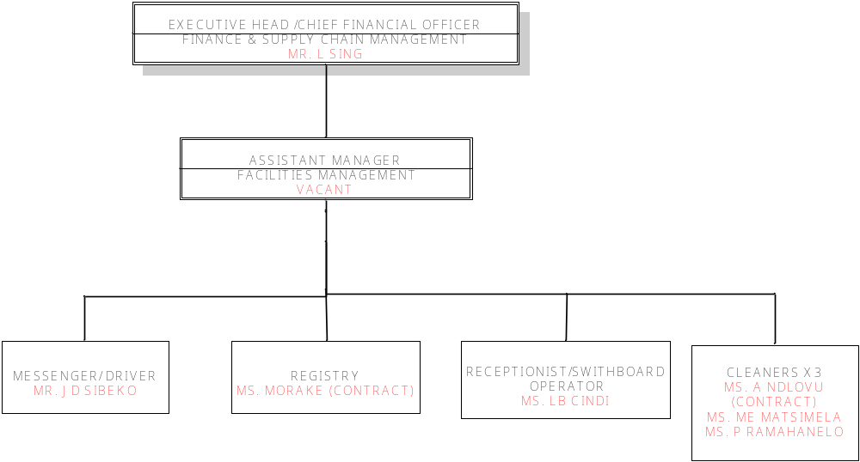

LANGUAGES BUSINESS UNIT

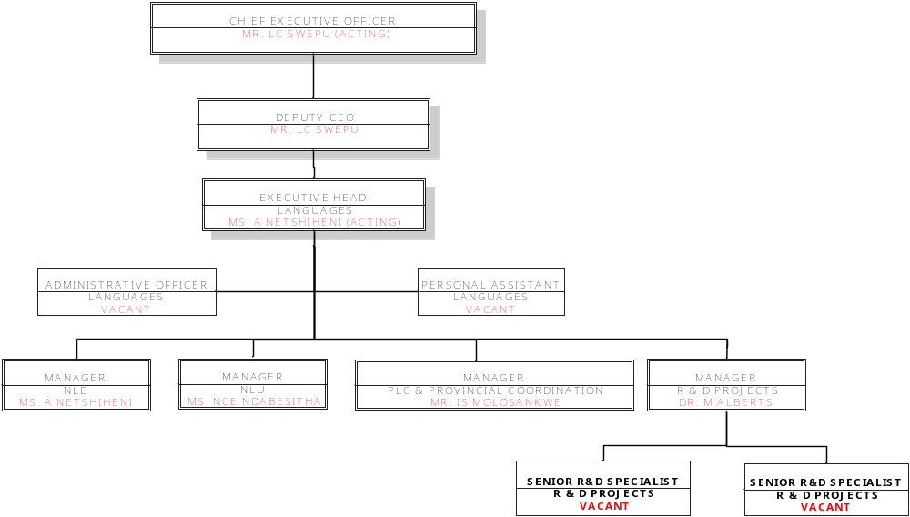
NLB

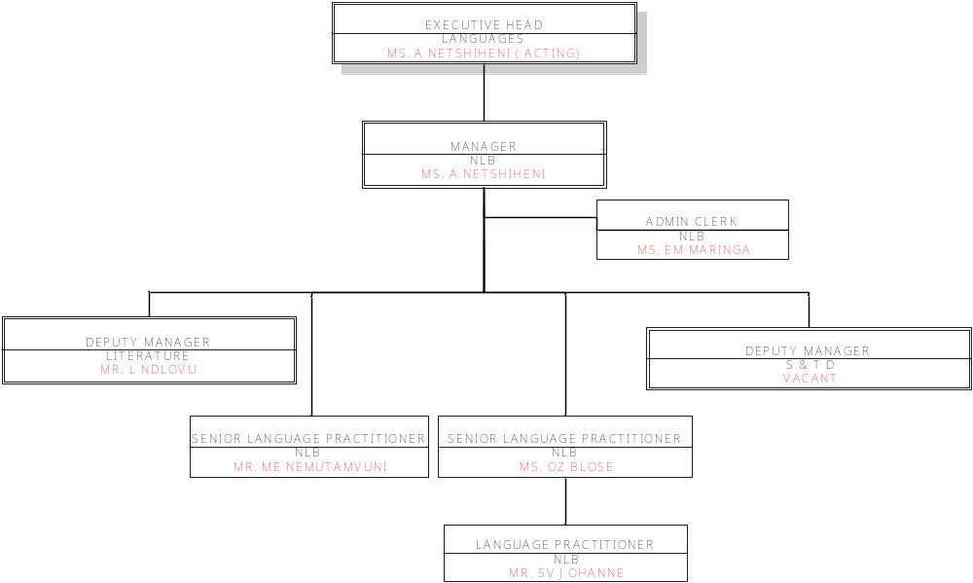
PLC & PC

MANAGER
PLC
&
PC
MR IS MOLOSANKWE
DEPUTY MANAGER
STATUS LANGUAGE PLANNING
VACANT
DEPUTY MANAGER
LANGUAGE IN EDUCATION
MS JM MATHIBELA
DEPUTY MANAGER
TRANSLATION
&
INTERPRETING
VACANT
ADMIN CLERK
VACANT
SENIOR LANGUAGE
PRACTITIONER
MS
.
P MPEBE
SENIOR LANGUAGE
PRACTITIONER
VACANT
SENIOR LANGUAGE
PRACTITIONER
MR
.
CL MPHELA
EXECUTIVE HEAD
LANGUAGES
MS A NETSHIHENI
(
ACTING
)
PROVINCIAL MANAGERS X
9
PROVINCIAL OFFICERS X
9
MR
.
BP MOREMI
-
NC
MR
.
MK MOLEBALOA
-
NW
MS
.
MJ MADIBA
–
LMP
MR
.
DM TYATYEKA
-
EC
MS
.
SM MAEPA
-
GP
MR
.
BD MOHLAMONYANE
-
MP
DR
.
N MALI
-
WC
MS
.
J NGCOBO
(
ACTING
)
–
KZN
MR
.
V NTLAKANA
- FS
NLU

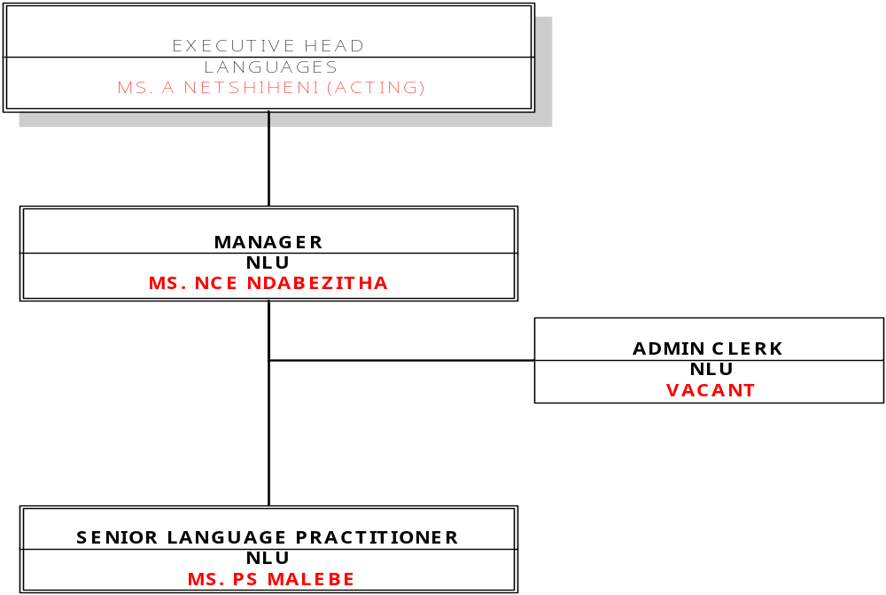

LIMPOPO PROVINCE

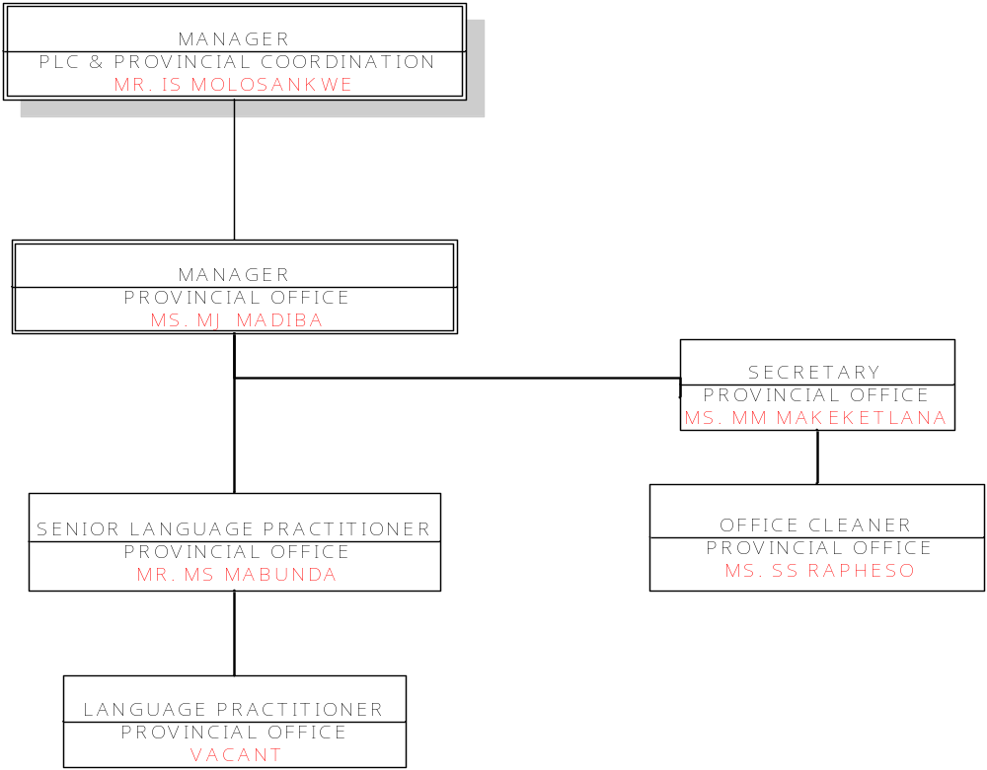

EASTERN CAPE PROVINCE

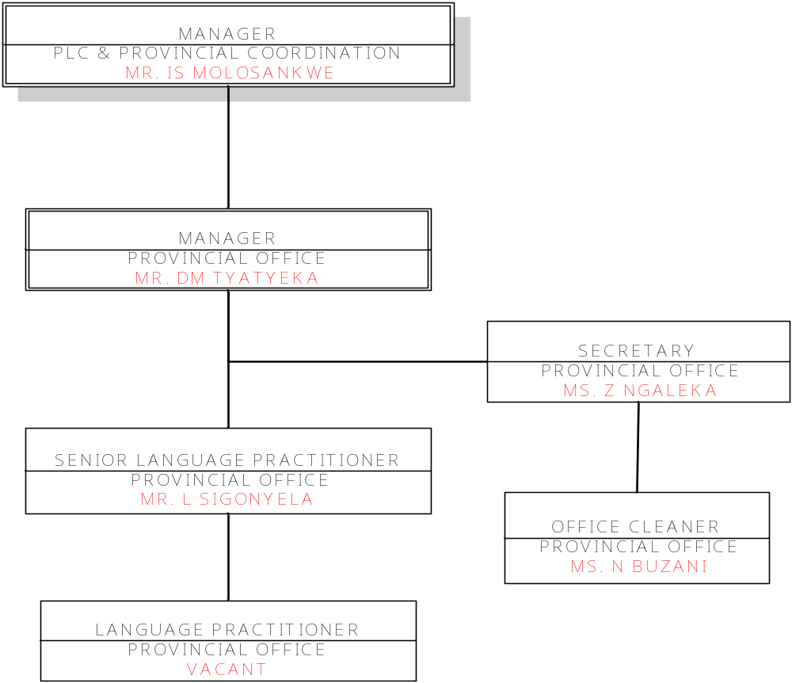

NORTHERN CAPE PROVINCE

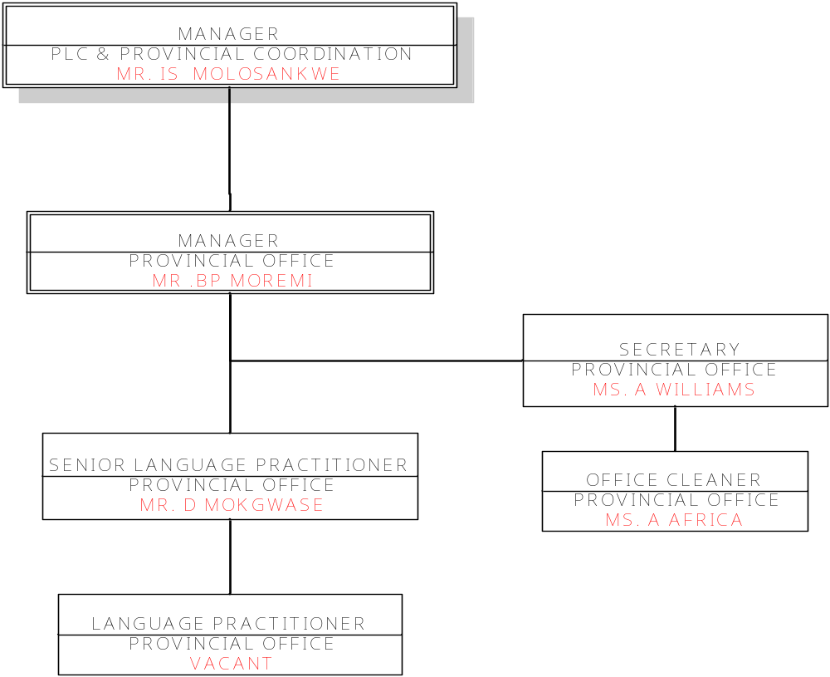

NORTH WEST PROVINCE

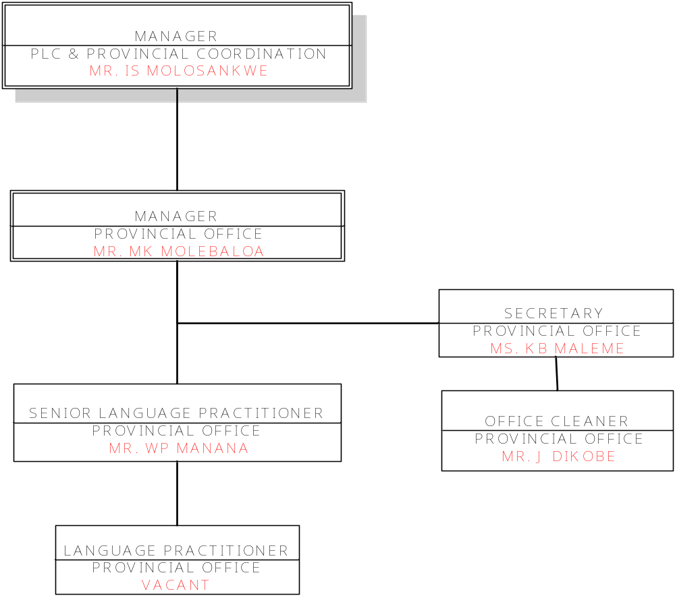

GAUTENG PROVINCE

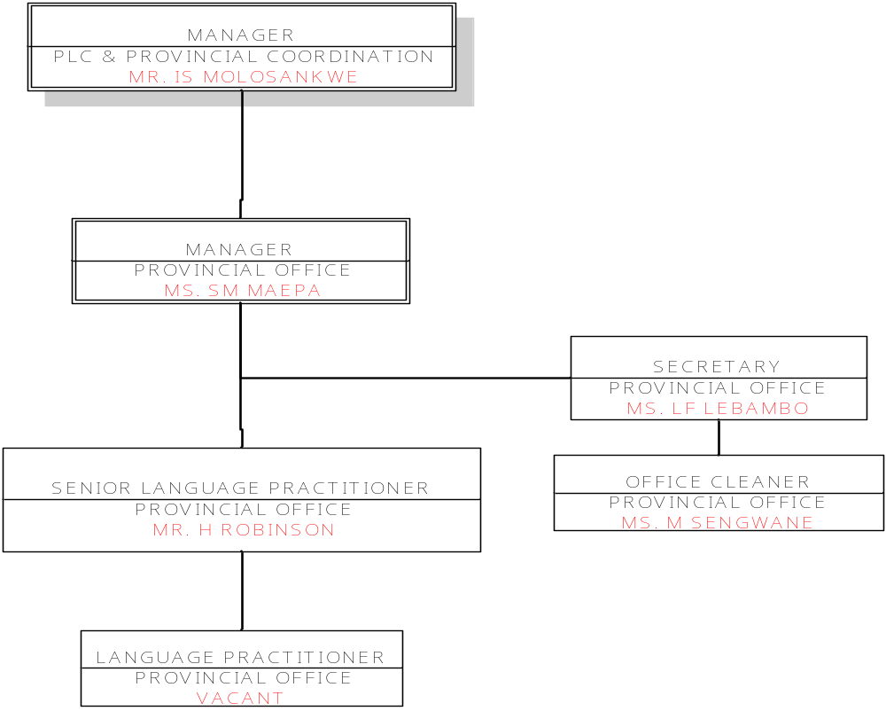

MPUMALANGA PROVINCE

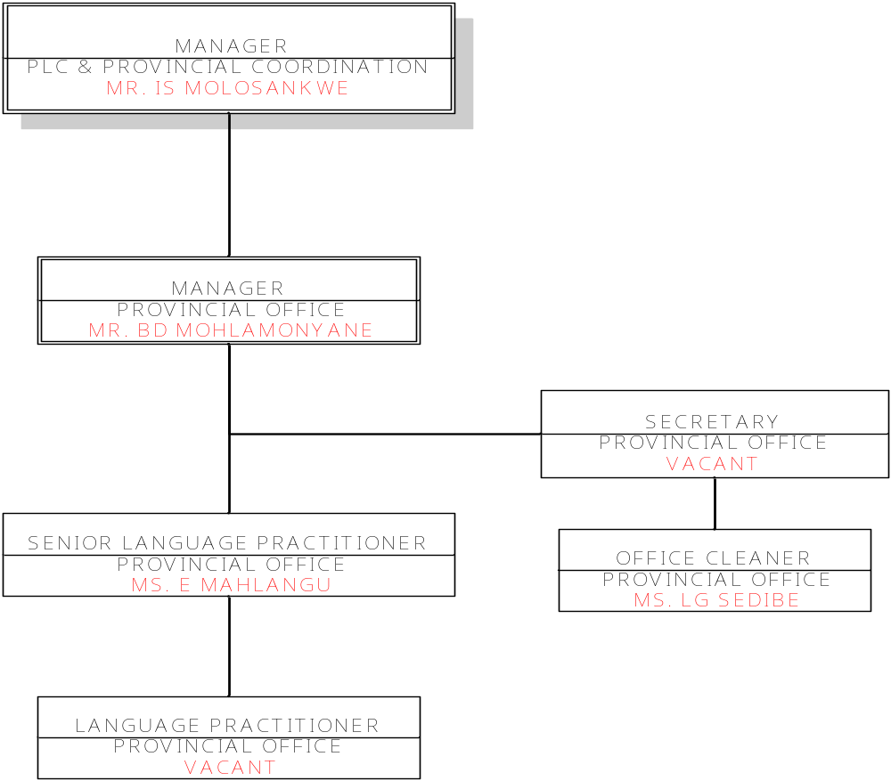

WESTERN CAPE PROVINCE

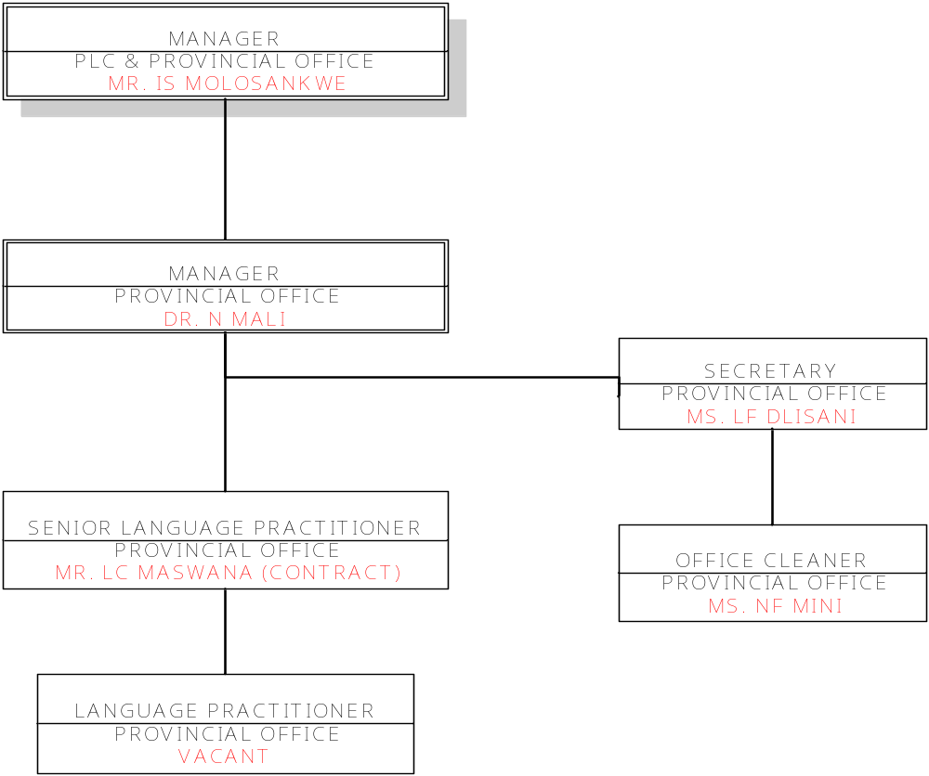

KWAZULU-NATAL PROVINCE

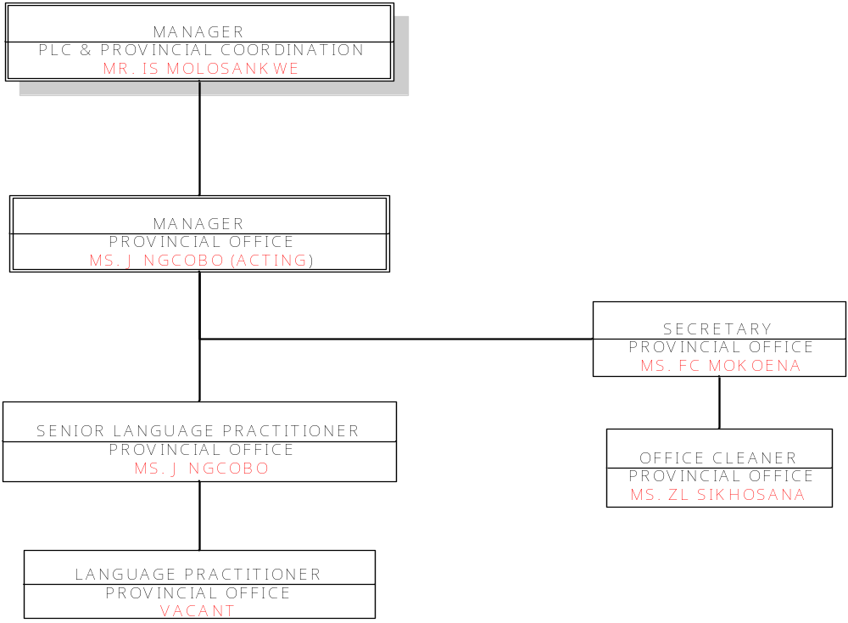

FREE STATE PROVINCE
SECRETARY
PROVINCIAL OFFICE
MS
.
NE TAUNYANE
SENIOR LANGUAGE PRACTITIONER
PROVINCIAL OFFICE
MS
.
N MATEBULA
MANAGER
PLC
&
PROVINCIAL COORDINATION
MR
.
IS MOLOSANKWE
MANAGER
PROVINCIAL OFFICE
MR
.
V
.
NTLAKANA
OFFICE CLEANER
PROVINCIAL OFFICE
MS
.
DS TSOLO
LANGUAGE PRACTITIONER
PROVINCIAL OFFICE
VACANT

