EASTERN CAPE DEPARTMENT OF HUMAN SETTLEMENTS INTERVENTION CLOSE-OUT REPORT

- PURPOSE

To present a report in respect of the progress made in the Intervention in the Eastern Cape Department of Human Settlements programme (hereafter referred to as “the intervention”) in terms of Section 100(1) (a) of the Constitution of the Republic of South Africa (1996).

- BACKGROUND

The Eastern Cape experienced declining performance in housing delivery and the expenditure since the 2004/5 financial year (table 1). Over a three-year period the Province lost over R 1 billion due to non-expenditure.
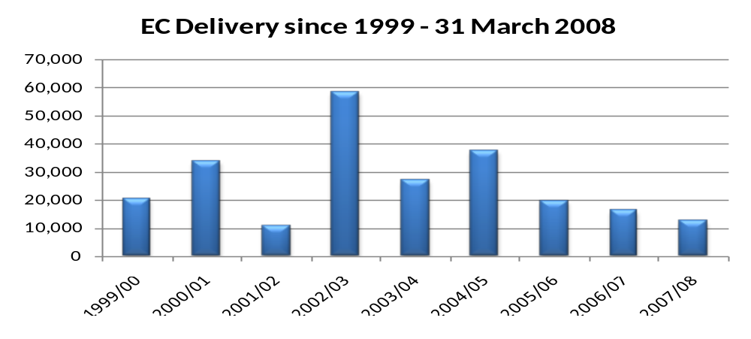
Table 1: Eastern Cape housing delivery

On 16 April 2008 Cabinet approved the Intervention in terms of Section 100(1) (a) of the Constitution (1996) as well as the Housing Act. The Intervention was scheduled to last for the 2008/9 financial year. On 29 April 2009, having considered a report from the Minister of Housing, Cabinet resolved to extend the period of the Intervention to 31 March 2010.
In compliance with Cabinet’s decision to extend the Intervention, the National Department of Housing deployed personnel and other resources to fulfil this mandate. In addition, the Minister of Housing issued Directives to the relevant Member of the Executive Committee as prescribed by Section 100 (1) (a) of the Constitution of the Republic of South Africa.
In order to give optimal effect to Cabinet’s decision, a Joint team comprised of both National and Provincial officials was established. The team was supplemented by professionals from the private sector spanning different professional fields such as: Engineering; Project Management; Town Planning; Land Surveying; Financial Analysis and Geographic Information Systems. These experts were physically deployed to the six districts of the province.

- APPROACH OF THE INTERVENTION

  - As part of the intervention the Minister of Human Settlements provided directives to give effect to all measures to be implemented. The directives relate to improvement in the following areas:

- Projects for the MTEF: 3/5 years;
- Projects to be implemented 2009/10;
- Trust accounts;
- Project approval process;
- Supply Chain Management;
- Contracts management;
- Payment of contractors/service providers;
- Role of Interdepartmental Bid Adjudication Committee (IBAC);
- Update on Housing Subsidy System (HSS); and
- Project Management capacity and reporting.

  - A standing arrangement was made for the intervention team and the Provincial Departmental Management to work closely together through a joint team, and report to the MEC for Human Settlement and obtain guidance of several mandates on a monthly basis.

  - In order to give effect to the cabinet decision, as well as the directives the joint team (Province and Intervention Team) focused on the following areas which had dedicated working teams:

- Engineering and projects management;
- Town planning, multi-year planning and policy management;
- Organizational development and capacity building;
- Financial support and strategic reporting; and
- Administration and support.

  - The Joint team identified key risks and challenges within the Housing Delivery Value Chain as it relates to the Eastern Cape. The following were identified as key risks and challenges to be addressed in order to enhance the achievement of delivery targets:

    - Town Planning

- Lack of understanding of planning legislation;
- Inadequate town planning procedures;
- Lengthy land acquisition process;
- Lack of adequate multi-year planning;
- Outstanding EIAs (e.g. Second Creek);
- Lack of professional land surveyors;
- Lapsing of EIA and township establishment approvals;
- Non-compliance to opening of township register; and
- Lack of dedicated Provincial planning section.

    - Technical /Engineering

- Lack of bulk services (e.g. Duncan Village, Ndlambe municipality, Flag staff & Mt. Frere projects);
- Assessment of blocked projects (e.g. Amathole District);
- Contractor capacity (incl. overloading of work for non-performing contractors);
- Inadequate quality controls due to few inspectors (e.g. Nelson Mandela has 8 inspectors for 141 projects);
- Contract Management (Need for standardization of contracts);
- Project and Construction Management Capacity (e.g. site minutes not kept);
- Availability of construction material (supplier database, collusion amongst suppliers);
- Standardization of house plans (in line with BNG specs);
- NHBRC enrollment and issuing of Final Unit Report (FUR) timeously; and
- Payment of Contractors.

    - Finance

- Misalignment of regional budget allocation to delivery outputs;
- Cash flow projections is not linked to project performance;
- Budget held up in blocked or slow moving projects;
- Monies in municipal trust accounts
- Inadequate in-year and multi-year budgeting;
- Payments to provincial agencies prior to delivery of outputs (pre-payments/ advances);
- Inconsistency between budgets allocated and actual spend; and
- Claims management process.

    - Administration

- Slow process for project and funding approval;
- Lengthy procurement processes;
- Contractor appointment based on pricing and not functionality, leading to prolonged processes and low quality;
- Lack of adequate systems to review and disqualification on non-performing contractors;
- Differing contract agreements (JBCC vs HSS);
- Beneficiary Administration (houses built without approval of beneficiaries affecting delivery including payment of contractors); and
- NHBRC capacity (Inspectors and Final Unit Reports).

  - FOCUS ON PROJECTS IMPLEMENTATION

The Joint Team prioritised projects implementation in order to ensure that the decline in housing delivery and the resultant decline in financial expenditure were addressed as a matter of urgency. To enhance the above, the National Department of Human Settlements deployed the project managers, engineers, town planers, gis specialist, land surveyor, financial experts, and other relevant specialists on a full time basis to the Eastern Cape since mid-June 2008 to date.

In the first year a lot of resources and time was deployed to deal with actual projects performance and expenditure, whereas in the second year focus shifted to the whole housing delivery value chain. Focus was on the whole housing delivery value chain in order to create long-term sustainability in human settlement development.

A decision was taken to identify projects to be fast-tracked. Having analysed all the projects using a “project readiness matrix” it became clear, that some of the projects could only start to deliver units in the latter part of the financial year and the next financial years. These includes projects which have been blocked for several years, and therefore issues like EIA, bulk services, etc, had to be resolved before the projects could be funded and implemented.

Based on possible high impact in terms of units the intervention team, working with the Province, under the guidance (and approval) of the MEC for Human Settlements identified certain projects as priority projects. These approaches were part of a multi-pronged strategy focusing on priority projects, other projects, blocked projects, rectification, etc, in order to achieve maximum impact, while ensuring that the overall human settlement delivery system improves, and becomes sustainable in the medium term to long term.

    - The National Intervention Team together with the Department of Human Settlements jointly identified 49 projects, amongst the different regions, with the potential to yield 12407 units to be prioritised for the remaining half of the financial year, starting from around September 2009.

    - The number of projects are tabulated below:
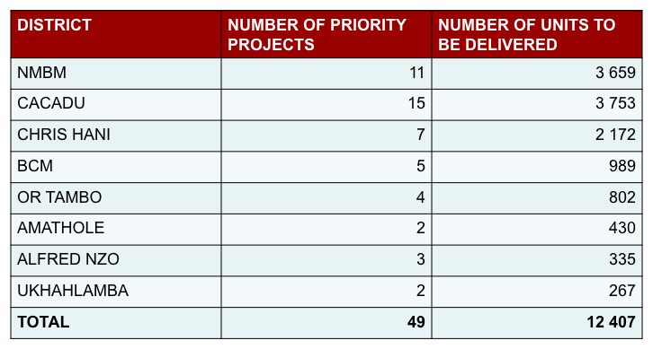
Table2: 2009/10 priority projects

To determine whether the projects were realistic and doable within the financial year, the teams conducted an information gathering and analysis exercise through desk-top, physical verification as well as discussion with relevant officials and other stakeholders which revealed that many of the projects were ready for implementation, with a significant number already having contractors on-site.

    - Unblocking of Disaster and Rural Blocked Projects

Many of the projects implemented over the years by the province are of poor and sub-standard quality and include many projects, which are currently blocked. These blocked projects and houses of sub-standard quality are a point of major concern among members of the communities.

      - Four areas were identified for immediate intervention with regard to unblocking projects in rural areas where there are major concerns. Contractors are currently appointed to unblock 2 433 units of the rural blocked projects in the areas of Flagstaff, Mt Ayliff, Mt Frere and Matatiele.

      - The project management team was established to oversee the successful completion of the projects. The team comprised of official from province, municipalities, community members, Intervention team and NHBRC.

- PLAN FOR THE 2009/10 FINANCIAL YEAR

  - MEC’s Policy pronouncements

In her 2009/10 budget speech the MEC for Human Settlements outlined the following key priorities and targets;

      - Rural Housing Development;
      - Informal Settlement Upgrading;
      - Provision of housing to vulnerable groups and military veterans;
      - Rectification of defective houses (pre and post 1994);
      - Emergency housing assistance program;
      - Reclaim monies previously reallocated by national housing to other provinces;
      - Land acquisition for housing development;
      - Social and rental housing;
      - Emerging contractor development and support;
      - Innovative construction methods and alternative building technology (4 pilots: 2 housing and 2 sanitation); and
      - Institution building and renewal.

Based on the above-mentioned policy priorities, the following overall targets were set for the 2009/10 financial year:

Land to be acquired | 225 ha (7 parcels)
Title deeds transfer | 15 000 title deeds
Social and Rental Housing | 731 houses
Site Services | 7 790 sites
Alternative Technology | 4 projects
Rectification | 3 682 houses
Integrated residential development program | 19 000 houses
Job Creation | 9 000 jobs
Table 3: Overall MEC targets for 2009/10

With regards to housing delivery, the following targets were set per region for the financial year:

District | Total Projects | Complete houses occupied | Sites serviced | Budget  Rm
Ukhahlamba | 10 | 793 | 658 | 53,7
Chris Hani | 27 | 3 979 | 1 414 | 139,8
O.R. Tambo | 39 | 2 361 | 217 | 84,9
- Nzo | 14 | 837 | 147 | 35,8
N. Mandela | 141 | 4 382 | 3 170 | 438,0
Cacadu | 30 | 3 691 | 1 410 | 93,9
Amathole | 27 | 1 232 | 0 | 192,6
Buffalo City | 21 | 1 725 | 774 | 56,0
Total | 309 | 19 000 | 7 790 | 1,094,76
Table 4: housing delivery targets for 2009/10

In summary, the 2009/10 target included 19 000 houses and 7790 serviced stands.

- PROGRESS TO DATE

  - HOUSING UNITS AND SERVICES DELIVERED
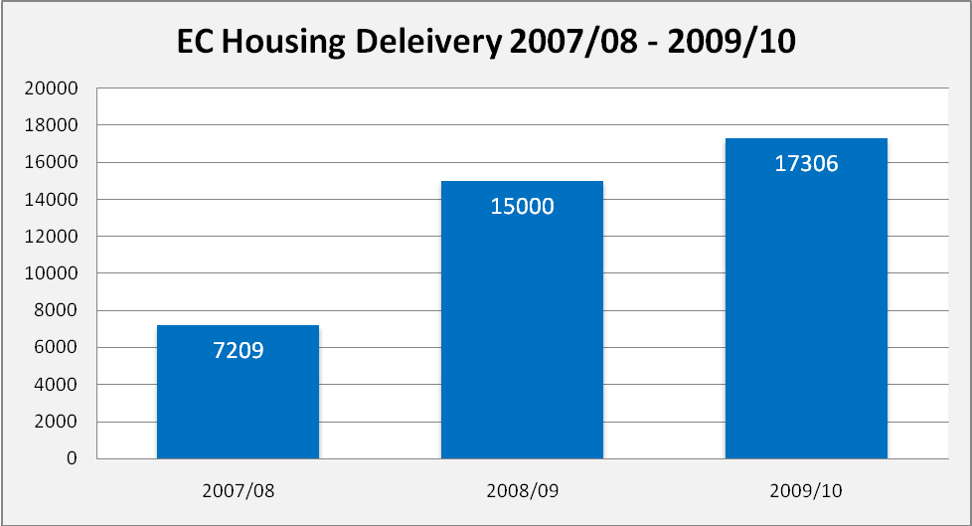

As at March 2010, the Provincial statistics for houses completed stood at 17 306 completed units and 11327 stands serviced (table 5). MEC target for the year was 19,000 units and 7,790 services.
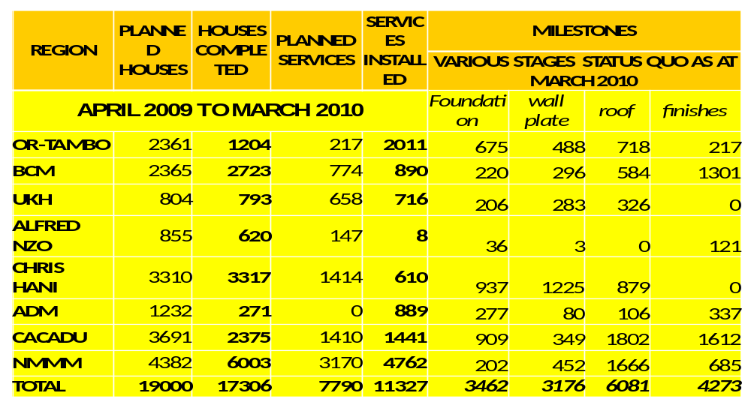

Table 5: Summary of non-financial performance in Eastern Cape

Overall, the achievement in services was 145% of the target. In terms of units, the shortfall in achieving targets emanates from Amathole District Municipality (ADM), which achieved 22% of the target, Chris Hani region (100%), OR Tambo region (51%), Ukhahlamba (99%), Alfred Nzo (73%), Nelson Mandela (137%) and Cacadu (64%). As a whole, the province delivered 91% of the MEC target. There were a total of 16992 units at various stages in the province (including finishes).These units constitute stock that will be continued into the next financial year.

  - EXPENDITURE

While the final audited figures are yet to be released, interim financial reports indicate that the province has spent its entire annual budget of R 1.313 billion – a first in many years (table 6).
MONTH | 2009/10 CASH FLOW PROJECTIONS | 2009/10 EXP | 2008/9 EXP | 2007/8 EXP
April | 77,941 | 37,055 | 53,593 | 21,581
May | 93,889 | 120,647 | 40,097 | 0,0011
June | 114,418 | 138,156 | 98,38 | 30,677
July | 118,448 | 128,206 | 37,307 | 7,849
August | 128,021 | 154,685 | 72,895 | 20,219
September | 144,998 | 136,992 | 53,765 | 15,244
October | 143,086 | 112,953 | 77,057 | 5,768
November | 126,354 | 100,822 | 172,14 | 23,924
December | 95,884 | 133,633 | 90,744 | 29,867
January | 74,189 | 38,754 | 83,704 | 27,587
February | 108,266 | 86,935 | 93,787 | 85,369
March | 87,884 | 124,498 | 107,547 | 106,965
TOTAL | R1,313,378 | R1,313,000 | R981,016 | R375,050
Table 6: comparative year-to-year financial performance

The month-to-month expenditure analysis of the last three year (one year preceding the Intervention and two years of Intervention) clearly demonstrate improvement in both overall figures but consistent monthly expenditure in 2009/10 (table 7)
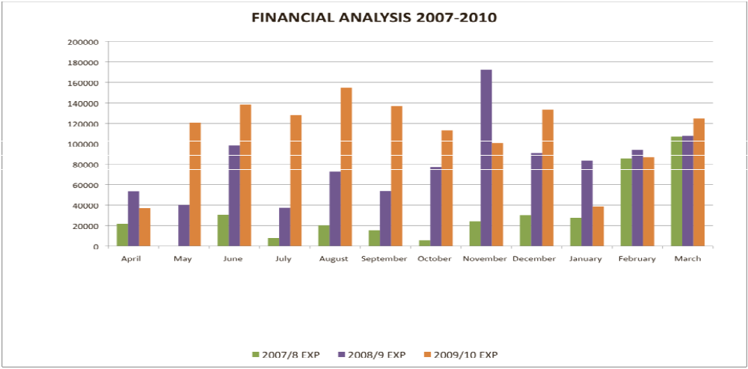
Table 7: Month-to-month financial performance analysis for 2007-2010

  - Comparative performance

Several indicators have been analysed to demonstrate improved performance of the Eastern Cape Province relative to the other eight provinces. Among these indicators is percentage increase in expenditure over the last three years. The Eastern Cape has been the best performer in this regard (table 8).
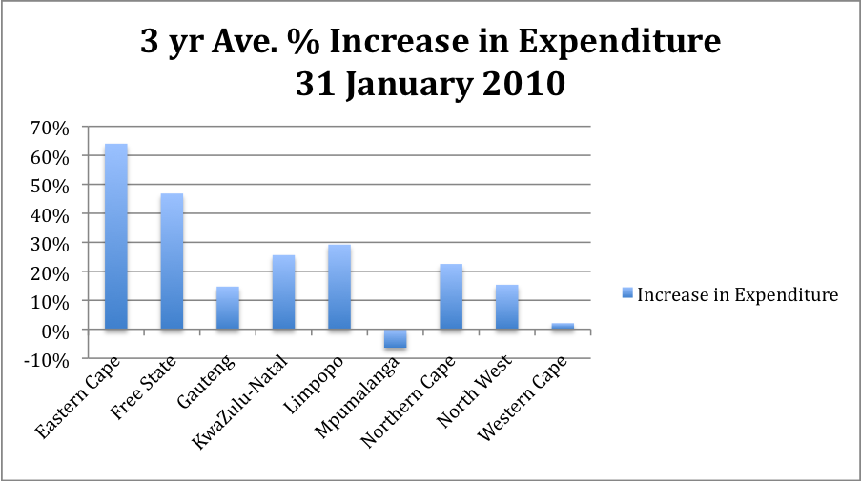

Table 8: percentage increase in expenditure 2007-2010

  - ORGANISATIONAL AND CAPACITY DEVELOPMENT

In order to strengthen the capacity of the provincial department and to ensure sustainability in improved delivery, the following were undertaken:

- Facilitated the approval by the Department of Public Service and Administration (DPSA) of the provincial department’s organizational structure;
- Conducted Job evaluation on the position of HOD in conjunction with the DPSA;
- Assisted the department with the development and implementation of Human Resources policies;
- Analysed the results of the competency assessment of senior managers and made recommendations;
- Developed a mentorship programme for the department.
- Supported the filling of vacant posts from 198 filled posts in April 2008 to 428 filled posts to date; and
- Recommended the review of the organisational structure of the department to strengthen the regions.

  - TOWN PLANNING

On establishment, the Planning Stream embarked on the following:

- Reviewed the settlement planning process;
- Reviewed the procedure for the development of Housing Sector Plans;
- Re-examined the reasons for blockages in respect of town planning, land survey and environmental impact assessment (EIA) application procedures;
- Established compulsory procedures to be taken for project readiness before implementation;
- Review the methodology for the development of the Human Settlement Conditional Grant Business Plan as well as the Multi Year Housing Development Plan; and
- Developed means of eliminating encroachments on site.

    - Achievements

- Site Encroachments: The Planning Stream assisted appointed contractors on site to outline building set-back lines (building footprints) from the provisions of the approved General Plans (GPs). Some contractors were work-shopped on reading General Plans as well as setting out building footprints.
- Skills Development: Officials from the Housing Policy and Planning Directorate were capacitated on ways of improving the planning processes, ranging from monitoring and development of proper settlement and housing sector plans to preparing projects for implementation as well as the development of Business Plans and Multi-Year Housing Development Plans.
- Project Readiness Matrix: A project readiness matrix was developed and adopted by the Eastern Cape Department of Human Settlements. The project readiness matrix outlines essential issues that have to be addressed before projects get implemented.
- Planning Applications: The team intervened in all relevant pre-construction application processes that is related to development of human settlements. The matters comprises of layout plan approvals, Environmental Impact Assessment (EIA) applications, township establishment applications, general plan approvals and opening of township register. The graphs below indicates progress made as at end of January 2010:
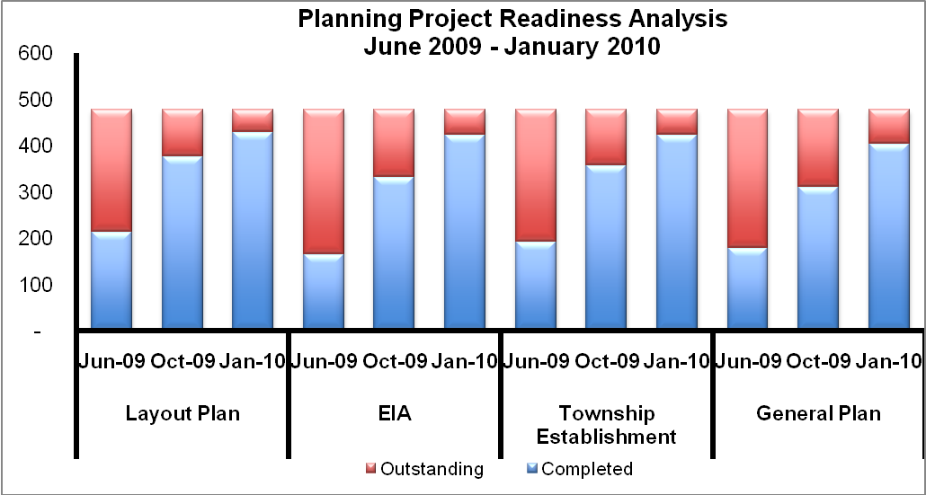

- Business Plan: The Team assisted the Eastern Cape Department of Human Settlements in developing an improved Human Settlement Conditional Grant Business Plan for 2010/11 financial year.
- Multi-Year Housing Development Plan (MYHDP): For the first time in the history of the Eastern Cape Department of Human Settlements, a credible five year Multi-Year Housing Development Plan (MYHDP) was developed and submitted to the National Department of Human Settlements. In developing the MYHDP, every project was critically analysed in relation to their readiness and implementation, before being listed in the MYHDP. The MYHDP is user friendly by design to enable officials of the Department carry out analysis using various criteria and indicators

  - RECTIFICATION AND BLOCKED PROJECTS

Many of the projects implemented over the years by the province are of poor and sub-standard quality and include many projects, which are currently blocked. These blocked projects and houses of sub-standard quality are a point of major concern among members of the communities.

      - The main objective of the rectification programme is to facilitate the improvement of poor build housing stocks funded through the State both before and after 1994. Thus, the rectification of these housing units seeks to ensure that their quality standards are in line with National and Provincial norms and standards.

      - To achieve the above objective the Provincial Department engaged the services of NHBRC, Stemele Bosch Africa (SBA) and Lilitha Project Manager to undertake the project management process. To date over 49 500 units has been assessed and an estimated budget of R 1.6 bn is required to rectify some of these units.

      - The main reason for rectification in the Eastern Cape is that most of projects were implemented by Municipalities as PHPs, and most of the completed units are poorly built due to the:

    - Poor workmanship by contractors;
    - Use of inferior construction materials;
    - Lack of adequate planning and technical inputs (mainly around foundation designs);
    - Lack of supervision, construction and project management; and
    - Projects not enrolled with NHBRC.

      - Pertaining to the rural blocked projects, the Matatiele project is complete and the other projects are envisaged to be completed by December 2010. In addition, the NHBRC played pivotal role in training the local builders in both building and construction management skills.

      - As part of the unblocking process as indicated above, the department introduced concrete roof tiles as alternative solution to prevent or minimise disasters induced by storms and strong winds common in these areas.

The following are challenges facing the implementation of the rectification programme:

  - Quantifying the amount of required Rectification work: The major challenge facing the Eastern Cape Department of Human Settlement is to finalize quantification of amount of rectification work required in the programme. This will, in our view, only happened after all projects built prior to April 2002 (most of which are developed by municipalities under PHPs programme) are assessed. In addition, the assessment of all blocked projects and those not enrolled with NHBRC.

  - Budgetary Constraints: The budget required for rectification is R1.5 billion. Currently of only 10% percent of conditional grant (on average, R130m per financial year) goes to rectification programme. It will take at least 10 years to complete work on already assessed houses. These costs are subject to escalating factors caused by inflationary pressures. Projects that are still to be assessed will not be rectified in the next ten years given the current budgetary allocations.

The following is recommended to deal with challenges above:

- That the Department assess all projects not enrolled with NHBRC (in particular those developed under PHP programme) and blocked projects to quantify amount rectification work and budget required.

- That the Department review its strategy in dealing with rectification backlog, in particular budget allocation for implementation and time frames to complete the programme. Therefore develop a realistic master implementation plan.

- That the Department adequately capacitate a programme management unit dedicated to rectification projects both at head office for coordination level and regional level where implementation takes place.

- Standardise the minimum norms and standards as guided by both National and Provincial policies and resolutions.

  - SUPPLY CHAIN

As part of the directives issued to the Provincial Department, it was required that a review of the procurement system be undertaken. The current system involves competition on price whereas the housing subsidy quantum is fixed. This environment creates problems as service providers under-price in order to win the tender but end up not performing or providing sub-standard work, this is particularly evident in the number of blocked projects and rectification projects in the Province.

The Provincial Department is also currently limited in its ability to procure building contractors on a overall and ad-hoc basis timeously due to the requirement in the current procurement policy stating that all contracts above R5 million should be referred to the Provincial Treasury “Interim Bid Adjudication Committee” for evaluation.

Thus the Eastern Cape Provincial Departments of Human Settlements and Treasury should amend the supply chain management policy where bidding is adjudicated based on functionality rather than price and functionality adjudicated by the Human Settlements Department.

- PROGRESS ON DIRECTIVES
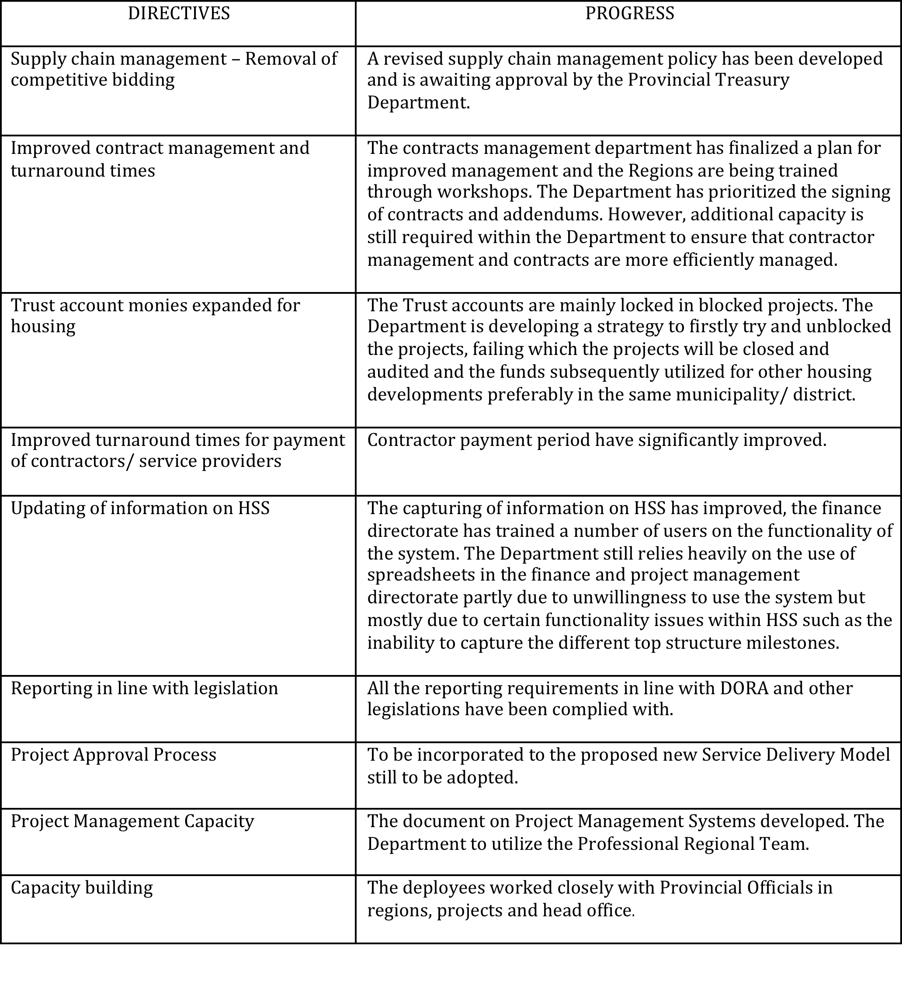

- visit by the portfolio committee on human settlements to the eastern cape

The Portfolio Committee on Human Settlement undertook an oversight visit to the Eastern Cape from the 4 to 10 October 2009, in order to oversee the state of delivery as well as visit several projects. On the basis of the visit the Portfolio committee produced a report having issues raised in different meetings as well as site visits. The report concluded with observations and recommendations.

The National Department discussed the report with the Provincial Department of Human Settlement and agreed to follow-up on all issues raised in each meeting as well as those that are project specific. Action plans were developed for each of the regions, as well as for each of the projects visited. Find attached as an Annexture A an update o the recommendations made by the Portfolio Committee

- lessons learned

The following represent the key lessons and risks that the Intervention together with the Department officials identified and endeavoured to deal with in improving performance:

  - Lack of institutionalised units: The intervention process revealed that the Eastern Cape Department of Human Settlements did not have dedicated geographical information systems (GIS), planning and environmental units. These units would specifically resolve matters relating to town planning, land survey, GIS and environmental applications by means of interacting with the relevant stakeholders and authorities to fast-track such applications. This view was considered relevant and shared by the Provincial officials.

  - Lack of adequate qualified technical professionals: The Provincial Department of Human Settlements was operating without some essential technical professionals such as qualified Town Planners and Land Surveyors. The contributions of these professional are very essential in the built environment delivery chain. The lack of such professionals within the system has contributed to the stalling and in some cases, very poor implementation of projects.

  - Support from National Department of Human Settlements: As a result of the inadequate technical capacity in the Eastern Cape Provincial Department of Human Settlement, it is expected that the National Department provide such technical support at provincial and municipal levels. However, it was observed that support was historically only provided in the form of policy and frameworks development as well as compliance. Through the Intervention, the National Department was able to provide these technical support to the Province which eventually led to development of the 2010/11 Multi-Year Housing Development Plan, the 2010/11 Human Settlement Conditional Grant Business, reduced encroachment on sites as well as the fast-tracking of town planning and EIA applications. The National Department will continue to provide hands-on support.

  - No systematic project readiness planning process in place: It was observed that there is no proper project readiness planning process in place that will evaluate and ensure the credibility of projects before they are implemented. The Team in conjunction with the Provincial officials was able to initiate a process that brought all key role players within the Department to partake in project evaluation sessions to determine readiness and budget allocation of projects. However, this session in question was a temporary measure to getting the relevant section in the Department to harmoniously work together, it imperative that such session is institutionalised in the Department.

  - The lengthy process for the acquisition of strategically located land parcels is a major obstacle to the housing delivery system in the Eastern Cape. However, the lack of co-ordination during the land acquisition exercise within the Department usually makes it difficult to attain the BNG principles of sustainable human settlements.

  - There is also uncoordinated purchases of land parcels by the Land Acquisition branch without adequate consultation with municipalities and other branches or directorates responsible for planning and project implementation within all the available instruments resulting in unclear strategies for land being acquired and best use thereof.

  - Historically projects that were being implemented by the municipalities mainly under peoples housing programme (PHP) and therefore not enrolled with NHBRC. The role of the department was mainly to transfer funds to these municipalities. This resulted into blocked project and poorly built houses which required rectification. This delivery method has subsequently been adjusted to make payments to municipalities only for value created on the ground.

  - Project management and quality control - the historical delivery model has made the department to have inadequate project management and quality control capacity, in particular in regions where project implementation is taking place. This area needs to be strengthened and adequately monitored as this is the nerve centre of service delivery.

  - Project approval process – the current approval process has the following challenges:

  - Bureaucratic and lengthy processes (up to 4 months on average required to finalize the approval of a standard project);
  - The project planning and approval process is skewed and does not take into account demographics and needs of different regions. All projects which are ready irrespective of area, municipality or region is approved.
  - The assessment of projects for approvals is not based on a standardized system. This led to some projects approval with some planning issues still outstanding (e.g. EIA, General Plans, Beneficiaries Approval, Bulk Infrastructure etc.). This has resulted in some cases to blocked projects which hold-up budget. Templates and project readiness matrix has been developed to assist regarding this challenge.

  - There is a general lack of adequate bulk services specifically in the traditionally rural areas. This poses a major challenge to the attainment of sustainable human settlements as prescribed in the BNG policy as well as the skewed approvals articulated in paragraph 7.9 above.

  - There is a generally poor contract formulation and enforcement capacity at both Provincial and Municipal level. There is also limited coordination and delineation of responsibilities between the legal and project management directorates.

  - The procurement process is generally very slow and cumbersome. On average it takes up to 6 months for the appointment of a contractor. This not only hampers service delivery but affects the strict enforcement of contract terms with contractors as project managers would avoid the termination of non-performing contracts in order not to endure protracted delays in the process and possible vandalism of uncompleted units.

  - There needs to be improved planning and coordination both within the Department and other sectors departments in order to deliver on the new mandate of moving towards sustainable human settlements.

  - There is a great difficulty in ensuring that there is alignment between the strategic plan, business plan, regional budgets, Project Management processes, land acquisition, reporting and monitoring & evaluation.

  - The National Department should perform an extensive review of its own requirements and monitoring of Provincial Departments. An assessment of whether there is duplication in the effort and the information and templates requested from the Provinces by the different branches and directorates in the National Department such as the CFO, Monitoring and Evaluation, Delivery Support, etc.

- RECOMMENDED FUTURE ACTIONS

  - EASTERN CAPE PROVINCE

    - DEPARTMENT OF HUMAN SETTLEMENTS

        - As part of ensuring that there is technical capacity, appropriate policy frameworks, efficient and effective workflow processes the intervention team has in the latter part of the intervention concentrated on ensuring that there is improvement in the following areas:
- Multi-year planning
- Supply Chain Policy framework
- Beneficiary management framework
- Project management and quality assurance

        - The systems and models that have been utilised during the intervention period have been mainstreamed within the Provincial Department of Human Settlement‘s operations, as part of capacity development, and the need to ensure human settlement delivery is sustainable beyond the intervention. Such institutionalisation will need to be carried forward by the departmental management and different components within the department.

        - The province is still relying on a partly outsourced project management system as its internal capacity require improvements, in particular in the area of scarce skills (town-planning, land surveyor, project managers and engineers, etc.).

        - The equitable share allocated for human settlements is insufficient to carry the allocated conditional grant. The availability resources should be directed to areas which directly support the core business, i.e. development of human settlements.

        - Service Delivery Model – Finalisation, adoption and implementation thereof. This should be considered in the context of shifting the province to a developer status or establishment of a system that accredits and approves municipalities with adequate capacity.

        - Project Management System - Adoption and implementation thereof. The current internal capacity has been judged inadequate for implementation of this strategy. It is suggested that, in the short-term, the outsourced professional regional teams (PRT) are utilised as Principal Agents in projects, and should work on developing more capacity for centralised co-ordination of projects implementation. In the long term, the department should move towards been a developer. In this regard the Department should establish a capacitated Project Management Unit internally, which will among others, focus on implementation of the rectification programme.

        - The information with regards to the different milestones achieved on the ground and being reported to management is inconsistent and misleading at times. The consolidation and reporting of this information is not only time consuming but also not timeously received in order to perform any meaning analysis thereof.

        - Financial and Non-financial information do not correlate and there is no linking of progress payments to actual delivery on the ground at a management level

        - Contract monitoring and management should be enhanced.

        - Training on the budgeting process and principles should be developed for all district senior managers and project managers.

        - The Department should develop a strategic implementation plan for both the rectification and blocked project programme. A high-level plan should be developed articulating the following:

- Extent of the problem,
- High-level budget implications and consolidated assessment reports,
- Policy directives in line with the housing code,
- Priority areas and/or regions, and
- Implementation method, period of assessment and implementation plan.
        - Focused attention on other policy priorities (vulnerable groups, military veterans, alternative technologies, etc.). As planned for the 2010/11 conditional grant, vulnerable groups and military veterans have a combined budget of R7,5 million whilst social and economic facilities have a budget of R17,6 million for a single project.

        - The reconciliation of BAS and HSS should be performed electronically rather than manually.

        - The Department should endeavor to communicate directly with beneficiaries regarding status of their applications and on progress of the development process. This will assist the Department as beneficiaries will not become anxious and will also take ownership of the development and their houses. This process will also ensure that projects being developed have approved beneficiaries. Additional capacity should be procured if required.

        - A comprehensive rural housing strategy should be developed, not only to deal with houses constructed on tribal land but the development of rural areas in general within the Province.

        - CURRENT COMMITMENTS

The Department has a commitment of R2,6 billion plus an additional funding allocation of R391 million totaling to an overall commitment of R3 billion. This commitment is for all outstanding projects approved since 1994, most of the projects are blocked whilst others are currently running. In-line with the Delivery model in the Province, the majority of these projects are being developed by the Municipalities and a significant number of those are PHP. Where, Municipalities are developers, blocked projects can be unblocked and implemented with the Department expected to honour the commitments made and potentially leading to rapid over expenditure. In order to avoid this potential over expenditure in a particular financial-year, the Department needs to analyze this commitment in line with new projects being introduced and have a formal plan in terms of which projects are brought on stream. This will be done in line with the overall planning exercise to determine how many new/ blocked/rectification/ policy instruments are prioritized for a particular financial year. Table 9 shows commitments of the department, broken down to regions.

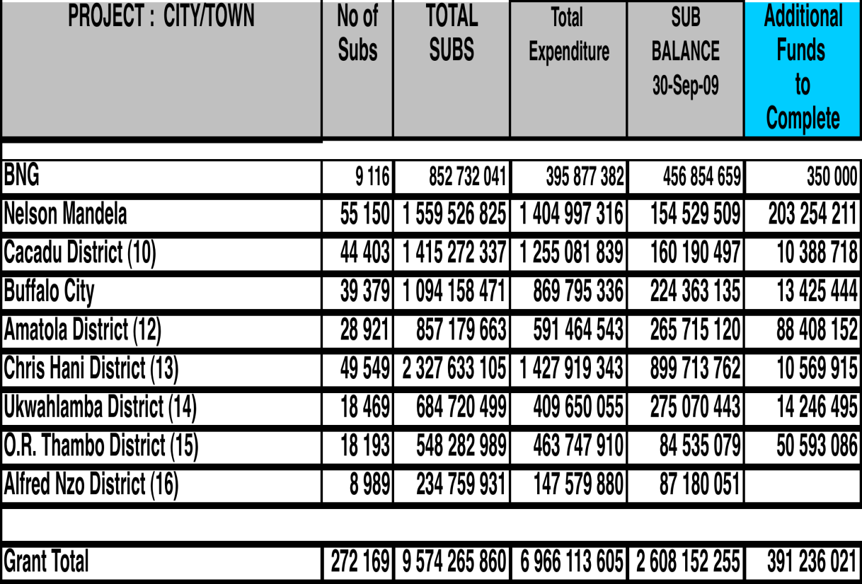

Table 9: Regional totals for funding commitments

    - PROVINCIAL TREASURY DEPARTMENT

        - Procurement policy – Approval of the amended procurement policy. The main issues centre on sourcing of contractors based on a competitive bidding process on price instead of functionality. The subsidy quantum is fixed. And also that all projects over R5m must be approved by Treasury, this accounts for almost all the projects implemented by the Department and thus reduces the effectiveness of the Department. The policy should be updated.

        - Review the funds available for the Equitable Share dedicated towards implementation of the exponentially growing Conditional Grant allocations to the Human Settlements Department.

        - Provide support and resources allowing the Department to implement on the New Mandate of Human Settlements and thus going beyond the building of houses.

  - NATIONAL DEPARTMENT OF HUMAN SETTLEMENTS

        - Provide technical support to the Department and Municipalities.

        - Undertake quarterly assessment of the progress of the Department to determine the sustainability of the turnaround and to offer assistance if required.

        - Provide additional support for the rural blocked projects, rectification and blocked projects.

        - Provide policy and technical support to the Department to deliver on the new mandate of creating sustainable human settlements.

  - CABINET

Cabinet takes note of :-
        - The steps taken to implement Cabinet’s decision to Intervene in the Eastern Cape intervention Human Settlements programme.

        - The progress during the Intervention period..

        - The closure of the Intervention as of 31 March 2010.

Cabinet approves to direct :-

        - That the Eastern Cape Provincial Departments of Human Settlements and Treasury should amend the supply chain management policy where bidding is adjudicated based on functionality rather than price and functionality adjudicated by the Human Settlements Department.

        - That the Province should consider reviewing the equitable share allocation for the Department of Human Settlements in order to ensure that sufficient capacity is created to support the development of human settlements in the Province.

