

Annual Industrial Action Report
2009

Publisher
Department of Labour
Chief Directorate of Communication
Private Bag X117
Pretoria
0001

Contributors
Editor-in-Chief: S Molapo
Editor: Abrahams Mutedi
Author: Thomas Mafela

Editing, layout and design, photography and distribution
Media Production Unit
Chief Directorate of Communication
Department of Labour

CONTENTS
Page
List of acronyms v
Acknowledgement viii
Executive Summary ix

Chapter One

Introduction 1

Chapter Two

Profiles of disputes in 2009 3

Chapter Three

Wage agreements 35

Chapter Four

Strike activity measured in labour disputes, working days lost, time-loss ratio
and wages lost, 2005-2009 38

Chapter Five

Labour disputes comparative analysis, 2008 and 2009 44
5.1 Provincial variation in labour disputes 44
5.2 Industrial variation in labour disputes 45

5.3 Working days lost 43

5.4 Working days lost per 1 000 employees 47

5.5 Working hours lost 48

5.6 Nature of labour disputes 49

5.7 Workers involved in labour disputes 50

5.8 Labour disputes by employment size of establishments 51

5.9 Duration of work stoppages 52

5.10 Principal cause of strike activity measured in working days lost 53
5.11 Working days lost and trade union movement 54

5.12 Unionisation rate 55

5.13 Determinants identified as giving rise to work stoppages in
South Africa 56

5.14 Work stoppage future outlook, 2010 58

Chapter Six

Conclusion 59
Bibliography 60

Annexure

A Data Appendix 61
B Methodology for monitoring industrial action 63

List of Tables

Table 1. Distribution of labour disputes and wages lost by province, 2008 and 2009 44

Table 2. Distribution of working days lost by industry, 2008 and 2009 47

Table 3. Distribution of working hours lost by industry, 2008 and 2009 48

Table 4. Working days lost distribution by principal cause of dispute,
2008 and 2009 54

Table 5. Distribution of working days lost by trade union movement, 2008
and 2009 54

List of Figures

Figure 1. Trends in the number of strike incidents in South Africa,

2005-2009 40

Figure 2. Working days lost in South Africa, 2005-2009 41

Figure 3. Rate of days not worked per 1 000 employees, 2005-2009 42

Figure 4: Wages lost in South Africa, 2005-2009 43

Figure 5. Distribution of labour disputes by industry, 2008 and 2009 46

Figure 6. Working days lost per 1 000 employees by industry, 2008 and 2009 48

Figure 7. Distribution of labour disputes by its nature, 2008 and 2009 50

Figure 8. Distribution of workers involved in labour disputes
by industry, 2008 and 2009 51

Figure 9. Percentage distribution of establishments affected by labour
disputes by employment size, 2008 and 2009 52

Figure 10. Percentage distribution of labour disputes by duration,
2008 and 2009 53

Figure 11. Trends in unionization rate, 2006-2009 56

List of acronyms

ABI Amalgamated Beverage Industries
ANC African National Congress
AWOL Away Without Leave
BCAWU Building, Construction and Allied Workers’ Union
BEMAWU Broadcasting, Electronic, Media and Allied Workers Union
BHP Broken Hill Proprietary
BRT Bus Rapid Transport
CCMA Commission for Conciliation, Mediation and Arbitration
CCTV Closed-Circuit Television
CEO Chief Executive Officer
CEPPWAWU Chemical, Energy, Paper, Printing, Wood and Allied Workers Union
COSATU Congress of South African Trade Unions
CPI Consumer Price Index
CPIX Consumer Price Index excluding mortgage interest cost for metropolitan and other urban areas
CRM Crocodile River Mine
CWU Communication Workers Union
D12 District 12
DCS Department of Correctional Services
DENOSA Democratic Nursing Organisation of South Africa
DJs Disc Jockeys
DRD Durban Roodepoort Deep
DTI Department of Trade and Industry
EASTPLATS Eastern Platinum
EHCWAWU Education Health Church Welfare and Allied Worker’s Union
EMS Emergency Management Service
EOCAF Employers Organisation of Cephalopod and Associated Fisheries
ERPM East Rand Proprietary Mines
FAWU Food and Allied Workers Union
FIFA Federation of International Football Association
FM Frequency Modulation
GDE Gauteng Department of Education
GDP Gross Domestic Product
GIWUSA General Industries Workers Union of South Africa
GMSA General Motors of South Africa
HIV/Aids Human Immunodeficiency Virus/Acquired Immunodeficiency
Syndrome
ICHAWU Independent Commercial, Hospitality and Allied Workers Union
ICLS International Conference of Labour Statisticians
ILO International Labour Organisation
IMATU Independent Municipal and Allied Trade Union
IMPLATS Impala Platinum
JMPD Johannesburg Metro Police Department
LMIS Labour Market Information and Statistics
LOC Local Organising Committee
LRA Labour Relations Act
KZN KwaZulu-Natal
MEC Member of the Executive Council
MTN Mobile Telephone Network
MTWU Motor Transport Workers Union (South Africa)
MWASA Media Workers Association of South Africa
NASUWU National Security and Unqualified Workers Union
NCS Natal Chemical Syndicate
NEHAWU National Education, Health and Allied Workers Union
NERSA National Energy Regulator of South Africa
NRF National Research Foundation
NTA National Taxi Alliance
NUFBWSAW National Union of Food, Beverage, Wine, Spirit and Allied Workers
NULAW National Union of Leather and Allied Workers
NUMSA National Union of Metal Workers of South Africa
NUM National Union of Mineworkers
OBP Onderstepoort Biological Products
OSD Occupation Specific Dispensation
PE Port Elizabeth
PPM Pilanesberg Platinum Mine
POPCRU Police and Prisons Civil Rights Union
PSA Public Servants Association
PTWU Professional Transport Workers’ Union
S.A South Africa
SAA South African Airways
SABC South African Broadcasting Corporation
SACCAWU South African Commercial, Catering and Allied Workers’ Union
SACTWU South African Clothing and Textile Workers Union
SACU South African Communications Union
SACWU South African Chemical Workers Union
SADNU South African Democratic Nurses Union
SADTU South African Democratic Teachers Union
SAFA South African Football Association
SAFATU South African Food and Allied Trade Union
SAFCEC South African Federation of Civil Engineering Contractors
SALGA South African Local Government Association
SAMA South African Medical Association
SAMWU South African Municipal Workers Union
SANC South African Nursing Council
SANDF South African National Defense Force
SAPPI South African Pulp and Paper Industries
SASSA South African Social Security Agency
SATAWU South African Transport and Allied Workers Union
SEIFSA Steel and Engineering Industry Federation of South Africa
STATS SA Statistics South Africa
SU Solidarity Union
TAWUSA Transport and Allied Workers Union of South Africa
TENUSA Tertiary Education National Union of South Africa
TUT Tshwane University of Technology
TV Television
UASA United Association of South Africa
UTATU United Transport and Allied Trade Union

Acknowledgement

My gratitude extends to various employers for submitting completed LRA 9.2 Forms, without their co-operation it would not have been possible to prepare this report. A special word of thanks to employer organizations and bargaining councils that met with their affiliates and encouraged them to comply with the stipulation in the Labour Relations Act relating to the reporting of any strike incident to the Department of Labour. The following have been of assistance to the Department in the collection of strikes data in 2009:

- Road Freight Employer Association;
- SAFCEC;
- Impala Platinum;
- Clothing sector employers;
- South African Revenue Service;
- DRD Gold; and
- Bargaining Councils in the clothing sector.

Executive Summary

Although strike activity measured in working days lost was higher in 2009 compared to 2008, it was lower by historical standards. About 51 industrial disputes were recorded by the Department of Labour in 2009 idling 172 772 workers, and resulting in the loss of 1 526 796 working days. Comparable figures for 2008 were 57 stoppages, 118 979 workers idled and 497 436 workdays of idleness.

Key features of industrial actions in 2009 include the following:

- A closer examination of the strike figures for 2009 shows that the greatest period of industrial activity was from June to the end of September 2009. These four months accounted for about 79.7% of the year’s industrial disputes and resulted in the loss of approximately 1 147 074 working days;
- About ten labour disputes accounted for approximately 84.3% (1 286 905) of the total working days lost in 2009;
- The longest work stoppage that began in February 2009 was between chokka fishermen (FAWU members) and the Employers Organisation for the Cephalopod and Associated Fisheries. It lasted for about 73 days and ended in June 2009;
- Unionisation rate increased from 24.2% in 2008 to 25.1% in 2009 despite a decrease in overall trade union membership;
- Approximately 119 working days were lost to industrial action per 1 000 working South Africans up from 36 in 2008;
- South Africa’s mining and quarrying industry has traditionally been plagued by high levels of industrial action with about 413 402 working days lost in 2009;
- Although one labour dispute was recorded in the electricity, gas and water supply industry, the industry has been experiencing industrial peace for some time now;
- Most of the disputes from 2005 to 2009 were complying with the provisions of the Labour Relations Act, 1995. The annual breakdown of compliant industrial disputes was as follows: 56.9% in 2005, 60.1% in 2006, 70.6% in 2007, 63.9% in 2008 and 89.2% in 2009. This development could be attributed to the role of unions in informing their members about the importance of legal industrial disputes;
- The use of replacement labour has increased in 2009 as 27.5% of firms reported to have used “scab” labour as opposed to 21.3% in 2008. The following are some of the companies that reported to have used replacement labour, i.e. Celrose (Pty) Ltd, BHP Billiton-Metalloys Division, Burhose, Elegant Square Trading 136 CC, Bibette Clothing and Trubok (Pty) Ltd;
- The number of firms that have resorted to locking-out strikers during industrial actions has increased from 6 in 2008 to 9 in 2009. This development might be due to the fact that the use of “scab” labour is on the rise. The following are some the companies that locked-out its employees during strikes: Rock and Roll Clothing, Prestige Clothing Lufil Packaging, Crown Gold Recoveries, Twin Clothing and Buffalo Clothing;
- There were few multi-union industrial disputes in 2009 such as the municipal strike that was supported by SAMWU and IMATU; and
- In 2009, about R235 458 414 in wages was lost due to the participation of employees in industrial disputes, compared to R47 705 846 in 2008.

Chapter One
Introduction

Work stoppages are as old as work itself, and they occurred before workers were first organised in trade unions. Threatening a strike is often a way to get negotiations going. Employees may see a strike as an effective method of improving their working conditions. As the ailing South African economy showed no sign of quick recovery from the recession and continued its disseminated infection on different sectors of the economy, strikes seemed to be unavoidable across all the industries. A strong wave of spontaneous and wide-spread legal strikes mushroomed in various sectors of the South African economy in 2009. The renewed working class militancy that has emerged since the beginning of the year 2009 was put to the test by the recession. The employers were on the offensive and were preparing for a showdown, as the working class. Employers need to be prepared for the impact that this has on their workforce and how best to tackle those problems. We anticipated increased workforce unrest and strikes as a result of the recession. As employees increasingly felt the pressure of a tough economic climate, workers were more likely to embark on strikes and employers were expected to suffer from this development. Indeed, during this tough time, industrial action was inevitable, as job losses were likely to prompt conflict with unions or workers. Preliminary indicators released by Statistics South Africa (Stats SA) confirmed that South Africa was in a recession. The data revealed that the seasonally adjusted estimate of the real GDP at market prices for the second quarter of 2009 decreased by an annualized rate of 3.0% compared to the first quarter of 2009, following an annualized decrease of 6.4% for the first quarter of 2009 compared to the fourth quarter of 2008 (Stats SA, P0441:2).

Workers were also struggling with the cost of living leading to demands for pay increases that employers would find difficult to afford. Although inflation was moving closer to the target of 3.0%-6.0% in September 2009, working class families in South Africa had suffered a swift erosion of their purchasing power. Data released by Statistics South Africa revealed that headline CPI annual inflation rate in September 2009 was 6.1%. This rate was 0.3 of a percentage point lower than the corresponding annual rate of 6.4% in August 2009. On average, prices increased by 0.4% between August 2009 and September 2009 (Stats SA, P0141:2). Against this background we expected the year 2009 to be an extremely tough one for Human Resources professionals in both the public and private sectors. Industrial action, whether threatened or real, leads to disrupted services, lost profits, bad public relations and low staff morale. At times like these, employers need a labour relations strategy that enables the organization to engage positively and meaningfully with its employees on its own terms, rather than adopting a reactive stance to threats of unrest.

Could the recession be changing the business of striking? One might say that the economic downturn always acts as a deterrent to strike action, and changing the way workers who do strike go about it. But as in the past, the recession might act as a brake on industrial action. When workers feel more confident in their job security they are more likely to strike. However, currently workers might feel less confident in their job security, and correspondingly, the preservation of jobs might be the point of focus during economic downturns and the inclination to strike might diminish. During economic downturn, the aims of both employers and employees are generally close enough to each other that the losses both partners would incur from long strikes are greater than any advantage that might be gained. The level of industrial action was at a low level in 2008; during the start of the economic slow down, following something of a major surge in 2007. The analysis below will try to shed some light on how strike incidents unfolded in the year 2009, and the extent to which the levels of strike activity in the country confirms our earlier expectations.

Chapter Two

Profiles of disputes in 2009

Below are profiles of disputes that provide a summary of all the disputes that took place in 2009. These cover all the disputes such as lunch-hour pickets, after-hours protests, etc. This illustration of labour disputes gives the general scenario in the country, irrespective of whether the disputes were covered by the department or not. The information has been gathered and summarised from several media reports.

January 2009

- On 7 January 2009, more than 100 members of South African Municipal Workers Union (SAMWU) at the Moretele Local Municipality in Makapanstad, north of Pretoria downed tools. The strike was as a result of a dispute with management over inadequate skills development and lack of equality in the workplace. Basic service was reported to be in shambles, with machinery degenerating into a state of disrepair. Workers also accused management of implementing labour policies that did not conform to labour relations regulations. They also accused management of lining their pockets at the expense of workers. Prior to the strike, SAMWU put forward a request to management for the creation of a local labour forum in accordance with the Labour Relations Act.

- Earlier in January 2009, more than 200 Adult Based Education and Training facilitators in Gauteng staged a protest after they were not paid. Though the facilitators had worked for months teaching adults, they did not receive their monthly salaries.

- Allegations of racism stopped construction work at the Gauteng project in Midrand on 12 January 2009 as about 2 000 workers downed tools. The work included the construction of a railway line and an overhead bridge. Trouble started when one employee had a seizure. It was reported that when he came around the supervisor assaulted him for feigning it. A witness said the supervisor called the employee a “k**ir and a drug pusher”.
- About 4 000 workers at the Buffelsfontein gold mine of Simmer and Jack mines went on strike on 14 January 2009 over pay and possible job cuts. National Union of Mineworkers (NUM) reported that workers demanded a 30.0% wage rise, while management offered only 5.0%. It was reported that in November 2008 Simmer and Jack indicated it would lay off about 500 Buffelsfontein workers by the end of January 2009 if the mine failed to meet output targets.

- Angry workers at the Elizabeth Donkin Hospital in Port Elizabeth called a two-day strike to protest against the claimed collapse of the institutional transformation unit and called for the removal of the Acting Nursing Manager. Workers alleged that the Acting Manager was incompetent and a union basher, and that there was a hostile relationship between the interim management structure and National Education, Health and Allied Workers Union (NEHAWU). NEHAWU said that its members staged a peaceful demonstration and kept the situation that way throughout the strike. It was reported that the issue that prompted the workers to strike had been a call for a danger allowance.

- On 21 January 2009, Johannesburg Metrobus drivers went on strike over salary dispute. It was reported that during the strike some passengers were forced out of buses and drivers were forced to join their striking colleagues. The strike began at the Village Main Depot, but did not spread to other branches.

- On 21 January 2009, thousands of mineworkers protested at the Rustenburg Platinum Mines as reported by NUM. The miners demanded that the mine employ an independent investigator to probe the disappearance of two mineworkers. NUM reported that all records including the Closed-Circuit Television (CCTV) showed that the two men went underground, but never returned. This was to assist and ensure that the families of these comrades found closure.

- On 23 January 2009, more than 200 workers at Tshwane University of Technology (TUT) downed tools following months of salary negotiations. The crowds, comprising among others academics, administrators and general service workers marched through TUT’s main campus in Pretoria, bringing the registration process to a standstill. Also, registration was affected at the institution’s satellite campuses in Soshanguve and Ga-Rankuwa. It was claimed that non-striking workers on duty were intimidated, leaving hundreds of students who came to register and to make enquiries stranded. The irate workers demanded a 15.0% salary increase in light of the credit crunch and the scrapping of the institution’s remuneration system in 2009.

- On 24 January 2009, about 900 Roshcon Construction Company workers went on strike. As the strike continued, ten striking workers were shot when police opened fire with rubber bullets outside the company in Polokwane.

- On 27 January 2009, hundreds of furious taxi conductors protested against their unfair dismissal by the very same bosses they had worked so hard for. This was after they were told by their taxi association that from the 2 February 2009 their services were no longer required. The KZN conductors gathered at the Market Taxi Association’s offices.

February 2009

- On 2 February 2009, hundreds of the Joburg Metro Police officers marched through the city to hand over a memorandum at the Executive Mayor’s office. They called for the Metro Police boss to be “recalled” or redeployed. They were also calling for the suspension of Johannesburg Metro Police Department’s (JMPD) licensing Station Manager and the Deputy Director of internal affairs. The march caused major traffic jams as the protesters sat down at intersections, resulting in impatient taxi drivers and motorists making U-turns.

- On 2 February 2009, lectures were cancelled at the Durban University of Technology when staff downed tools demanding a pay increase.

- On 4 February 2009, farm workers from Ottosdal and surrounding areas marched to the departments of Justice and Agriculture to hand over a memorandum. The workers demanded “that North-West farmers stop evicting and mistreating farm workers”. Farm workers and their supporters took a few hours off from work and demonstrated outside the Ottosdal Magistrate’s Court.

- About 150 employees of Eskom subsidiary Roshcon continued striking on 5 February 2009 in Merapong over salary increases. Police reported that workers gathered outside the Medupi power station at 4am, barricaded the street and stoned two houses.

- On 6 February 2009, about 2 000 workers at the Mbombela 2010 Federation of International Football Association (FIFA) World Cup stadium embarked on a strike. The workers downed tools after demanding money they claimed was “promised” to them by the Mbombela Municipality’s Mayor on a Radio Station. According to NUM, the stadium management had denied all knowledge of any promised bonuses that the workers said they were expecting.

- On 7 February 2009, workers at a Tata Rosslyn bus and truck plant took to the streets in protest against the non-payment of their salaries. Management was reported to have said that workers were not paid because they had missed their production targets. Tata management said it was not their responsibility to pay workers, but the responsibility of the outsourcing company called Tiro. They said that they had a contract with Tiro which states that if they did not reach production targets, they will not pay Tiro. Tiro indicated that they were in the process of forking out more than R600 000.00 to pay the workers.

- On 11 February 2009, about 100 SAMWU drivers and support staff embarked on an impromptu industrial action which disrupted services for the rest of the day. Allegations of incompetence and racism had been leveled against management at the Tshwane Metro’s bus depot in Church Street. According to the municipality, the shop stewards listed among their grievances non-procedural suspension of bus drivers, non-procedural charging of bus drivers; problems at the workshop including “whites only” toilet; problems with the cleaning company that was alleged to be ill-treating employees; and employment of bus drivers on contract basis. SAMWU called for the immediate removal of a manager at the planning office because he apparently had a bad attitude; was unable to communicate properly; was incompetent; was a racist; and because of the manner in which he allocated shifts.

- On 13 February 2009, teachers at Mpumelelo Primary School in Ivory Park, near Midrand went on strike demanding that the Principal be removed. Parents, teachers and members of the School Governing Body gathered at the school and demanded that the Principal be redeployed. They accused the Principal of laying false charges against teachers and not following procedures when hiring teachers.

- South African Airways (SAA) workers embarked on a strike on 20 February 2009 in a dispute over the payment of premiums and labour brokers. The union demanded that the payment of retention premiums be extended to all workers and that SAA halt the use of labour brokers. The union also asked that all suspended shop stewards that were dismissed be reinstated. SAA said it was not possible to do away with labour brokers as they were on contracts which could cost millions to cancel. The union said they could drop their demands as long as the senior management can repay the bonuses they received with interest.

- On 21 February 2009, an apparent “go slow” at the Deeds Office in Pretoria by employees unhappy about the abolition of overtime resulted in huge delays in the processing of files, according to lawyers doing business with the office. However, the Department of Land Affairs said it had no knowledge of a go-slow or strike, although it acknowledged that there had been a problem regarding overtime. According to the attorneys, the lodging of deed applications and transfers that usually took between 8 and 12 working days, took weeks to be finalised.

- On 23 February 2009, about 300 police reservists demonstrated outside Luthuli House {African National Congress (ANC) Head Quarters} in Johannesburg demanding that they must be incorporated into the police service with better salaries. Safety and Security Minister promised police reservists that their demands would be given attention. Congress of South African Trade Unions (COSATU) said reservists were being exploited by the government.

- Teachers at Bonella Secondary School in Cato Manor in Durban downed tools on 26 February 2009 following a brutal attack on a female teacher at the school. The teacher was alone in her classroom when an armed robber, believed to be a former pupil, assaulted her at gunpoint on 25 February 2009. The attacker fled with jewellery and handbag after locking her in the classroom.

March 2009

- On 2 March 2009, cash-transit workers embarked on a strike. The union had demanded a minimum basic salary of R6 000.00 a month for drivers, crewmen and vehicle guards, R7 000.00 a month for custodians, and a 12.0% increase for all its members. The strike affected Protea Coin, Group 4 Securicor, etc. It was reported that negotiations over salaries and conditions of employment for drivers, crewmen and vehicle guards started in August 2008.

- More than 4 000 workers at Pamodzi Gold operations in the Free State embarked on a stay-away since the 2 March 2009 because their wages were not paid. The National Union of Mineworkers further said the workers experienced the same problems of a delay in salary payments in January 2009. However, the mine was later declared insolvent.

- On 3 March 2009, some employees at Takalani Home for Disabled children protested after going for five months without pay. The Board of Trustees for the home said there was no money to pay the workers.

- On 4 March 2009, municipal workers in Mafikeng and surrounding areas embarked on strike that resulted in the interruption of water supply. The Local Government Department claimed that municipal workers closed valves at a reservoir and security was tightened thereafter.

- Commuters in several parts of the Free State were left stranded on 4 March 2009 following a march by about 5 000 taxi operators who were members of the Provincial Taxi Alliance. Alliance spokesman said operators marched over discrimination on the part of the Free State transport department against Taxi Alliance members.

- African language interpreters embarked on a go-slow on 9 March 2009 for more than two hours singing protest songs and dancing in the Magistrate Court building in Johannesburg. The 35 interpreters sang protest songs in corridors, refusing to return to court rooms until management addressed them. They protested against a fellow interpreter “who got paid to do nothing”. They reported that their colleague had been reporting to work since September 2008, but refused to work. NEHAWU said the interpreter in question told his colleagues that he would only work once a complaint he lodged with court management was resolved. Workers felt it was unfair for them to be working while their colleague sat around doing nothing.

- On 9 March 2009, workers at the Onderstepoort Biological Products (OBP), an animal vaccine producer which is 51.0% owned by the Department of Agriculture embarked on a go-slow protest action and refused to work overtime until their demands were met. Workers who were members of NEHAWU lashed out at the company for mismanagement, misuse of company funds by frequently changing senior management and nepotism.

- On 10 March 2009, more than 100 police reservists gathered near the Soshanguve Police Station and embarked on a sit-in at the same police station. The reservists from Soshanguve, Rietgat and Temba demanded basic salaries plus benefits every month, just like full-time police receive.

- On 11 March 2009, South African Broadcasting Corporation (SABC) staff members staged a sit-in in the offices of the group Chief Executive Officer (CEO) and threatened to take their concerns all the way to the Presidency. This was after members of the SABC’s marketing department belonging to the Communications Workers Union (CWU) decided to voice their unhappiness at what they believed amounted to nepotism, favouritism, wasteful expenditure and unilateral changes to their conditions of service. The union complained that the public broadcaster had been frittering away huge amounts of money at a time when it was running at an R700m deficit. The union was demanding the removal of SABC managers and had resolved to call on the Department of Communication, Treasury and the Presidency to investigate their claims before further funds were released to the SABC.

- On 11 March 2009, Exstrata dismissed 106 workers at its Rustenburg smelter because they decided to attend pay strike rather than a mandatory health programme. The workers had demanded to be paid 50.0% of their wages, as well as shift allowances during their extended leave in December 2008, when such payments were normally not due to them.

- Nurses that included those who perform pregnancy terminations at hospitals in East London and Mthatha, and those in the primary health care went on strike on 11 March 2009. The nurses demanded the implementation of Occupation Specific Dispensation (OSD).

- On 11 March 2009, about 4 000 workers at the King Shaka Airport building site, downed tools. Workers at the site, in La Mercy, on the North Coast, claimed that their hourly pay rate was inflated on a document they found on site. The document stated that the crew was paid R15.90 an hour, instead of the R14.00 an hour that they actually receive. The strike later turned violent as workers stoned police, and trashed offices and cars.

- On 12 March 2009, members of the National Taxi Association burnt tyres in the city centre in violent protests against Cape Town’s new integrated rapid transport system, which it was reported would bring all taxis, buses and trains under the control of one private company.

- On 12 March 2009, hundreds of Fishermen in Port Elizabeth invaded the Department of Labour’s offices. Some fishermen were arrested together with their wives. The angry crowd demanded answers from the department after submitting a list of their grievances. They wanted a basic salary of R1 000.00 and commission of R4.00 per kilogram of fish. They also wanted the Department to regulate the industry. The strike had been going on since September 2008.

- About 600 workers at the eThekwini municipality’s water depot in Springfield downed tools on 16 March 2009. The workers decided to down tools after arriving at work on the same morning to find new staff on the site.

- On 18 March 2009, Ekurhuleni Metro Police protested outside the Alberton precinct, demanding the immediate suspension of a “racist” superintendent who had been charged with “crimen injuria” (for calling a colleague with the “K” word”) and assaulting a civilian.

- On 24 March 2009, Taxi operators in Johannesburg embarked on a protest action against the introduction of the Bus Rapid Transport (BRT) System in Gauteng. Rogue operators blocked major routes into cities claiming they had not been properly consulted on a plan that could cost them their livelihood. The taxi industry felt threatened by the new bus system, which involves the removal of 550 taxis from the Soweto-Johannesburg route as a first step. Taxi operators also barred bus operators from ferrying commuters to work.

- Chaos continued to reign at the Spruitview based Community Radio Station Kasie FM (Frequency Modulation) on the East Rand on 25 March 2009 when striking DJs disrupted broadcasting in the morning by confiscating equipment and reportedly intimidating colleagues. The Disc Jockeys (DJs) downed tools accusing management of running the station “like spaza shop” and firing DJs at will.

- Members of South African Commercial, Catering and Allied Workers Union (SACCAWU) embarked on a one-day protected strike at the Development Bank of Southern Africa on 26 March 2009. About 150 union members gathered outside the bank in a peaceful protest. SACCAWU said the bank’s managers gave themselves “huge bonuses” while support staff did not receive similar treatment.

- On 27 March 2009, more than 2 000 employees of Autopax, a company that includes Translux and City to City embarked on strike. They demanded outstanding money from Translux. On 1 April 2009, Autopax was to merge operations, personnel and assets with the South African Rail Commuter Corporation, Metrorail, Intersite Property Management Services and Shosholoza Meyl into the newly established Passenger Rail Agency of South Africa. Workers had not been paid since a new company; South African Commuters Co-Operation took over. It was reported that South African Transport and Allied Workers Union (SATAWU) had been negotiating with management for a long time about wages, working conditions and the hours of work.

- Disgruntled workers at Ishmael Mall Mohammed pharmacy in Pinetown embarked on strike on 31 March 2009, demanding a living wage and better working conditions. GM Pharmaceuticals employees protested over a number of grievances, including low salaries and poor working conditions, outside Ishmael Mohammed’s pharmacy in Pinetown.

- Administrative staff at the Department of Education in KwaZulu/Natal (KZN) embarked on strike at the end of March 2009. The strike included other general workers and security guards. South African Democratic Teachers Union (SADTU) was in dispute with the department over a number of issues, including the lack of recognition of qualifications of clerical staff, the performance management development system, the upgrading of salary levels and an alleged lack of transparency on promotions. Other grievances included the suspension of staff at the department’s service centres, the termination of consultancy contracts and re-instatement of temporary teachers whose contracts had not been extended. While SADTU was adamant the workers’ strike was legal, the department said it was unprotected and obtained a court interdict ordering them to return to work. It was further reported that property at the department’s buildings was damaged, workers intimidated and the payment of temporary teachers delayed as a result of the strike.

April 2009

- On 1 April 2009, the Johannesburg Zoo closed after a “substantial” number of staff members downed tools. It was reported that the strike was illegal and a memorandum of grievances was handed to zoo management.

- On 1 April 2009, staff at the South African Nursing Council (SANC) staged a sit-in at the registrar’s office after hearing allegations that the CEO’s contract was extended “illegally” for three months by the Chairperson of the council’s board. Employees of the council, under the banner of NEHAWU refused to work when they learnt that the registrar and the CEO of SANC had turned up for work although the Chairperson’s contract had ended on 31 March 2009. NEHAWU said that the extension of the Chairperson’s contract was illegal because it was not a decision made by the council’s board, but by an individual.

- On 7 April 2009, striking truck drivers kicked-off with an “indefinite” industrial action in Johannesburg. This came after talks between the employer, the union and the CCMA aimed at averting the strike that saw petrol stations running dry as well as the non-delivery of other important supplies such as medicines and building materials, failed to yield results. SATAWU had been at loggerheads with the employer over wages. The union demanded a salary of R6 000.00 per month for long distance drivers who earned R4 317.00 per month. The employers offered an overall 11.0% increase which the union opposed, demanding 13.0% and four months paid maternity leave. Some of the issues raised by SATAWU included minimum wages, allowances and maternity leave. The union demanded that the minimum wage for ultra-heavy long-distance drivers be increased to R6 000.00 a month from R4 300.00, while general workers’ salaries should rise to a minimum of R3 000.00, up from R2 500.00. It was reported that employers were willing to grant women maternity leave only after 24 months of employment. Workers then had to apply to the bargaining council for only 55.0% of their salaries. The strike did not just affect the fuel industry, but also sectors responsible for the transport of chemicals, medical supplies, building supplies, perishable goods and livestock. Police spokesperson said cases of intimidation and stone-throwing were reported in Boksburg, Kempton Park and Pretoria.

- On 8 April 2009, employees of embattled junior miner Pamodzi Gold handed over a memorandum of demands to the company during a protest march. Solidarity reported that the march took place at Pamodzi Gold’s President Steyn mine near Welkom and was attended by almost 3 000 workers. The union said employees of President Steyn mine had received only 70.0% of their February salaries.

- About 500 Eskom Holdings workers marched in Johannesburg on 8 April 2009 to protest against the use of contractors to hire temporary workers. National Union of Mineworkers (NUM) reported that there was no disruption of operations because Eskom planned for that in advance.

- On 14 April 2009, some few members of National Union of Metal Workers of South Africa (NUMSA) embarked on a national strike against Defy Appliances. Workers were striking over “unjust” retrenchments. It was reported that the strike was not well supported by workers.

- On 16 April 2009, about 200 interns and registrars downed tools at George Mkhari Hospital, while about 30 interns met at Steve Biko Academic to plan their action. The sit-ins by intern doctors and registrars had spread to several hospitals in the North-West Province. The interns at Steve Biko Academic handed a letter to the Office of the Chief Executive, which stated they had decided to partake in a stay-in. The stay-in was in protest against the appalling salaries and their exclusion from the Occupation Specific Dispensation (OSD) fees that were already being paid to nurses. Protesters indicated that they demanded a 50.0% increase in their basic salary. The unprotected strike, which began in Ga-Rankuwa, was reported to have had support in the Free State, Limpopo and North-West. The strike followed the failure of the implementation of the Occupation Specific Dispensation by July 2008. Beneficiaries of the OSD included pharmacists, dentists and emergency service workers as well as doctors.

- On the night of 16 April 2009, thousands of Pretoria bus commuters were left stranded throughout the city as hundreds of drivers downed tools in an illegal strike. The strike, which workers had said was an indefinite work stoppage, began shortly after drivers completed their early morning “rush hour” shift. It was reported that the strike was over alleged racism within management at the municipal bus company. It was further reported that Blacks were not treated as equals.

- The week of 20 April 2009 witnessed a strike by members of SADTU in KwaZulu-Natal. The strike was over grievances ranging from racism by senior managers in the Pietermaritzburg office to unpaid service bonuses. The Department of Education later won a court interdict that was defied by the union.

- On 24 April 2009, farm workers of Jonker Group, of Onverwacht near Oudtshoorn, the biggest ostrich farm in South Africa, embarked on strike. Farm workers proclaimed that the ostrich king pays low salaries and that their remuneration was “below the breadline”. The South African Catering Trade Workers’ Union said workers demanded an 8.5% increase while Jonker, offered 5.0%. The union further said average salary was R250.00 per week and that some workers only took home R1 000.00. Jonker said employees determined their own earnings through the time they spent working, and that many did not work a full week.

- On 28 April 2009, at least 500 drivers and 300 support staff of the Johannesburg Metro, all of them aligned to SAMWU downed tools. The union protested against the different salary bands in the company that payed junior drivers the same amount, about R7 000.00, as experienced drivers, some of whom had been doing the job for more than 10 years. The strike threatened to turn violent when striking drivers barricaded the entrance to the Metrobus head office in Braamfontein. The union wanted salaries of its members to increase in line with their years of service because bus drivers with eight years’ experience were being paid the same as their entry-level colleagues. The union demanded that drivers with five to seven years’ experience move on to the medium salary band of R9 000.00-R10 000.00 a month, while newer drivers should earn R7 000.00-R8 000.00.

- On 28 April 2009, bus drivers in the Tshwane Municipality went on strike leaving commuters stranded for the second time in April 2009. Bus drivers under the banner of SAMWU were angry with the council for not fulfilling promises following their previous meeting on 17 April. The drivers claimed their grievances had fallen on deaf ears as there had been no action on the part of the council, which was apparently supposed to suspend at least six employees. Allegations of racism, corruption and incompetence had been leveled against management at its depot in Church Street.

- On 30 April 2009, more than 100 casual workers at the Nelspruit Coke Fortune depot downed tools demanding permanent contracts and better wages. The company allegedly halted fixed contracts which resulted in reductions in pay for workers. It was reported that the cancellation of fixed contracts was a blow because in the past workers would be paid for reporting for duty even when there was no work on that day, whilst with the new arrangement they get paid only if there was work on a particular day.

May 2009

- Academic activities at the Tshwane North College campus in Soshanguve were brought to a halt on 4 May 2009 when lecturers went on strike in protest over the failure to pay overtime for afternoon classes at the college. About 60 lecturers who offer the afternoon classes, commonly known as National Technical Certificate courses, in engineering and business studies, had apparently not been given their overtime pay for March and April 2009. The lecturers said they are not paid overtime by the Gauteng Education Department, but are paid from the college’s funds, which were sustained by the fees students paid. They said the college’s management had told them it did not have enough money.

- On 4 May 2009, about 117 members of General Industries Workers Union of South Africa (GIWUSA) {Employees of Prominent Paints in Alberton} downed tools after employers failed to meet their demands. Workers demanded the following:
  - the removal of human resources manager who they accused of “unfair practices” in implementing disciplinary measures;
  - the reinstatement of the “Rainbow Policy”, an incentive system which gave employees R3 000.00 quarterly from profits made by the firm;
  - employers reduced the incentive to R700.00 in mid 2008;
  - for the 21 contract workers to be permanently employed;
  - that the permanent total disability be increased from one times the annual salary to three times the annual salary; and
  - the funeral cover be increased from R4 000.00 to R10 000.00.

- Thousands of patients around Johannesburg continued to bear the brunt of the municipal clinics nurses’ strike. Nurses embarked on a “go-slow” early in May 2009 demanding salary increases and better working conditions. Clinics slammed their doors on patients, instructing them to go to provincial clinics as they had stopped to attend to the sick, the pregnant and those with chronic diseases. The strike by nurses at municipal clinics took its toll on their provincial counterparts.

- On 6 May 2009, nursing staff at ante-natal clinics in Johannesburg embarked on a go-slow without the support of their union, South African Democratic Nurses Union (SADNU). The union called on them to respect the labour court ruling of April 24 and return to work. The union said some nurses were not happy with their remuneration and working conditions. It was reported that nurses without specializations were excluded from the Occupation Specific Dispensation and that group of nurses represented a large number of nurses who just did not benefit.

- On 7 May 2009, workers went on strike at Elgin Poultry Abattoir in a dispute over pay. United Association of South Africa (UASA) alleged that the company, which supplies chickens to Shoprite, Checkers and Woolworths was “grossly exploiting” the workers. The average pay was reported to be only R700.00 per month.

- On 13 May 2009, about 4 200 Pamodzi Gold East Rand workers, at the provisionally liquidated company’s only mine still operating, went on strike, as management held thumbs for the arrival of R40 million from a German Bank (Hype Vereinsbank). NUM reported workers had downed tools over non payment of April wages.

- On 13 May 2009, personnel at the Master of the High Court’s office in Pretoria refused to go back to work as they feared the building might be unsafe after a fire on 12 May 2009. The Department of Justice said a large group of employees demonstrated with placards and posters outside the Head Office in Pretorius Street after a fire at their offices in Church Street. The fire broke out in an office on the 12th floor where the Master’s office is housed. The building was evacuated and one person was injured during the stampede. The fire was soon extinguished. As the building was structurally sound, there was no damage to it, and it was safe to go inside as reported by the Department. However, the staff did not agree, and protested for most of the morning, saying it was not safe to return before the damage was repaired.

- On 13 May 2009, about 300 Willard Batteries workers embarked on a strike which started following an announcement by the company of its intention to retrench about 99 workers. On the very same day workers were locked-out after NUMSA issued the company a notice to strike on 8 May 2009. The industrial action had also prompted management to also recall about 13 workers who had already been retrenched.

- Construction on the R70 billion Medupi power station in Limpopo grounded to a halt as workers downed tools over the retrenchment of more than 300 colleagues. It was reported that the strike had been going on since the 15 May in protest against workers being retrenched without “good reason”. The union further reported that more than 300 workers were retrenched without any good reason and workers said that they were not going back to work until these workers were brought back.

- On 18 May 2009, about 300 motor car workers protested outside two branches of General Motors in Eastern Cape and said they would continue their protest each lunch break until the 25 May 2009 when they were to appear in the Labour Court. NUMSA had requested the court to have General Motors of South Africa (GMSA) declare 300 dismissals null and void. Since January 2008, about 1 000 workers were reported to had been retrenched by GMSA, but NUMSA said the court action was related to about 300 of the retrenched workers.

- On the week of 22 May 2009, some Robben Island staff members picketed in protest against the management’s planned restructuring process, which was being driven by the organisation’s acting CEO.

- On 27 May 2009, members of NUMSA threatened to storm into the Reserve Bank during their march to the building in Pretoria. More than a thousand NUMSA members marched to the Bank demanding a drastic cut in interest rates, which they believed were costing many people jobs. NUMSA also wanted Reserve Bank Governor to abandon the inflation-targeting policy, which they claim was worsening financial conditions for workers.

- Traffic officers in the North-West wanted the provincial government to change their working conditions. And to back up their demands the officers took to the streets of Mafikeng on 27 May 2009. They demanded the scrapping of inflated prices by companies conducting business with the department. They further demanded the immediate reinstatement of previous work arrangements to start work at 7am and end at 8pm. The officers also criticised “jaws”, the much publicized unit within the traffic department that was set up by the provincial government as a unit to clamp down on traffic offenders across the province. To make matters even worse, municipal workers in the town were also on strike.

- On 28 May 2009, workers of South African Pulp and Paper Industries (SAPPI) at the Entra mill in Johannesburg embarked on the safety strike. The incident started when shop stewards prevented a worker from doing unsafe work. The worker was assigned to do cleaning in a part of the paper mill that a piece of equipment normally performs. When shop stewards protested the unsafe act, management hardened and the safety strikes began. The matter was compounded when a joint labour management report on the safety incident and subsequent strikes was ignored by the mill manager.

- On 29 May 2009, about 1 000 employees at the Department of Health’s Port Elizabeth depot stopped working in protest against the Department of Health’s failure to honour a 2007 agreement, which included the payment of allowances dating back to 2003. The workers protested against a lack of staff training and the filling of vacant posts. The protest would, had if allowed to continue hit primary health care facilities, including more than 500 clinics and community health centres across the province, potentially depriving up to three million people of medication. The action by NEHAWU was supported by pharmacy assistants, managers and general assistants. One of the major causes of the strike was that general assistants had been filling in for pharmacy assistants at the depot for years while their ranks remained unchanged. The union said they had taken care of sorting medication, packing, sealing and addressing boxes for dispensation without due recognition from the department. The controversial Occupation Specific Dispensation introduced in 2007 as an incentive and to address public workers’ pay and working conditions had formed part of the problem.

- On 29 May 2009, about 500 prison warders embarked on a lunchtime picket and were later suspended by the authorities. Police and Prisons Civil Rights Union (POPCRU) reported that the affected warders were from Johannesburg and surrounding areas. Warders picketed around the country about due payments of their OSD. It was agreed in 2007 that the OSD was going to be implemented, but the union said it had never happened. Prison warders were suspended after picketing outside Boksburg, Leeuwkop and Baviaanspoort prisons in Gauteng.

June 2009

- Johannesburg paramedics and firefighters went on strike over salary dispute for the second time in a week in June. On 2 June 2009, striking personnel from the Johannesburg Emergency Management Services stormed the services call centre in Constantia Kloof, forcing its evacuation and subsequent closure. Paramedics continued on a strike on 5 June demanding immediate implementation of salary increases and career progression. Municipal nurses had been on strike since the beginning of April. They also protested against “low wages”. SAMWU reported that workers failed to turn up for work because emergency services management did not implement a wage agreement reached in 2008. This was meant to be implemented in May 2009. Emergency workers, from ambulance drivers to call-centre operators, who dispatch service teams, were part of the action.

- On 2 June 2009, a drivers’ strike crippled a council transport service for the disabled. About 40 drivers for the Dial-A-Ride, a transport contractor to the city of Cape Town, went on strike to support their demand for a wage increase. The company offered a 12.6% increase, but the drivers turned it down since it was still lower than their demanded 13.0%. The service to the townships was cut after the striking drivers threatened to stone and set vehicles alight if they found them there. Disabled residents said it was difficult for them to use taxis and buses because the drivers show no compassion for their condition.

- On 3 June 2009, administrative work at the Port Elizabeth Education Department district offices came to a halt after administrative staff and clerks in public schools staged a sit-in following a dispute over non-payment of outstanding benefits back to July 1999.

- Since the 3 June 2009, SADTU members in Soweto were on a protest action, because teachers earmarked to fill advertised posts were not duly appointed. On 8 June 2009, SADTU Gauteng Central Region members went on a strike demanding that the director of District 12 sign appointment letters for certain principals of their choice. SADTU acted on its threat to bring schooling in Soweto to a standstill by disrupting office work at the Gauteng department of education’s District 12 offices in Florida. SADTU picketed outside the D12 offices demanding that its director, sign the appointment of recommended teachers to fill advertised posts. SADTU instructed employees at the D12 offices to go home and not return to work until the Director had signed the appointment letters. Employees at the D12 offices, some of whom were still at lunch, walked out of their offices, taking all their belongings. It was reported that after chasing away the staff, SADTU members went to Die Burger High School and caused chaos by interrupting examinations. They claimed it was unfair for some pupils to be allowed to sit for an examination while others could not do so. Union members disrupted examinations throwing examination papers away, while pupils were busy writing, saying that all pupils should have an equal right to education.

- On 4 June 2009, actors, producers, writers and crew members with their music blaring and props to match their personalities gathered at the Atlas Studios in Milpark, Johannesburg, to protest against what they said was the mismanagement of the SABC. Some protestors claimed to have not been paid for their performance. Marching under the umbrella of the Television (TV) industry Emergency Coalition, about 1 000 actors, producers, writers and technical people danced and laughed as they assembled to highlight a growing list of concerns. These included worries that the SABC was not paying for work on time, causing a knock-on effect in the industry; that it was not commissioning enough local content; and that it was not paying for repeat programmes.

- On 12 June 2009, Professional Transport Workers’ Union (PTWU) members went on strike at Real Landscape in Gauteng. The union said its 600 members went on strike after the landscaping company’s management refused to increase monthly pay from R1 100.00 to a minimum of R2 600.00. Workers demanded fair rewards for their hard work as gardeners.

- On 14 June 2009, stewards began strike at the opening match of the FIFA Confederations Cup between South Africa and Iraq. Police were deployed to monitor the situation. The deployments came as stewards, who were hired through companies employed by the Local Organising Committee (LOC) to conduct access control, went on strike and a go-slow over a wage dispute. Some reports also indicated that the stewards were initially offered R600.00 for working on the day of the matches, only to be told they would be paid R250.00. It was reported that the problem was not with FIFA itself, but with the LOC. This was after the potentially embarrassing strike over wages by about 850 stewards based at the stadium was averted moments before the opening match. The 2010 Local Organising Committee had to increase their fee from R200.00 to R250.00 for each match day. The stewards were recruited from the community patrollers in conjunction with Local Community Policing Forums.

- On 22 June 2009, public sector doctors in KwaZulu-Natal embarked on strike action. The strike came as a result of the slow implementation of doctors’ Occupation Specific Dispensation. On the same day, groups of doctors picketed outside Durban’s King Edward VIII Hospital. KwaZulu-Natal Health spokesman said Durban’s major hospitals affected by the strike, which was unprotected, included RK Khan, Addington, Osindisweni, Prince Mshiyeni Memorial, Wentworth, King George, Mahatma Gandhi Memorial, King Edward, Inkosi Albert Luthuli Central, Stanger and Grey’s hospitals. Doctors downed stethoscopes in the province (KZN) in protest of poor working conditions and the delay in the implementation of the Occupation Specific Dispensation which was scheduled to be implemented in July 2008. The South African Medical Association (SAMA) demanded a 50.0% wage increase, government’s previous offer ranged between 0.3% and 5.0%.

- On 22 June 2009, scores of patients were turned away as the strike by public sector doctors crippled major hospitals in KwaZulu-Natal and Mthatha in the Eastern Cape. Most hospitals in KwaZulu-Natal and Mthatha were running on skeleton staff as the strike hit services. The public sector doctors, who are not allowed to strike, had gone on an unprotected strike demanding a 50.0% salary increase as part of Occupation Specific Dispensation that was introduced in 2007 but had not been implemented yet.

- On 22 June 2009, about 400 employees at Xstrata mine in Steelpoort embarked on strike. Two temporary employees at the mine near Burgersfort in Limpopo burnt their faces while allegedly performing “scab” duties. The two scabs (people employed to temporarily replace workers on strike) had been employed while the strike was on. The two allegedly could not competently operate some of the mine’s machines. NUM accused mining company Xstrata Alloys’ Lion Ferrochrome in Steelpoort of refusing to negotiate further with the workers.

- On 23 June 2009, the Bisho Legislature came to a halt when staff stopped work in a dispute over payment of performance-related bonuses. Portfolio committee meetings scheduled to scrutinize budgets of provincial departments were crippled because the staff walked off their jobs. At the centre of the dispute was the calculation of bonuses. The industrial action was a sequel to a notice filed by NEHAWU on June 10 threatening industrial action on the day of the State of the Province Address.

- On 30 June 2009, labour unrest in the Tshwane Metro Council’s department of Agriculture and Environmental management disrupted refuse collection across the city. Workers protested against the continuing use of outsourcing companies by the Metro Council in refuse removal.

July 2009

- On 1 July 2009, drivers’ licence testing stations around Johannesburg were closed as Metro police officials downed tools in solidarity with their colleagues who appeared before a disciplinary committee over a violent strike that occurred in 2008. Many angry and frustrated people at the Langlaagte testing centre accused the officials who downed tools of reneging on their duties.

- On 6 July 2009, communication workers at the SABC embarked on a go-slow over wages. The unionists said their members would not lift a finger to do extra work, performing only their core functions. The Broadcast Electronic Media Allied Workers’ Union (BEMAWU) noted that workers from all three major unions followed the “work-to-rule” principle. The action was aimed at forcing management to accede to a 12.2% salary demand.

- On 7 July 2009, more than 200 members of Cosatu in Brits marched to the Magistrate Court. They sang liberation songs and waved placards. They protested as the farmer appeared in court in connection with the attempted murder of four people in his farm Klipkop. In a memorandum handed over to the court, Cosatu demanded the withdrawal of the bail granted to the farmer and that his case be transferred to the Pretoria High Court. The farmer appeared on charges of attempted murder for allegedly shooting four people on 14 June 2009 at his farm after suspecting that they were stealing oranges.

- On 8 July 2009, construction at 2010 World Cup stadiums around the country came to an abrupt halt, as unionized workers embarked on a strike demanding higher pay that their employers said they could not afford. The strike by workers affiliated to NUM and Building, Construction and Allied Workers Union (BCAWU) affected the Gautrain project in Gauteng, Eskom’s new power stations, the Coega oil refinery outside Port Elizabeth, King Shaka Airport in Durban, as well as mining, construction companies and road builders. The unions demanded 13.0%. Employers, represented by South African Federation of Civil Engineering Contractors (SAFCEC), had rejected demands for a 13.0% increase. They upped their previous offer of a 10.0% increase to 10.4%. Additional benefits workers demanded included being paid when they don’t work on rainy days, six months maternity leave, with full pay for pregnant women and a health care facility at every construction site. Construction workers also marched to South African Football Association (SAFA) offices next to the calabash-shaped stadium to hand a memorandum to its Vice-President who was not available. Road builders, next to Soccer City stadium and employed by Group Five, downed tools and joined the stadium workers. NUM also wanted a review of regulations to improve safety, as well as an increase in annual leave, which they said was 15 days.

- On 9 July 2009, mining group Eastern Platinum (Eastplats) was affected by an illegal strike action by approximately 500 contract miners at its Crocodile River Mine (CRM). Workers embarked on a sit-in at one of the walk-in shafts in the Zandfontein section of the mine. The strikers said the mine had reneged on a commitment to absorb them as permanent employees. The contract workers demanded that they be directly employed by CRM, which Eastplats said was in contravention of all the contractual agreements between the mine, the mining contractors and their employees. This demand and associated action was understood not to have had the support of Eastplats, NUM or the mining contractors involved. The contract workers involved in the action had staged a “sit-in” in an underground area close to the entrance of the mine. Eastplats said workers had also detained seven supervisory employees of the mining contractors against their will and who were not involved in the action. The 1 500 contract workers at the Crocodile River Mine near Brits, found themselves without work after the termination of their contracts by the mine. The workers, full-time employees of mining contract firms JIC Mining Services and Sindile camped at the gates.

- On 13 July 2009, frustrated South African Social Security Agency (SASSA) workers disrupted Social Development Department services in Port Elizabeth over outstanding benefits. SASSA offices around the city were closed after mid-morning. Workers gathered at the Trust Bank Building in Govan Mbeki Avenue for their protest. NEHAWU said the protesters complained about security grants and liability funds they were supposed to receive from the government after they were transferred from the Department of Social Development to SASSA in 2006. NEHAWU claimed that SASSA senior management had already received their money, questioning why it took so long for ordinary employees to get their money. NEHAWU further claimed that the agency had not paid workers overtime from January to March 2009 and no reasons for this had been provided.

- On 13 July 2009, temporary employees who claimed that they were employed by the 2010 LOC cried foul. At least 50 dissatisfied casual workers gathered at the offices of South African Football Association in Soccer City to demand their money from the LOC.

- On 14 July 2009, hundreds of disgruntled SABC workers besieged its headquarters, handed in a memorandum of their demands, and gave the broadcaster the tight deadline of two days. Workers called for the immediate implementation of the 12.2% pay hike that was supposed to have come into effect in April 2009, and the rooting out of corrupt managers.

- On 20 July 2009, about 40 000 disgruntled workers in the pharmaceutical and paper sector embarked on an “indefinite” industrial action. The union reported that workers around the country downed tools due to a wage dispute and a demand for better working conditions. The employer had offered a wage increase of between 6.0% and 7.0% to the workers. Striking workers demanded a 13.0% wage increase as well as fully paid six months’ maternity leave. Workers further demanded that employers do away with labour brokers, and casuals should be made permanent. In terms of the two-year wage agreement, employees were to receive a wage increase of 9.5% in 2009, implemented retrospectively from 1 July. It was said employees would also receive a 0.5% increase in January 2010, based on salaries as at June 2009.

- The taxi industry’s protest against violence in the sector was highlighted by a shooting at a taxi rank in Johannesburg on 21 July 2009. SATAWU members marched to the offices of the Member of the Executive Council (MEC) of Transport and Community Safety. The protestors were dissatisfied with what they called the deteriorating conditions in the taxi industry. Union members took to the streets, incensed by the killing of eight colleagues at a Kempton Park taxi rank. They accused the government of being slow in dealing with violence in the industry.

- On 21 July 2009, disgruntled SAMWU members in Pietermaritzburg called for swift action against “lazy members” in the Msunduzi Municipality. The workers, who briefly disrupted traffic in the city during a march, accused some senior managers of loafing while being quick to suspend or dismiss staff members. They also called for services such as firefighting to be expanded in the area.

- About 200 employees of the Department of International Relations and Cooperation picketed outside their offices in Pretoria on 22 July 2009 demanding an immediate end to “sex for promotion”. Employees who were members of NEHAWU claimed in their memorandum that staff in the Department were involved in “paying” for promotion and postings with sexual favours. They demanded the immediate termination of the contract of their Director-General. His contract was to expire at the end of August 2009. Workers also called for the suspension of the Deputy Director-General of Human Resources, whom they claimed placed herself on the top salary notch despite being at entry level. They further called for an immediate forensic audit. NEHAWU also said they also demanded the end to nepotism. Workers also demanded the implementation of Resolution 1 of 2004, which states that all general workers on level 2 to 5 above 10 years’ experience in the public service must be upgraded.

- On 22 July 2009, angry Lotus FM staff went on strike at the SABC offices in Durban. Members of the Broadcast, Electronic Media and Allied Workers’ Union demanded that the SABC get rid of the Station Manager. The union wanted the broadcaster to re-open a recent disciplinary hearing against the Station Manager and wanted an independent party to take charge of the case. The employees embarked on strike because of what they called an increasingly sour relationship between Lotus FM staff and the Station Manager. The union further reported that at least 98.0% of full-time staff and some freelancers protested outside the SABC offices, where Lotus FM is situated. The union reported that they had lost trust and confidence in the Station Manager because of her management style.

- On 23 July 2009, state prosecutors in the Cape Town regional and magistrates’ courts picketed outside the courts. They protested against the government’s inefficient handling of OSD salary issue. They had embarked on the picket to persuade the government to sign-off the OSD. The OSD encompasses a new pay structure for the state lawyers, based on their experience and the position they occupy. Doctors and teachers also had embarked on similar strike before.

- SACCAWU members took to the streets around South Africa on 24 July 2009. The protest followed series of unresolved disputes against Makro and Massdiscounters over wages and unilateral changes to terms and conditions of employment. SACCAWU’s list of demands included a R460.00 or 8.5% salary increase for Makro workers, overtime payment on Sundays and an end to a seven day rolling week. The union also wanted all part-time workers to become full-time employees after three years. The strike centered on the union’s demands for wage increases, and an end to casual labour, the banning of labour brokers and various subsidies. The union claimed the company had locked out workers for refusing to accept unilateral changes in their conditions of employment. It was reported that Game and Dion workers wanted an across-the-board increase of R500.00 a month, an R80.00 laundry allowance, a 15.0% staff discount, and Christmas vouchers. Worker demands at Makro included an across-the-board increase of R460.00 or 8.5%, whichever was bigger, the conclusion of a job security agreement within three months that caters for childcare facilities, a ban on labour brokers and casualisation. They also wanted a normal 45-hour working week for workers at Silver Lakes Store instead of current 40-hour, seven-day rolling week and the conclusion of an agency shop agreement as soon as possible. They also wanted their laundry allowance increased to R100.00, and staff discount raised to 15.0%.

- On 27 July 2009, thousands of municipal workers went on strike to demand higher wages, dumping trash on Johannesburg streets and disrupting bus, street sweeping and vehicle licensing services across South Africa. The labour union wanted a 15.0% pay increase, a monthly minimum wage of R5 000.00 and a 70.0% increase in housing allowances. Thousands of council workers marched in Johannesburg’s city center, emptying garbage cans in the streets and disrupting informal traders from selling goods on sidewalks. The media reported that police fired rubber bullets, injuring three protesters in Polokwane. Marches also took place in Pretoria, Bloemfontein, Durban and Cape Town. South African labour unions demanded higher wages to compensate for inflation. A new wage proposal was concluded between municipal labour unions and the employers’ group on July 25, which was to be considered by union members before a meeting on July 30. Services affected included bus transport, street sweeping, issuing of vehicle licenses and payment of municipal rates and taxes. South African Local Government Association (SALGA) had put a revised offer of 11.5% and a further 1.5% in January 2010 on the table, but it was rejected by the unions. Rampaging municipal strikers smashed bottles and tipped rubbish and faeces onto the streets. It was reported in the Eastern Cape that one police officer was hit by a flying bottle while filming the strikers. Essential services workers, which included health, traffic, metro police, law enforcement, fire and emergency, the provision of water, electricity and sanitation and some solid waste staff, were not permitted to strike. Workers demanded 15.0% or R2 500.00 wage increase, whichever was greater; minimum wage of between R3 000.00 and R5 000.00 per month; a 70.0% housing loan assistance for a bond up to R300 000.00; filling of all vacant posts at municipalities by not later than January 2010.

- On 29 July 2009, about 1 500 SABC workers joined a nationwide stayaway. It was reported that unions demanded a 12.2% increase, while the SABC only offered 8.5%. The SABC said that as part of the agreement, the 8.5% increase would be paid immediately while the 1.5% rise would be effected in December 2009. Workers picketed in Gauteng (Pretoria and Johannesburg), Limpopo, and Eastern Cape offices. The unions said management used the SABC’s three-year multiterm agreement with its employees to stall wage talks and that was a reason why they had gone on strike. It was reported that the multi-term agreement conveniently prohibited SABC staff from going on strike during the 2009 general elections and during the confederations cup. It was reported that there would be no further industrial action during the 2010 Soccer World Cup because talks and wage negotiations will only commence in 2011. Both increases would be backdated to April 2009.

August 2009

- On 3 August 2009, hundreds of employees downed tools against Telkom’s “poor” wage increases in Gauteng, Mpumalanga, KwaZulu-Natal and the Western Cape. The CWU wanted Telkom to adjust employees’ salary scales and then grant a 7.5% raise on the new scales backdated to April 1. This would translate into at least a 12.0% pay rise. However, Telkom was offering 7.5% on the current salary scales with promises of introducing new salary bands on October 1. Hundreds of workers continued to picket outside the Commission for Conciliation, Mediation and Arbitration (CCMA) in Johannesburg where the talks were being held. The union wanted Telkom to review the existing pay scales before implementing a tabled 7.5% wage increase. This included backdating the salary increment and the wage adjustment to 1 April 2009. The union also demanded the “equitable distribution of Telkom profits to its employees”. But workers in other provinces such as Eastern Cape, Free State, Limpopo and North-West only had a lunch-time demonstration as a build-up for industrial action. Workers demanded a 13.0% wage increase and the adjustment of what they described as “racially classified” grades.

- On 4 August 2009, NEHAWU members at the University of Rhodes embarked on strike. The 460 NEHAWU members downed tools over a salary adjustment disagreement and had since brought key services in the university close to a halt. Dining hall staff and cleaning personnel were virtually absent.

- On the morning of 11 August 2009, Golden Arrows bus drivers embarked on an illegal strike after allegations of racism in the workplace. One of the managers was accused of an act of racism directed at an employee. Following the incident, an agreement was reached to suspend the manager. He was, however, reported to be still on duty.

- The Western Cape National Taxi Alliance embarked on strike on 12 August 2009. The NTA were concerned about the BRT.

- On 12 August 2009, workers of Mogale City in Krugersdorp went on strike. It was reported that the union embarked on strike after reaching a deadlock with management. It was said that SAMWU wanted the Municipal Manager, Executive Managers, Chief Financial Officer and public safety and human capital managers to be removed from their positions. Other demands were that employees be given letters of placement and be allowed to sell their leave days, and that the council stop outsourcing services.

- Platmin reported on 13 August 2009 that mining activities at the company’s Pilanesberg Platinum Mine (PPM) was interrupted following the dismissal of approximately 500 employees of MCC Contracts Limited. MCC is the mining contractor engaged by Platmin to manage the open-cast mining activities at PPM. The dismissal follows strike action that was illegal under South African labour legislation, and the subsequent failure of the employees of MCC to return to work, despite the implementation of regulatory labour relations processes.

- On 16 August 2009, Diesel Power, a subsidiary of listed Buildmax’s mining services unit was affected by a strike by a significant portion of the workforce. This action disrupted several operations of Diesel Power. The firm was reported to have lost about R95m in revenue and severely dented its interim financial results.

- On 16 August 2009, workers from Thembisile Hani Municipality embarked on strike because of the exorbitant and illegal salary adjustments granted only to a specific category of employees, namely municipal managers. Workers demanded that these employees pay back “the unlawful and illegal increases received”.

- On 17 August 2009, workers at South African commuter rail service, Metrorail embarked on strike over wages. The union demanded a 10.0% raise and higher housing and medical allowances, while the state-owned company was offering an 8.0% increase. The main sticking point was a proposed limitation on the number of overtime hours workers could claim. United Transport and Allied Trade Union (UTATU) said the rejected final offer would have seen the union members losing between R4 000.00 and R6 000.00 because overtime would be cut. UTATU demanded an additional 2.0%, while other unions had reached an 8.0% wage agreement across the board. Other demands included the removal of the clause referring to the Basic Conditions of Employment Act, which the union believed could result in workers losing R4 000.00 a month if implemented. Workers demanded a further 8.0% increase in the housing and medical subsidy.

- Staff from the Pretoria Zoo took to the streets of the city on 17 August 2009 demanding salary increases. About 600 staff, marching under the banner of NEHAWU handed over their memorandum at the National Research Foundation (NRF) offices. They then picketed outside the Zoo’s grounds on Boom Street. Workers demanded an 11.0% salary increment or a minimum of R6 500.00 per month for the lowest paid employees. NRF offered 9.0% salary increase.

- On 17 August 2009, prison warders in Johannesburg (prison, popularly known as Sun City) embarked on a go-slow. The warders’ action was aimed at protesting against the Department of Correctional Services’ (DCS) decision to declare Saturday and Sunday normal working days and at urging the DCS to agree to time-frames for the implementation of OSD. Since the start of the go-slow, trials and bail hearings set down to be heard at several Johannesburg courts had to be postponed because the accused, being held at prisons around the city, were not brought to court. Public Servants Association (PSA) said the OSD and the seven day regimen would reduce the income of DCS workers, as they would no longer receive overtime remuneration for work done over weekends.

- Chemical, Energy, Paper, Printing, Wood and Allied Workers Union (CEPPWAWU) reported that workers at Blendcor SA, a lubricant oil blending plant embarked on strike on 17 August 2009. The strike was started after no resolution was found to issues that had been the subject of a dispute since May 2009.

- On 19 August 2009, workers at the rural municipality of Moretele in North-West embarked on a strike. Workers went on strike over outstanding housing allowance.

- Workers at the National Energy Regulator of South Africa (NERSA) embarked on a strike over a 15.0% salary increase on 19 August 2009. They picketed outside their offices in Arcadia, Pretoria, and demanded that their CEO be fired immediately. NERSA offered 7.5% while workers demanded 15.0%. The union said a study showed staff was not being paid market-related salaries.

- On 20 August 2009, at least 9 000 post office workers, undeterred by snow and gusty winds began a nationwide strike. It was reported that 9 000 of 14 000 members had began picketing at various post offices, mail depots, and mail vendors in all nine provinces. Disgruntled workers demanded an end to the “apartheid wage gap” within the post office, saying black workers earned the lowest salaries. The strike was related to salary differentials within the various salary bands. Some carried placards demanding a 6.0% wage increase. It was reported that some white workers earned twice as much as black colleagues doing the same job. The Communication Workers’ Union has accused the post office of paying its staff based on racial preferences, with blacks getting the short end of the stick.

- On 21 August 2009, about 280 rubbish collectors in Tembisa contracted to the Ekurhuleni Muncipality embarked on a strike. The employees were members of SAMWU. The employees demanded the implementation of the agreement concluded in June 2008. The agreement included the payment of bonuses, backdated to 2002, same salaries with the municipality’s employees, and the granting of annual leave in terms of the Basic Conditions of Employment Act.

- It was reported by SAMWU that thousands of its members went on strike in Cape Town over a new fingerprint clock-in-system that deducts the pay of workers who arrive late. It was reported that the system only allows workers to clock in twice a day, which means workers who get permission to attend to urgent personal business were unable to clock in when they return and lose a day’s pay.

- Aquarius Platinum Limited reported that up to 4 600 employees of the principal underground mining contractor, Murray and Roberts Cementation, working for Aquarius Platinum’s Kroondal and Marikana operations, embarked on an unprotected industrial action since the evening shift on Sunday 23 August, affecting about three-quarters of the underground operations. The company further reported that workers embarked on an industrial action despite an original strike notice being cancelled and NUM agreeing to a 10.2%.

- One of the world’s largest platinum producers, Impala Platinum, continued to bleed more than R9 million a day since the 24 August 2009 after 20 000 employees downed tools over wage demands plus housing and transport pay. Initially NUM demanded 10.0% across the board, which the company said it agreed to “verbally” on 23 August. At the time, the union had already obtained a certificate from the CCMA permitting the workers to go on strike. Management reported that the union turned around and started demanding 14.0% and additional benefits for housing and travelling allowance.

- On 26 August 2009, about 3 000 soldiers embarked on an illegal protest. The soldiers demanded 30.0% salary increases and better working conditions. Another grievance was the lack of transformation in the South African National Defense Force (SANDF). It was reported that there were soldiers who had not been promoted since 1994. It was said that soldiers were the worst paid in the security cluster and soldiers needed parity. A virtual war broke out in Pretoria with “Away Without Leave” (AWOL) soldiers storming the Union Buildings, forcing police to open fire and use tear gas. About 12 soldiers were taken to 1 Military Hospital some with serious injuries. One had been shot in the face. Almost 20 military and police vehicles were damaged. The trouble began when soldiers demanded to get inside the Union Buildings’ south l entrance.
- A group of actors, producers and directors demonstrated on 27 August 2009 against the SABC’s planned R500 million local content cut. One man moved from one person to another, tied a rope around his neck and pulled it until the character symbolically “died”. They claimed that a R500 million cut in new commissions, forced by the state broadcaster’s dire financial problems, would cause widespread job losses in an industry that employs 88 000 South Africans. Producers and directors claimed earlier in August that the SABC had cancelled or postponed 35 of the 47 shows planned for 2009, and had placed a moratorium on production for 2010.

- About 920 miners and smelting-plant workers at BHP’s Hozatel Manganese operation in the Northern Cape downed tools on 28 August 2009. It was reported that their dispute was not just about wages, but about parity between black and white miners, and for improved conditions for women. Management offered 7.0%, whilst the union demanded a wage increase of 15.0%, more than double the current annual inflation rate of 6.9%. It was further reported that the management of the company cancelled meetings both at the local and national levels with NUM officials. With 90.0% of the 920 workers black, NUM discovered that white workers at Hozatel got better medical assistance benefits, and received transportation allowance of R2 000.00 per month, while blacks received R440.00. It was further reported that many miners lived in hostels, but others travel from the village of Kuruman to the Hozatel operation. Due to outside pressure on BHP, local management finally got serious on addressing issues that caused the strike and called for talks. Both sides agreed to an 8.0% pay increase effective 1 September 2009, with a once-off R4 000.00 payment per worker for the period July-September 2009. This settlement was to be effective until 1 September 2010. Another key issue resolved related to NUM’s ability to recruit into membership workers in higher level classifications. BHP originally demanded a 66.0% vote, but later moved that to the standard 50.0% plus one, or a simple majority. Related to the parity issues, the two sides agreed to establish a separate bilateral forum to address and even out the disproportionate medical and transportation benefits between the white and black workers. A deadline of 30 December 2009 was put to resolve that issue. The same deadline held for dealing with employment equity between women and men, as well as the company’s draconian policy of not granting maternity leave to women who have less than three years of employment service.

- On 30 August 2009, SATAWU members who work for World Net Logistics, in Johannesburg embarked on strike. The workers embarked on strike to protest against the company’s refusal to recognize their union. Workers alleged that employers had been harassing them since they started picketing outside the company. On the first day of picketing, workers alleged that the company’s risk manager came to the picketing workers at the gate and grabbed a fire arm from a security guard and pointed the workers with the gun and instructed them to disperse. When the workers refused to follow the instructions, he allegedly instructed the company’s transport manager to run over the picketing workers with an eight-ton truck. As the truck went through the gate, one of the picketing workers was run over, leaving him severely injured. A case of attempted murder was opened by the police. After realizing that their attempts to disrupt the strike were not heeded by the workers, the employers approached the Labour Court in a bid to halt the strike. The court ruled in favour of the union that the strike was legal and protected. Since the strike began, the company used “scab” labour, sourced from labour brokers. To add insult to injury, the employers had also refused to pay the workers for the days they had worked before embarking on strike.

September 2009

- On 7 September 2009, South African Revenue Services’ (SARS) employees who were members of NEHAWU downed tools on a one-day national strike action pending the outcome of the union consultation with its members. The strike action affected revenue services at harbours, airports, borders and the Receiver’s offices nationwide. The union members demanded a 12.8% across the board wage increase, while the Receiver offered between 9.0% and 11.0% on a sliding scale. The unions also wanted danger pay for workers exposed to hazardous conditions and the implementation of appropriate career paths.

- More than 500 mineworkers at Petra Diamond’s Sedibeng operation in South Africa embarked on a strike over wages and other conditions of employment on 8 September 2009. The workers rejected a 5.0% wage increase offered them by Petra and instead demanded a salary increase of R1 050.00 in addition to a R1 000.00 housing allowance. NUM regional organizer in Kimberley said that the majority of workers earned a minimum salary of R2 200.00. Petra further said that its offer was in line with industry settlements and that its negotiations with NUM were conducted in compliance with South African labour legislation.

- On 14 September 2009, dozens of Cape Town parking attendants shut down the city administration in protest against being fired for standing up for a colleague who was allegedly stripped to her underwear by her male boss. Groups of security guards locked the doors to municipal headquarters while attendants protested inside the building. The workers were fired by Street Parking Solutions, which had just won a contract from the city and employed about 250 parking attendants. Workers said that the company took over operations and attendants were allocated five parking bays each, from which they had to make R500 a month. Workers were paid a monthly salary of R450 and could keep as commission any money above the R500 they had to make. Workers reported that under Street Parking Solutions the basic pay had been scrapped, attendants were given only four parking bays from which to generate R500 and they were charged with misconduct and dismissed if they failed to bring in the money.

- On 15 September 2009, South African Clothing and Textile Workers Union (SACTWU) members embarked on an “indefinite” strike in demand of a 7.9% wage increase. The employers offered a weekly wage increase of between R19.00 and R32.00 which was equal to a 5.0% salary increase. The union reported that the low offer was conditional on clothing workers agreeing to forfeit overtime earnings for any form of absenteeism, even where such absenteeism was legally authorized. It was reported that nationally, a total of 336 factories jointly employing about 33 000 workers were surveyed and the preliminary outcome indicated close to 90.0% support for the strike, extrapolating this result nationally, it meant that about 55 000 clothing workers embarked on a national strike. The union had demanded 11.5% for rural workers.

- About 4 000 members of NUM embarked on strike on 15 September 2009. The NUM members demanded a 13.0% wage increase. Durban Roodepoort Deep (DRD) Gold offered a 7.0% wage increase, for lowest-category employees and 6.5% for the other grades workers. UASA signed a wage agreement with DRD Gold. In terms of the settlement employees in UASA recognition agreement at Blyvoor were to receive a 6.5% increase, at Crown, 6.0% and at East Rand Proprietary Mine (ERPM), 4.0%. In addition, workers were eligible for a gold price/profit linked incentive scheme, in terms of which their overall increases could rise to a total of 15.0%.

- Employees at the Itireleng workshop for the blind in Garankuwa went on strike on 21 September 2009 demanding salary increases. The workshop manufactured cane furniture and other household goods. It also provided rehabilitation services to persons with disabilities. Allegations of mismanagement, incompetence, maladministration and corruption were leveled against management in the memorandum. Workers also demanded that management stop plans to convert the workshop into an old age home and a home for the blind people, a move that was claimed would phase out jobs. Workers also said the centre was a government property, and reasoned that they should receive the same increment as government employees.

- The clothing workers’ strike which was reported to have been suspended due to the intervention by CCMA was resumed on 28 September 2009 after wage negotiations between SACTWU and Appelo Manufacturers of Southern Africa deadlocked. The major stumbling block was that the employer’s wage increase offer was linked to workers losing part of their annual bonus and annual leave payment. SACTWU demanded a 7.9% wage increase for textile workers in metro areas. But the employer, Appelo, only offered 8.0% across the board. The offer included that if a textile worker was absent and had medical proof for it the employer would still consider the worker’s absence as unauthorized. The worker would have money deducted from his/her salary.

October 2009

- Traffic around the Department of Trade and Industry (DTI) in Sunnyside, Pretoria, came to a near standstill when about 100 tow truckers in their vehicles arrived “en masse” to protest against alleged monopolies in the industry. Members from across the country called on the DTI to step in to end exclusive contracts between “large white-owned” companies and the insurers and manufacturers. South African Auto Repairers and Salvage Association national chairman said the industry desperately needed the transformation to free itself from the grip of the white-owned industry players. The chairman referred to agreements such as a particular insurance company awarding exclusive rights to a towing company to tow, in some cases repair, vehicles it insured.

- Cosatu affiliate, the Communication Workers’ Union set the ball rolling on 6 October 2009 with a picket by about 400 members at Witspos in Ormonde denouncing the Post Office’s use of labour brokers. Post office employees from as far afield as Carletonville took part. CWU said they had chosen the Witspos Mail Centre for the picket because 80.0% of the workers employed there were supplied by labour brokers.

- On 7 October 2009, at Isipingo in KwaZulu-Natal, workers from Edcon spent the entire day picketing against the use of labour brokers.

- Johannesburg Metro Police Department officials affiliated to SAMWU had a sit-in at their Martindale offices in Johannesburg on 7 October 2009, a demonstration of their rejection of the outcome of a probe into JMPD boss. The boss officially resumed his duties as the JMPD’s chief after a court cleared him, together with three other JMPD employees, of corruption charges brought forward by the union earlier in 2009.

- On 7 October 2009, employees of the Energy Sector Education and Training Authority (ESETA) embarked on a strike over wages and mismanagement. NEHAWU demanded that ESETA management released its annual report, so the public and union members were able to review SETA’s financial statements. The Seta implemented a salary grading system so employees can earn what they were worth, and that they received a 15.0% salary increase. NEHAWU also alleged that managers received exorbitant performance bonuses and outsourced their responsibilities to consultants; and that the chairperson of the board of ESETA also served on the recruitment committee.

- On 18 October 2009, about 200 mineworkers at Two Rivers near Lydenburg staged a sit-in from Sunday night, demanding the reinstatement of four colleagues who were fired for allegedly failing “to prevent a rock that fell on their colleague’s foot”. On 19 October 2009, about 100 workers refused to resurface after their shift ended and were later joined by another 140. The workers spent 40 hours underground, only resurfacing on the morning of 20 October 2009. NUM reported that they did not support underground sit-ins but indicated that they were “glad” that the members got what they were looking for. Workers called on the mine management to dismiss the Manager, saying that he had fired four workers without proper justification.

- Chemical, Energy, Paper, Printing, Wood and Allied Worker’s Union (CEPPWAWU) members held three pickets in KwaZulu-Natal on 28 October 2009, demanding the banning of labour brokers.

- On the week of 29 October 2009, Tshwane municipal waste refusal workers embarked on an illegal strike after they were not paid their overtime bonuses. This action disrupted waste management services in and around Pretoria. It was reported that workers protested peacefully but illegally in the Centurion area. The council reported that its payment system was out of order in September 2009, and as a result there was a delay for them to get paid overtime.

- Disgruntled “volunteer” workers on Johannesburg’s Bus Rapid Transit project protested on 29 October 2009 against what they claimed was management corruption. The workers, employed on a three-month contract, handed memorandum of grievances to the Mayor’s representative. The memorandum brought to the attention of the Mayor allegations of corruption in the selection and appointment of support workers in the BRT. Workers demanded fair treatment in selection and proper employment contracts. The support workers included station ambassadors and security staff.

November 2009

- Mineworkers from Anglo Coal’s Mpumalanga operations marched on Anglo American’s headquarters in Johannesburg on 7 November 2009. Demands on a memorandum handed over to Anglo Coal CEO included salary raises, an end to compulsory Human Immunodeficiency Virus/Acquired Immunodeficiency Syndrome (HIV/Aids) tests, the building of child care facilities and the implementation of funeral cover for dependants.

- On 13 November 2009 afternoon, the Tshwane Metro Council bus drivers embarked on an illegal strike. SAMWU members claimed that the council was “provoking” them and had backtracked on agreements to resolve issues. The industrial action continued on 16 November 2009 and caused disruptions for commuters on several routes. About 60 drivers and cashiers downed tools demanding that the council address issues which were believed to relate to racism in the workplace and the suspension of a bus driver. The interruption in service resulted in buses running 10 minutes behind schedule, an inconvenience that many commuters complained about as they were late for either work or school.

- Around 200 baggage handlers at the OR Tambo International Airport in Ekurhuleni embarked on strike over wages on 18 November 2009. It was reported that the strike started at 6:00 am and ended at 8:00 am the same day.

- Several Kulula and British Airways flights were grounded for two hours on 18 November 2009 when ramp handler Bidair’s staff downed tools. The company said the action was aimed at forcing management to recognize their union membership.

- On 19 November 2009, members of SATAWU took to the streets of Johannesburg to protest deteriorating conditions in the taxi industry. They marched to the offices of the Gauteng Department of Community Safety to hand over a memorandum. Union officials said the memorandum was a follow-up to one handed to the department on July 21. Taxi drivers’ demands included a commission of inquiry into taxi violence in Kempton Park, the registration of workers by the labour department; and the introduction of benefits such as a provident fund and unemployment insurance fund.

- Musina municipal workers staged a sit-in on 23 November 2009 in protest against alleged corruption and financial mismanagement by officials. SAMWU leveled accusations of corruption against the municipal manager and financial officer. The union also claimed that the manager’s conduct had negatively affected workers’ ability to do their jobs. Earlier at the beginning of November 2009, a similar protest march was held calling for the suspension of the municipal manager.

- Workers at Builders Warehouse, part of Massmart group in Glenvista briefly blockaded the entrance to the shop on 23 November 2009. About 60 employees were on strike for salary increments. Builders Warehouse workers were on a national strike. The employer offered R370.00 across the board, while the workers, led by trade union SACCAWU, demanded R520.00 increase. The union said Builders Warehouse was dependent on permanent casuals who made up 90.0% of the staff. Permanent casuals did not have benefits; they have no sick leave and medical aid. It was further reported that workers got paid for Sunday work just like any other day and had money for uniforms deducted from their pay.

December 2009

- On 3 December 2009, an estimated 1 000 protesters converged at Sun City demanding the dismissal of certain managers and the termination of the contracts of the resort’s two security companies. The picketers said they would not leave until an agreement had been reached. Cosatu complained that a Falcon security employee played a racially offensive Compact Disk CD at a staff function and that, guards had strip-searched employees accused of theft. Police said no violence had been reported though SABC radio had reported a confrontation between workers and the police.

- On 4 December 2009, members of SACCAWU at hotel operator Sun International embarked on a national strike. The action was taken to push for wage increases, improvement of terms and conditions of employment and other related issues. Workers demanded a 13.0% wage increase and an increase in the night shift allowance from R2.30 to R7.00 an hour, whilst the company offered an 8.0% across the board increase. SACCAWU further reported that Sun International had locked striking workers at some of its establishments “to break the determination and unity of workers”. Violence by workers was reported at GrandWest in Cape Town.

- On 7 December 2009, lecturers at the University of the Witwatersrand held lunchtime protest over the possible retrenchments of cleaning staff by Supercare. It was reported that Supercare had retrenched staff giving them one month’s notice. A letter by Supercare Cleaning Services to the staff stated that their service level agreement with the university had been cancelled and was to be terminated at the end of December 2009. It was reported that the retrenchments were done with no consultation and with no union input.

- On 11 December 2009, workers from Pick ŉ Pay handed a memorandum outlining issues and demands to executives at the group’s head office in Kesington, Johannesburg. Several hundred workers marched nationwide and thousands more went on strike in Johannesburg, Bloemfontein, Durban and Port Elizabeth. It was reported that up to 90.0% of workers affiliated to SACCAWU did not show up for work in many stores in Gauteng, and KwaZulu-Natal, but business continued as the supermarket chain had made contingency plans. Central to workers’ demands was the company’s response to allegations of racism. It was reported that many of the demands were generic, because underlying all these issues was transformation of the workplace in a fundamental way. SACCAWU claimed racial discrimination existed and that employment contracts for whites were extended beyond retirement age and this was not the case with blacks. Workers also alleged Pick ŉ Pay CEO had made remarks about Blacks and demanded that they be withdrawn. The CEO commented on the Blacks’ capacity to learn some years ago. The union further claimed discrepancies between what black and white staff earned, particularly among junior management, and that Pick ŉ Pay fast-tracked white “casual” staff over experienced black employees. The strike was extended to Cape Town on 18 December 2009 as permission for the protest march that should have been held on 11 December 2009 could not be obtained.

- On 19 December 2009, unions marched to Telkom head offices in Pretoria to demand an end to labour broking in the communications sector. CWU was joined by Gauteng Provincial officials from Cosatu and the Young Communist League in the protest. They handed a memorandum to Telkom employee relations manager. Vodacom and Mobile Telephone Network (MTN) were also invited to collect memorandums, but they were not present. The protest then moved to the South African Post Office Pretoria offices, but no one was there. The unions claimed that labour broker workers were paid less than permanent employees and did not have benefits like medical aid. It was claimed that they also worked in unacceptable conditions. Companies were also accused of using the recession as a pretext to retrench. They then used labour brokers instead of permanent employees to escape their responsibilities under the Labour Relations Act.

- More than 3 500 workers from SABMiller Plc’s Amalgamated Beverage Industries (ABI) Ltd embarked on a strike on 22 December 2009. Workers were demanding a 9.5% increase, while the company was offering 7.8%. It was reported that the union also demanded that the company placed a moratorium on the driver-owner concept, which “amounts to labour brokering”. The union said drivers were sold a truck by ABI and the rest of that truck’s crew were retrenched, leaving the owner to employ his own people at far less favourable conditions and wages. Another issue of concern was that the shift patterns that make a 45 hour working week were also extended to a Saturday, which implies that workers were not paid overtime. Workers wanted this to change.
- Some of Nelson Mandela Bay traffic officers failed to turn up for work over the Christmas weekend. The officers staged an illegal stayaway because they claimed they were not kept in the loop about their incorporation into the newly formed metro police.

Chapter Three

Wage agreements

In 2009, collective bargaining continued in South Africa (S.A) as a means of setting the pay and employment conditions of workers. In South Africa, bargaining is conducted at all levels from the national intersectoral to the individual workplace. Mechanisms are there to extend agreements beyond the signatories; hence bargaining coverage does not exactly match union density. That the central intersectoral bargaining level plays a key role in S.A was underlined by the conclusion, renewal or negotiation of major comprehensive national framework agreements on pay and other conditions. In South Africa, given the current difficult economic conditions, the winter wage negotiations were difficult for workers as they had been forced to choose between maintenance of employment levels and pay rises. The following were some of the wage agreements concluded with or without a strike in 2009:

- In February 2009, wage talks in the Grain Bargaining Council were concluded on a high note after a salary agreement of a minimum average of 8.0% and 10.0% was reached. It was reported that the wage hike would be implemented at agricultural companies.

- On 15 April 2009, SATAWU and the Road Freight Employers’s Association reached a wage deal. SATAWU reported that they had managed to get the association raise minimum wages by 37.0%. In terms of the deal, ultra heavy, long distance drivers’ minimum wages would increase from R4 317.00 to R6 000.00. The association reported that the deal included an across-the-board increase of 11.0% and 9.5% over two years. Wage negotiations included other unions, the Motor Transport Workers’ Union, the Professional Transport Workers’ Union and the Transport Allied Workers’ Union of South Africa. These unions did not take part in the strike. It was reported that there had been agreement on subsistence, cross-border, night shift and sugar cane allowances. The settlement also included maternity leave, with 33.0% of the normal basic wage being paid during maternity leave and full compliance with the provisions of the Basic Conditions of Employment Act.

- In June 2009, a wage deal between the Steel and Engineering Industries Federation of South Africa (SEIFSA) and NUMSA was reached. The wage hike of 8.8% was in line with inflation and was effective from July 2009. The 8.8% increase applied to all industry workers whose minimum rates of pay were scheduled in the industry agreement and all apprentices.

- In June 2009, the Southern African Clothing and Textile Workers’ Union settled its 2009/10 footwear industry wage negotiations, its first centralized collective bargaining settlement for 2009. The settlement amounted to an 8.5% across-the-board wage increase with effect from 1 July 2009.
- A wage agreement was signed between the South African Federation of Civil Engineering Contractors (SAFCEC) and labour unions (NUM and BCAWU) on 15 July 2009 after a week long strike. The agreement was reached for a 12.0% wage increase.

- In July 2009, a wage deal was signed to avert a possible strike in the petroleum sector. It was reported by Solidarity that a two-year wage deal signed in the sector would result in workers receiving a 9.5% wage hike from the beginning of 2009 and a further 0.5% in January 2010 based on the June 2009 salaries. Furthermore, in July 2010, workers would get a rise of consumer inflation plus 1.5% and a further 0.5% in January 2011 based on salaries in June 2010.

- On 28 July 2009, gold and coal producers signed a wage deal. Colliery members of the Chamber of Mines signed a two-year pay agreement with NUM, Solidarity and the United Association of South Africa providing for average increases of 9.0%-10.0%, except for entry level workers, who would earn 11.0% more. According to the wage agreement reached in the coal sector, employees of Anglo Coal, Xstrata, Exxaro, Delmas Coal and Kangra would receive an increase of 9.0% in 2009. The Chamber of Mines reported that it was the first time that chamber-level wage negotiations had been settled without being reported to the CCMA. The very same day, the gold industry pay agreement was signed. Gold members of the chamber offered increases of between 9.0% and 10.5%. In terms of the wage agreement reached in the gold sector, miners, artisans and officials would receive 9.0% in 2009, while category 4-8 employees would receive a 10.0% increase.

- On 28 July 2009, CEPPWAWU and employers in the pharmaceutical and paper industry reached a wage agreement. The unions accepted the employers’ increased offer of 9.0% on actual basic wages for all employees in the bargaining unit.

- On 30 July 2009, striking municipal workers reached a wage agreement with SALGA. A three-year deal was signed resulting in workers getting 10.5% across the board from 1 July 2009 as well as a 2.5% non-pensionable allowance. It was reported that in July 2010, that 2.5% would become pensionable.

- On 14 September 2009, members of NUM and Anglo Platinum (Anglo Plat) agreed to a one-year wage deal, averting a possible strike. The wage deal was to take effect from 1 July 2009. AngloPlat had offered increases of between 9.0% and 10.0% for different categories of workers.

- NUM and Impala Platinum (Implats) reached a wage agreement in September 2009. The two parties had agreed on a 10.0% pay increase after a strike.

- On 15 October 2009, the Southern African Clothing and Textile Workers Union and clothing industry employers signed a national wage agreement worth R128m in increased wages. Wage increases were to range from between 7.0% to 11.8% per week on the current minimum wage levels, depending on job category and geographical area. The agreement provided for the establishment of a clothing industry productivity institute, a clothing industry training board to upskill workers, mechanisms to address non-compliance with provisions of the industry agreement by some employers, and a narrowing of the wage gap between metro workers and non-metro workers. In areas such as Botshabelo, Qwaqwa and Isithebe where people earn very low wages, increases would range between 18.0% and 22.0% per week. It was reported that the increases would be backdated to 1 September 2009, the date on which the new wage levels were to take effect.

- On 4 December 2009, Platinum miner Lonmin and NUM signed a two-year wage agreement in respect of its Marikana operations. In 2009, employees would receive a 10.0% wage increase, which would be backdated to 1 October 2009. In 2010, employees would be eligible for a consumer price index plus 2.0% increase.

Chapter Four

Strike activity measured in labour disputes, working days lost, time-loss ratio and wages lost, 2005-2009

In 2009, South Africa experienced a number of labour disputes both big and small. However, there were a number of national strikes that affected various sectors from transport early in the year to community services. National labour disputes always have a huge impact on the economy. The ten disputes indicated below that occurred in the various sectors of the economy had a significant impact on work stoppage activity in 2009. These disputes accounted for about 84.3% (1 286 905) of the total working days lost in 2009. These disputes are profiled in this section as follows:

- Road Freight Employers’ Association vs SATAWU: On 7 April 2009, truck drivers kicked-off with indefinite industrial action in Johannesburg. This came after the talks between the employer, the union and the CCMA aimed at averting the strike collapsed. SATAWU had been at loggerheads with the employer over wages. The union demanded a salary of R6 000.00 per month for long distance drivers who were then earning R4 317.00 per month. The employers were offering an overall 11.0% increase which the union opposed, demanding 13.0% and four months paid maternity leave. Some of the issues raised by SATAWU included minimum wages, allowances and maternity leave. The union was demanding that the minimum wage for ultra-heavy long-distance drivers should increase to R6 000.00 a month from R4 300.00, while general workers’ salaries should rise to a minimum of R3 000.00, up from R2 500.00.

- Government vs NEHAWU, POPCRU, DENOSA and PSA: From April 2009, nurses, doctors and prison warders embarked on intermittent protests against government’s failure to implement Occupation Specific Dispensation which was scheduled to be implemented in July 2008. It was reported that nurses without specializations were excluded from the Occupation Specific Dispensation and that group of nurses represented a large number of nurses who just would not benefit. In some provinces, doctors downed stethoscopes. The South African Medical Association demanded a 50.0% wage increase, government’s previous offer ranged between 0.3% and 5.0%.

- SAFCEC vs NUM and BCAWU: On 8 July 2009, construction workers around the country embarked on strike demanding higher pay that their employers said they would not afford. The unions were demanding 13.0%. Employers, represented by SAFCEC, had rejected demands for a 13.0% increase. They upped their previous offer of a 10.0% increase to 10.4%. Additional benefits workers demanded included being paid when they don’t work on rainy days, six months maternity leave with full pay for pregnant women and a health care facility at a construction site.

- Pharmaceutical and Paper employers vs CEPPWAWU: On 20 July 2009, disgruntled workers in the pharmaceutical and paper sector embarked on an “indefinite” industrial action. The union reported that workers around the country downed tools due to a wage dispute and a demand for better working conditions. The employer had offered a wage increase of between 6.0% and 7.0% to the workers. Striking workers demanded a 13.0% wage increase as well as fully paid six months’ maternity leave. The union further said that employers had to do away with labour brokers, and casuals should be made permanent.

- The South African Local Government Association vs IMATU and SAMWU: On 27 July 2009, thousands of municipal workers went on strike across the country demanding higher wages. The labour unions wanted a 15.0% pay increase, a monthly minimum wage of R5 000.00 and a 70.0% increase in housing allowances. The South African Local Government Association, which represents municipalities, said it was willing to boost pay by 11.5%.

- Telkom vs CWU: On 3 August 2009, hundreds of employees downed tools against Telkom’s “poor” wage increases across the country. The CWU wanted Telkom to adjust employees’ salary scales and then grant a 7.5% raise on the new scales backdated to 1 April 2009. This would have translated into at least 12.0% pay rise. However, Telkom was offering 7.5% on the current salary scales with promises of introducing new salary bands on 1 October 2009.

- South African Post Office vs CWU: On 20 August 2009, at least 9 000 post office workers began a nationwide strike. Disgruntled workers demanded an end to the “apartheid wage gap” within the post office, saying black workers were earning the lowest salaries. The strike was related to salary differentials within the various salary bands. It was reported that some white workers earned twice as much as black colleagues doing the same job.

- Impala Platinum vs NUM: On 24 August 2009, about 20 000 employees at Impala Platinum downed tools over wage demands plus housing and transport pay. Initially, NUM demanded 10.0% across the board, which the company said was agreed to “verbally” on 23 August 2009. At the time, the union had already obtained a certificate from the CCMA permitting workers to go on strike. Management reported that the union turned around and started demanding 14.0% and additional benefits for housing and travelling allowance.

- DRD Gold vs NUM: On 15 September 2009, workers at DRD Gold embarked on strike. NUM members demanded a 13.0% wage increase. DRD Gold offered a 7.0% increase, for lowest-category employees and 6.5% for the other grades of workers.

- Clothing employers vs SACTWU: On 15 September 2009, SACTWU members embarked on an “indefinite” strike in demand of a 7.0% wage increase. The employers offered a weekly wage increase of between R19.00 and R32.00 which was equal to a 5.0% salary increase. The union reported that the low offer was conditional on clothing workers agreeing to forfeit overtime earnings for any form of absenteeism.

Figure 1 shows that there were about 51 strike incidents in 2009. In general it is clear that strike incidents have been on the decline since 2005. These included those labour disputes that affected the Road Freight Association, Telkom, South African Post Office, Pharmaceutical and Paper firms, Municipalities, Clothing employers and Pick and Pay etc. However, there were also some low profile strikes that occurred in 2009. These included those that affected the Johannesburg Zoo lasting for 5 days and involving 115 workers, the work stoppage that affected Stapol (Pty) Ltd involving 14 workers and lasting for only 8 days, Giflo Engineering involving 59 workers and lasting for only a day and many more. Between 2005 and 2009, labour disputes decreased by approximately 50.0%. The disputes declined from 57 in 2008 to 51 in 2009. This represents a decline of 10.5%.

Figure 1: Trends in the number of strike incidents in South Africa, 2005-2009
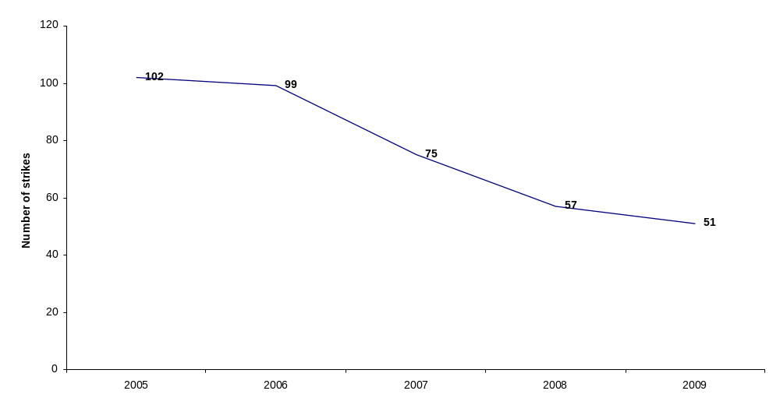
Source: Department of Labour, Strikes Statistics

Figure 2 indicates that strike incidents that occurred in 2009 resulted in 1 526 796 days of idleness. Although these figures are up by 1 029 360 (207.0%) from the previous year, they are low by historical standards. The increase compared to 2008 might be attributed to major labour disputes that affected Road Freight Employers, municipalities, Telkom, South African Post Office, Impala Platinum, Clothing employers etc. Nationwide strikes always account for a higher number of workers involved which results in a higher number of days of idleness. Labour disputes that affected Impala Platinum accounted for about 297 682, followed by the construction strike contributing about 264 654 working days lost, truck drivers’ strike with 108 000 working days lost, South African Revenue Services with about 76 055 working days lost and Emergency Management Services in Johannesburg with 66 906 working days lost.
Figure 2: Working days lost in South Africa, 2005-2009

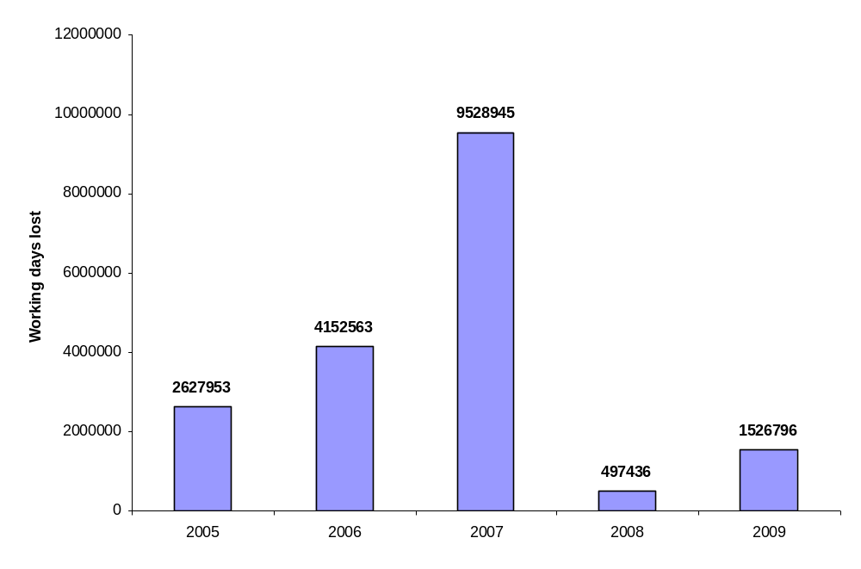
Source: Department of Labour, Strikes Statistics

Figure 3 depicts the rate of days not worked due to labour disputes per 1 000 employees between 2005 and 2009. This is in short called the time-loss ratio. This ratio is closely related to working days lost and total employment in the country. An increase in working days lost whilst employment levels remain the same will lead to an increase in the ratio. On the other hand, an increase in employment levels whilst working days lost remain constant will result in a decrease in the ratio. An increase in the ratio means that there are more and more working days lost per 1 000 employees due to disputes. Time-loss ratio increased from 36 in 2008 to 119 in 2009. This represents an increase of 83 (230.6%) in the ratio between 2008 and 2009. This implies that for every 1 000 employees in 2009, there were 119 working days lost. Although the time-loss ratio has increased in 2009, this still remains low by historical standards.

Figure 3: Rate of days not worked per 1 000 employees, 2005-2009

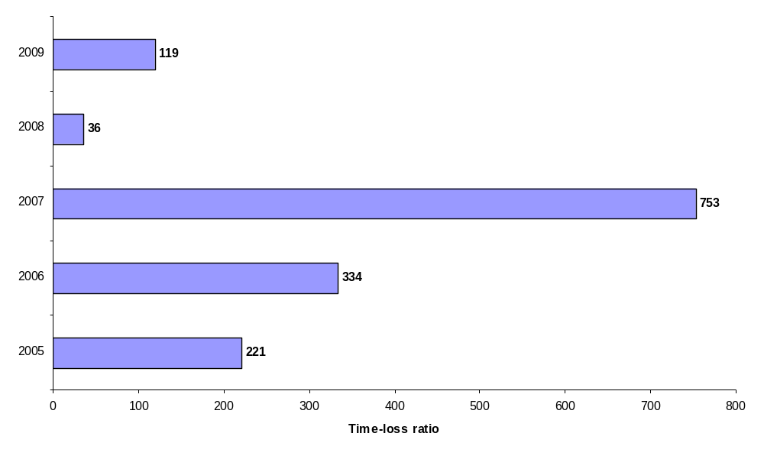
Source: Department of Labour, Strikes Statistics

Although it is common knowledge that work stoppages have various and wide-ranging negative impacts, demonstrating these consequences by hard empirical evidence remains challenging and there is little research in the Department to support any conclusion. It is also recognized that work stoppages have important economic impacts on individual workers and this section will focus on costs on labour. There are three primary ways in which strikes can be costly for labour. First, workers on strike experience lost wages. Striking workers may also lose fringe benefits like health care. The potential for lost wages can be alleviated by income from alternative employment. The potential for lost wages has recently been reduced with increased incidence of dual earner families and liquid financial positions.

A second cost of a strike to labour is union divisiveness. Unless there is strong support for the strike by workers, strikes may increase union divisiveness. Finally, strikes hurt unions by increasing membership loss. Membership is lost in three ways. First, workers could quit the union and return to work. Second, permanent replacements could be hired, and these replacement workers are generally less likely to join the union. Additionally, striking workers may find alternative employment and never return to their old jobs, even when the strike is over. This may lead to calls for de-certification. Figure 4 shows wages lost due to labour disputes. In 2009, approximately R235 458 414 was lost in the form of wages to employees compared to only R47 705 846 in 2008. Wages are lost when employers apply a “no work, no pay” principle.

Figure 4: Wages lost in South Africa, 2005-2009
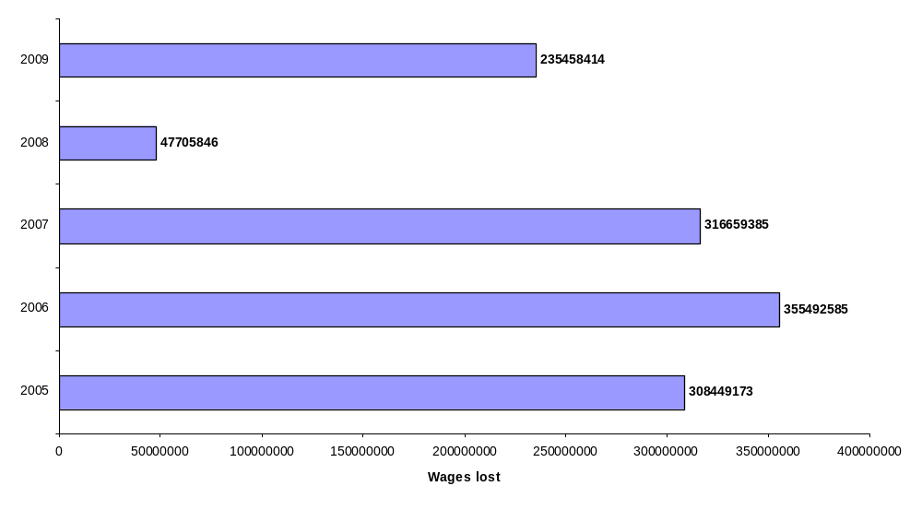
Source: Department of Labour, Strikes Statistics

Chapter Five

Labour disputes comparative analysis, 2008 and 2009

As the global economic crisis took hold in 2009, there were more workers idled because of work stoppages according to data collected by the Department of Labour. Work stoppages idled about 172 772 workers for approximately 1 526 796 working days lost. In 2008, there were 118 979 workers idled for 497 436 working days lost. This section compares the years 2008 and 2009. It focuses on the details of strike incidents by province, industry and nature of strike incidents. Important indicators of strike activity, like working days lost, working hours lost are also described in the report. The section also touches on the reasons for strikes and their determinants.

5.1. Provincial variation in labour disputes

Labour disputes in South Africa are categorized in line with the prescriptions provided by the International Labour Organisation. However, classifying labour disputes by province has proved to be a challenge. This is the case since a national labour dispute affecting companies that have a presence in almost all the provinces will be replicated in all the provinces. Since we have nine provinces in the country, this implies that one national labour dispute involving for instance Pick ŉ Pay will be counted nine times. Hence readers might confuse figures on the number of labour disputes provided in the current section and section four.

Table 1 illustrates the number of labour disputes in both 2008 and 2009. Gauteng has traditionally been plagued by high levels of industrial action in terms of both national and workplace based disputes. About 32 strike incidents were recorded in Gauteng in 2009 as opposed to 20 in 2008. This represented an increase of 60.0% in the number of strike incidents in the province. The annual average strike incident in Gauteng is 26. This might be attributed to high level of diverse economic activities in Gauteng as opposed to some provinces that are dominated by agricultural activities and mining. All other provinces recorded less than nine strike incidents in 2009. The number of strike incidents recorded in the Western Cape remained the same at six. Gauteng further incurred the highest wages lost due to strike incidents.

Table 1: Distribution of labour disputes and wages lost by province, 2008 and 2009

Province | Labour disputes
Province | 2008 | 2009 | % change | Annual average | Wages lost
 |  |  |  |  | 2008 | 2009
Gauteng | 20 | 32 | 60.0 | 26 | 22 879 042 | 107 435 951
Western Cape | 6 | 6 | 0.0 | 6 | 8 116 999 | 15 920 072
Mpumalanga | 6 | 5 | -16.7 | 6 | 163 404 | 8 361 169
KwaZulu-Natal | 9 | 8 | -11.1 | 9 | 2 843 984 | 23 793 533
Eastern Cape | 6 | 8 | 33.3 | 7 | 6 059 281 | 4 861 033
Limpopo | 7 | 1 | -85.7 | 4 | 2 856 745 | 1 094 353
North-West | 2 | 8 | 300.0 | 5 | 3 588 405 | 71 124 162
Northern Cape | 3 | 1 | -66.7 | 2 | 653 662 | 1 950 000
Free State | 4 | 5 | 25.0 | 5 | 544 324 | 918 141
Total | 63 | 74 | 17.5 | 69 | 47 705 846 | 235 458 414
Source: Department of Labour, Strikes Statistics

5.2. Industrial variation in labour disputes

Figure 5 shows the number of labour disputes by industry. Transport, storage and communication recorded the highest level of labour disputes in South Africa. About 11 labour disputes were recorded within this industry, followed closely by mining and quarrying, manufacturing and community, social and personal services industries with 10 disputes each. The agricultural and electricity industries have always recorded the lowest levels of labour disputes. This development might be attributed to the fact that few workers are unionized in the two industries, whilst NUM, SATAWU, SACTWU and CEPPWAWU are more visible in mining and quarrying, transport, storage and communication, manufacturing industry and chemical sector. Comparatively, the community, social and personal services industry, an industry that recorded the highest level of disputes in 2008, experienced a decline in disputes from 20 in 2008 to 10 in 2009, strike incidents in the manufacturing industry also declined from 10 in 2008 to 8 in 2009, in the mining and quarrying industry, labour disputes increased from 7 in 2008 to 10 in 2009.

Figure 5: Distribution of labour disputes by industry, 2008 and 2009

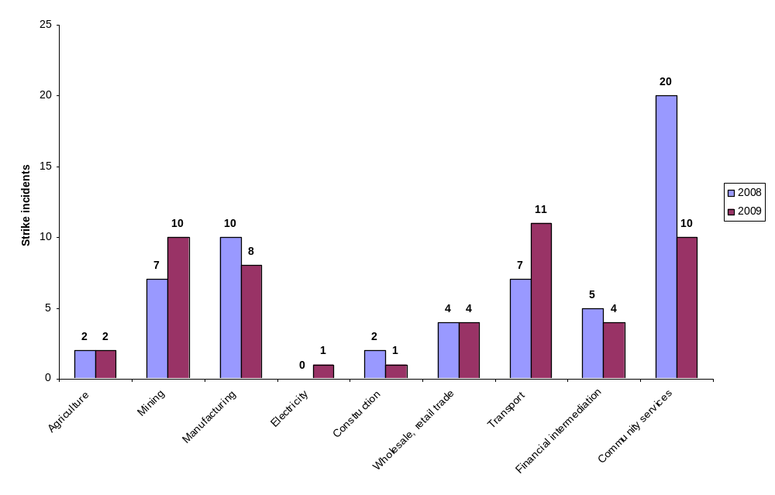
Source: Department of Labour, Strikes Statistics

5.3. Working days lost

Table 2 shows working days lost due to labour disputes by industry. All industries have been affected by one strike or another in 2009, hence the number of working days lost in all the industries. However, those industries that were affected by national strikes or high profile labour disputes accounted for a higher working days lost. One such industry is mining and quarrying with a huge strike affecting Impala Platinum involving more than 20 000 employees and lasting for about 14 days. The very same industry experienced a gold strike affecting Blyvooruitzicht Gold Mining Company Limited and Crown Gold Recoveries (Pty) Ltd. This industry recorded the highest working days lost (413 402) in 2009. This was followed by the manufacturing industry with 317 174 working days lost. The same industry was also affected by high profile strikes in the clothing sector and the chemical and pharmaceutical sectors. The construction sector was also affected by a national strike that led to the loss of 264 654 working days lost. The national strike by truck drivers, Telkom and South African Post Office resulted in the loss of 252 783 working days in the transport, storage and communication industry. The national municipal strike also led to the loss of 215 008 working days in the community, social and personal services industry. Comparing 2008 and 2009, almost all industries except for financial intermediation recorded an increase in the number of working days lost. However, electricity, gas and water supply industry remains with the lowest working days lost, perhaps due to the fact that this is a predominantly essential service industry.

Table 2: Distribution of working days lost by industry, 2008 and 2009

Industry | Working days lost
Industry | 2008 | 2009
Agriculture | 9 081 | 29 760
Mining and quarrying | 82 535 | 413 402
Manufacturing | 72 073 | 317 174
Electricity, gas and water supply | 0 | 47
Construction | 15 415 | 264 654
Wholesale, retail trade | 15 817 | 24 705
Transport | 106 622 | 252 783
Financial intermediation | 13 082 | 9 263
Community services | 182 811 | 215 008
Total | 497 436 | 1 526 796
Source: Department of Labour, Strikes Statistics

5.4. Working days lost per 1 000 employees

Figure 6 shows working days lost per 1 000 employees by industry in both 2008 and 2009. This is called time-loss ratio in short. It is an indicator of strike activity that is useful for comparing different countries over a period of time as employment in each country varies over time. Mining and quarrying industry has consistently recorded a high time-loss ratio over some years. However, in 2009, time-loss ratio in the mining and quarrying industry was unusually high at 1 383. This implies that for every 1 000 workers in the mining and quarrying industry, about 1 383 working days were lost in South Africa in 2009. This consistently high ratio might be attributed to the fact that the Chamber of Mines negotiate with individual employers in the mining and quarrying industry. Negotiations do not take place on a sectoral level. This implies that almost every year there is a wage negotiation in the mining and quarrying industry. In 2009, some gold and coal mines managed to reach wage settlements. Furthermore, the high ratio might be attributed to the decline in employment levels in the mining and quarrying industry. The electricity, water and gas industry recorded the least time-loss ratio as usual, perhaps because this is mainly an essential service industry.

Figure 6: Working days lost per 1 000 employees by industry, 2008 and 2009

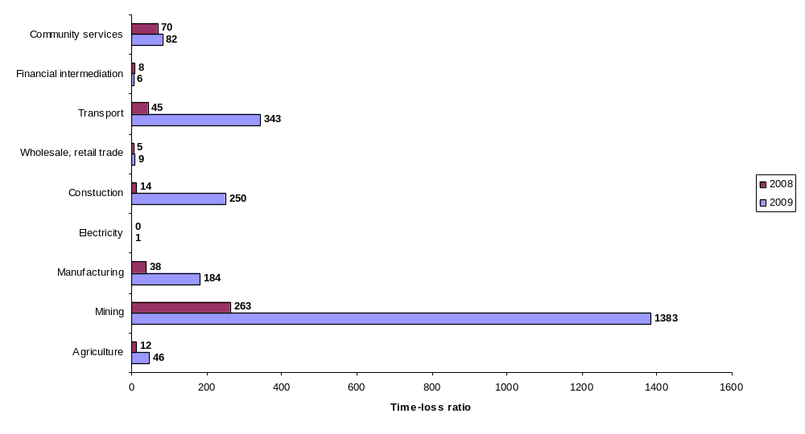
Source: Department of Labour, Strikes Statistics

5.5. Working hours lost

Table 3 depicts the distribution of working hours lost as a result of work stoppages by industry in both 2008 and 2009. Working hours lost is closely related to working days lost in terms of size. An increase in working days lost will lead to an increase in working hours lost. Mining and quarrying accounted for the highest number of working hours lost in 2009. This industry recorded about 2 871 523 working hours lost in 2009 as opposed to 743 935 in 2008. This was followed by manufacturing with approximately 2 448 795 working hours lost, and construction with 2 381 886 working hours lost. This pattern of distribution of working hours lost again might be attributed to high profile and big labour disputes that affected Telkom, South African Post Office, Impala Platinum, national strikes in the Clothing sector, chemical sector, pharmaceutical sector and municipalities.

Table 3: Distribution of working hours lost by industry, 2008 and 2009

Industry | Working hours lost
Industry | 2008 | 2009
Agriculture | 76 563 | 241 560
Mining and quarrying | 743 935 | 2 871 523
Manufacturing | 528 738 | 2 448 795
Electricity, gas and water supply | 0 | 419
Construction | 146 175 | 2 381 886
Wholesale, retail trade | 47 089 | 197 640
Transport | 865 310 | 1 848 214
Financial intermediation | 132 397 | 53 596
Community services | 888 964 | 1 485 182
Total | 3 429 171 | 11 528 815
Source: Department of Labour, Strikes Statistics

5.6. Nature of labour disuptes

Labour disputes take different forms. Some labour disputes cover the whole country, but still affecting one company such as the strike against racism involving Pick ŉ Pay. Whilst other disputes are nationwide covering different companies in the sector like chemical strike that affected Valspar Corporation (Pty) Ltd and Natal Chemical Syndicate (NCS) Resins. Some industrial actions are isolated and affect a specific workplace. Some work stoppages come in the form of stayaways, pickets and employers might also decide to lockout workers.

Figure 7 indicates labour disputes by their different forms. By their very isolated nature strikes that affect a single company at a time are always more than any other form of a work stoppage. Figure 7 reveals that about 19 work stoppages affected one company at a time in 2009 compared to 17 work stoppages in 2008. South Africa experienced about 11 stayaways and protest actions in 2009 as opposed to 17 in 2008. Approximately nine lockouts were recorded in South Africa compared to only 2 in 2008. About 5 multi-employer work stoppages were recorded in 2009 in the country. These are work stoppages that affected the clothing sector, chemical and pharmaceutical sectors, road freight sector and the construction sector. Secondary strikes were also few in 2009.

Figure 7: Distribution of labour disputes by its nature, 2008 and 2009

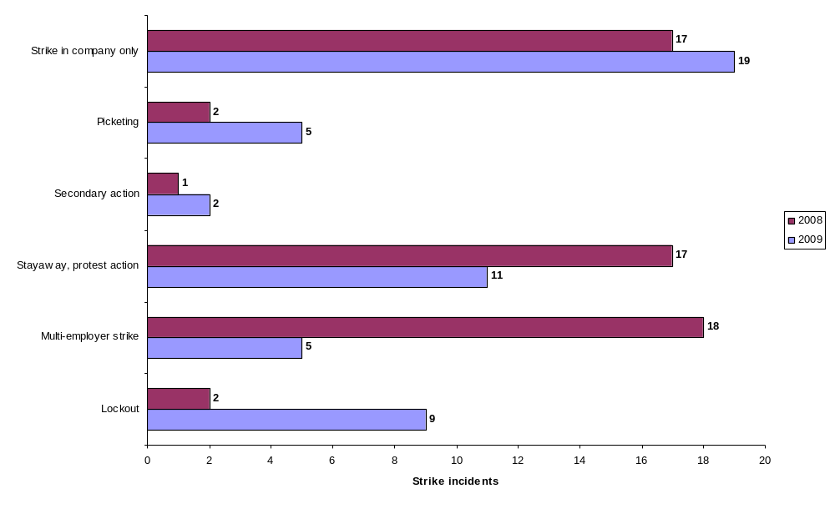
Source: Department of Labour, Strikes Statistics

5.7. Workers involved in labour disputes

A work stoppage sometimes may be classified as high profile due to the number of employees that have participated. National work stoppages like the Impala Platinum strike and the clothing sector strike had a large number of workers participating in them. The Impala Platinum work stoppage had more than 20 000 workers getting involved in the strike. Isolated strikes are small and involve few workers. Figure 8 shows workers involved in labour disputes by industry. In 2009, the construction sector had the highest number of employees involved in labour disputes (40 716), however, that national strike only lasted for 6.5 days. Transport, storage and communication had the second highest number of workers participating in work stoppages. This was as a result of the truck drivers strike, Telkom strike and Post Office strike. All these strikes had some support. Community services and mining and quarrying industries also recorded a huge number of workers participating in strikes. The above-mentioned industries had a high participation of their workers in work stoppages because they are highly unionized compared to other industries. In total, about 172 772 workers participated in work stoppages in 2009.

Figure 8: Distribution of workers involved in labour disputes by industry, 2008 and 2009
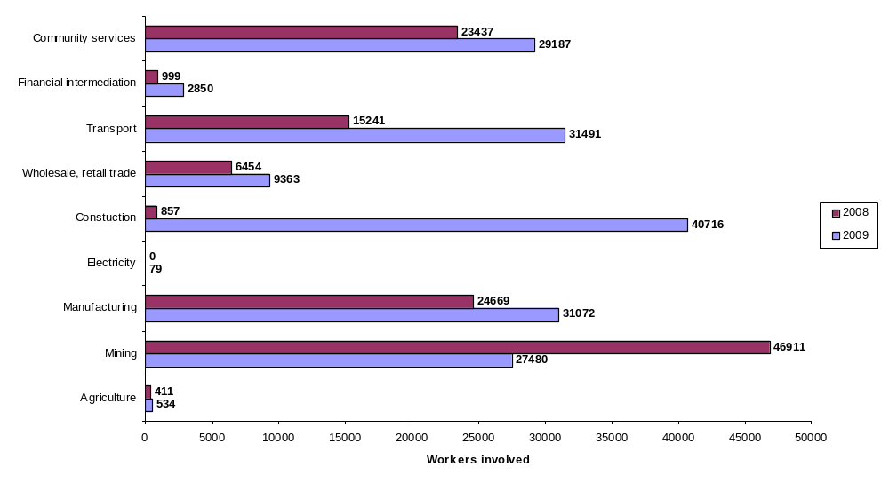
Source: Department of Labour, Strikes Statistics

5.8. Labour disputes by employment size of establishments

Figure 9 depicts percentage distribution of the establishments affected by labour disputes by employment size in both 2008 and 2009. The disputes affected both big and small companies. Impala Platinum with more than 20 000 employees was also affected by a labour dispute in 2009, whilst Lake International in KwaZulu-Natal with less than 50 employees in total was affected by a chemical strike. According to Figure 9, about 23.9% of establishments affected by labour disputes in 2009 had a total workforce of less than 50 employees compared to 9.4% in 2008. Establishments with 1 000 and more employees affected by labour disputes declined in relative terms from 41.5% in 2008 to 13.5% in 2009.

Figure 9: Percentage distribution of establishments affected by labour disputes by employment size, 2008 and 2009

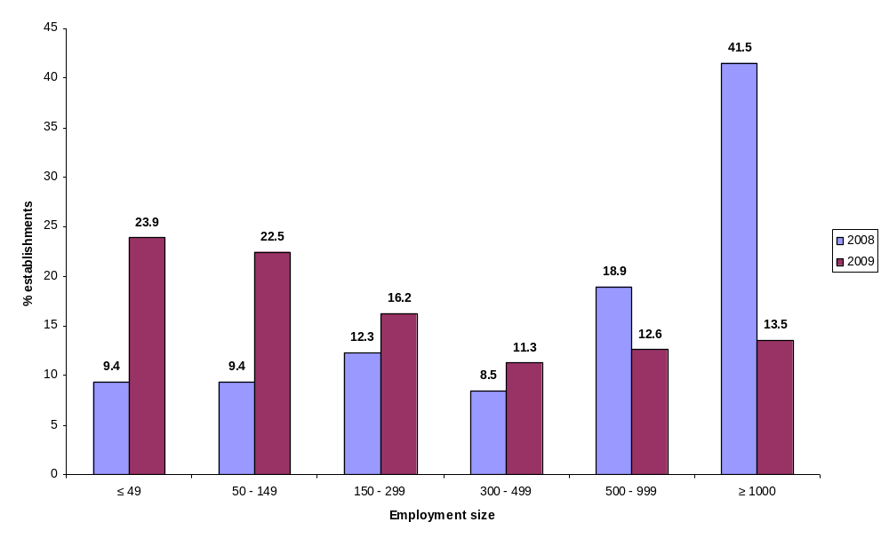
Source: Department of Labour, Strikes Statistics

5.9. Duration of work stoppages

Figure 10 illustrates the percentage distribution of work stoppages by duration in both 2008 and 2009. Most work stoppages (49.1%) lasted between 6-10 days in 2009 as opposed to 9.4% in 2008. Work stoppages that lasted for about 41 days and more declined from about 1.9% in 2008 to 1.4% in 2009. In 2009 there were some work stoppages that lasted long. The work stoppage that affected Employers Organisation of Cephalopod and Associated Fisheries (EOCAF) was the longest in 2009 lasting for about 73 days, followed by the strike that affected Xstrata Alloys-Lion Ferrochrome in Mpumalanga lasting for approximately 66 days. It is difficult to provide concrete reasons for this pattern of duration. Possibly, concessions sought from unions and related security issues were so fundamental that neither side could back down. Better preparation for work stoppages by employers and unions might also have been a factor. Both management and unions might have increased their ability to sustain long work stoppages.

Figure 10: Percentage distribution of labour disputes by duration, 2008 and 2009
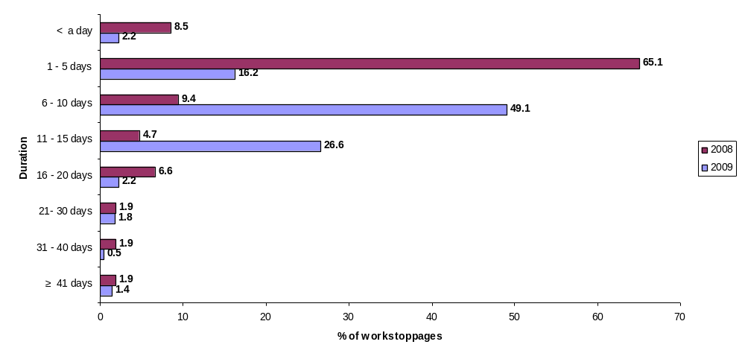
Source: Department of Labour, Strikes Statistics

5.10. Principal cause of strike activity measured in working days lost

The primary reason for striking occurs when labour and management reach an impasse in the collective bargaining process. The work stoppage is a step in this collective bargaining process, if management does not agree to union terms; a strike is one of the possible results. The threat of a strike and the strike itself give the union bargaining power in collective bargaining negotiations. Workers may also go on strike to show management that labour has the power to disrupt production with a work stoppage. Further, a strike can be a therapeutic device for labour to vent frustration and anger. A work stoppage can also give the workers a needed vacation. This is especially useful if labour has been overworked. Additionally, a strike may bring union unity. A dispute with management has the potential to engender unity among the workers. Lastly, a strike may be used to show management that labour resents having to grant concessions to management.

Table 4 illustrates the principal causes of strike activity measured in working days lost in both 2008 and 2009. Wages, bonuses and other compensation have historically been the leading causes of labour disputes and 2009 is no exception. In 2009, disputes related to wages, bonuses and other compensation led to the loss of approximately 1 394 125 (91.2%) working days compared to 217 277 (43.7%) in 2008. This is largely attributed to national strikes that affected municipalities, construction sector, road freight sector, chemical and pharmaceutical sectors and Impala Platinum. About 68 398 (4.5%) working days were lost due to work stoppages related to working conditions in 2009, compared to 10 189 (2.0%) in 2008. Retrenchments/redundancy, refusal to bargain and trade union recognition were no factors in 2009.

Table 4: Working days lost distribution by principal cause of dispute, 2008 and 2009

Principal cause | 2008 | % | 2009 | % | % difference
Wages, bonus and other compensation | 217 277 | 43.7 | 1 394 125 | 91.2 | 47.5
Working conditions | 10 189 | 2.0 | 68 398 | 4.5 | 2.5
Disciplinary matters | 923 | 0.2 | 4 510 | 0.3 | 0.1
Grievances | 55 200 | 11.1 | 39 804 | 2.6 | -8.5
Socio-economic and political conditions | 186 935 | 37.6 | 14 655 | 1.0 | -36.6
Secondary action | 3 042 | 0.6 | 1 665 | 0.1 | -0.5
Retrenchments/redundancy | 615 | 0.1 | 2 631 | 0.2 | 0.1
Refusal to bargain | 4 873 | 1.0 | 0 | 0.0 | -1.0
Trade union recognition | 18 382 | 3.7 | 1 008 | 0.1 | -3.6
Total | 497 436 | 100.0 | 1 526 796 | 100.0 | 0.0
Source: Department of Labour, Strikes Statistics

5.11. Working days lost and trade union movement

Table 5 shows unions by working days lost. Some work stoppages are sanctioned by unions whilst others are not. Those work stoppages sanctioned by unions are in most instances legal. Some of the work stoppages that do not have the support of unions occur while the collective bargaining agreement is in force. A work stoppage under these circumstances could result in management suing the striking union, seeking a court injunction demanding that labour return to work, or firing the striking workers. In 2009, most working days were lost in labour disputes sanctioned by NUM, SACTWU, SATAWU and SAMWU. Work stoppages initiated by NUM accounted for about 537 922 working days lost, followed by SACTWU with 220 985 working days lost, SATAWU with 133 008 and SAMWU with 93 770 working days lost.

Table 5: Distribution of working days lost by trade union movement, 2008 and 2009

Trade union | 2008 |  | 2009
Trade union | Working days lost | % | Working days lost | %
BCAWU | 5 487 | 1.1 | 132 327 | 8.7
BEMAWU | 0 | 0.0 | 3 | 0.0
CEPPWAWU | 11 340 | 2.3 | 50 182 | 3.3
CWU | 12 380 | 2.5 | 82 203 | 5.4
EHCWAWU | 0 | 0.0 | 635 | 0.0
FAWU | 11 325 | 2.3 | 31 555 | 2.1
GIWUSA | 0 | 0.0 | 10 788 | 0.7
ICHAWU | 228 | 0.0 | 0 | 0.0
IMATU | 720 | 0.3 | 55 120 | 3.6
MTWU | 0 | 0.0 | 7 656 | 0.5
MWASA | 0 | 0.0 | 4 | 0.0
NASUWU | 3 484 | 0.7 | 0 | 0.0
NEHAWU | 12 043 | 2.4 | 38 776 | 2.5
WITHOUT UNIONS | 3 566 | 0.7 | 0 | 0.0
NUFBWSAW | 24 | 0.0 | 19 | 0.0
NULAW | 0 | 0.0 | 173 | 0.0
NUM | 113 143 | 22.7 | 537 922 | 35.2
NUMSA | 45 339 | 9.1 | 17 569 | 1.2
PSA | 0 | 0.0 | 38 028 | 2.5
SACCAWU | 13 740 | 2.8 | 27 792 | 1.8
SACU | 10 969 | 2.2 | 0 | 0.0
SACTWU | 0 | 0.0 | 220 985 | 14.5
SACWU | 615 | 0.1 | 1 755 | 0.1
SADTU | 0 | 0.0 | 11 466 | 0.8
SAFATU | 1 332 | 0.3 | 0 | 0.0
SAMA | 0 | 0.0 | 5 845 | 0.4
SAMWU | 164 263 | 33.0 | 93 770 | 6.1
SATAWU | 85 289 | 17.1 | 133 008 | 8.7
SOLIDARITY UNION | 0 | 0.0 | 11 948 | 0.8
TAWUSA | 2 149 | 0.4 | 0 | 0.0
TENUSA | 0 | 0.0 | 749 | 0.1
UASA | 0 | 0.0 | 11 368 | 0.7
UTATU | 0 | 0.0 | 5 150 | 0.3
Source: Department of Labour, Strikes Statistics

5.12. Unionisation rate

Figure 11 shows trends in unionization rate. This represents the percentage of total workers unionized in South Africa. The rate of unionization increased from 24.2% in 2008 to 25.1% in 2009 despite a decrease in trade union membership between 2008 and 2009. According to Department of Labour’s Collective Bargaining statistics, trade union membership decreased by 60 040 from 3 298 559 in 2008 to 3 238 519 in 2009, whilst employment decreased by 770 000 from 13 655 000 in September 2008 to 12 885 000 in September 2009. This is the case since the levels of employment decreased by a higher margin than trade union membership. Therefore, unionization rate continues to rise along with an overall increase in strike activity. The decrease in trade union membership has not yet weakened the union movement as they continue to fight for their members’ wages and living standards. The decline in trade union membership might partly be attributed to job losses and the failure by the trade union movement to recruit young members of the workforce.

Figure 11: Trends in unionisation rate, 2006-2009

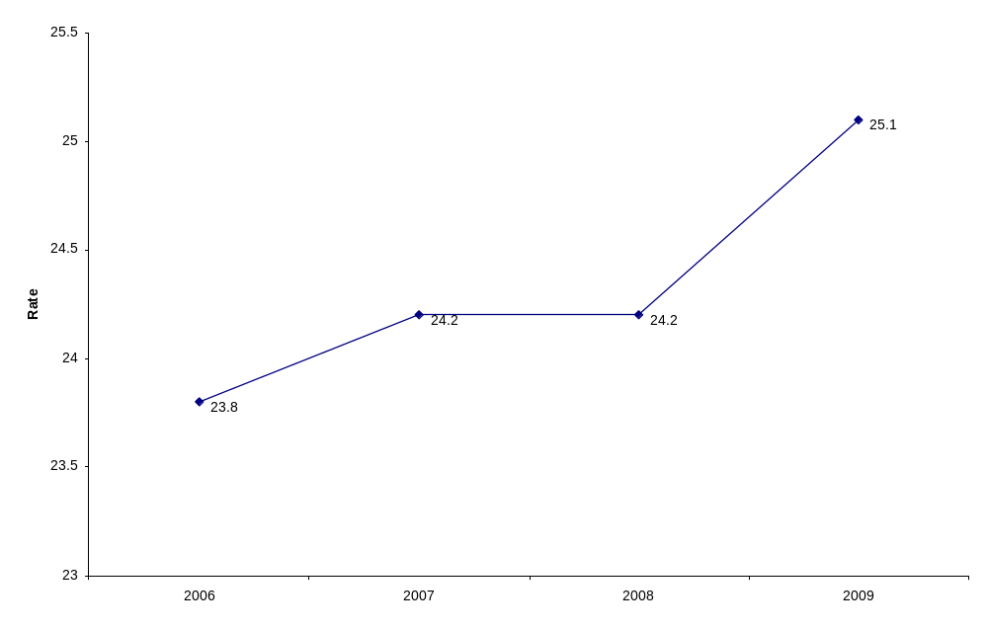
Source: Department of Labour, Collective Bargaining Statistics

4.13. Determinants identified as giving rise to work stoppages in South Africa

It is a challenge to explain the causes of work stoppages because they are, by nature, unique and largely determined by the values and expectations of participants or the unique circumstances in which they occur. Some may argue that work stoppages are not reducible to causal models, since collective bargaining is often far from a rational business process. However, the relationships and attitudes that stakeholders bring to the table play a significant role in determining whether bargaining will lead to an agreement. The motivation to build relationships can, over time, foster the development of constructive practices that help parties resolve their differences. In contrast, long standing adversarial relationships and the absence of common understanding or shared experience, normally reflect that parties have not developed the right attitudes to overcome their differences, to manage their conflicts or to arrive at solutions that build on shared interests or accommodate opposing ones. Hence developing good relationships between workers and management will help reduce work stoppages.

Changes in attitudes do not arise out of thin air. While adversarial labour-management relationships may have their genesis from the inherently conflictual nature of the parties’ interests, those beginnings do not necessarily determine the final outcome of their dealings. Union-management relationships have traditionally been characterized by disputes over wages and benefits, a well-developed grievance procedure, strong adherence to seniority, and restrictive work rule and job classification procedures. They have been typically adversarial and power-oriented with both parties viewing their relationship as distributive and accepting the notion that management is responsible for increasing the organisation’s wealth, whereas unions’ responsibility is to bargain on behalf of employees for a share of that wealth, including productivity bargaining. While there has been progress made towards changing this traditional relationship, it continues to characterize most industrial relations in South Africa and affects the determinants of work stoppages. In this case, one would see work stoppages as a manifestation of collective resentment. Distrust and resentment is almost always present in the workplace.

The recent case in point was the on-and-off illegal strike by members of SAMWU at the Tshwane Metropolitan Council. On 11 February 2009, about 100 SAMWU bus drivers and support staff embarked on impromptu industrial action which disrupted bus services for the rest of the day. Allegations of incompetence and racism were leveled against management at the Tshwane Metro’s bus depot in Church Street. According to the municipality the shop stewards listed among their grievances non-procedural suspension of bus drivers, non-procedural charging of bus drivers; problems at the workshop including a “whites only” toilet; problems with the cleaning company that was allegedly ill-treating employees; and employment of bus drivers on contract basis. SAMWU called for the immediate removal of a manager at the planning office because he apparently had a bad attitude, was unable to communicate properly; was incompetent; was a racist; and because of the manner in which he allocated shifts. On 16 April, 28 April and 16 November 2009, the illegal strike recurred for the same reasons with SAMWU further accusing management for not honouring their promise. Indeed this is an example of a bad working relationship, and it will be difficult for the two parties to trust each other.

Another case was the uncoordinated illegal strike by doctors, nurses, dentists, emergency service workers, teachers and prison warders. The illegal strike that started on the 16 April 2009 at George Mkhari Hospital in Garankuwa followed the failure of the implementation of the Occupation Specific Dispensation by government by July 2008. This labour dispute was badly handled by both the government and unions involved. At one stage some doctors felt the South African Medical Association was not representing their interests and decided to break away and formed their own union. This shows incompetency within the union leadership, whilst at the same time emphasizing that government cannot be trusted.

Adversarial relationships can also reflect questionable intentions. Employers may act in a disrespectful but contemptuous fashion, reflecting the anti-union animus that can, in some cases, motivate their actions. Some union representatives reported in the media instances where employers attempted to deliberately sabotage relationships and have them destroyed. Unions can also be unhelpful if their negotiators approach bargaining with doctrinaire views or overly politicized values. This can result in similar over-arching negative attitudes towards all employers, and the employment of unnecessarily adversarial bargaining tactics. In addition, strikes may be used “to establish or enhance reputations for subsequent rounds of bargaining” or “by union leaders to solidify the rank and file, to find out what they really want and are prepared to give up or to lower their expectations as the strike runs its course”. Identifying measures to change such attitudes should be approached carefully, since they are prone to result in intractable situations. However, since there appears to be nothing in South Africa in the way of research attempting to correlate relationships between work stoppage incidence and duration, there is a need to fill this knowledge gap. Multivariate analysis of some relationship-related issues needs to be done. More research is required in this area since some experts have long trumpeted integrative bargaining and collaborative relationships as the direction that unions and management should be pursuing to achieve a less adversarial workplace and better collective bargaining results.

5.14. Work stoppage future outlook, 2010

The economy is gradually but slowly recovering as third quarter figures from Statistics South Africa reveal that real GDP at market prices increased by 0.9% quarter-on-quarter, seasonally adjusted and annualized (Stats SA, P0441:4). Although the economy is out of recession, workers will continue losing their jobs as the effects of the recession will be with us for some time. Workers might rather decide to protect their jobs rather than going on strike during this difficult time. Inflation rates remain particularly important if the theory that work stoppages are caused by instabilities such as prices is true. Higher inflation correlates with increased work stoppage activity as workers demand higher wages when the prices of goods and services rise, whilst lower inflation correlates with decreased work stoppage activity, as the demand for higher wages cannot be justified on the basis of lower prices. However, figures from Statistics South Africa indicate that headline CPI (for all urban areas) annual inflation rate in November 2009 was 5.8%. This rate was 0.1% of a percentage point lower than the corresponding annual rate of 5.9% in October 2009 (Stats SA, P0141:2). This is well within government’s target of 3%-6%. The fact that there were a number of wage agreements concluded in 2009, e.g. in the clothing sector, municipal sector, construction sector and some coal, platinum and gold sectors and the road freight sector might imply that the country is less likely to experience an upsurge in strike activity in the future. It is against this background that we predict less strike activity in 2010 than 2009.

Chapter Six

Conclusion

Although 2009 was a year with a high strike activity compared to 2008 and that a number of major labour disputes during that time attracted significant media attention, either because the disputes were sufficiently large or because the protagonists brought the disputes to the attention of the public, South African employers and employees have proven their increasing capacity to work together at the workplace level without resorting to strikes, bans and go-slows. This is attested to by the number of wage agreements concluded without resorting to strike first. These include wage agreements in the grain sector, the agreement between NUMSA and SEIFSA, the agreement in the petroleum sector, the agreement in the coal and gold sectors and the agreement between NUM and Anglo Platinum.

Bibliography

Barker, et al (1996), South African Labour Glossary, Cape Town: Juta & Co Ltd.

ILO (1993 Bulletin of Labour Statistics 1993-2, Annex I, XI

Statistics South Africa (2009), Consumer Price Index, November 2009, P0141:Pretoria

Statistics South Africa (2009), Consumer Price Index, September 2009, P0141:Pretoria

Statistics South Africa (2009), Gross Domestic Product, Second Quarter 2009, P0441:Pretoria

Statistics South Africa (2009), Gross Domestic Product, Third Quarter 2009, P0441:Pretoria

Annexure A

Data Appendix

The following two supplementary tables contain data not included in the main report:

Table A1: Number of workers involved, working days lost and working hours lost by Industry/sector, 2009

Industry/Sector | Workers involved | Working days lost | Working hours lost
Manufacturing | 31 072 | 317 174 | 2 448 795
Basic metals, fabricated metal products, machinery and equipment | 429 | 3 835 | 23 131
Coke, refined petroleum products and nuclear | 8 975 | 73 746 | 572 609
Food products, beverages and tobacco products | 551 | 5 129 | 43 277
Textile, clothing and leather goods | 19 736 | 218 915 | 1 689 131
Transport equipment | 390 | 6 630 | 53 040
Wood and products of wood and cork | 991 | 8 919 | 67 607
Community, social and personal services | 29 187 | 215 008 | 1 485 182
Education | 2 636 | 12 963 | 109 692
Health and social work | 618 | 5 845 | 46 760
Recreation, cultural and sporting activities | 240 | 638 | 5 175
Public administration and defence activities | 25 693 | 195 562 | 1 323 555
Mining and quarrying | 27 480 | 413 402 | 2 871 523
Coal and lignite | 58 | 2 204 | 19 836
Gold and uranium ore | 4 944 | 87 465 | 662 864
Metal ores except gold and uranium | 22 478 | 323 733 | 2 188 823
Wholesale and retail, repair of motor vehicles | 9 363 | 24 705 | 197 640
Wholesale and commission trade, except of motor vehicles and motor cycles | 1 240 | 14 880 | 119 040
Retail trade, except of motor vehicles and motor cycles of personal household goods | 8 123 | 9 825 | 78 600
Agriculture, hunting, forestry and fishing | 534 | 29 760 | 241 560
Agriculture, hunting and related services | 174 | 3 480 | 31 320
Fishing, operation of fish hatcheries and fish farms | 360 | 26 280 | 210 240
Transport, storage and communication | 31 491 | 252 783 | 1 848 214
Air transport | 802 | 16 176 | 84 455
Land transport, transport via pipelines | 22 134 | 149 352 | 1 045 030
Post and telecommunications | 7 546 | 82 210 | 678 369
Public transport | 1 009 | 5 045 | 40 360
Financial intermediation, insurance, real estate | 2 850 | 9 263 | 53 596
Activities auxiliary to financial intermediation | 127 | 635 | 5 940
Security services | 2 552 | 7 656 | 36 000
Hotels and Restaurants | 171 | 972 | 11 656
Construction | 40 716 | 264 654 | 2 381 886
Electricity, gas and water supply | 79 | 47 | 419
Source: Department of Labour, Strikes Statistics

Table A2: Number of working days lost by nature of organization, 2009

Nature of organisation | Working days lost
Government enterprise | 91 385
Local government general | 150 914
Private sector | 1 267 186
Provincial government general | 17 311

ANNEXURE B

B: Methodology for monitoring industrial action

B1. Introduction

The collection and analysis of industrial action statistics is guided by the guidelines and practices that have been developed by the International Labour Organisation (ILO). The point of departure can be found in the ILO Resolution adopted by the Fourteenth International Conference of Labour Statisticians in January 1993, concerning statistics of strikes, lockouts and other action due to labour disputes. This resolution is accommodative rather than prescriptive in its approach. It states that; “Each country should aim at developing a comprehensive programme of statistics of strikes, lockouts and where relevant other action due to labour disputes in order to provide an adequate statistical base for the various users, taking into account the specific national needs and circumstances” (ILO Bulletin of Labour Statistics, 1993-2, Annex I, XI). The Department has been provided with a legislated instrument {Form Labour Relations Act {LRA} 9.2} to collect data on labour disputes.

B2. Definitions

Section 213 of the Labour Relations Act, 1995 provides the following definitions:

A strike:

The partial or complete concerted refusal to work, or the retardation or obstruction of work, by persons who are or have been employed by the same employer or by different employers, for the purpose of remedying a grievance or resolving a dispute in respect of any matter of mutual interest between employer and worker, and every reference to work in this definition includes overtime work, whether it is voluntary or compulsory (s 213).

A lockout:

The exclusion by an employer of workers from the employer's workplace, for the purpose of compelling the workers to accept a demand in respect of any matter of mutual interest between employer and worker, whether or not the employer breaches those workers' contracts of employment in the course of or for the purpose of that exclusion.

A protest action:

The partial or complete concerted refusal to work, or the retardation or obstruction of work, for the purpose of promoting or defending the socio-economic interests of workers, but not for a purpose referred to in the definition of strike".

Barker, F et al (1996) in “South African Labour Glossary” defined the following concepts as follows:

Picketing:

Action by employees or other persons to publicise the existence of a labour dispute by patrolling or standing outside or near the location where the dispute is taking place, usually with placards indicating the nature of the dispute. The aim of picketing might simply be to communicate the grievance to the public or it might be to persuade other employees in that workplace not to work and to take their side in the dispute, to deter scab labour, to persuade or pressurise customers not to enter the workplace, to disrupt deliveries or drum up public support.

A secondary strike:

A strike in support of a strike by other employees against their employer. The strikers have no issue with their employer, but that employer might be in a strong position (due to there being a close business relationship as either an important customer or supplier) to pressurise the employer who is in dispute.

Stayaway action:

Industrial action by a group of employees in the form of absenting themselves from work without permission in support of some socio-political or socio-economic issue which does not relate to their employment situation.

Work stoppage:

A collective refusal to work which is not linked to a demand or, if so, such demand is not related to the employment relationship.

Industrial action:

Action by unions, employees to pressurise the other party in the furtherance of an industrial dispute. It usually refers to strikes and lockouts but could also include picketing, product boycotts, sit-ins, go-slow strikes and other actions which disrupt the production process.

Work hours:

Those hours during which an employee is obliged to work.

B3. Coverage

Data collection attempts to cover the entire country, all economic activity and all sectors of the economy, legal and illegal industrial action. The system attempts to cover all industrial action due to labour disputes. The figures in this report are inclusive of all industrial actions which come to the knowledge of the Department, and the methods taken to secure information practically preclude probability of omissions of a serious nature. This is a painstaking exercise, and it is believed that the statistics indicates the conditions of labour disputes in the country with reasonable precision. Since LRA Form 9.2 has been redesigned, the Department is now in a position to cover employees both directly and indirectly involved in industrial actions separately, that is, those who participate directly or indirectly by stopping work. Workers absent from their normal place of work at the time of a strike or stoppage, for reasons such as sick-leave, vacation, business or personal reasons, whether authorised or unauthorised, are excluded from participation in industrial actions and are therefore not counted.

The LRA excludes independent contractors from the definition of employee. The LRA further excludes from the scope of coverage certain categories of workers, namely members of the National Defense Force, National Intelligence Agency and South African Secret Service. The coverage by the Department of industrial action, however, includes all of the above, provided they embarked on an industrial action in the period under consideration.

B4. Data collection

In addition to the legal obligation on employers to report industrial action, the Department has introduced an active media monitoring programme. Through this system, media information on industrial action is used to make contact with employers and to encourage voluntary compliance with reporting requirements. Telephone and telefax communication with affected employers ensure a reasonably accurate coverage of all industrial action.

The cooperation of private sector employers also speeds up the process of data collection. After completing the form, most employers send it to the Head Office of the Department. Some employers keep blank forms with them to complete and when an industrial action arises they voluntarily complete the forms and send them to the Department.

After receiving the form either directly from the employer or from the provincial office, Head Office staff members check the form to assess if the information provided is sufficient. If the information is insufficient, Department of Labour staff contact employers with the aim of getting relevant information, after which the data is captured on a database specifically designed for monitoring industrial action. The form is designed for workers who are both directly and indirectly involved in the industrial action, excluding all those who are on leave. The method of data collection and processing has remained the same ever since. The Department has to rely on the employers affected by disputes for detailed information on such matters as size, length, reason given for striking, etc., which it requires for its records as required by the 1995 Labour Relations Act. No attempt is made to contact other parties to disputes, e.g., unions to verify the information that has been supplied by employers. Hence at this level, employers constitute a principal source of strikes data.

B5. Calculations

Working days lost

All calculations are made on the basis of information recorded on the LRA Form 9.2. After capturing the data, the loss of working days is calculated by multiplying the number of workers involved in each stoppage by the duration of the stoppage in days lost and adding the totals for all stoppages during the reference period. For example, if during the reference period there is one stoppage, involving 2 000 workers and lasting three days, working days lost would be computed as follows:
- 2 000 workers x 3 days =6 000 working days lost

Working hours lost

Working hours lost are the aggregate number of working hours lost stemming from all work stoppages during the reference period. The statistic is calculated by multiplying the number of workers involved in each stoppage by the number of hours of the stoppage and summing the products thus obtained for all stoppages during the period. For example, if during the reference period there is one stoppage, involving 2 000 workers and lasting three hours, working hours lost would be computed as follows:

- 2 000 workers x 3 hours = 6 000 working hours lost

Estimated working time is computed by multiplying the employment for the period by the number of days typically worked by most employed workers during that period. In some cases, Saturdays (when customarily not worked), Sundays, and established holidays are excluded. It is also to determine the normal hours of work for groups of workers since LRA form 9.2 provides for this. An average eight hour day is used to represent the normal working day in the country.

Time- loss ratio

This is the number of working days lost due to industrial action per 1 000 employees. It is the standard method that has been used to convert working days lost into a strike rate that takes account of the size of total employment. This also enables comparisons to be made across industries and provinces that differ in employment size. For example, a country with 12 488 000 employees and loosing 1 662 000 working days will have a ratio of 133 arrived at as follows: 1 662 000/12 488 000 x 1 000

Measurement

The criterion used to identify a single strike, lockout, stoppage or protest action, is the industrial action in question. The following is, therefore, used to denote one industrial action:

- a temporary work stoppage, due to one industrial action, occurring among workers in one establishment at one time;
- temporary work stoppages, due to one industrial action, occurring among workers in several establishments at the same time;
- temporary work stoppages, due to one industrial action, occurring among workers in one establishment at different times, in which the period between stoppages is not more than two months; and
- temporary work stoppages, due to one industrial action, occurring among workers in several establishments at different times, in which the period between stoppages is not more than two months.

While attempts to satisfy the ILO requirements are made, the instrument of data collection (LRA Form 9.2) served as the point of departure in order to meet the specific needs of the Department.

It should be emphasized that the chronological list of incidents of labour disputes in Chapter 2 should not be confused with the quantitative data in Chapters 4 and 5. Chapter 2 covers all disputes, including those that are pre-arranged between management and employees like cases related to the mourning of the death of miners at the workplace. This Chapter also includes protest actions and pickets during lunch-hours and after hours. It also includes protests by workers who were on leave. In all these cases, employers are not expected to submit completed LRA 9.2 Forms, since there can only be a recognized industrial action during office hours and by workers who are expected to be at work. Hence, these cases would not form part of chapters 4 and 5. The consent of employers on whether an incident is a strike or not is always important to consider before we sent a form to the employer affected to complete. Chapters 4 and 5 deal specifically with those incidents where forms were completed and sent to the Department for capturing. Some industrial actions do not come to the knowledge of the Department’s officials; however, since employers are expected to complete the LRA 9.2 Form after been affected by a dispute, some employers do complete LRA 9.2 Form and send it to the Department for capturing even without the knowledge of the officials. This implies that this kind of a dispute will not be recorded in Chapter 2 since it was not identified by departmental officials.
The total for strike incidents in 2009 in Table 1 differs from the total of 51. This is due to national strikes that may affect a number of branches or establishments in the nine provinces, being counted as one in the national total but according to workplaces affected in several provinces being counted more than once.
Annual averages have been rounded to the whole number since we cannot have half a strike incident.
Stats SA’s Quarterly Labour Force Survey remains the source for employment statistics.

