Education Roadmap

Focus on schooling system

(November 2008)

Narrative report July 2009
Roadmap process

Phase 1: Diagnose the status of the Education schooling system

On 25 July 2008, a broad stakeholder group met at DBSA under the guidance of Jay Naidoo (DBSA chair), Zweli Mkhize (ANC Education and Health subcommittee) and Naledi Pandor (Minister of Education). The aim was to agree on a process to draw up a roadmap for education (to parallel the health process running concurrently in DBSA).

The roadmap identifies achievements that can be built on, blockages (or problems), and interventions that are institutionally feasible in terms of the time and cost of implementation. The roadmap prioritises public schooling: i.e. the General Education and Training Band (GET Grades R to Grades 9) and Further Education and Training Band (Grades 10 to 12). The roadmap was intended to emerge out of a consultative process and the process to date is described below.

The stakeholders participating include SADTU, NAPTOSA, ANC NEC sub-committee on Health and Education, the Minister of Education, National Department of Education, provincial departments, DBSA, School of Education (Wits), CEPD, EPU, National Treasury, academics, NGO’s and training institutions.

A tight and consultative process was followed: Two subgroups met on 22 August 2008 to prepare inputs for the broader diagnostic workshop, each with about a dozen members. A discussion document captured the inputs from the two subgroups’ deliberations. Two drafts of this discussion document were circulated within the DBSA working group on 26 of August and 15 September 2008 respectively. Two technical meetings were held on 19 September 2008 and 20 October 2008 (which included members of the two subgroups) and input was added to the preparation of the discussion document for the consultative meeting on 7 November 2008.

The considerable achievements in the transformation of education in South Africa are acknowledged, as these have begun to make a dent in redressing some of the inequalities that we have inherited from the past. The purpose of this roadmap process was to identify the gaps, and build on the gains made in the last fifteen years of democracy in South Africa.

It must be said that many of the Department of Education’s (DoE) policies are in place, as well as the logistical capacity to deliver on large-scale exercises such as the national matriculation examinations.

Important achievements since 1994:
- Access to primary and secondary schooling improved to near universal enrolment. The participation rate among girls is also among the highest in the world.
- Numbers of pupils that have progressed to higher levels of schooling have increased significantly from 1994.
- Access to school education was further enhanced by exempting poor learners from paying school fees and outlawing discrimination against, and exclusion of, learners who cannot afford school fees.
- The Matriculation pass rate increased from 58% in 1994 to 65% in 2007.
- Pupil-to-teacher ratios have improved from 43:1 (1996) to 32:1 (2006).
Phase 2: Identify reasons for the current education outcomes

Notwithstanding these gains in post-apartheid South Africa, education is not performing at the levels required to effect large-scale redress. The problems in the public schooling system impact negatively, especially on poor and working class children and families. The severity of public schools’ underperformance is confirmed in the diagnostic attached.

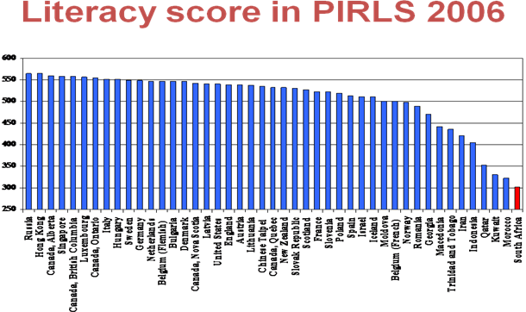

South Africa has the lowest score in the Progress in Reading Literacy Study 2006 (PIRLS). This is despite the fact that SA tested Grade 5 learners against Grade 4 in other countries. (SA learners were a full year older than those in other countries, yet they failed to perform.) SA is 2 standard deviations below the norm, which is extremely poor. The test is completed in the home language: 72% wrote in an African language. The average achievement for SA was significantly lower than every other country assessed.

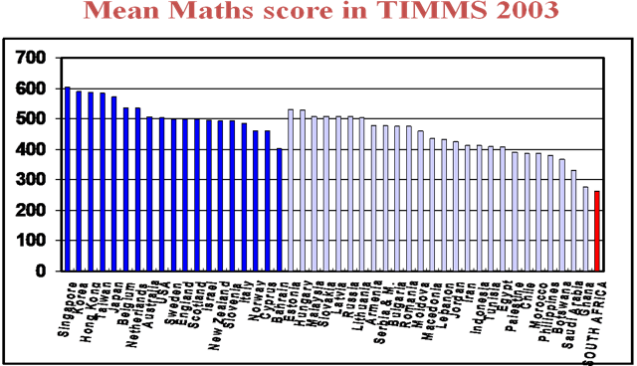

Ranked against 46 countries, South Africa’s mean Grade 8 maths score is the lowest. While, the study includes both developed and emerging countries, South Africa must be internationally competitive and should be ranked on a global basis. On the science scores, South Africa is only better than Ghana.

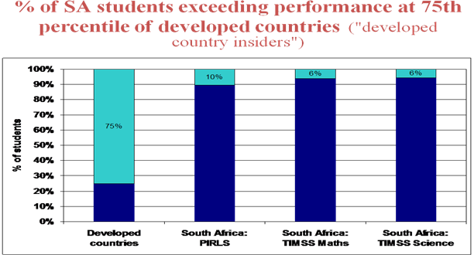

This graph seeks to answer the question: “How many South African students would be performing at the same standard as the top 75% in developed countries?” Only 10% of SA students match the developed countries’ top 75% in literacy. This falls to 6% for both maths and science. From a labour market point of view, South Africa lies far behind global counterparts.

The results imply that South Africa will continue to experience a skills shortage. Only 1 in 40 children who started school in 1995, passed maths at the higher grade level in matric, while 93% of maths passes came from only 21% of schools. Poor maths results also affect key economic skills, such as engineering. It should be noted that South Africa has approximately 30 engineers per 100,000 people compared to 255 in the US and 340 in Australia. This skills shortage will result in a binding constraint on growth and employment creation.

Some concerns exist around the class of 2010. When this class (now in Grade 10) was in Grade 3 in 2001, the average literacy score was 30%. In 2007, the average score in the Grade 3 test was 36%, but only 15% of children passed both numeracy and literacy. This raises serious concerns regarding teaching and learning (and ‘OBE’) in primary schools.

The current interventions by the Department of Education are as follows:

Early Childhood Development (ECD)
Development during the formative years is critical for optimal education outcomes. The target set out in Education White Paper is to reach full coverage of Grade R (age 4-5) by 2010, with 85 % of provision located in public primary schools and 15 % through community sites. The coverage is currently 70%.

Target population (100%) is 990 000.
- 424 000 Grade R learners in public ordinary schools
- 17 000 Grade R learners in independent schools
- 290 000 learners in community centres

The cost of ECD is R686 per child per year, however this “holds significant quality risks” (Review of National Policies for Education: South Africa, OECD, Sept 2008).

Further Education and Training (FET)
While ‘unitech’ enrolments have grown from 57,000 in 1988 to 400,000 in 2007, enrolment and the rate of graduation has been declining in crucial fields such as engineering. For many years there was confusion over the status of apprenticeship training in South Africa: from 2001-2006, SA produced an average of 5,600 artisans a year compared with the annual need for 12,500 artisans. This has resulted in a large artisanal deficit.

Previously FETs (technical colleges) worked in tandem with employers as vocational training, and employers sponsored students. This link has weakened since the 1990s and a graduate from an FET college has about a 30% chance of getting a job.

Higher education institutions (HEI)
More students have been registered and the HEIs have been recapitalised, but student readiness is a concern. An early focus post-1994 was on the massification of HEIs due to a high (75%) participation of white students in 18-25 age group and a low (5%) participation rate for black students. Headcounts have increased from 473,000 in 1994 to 737,000 in 2005. Since 2004, 30% of students have received financial aid from the state.

The number of HEIs was reduced from 36 to 23. A focus was placed on increased capital investment in historically black institutions as well as more effective financial management. However dropout rates remain high (50% over first 2 years), and only 22% of students finish three-year degree in three years. This implies that student intake is a problem: the HEIs are carrying a lot of weight.

More focus on academic-support programmes to compensate for schooling deficiencies is required.

Key priorities of the Department of Education in 2008 are:
- The ongoing implementation of the National Policy Framework for Teacher Education and Development in South Africa
- The ongoing implementation of the Revised National Curriculum Statement
- Teacher and principal training
- Teacher-training bursaries to encourage new entrants to join the profession
- Growing the number of Dinaledi high schools, currently 488 such schools prioritise mathematics, science and literacy
- The roll out of information management systems (EMIS, DEMIS, LURITS, Education HR MIS)
- The roll out of the Integrated Quality Management System
- The intention to supply two computers per school (and/or one laptop per teacher) to allow for the electronic distribution of information
- The roll-out of the Thutong information electronic portal which is intended to support the electronic distribution of, for example, learner support material and professional development materials
- Improvements to school infrastructure
- Literacy and numeracy in primary schools through the ‘Foundations for Learning’ Campaign.

Fundamental challenges which remain

- Socio-economic status

A factor which hinders educational advancement is social disadvantage. The level of parent education and socio-economic status are strong predictors of educational outcomes, thus limiting inter-generational social mobility. There is a power differential between poor parents and their children’s teachers thus limiting teacher accountability and proper functioning of School Governing Bodies (SGBs).

Poor parents face an information vacuum due to the absence of external exams prior to grade 12. They are not in a position to judge how well their children are learning until it is too late. In addition, many learners are single or double orphans, victims of violence or face other traumas which affect learning.

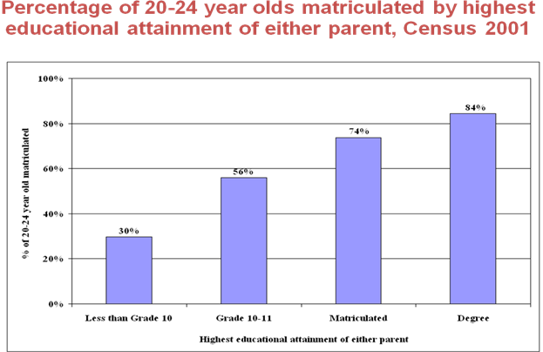

Of children with at least one parent who has attained less than Grade 10, only 30% gain a Matric. This rises to 56% where one parent has Grade 10 or 11, 74% where a parent has matriculated and 84% if a parent has a degree. This implies that the more parents understand about education, the more they value it and create a conducive environment for education, the more learning takes place.

- Teachers

School-level continuous assessment (CASS) compared to exam marks for Maths HG 2005:
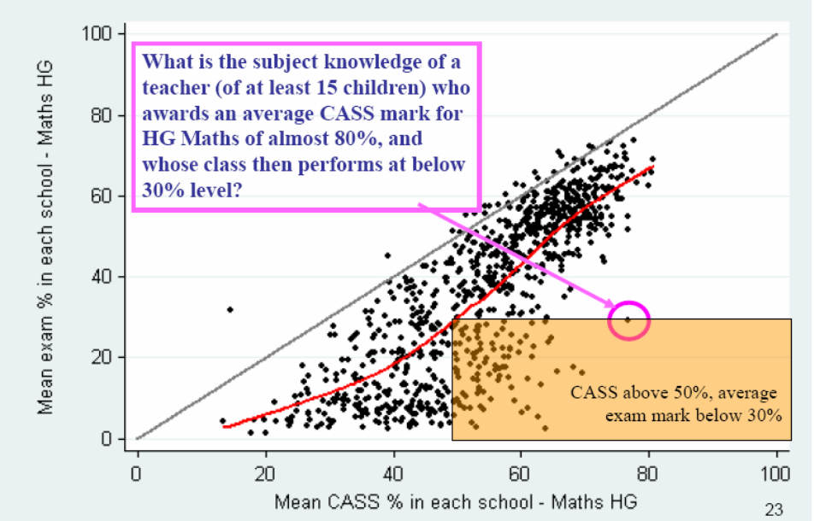

Most continuous assessment scores (for schools with at least 15 children learning HG Maths) fall short of the exam result. This means that teachers are not accurately assessing learners; the subject knowledge of teachers is poor; learners have no mechanism for benchmarking themselves and are thus unable to improve their results; parents receive inadequate feedback; and systems to support teacher assessment are needed, for example common assessment instruments.

Teacher knowledge has been called into question. A baseline survey conducted in 2004 assessed the knowledge of a sample of Grade 3 teachers drawn from 24 primary schools selected at random. A literacy test and a mathematics test (Grade 6 learner level) were administered. The average score on the language test for 23 teachers was 13 correct responses out of 24 items (55%). The majority of teachers scored between 7 and 12 marks out of a possible 24 (29%-50%). (Taylor et al, 51: 2008. Office of the President, 15-year review input paper.)

The same survey has identified teaching practices as problematic:
- “One of the most disturbing findings was that, although books were available for both language and maths in all but two of the schools, no books were seen being used in 43% of language classes and 69% of maths classes.”
- “The most common form of reading in these classes consisted of teachers writing 3 or 4 sentences on the board and then leading the reading of these, with children following in chorus.”
- “When faced with these practices, it is no wonder that South African children are not learning to read.”
- “Similarly, an examination of the books of these children revealed that in the majority of classes children engage in writing exercises no more than once a week. What little writing is done consists predominantly of exercises composed of isolated words; sentences are seldom seen, while longer passages are virtually non-existent. “
(Taylor et al, 49: 2008. Office of the President, 15-year review input paper)

These issues point to the quality of teaching as being central to the crisis in education. The problem of subject knowledge is even more serious issue than under-qualifications. It has been surmised that some teachers may be encouraging pupils to take lower-level (easier to teach) subjects. As a result, effective teacher development is critical.

In addition to the problem of quality teaching, the quantity of teachers emerges as presenting challenges too. There are 386,000 teachers, with most of them having been trained prior to 1994. Post-1996, voluntary severance packages offered by the state led to many skilled teachers leaving the profession. There is likely to be a shortage of teachers in the future, based on the anticipated effects of:
  - –the impact of HIV and Aids on educators
  - –fewer candidates entering the teaching profession
  - –attrition rates among educators as a result of factors other than HIV and AIDS

With the change from teacher training colleges (often sub-standard) to universities, the number of teacher graduates has fallen from 70,000 in 1994 to 6,000 in 2006 (one-third of whom do not intend to teach in SA). The teacher attrition rate is currently estimated at between 17,000 and 20,000 teachers who are lost to the system each year.

Poor teacher remuneration accounts for some of the loss. The following graph shows the monthly pay of teachers relative to other employees with tertiary qualifications, in 2000 prices:
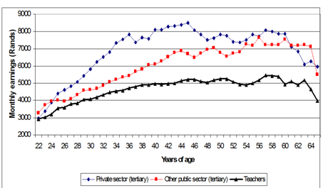

Prior to the Occupational Specific Dispensation (OSD), teacher salaries fell far short of those for others with tertiary qualifications. While starting salaries are comparable (at age 22), a gap rapidly opens leaving teachers substantially underpaid relative to both public and private sector salaries of those with tertiary education. The weak salary prospects reinforce low motivation and low esteem while teacher compensation is poorly linked to performance. It is hard to retain teachers in the profession – particularly the better quality teachers. Salaries are not commensurate with the responsibility that teachers bear.

The DoE is beginning to focus on performance and evaluation, however there are obstacles to overcome. The negative experience of inspection in African schools during apartheid remains in the system’s memory, while in the post-1994 era, teacher appraisal has effectively been absent.

The Integrated Quality Management System began to be introduced into schools in 2004, but the 1% salary increment it affords is not commensurate with the complexity of the process. In 2008, the OSD agreement was introduced with performance agreements for school-based managers (Principals and Deputy Principals) and office-based educators. This allows for rewarding “good” and “outstanding” teachers.

- Dysfunctional schools

These trends have resulted in a middle-and working-class exodus from dysfunctional schools. Examples of the level of dysfunctionality are:
- Teachers in township schools spend 3.5 hours per day on instruction, compared to 6 hours per day in suburban schools
- Loss of teaching time arises from: Form filling (28%); Absenteeism; Lack of organisation; Failure to enroll students in time; Logistical problems in the delivery of books; Lack of discipline among pupils; External interruptions; and Inactivity

In 2007, 77% of children in SA schools did not feel safe in the classroom. At great cost, parents opt to send their children from the township to schools in the suburbs.

- “OBE” in schools without capacity

Criticism of Outcomes Based Education (OBE) in primary schools has resulted in a revision, contained in the Revised National Curriculum Statement. OBE requires teachers to have considerable subject knowledge and skills and for schools to have a degree of resources. The problem is exacerbated with most pupils not being taught in their home language, so learning is more difficult for them.

The Review of National Policies for Education: South Africa (OECD, Sept 2008) notes that: “[NCS is] a fine vision, but in the reality of the average South African school, it does not hold true” and that “In early grades, less is more.”

The National Department of Education “Foundation for Learning” campaign has been designed to address this issue. The strategy was launched in March 2008 in response to poor learning outcomes achieved by South African learners in national and international learner assessment tasks (Grades R to 6). The projected measure of the campaign is to increase average learner performance in languages and mathematics to no less than 50% by 2011. Primary schools will have 30 minutes of reading and 10 minutes of mental mathematics, as well as 20 minutes of written mathematics every day. Learner assessment is to take place on a regular basis with standardised assessment tasks provided by the Department of Education.

- Financial resources

Looking at funding, real spending on education reduced between 1996 and 2002, after which a real 18% increase to 2007 occurred. While education spending is 5% of GDP, this is below the UNESCO benchmark of 6%. Considerable inefficiencies (such as textbook procurement, feeding schemes and scholar transport) are in the system. Attempts are being made to overcome this, for example, Grade 10-12 textbooks are now (2008) being procured through centralised process, though other inefficiencies persist. The proportion of provincial budgets expended on education has fallen.

Many schools suffer an infrastructure backlog. National Education Infrastructure Management System (NEIMS) indicates that:
- 42% of schools are overcrowded
- 3,152 are without water
- 1,532 are without toilets
- 4,297 are without electricity
- 79% are without libraries
- 68% are without computers
- 60% are without laboratories
NEIMS estimates that R153bn capex is required to overcome this backlog and a further R30bn is required for maintenance. This compares with the R18bn budgeted over the next three years.

Learners at the poorest 40% (poorest two quintiles) of schools nationally are currently exempt from paying fees – these are termed “no fee schools”. However, the poorest schools get a disproportionate slice of non-personnel funding. On a provincial basis, the no fee schools range from 56% in the poor Eastern Cape to 14% in the richer Western Cape. A new policy decision has been taken to increase the no-fee schools from the poorest 40% to the poorest 60% (quintile 3). It is noted that schools that are prohibited from charging fees must receive adequate compensatory transfers from government and in good time, or else some schools will go into decline.

- Responsibilities and accountabilities

There is insufficient alignment between the national and provincial levels of the Department of Education. National government has exclusive legislative responsibility for tertiary education, and concurrent responsibility with the provinces for all other levels of education. National government, working with provinces, formulates national policy.

However, provincial governments must implement nationally determined policy and the provinces are not obliged to observe national priorities, particularly regarding allocation of financial resources.

There is insufficient district and SGB focus on learning and teaching. District offices are responsible for managing the financial and material resources of schools (ex “Section 21” schools). Significant powers are accorded to School Governing Bodies, however, there is a general lack of capacity at most SGBs and their actual focus is on finances, not learning and teaching.

Phase 3: Consolidate findings to make recommendations around short term interventions

Three main educational levers have been identified:
- In school / what happens in the classroom: teachers, learners, resources for learning;
- Support to schools: the management and delivery of support to schools; strengthening DoE’s capacity and accountability, particularly at provincial and district level, including principals;
- Societal: measures to address poverty, nutrition, crime, transport etc. that impact on learning through the provision of school buses, feeding schemes, security at schools, measures to address shortfalls in infrastructure etc.

Key interventions needed

- In-school
- Implement “in class, on time, teaching”. Also zero-tolerance for anti-social behavior by teachers e.g. drunkenness, sexual assault, etc.
- In primary schools, prioritise:
  - Foundation for Learning Campaign
  - Use of textbooks
- Scale-up practical management courses for principals, deputies, HODs and district supervisors
- Clarify and complete filling all teacher vacancies (per class size and per subject area)

- Support to schools
- Stabilise, reinforce and accelerate schools that are “working” (achieving relatively good results)
  - Delegations empowering principals to focus on teaching and learning
  - Allocate infrastructure funding as an incentive for schools that achieve the biggest improvements in student results (grant for staffrooms, laboratories, etc.)
- Strengthen education districts, beginning with deployment of competent management teams to selected districts to assist dysfunctional schools
  - Support Principal/school management teams
  - Prioritise implementation of in-class, on time, teaching
  - Share districts resources (e.g. remediation classes) for learning and teaching
  - Provide social workers for children
  - Extramural school activities (e.g. sport, chess, dance, etc.)
- Improve capacity and define roles, functions and responsibilities of districts
- While schooling is being “fixed”, find an interim solution for high-potential children already in the system
- Review “OBE” and, if needs be, issue its “death certificate”
- Shift national funding to conditional grants
- Revise regulations to enable national procurement of textbooks, feeding schemes, and scholar transport
- Implement regular external testing of learners in primary and secondary school
- Finalise and implement a decisive approach to teacher evaluation

- Societal
- Scale-up and resource early childhood interventions
- Conduct regulatory impact assessments on all future design changes to education (beginning with extension of no-fee school programme to quintile 3 schools).
- Give teacher unions a formal and funded role in supporting teacher development
- Council of Education Ministers to review and agree to performance inputs and output targets for national and provincial government
- Create a basis for a social compact on education, through establishing National Education Consultative Forum, with formal roles (including reviewing performance targets)

In conclusion, South Africa’s skills agenda needs quality education. This requires working schools and quality teaching. The proposals above are based primarily on strengthening/ refining what already exists rather than redesigning the system. The complexity of the situation requires a social compact (sufficient consensus), public participation, and ongoing evaluation.

The prerequisites for success are to narrow the gap between desired policy outcomes and actual implementation and a leadership role of the teacher unions in teacher development and quality education.

Phase 4: Postscript: Facilitating the implementation of the recommendations

Long Term: Implementation implies that the new Ministers of education would take on board the recommendations of the process as summarized in the 10-point programme below. In addition, stakeholders such as teachers and the broader society would be required to play their part. Education has been identified as a national priority under the new government and administration of President Jacob Zuma.

There is a need to find ways to support the process of implementation, and for further social dialogue on relevant new system design interventions. Events such as the recent Teacher Development Summit (July 2009) suggest how progress may be made in particular areas.

For its part, DBSA has continued to popularize the Education Roadmap and 10-point programme through media and talks to stakeholder groups. In addition, thre have been approaches to national and provincial departments of education to assist in particular aspects of delivery relevant to the programme. Further research, such as into the role and functioning of education districts, is also to be commissioned.

10-point programme

A. In-school
- Teachers to be in-class, on time, teaching. Teachers also to be required to use textbooks in class.
- Focus efforts on improving the quality of early childhood education and primary schools, including implementing the “Foundations for Learning” Campaign emphasizing the promotion of language and numeracy.
- Conduct external tests for all Grade 3 and Grade 6 learners every year, and provide the results to parents.
- Ensure effective evaluation of all teachers based on the extent to which learner performances improve, with results influencing occupationally specific dispensation (OSD) pay for teachers.
- Enhance recruitment of quality teachers and strengthen teacher development
  - Offer bursaries to attract quality student in-take into teacher training institution and offer student loan repayments to attract young graduates into teacher contracts.
  - Enhance pre-service and in-service teacher training, including through better coordination and resourcing.
  - Ensure that teacher unions have a formal and funded role in teacher development.

B. Support to school
- Strengthen management capacity to ensure working districts and schools. This entails bringing in management capacity from the private sector, civil society and elsewhere in the public sector.
- Phase in a process of measurable improvements through targeting efforts at selected education districts and dysfunctional schools.
- Use infrastructure budgets as an incentive for schools that deliver improved teaching and learning.
- Increase the use of ICT in education, including audiovisual teaching materials in the classroom to supplement teaching and demonstrate quality teaching to learners and educators.
- Improve national-provincial alignment and efficiency of education expenditure, through procuring textbooks nationally and allocating resources to improve district capacity. In this regard, the use of conditional grants is an important tool to ensure alignment.

C. Societal
- Develop a social compact for quality education. This will include a National Consultative Forum dedicated to clarifying the “non-negotiables” and performance targets for key stakeholders, and the monitoring thereof.
- Encourage the mobilisation of communities at all levels to raise awareness and participation in education issues. Examples include graduates assisting their former schools or dysfunctional schools, corporate social investment, party branch campaigns to clean up schools, supporting food gardens, and encouraging young graduates to enter teaching (“Teach SA”).
- Implement poverty-combating measures that improve the environment for learning and teaching, such as a nutrition programme (cross-cutting programme with health), basic infrastructure for schools and social support for children.

