

Office of the Public Protector

Performance on strategic objectives 08/09

ABBREVIATIONS

AORC | African Ombudsman Resource Centre
CSAP | Civil Society Advocacy Programme
DPW | Department of Public Works
EWP | Employee Wellness Programme
HRD | Human Resource Development
HRMIS | Human Resource Management Information System
ICT | Information and Communication Technology
JYP | Justice Yellow Page
MOU | Memorandum of Understanding
OPP | Office of the Public Protector
PPDMS | Personnel Performance Development Management System
PSETA | Public Service Sector Education and Training Authority
SDI | Service Delivery Indicator
UKZN | University of KwaZulu-Natal

2. EXECUTIVE SUMMARY
- This report covers the operations of the office of the Public Protector (OPP) for twelve months period starting from 1 April 2008 to 31 March 2009.
- The report includes highlights for the year, statistical achievements, challenges and measures to address them.
- The OPP operates with four programmes which are as follows:

PROGRAMME | SUB PROGRAMME
Programme 1. Investigations and Reporting | 1.1. National Investigations  1.2 Provincial Investigations  1.3 Special Investigations
Programme 2. Executive Management | 2.1 Public Protector  2.2 Deputy Public Protector  2.3 Chief Executive Officer  2.4 Executive Support  2.5 Communications  2.6 Security and Risk Management
Programme 3. Outreach | 3.1 National Outreach  3.2 Provincial Outreach
Programme 4. Corporate Support Services | 4.1 Human Resource and Management  Development  4.2 Finance and Supply Chain  Management  4.3 Knowledge Management  4.4 Information Technology  4.5 Administration Support

- PROGRAMME 1: INVESTIGATIONS AND REPORTING
  - In 2008/09 financial year, 6 780 complaints were brought forward from the 2007/08 financial year and 12 435 received. A total of 19 215 complaints were considered, of these complaints, 13 220 were finalised and 5 995 carried over to 2009/10 financial year.

  - Programme 1, which is the core of the OPP has generally achieved its objectives except for own initiative, systemic investigations and reducing the turnaround time for the finalisation of complaints.

5. PROGRAMME 2: EXECUTIVE MANAGEMENT

  - The following two objectives under sub-programme: CEO were not achieved:

    - To ensure the improvement of efficiency and effectiveness of the
Investigation process. This is due to none alignment of the target, measure and output. A decision was taken by EXCO to review the objective.

    - To ensure the development of strategy on skills diversification for all OPP staff. This was not achieved due to research not conducted to inform the process to be followed.

  - The following strategic objectives and/or outputs under sub-programme Communications were not achieved as some were dependent on the development of share point technology. The other objectives were not achieved due to budgetary constraints:
    - Communication strategy that includes external and internal communications;
    - Electronic newsletter;
    - To enhance the corporate brand of the OPP

6. PROGRAMME 3: OUTREACH

6.1 The roll out of mobile office pilot project (MOPP) was not achieved due to financial constraints.

7. PROGRAMME 4: CORPORATE SUPPORT SERVICES

7.1 The project to review the performance management system was finalised, and the only challenge is the smooth implementation of the system.

7.2 An electronic case management system has been developed and is functional save for its teething problems.

7.3 The Upington Regional Office was officially opened by the Deputy President in November 2008. There are still challenges of finding suitable premises for additional regional offices in the identified areas.

8. ACHIEVEMENTS

  - A knowledge portal has been developed and is fully operational.

  - The Case Management System project was finalised in January 2009 and preliminary training conducted for administrative and investigative staff.

9. CHALLENGES

9.1 Complaints older than 1 year for Provincial offices have increased from 378 in 2007/08 financial year to 448 in 2008/09 financial year due to capacity constraints, high workload and high staff turnover.

9.2 Key projects have been deferred to the next financial year due to budgetary constraints for example, system upgrade, video conference facility, intranet and share point technology.
9.3 The office has not yet developed a cost centre which hampers the tracking of expenditure and these will be considered during the 2010/11 financial year.

10. MEASURES TO ADDRESS CHALLENGES

10.1 The implementation of the retention strategy will address high staff turnover.

10.2 Transferring investigation posts from National office to provincial offices as and when they become vacant.

11. CONCLUSION

11.1 In spite of the capacity constraints due to high staff turnover, higher than anticipated salary adjustments, revised salaries of employees on senior management services (SMS), the implementation of the first phase of the occupational salary dispensation (OSD), legal costs and settlement, the office achieved its main objectives.

- STATISTICAL OVERVIEW

Chart 1: Statistics of complaints brought forward, received, finalised and carried over the 2009/10 financial year reflected as per National and Provincial investigations.

BRANCH | COMPLAINTS BROUGHT FORWARD=6780 |  | COMPLAINTS RECEIVED=12435 |  | COMPLAINTS FINALISED=13220 | COMPLAINTS CARRIED OVER 2009/10=5995
NATIONAL |  | 1042 |  | 2130 | 2713 | 459
E. CAPE |  | 659 |  | 1235 | 1336 | 558
F. STATE |  | 277 |  | 650 | 806 | 121
GAUTENG |  | 544 |  | 1578 | 1291 | 831
K. NATAL |  | 1000 |  | 1285 | 1270 | 1015
LIM |  | 1010 |  | 1643 | 1623 | 1030
MPU |  | 587 |  | 709 | 685 | 611
N. CAPE |  | 399 |  | 524 | 710 | 213
N.WEST |  | 748 |  | 1869 | 1952 | 665
W.CAPE |  | 514 |  | 812 | 834 | 492
TOTAL |  | 6780 |  | 12435 | 13220 | 5995

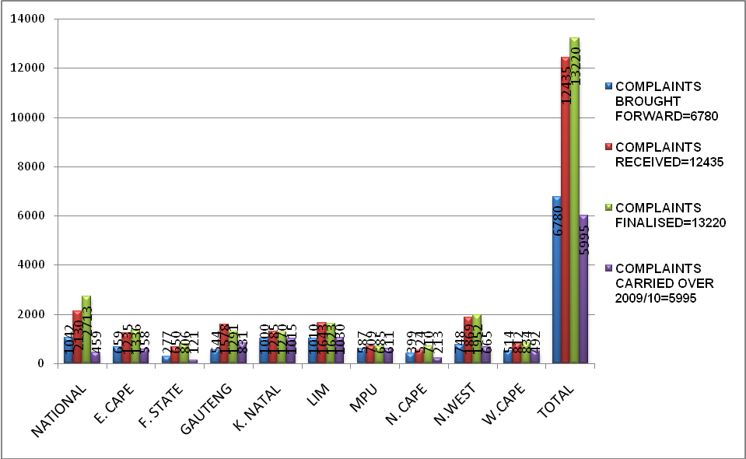

Chart 2: Statistics of non jurisdictional matters dealt with and complaints referred to other institutions in 2008/09 reflected as per National and Provincial investigations.

BRANCH | NON-JURISDICTIONAL | COMPLAINTS REFERRED TO OTHER INSTITUTIONS
NATIONAL | 424 | 176
E. CAPE | 71 | 61
F. STATE | 104 | 143
GAUTENG | 1203 | 439
K. NATAL | 101 | 11
LIM | 113 | 70
MPU | 161 | 12
N. CAPE | 23 | 46
N.WEST | 676 | 5
W.CAPE | 243 | 18
TOTAL | 3119 | 981

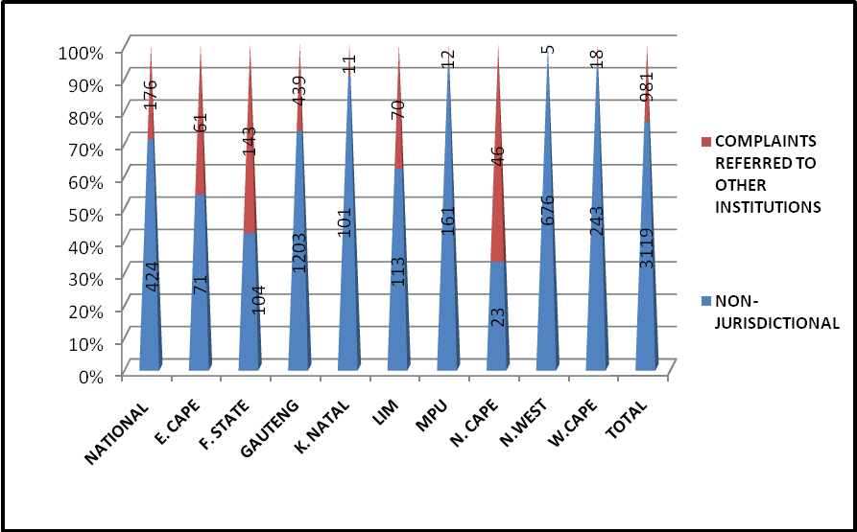

Chart 3: Comparison of statistics received and finalized in 2005/06 until 2008/09 financial years.

Financial year | Complaints received | Complaints finalized
2005/06 | 17415 | 17619
2006/07 | 12629 | 13434
2007/08 | 13195 | 11280
2008/09 | 12435 | 13220
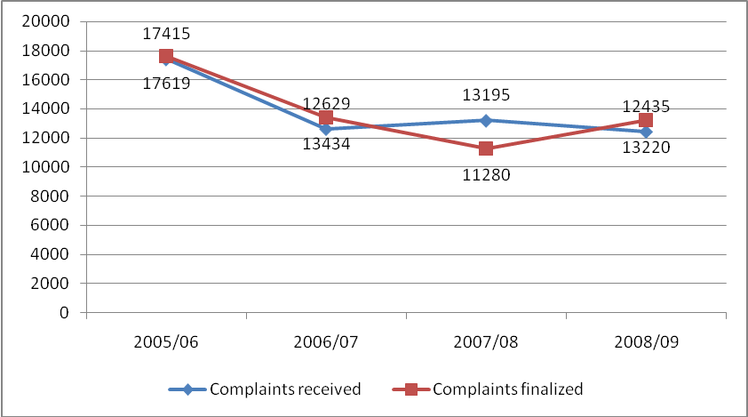

Chart 4: Sample of Gender breakdown of complaints taken from 4 897 of the investigations finalized in 2008/09 financial year.

FEMALE | MALE
1595 | 3302
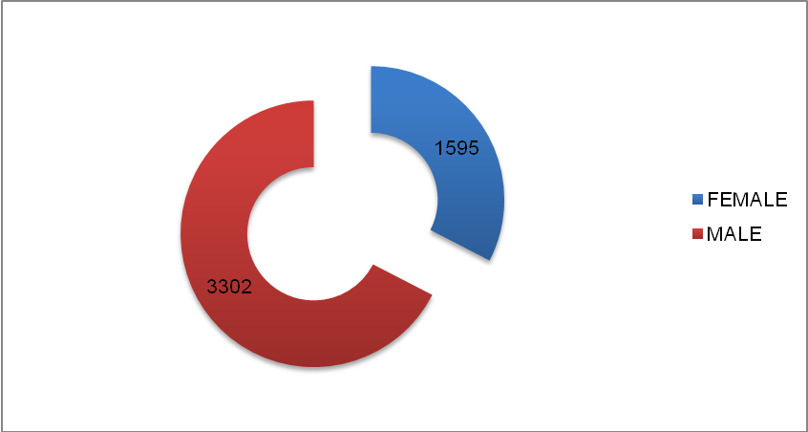

Chart 5: Statistics of cases older than 1 year as at 31 March 2009 reflected as per National and Provincial Investigations.

NATIONAL | 17
EASTERN CAPE | 23
FREE STATE | 0
GAUTENG | 103
KWAZULU-NATAL | 39
LIMPOPO | 136
MPUMALANGA | 65
NORTHERN CAPE | 11
NORTHWEST | 71
WESTERN CAPE | 0
TOTAL | 465

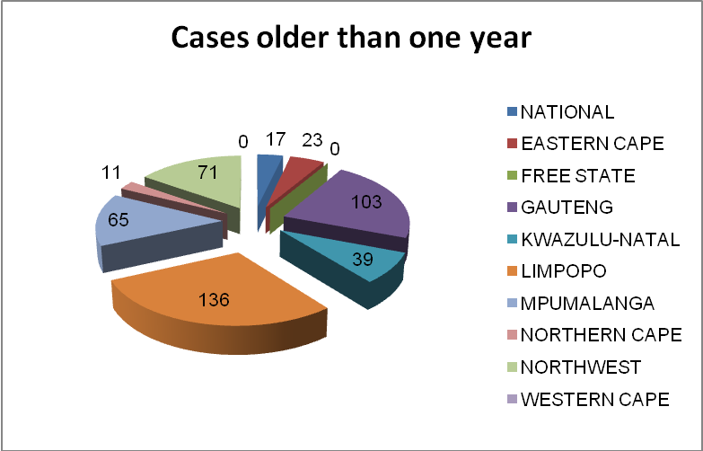

Chart 6: Sample of average turnaround times which investigations were finalised in 2008/09 reflected per period.

Period
0-3 Months | 5783
4-9 Months | 2360
7-12 Months | 2926
13-24 Months | 1257
25+ Months | 229
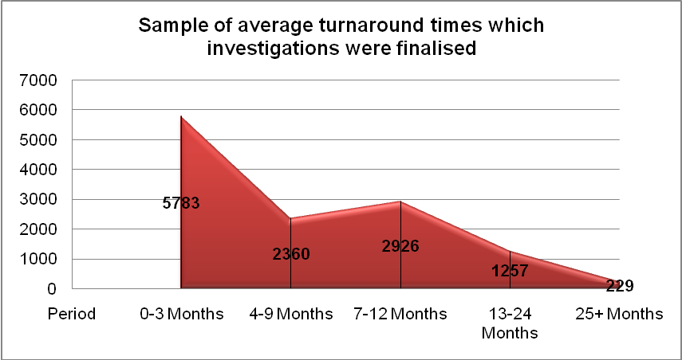

Programme 1: Investigations and Reporting

    - Objective of the programme:
      - To conduct national, special and provincial investigations that are effective, efficient, informed, timeous and of high quality.

    - Outcome of the programme:
      - Improved service delivery to stakeholders.

    - Strategic objectives for the programme:
Sub-Programmes: ALL | Responsibilities
- To conduct investigations in compliance with the constitutional mandate of the OPP | - Control Investigator: National Investigations  - Control Investigator: Special Investigations  - Executive Manager: Provincial Investigations
      - To conduct systemic investigations.
      - To conduct own-initiative investigations.
      - To develop investigative techniques, processes and training.
      - To reduce the turnaround time of investigations.
      - To ensure effective, relevant reporting in all finalised investigations.
      - To monitor and report on remedial actions recommended to organs of State.

    - Sub – Programmes: ALL (NATIONAL, SPECIAL AND PROVINCIAL INVESTIGATIONS)
Strategic Objective | Output | Measure | 2008/9 Target | Achievement of Targets for the year 2008/09
- To conduct investigations in compliance with the constitutional mandate of the PP | Investigation plans for all investigations | % of investigation plans for all investigations | Investigation plans defined for 100% of all investigations | Achieved  Investigation plans defined for all investigations.
 | Approved project plans for appropriate investigations | % of project plans for appropriate complaints | Project plans defined for 100% of appropriate complaints | Achieved  Project plans defined for all appropriate complaints.
 | Jurisdictional complaints received | % of attendance to all complaints received | 100% of attendance to all complaints received | Achieved  6780 complaints were brought forward to the 2008/09 financial year, 12 435 received, 19 215 attended to
 | Jurisdictions complaints investigated and finalised | % of complaints investigated and finalised | 100% of complaints investigated and finalised | Partially Achieved  Target not met partly due to capacity constraints and ambiguity of the target. 13 220 complaints finalised, and 5995 carried over to the 2009/10 financial year.
 | Complaints where Prosecuting Authority is notified due to facts disclosing the commission of an offence. | % of complaints finalised by notification to the Prosecuting Authority | 100% of complaints finalised by notification to the Prosecuting Authority | Achieved  2 complaints were finalised by notification to the Prosecuting Authority
 | Complaints disposed of by way of referral to appropriate public bodies | % of complaints disposed of by way of referral to appropriate public bodies | 100% of complaints disposed of by way of referral to appropriate public bodies | Achieved  981 complaints were disposed of by way of referral to appropriate public bodies
 | Complaints not investigated because:  - Remedies not exhausted or  - Reported after 2 years and no special circumstances exist | % of complaints disposed of as no jurisdiction | 100% of complaints disposed of as no jurisdiction | Achieved  3119 complaints were disposed of as no jurisdiction
 | Jurisdiction complaints finalised by ADR (Alternative Dispute Resolution) | % of complaints finalised by ADR | 100% of complaints finalised by ADR | Achieved  All finalised complaints have closing reports. All 13 220 complaints were finalised by way of closing report where a matter has been negotiated and settled.
- To conduct systemic investigations | Systemic investigation Reports | Number of systemic investigations reports submitted | Submission of Report on the number of systemic investigations | Achieved  16 systemic investigations conducted, 4 finalised, two finalised by way of closing report and 10 still under investigation and will be finalised in the 2009/10 financial year. All systemic investigations have reports.
- To conduct own-initiative investigations | Own-initiative investigations Report | Number of own initiative investigations finalised per annum | Minimum of 1 own initiative investigation finalised per province  Minimum of 1 own initiative investigation finalised per Investigative Unit | Not Achieved  Target not met due to high staff turnover of investigative staff in Provincial offices, capacity constraints and high workload. However, 5 own initiative investigations were conducted 2 finalised, 3 still under investigation.  Achieved  11 own initiative investigations conducted 3 finalised by a closing report, 4 signed by the Public Protector and 4 still under investigations and will be finalised in the 2009/10 financial year.
- To develop investigative techniques, processes and training | Investigators trained on process manual | % of investigators trained | 100% of investigators trained. | Achieved  The investigative techniques process manual has been developed and all the investigators trained
- To reduce the turnaround time of complaints | Regular statistical report on relevant complaints  Comparative statistical report on complaints older than one year to be included in quarterly report | % compliance  Reduced turnaround time for finalisation of complaints | 100% compliance  Finalise all complaints within one year | Achieved  Statistical report compiled on a monthly basis  Not Achieved  Target not met due to complexity of some of the complaints, high workload and high staff turnover. 6780 complaints were brought forward to the 2008/09 financial year, 12 435 received, 19 215 attended to and only 465 complaints were older than 1 year as at 31 March 2009.
- To ensure effective, relevant reporting on all finalised investigations | Report for every finalised investigation | % of reports produced | 100% of reporting on all finalised investigations | Achieved  Reports (formal or closing) were compiled for all finalised investigations
- To monitor and report on remedial actions recommended to organs of State. | Remedial action Monitoring Report | Quarterly Reporting | 100% compliance | Achieved  100% of all complaints where recommendations were made were accepted and in the process of being implemented

Programme 2: Executive Management

    - Objective of the programme:
      - To provide strategic direction and improve internal and external communication to inculcate a common vision and improved profile for the OPP.

    - Outcome of the programme:
      - Improved service delivery to stakeholders.
      - Smooth, timeous flow of accurate information to all OPP staff.
      - Increased awareness and knowledge of the constitutional mandate of the OPP

    - Strategic objectives for the programme:
Sub-Programmes: CEO | Responsibilities
- Manage the definition and review of Organisational Strategic Performance Assessment and Reporting.  - To ensure the consolidation and continuous update of the Policies into an integrated Staff Corporate Manual.  - To ensure the improvement of efficiency and effectiveness of the Investigation Process  - Definition of Business Processes linked to the organisational structure  - Ensure that Staff strategic involvement process is outlined  - Ensure the Development of strategy on skills diversification for investigators  - Consolidate Organisational Risk Management Plan  - Facilitate and monitor Change Management and Transformation processes  - Ensure attainment of Unqualified audit reports  - Quality Internal Audit Reports | CEO
Sub-Programme: Executive Support | Responsibility
- To conduct file inspections.  - To implement and review think-tank committee procedures and processes  - Enhance collaboration with stakeholders.  - To co-ordinate the OPP Management, EXCO and Think tank meetings  - Establish, migrate and launch AORC.  - Development of the Exchange programme Strategy.  - To implement and monitor the Service Delivery Charter. | Senior Manager : Executive Support
Sub-Programme: Security and Risk Management | Responsibility
- To implement and monitor processes for the protection of OPP information and assets, including staff  - Monitor the implementation of the Risk Management Plan | Security Manager
Sub-Programme: Marketing and Communications | Responsibility
- Improve communication and routing of information to stakeholders  - Effective internal communication  - Manage media relations  - To Enhance Corporate Brand of the OPP  - Establish Events Co-ordinations function and manage events, including the Annual Theme conference  - Ensure staff of OPP adhere to Protocol procedures  - Effective co-ordination of International Visits | Senior Manager: Communications

    - Sub – Programmes: CEO
Strategic Objective |  | Output |  | Measure |  | 2008/9 Target |  | Achievement of Targets for the year 2008/09
- Manage the definition and review of Organisational Strategic Performance Assessment and Reporting. |  | Organisational Strategy Performance and  Statistical Reports |  | Frequency of Strategy Performance meetings and Statistical reports |  | Quarterly Strategy performance meetings and Statistical reporting |  | Achieved  Quarterly strategic performance meetings held and quarterly statistical reports submitted.
 |  |  |  | Number of meetings and reports |  | Annual strategy review meeting and reporting |  | Achieved  Annual strategy review meeting held.
 |  |  |  | Number of meetings and reports |  | Annual reporting to Parliament |  | Achieved  Annual report tabled in Parliament as prescribed.
 |  | Strategic Performance Assessment Framework and Templates |  | % completion of assessment framework |  | Approved and Finalised Assessment Framework and Templates. |  | Achieved  Assessment framework and templates approved and has been implemented.
- To ensure the consolidation and continuously update of the Policies into an integrated Staff Corporate Manual. |  | Integrated Corporate Staff Manual |  | % Completion of Staff Manual |  | Review and Update |  | Achieved  Integrated Corporate staff manual reviewed, updated and has been implemented.
 |  | Policy Formulation Review Procedure |  | % Completion of Procedure |  | Review and Update |  | Partially Achieved  Target not met due to budgetary constraints which resulted in re-negotiating terms of reference and deliverables with the service provider. However, Policy formulation review procedure has been drafted and tabled at EXCO for approval and will be finalised in 2009/10 financial year.
- To ensure the improvement of efficiency and effectiveness of the Investigation Process | Project Charter template |  | Complete and approved project charter  Improved Statistical Reporting |  | 100% completion of Project Charter |  | Achieved  Project Charter template approved and has been implemented  Monthly and quarterly statistics analysed and verified.
 | Indices defined for management of Investigations and Complaints against institutions |  | Approval of Index variables |  | 100% Utilisation of Indices |  | Achieved  Indices for management of investigations and complaints against top institutions defined.
 | Monitoring and Evaluation Function |  | Quality of Terms of Reference and Monitoring and Evaluation report |  | Monitoring and Evaluation report as part of Annual Report |  | Not Achieved  N.B The target, measure and output were not aligned and a decision was taken by EXCO to review the objective.
- Definition of Business Processes linked to the organisational structure | Business Process Report and Organisational Structure |  | % completion of Organisational Structure |  | Approved Realignment of Business Process and Approved Organisational Structure. |  | Partially Achieved  Target not met due to the delay caused by the consultative processes with relevant stakeholders e.g. Minister of Finance and Department of Public Service and Administration.
- Ensure that Staff strategic involvement process is outlined | Adopted Policy Document and Policy Process Flow Chart |  | % completion of policy document and process flow chart |  | 100% completion of policy document and process flow chart |  | Partially Achieved  Policy document and process flow chart not achieved, however questionnaire on the involvement of staff on the strategic process was outlined. Target not met due to capacity constraints.
- Ensure the Development of strategy on skills diversification for all OPP staff | Adopted Policy on skills diversification for all OPP staff |  | % completion of policy on skills diversification for all OPP staff |  | 100% completion of policy on skills diversification for all OPP staff |  | Not Achieved  Policy on skills diversification for all OPP staff not achieved as it was dependent on research. . Target not met due to capacity constraints.
- Consolidate Organisational Risk Management Plan | Annual Plan |  | % completion of Annual Risk management Plan |  | 100% completion of Annual Risk Management Plan |  | Achieved  The annual risk management plan has been implemented and monitored.
- Facilitate and monitor Change Management and Transformation processes | Change Management Strategy & Policy  Developed |  | % Development & implementation |  | 100% development and approval of change management Policy & Strategy |  | Not Achieved  Change Management Strategy and Policy development not achieved and has been deferred to the 2009/10 financial year due to budgetary constraints
- Ensure attainment of Unqualified Audit Reports | Unqualified audit reports |  | % compliance |  | 100% compliance |  | Achieved  Unqualified audit report obtained in the 2007/08 financial year.
- Quality Internal Audit Reports | % Implementation of recommendations |  | 100% Implementation of recommendations |  | 100% Implementation of recommendations |  | Achieved  Internal Audit recommendations have been implemented.

    - Sub – Programmes: EXECUTIVE SUPPORT
Strategic Objective |  | Output |  | Measure |  | 2008/9 Target |  | Achievement of Targets for the year 2008/09
- To conduct file inspections |  | File inspection report |  | Number of file inspection |  | 1 per national and provincial office |  | Achieved  File inspections conducted at national and provincial offices.
- To implement and review Think Tank Committee procedures and processes |  | Implemented Think Tank Operational Process Manual |  | Implementation of Think Operational Process Manual |  | Implement, Review and Improve |  | Achieved  Think Tank Operational Process Manual has been reviewed, improved and implemented.
 |  | Think Tank reports submitted |  | Number of certified reports submitted to Think Tank |  | On average, 1 certified report per investigator per year |  | Partially Achieved  Target not met due to high staff turnover of investigative staff and training of new investigators who are appointed. At the beginning of 2008/09 financial year 96 investigator posts were filled, nine resigned, 88 remained and only 40 certified reports were signed and issued by the Public Protector.
- Enhance collaboration with stakeholders | Stakeholders Collaboration Framework in relation to Chapter 9 and related institutions |  | % Completion of Stakeholders Plan |  | 100% Completion of Stakeholders Plan |  | Achieved  Stakeholders plan drafted and adopted. (Collaborative framework).
- Enhance collaboration with stakeholders | OPP Participation |  | Minutes of OPP Participation Chapter 9 and related structures forums |  | Record minutes for all necessary participations |  | Achieved  Record of minutes for all OPP Chapter 9 participation at necessary meetings in place.
- To co-ordinate the OPP management EXCO and Think Tank meetings | Approved Structure of meetings |  | Number of meetings in terms of the structure |  | Meetings as per Meetings structure |  | Achieved  5 Management and 12 Executive committee meetings held.
- Establish, migrate and launch AORC | AORC established, migrated and launched |  | % of AORC established and migrated |  | 100% functional |  | Achieved  The AORC has been established, migrated and functional but not launched due to budgetary constraints.
- Development of the Exchange Programme Strategy | Exchange Programme Strategy |  | Development and implementation |  | 100% Implementation of strategy |  | Achieved  The Exchange Programme Strategy has been adopted and implemented.
- To implement and monitor the Service Delivery Charter. | Service Delivery Charter |  | Report on Implementation (Quarterly and annual Report) |  | Approval of Charter |  | Achieved  The Service Delivery Charter has been approved and has been implemented.
    - Sub – Programme: Security and Risk Management
Strategic Objective | Outputs | Measure | 2008/9 Target | Achievement of Targets for the year 2008/09
- To establish and implement processes for the protection of OPP information and assets, including staff | Security management Policy | % development and implementation | 100% Implementation of policies | Achieved  Security management policies have been implemented
 | Security management Strategy | % development and implementation | 100% development of strategy | Achieved  The security management strategy has been developed and implemented
 | Security procedure manual | % development and implementation | 100% development of Procedure manual | Partially Achieved  The security procedure manual has been drafted and will be finalised in the 2009/10 financial year. Target not met due to budgetary constraints. However the security procedure manual has been drafted and will be finalised in the 2009/10 financial year.
- Develop and implement Risk Management Strategy | Risk Management Strategy | % development of the Strategy | 100 % development of the Strategy | Achieved  The Risk Management Strategy has been developed
- Develop and implement Risk Management Strategy | Compliance report on the implementation of Risk Management Strategy | % implementation of Risk Management Strategy | 100% implementation of Risk Management Strategy | Achieved  The Risk Management Strategy has been implemented

    - Sub – Programme: Communications
STRATEGIC OBJECTIVE | OUTPUT | MEASURE | 2008/09 TARGET | Achievement of Targets for the year 2008/09
- Manage communication and routing of information to stakeholders | Communication strategy that includes external and internal communications | Submission of approved Communication strategy that includes external and internal communications to PP | Implementation and monitoring of Communication strategy | Not Achieved  Target not met due to capacity constraints. However, the communication strategy approved in 2007/08 financial year was implemented and will be reviewed in the 2009/10 financial year.
 | External Newsletter to increase awareness of OPP and highlighting success stories | Number of newsletters printed and distributed according to the approved Communications Plan | Print and distribute the approved number of external newsletters | Achieved  Two external newsletters printed and distributed.
 | Information brochures, posters, display stands and banners | Production of brochures in different languages | Print and distribute the approved number of material | Achieved  Information brochures, posters, display stands and banners have been printed and distributed.
 | Editing & Translation | When required | 100% compliance with the requirements | Achieved  Editing and translation done as and when required.
 | One on one Radio Interviews | Use electronic media as a lobby tool to enhance positive publicity. Current affairs and talk shows will be targeted | One on one interviews as initiated and approved | Achieved  One on one interviews conducted.
 | PP‘s Road Show | - Number of visits to targeted editors and senior journalists  - Increased awareness and utilisation of OPP Services | Visits as approved | Achieved  Approved PP’s Road Shows conducted.
 | Speeches and speakers / briefing notes | When required | 100 % compliance with the received request for speeches / briefing notes from the PP | Achieved  Speeches and briefing notes from the PP compiled as requested.
 | Website content management | Update within 48 hours after approval of information | 100% compliance with approved information for updating the website | Achieved  Approved information for updating the website complied with.
- Ensure effective internal communication | Electronic Newsletter | Produce and issue monthly newsletter | Produce and issue monthly newsletter | Not Achieved  Target not met due to capacity constraints. One electronic newsletter produced.
- Ensure effective internal communication | Intranet | Relevant content:  - Organisational info  - E-newsletter  - Classified ads | Introduce the Intranet by April 2008 | Not Achieved  Intranet not introduced in the financial year as it was dependent on the provision of share point and budgetary constraints.
- Manage media relations | Media relations programme, including:  Media Briefings, Media visits, Opinion Pieces, Editorials  Advertorials, etc | Increase in the publication of OPP positive news stories  Developed Media Relations Programme | Implement the Plan | Achieved  The approved Communication Strategy included the implementation plan.
- Manage media relations | Media Monitoring Report | Frequency of Monitoring | - Daily media clippings  - Weekly media summaries  - Monthly Media Impact Analyses | Achieved  - Report on the daily media clippings, weekly media summaries circulated to all relevant OPP staff on a monthly basis.
- To enhance the Corporate Brand of the OPP | Corporate Branding enhancement Strategy and Plan | Approval of Corporate Brand enhancement Strategy and Plan | Implementation of the enhanced Corporate Brand Strategy and Plan  Compliance with approved Strategy and Plan | Not Achieved  Target not met due to budgetary constraints however, guidelines on corporate branding have been approved and implemented.
- Establish Events Co-ordinations function and manage events, including the Annual Theme conference | Events Management Strategy and Plan | Accurate Management of OPP Events | Appointment of Events Co-coordinator  Events Calendar  Development Events Management Strategy and Plan | Achieved  -Events Co-ordinator appointed  Achieved  -Calendar for all OPP events Management Strategy and plan developed.
- Effective co-ordination of International Visits | Management of international visits through the Host Plan | Implement Host Plan | 100% success (compliance with the Host Plan) | Achieved  The host plan has being implemented.
- Ensure staff of OPP adhere to Protocol procedures | Protocol Procedures / Requirements | Compliance to protocol procedures and requirements | 100% compliance to procedures | Achieved  Protocol procedures have been implemented and complied with.

Programme 3: Outreach Programme

    - Objective of the programme:

      - To empower the people through knowledge, and ensure accessibility of the services
      - of the OPP.

    - Outcome of the programme:

      - Improved stakeholder perception, co-operation and accessibility of OPP services.

    - Strategic objectives for the programme:

Sub-Programme: Outreach Programme | Responsibility
- Increase accessibility to OPP services  - Increase public awareness  - Manage Outreach Activities at National Office  - Liaise with Civil society organisations to facilitate access  - Develop Training and Process Manuals on Outreach  - Assess the impact of the Outreach Programme | - Executive Manager: Outreach

    - Sub – Programme: OUTREACH PROGRAMME

Strategic Objective | Output | Measure | 2008/9 Target | Achievement of Targets for the year 2008/09
- Increase accessibility to OPP services | Reviewed Outreach strategy | % Outreach strategy reviewed and implemented | 100% implementation of the reviewed Outreach Strategy | Not Achieved  Target not met due to capacity constraints however, the adopted outreach strategy is being implemented.
- Increase accessibility to OPP services | Clinics conducted | Clinics conducted per month | 6 clinics per province  2 clinics per regional office  4 clinics per national office | Partially Achieved  Target not met due to budgetary constraints and a decision was taken by EXCO to reduce the number of clinics to be conducted. Out of the 852 planned 763 Clinics were conducted.
- Increase accessibility to OPP services | Review report outlining sustainability and relevance of the clinics and input to reviewed strategy | Number of clinics reviewed per annum | Six clinics per province | Achieved  Six clinics per province were reviewed and report compiled.
- Increase accessibility to OPP services | Mobile Office of the Public Protector (MOPP) established | Number of areas covered | Roll out MOPP in the 3 additional provinces | Not Achieved  Target not met due to budgetary constraints.
- Increase accessibility to OPP services | MOPP Pilot Project Report | Frequency of Report | Annually before Sept 2008 | Achieved  Monthly report on MOPP Pilot project compiled.
- Increase Public Awareness | Information sessions and Advocacy workshops with stakeholders | Number of Information Sessions and Advocacy Workshops per annum | 2 Advocacy workshops and  six information sessions per province | Achieved  45 Advocacy workshop and  193 Information sessions per province conducted.
- Increase Public Awareness | Road shows on theme conducted | Number of road shows conducted per annum | 2 road shows per province | Achieved  22 road shows were conducted throughout the country.
- Increase Public Awareness | Coordination of national Outreach events | Number of events co- ordinated | 1 event per province | Achieved  5 events co-ordinated.
- Manage Outreach Activities at National Office | National Office Work plans and Implementation | % completion of National Office Work plans and Implementation according to Plan | 100% completion of National Office Work plans and Implementation according to Plan | Achieved  National office work plans implemented according to plan.
- Liaise with Civil society organisations to facilitate access | MOU’s and Forums developed | Number of MOU’s and Forums established | One Forum per Province | Achieved  One forum per province developed.
 | Database of CSOs | % of completion of database | 1 complete and accurate database | Achieved  Accurate database of CSOs completed.
- Develop Training and Process Manuals on Outreach | Outreach Facilitator  Training manual | % of completion of manual | 100% completion of manual | Partially Achieved  Target not met due to budgetary constraints however, draft outreach facilitator training manual submitted to EXCO for approval.
- Develop Training and Process Manuals on Outreach | Outreach Facilitators trained | Number of training session per annum | 1 training session | Not Achieved  Target not met due to capacity and budgetary constraints. Training deferred to the 2009/10 financial year.
- Develop Training and Process Manuals on Outreach | Guidelines on Outreach events and activities | % of completion of guidelines | 100% completion | Partially Achieved  Target not met due to capacity constraints however, Guidelines on Outreach events and activities submitted to EXCO for approval.
- Develop Training and Process Manuals on Outreach | Cooperation manual | % of completion of manual | 100% completion | Partially Achieved  Target not me due to capacity constraints. The cooperation manual is the codification of collaboration of the outreach branch with other branches. Although the cooperation manual was not adopted collaboration with other branches took place.
- Assess the impact of the Outreach Programme | Impact Assessment Report | - % increase of jurisdictional complaints  - % Reduction of no jurisdictional complaints | - 20% increase of jurisdictional complaints  - 50 % Reduction of no jurisdictional complaints | Not Achieved  Target not met due to capacity constraints. However, draft impact assessment report compiled and will be finalised in the 2009/10 financial year.

Programme 4: Corporate Support Services

    - Objective of the programme:

      - To achieve and sustain an efficient and effective corporate support service that is compliant with legislation.

    - Outcome of the programme:
      - Improved service delivery.

    - Strategic objectives for the programme:
Sub-Programme: Human Resources Management and Development | Responsibility
- Ensure attraction, maintenance and retention of high quality staff for OPP.  - Continuous monitoring and evaluation of OPP Personnel Performance Management and Development System (PPMDS) to ensure an improved and sustained PPMDS).  - Training and development of staff according to OPP needs  - Implementation and monitoring of EWP for the OPP.  - Facilitate and monitor Employment equity and diversity  - Define the requirements for Human Resources Management Information System (HRMIS)  - To improve, monitor and advise on Labour Relations. | Human Resources Manager
Sub-Programme: Finance and Supply Chain Management | Responsibility
- To develop a costing model for investigations  - Improve OPP financial management and reporting  - Ensure compliance of OPP with financial prescripts  - Develop and implement cost-effective procurement processes | - Accounting Officer  - Chief Financial Officer  - Supply Chain Manager
Sub-Programme: Administration Support | Responsibility
- To enable the optimum application and utilisation of resources  - To promote the effective and efficient functioning of the registry  - To establish and maintain suitable office accommodation | Accounting Officer  Administration and facilitation Manager
Sub-Programme: Knowledge Management | Responsibility
- Create Knowledge Management Institution of the OPP | Manager: Knowledge Management
Sub-Programme: Information and Communications Technology | Responsibility
- Develop Master Systems Plan (MSP). | ICT Manager
- Implement Master Systems Plan (MSP). | ICT Manager

    - Sub – Programme 3.1: HUMAN RESOURCES MANAGEMENT AND DEVELOPMENT
Strategic Objective | Output | Measure | 2008/9 Target | Achievement of Targets for the year 2008/09
- Ensure Attraction, maintenance and retention of high quality staff for OPP. | Sourcing and Retention Strategy finalised/ approved and Implemented | % of Strategy  implemented  (Approved Strategy) | 50% of Strategy implemented according to approved strategy. | Achieved  Sourcing and Retention Strategy has been approved and has been implemented.
 | Approved HR Policy Staff Manual | % of HR Policy Manual completed | HR Policy Manual completed and implemented | Achieved  HR Policy Manual completed and has been implemented.
 | Reward Incentive Scheme developed | % of Incentive Scheme Developed | Approved Reward Incentive Scheme Developed | Achieved  Reward incentive scheme has been developed and approved.
 | Career Progression Framework developed | % of Framework Developed | Approved Career Progression Framework Developed. | Achieved  Career progression framework has been developed and approved.
 | Organisational Design and Job Evaluation Report | % Report approved and implemented | 50% implementation of approved Report | Achieved  Organisation design and job evaluation report has been approved and implemented.
- Administration, co-ordination and continuous monitoring and evaluation of OPP PPMDS to ensure an improved and sustained PPMDS | An improved and sustained OPP  Performance management system. | Moderation Committee and HR Report detailing issues that need to be dealt with in order to improve system | Review and Improve | Achieved  PPMDS has been reviewed, improved and has been being implemented.
 | All OPP Staff Trained on Revised PPMDS | % of OPP staff trained | Review, update and training of all OPP staff | Not Achieved  Target not met due to budgetary constraints and training deferred to the 2009/10 financial year.
- Training and development of staff according to OPP needs | - Human Resources Development (HRD) Strategic Plan  - Skills Audit Report  - Workplace Skills Plan  - Training Plan | - % HRD Strategic Plan development and implementation  - Submission of WSP by 30 June 2008  - % Training conducted per training plan | - Implementation of the programmes according to the plan contained in the HRD Strategy  - Submission of WSP by 30 June 2008  - 100% training according to the Training Plan | Achieved  Programmes contained in the HRD strategy have been implemented.  Achieved  WSP was submitted to Dept of Labour by 30 June 2008  Not Achieved  Target not met due to budgetary constraints. Training deferred to 2009/10 financial year.
- Implementation and monitoring of EWP for the OPP | - EWP and HIV AIDS policies developed and approved  - EWP and HIV AIDS programme implemented | - % of policies developed  - % of programme implemented | - 100% of EWP and HIV policies implemented  - New EWP Service Provider appointed | Achieved  EWP and HIV policies have been implemented.  Achieved  The new EWP Service Provider has been appointed.
- Implementation and monitoring of EWP for the OPP | Disease management programme developed and approved | % of Disease Management Programme developed | 100% implementation according to Disease Management programme plan | Achieved  Disease Management Programme plan has been implemented.
- Facilitate and monitor employment equity and diversity | Approved Employment Equity Plan | % of Employment Equity plan implemented | 100% of Employment Equity Plan Implemented | Achieved  Employment Equity plan has been implemented.
- Define the requirements for Human Resources Management Information System (HRMIS) | Specifications for improved HRMIS developed (Employee Self Service, automated workflow, Crystal report Writer, New System) | % of Specifications developed | 100% of Specifications developed | Achieved  Specifications for HRMIS have been developed.
- To improve, monitor and advise on Labour Relations | Approved Industrial Relations Policy  Managers and staff Trained on Labour Relations policies | % Industrial Relations Policy implemented  % of employees trained on Labour Relations policies | 100% implementation according to Plan  100% of employees trained | Achieved  Industrial Relations policy has being implemented.  Not Achieved  Target not met due to budgetary constraints. Labour Relation training deferred to the 2009/10 financial year.
    - Sub – Programme 3.2: FINANCE AND SUPPLY CHAIN MANAGEMENT
Strategic Objective | Output | Measure | 2008/9 Target | Achievement of Targets for the year 2008/09
- To develop a costing model based on the Specifications from Investigations | Costing model | % of costing model developed and implemented | 100% implementation as per costing model plan | Not Achieved  Target not met due to budgetary constraints. However, a research was conducted which indicated a need for the appointment of a cost accountant. This project is deferred to the 2009/10 financial year.
- Improve financial management and reporting | Financial management policies developed and implemented | % of financial policies developed and implemented | 100% implementation (training and accessibility of policy) | Achieved  Financial management policies have been developed and implemented.
- Improve financial management and reporting | Divisional budgets | % of divisional budget implemented | 100% implementation as per Divisional Budget Plan | Achieved  Divisional budgetary plan has been implemented.
- Ensure compliance with financial prescripts | Unqualified audit reports | % compliance | 100% compliance | Achieved  Unqualified audit report obtained for the 2007/08 financial year.
- Develop and implement cost-effective procurement policies and processes | Cost-effective procurement processes implemented | % implemented | 100% implementation | Achieved  Cost effective procurement processes have been implemented.
- Compliance with Legislative requirements | Reporting on Compliance to Legislation | % Compliance | 100% Compliance | Achieved  Legislative requirements complied with.
- Compliance with Legislative requirements | Training on Legislative requirements | % appropriate staff trained | 100% appropriate staff trained | Achieved  Appropriate staff trained.

    - Sub – Programme 3.3: ADMINISTRATION SUPPORT
Strategic Objective | Output | Measure | 2008/9 Target | Achievement of Targets for the year 2008/09
- To enable the optimum application and utilization resources | Vehicle monitoring system | % implementation of vehicle monitoring system | Review and Improve | Achieved  Vehicle monitoring system has reviewed and improved.
- To promote the effective and efficient functioning of the registry | Records management system that complies with National Archives Act and Guidelines | % implementation of Manual & electronic records management system | 100% electronic Records management operational | Partially Achieved  Target not met as it was dependent on the provision of share point and also due to budgetary constraints. However manual records management system is operational.
- To establish and maintain suitable office accommodation | Additional regional office established | Number of additional regional offices established | Limpopo  Eastern Cape  - Graaf Reinnet | Partially Achieved  Target not met as it was dependant on the assistance of the Department of Public Works in the identification of suitable premises. However, establishment of regional offices at Eastern Cape (Mthatha), Free State ( Qwaqwa) KZN (Newcastle) is at an advanced stage and will be finalised in the 2009/10 financial year.
- To establish and maintain suitable office accommodation | Office relocated | Number of offices relocated | Kuruman | Achieved  Kuruman office space increased and Rustenburg relocated.
- To establish and maintain suitable office accommodation | Establish Facilities management function | Facilities Management Plan | Develop and implement Facilities Management Strategy | Not Achieved  Target not met due to capacity constraints.
- Ensure compliance with Health and Safety regulations | Compliance with OHSA  Develop Occupational Health & Safety Strategy and plan | % Compliance | Implementation of the Strategy according to the Strategy / Plan  100% compliance | Not Achieved  Target not met due to capacity constraints. However, draft strategy completed and consultation with Department of Public Works underway to ensure compliance with OHSA.

    - Sub-Programme: KNOWLEDGE MANAGEMENT

Strategic Objective | Outputs | Measure | 2008/9 Target | Achievement of Targets for the year 2008/09
- Create a knowledge management institution for the OPP | Knowledge and Research Manager appointed | Appointment of Knowledge and Research Manager | Appointment of Knowledge and Research Manager | Achieved  Knowledge and Research Manager appointed.
- Create a knowledge management institution for the OPP | Knowledge audit conducted – Create a Grid (Matrix) | % of audit conducted | 100% of audit conducted | Achieved  Knowledge audit conducted.
- Create a knowledge management institution for the OPP | Knowledge management strategy developed and implemented | % of KM strategy developed and implemented | 100% of strategy developed | Achieved  KM strategy developed, approved and has been implemented.
- Create a knowledge management institution for the OPP | Research conducted | Continuous research | Continuous research performed | Achieved  Continuous research performed.
- Create a knowledge management institution for the OPP | Precedent System implemented | % Precedent System developed and implemented | 100% of Precedent System developed | Not Achieved  Target not met as it was dependant on the finalisation of the case management system. However, OPP portal was developed and has been implemented.
- Create a knowledge management institution for the OPP | List of documents that are available for Public Access | Compliance with PAIA | 100% Compliance | Achieved  The access to information manual has been compiled in compliance with PAIA.

1.4.8 Sub-Programme: INFORMATION AND COMMUNICATIONS TECHNOLOGY
Strategic Objective | Output | Measure | Target 2008/09 | Achievement of Targets for the year 2008/09
- Implement Master Systems Plan (MSP). | Projects delivery Roadmap. An approved Master Systems Plan detailing projects that will be undertaken by the IT division to provide automated solutions for the effective operation of the OPP business. | Numbers of listed projects, delivery on time and within the allocated budget. | - 100% implementation of the Complaint Management System.  - Implementation of the Share Point technology.  - Development of the Intranet.  - 2 Rehearsals for the Disaster Recovery plan.  - Feasibility Analysis and Assessment Report of the Human Resources and Finance Management and Procurement Integrated System.  - Setup an IT Training Centre  - Automation of Leave Application System | Achieved  The Case Management System development was completed not withstanding teething challenges.  Not Achieved  Target not met as it was dependant on the provision of share point and also due to budgetary constraints.  Achieved  A backup and recovery plan documented.  Achieved  Feasibility analysis and assessment report completed but implantation will be deferred to the 2010/11 financial year due to budgetary constraints.
 |  |  | - Creation of electronic database for Supply Chain management  - Analysis of Feasibility of Video Conferencing | Achieved
- Technical support to Staff | Incidents and problems Management system | - Reduced downtime.  - 48 hours turnaround time to resolve reported incidents and problems. | - Call Centre setup.  - Automated Incidents and problems management system. | Achieved  Call centre has been setup.  Achieved  Automated incidents and problems management system in place.
- Ensure Compliance to IT Governance | Access logs and log-sheets. | Reduced incidents of “logical” security violations. | Automated mechanism for Management to review users’ access logs and log-sheets. | Achieved  Access logs and log sheets in place.

