COURT SERVICES
NARRATIVE REPORT TO JUSTICE AND CONSTITUTIONAL DEVELOPMENT PORTFOLIO COMMITTEE

17 JUNE 2009

CONTENT

- COURT SERVICES ACTIVITIES (p2)
- JCPS ACTIVITIES (p3)
- DEMOGRAPHICS REGARDING COURTS (p3)
- ACHIEVEMENTS 2008/ PRIORITIES 2009 (p6)
  - PRO-POOR COURT FACILITIES MANAGEMENT (p6)
  - CONSTITUTIONAL DEVELOPMENT (p8)
  - POLICY DEVELOPMENT (p11)
  - COURT PERFORMANCE (p12)
    - REGIONAL COURT BACKLOG PROJECT (p36)
  - CHIEF FAMILY ADVOCATE (p41)
  - VULNERABLE GROUPS (p43)
  - REVIEW OF THE CRIMINAL JUSTICE SYSTEM (p52)
- CONCLUSION (p54)
COURT SERVICES

NARRATIVE REPORT AND BACKGROUND INFORMATION TO THE COURT SERVICES PRESENTATION TO THE COMMITTEE 2009

- COURT SERVICES ACTIVITIES

- NATIONALLY

To assist the Department to deal with its objectives, the Branch Court Services was established during 1999 to focus on those aspects relating directly to the courts. The problem sought to be addressed by then was to avoid duplication and lack of focus on the core functions of the Department. In practice the Branch assisted with the following aspects:
- The facilitation of the adjudication of criminal matters, the resolution of civil disputes, the addressing of family law related matters, improving the situation of vulnerable groups and the management of courts facilities;
  - The coordination and alignment of departmental strategies and programmes in relation to courts within the JCPS and Social clusters, including work relating to JOINTS and the Development Committee;
  - The monitoring and evaluation of the implementation of departmental policy in relation to courts; and
  - The allocation of budget and monitoring of expenditure regarding national projects, whilst the actual implementation was dealt with at court and Regional Office levels.

In 2009, the DG has requested that Court Services be reconfigured to reflect Court Services’ Policy Development role and that the various Policy related Chief Directorates of the ODG and Court Services merge, with a reconfiguration of mandate and functions, with a focus mainly on policy development and management with specific reference to courts.. This will have an impact on priorities and budget allocation. This will entail that the Branch will henceforth deals with Policy Development and Management as its main mandate, whilst implementation will be done at regional and court level, through coordination by the Regional Heads. It may, however, require that the Branch will have to deal with some coordination and monitoring and evaluation of cross-cutting projects and activities.

The Branch under the DDG Adv S Jiyane, will, on the request of the DG, focus on the functions dealt with by following Chief Directorates:

- Policy Development (Judicial system) Headed by Adv JB Skosana
- Constitutional Development Headed by Adv O Sewpaul
- Vulnerable Groups: Headed by Adv S Said
- Chief Family Advocate: Headed by Adv P Seabi (The approved establishment of the Chief Directorate comprises of the Office of the CFA at National office (Chief Directorate) and 9 provincial offices (each headed by a Family Advocate (Director))
- Court Performance/ National Operating Centre (NOC): Headed by Adv M Sejosengwe
- Criminal Justice System Review: Headed by Adv P A du Rand
- New: Specialised Services: Dedicated Courts such as Small Claims Courts; Language Services (new post). It is proposed that the Chief Directorate should have a Directorate on Language Services and a Directorate on Small Claims Courts.
- The Chief Directorate: Facility Management: Headed by Ms T Ramanyimi .

- PROVINCIALLY:

Dealt with by the regional offices who reports to the DG.

- JCPS CLUSTER ACTIVITIES

Court Services also participates in the JCPS cluster activities through both the Development and JOINTS Committees. In relation to the criminal justice system, the following main cluster priorities are receiving attention:

    - Continuation of the implementation of IJS programmes, predominantly in respect of modernising the justice system and improving the management of persons and cases through the justice system chain;
    - Improving the effectiveness of the Criminal Justice System, in part, through a review of the Criminal Justice System;
    - Reducing the backlog of cases pending trial and the related problem of awaiting trial detainees;

The Development Committee has facilitated, in addition to national intersectoral engagement, the establishment of provincial and local committees.

Through the Development Committee, IT Integration initiatives are continuing.

- DEMOGRAPHICS REGARDING COURTS

- There are 366 magisterial districts, within which there are the following lower court houses:

    - 366 main court seats,
    - 90 branch courts,
    - 44 detached offices and
    - 246 periodical courts

MAGISTRATE COURTS SUMMARY

PROVINCES | DISTRICTS | OFFICES | DETACHED  OFFICES/  DETACHED COURTS (D/C) | BRANCH COURTS | PERIODICAL COURTS
EASTERN CAPE | 78 | 78 | 1 | 6 | 25
FREE STATE | 53 | 53 | 14 | 1 | 13
GAUTENG | 23 | 23 | 1 | 26 | 10
KWAZULU-NATAL | 51 | 51 | 4 | 25 | 34
LIMPOPO | 36 | 36 | 1 | 5 | 51
MPUMALANGA | 30 | 30 | 3 | 5 | 37
NORTHERN CAPE | 26 | 26 | 9 | 10 | 20
NORTH WEST | 27 | 27 | 5 | 2 | 29
WESTERN CAPE | 42 | 42 | 6 | 10 | 27
TOTAL | 366 | 366 | 44 | 90 | 246

- Progress was made during 2008 in terms of improving race and gender representation on the Bench – at both lower and higher courts. The outcome of the programme to train women judges to prepare them for positions on the Bench was also positive.

- There are on average per month approximately 1559 courts in operation (69 High Courts; and 1490 Lower Courts)

- There were 13 High Court Divisions with 205 judges as on 31 May 2009

RACE AND GENDER BREAKDOWN OF JUDGES
 | African  Male | African  Female | Indian Male | Indian Female | Colored  Male | Colored  Female | White  Male | White  Female | Total
Total number all Judges | 62 | 16 | 10 | 8 | 12 | 4 | 79 | 14 | 205
% | 30% | 8% | 5% | 4% | 6% | 2% | 38% | 7% | 100%
 | 55% |  |  |  |  |  | 45% |  | 100%
Judges per post classification
Chief Justice | 1 | 0 | 0 | 0 | 0 | 0 | 0 | 0 | 1
Deputy Chief Justice | 1 | 0 | 0 | 0 | 0 | 0 | 0 | 0 | 1
President/  Judge President | 9 | - | - | - | - | - | - | - | 9
Deputy Judge President | 2 | - | - | - | - | - | 2 | 1 | 5
Judges | 49 | 16 | 10 | 8 | 12 | 4 | 77 | 13 | 189
Total all Judges | 62 | 16 | 10 | 8 | 12 | 4 | 79 | 14 | 205

Vacancies Not Yet Advertised: 33
- Supreme Court of Appeal 3
- Northern Cape High Court, Kimberley 1
- Eastern Cape High Court 1
- Western Cape High Court, Cape Town 4
- Free Stat High Court, Bloemfontein 1
- North and South Gauteng High Court 18
- Labour Court 5

Vacancies Already Advertised: 14
- Supreme Court of Appeal 3
- Eastern Cape High Court 1
- Western Cape High Court, Cape Town 2
- Free Stat High Court, Bloemfontein 1
- North and South Gauteng High Court 6
- Limpopo High Court, Thohoyandou 1

It should be noted that the JSC will meet from 19 – 21 July 2009 to consider the filling of some of the vacancies of Judges posts.

- There were 1906 permanent Magistrates as on 31 May 2009

RACE AND GENDER BREAKDOWN OF ALL MAGISTRATES AS ON 31 May 2009
POST CLASS | African Male | African Female | Indian Male | Indian Female | Coloured Male | Coloured Female | White Male | White Female | Total
Number of Magistrates | 508 | 231 | 68 | 84 | 85 | 53 | 617 | 260 | 1906
Percentages | 27% | 12% | 4% | 4% | 4% | 3% | 32% | 14% | 100%
 | 54% |  |  |  |  |  | 46% |  | 100%
Magistrates per post classification
Regional Court President | 2 | 2 | 1 | 0 | 1 | 1 | 0 | 1 | 8
Regional Magistrate | 68 | 39 | 11 | 17 | 13 | 7 | 152 | 36 | 343
Chief Magistrate | 6 | 3 | 1 | 2 | 0 | 1 | 3 | 1 | 17
Senior Magistrate | 61 | 7 | 2 | 2 | 3 | 2 | 39 | 21 | 137
Magistrate | 369 | 178 | 53 | 63 | 68 | 42 | 422 | 201 | 1396
Grand Total | 508 | 231 | 68 | 84 | 85 | 53 | 617 | 260 | 1906

Number of vacancies as on 31 May 2009: 131
- Regional Court: 1 x Regional Court President [to be advertised during July 2009]; 24 x Regional Magistrate [advertising of vacancies kept in abeyance pending creation of posts for Regional Civil Courts];
- District Court: 4 x Chief Magistrate [to be advertised during July 2009]; 21 x Senior Magistrate [to be advertised during July 2009] 81 x Magistrate [to be advertised during July 2009].

- ACHIEVEMENTS IN 2008; PRIORITIES FOR 2009

1. PRO-POOR COURT FACILITIES DEVELOPMENT PROGRAM

Court Services has continued to develop capacity at rural and previously disadvantaged areas. In this regard the following courts were completed and were officially opened in the year 2008/2009:

- Daveyton
- Limpopo Circuit High court
- Augrabies Magitrate court
- Richmond Magistrate court
- Mitchellesplain Magistrate court

The Department will this year complete the construction of the following 5 courts and 5 additions/ conversions to existing courts:

- Tsakane Magistrate court
- Stanger Magistrate court
- Colesberg Magistrate court
- Kagiso Magistrate court
- Ekangala Magistrate court

In addition the development process for the following facilities will start in this financial year:

- Katlehong Magistrate Court (Prioritised)
- Mamelodi Magistrate court
- Ntuzuma Magistrate court
- High court for Mpumalanga (Priority)
- High court for Limpopo (Priority)

A Central Archive System was piloted in the 2 courts being Pretoria and Krugersdop to eliviate the court document archiving constraints. The roll-out is being explored subject to availability of funds.

EXPENDITURE WAS OCCURRED IN THE FOLLOWING REGARD IN ORDER TO IMPROVE THE CONDITIONS AND INFRASTRUCTURE AT SERVICE DELIVERY POINTS

Capital Works | R333 622M
RAMP | R 71 000M
Accommodation Charges | R125 630M
Leases | R124 138M
Municipality Charges | R95 174M
Day to Day Maintenance | R22 000M
GG and Judges Vehicles | R30 306M
Upgrading of Infrastructure | R40 280M
TOTAL | R842 150M

- Courts have been made available in the following urban development nodes: Mdantsane, Inanda, Khayelitsha, Mitchell’s Plain, Motherwell

- Capital works: New facilities were completed in Polokwane and Daveyton

- Major extensions were completed in Richmond and Mitchellesplain

- Projects where construction is in progress (multi year projects) include – new accommodation:
    - Tsakane Branch Court
    - Ekangala MO
    - Kagiso MO
    - Galeshewe MO

- Major extensions court buildings (multi year projects) include:
    - Stanger MO
    - Colesberg MO
    - Supreme Court of Appeal

- 4 sites acquired for construction of new facilities for courts

- 462 courts were provided with facilities for people with disability

- Improvement of accessibility for people with disability
  - Completed = 355
  - In construction = 11
  - Planning = 480

- CONSTITUTIONAL DEVELOPMENT

What is Constitutional Development (CD)?
- CD was established in 2002 to perform the functions relating to constitutional development that were assigned to the Department and to administer the legislation that were transferred to the Minister for Justice and Constitutional Development.
  - CD is involved with the implementation of constitutional values, norms and principles, the rule of law, and respect for human rights.
  - It also deals with implementation, co-ordination, monitoring and evaluation of programs and activities aimed at deepening democracy, the rule of law, equality (non-sexism and non-racism), good and cooperative governance, separation of powers, social justice, popular participation, promotion of human rights and the commitment to respect international law.
- It deals with three Components of the Constitution:
  - Constitutional democracy.
  - State and Government Institutions, structures and systems.
  - Culture of respect of human rights.
- It is involved with:
  - Overall monitoring of the performance as well as actively empowering State and non-State Institutions and individuals in relation to constitutional matters.
  - Co-ordinating Government’s efforts aimed at promoting and protecting human rights.
  - Supporting State Institutions.
  - Safeguarding democratic governance by ensuring adherence to democratic principles.
- Playing a gatekeeper’s role in relation to constitutional and human rights jurisprudence. Also keeping track of developments and trends at both international and regional levels.

Responsibilities

- Administer the Constitution of the Republic of South Africa, 1996, constitutionally mandated legislation, Promotion of Equality and Prevention of Unfair Discrimination Act, 2000 (Equality Act) and the Promotion of Administrative Justice Act, 2000 (PAJA) .
- Assist and protect Chapter 9 Institutions to ensure their independence, impartiality, dignity and effectiveness.
- Promote the Constitution and its values.
- Combat racism, racial discrimination, xenophobia and related intolerance.

Achievements for 2008
- Promoting the Constitution and its values
- Launched a Constitutional and Human Rights Education Programme.
- Information sessions were conducted in Middelburg and Hazyview with Community Development Workers (CDWs) on Constitutional and Human Rights Education which included information sessions on the Equality Act and Equality Courts. Approximately 251 CDWs attended the sessions.
- Conducted workshops on constitutional education held with CDW’s from Vhembhe, Sekhukhune district and Capricorn district in Limpopo. The workshop dealt with, amongst others, the Constitution, Human Rights, Equality and Equality Courts.
- A public awareness session on equality was conducted in Piet Retief, Mpumalanga during the period under review. The event was attended by about 600 people from the farming community in the area.
- Outreach programmes aimed at popularising the PEPUDA and Equality courts were held in the Mqanduli attended by 500 people, Eldorado Park attended by 250 people, and Bizana attended by 1000 people.
- Information sessions and seminars were conducted with the National House of Traditional Leaders, as well as the Free State Provincial House of Traditional Leaders to educate traditional leaders about the implications of Constitutional Court judgments on customary law as well as the rights in general.
- Development of Material on the Constitution and Human Rights
- In order to ensure awareness of the Equality Act by members of the public, the Unit has also translated the Equality Act into all the eleven official languages, developed a simplified Equality booklet, posters and leaflets.
- Developed educational material, such as the booklet on the Bill of Rights entitled Know Your Rights; PAJA in all eleven languages; the three human Rights Acts (PEPUDA, PAIA and PAJA) in four languages, PAJA leaflet in eleven languages and PAJA booklet in eleven languages, Equality Act in eleven languages.
- Developed Handbook on the Constitution for Members of the Executive. Distributed to Members of Cabinet (Ministers and Deputy Ministers)
- Launch of European Union (EU)/DOJCD Programme on Access to Justice and Promotion of Constitutional Rights Programme
(i) Officially launched the partnership with the EU on Access to Justice and Promotion of Constitutional Rights programme with the objective to contribute to the strengthening of democracy by improving access to justice and promoting constitutional rights for the most vulnerable, in partnership with civil society organisation, in Orange Farm on 10 December 2008. The event was attended by 500 community members and was officially launched by the then Deputy President of the Republic of South Africa, Ms Baleka Mbete.

- Launch with Civil Society Organisations
The programme was later launched by the former Minister of Justice and Constitutional Development, Mr Enver Surty on 11 March 2009 wherein a Memorandum of Agreement was signed with Foundation for Human Rights as the implementing agency.

- Commemorating National Human Rights Days
In commemorating the National Human Rights Day, the Unit facilitated a human rights day event which was held in Kimberley under the theme” Celebrating 15 Years of Freedom and Human Rights with the keynote speaker being the then President of the Republic of South Africa, Mr Kgalema Motlanthe. This event was attended by 2000 people.

- Promotion of PAJA
Although the Promotion of administrative Act (PAJA) was promulgated in 2000, awareness of this important piece of legislation is still a challenge for both administrators and the public at large.
- In order to improve compliance of the PAJA, the Department conducted a number of activities such as road shows with Community Development Workers (CDW’s) in Limpopo, Free State and the North-West province. The Road shows were attended by 425 CDW’s in Limpopo, 245 in Free State and by 253 CDWs in the North-West province to ensure the effective implementation of the PAJA.
- Conducted workflow evaluations to determine whether government and agencies are complying with the PAJA. This is aimed at ensuring that government and agencies’ processes are in line with the provisions of the PAJA. Conducted workflow evaluations of the processes in three Local Municipalities namely, Randfontein Local Municipality, Westonaria Local Municipality and Mogale City Local Municipality.
- Presented a paper for PAJA and the challenges facing the legislation at an International Administrative Law Conference held in Windhoek, Namibia on 18-21 August 2008. The conference was attended by over 60 delegates from SADC countries aimed at sharing experiences on the implementation of the administrative legislation.

- Assistance to Chapter 9 Institutions (South African Human Rights Commission (SAHRC), Public Protector and Commission for Gender Equality (CGE))
- Faciitated approval for the adjustment of the remuneration of the members of the SAHRC and the CGE. The adjustment was approved by Cabinet and signed by the President.
- Briefed and advised the Minister on the problems at the CGE. Facilitated the secondment of the Chief Director: Budgets to assist the CGE with the financial issues.

- Combating Racism, Racial Discrimination, Xenophobia and Related Intolerance
- Developed a draft Policy Framework on the Prevention and Combating of Racism, Xenophobia and Related Intolerance as well the Draft National Action Plan to Combat Racism, Racial Discrimination, Xenophobia and Related Intolerance.
- An Inter-Ministerial Committee (IMC) was established by Cabinet to oversee the finalisation of the National Action Plan (NAP).
- Developed first draft of the NAP, presented to the IMC and received comments.

PRIORITIES FOR 2009
- Give effect to the Minister’s vision for Constitution Development, with a view to making the Constitution a living document. Strengthen programmes on Constitutional and Human Rights Education.
- Facilitate the implementation of the EU/DOJCD Programme on Access to Justice and the Promotion of Constitutional Rights Programme.
- Strengthen programmes on the implementation of the constitutionally mandated legislation emanating from the Bill of Rights, PAJA and the Equality Act.
- Designation of equality courts in the remaining magisterial districts.
- Designation of Magistrates courts to hear PAJA matters.
- Provide training to organs of state on the implementation of the provisions of PAJA.
- Conduct awareness campaigns aimed at educating society at large about their rights as entailed in the PAJA.
- Prepare progress reports to the Governance and Administration Cluster on the above.
- Organise national consultative conference on the National Action Plan to Combat Racism, Racial Discrimination, Xenophobia and Related Intolerance.
- Finalise the development of the National Action Plan to Combat Racism, Racial Discrimination, Xenophobia and Related Intolerance.
- Continue to participate in the African Peer Review Mechanism (APRM) process.
- Provide strategic assistance to the Chapter 9 Institutions, facilitate the filling of vacancies in the SAHRC, CGE and PP.
- Conduct Constitutional Research on key problems or questions of a constitutional nature, to test or clear perspectives and give guidance in order to promote effective governance.
- Monitor trends in the constitutional system, stimulate research and debate in order to promote ongoing development and improvement of the Constitution and constitutional system.

- POLICY DEVELOPMENT

MAIN PRIORITIES
- The finalisation of the policy of the transformation of the judiciary and the Superior Courts Bill
- The finalisation of the policy of the transformation of the legal profession and the Legal Practice Bill
- The finalisation of the Regulations on the Traditional Courts
- The implementation of the Jurisdiction of Regional Courts Amendment Act, 2008
- The implementation of the Judicial Service Commission Amendment Act, 2008
- The establishment of the Judicial Education Institute
- The Commencement of the review of the civil justice system
- The finalisation of the policy on the transformation of sheriffs

OTHER PRIORITY FUNCTIONS
- Legislation implementation regarding the transformation of the judiciary, including the facilitation of the development of policy guidelines for the effective implementation of the said legislation. The following four Acts were passed by Parliament and assented to by the President between October and December 2008: The Judicial Education Institute Act, 2008 (Act No. 14 of 2008); The Judicial Service Commission Amendment Act, 2008 (Act No. 20 of 2008); and the Jurisdiction of Regional Courts Amendment Act, 2008 (Act No. 31 of 2008).
- The following are activities and projects which have not been included in the above priorities, which are vital for the accountability and independence of the Lower Court judiciary:
- The alignment of the work of the Secretariat of the Magistrates Commission
The Secretariat of the Magistrates Commission provides administrative support to an independent Magistrates Commission. The policy initiatives relating to the integration of the Magistrates Commission to the Judicial Service Commission could require the integration/alignment of the Secretarial functions relating to the merged statutory body. Pending such integration, the Secretariat of the Magistrates Commission should remain linked to the Policy Development Branch.
- Realignment of the administrative clusters of the Lower Courts:
The judicial administrative clusters need to be brought in line with the judicial governance structure envisaged in the Superior Courts Bill to create a rationalised single judiciary.

4. COURT PERFORMANCE

COURT SERVICES NOC INFORMATION
PERFORMANCE OF COURTS DURING APRIL 2008 – MARCH 2009

Constitutional Court
The Constitutional Court is the highest court in all constitutional matters (Section 167(3) - (5) of Constitution) and has inherent power to regulate process and to develop common law (Section 173 of Constitution).

This court handled a case load of 123 cases (1 Old Case and 122 New Cases) in the period under review, of which 69 (56%) were finalized. Only 54 (44%) cases remained pending as they were still awaiting direction.
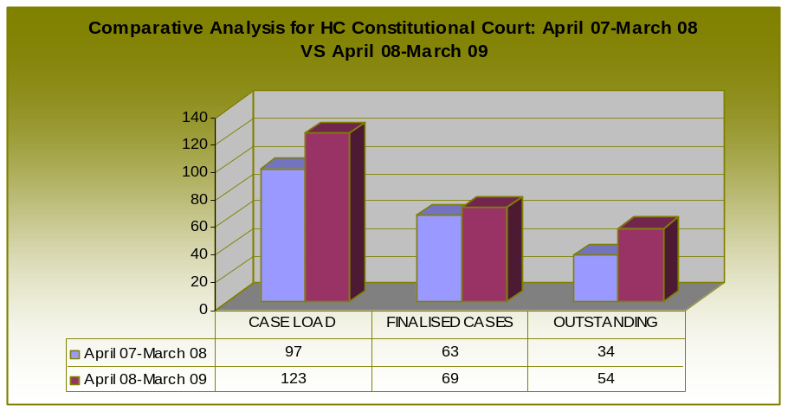

The chart shows that there has been an increase in the case load, finalized cases and outstanding cases.

Supreme Court of Appeal
The SCA is - highest court of appeal in all except constitutional matters (Section 168(3) of Constitution) and has the inherent power to regulate process and to develop common law (Section 173 of Constitution)

The SCA had a case load of 58 Criminal Appeals of which 20 (34%) were finalised and total of 38 (66%) cases are pending.

The SCA had 32 (23%) old petitions and received 137 new petitions during 2008/2009, giving a total caseload of 169 petitions. The SCA finalized 127 (75%) petitions and 42 (25%) remain outstanding.

The SCA had 140 (55%) old Civil Appeals and received 113 new civil appeals during 2008/2009, giving a total case load of 253 Civil Appeals. 131 (52%) of the civil appeals were finalized and 122 (48%) cases remain outstanding.
The SCA had 82 old civil petitions received and received 198 new cases during 2008/2009, giving a total case load of 280 civil petitions. 265 (95%) of the civil petitions were finalised and 15 (5%) petitions remain outstanding.

Labour Court and Labour Appeal Court

The Labour Appeal Court has exclusive jurisdiction to determine appeals from Labour Court, and to decide questions of law in terms of section 158(4) of the Act (Section 173 of Labour Relations Act 66 of 1995). The court also has inherent power to regulate process and to develop common law (Section 173 of Constitution).

The Labour Court has exclusive jurisdiction in respect of all matters which must, in terms of the Act or any other law, be determined by the Labour Court (Section 157(1) of Labour Relations Act 66 of 1995). This court is also having - concurrent jurisdiction with the High Courts in respect of violations of fundamental rights related to labour matters (Section 157(2) of Labour Relations Act). The court is having inherent power to regulate process and to develop common law (Section 173 of Constitution).

The court received 12 Appeals, 1643 Applications from CCMA and BC, 2710 Normal Applications, 12 Petitions, 545 referrals from CCMA and BC, which gives a total workload of 4807 labour matters.

Land Claims Court
The Land Claims Court has exclusive jurisdiction to determine matters emanating from the application of the Act (Section 22 of Restitution of Land Rights Act 22 of 1994). The court has inherent power to regulate process and to develop common law (Section 173 of Constitution).

Restitution Cases
The court had 246 old restitution cases, and received 110 new cases. 44 judgments were issued by the court and 312 cases are still outstanding.

Figure 1: Restitution Land Claims: April 07-March 08 vs. April 08- March09
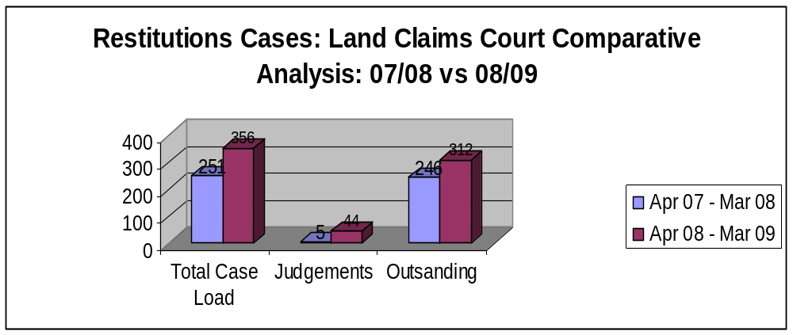

The chart above portrays that the total number of case load increased by 105 (42%) cases in the period under review. Similarly the number of cases finalized increased by 39 in April 2008 to March 2009 and the number of outstanding cases increased by 66 (27%). Overall the performance increased by 10%.

Extension of Security of tenure act 62 of 1997
A total of 277 (81%) cases were carried over from April 07 – March 08 and only 63 (19%) new cases were received in the period under review. The court managed to finalize 143 (42%) cases from April 2008 to March 2009. About 197 (58%) cases remained outstanding.

Figure 2: Extension of Security Act 62 of 1997: April 07 to March 08 vs April 08 to March 09
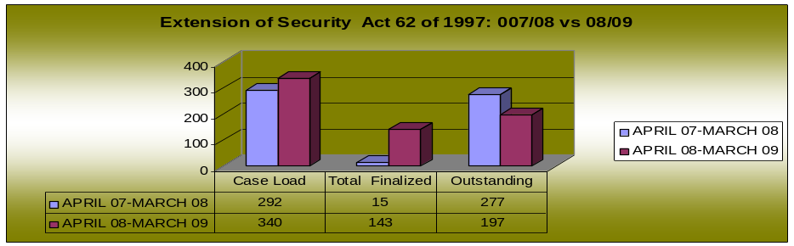

The chart above shows that the total number of case load increased by 48 (14%) cases in the period under review. Similarly the number of cases finalized increased by 128 in April 2008 to March 2009 and the number of outstanding cases decreased by 80 (29%). Overall the performance increased by 37%.

Land Reform (Labour Tenant)
A total of 158 (63%) cases were carried and only 94 (37%) new cases were received bringing the total case load to 252 cases. 216 (86%) of cases were finalized and only 36 (14%) cases remained pending.

Figure 3: Land Reform Labour Tenant Act3: April 07-March 08 vs. April 08- March09
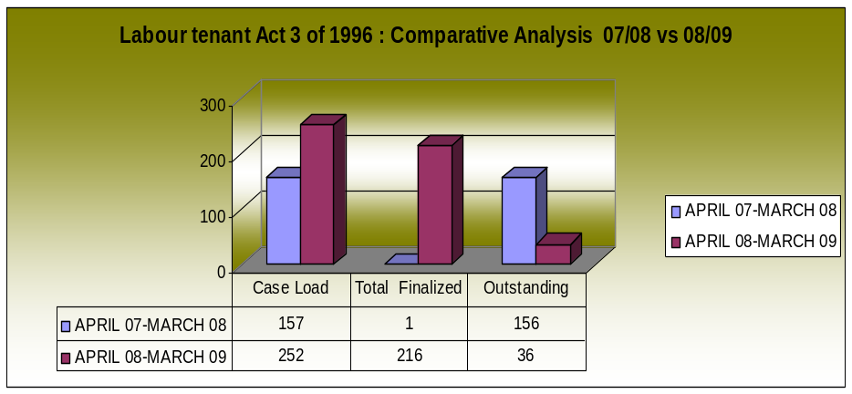

The chart above portrays that the number of case load increased by 95 (38%) cases in the period under review. Similarly the number of cases finalized increased by 215 in April 2008 to March 2009 and the number of outstanding cases decreased by 120 (78%). Overall the performance increased by 86%.

High Courts
The High Courts have:-
- jurisdiction in any constitutional matter not falling within the exclusive jurisdiction of the Constitutional Court or assigned to another court of a status similar to High Court (Section 169(a) of Constitution).
- jurisdiction in any other matter not assigned to another court by an Act of Parliament (Section 169(b) of Constitution).
- inherent power to regulate process and to develop common law (Section 173 of Constitution).
- general jurisdiction, including determination of appeals from, and review of proceedings of, inferior courts (Section 19 of Supreme Court Act 59 of 1959)

High Courts criminal trials

A positive clearance ratio was managed by the High Court Divisions during the financial year 2008/09. This could be ascribed to the 35% decrease in new cases received (from 2420 cases in 2007/08 to 1577 in 2008/09). The following graph illustrates the input and output of the High Court Divisions:

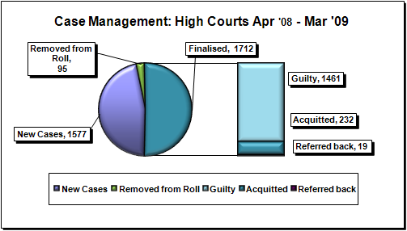

The number of new trial cases decreased slightly from 1344 the previous financial year to 1285 during this year. The High Courts had 960 old criminal trials and enrolled 1285 new criminal trials during 2008/2009. A total of 1161 cases were finalized and 1142 remain outstanding.

The division with the highest case load are TPD (544), followed by NPD with the case load of 431 and TRA with 308 in that order.

The number of outstanding cases on the High Courts’ rolls had over the past years only increased slightly. The number of cases on the roll for longer than 12 months – the backlogs - however increased quite dramatically. See the following illustration:

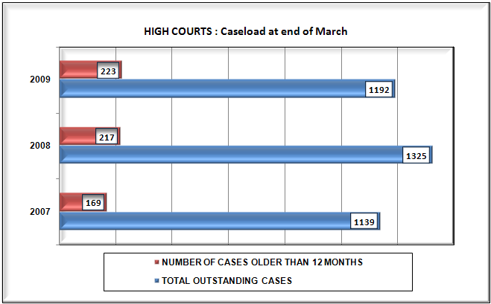

The number of backlog cases might drop as a result of the fewer minimum sentence matters that are being placed on the roll. These cases took exceptionally long to be finalized more than a year. Only four of the minimum sentence matters were convicted in the financial year 2008/09 and the other 457 matters were convicted before March 2008. During the audit conducted at the end of November 2008, it emerged that 72% of accused appearing in the High Courts are in custody. Hence, the extended cycle times of minimum sentences against the period awaiting trial in custody are very alarming.

Figure 4: Comparative Analysis for HC Criminal Trials: April 07-March -08 VS April 08-March 09
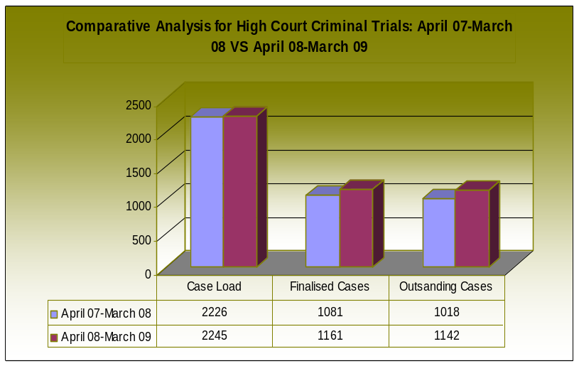

The chart above portrays that the criminal trial case load increased by 19 cases in the period under review. Similarly the total number of cases finalized increased by 80 and the total number of outstanding cases increased by 124.

High Court criminal: section 52s
The decrease in the number of minimum sentences received by the High Courts had a huge impact on the performance of the High Courts. The number of new minimum sentence matters decreased from 1076 in the previous financial year to a mere 292 matters during this financial year. The High Courts had 307 old Minimum Sentence cases (Section 52s) and 292 new cases were enrolled during 2008/2009. The divisions with the highest case load are the TPD (258 cases), and CPD (98 cases). About 92% of the cases were finalized national.

Figure 7: Comparative Analysis for Section 52: April 07-March -08 VS April 08-March 09

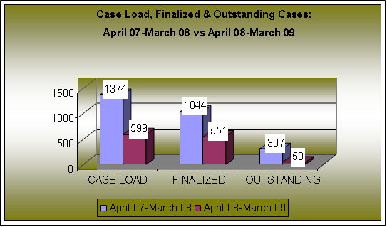

The chart above shows that the case load decreased by 56 %, the total finalized cases decreased by 47% and outstanding cases decreased by 84 % when compared to the same period in the previous year (2007/2008).

CONVICTION RATES
The conviction rates in the High Court decreased from 91% to 86%. Although the number of convictions decreased, the number of acquittals has increased as shown in the following graph:

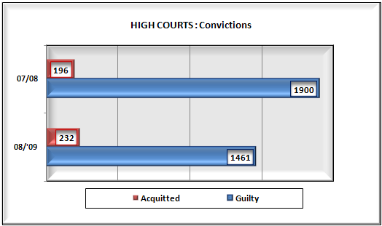

High Criminal Automatic Reviews

The High Courts had 3615 Old Automatic Criminal Reviews and received 7547 new automatic reviews during 2008/2009. 7208 reviews were finalized and 3954 remains outstanding.

The High Court with the highest case load is TPD with 4190 reviews followed by Cape Town High Court with 2717 reviews.

Figure 7: Comparative Analysis Automatic Reviews: April 07-March 08 VS April 08-March 09.

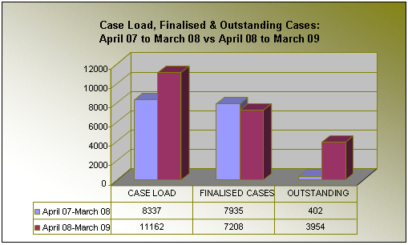

The chart above shows that the case load increased by 2825 (33, 9%), finalized cases decreased by 727 (9%) cases, while outstanding cases increased by 3552.

Petitions
The High Courts had 908 Old Petitions and received 836 new petitions during 2008/2009. 705 petitions were finalized and 1039 remains outstanding.

The High Court with the highest case load is the North Gauteng High Court with 926 petitions, followed by the Western Cape High Court with 381 petitions.

Figure 8: Criminal petitions dealt with within the period under review

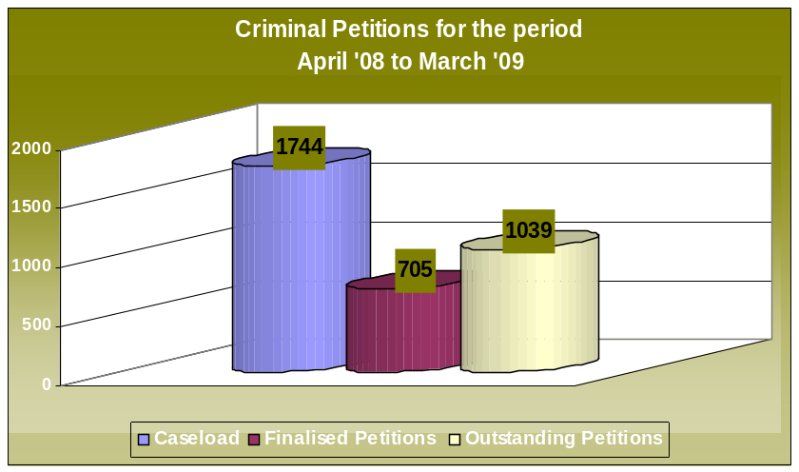

The above chart portrays that out of 1744 cases, only 705 (40%) of these cases were finalized and 1039 (60%) remained outstanding in the period under review.

High Courts Civil Trials
The High Courts had 15895 Old Civil Trials and received 15650 new civil trials during 2008/2009. 6286 civil trials were finalized and 25259 remains outstanding.

The high courts with the highest case load is North Gauteng High Court, (74.1%), Western Cape High Court (9.6%) and South Gauteng High Court (6.1%) in that order.

Figure 5: Comparative Analysis for HC Civil Trials: April 07-March 08 VS April 08-March 09.

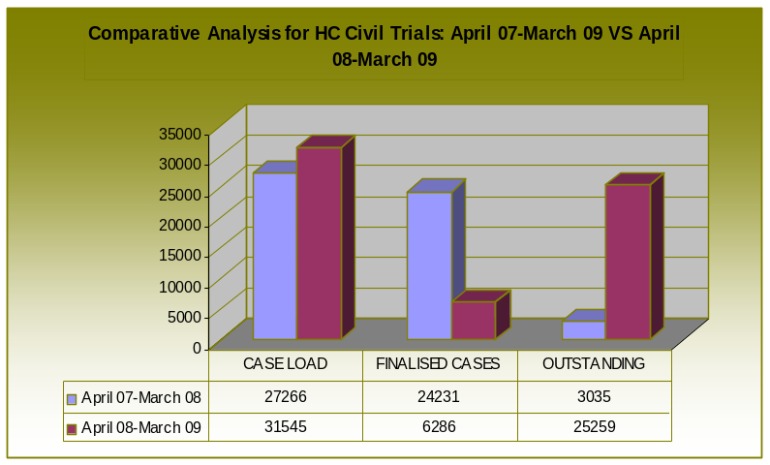

The chart above shows that the case load increased by 4 279 and finalized cases decreased by 17 945 cases which resulted in an increase of 22 224 outstanding cases.

Motion Applications
The High Courts had 24395 Old Motion Applications and received 59722 Motion Applications during 2008/2009. 54427 Motion Applications were finalized.

The courts with the highest case load are the North Gauteng High Court with 43 538 of which 26 510 (60.9%) cases were finalized, followed by the Western Cape High Court with 11 165 of which 9 169 (82.1%) cases were finalized, Pietermaritzburg High Court with 8 692 of which 2 810 (32.3%) cases were finalized and South Gauteng High Court with 6 806 of which 5 906 (86.8%) cases were finalized.

Figure 61: Comparative Analysis for High Court Motions:
April 07-March 08 VS April 08-March 09.

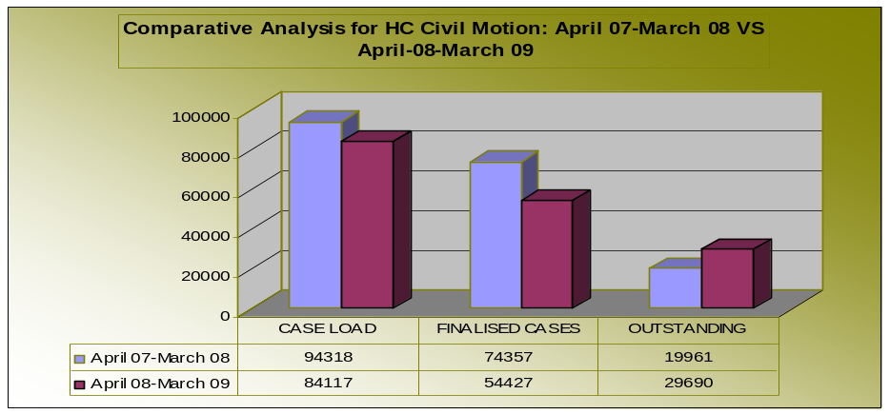

The chart shows a decrease in the case load of High Court Motions (10 201) and finalized cases(19 930) The outstanding cases has however increased by (9 729).

Default Judgments
A total of 46485 Default Judgments were received by the High Court and 26162 were finalized.

The courts with the highest case load are North Gauteng High Court with 29811 and out of this case load 13912 (47%) were finalized, followed by Western Cape High Court with 6956 and 5246 (75%) cases were finalized and thirdly South Gauteng High Court with 4115 and 2120 (51%) cases were finalized.

Figure 7: Default Judgments statistics from April 2008 to March 2009.

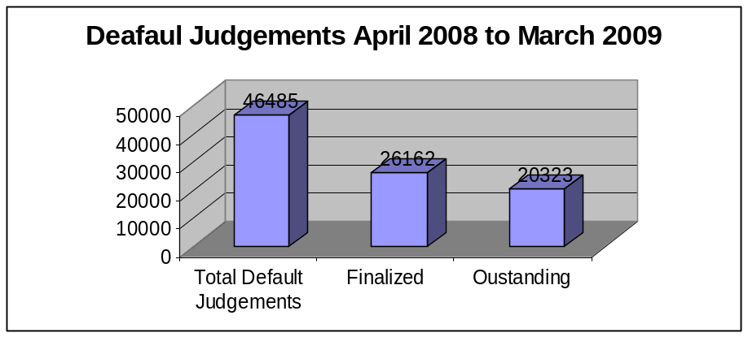

The graph above shows that from April 2008 to March 2009 there was a total case load of 46485 nationally and out of these case load 26162 (56%) cases were finalized and 20323 (44%) are outstanding.

Civil Appeals
The High Courts had 2742 Civil Appeals and received 447 New Civil Appeals during 2008/2009. 365 Civil Appeals were finalized.

The North Gauteng High Court had the highest case load of 2550 appeals as compared to all the other courts.

Figure 8: Comparative Analysis for High Court Civil Appeals: April 07-March -08 VS April 08- March 09.

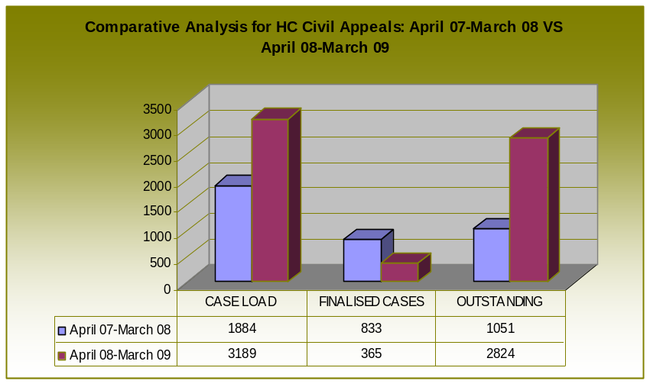

The chart above shows the total case load increased by 1305 cases in April 08-March 09. Finalised cases were much higher in (April 07-March 08) and decreased by 468 during April 08-March 09 and Outstanding Cases increased by 1773 cases during April 08-March 09.

Lower Courts
Civil jurisdiction:
- jurisdiction by consent if matter would otherwise fall outside jurisdiction (Section 45 of Magistrates’ Courts Act 32 of 1944)
- matters beyond jurisdiction (Section 46 of Magistrates’ Courts Act)
Criminal jurisdiction - Section 89 of Magistrates’ Courts Act:
- regional courts have jurisdiction in all matters except treason
- district courts have jurisdiction in all matters except treason, murder and rape
Penal jurisdiction - section 92 of Magistrates’ Courts Act:
- regional courts has jurisdiction to impose imprisonment not exceeding 15 years, fine not exceeding R300 000 (amount determined by notice in Gazette)
- regional courts has jurisdiction to discretionary minimum sentence for certain serious offenses (Criminal Law (Sentencing) Amendment Act.2007)
- district courts has jurisdiction to impose imprisonment not exceeding three years, fine not exceeding R60 000 (amount determined by notice in Gazette)

Other jurisdiction as determined by various Acts of Parliament, notably the following:
- hearing of (civil) appeals against decisions by Chiefs and Headmen (Section 12(4) of the Black Administration Act 38 of 1927)
- every magistrate’s court is a maintenance court for the purposes of that Act (Section 3 of the Maintenance Act 99 of 1998)
- holding of inquests by magistrates or regional magistrates (Section 6 of the Inquests Act 58 of 1959)
- adjudication of matters emanating from the Act, including liquidation of Close Corporations (Section 7 of the Close Corporations Act 69 of 1984)
- review of administrative actions (Section 1 of the Promotion of Administrative Justice Act 3 of 2000)
- applications regarding decisions not to disclose information (Sections 1 and 78 of the Promotion of Access to Information Act 2 of 2000)
- every magistrate’s court is an equality court (Sections 1 and 16 of the Promotion of Equality and Prevention of Unfair Discrimination Act 4 of 2000)
- every magistrate's court is a children's court (Section 4(2) of the Children's Act 33 of 1960)
- Divorce matters (Section 10(1) of the Administration Amendment Act 9 of 1929)
- Small claims matters (Sections 15 (causes of action) and 16 (matters beyond jurisdiction) of the Small Claims Courts Act 61 of 1984)

A positive clearance ratio was managed by the Lower courts during the financial year 2008/09. A total of 1,056,482 new cases were enrolled by the Lower Courts and 1,068,457 cases were disposed which means that 11,975 more cases were disposed than received. The Lower courts should be commended for their outstanding performance.

The following graph illustrates the input and output of the courts:

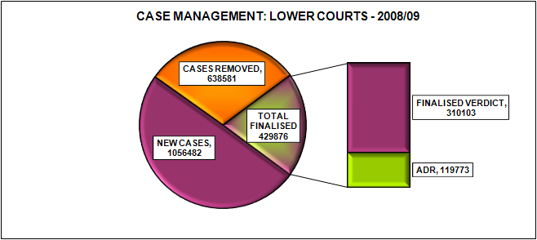

NEW CASES

An increase of 2.1% is noted in the number of new cases received by the Lower Courts during 08/09 compared to the total new cases enrolled during 07/08. The inflow of new cases in the District courts increased also with 2.1% and in the Regional courts with 1.6%.

The number of cases carried over from the previous financial year (end of March 2008) comprised a total of 231 203 cases of which 17% were backlog cases. The number of cases carried forward to the 2009/10 financial year has increased marginally with 0.7% to a total of 232 766 cases with a total of 42 272 backlog cases. The backlog cases has increased with 7% compared to the total of 39 519 recorded the previous year. A focused approach by the Lower courts (specifically the district courts) during the 2009/10 is therefore required to reduce the number of backlog cases.

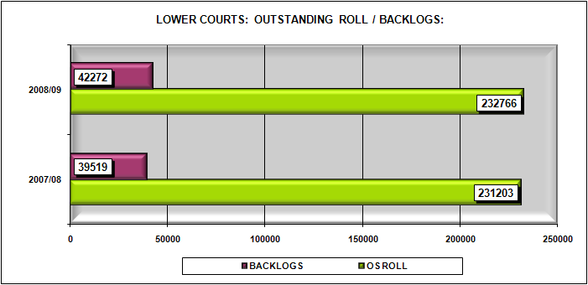

The table below indicates that the outstanding cases in the Regional courts have increased more than the outstanding cases in the District courts.

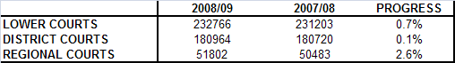

A different scenario is illustrated with the backlog cases. The number of backlog cases in the District courts has increased significantly with 19.5% whilst the backlog in the Regional courts has been reduced by 9%.

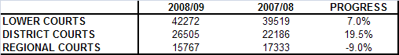

The Lower courts should be commended as they have managed an exceptional finalization rate during this financial year. The total number of cases finalised has increased with 11.2% The District courts managed a 10.2% increase and the Regional courts have managed a 14.8% increase. The high increase in the Regional courts could be ascribed to the additional assistance received from the Backlog courts.

CASES FINALISED WITH A VERDICT:
The Lower courts have increased the number of cases finalised with a verdict with 5.3%. This means that a total of 310103 trial cases were dealt with during 2008/09 –which is 15 670 more trial cases compared to the total of 294 433 finalised with a verdict during 2007/08.

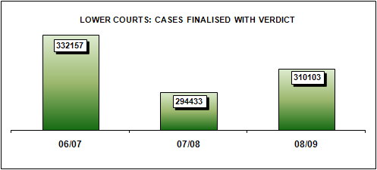

The table below illustrates the achievements of the Lower courts. The District courts have also increased their verdict cases with 4.2% which comprise a total of 10 926 more cases finalised than the previous year. They further managed a conviction rate of 88.1%. The Regional courts managed the highest increase of 13.6% comprising 4 744 more verdict cases finalised than in the previous year and they have also managed to attain their conviction rate target of 74%.

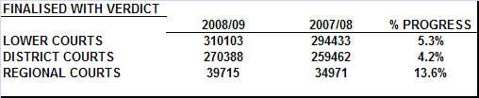

CASES FINALISED BY MEANS OF ADR METHODS:
The Lower courts have managed to increase the use of delivering justice through alternative ways by increasing cases finalised by means of alternative dispute resolution methods with 30.2% compared to the previous year. The number of diversions has been reduced with 5.9%, the number of admission of guilt accepted in terms of Sec 57A of Criminal Procedure Act, Act 51of 1977 has increased with 26.2%. A significant increase of 147% is also noted in the number of cases finalised by means of informal mediations.

The District courts managed a 29.9% increase in the use of suitable alternatives to punitive justice while a significant of 60.2% increase is noted in the Regional courts.

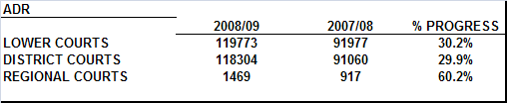

OUTPUT: CASES REMOVED FROM THE ROLL
The Lower courts have managed to reduce the number of cases removed from the roll with 2.5% as 16 453 fewer cases have been removed compared to the previous year. The District courts managed a 2.6% reduction and the regional court a 1.8% reduction.

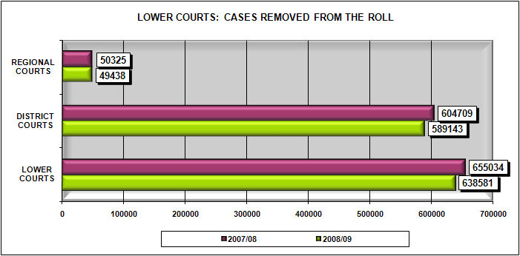

WITHDRAWALS:
It is evident that the Lower courts have improved their screening processes as a reduction of 6.2% is noted in the number of cases withdrawn.

WARRANTS:
The number of cases removed from the roll due to warrants being issued for the accused has increased with 3.9% in the Lower court. During 2008/09, an average of 16 616 cases were removed from the roll due to warrants issued as opposed to the 15 997 cases removed during the previous year. A reduction of 1.2% is however noted in the Regional courts.

CASES STRUCK FROM THE ROLL
The Lower courts have also managed a reduction of 3.3% in the number of cases struck from the roll. A matter of concern is however the 3.3% increase in cases struck from the Regional court rolls. The reduction in the District courts is however very positive.

REGIONAL COURT DIVISION: CRIMINAL TRIALS

4% of accused registered to appear in the Regional Court are less than 18 years of age, and 13% are between the ages 18 and 20 years, 24% are between the ages 21 and 25 years, 23% are between the ages 26 and 30 years, 15% are between the ages 31 and 35 years and 9% are between the ages 36 and 40 years.

Murder and rape are the highest common related charges registered by all provinces; except in Limpopo and Gauteng were murder does not feature among the highest three main charges. In Gauteng the highest registered charges are Rape, House Breaking and Robbery under Aggravated Circumstances and in Limpopo are Rape, Assault and House Breaking. The highest rape charges are registered in Gauteng (3588), followed by KZN (2805) and Western Cape (2758).

For the previous financial year (April 2008 to March 2009) a total of 84,481 new cases were enrolled by the Regional Court Division. A total of 41,133 criminal trials were finalized during the same period. The division with the highest new criminal trials enrolled is Gauteng (28.6%), KwaZulu-Natal (18.2%) and Western Cape (13%).

Figure 9: Trials Comparative Analysis: April 07-March08 vs April 08- March09
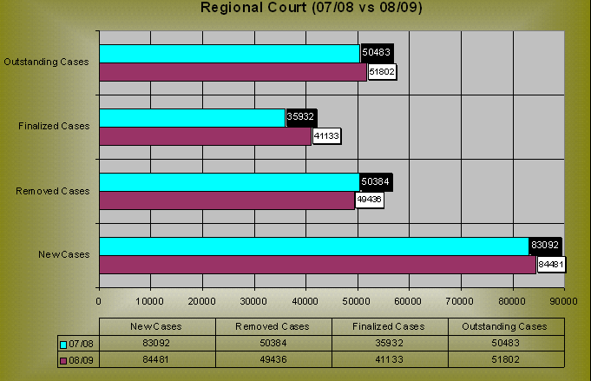

Compared to the 2007/2008 financial year the number of new cases increased by 1.7%, the total number of cases removed from the roll decreased by 1.9%, cases finalized increased by 14.5% and the outstanding cases on the court roll increased by 2.6% for the current period (2008/2009).

69.2% of cases within the Regional Court Division are completed within six month, 81.5% within 9 months and 88.2% of cases within 12 Months. A small percentage (about 0.2%) of cases were completed above 5 years

DISTRICT COURTS: CRIMINAL TRIALS
4% of accused registered to appear in the District Court are less than 18 years of age, and 10% are between the ages 18 and 20 years, 22% are between the ages 21 and 25 years, 21% are between the ages 26 and 30 years, 14% are between the ages 31 and 35 years and 11% are between the ages 36 and 40 years.

Assault, Theft and Traffic related charges are the highest common main charges registered throughout the country by all Provinces with the exception of North West where House Breaking related offenses are fairly high and Western Cape were Drug related offenses are also fairly high as well.

For the previous financial year (April 2008 to March 2009) a total of 973,658 new cases were enrolled by the Magisterial District Courts. A total of 388,797 criminal cases were finalized during the same period. The province with the highest new criminal cases enrolled is Western Cape (23.5%), Gauteng (19.1%) and KwaZulu-Natal (14.5%).

Figure 10: Trials Comparative Analysis: April 07-March08 vs April 08- March09

District Court (07/08 vs 08/09)
973658
590160
388797
181267
952163
604571
350396
180720
0
200000
400000
600000
800000
1000000
1200000
New Cases
Removed Cases
Finalized Cases
Outstanding Cases
07/08
952163
604571
350396
180720
08/09
973658
590160
388797
181267
New Cases
Removed Cases
Finalized Cases
Outstanding Cases

Compared to the 2007/2008 financial year the number of number of new cases increased by 2.3%, the total number of cases removed from the roll decreased by 2.4%, cases finalized increased by 11% and the outstanding cases on the court roll increased by 0.3% for the current period (2008/2009).

77.3% of district court cases are completed within six month, 87.5% within 9 months and 92.1% of cases within 12 Months. A small percentage (about 0.7%) of cases were completed above 5 years

At the end of March 2009, 27.6% of cases were outstanding for more than 6 months, followed by 13.8% for more than 9 months, 8.2% for more than 12 months, 3.7% for more than a year and 2% for more than 24 months.

Lower Courts Civil Trials
The lower courts had 292684 old civil cases and received 693911 new civil cases during 2008/2009. 476660 cases were finalized.

Western Cape Province has the highest percentage case load (23%) followed by Gauteng (20%) and KZN (14.9%). North West Province has the highest finalisation percentage (72.2%) followed by Mpumalanga (71.1%) and Limpopo (68.8%). Western Cape Province has the highest percentage pending cases (61.4%) followed by Free State and Eastern Cape respectively (58%)

Lower Courts Civil Reviews
The lower courts had 13529 old civil reviews and received 3245 new civil reviews during 2008/2009. 9570 reviews were finalized.

Figure 11: Civil Reviews for the lower court (April ’08 – March ’09)
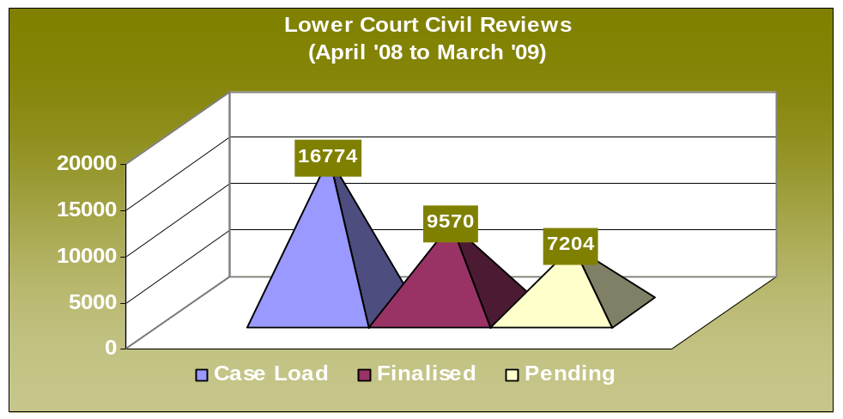

Mpumalanga Province has the highest percentage case load (43%) followed by Eastern Cape (17.6%) and Gauteng (10.4%). Western Cape Province has the highest finalisation percentage (95.1%) followed by Mpumalanga (90.5%) and Gauteng (88.6%). Limpopo Province has the highest percentage pending cases (95%) followed by Free State (89.2%) and Eastern Cape (87.4%).

Lower Courts Default judgments
372 007 Default Judgments to the value of 1.7 billion were issued by the Clerk of the Civil Court against individuals. 72990 Default Judgments to the value of 1.5 billion were issued by the Magistrates against individuals.

18707 Default Judgments to the value of 277 million were issued by the Clerk of the Civil Court against businesses. 31861 Default Judgments to the value of 306 million were issued by the Magistrates against businesses.

PLEA AND SENTENCE AGREEMENTS ALL HIGH AND LOWER CRIMINAL COURTS:
The national number of Plea and Sentence Agreements in terms of Section 105A of Act 51 of 1977 has been reduced from 1142 the previous year to 1120 agreements during 2008/09 financial year. Noteworthy is the fact that the number of matters in which direct imprisonment were agreed to, has increased from 31% of the cases to 35%. The following graph illustrates the sentences agreed to during the plea agreements concluded:

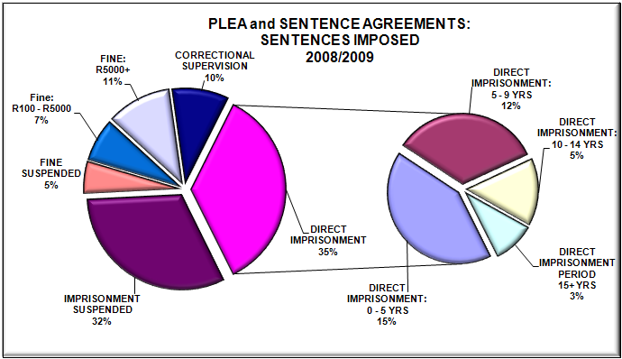

Small Claims Court
The court had a total of 46361 old Small Claims Cases and received 76329 new cases during 2008/2009. 37226 cases were finalized and 85464 are still outstanding.

Figure 12: National Small Claims Court Statistics from April 2008 to March 2009

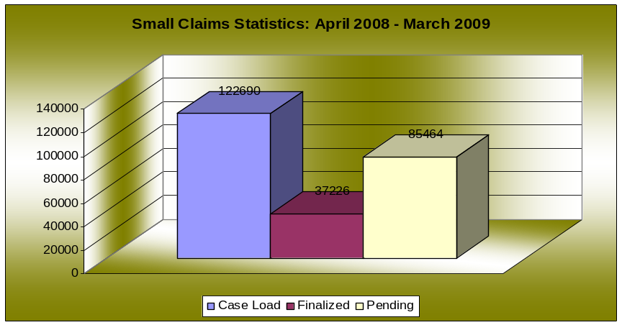

The chart above portrays that from April 2008 – March 2009 there was a total case load of 122690 nationally. Out of this case load 37226 (30.3%) cases were finalized and 85464 (69.7%) are pending cases.

Gauteng Province has the highest case load (40172) followed by Eastern Cape (20461) and Western Cape (14613). Gauteng Province has finalised the most cases (12334), followed by KZN (4451) and Western Cape (4268). Gauteng Province has the highest pending cases (27838) followed by Eastern Cape (16438) and Western Cape (10345).

Equality Courts
During 2008/2009 the equality courts received 10 harassment cases, 27 unfair discrimination cases, 18 hate speech cases and 4 dissemination and publication that unfairly discriminates.

Kwa-Zulu Natal, Mpumalanga and Western Cape all had the 2 cases for harassment. North West had a high number of Unfair Discrimination indicated by 7 (26%), followed by Gauteng, Mpumalanga and Western Cape. Kwa-Zulu Natal had the highest number for hate speech (5), followed by Mpumalanga and Western Cape.

Figure 13: Equality comparative Analysis: April 07-March 08 vs. April 08-March 09
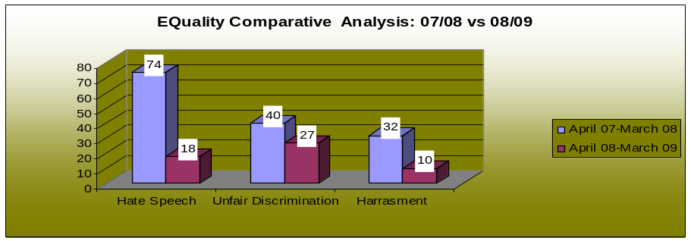
The chart above portrays a decrease in all relevant complaints.

Divorce Courts
The three divorce seats granted 21867 divorces during 2008/2009 and issued 36350 divorce summonses, and achieved 5857 divorce settlements.

Figure 14: Divorce Court Statistics from April-March 2009

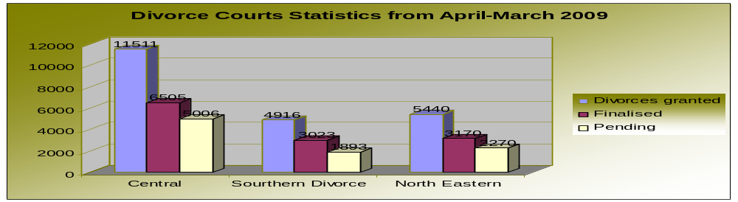

Children’s Courts
During 2008/2009 the courts received 5217 adoptions and 1003 inter country adoption. 60051 children were in need of care. 64236 children were placed with foster care.

The number of children in need of care is the highest in KZN (21257), followed by Eastern Cape (8693) and Gauteng (7349). The same order is visible in respect of children placed in foster care; that is KZN (21475), Eastern Cape (11393) and Gauteng (8065).

Figure 15: Children’s Court statistics from April 2008 to March 2009

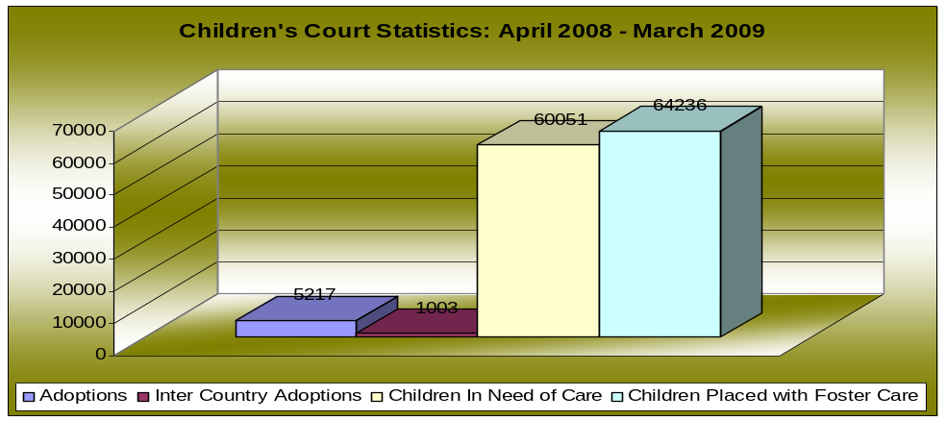

Maintenance Court
During 2008/2009 the maintenance courts received a total of 109890 maintenance applications and dealt with 156356 maintenance enquiries. 5315 maintenance orders were issued by default and 14525 section 31 cases were finalized. 19746 emolument orders and 2591 warrants of execution were issued.

Western Cape Province received the highest number of enquiries (34718), followed by KwaZulu-Natal (30684), and Gauteng (21121).

The highest number of applications received was from Western Cape province (22855) followed by Gauteng (17374) and Eastern Cape (16499).

The graph below reflects comparative statistics pertaining to enquiries, orders and warrants relating to maintenance matters for the period 07/08 vs 08/09.

Figure 16: Maintenance comparative analysis: April 07-March 08 vs April 08-March 09

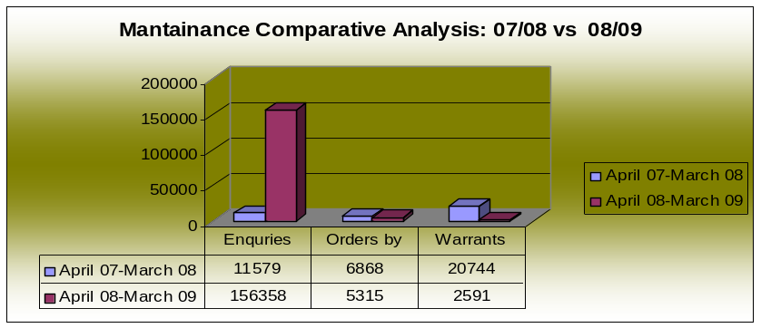

Maintenance inquires increased by 144779, orders by default decreased by 23% and warrants of execution decreased by 88%.

Domestic Violence

During 2008/2009 222919 new Domestic Violence applications were received. 177133 orders were granted, 89614 were made final, 27984 were set aside and 85330 were withdrawn or struck off the roll. 17396 warrants were issued for breach of protection order.

CASE FLOW MANAGEMENT AND MODERNISATION ISSUES

Court Performance is engaged with the following priorities in rendering support to the courts:

1. INTEGRATED CASE FLOW MANAGEMENT (ICFM) - Case Flow Management has been introduced in our courts since 2002 as an initiative to monitor the flow of cases, from the point of initiation through to finalization. The system has been introduced as a way of changing perception on public confidence in the justice system which had been severely tarnished prior to democratization. Issues that gave rise to the lack of confidence include the following:
- A high rate of uncontrolled postponements of matters at court,Many lost or missing files and charge sheets resulting in cases/court rolls collapsing,
- Court rolls lack integrity with the result that witnesses and legal representatives do not take court dates seriously,
- Lack of co-operation from relevant role-players and absence of a common system vision,
- Lack of accountability throughout the system resulting in loss of productivity due to non value adding activities to the court system,
- Criminal courts experiencing most serious problems with protracted delays in finalizing cases.

Magistrates Empowerment Workshops: Court Performance in consultation with the LCMC conducted 20 workshops nationally with both Regional and District court magistrates, the objectives being to equip magistrates with skills, knowledge, understanding and expertise in order to develop and facilitate court and case flow management. A total of 256 district and 109 regional court magistrates were empowered on the principles of CFM.

CFM Guidelines: The integrated CFM guidelines have been revised and the enhanced version of the guidelines is in the process of being prepared for printing, binding and distribution.

Court Management Development: A total of 100 court managers have been enrolled into a two year learnership to assist them with the skills and competencies required to manage the functions of the courts. The learnership was concluded with a graduation ceremony in March 2009.

Court Interpreters’ learnership: a two year learnership program is currently in place and 100 interpreters have been attending the internship which commenced in 18 February 2008. The University of Free State has been appointed as the Service Provider and the learnership has been evaluated at NQF level 5 with 240 credits.

- LANGUAGE SERVICES – South Africa as stated in the Constitution Act has eleven (11) official languages, namely; Sepedi, Sesotho, Setswana, IsiSwati, Tshivenda, Xitsonga, Afrikaans, English, IsiNdebele, IsiXhosa and IsiZulu. All these languages according to the Constitution of South Africa 1996 must enjoy parity of esteem and must be treated equally. Section 35(3)(k) of the Constitution has a bearing on the language usage in courts in that the accused person must be tried in the language that he or she understands, or if that is not practicable, to have the proceedings interpreted in that language.
It is in view of the above challenges that the previous Minister identified as one of the Departmental priorities, the piloting of indigenous language court proceedings in all regions. To this end, the DG also engaged with the DG in the Department of Arts & Culture to solicit partnership on linguistic services and expertise to help create internal capacity in the courts.
The piloting of indigenous languages in all regions has commenced during February 2009 and the courts with the respective indigenous languages are reflected in the table below:

 | Province | Court | Dominant Language
1 | KZN | 1. Msinga @ court room A  2. Hlabisa MC  3. Impendle MC court room A  4. Nongoma | isiZulu  isiZulu  isiZulu  isiZulu
2 | Free State | Thaba Nchu MC | Sesotho and Tshwane
3 | North West | Lehurutshe MC court room A | Setswana
4 | Western Cape | Khayelitsha MC | isiXhosa
5 | Eastern Cape | Zwelitsha MC E court | isiXhosa
6 | Northern Cape | Kimberley MC @ court A | Setswana
7 | Limpopo | 1. Malamulele  2. Dzanani  3. Sekhukhune | Tsonga/Shangaan  Tshivenda  Sepedi
8 | Mpumalanga | Mdutjana | isiNdebele
9 | Gauteng | Attridgeville | Setswana

Other interventions are also in place to support the transformation of language services in the courts which include change management for serving interpreters; language proficiency training; linguistic internship in partnership with Department of Arts and Culture (DAC) and universities; development of legal terminology in indigenous languages; transforming the role of interpreters to become language practitioners; creating translation capacity; piloting of simultaneous interpretation targeting foreign languages; partnership with Justice College for training of interpreters to be conducted by linguists and establishment of a language unit in the Department.

3. TRANSCRIPTION SERVICES - In its endeavor to meet its Constitutional obligations the Department of Justice and Constitutional Development committed itself to providing efficient transcriptions of court recordings. Transcription services to provide for all the courts countrywide were procured and are currently performed by service providers outside the Department as an outsourced entity. The contracts will be expiring in November 2009 and processes have already been put in place to ensure that the tender procedures are followed to secure new services timely without disrupting services in the courts.

4. AUDIO VISUAL POSTPONEMENT PROJECT - This project obtained its basis from the initial Criminal Justice Review quick-fix recommendation to explore the use of technology as a means to fast track the enormous number of postponements that were crippling the smooth operations in our courts. The SALRC finalised a Report in July 2003, recommending legislation pertaining to audio-visual remands, under Project 113. The concept was thereafter researched and the video remand system introduced for the first time in Kwa-Zulu Natal during 2005 linking two separate courts to a single Correctional Centre. The system has been successfully utilised and since inception a total of 7200 cases has already been processed. The project gained momentum after the benefits to the utilisation of the AVR system was realised and a national roll-out of the system was approved.

The tender processes have been finalised and deployment of the system to the identified high volume courts and correctional centres have already commenced. A total of 47 court rooms and 36 correctional sites (virtual courts) have been scheduled to be completed within this financial year. The project is well on track and stakeholder buy-in and change management processes are currently underway in all provinces.

Amendments to the legislation which provides for the creation of an enabling environment and the utilization of the system has already been finalised and provided for in the Criminal Procedure Amendment Act 65 of 2008 with the Regulations and date of implementation of the Act still being awaited.

5. LAY ASSESSORS SYSTEM - The lay assessor system was introduced to comply with the Constitutional mandate relating to the involvement of communities in judicial matters other than judicial officers in court decisions. Parliament deemed it important to further entrench and promote community participation in the administration of justice in order to restore the legitimacy of the courts in the eyes of the public. The Magistrates Court Amendment Act, 1998 was passed for the utilization of lay assessors. Section 93ter of the Magistrates Court Act 32 of 1944 has been amended to remove the discretionary powers of judicial officers to provide for the utilization of assessors. Draft regulations have been amended in accordance with the previous Deputy Ministers views but have not been promoted further and have consequently been left in a state of limbo.

6. E-SCHEDULER/ICMS – the e-scheduler (an electronic case flow management system) is a web-based electronic system that has been developed and deployed in 471 courts to assist the management of criminal matters enrolled in courts. It is one of the key projects undertaken within the DoJCD to improve the management and productivity of the courts. It allows for access by all court users (Judiciary, Prosecution and Court Support Services personnel) within the Department, based on a security policy of open and view access.

The e-scheduler has since 2007 been evolved into an Integrated Case Management System (ICMS) which has been developed in phases and provides for electronic case management systems to the entire court industry. The criminal and civil module of the ICMS is currently being deployed into courts for utilisation.

REGIONAL COURT CASE BACKLOG REDUCTION PROJECT

This project was initiated in November 2006 as a result of the realization of the high level of case backlogs in the country. It was realized that there are too many cases that are not being finalized speedily enough on the court roll. Since the project was initiated significant progress has been made in the reduction in regional court backlogs, despite the challenges that have been encountered in centres that were identified as pilot sites.

Backlogs are measured as cases which are part of the outstanding roll for longer than a certain period, namely District Courts: cases longer than 6 months on that roll; Regional Courts: cases longer than 9 months on that roll and High Courts: cases longer than 12 months on that roll.

REDUCTION IN BACKLOGS PROGRESS

- At the specific Case Reduction Backlog sites

Backlog cases (that is, those cases more than 9 months on the regional court rolls) in the regional court hotspots, during the past financial year, were reduced at the current 38 backlog sites with 4497 cases that were finalised, representing a 13.3% reduction, notwithstanding the fact that the number of outstanding cases on the court rolls (that is, all the cases that are still to be finalised in the regional courts) at those backlog sites increased by 1.8%.

- Nationally

At the end of March 2008, the country-wide regional court situation reflected 17 333 backlog cases (34% backlog) on an outstanding roll of 50 483. At the end of March 2009, this was reduced to 15 767 cases (30% backlog) on an outstanding roll of 51 802. This reflects a reduction of 9% on the country-wide backlog cases of all regional courts for the past financial year.

BACKLOG ROLLS AT THE END OF MARCH 2009

PERIOD | OUTSTANDING ROLL | BACKLOG | BACKLOG %
 | High Courts
End March 2009 | 1192 | 223 | 18,7%
 | Regional Courts
End March 2009 | 51802 | 15767 | 30,4%
 | District Courts
 | 180964 | 26505 | 14,6%
 | Lower Courts (DC & RC)
End March 2009 | 232766 | 42272 | 18,1%
 | All Courts (HC, RC, DC)
End March 2009 | 233301 | 42351 | 18,2%

The Project is an integrated project between the Department of Justice and Constitutional Development, the NPA, LAB, the SAPS and the Regional Court Presidents, co-ordinated by the Department of Justice and Constitutional Development. Through additional funding received from National Treasury, specific interventions, such as additional capacity, is put in place – the aim is improved case flow management, screening and effective use of court hours and to deal with this the goal is to have at least 2 prosecutors and 2 legal aid representatives per backlog court to deal with the backlog matters more effectively.

The case reduction backlog project has been integrated into the Review of the Criminal Justice System process. This entails that where required in terms of interventions on an urgent basis – e.g. the prioritisation of xenophobia matters, inquest backlogs and election criminal matters - the backlog courts are also used. The monitoring of the backlog rolls includes an analysis of all outstanding regional court cases at that site, promoting the re-screening and re-prioritization thereof, and includes the promotion at Provincial and local levels of holistic operational plans; liaison with the relevant Regional Court President, Director of Public Prosecutors (DPP), SAPS and the Regional Heads of the Department of Justice and Constitutional Development (DOJCD); as well as the strengthening of governance and monitoring aspects pertaining to these interventions and the backlog courts in general.

The backlog reduction project has thus far helped to stabilise the rolls in the regional courts and has also helped to increase the performance in those regional court centres where they were established as a focus area and though the number of outstanding cases on the court rolls country-wide has generally increased in the lower courts and also the regional courts – the number of backlog cases (i.e. those longer than 9 months on the regional court roll) has decreased as a result of the functioning of the backlog reduction sites.

Since the reduction of case backlog project was initiated in 2006 as a specific intervention to deal with the large number of backlog cases in the regional courts, there has been a very positive reduction in the backlog percentage in the regional courts. Statistics indicate a steady decrease in the number of all regional court backlog cases country-wide (and not just at the 38 backlog sites:
- The backlog number initially was 20 452 backlog cases (representing a 43% backlog) (on an outstanding roll of 47 343) in November 2006.
- At the end of March 2007, the situation reflected 18 619 backlog cases (39% backlog) on an outstanding roll of 47 926.
- At the end of March 2008, the situation reflected 17 333 backlog cases (34% backlog) on an outstanding roll of 50 483.
- At the end of March 2009, 15 767 (30% backlog) on an outstanding roll of 51 802.

This reflects a steady continuous reduction in backlog cases. It also shows a reduction of 9% on the country-wide backlog cases of all regional courts for the past financial year.

The current 38 case reduction backlog courts have sat on average 3h34 minutes per day since 1 Nov 2006 till the end of March 2009. They received 11 978 cases in total and finalized hereof 8855 cases (73.9%) as follows:
- Guilty: 6581 (75, 7%) (of which 371 were as a result of plea bargains)
- Not guilty: 2114
- Diversions: 69
- Admission of Guilt: 91

Cases removed at these case reduction backlog sites through re-screening and withdrawals were 3649, whilst, they also transferred externally 609 cases to other courts (eg. To higher courts for sentencing ito minimum sentences previously)

The total number of cases permanently removed from the regional court rolls as a result of the backlog courts from November 2006 till the end of March 2009 is 13 113 (comprising 8855 cases finalized + 3649 withdrawn after rescreening of regional cases at backlog sites + 609 transferred). (At the end of April 2009, the number of cases finalised increased to 9229 cases.)

The number of 4685 less country-wide backlog cases (20 452 (backlog November 2006) – 15 767 (backlog March 2009 = 4685) on the regional court rolls, is however, in fact a 22.9% reduction from the initial number of backlog cases (20 452) when the project started in November 2006 – this notwithstanding the fact that there was an increase in the number of new cases to the regional courts and an increase in the number of outstanding cases (from 47 343 in 2006 to 51 802 at the end of March 2009 = 4459 cases (9,4% increase).

If we subtract the total number of cases removed as a result of the Backlog courts (13 113) then the impact is a 64% decrease in cases on the roll (from the 20 452 backlog cases on the roll in November 2006) and a significant positive impact on what the rolls would have been now without the backlog courts.

- POSITIVE ASPECTS FLOWING FROM THE REGIONAL COURT CASE REDUCTION BACKLOG SITES

- The number of partly heard matters has come down and the average conviction rates for all the backlog courts are satisfactory (approx 77% against the average of all regional courts of 73%). Most backlog courts have double the finalisation rate per month than normal regional courts (the backlog courts finalise on average 10 plus cases p.m.)
- The places with channelisation courts to prevent that the regional courts just become bail/ remand courts have also shown increased productivity. For example in Pretoria a channelization court was established to help deal with all the postponements and bail applications for the regional courts and now for the first time in 2 years the regional court outstanding rolls for Pretoria have come down to below 200 per court.

- GOOD PRACTICES THAT ARE BEING PROMOTED

- Additional prosecutors and legal representatives have been the key success factor of backlog courts. In addition to additional prosecutors for these courts, the Legal Aid Board has appointed additional legal representatives where required for the backlog and other regional courts and has also ensured that they improve consultations before the trials with their clients and so improve court productivity.
- More cases are finalised in view of better court preparation by the prosecutors and better consultation with the witnesses because the backlog rolls consist of only trial ready cases. Improved screening of the cases indicated where further investigation were required that could be quickly followed up and where there were no further prospects of success (for example witnesses not traced etc.) they could withdraw the cases quicker. This has all assisted in ensuring less wastage of court time (for example, cases having to stand down or the court having to adjourn repeatedly).
- Case cycle time has improved in general at these sites and as a result of the closer scrutiny of the court rolls by the Regional Court presidents and the coordinators of the court rolls, better workload spread is been implemented across the various normal regional courts.
- The focus has also been to bring the oldest long outstanding cases forward for speedier finalisation.
- A big positive factor is the existence of a good working relationship between key role-players within the provinces, for example the Director of Public Prosecutions and his staff members (DDPP’s, Chief Prosecutors and SPP’s), the Judiciary (Regional Court President and the Chief Magistrates) the Regional Head of Justice, Head of Detectives (SAPS), Heads of Legal Aid Board and other role-players form the members of the provincial case flow management team and interact on a regular basis to plan activities and resolve challenges. They also promote the establishment and monitoring of the backlog court sites.
- The cases are finalised speedier if a continuous roll is used, such as is the case in the backlog courts.
- In addition to country-wide case flow management meetings held with all role players to improve the effectiveness of the courts, a National Intersectoral Case Backlog Reduction Workshop was held on 14/15 May 2008 to obtain more buy-in into the backlog project, find consensus on operationalising the project more efficiently.

- CHALLENGES

The project includes an analysis of all outstanding regional court cases at the various sites, re-screening thereof and re-prioritization which includes liaison with the relevant regional court president. From this analysis, the following has become clear:

- There is a need to establish additional capacity in some areas – for example North West, but accommodation is an acute challenge at the sites required. Mobile courts are now being planned as well as possible other options.
- There are challenges in dealing with certain district court matters that are creating backlogs; in this regard inquests are problematic in the Western Cape and assistance will be provided to deal with this.
- Additional traffic courts for the Western Cape and Gauteng have also been requested as the workload has increased substantially in that regard. This is being considered in conjunction with the move towards dealing with these matters in an administrative manner.
- A major challenge is currently being experienced in the district courts and a policy decision will be sought to also include the backlogs of the district courts under the backlog project. At present the focus is only the regional courts.

- WAY FORWARD

An operational plan for 2009/2010 is in progress and entails:
- Further additional backlog courts at all priority regional court sites countrywide;
- Reduction of backlogs at both regional and district court level;
- Improved case flow management and efficiency at court level;
- Improved finalization rates in all cases;
- Improved use of restorative justice and ADR;
- Further alignment with the CJS Review and implementation of good practices at other courts; and
- Strengthening of governance and monitoring aspects.

5. VICTIM SUPPORT & SPECIALISED SERVICES AND FAMILY ADVOCACY

OFFICE OF THE FAMILY ADVOCATE.

The purpose of the office of the Family Advocate is to promote and protect the best interest of minor and dependant children in matters relating to parental responsibilities and rights disputes.

The professional component of the office comprises of Family Advocates (Lawyers) and Family Counsellors (Social Workers). The Family Advocate renders legal as well as family mediation services through multi-disciplinary teams made up of lawyers and social workers so as to ensure a holistic and qualitative approach to the best interest of the children throughout the dispute resolution or adjudication process. Currently there are 16 service delivery points situate in the provinces, 55 Family Advocates, 10 Senior Family Advocates and 76 Family Counsellors on the establishment.
The mandate of the Family Advocate accords with section 28(2) of the Constitution, viz that “A child’s best interests are of paramount importance in every matter concerning the child”. The powers and duties of the Family Advocate are set out in section 4 of the Mediation in Certain Divorce Matters Act 24 of 1990 as follows:
    - To institute an enquiry so as to be able to furnish the court with a report and recommendation on any matter concerning the welfare of minor/ dependant child
    - to appear at the trial of any divorce action or the hearing of a related application
    - adduce any available evidence relevant to the action or application and
    - to cross-examine witnesses giving evidence at such trial or hearing of application.
Such powers and duties were subsequently extended to six other pieces of legislation thus extending the mandate of the Family Advocate from High Court work to include special divorce courts matters, disputes arising from customary and religious marriages, as well as children born out of wedlock.
In terms of amendments to the Domestic Violence Act and the Maintenance Act, presiding officers hearing maintenance and domestic violence cases can obtain Family Advocate reports regarding the best interests of the child prior to making orders. The clients of the family Advocate are consequently, members of the public, children as well as the courts hearing such matters. The primary need of the clients is speedy resolution of disputes as well as the availability of Family Advocates in court to ensure efficient completion of hearings. Children need to be served in a child favorable, non-intimidating environment which is sensitive to and responds to their developmental needs. The best interests of the child require that disputes be resolved in the most non-conflictual manner as possible.

The most prominent challenge facing the Family Advocate is staff shortage as well as limited accessibility: clients travel long distances to obtain the services. Courts often postpone matters, sometimes at parties’ costs due to delays in obtaining reports or availability of family advocates to appear in court. Such delays compromise the welfare of the child.

During the 2008/9 year the office of the Family Advocate has received 8 957 cases of which 8005 were finalized. The aforegoing figures exclude the backlog of 2937 cases accumulated over the past years.

INTERNATIONAL CHILD ABDUCTION

The Chief Family Advocate is the designated Central Authority for South Africa in terms of the Hague Convention on the Civil Aspect of International Child Abduction, which was ratified in 1996. The main function of the Central Authority is to ensure speedy return of children abducted to and from South Africa through the judicial process as well as to ensure that the child’s right to contact with both parents is not jeopardized unduly. This Convention is enforceable between South Africa and 47 countries.

MEDIATION SERVICES

The new Children’s Act 38 of 2005 came into operation (22 sections only) on 1 July 2007. The Act has expanded duties of the Family Advocate extensively. A rights based approach is propagated by the Act when dealing with children’s matters. Most notable is the introduction of compulsory mediation in section 21 i.e. disputes over parental rights and responsibilities of fathers of children born out of wedlock. Family Advocates and Family Counsellors provide the service through the co-mediation model. 80 members of the professional staff have been trained in mediation techniques focusing on family mediation.

During the 2008/9 year 3 014 request for mediations were received, 1 491 were completed by the personnel of the office while 1 523 were finalized with the assistance of NGO’s that specialize in family mediation.

GENERAL

The office of the Family Advocate has rendered over 120 parental education workshops in the different provinces whereby parents were educated about their rights and responsibilities over their children, promoting the new Children’s Act as well as mediation as an effective dispute resolution method. It is anticipated that as more people get to know and understand their rights the demand for service that are available under this new legislation will increase significantly.

VULNERABLE GROUPS

PRIORITIES
Project 1: Small Claims
- Develop a Policy Framework for Small Claims Courts
Project 2: Restorative Justice
- Develop a Policy Framework for Restorative Justice
- Formulate the DOJ Strategy
Project 3: HIV/AIDS
- Develop a Policy Framework on HIV/AIDS
- Formulate DOJ Strategy
Project 4: Mental Health
- Formulate a Policy Document for Mental Health
- Formulate DOJ Strategy
Project 5: Domestic Violence
- Develop a Policy Framework for Domestic Violence
- Formulate DOJ Strategy
Project 6: Children
- Develop a Policy Document
- Co-ordinate the Implementation of Chapter 4 of the Children’s Act
Project 7: Trafficking
- Formulate a National Policy Framework on Human Trafficking
- Formulate DOJ Strategy
Project 8: Sexual Offences
- Finalise the National Policy Framework
- Co-ordinate the Implementation of the National Register for Sex Offenders
Project 9: Maintenance
- Develop a Policy Framework for Maintenance
Project 10: Child Justice
- Drafting a National Policy Framework for Child Justice Act
- Co-ordinate Implementation of the Child Justice Act Nationally and in Regions.

ACHIEVEMENTS OF PROJECTS 2008/09

During this cycle, the following areas were prioritized and where gaps may appear, it reflects projects incomplete and likely to follow during the next cycle;
- Children, includes children in criminal and civil streams,
- Domestic Violence,
- Mental Health,
- Small Claims Courts,
- Maintenance
- Sexual Offences

Children
Child Justice
During this reporting period a great deal of time was spent in supporting the passage of the Child Justice Bill through the various stages of Parliament. To further augment this approach the Child Justice Bill, 2008 (No B49B of 2008) was passed by the National Parliament during November 2008, incorporating many of the practical strategies developed to divert as many as possible children out of the criminal justice system and into programs to assist the children, their families and communities and the victims of crime.

The Child Justice Bill will be the first legislation where operational systems and policies will be in place, before the implementation of the Act on the 1st April 2010. This marks a radical and positive shift in the management and implementation of legislation. By the time of compiling this report the Child Justice Bill was signed by the President on the 7th May 2009 and is now the Child Justice Act 75 of 2008.

Other activities related to Child Justice are the convening of the Inter-sectoral Child Justice Steering Committee (ISCCJ), on National level supported by the same structure in each of the nine provinces. This Committee also reports to the Justice cluster on its activities. This forum convened by the relevant government departments meet on a regular basis and include members from the relevant NGO’s and other civil society partners as well as the institutions protecting democracy such as the Human Rights Commission and the Office of the Public Protector. One of the major successes of this forum is the reduction of children awaiting trial by 50% during the past five years. Changing the system from an adversarial to a more restorative system has contributed greatly to this reduction.

Although accurate statistics from the various Government Departments concerned are difficult to ascertain, the average trends and numbers of children in conflict with the law in the criminal justice system, on a monthly basis, can be summarized as follows:

- Between 9 000 and 13 000 children are arrested by the South African Police Service on a monthly basis.
- Of these, the number is reduced by 50% within the first 48 hours when children are released into their parents’ or guardian’s care; released on warning or without charge; are found to have given wrong ages and are processed as adults through the courts, the cases are withdrawn by the National Prosecution Authority, or converted into children’s court inquiries. This means that approximately 4 500 to 5 000 cases on a monthly basis, are converted into Children’s Court Inquiries in terms of the Child Care Act, 1983 (Act No 74 of 1983), especially for younger children and children who have for example, committed theft or other socio-economic crimes, and these children are then declared as in need of care and protection and handled outside the criminal justice system.
- Of the remaining numbers of children in the criminal justice system, between 3 000 and 5 500 children go through the courts on a monthly basis.
- On average, 1 900 children are diverted from the mainstream criminal justice system on a monthly basis. This means that where children acknowledge wrong-doing, the prosecutor provisionally withdraws charges against the children, on condition that they attend diversion programs such as life skills and anger management programs. If the programs are completed successfully, the charges are withdrawn by the prosecution authority; but if not, the trials can still go ahead. Diversion has not been an option before 2003/04 in the criminal justice system and has increased by 20% each year. Approximately 48% of children, who appear in court, are diverted from the mainstream criminal justice system.
- Of the children who await trial and appear in court, approximately 1 000 children between the ages of 14 and 17, await trial on a monthly basis in correctional facilities (prisons), usually for serious and violent crimes.
- Approximately 3 000 children await trial in detention in Secure Care Facilities, Places of Safety and Home-based Supervision, run by the DSD.
- Of the numbers of children originally arrested and charged, approximately 1% is sentenced to direct imprisonment; whilst approximately 20% are sentenced to non-custodial sanctions, including correctional and parole supervision; community service and/or non-custodial programs similar to the diversion programs. Such programs will be tailor-made to each individual child offender and could include life skills programs, substance abuse programs, anger management programs, and restorative justice programs such as victim-offender mediation or family group conferencing. These last options will only be done after consultation and approval by the victim of the crime and/or family members.
- Approximately 5% of sentenced children are sentenced to Reform Schools at present being run by the Department of Education, which is also a custodial sanction. The facilities of the Reform Schools (sentenced children) and Schools of Industry (children in need of care and younger sentenced children), will be transferred to the DSD within the next two (2) years, in terms of Chapter 13 of the Children’s Amendment Act, 2007 (Act No 41 of 2007). The Reform Schools and Schools of Industry were established in terms of the Child Care Act, 1983 and its predecessors, to enable residential placement and schooling of children who may have behavioral challenges.

Increase in diversion and reduction in children awaiting trial may be attributed to the number of services and programmes on diversion. Some of the diversion programmes include Home Based Supervision.

The preliminary inquiry is further being piloted at Mangaung One Stop Child Justice Centre, which seems to indicate preliminarily, that only 7 to 21% of the children going through preliminary inquiries go through a full-blown criminal trial. This means that even though more emphasis will be placed on the preliminary inquiry, fewer children will go through full trials, and more children will need to go through diversion programs and be assisted by the Department of Social Development’s aftercare programs.

This centre also received the UN certificate of Recognition for Excellence in Urban Safety, Crime Prevention and Youth in September 2008.

Already in place in so far as Child Justice is concerned is the following, the development of training for all personnel within the criminal justice system, the manual is currently being tested and roll out for training will commence shortly thereafter.

Prior to the passing of the Child Justice Bill, the department as part of the its campaign to reduce the numbers of children in detention, created an enabling project by providing alternatives to detention with the support of The National Institute for Crime Prevention and Re-integration of Offenders (NICRO). In conjunction with the rest of the Criminal Justice Cluster-member Departments, a pilot project was launched during 2008, in 5 Magisterial Districts, namely, Odi, North-West; Kimberley, Northern Cape; East London, Eastern Cape; Bellville, Western Cape; and Randburg, Gauteng.

The figure below indicates the numbers of referrals, placements and successful completion of the programs concerned.

Table 1:Non-custodial Sanctions pilot project in 5 Magisterial Districts: February 2008 – March 2009
Number of cases referred for assessment | Number of cases recommended to programs | Number of offenders placed on NCS programs | Number of offenders who have successfully completed the NCS programs
292 | 184 | 107 | 15
Source: e-scheduler

Whilst the outcome of the project may seem to indicate low numbers, they must be seen within the more holistic perspective of transformation. The social ripple effect of 15 people being given a second chance in the community, as against being imprisoned, is valuable. In preliminary assessing further the low numbers, it was concluded that managing from an adversarial and punitive justice system to a restorative, therapeutic system need intensification both with personnel within the justice system as well as the general public, operational systems within and between departments needed further rigor and general communication within the national and provincial levels of government needed further improvement, the reporting time period was quite short within which matters were finalised for effective sentencing, amongst others. A more intensive and expansive assessment is currently underway. Nonetheless, these results provide invaluable in the setting up of the system in view of the implementation of the Child Justice Act.

The Child Justice act is dependant on the recently enacted Children’s Act, 2005 creating a natural link between the pieces of legislation. Preparation for both pieces of legislation is currently underway and will be more comprehensively reported on during the next cycle.

The Children’s Act places a great deal of emphasis on protecting children, including child-headed households predominantly created as a result of the Aids pandemic. These special categories of vulnerable children are specifically catered for as well as children that are trafficked amongst the provisions that relate to neglected, abused, exploited or vulnerable children in society. The Department of Justice & Constitutional Development is responsible for implementing Chapter 4 of this Act that manages child related matters as they are processed through the Courts. DOJ&CD forms part of the implementation task team convened by the Department of Social Development as the lead department responsible for the implementation of this Act.

Table 2: Children processed through Children’s Court: April 2008 – March 2009
Adoption | Inter-country adoptions | Children in need of care | Children placed in Foster Care
5217 | 1003 | 60 051 | 64 236

Domestic Violence
The Domestic Violence 116 of 1998 provides speedy interim and final relief to victims of violence in the family environment. Considering that this act has been in place for the past 10 years, the department of Justice and Constitutional development is currently reviewing the implementation with a view to ensuring further efficiency. In addition, the Chief Directorate has facilitated the development of Guidelines for the Implementation of the Domestic Violence Act 116 of 1998 (DVA) for the Magistrates in conjunction with the Family and Gender Service Delivery Committee of the Lower Court Management Committee (LCMC). These guidelines, which were developed by the Magistracy, were launched by the former Minister of Justice and Constitutional Development, Minister Ms Bridgette Mabandla, in June 2008. The guidelines will impact on the standardisation of the implementation of the DVA and also in the effective management of Domestic Violence cases within the Judiciary and the courts.

The Ndabezitha Training Project, which was initiated by the National Prosecuting Authority’s (NPA) SOCA Unit in collaboration with the DOJ & CD and the National House of Traditional Leaders, is a project that focuses on domestic violence. This project focuses on training traditional leaders and domestic violence clerks on the DVA and the utilisation of ADR and Restorative Justice processed in domestic violence cases by traditional leaders. Thus far 81 traditional leaders underwent the course offered.

Mental Health
During 2008/09, the Department of Justice and Constitutional Development identified the need for evidence based best practice development in the assessment, treatment and care of mentally ill persons in courts and the justice system. To this end, various collaborative processes between the relevant Government Departments, have commenced during 2008/09, based on the Forensic Mental Health Seminar facilitated by the Departments of Health and Justice and Constitutional Development in July 2008. This initiative was prompted by challenges with regard to the implementation of the Criminal Procedure Act, 1977, Act no 51 of 1977, the Mental Health Care Act No 17 of 2002, the Criminal Law Amendment (Sexual Offences and Related Matters Amendment Act), No 32 of 2007 and the Victims’ Service Charter relating to the forensic psychiatric evaluations, care, treatment and rehabilitation for awaiting trial prisoners, victims of crime and violence, state patients and mentally ill prisoners. A comprehensive strategy and plan to address the various shortcomings were still underway at the time of reporting.

Small Claims Courts
The Small Claims courts services are regulated by the Small Claims Act ?? and its related enabling legislation. These courts provide speedy and cost effective relief to minor civil disputes to the value of R7000, 00. In terms of this act, Small Claims Courts must be designated if an Advisory Board and Commissioners are appointed. With the assistance of the Legal profession especially attorneys, who provide their services voluntarily as well as the general public, 188 Small Claims courts have been established countrywide, 113 Advisory Boards set up and 114 Commissioners appointed. In further assisting access to justice, some of these courts are operational on Saturdays for administrative purposes of enabling to enable litigants to process their administrative processes. Attached, is a map depicting the number of Small Claims Courts countrywide.
Region | Old Cases | New Cases | Total Case Load | Withdrawn | Struck of the Roll | Dismissed | Granted | Out of Settlement
Eastern Cape | 8444 | 9448 | 17892 | 162 | 469 | 254 | 1531 | 868
Free State | 901 | 3451 | 4352 | 84 | 97 | 235 | 626 | 237
Gauteng | 17332 | 22836 | 40168 | 1999 | 2554 | 833 | 4466 | 426
KZN | 4457 | 8424 | 12881 | 89 | 1097 | 310 | 2316 | 407
Limpopo | 3119 | 7473 | 10167 | 162 | 477 | 276 | 1169 | 954
Mpumalanga | 1863 | 35714 | 6677 | 208 | 677 | 224 | 1096 | 734
North West | 3959 | 9689 | 13648 | 237 | 564 | 335 | 1358 | 509
Northern Cape | 257 | 992 | 1249 | 141 | 136 | 64 | 542 | 50
Western Cape | 4412 | 10669 | 15081 | 241 | 809 | 394 | 2385 | 222
Grand Total | 44744 | 108696 | 122115 | 3223 | 6880 | 2925 | 15489 | 4407

In addition to the Department’s allocation to managing the Small Claims courts services, the Swiss Development Agency for Co-operation contributes equitably in the re-engineering of small claims services. A National Steering Committee to oversee this portion of the project, whose membership comprises of representatives from the Law Society of South Africa, the General Council of the Bar, the University of Cape Town, DOJ & CD and the Swiss Agency for Development and Cooperation is convened periodically by the Deputy Minister of Justice & Constitutional Development.

This project has for the reporting cycle and in an effort to strengthen the functioning of these courts overseen the development of training manuals for Commissioners as well personnel working within theses courts. Roll out of training for these official and Commissioners will commence shortly.

Table 3: Statistical Data

In addition, the Department has set up an external space on the DoJ&CD website and ran several programmes on both local and major radio stations, namely Phalaphala FM (Tshivenda), Mongana Lonene FM (Xitsonga), Thobela FM (Sepedi), Ikwekwezi FM (isiNdebele), Lesedi FM (Sesotho), Ukhozi FM (isiZulu), Mhlobo wenene FM (iXhoza), Radion 702.

Maintenance
The Department further supported the Parliamentary hearings on the Extension of Civil Regional Jurisdiction Bill, 2008, during 2008, which will improve access to justice for persons requiring family law services as well, including access to Divorce Courts, as the Regional Courts will also now be able to hear civil matters and not only criminal matters. Policy proposals were made and supported; and the Department has developed a phased-in implementation plan together with budgets and the necessary resources, where the Chief Directorate: Promotion of the Rights of Vulnerable Groups, will ensure the transitional arrangements between the present Divorce Courts and the new Regional Courts enabled to hear Domestic Violence-cases.

As part of its Restorative justice programme and based on the number of instances, court clerks reported the intensification of family disputes as a result of unpaid maintenance monies, a test project within the current legislative framework was undertaken to provide mediation in resolving maintenance disputes. As a result maintenance personnel in the Johannesburg Family Court and the Pretoria Magistrate’s Court were provided with basic training on mediation skills. Subsequent to an external assessment of this project, it has been noted the utilisation of mediation skills by the court clerks assisted in alleviating the acrimony involved in resolving maintenance disputes. As a result thereof, the department will roll-out this training for all maintenance clerks.

As at August 2008, capacity for managing maintenance, in terms of the number of Maintenance Officers and Investigators appointed countrywide is depicted in the table and map below.

Table 4: Audit of capacity in Maintenance Courts: August 2008 – March 2009
Maintenance Officers | Maintenance Investigators | Admin Clerks in Family Law sections | Legal Interns | Maintenance Prosecutors | Senior Maintenance Prosecutors
171 | 200 | 855 | 43 | 118 | 10

Sexual Offences
The Criminal Law Amendment Act (Sexual Offences and related matters) 32 of 2007 (hereafter referred to as the Act) attempts to achieve, among other objectives; provision of services to certain victims of sexual offences and strives to eliminate secondary victimization. This is one of the achievements of public participation in drafting legislation that is responsive to social challenges and crime in South Africa. The Act expands on Constitutional guarantees of rights to privacy, dignity, freedom and security of the person, as well as the right to be free from all forms of public and private sources of violence.

The Act includes “new” categories of sexual crimes, for example ‘Compelled rape’ which is defined as a third party forces a person to have sexual acts with someone. Other forms of crime include Child prostitution, Engaging sexual services of person 18 years or older for financial reward – adult prostitution, Incest – sexual acts within the family, even if consensual, Bestiality – sexual acts with animals, Sexual acts with corpses, Sexual Offences, against persons with mentally disability, Statutory rape – 12 years or older but under 16 years, Child pornography. The Act also seeks to address one of the dire consequences of rape; exposure to HIV/AIDS. The Act makes provision for the right to apply for HIV testing of an alleged sexual offender, thus affording victims with an appropriate legal response to the crime of sexual violence. With an expanded definition of sexual violence, the Act has placed significant degree of responsibility on government departments to deliver services, based on human rights, responsive to challenges of socio-economic conditions of beneficiaries and in an integrated and coordinated approach to service delivery.

Unique and novel of this act is the entrenchment of the inter-sectoral coordination of services which reflects a major departure from political past of fragmented service delivery. This framework is based on the principles of the rights based approach whereby all policies and programmes must be aligned with a view to developing effective monitoring and evaluation systems for measuring progress.

Displaying its commitment to prioritizing the plight of vulnerable groups specifically women and children and in view of the scourge of gender based violence, the act requires that the policy framework is presented to parliament on approval of the cabinet members responsible for the Administration of Justice, after consideration by the most senior government officials namely the relevant Directors- General. Considering that the last part of the Act comes into effect later in June 2009, this Committee has convened at least twice thus far and as a result will table shortly before Parliament, the National Policy Framework on the Management of Sexual Offence Matters, directives of the different departments as required in terms of the Act and report progress on the alignment of services and general implementation of the act.

Other Implementation to date and in view of the aforementioned Act making provision for specialized training for all professionals and support staff, who handle matters relating to the prosecution of sexual offenders and the support of victims of sexual offences and trafficking. This includes training on diversity and social context training. To this end, training manuals on the aspects mentioned above have been complete and training has commenced on this Act within all relevant departments.

Finally, During the reporting period, the Department of Justice and Constitutional Development had become aware of the challenges surrounding the availability of intermediaries prior to the judgement of Bertelsman J in S v Mokoena; Phaswane (Case no: CC7/07 and CC 192/07). In response, the DoJ&CD had undertaken the full-time contractual employment of 30 intermediaries to ensure the availability of these services and rigorous training of these intermediaries was conducted in 2007. A further 32 intermediaries were appointed on contract. At the time Intermediaries were inconsistently appointed by various departments not limited to the Department of Justice & Constitutional development. As a result, doj&cd rationalised this position, developed a governance framework within which the intermediaries would be appointed and will ensure that for the next reporting cycle an additional 71 intermediaries would be appointed countrywide.

It is also noteworthy mentioning that since December 2008, Intermediaries appointed by doj&cd have all undergone an initial intensive training for 5 days. New recruits and those appointed by other departments who will progressively be assimilated into the DoJ&CD appointments, will undergo similar training. The training includes, amongst others, the following topics: understanding the adversarial approach, child development, the effects of disclosure and trauma, child language and communicating with children, techniques for interviewing children and the use of anatomically detailed dolls as well as applicable legal concepts. The aim of the training is to provide the intermediary with the knowledge and skills necessary to perform her functions in terms of s170A of the Criminal Procedure Act 51 of 1977.

6 REVIEW OF THE CJS

- The Review of the CJS is an intervention, complementing the existing government initiatives to combat crime, specifically focused on addressing the weaknesses and shortcomings within the daily functioning of the CJS.
- The CJS Review comprises 2 parallel processes –
  - Research Review project
    - A number of challenges and proposed solutions have been identified
    - A draft report on the Research conducted has been finalised
  - The Implementation of the CJS Seven-Point-Plan (based on the recommendations of the joint Government / BBWG Anti-Crime initiative in 2007), that was approved by Cabinet on 7 November 2007 and endorsed by the President and the current Cabinet during December 2008. Task Team work in various stages of finalisation, include aspects such as –
    - Implementing a Bail protocol relating to persons granted bail, but remaining in prison simply because they are too poor.
    - Researching and Developing various Protocols aligning processes/ procedures and work across CJS such as
    - a holistic CJS Protocol,
    - a Court Protocol regarding screening of trial ready cases;
    - a Forensic Services Protocol re coordinating sample collection, hand-over and analysis;
    - a Crime Scene Management and Investigation Manual and Protocol;
    - a Protocol to address deficiencies in the handling of sexual offences and especially rape cases;
    - a Legal Profession Protocol re unethical conduct of private practitioners
Certain legislation flowing from the Review process have already been finalised and approved by Cabinet:
    - The Criminal Law (Forensic Procedures) Amendment Bill, 2 of 2009 was approved by Cabinet on 3 December 2008 and introduced into Parliament on 13 January 2009 and is set to be promulgated during this term of Parliament. It deals amongst others with DNA, Fingerprinting and Biometric issues (including the sharing of “person information” across government departmental boundaries, strengthening of the forensic crime fighting capacity, i.e, collection, storage & use of fingerprinting & DNA evidence, and the establishment of a DNA database
    - Legislation introducing Video conferencing to postpone cases of ATD has been dealt with by Parliament
Cabinet also approved on 3 December 2008:
    - A Plan for the establishment of an Integrated, Seamless and national CJS Business Information System, which will be operationalised in 3 phases, and will lead to the various CJS Departmental IT systems and databases being refined and adapted to form the core of the proposed new system; appropriate IT infrastructure being developed; and providing reliable data to inform government planning and decision making. An implementation plan to put into operation the single IT plan adopted by Cabinet, is being finalised
The Review process has further focused on improving capacity constraints across the CJS with as aim appropriate capacity planning, efficiency management and specifically remuneration and retention strategies, including possible OSDs for staff in the following disciplines:
    - SAPS Crime Scene investigators (now 1850 – need at least 5100 on short term)
    - SAPS Forensic analysts and support staff (now 1850 – need at least 3100 on short term)
    - DoH Forensic analysts (now 54 - need 3 – 4 times as many)
    - SAPS detectives (now 18326 general and 3398 specialised detectives - need over next 3 years increase in detective numbers to double the current numbers or at least one third of the total SAPS staff appointed under the Police Act, approximately 60 000 (SAPS staff 183 180 (in 2008/09) and growing to 205 000 in 2010/2011
MAIN PRIORITIES
- Assistance to the Deputy Minister and the JCPS regarding the CJS Review (CJSR) and the Office of the CJSR (OCJSR) in the Office of the Deputy Minister, in terms of policy formulation regarding the input received during the Research process of the CJSR and the implementation of the CJSR Research recommendations.
- Policy formulation and implementation regarding the 7 point plan of the Cabinet Approved CJSR.
- Inter-sectoral Coordination regarding the Case Backlog Reduction Project as part of the CJSR.
- Promote interdepartmental and cross-cutting activities to implement a more efficient CJS through amongst other things, Protocols, MOUs etc.

5 CONCLUSION

Court Services will continue during 2009 to address the following policy related priority challenges:

  - Aligning the court structure with the Constitution and ensuring compliance and compatibility with judgments and International Instruments. Part and parcel hereof will be policy development relating to the legal system. Transformation of the judiciary, legal profession, sheriffs profession, and traditional court aspects through legislation

  - Focus on developing Constitutional Development as part of the portfolio mandate

  - Improving Case Flow Management and reducing case backlogs

  - Improving court effectiveness through the Review of the Criminal Justice System Review and envisaged Civil Justice Review

  - Extending access to justice and simultaneously transforming services to previously disadvantaged communities and vulnerable groups, particularly regarding maintenance

  - Extending family advocacy services

  - Improving the facilities and infrastructure of the courts, especially the lower courts, which at many places still leaves much to be desired

  - Changing how courts operate and the mindset of court personnel

