

GOVERNMENT INTERVENTIONS IN THE FET COLLEGES:

A BRIEFING TO THE

PORTFOLIO COMMITTEE ON EDUCATION

4 FEBRUARY 2009

- INTRODUCTION

- The aim of this report is to provide a briefing to the Portfolio Committee on Education on Government interventions in public FET colleges with a particular focus on:

  - Infrastructural development
  - Student enrolment in the scarce skills programmes
  - The roll-out of the FET college bursary scheme through NSFAS
  - Reskilling of teachers for the delivery of the new programmes

B. INFRASTRUCTURAL DEVELOPMENT

- In 2005 Government conducted an assessment of the FET college sector to determine the extent to which colleges could make a contribution through skills development to meeting the targets that Government had set itself, namely:
- Reduction of unemployment
- Increasing GDP growth
- Poverty reduction

- This assessment revealed that the FET college sector was beset by a variety of challenges and constraints, from which it had to emerge if it was to play a meaningful role in serving the country’s needs. These challenges included:
- Poor co-ordination of the FET College sector
- Poor public perception and lack of sector identity
- Poor student access and low student participation rates in vocational programmes
- Poor quality programmes and qualifications
- Low graduation and throughput rates arising out of high failure rates and low retention rates
- Low technical and cognitive skills of graduates
- Lack of relevance and responsiveness to the needs of the economy
- Dearth of managerial skills and capacity
- Low funding of the FET college sector
- Absence of an effective management information system to inform decision-making
- Lack of understanding of vocational education
- Shortage of suitably qualified lecturers to drive vocational education

- In order to counter these challenges, the FET College Sector Recapitalisation Project was initiated in November 2005 with an announcement that an amount of R1,9 billion would be allocated over a three-year period starting from 2006/07 for the recapitalisation of the FET College Sector to respond to the skills needs of the country.

- The Department undertook macro costing of the recapitalisation needs of the 50 merged FET Colleges. This process was taken further in 2005 with the allocation of R50 million to the Department to begin the preparatory measures to set up systems and capacity for the college sector to begin recapitalising.

- As an intervention to support teaching and learning in FET Colleges, the Department introduced the following seven key strategic objectives that were in line with the broad framework for the FET College Sector Recapitalisation Grant:

- Re-skilling staff to offer responsive programmes
- Upgrading physical infrastructure to offer vocational programmes
- Providing suitable equipment to support programme delivery
- Providing support for the development of modern vocational programmes
- Establishing student support services units
- Establishing connectivity of 50 FET Colleges to improve communications, information management and curriculum delivery.
- Buying or building of new classrooms, laboratories, offices etc.

- It is the performance against these strategic areas that the College Sector Recapitalisation Conditional Grant should be understood. To achieve these, colleges were requested to draw up their own operational plans linked to the MTEF allocations below.

- Monthly and Quarterly reports were submitted by colleges for evaluation and analysis as prescribed in the PFMA.

- The expenditure reported as at 31 December 2008 is as follows:
 | R’000
Province | Allocation 2006/07-2008/9 | Actual Expenditure 1 April 2006- 31 December 2009 | Actual % Spent
Eastern Cape | 255 603 | 211 645 | 83%
Free State | 118 200 | 104 094 | 88%
Gauteng | 414 072 | 356 242 | 86%
Kwazulu Natal | 368 824 | 322 397 | 88%
Limpopo | 222 361 | 193 513 | 87%
Mpumalanga | 109 646 | 102 682 | 92%
Northern Cape | 25 620 | 24 522 | 96%
North West | 118 369 | 95 711 | 81%
Western Cape | 227 305 | 207 866 | 91%
Total | 1 860 000 | 1 618 672 | 87%

- The R1,86 billion was allocated over a three year period commencing in the 2006 MTEF. The allocations were published in the 2006 Division of Revenue Act (DoRA). In 2006/07, 2007/8 and 2008/9 the initial allocation was R470 million, R595 million and R795 million respectively.

- In 2007/08 the allocated amount of R595 million was adjusted by the nationally approved roll over amount of R35,4 million, the provincial approved roll over amount of R16,3 million that was announced later in the financial year as well as the additional amount of R600 000 allocated for Ehlanzeni FET College . The additional allocation to the college was the result of the inheritance of Mapulaneng Campus that was moved from Mopani FET College due to municipal demarcation processes. The adjusted 2007/8 allocation was R647, 4 million. 99,3% (R642,9 million) was spent and 0,6% (R4,4 million) was requested to be rolled over to 2008/9 financial year. 3,8% (R170 000) was approved as a rolled over allocation to 2008/9.

- In the current financial year, as at 31 December 2008, 70,1% (557,3 million) had been spent and 25,9%( R206,3 million) had been committed to projects that are in progress. The colleges however expect projects to spend 100% at the end of the financial year.

- During the planning phase in 2005/06, various targets and performance indicators were set for the three year period starting from 1 April 2006 to 31 March 2009. These targets include training 2000 staff for curriculum development and programme delivery, installing equipment in 50 FET Colleges, establishing 150 student support units within student resource centres, upgrading 216 college sites within the 50 colleges and establishing WAN & LAN infrastructure at 216 sites across 50 colleges.

- The three year targets were broken down into annual targets. These in turn allocated the various strategic areas of the Grant. The provinces and colleges then developed and determined the costs of the Provincial Business Plans and Colleges Operational Plans to meet these targets on an annual basis over the three year period. In line with the targets the following achievements were reported:

Key performance Indicators | ACHIEVEMENTS OVER THE 2006/7-2008/9 MTEF
Key performance Indicators | 2006/07 | 2007/08 | 2008/9
Number of college staff trained on delivery of NC(V) | 4410 | 4775 | 4 366
LAN and WAN installed in colleges | 55 sites | 64 sites | 71 sites
Number of workshops upgraded at FET Colleges | 49 | 216 | 129
Number of new classroom purchased or built | 36 | 166 | 132
Number of new workshops purchased or built | 23 | 137 | 39
Number of new offices purchased or built | 0 | 53 | 63
Number of laboratories purchased or built | 0 | 81 | 23
Number of college sites upgraded | 119 sites | 103 sites | 45 sites
Number of college workshops installed with modern equipment. | * 85 workshops | 235 workshops | 232
A selection of NC(V) programmes at level 2 and 3 implemented at all FET Colleges in 2008 | 11 programmes | 12 programmes | 14 programmes
Additional programme developed and implemented | 0 | 1 programme developed
Additional subjects developed and implemented | 0 | 2 additional subjects developed and will be implemented in 2009
- The role of the Department of Education is set out the Conditional Grant Framework as follows:
- To set up a dedicated monitoring unit responsible for the monitoring the implementation of the recapitalisation project
- To oversee the implementation of the plans assisted by the Inter-provincial FET College Recap Committee
- To monitor the implementation against the approved college operational plans
- To conduct quarterly on-site visits to colleges to assess implementation
- To provide regular support to provincial education departments and colleges that experience challenges in any of the areas of implementation
- To analyse provincial quarterly and annual reports to monitor progress and identify gaps in implementation, which inform the support strategy
- To host quarterly meetings of the inter-provincial committee on FET College recapitalisation

- In conclusion, it can be argued that the R1,9 billion investment has indeed been put to good use, as shown in the Table above.

- In view the expected increase of student enrolment to 1 000 000 by 2014, there is a need for Government to continue to provide funding for colleges to continue investing in capital expansion. In this regard, National Treasury agreed to incorporate FET College Sector Recapitalisation Conditional Grant allocations of the final year of the Grant into the provincial equitable shares with effect from the 2009/2010 financial year. Without this kind of capital investment, colleges cannot respond adequately to the human resource development needs of the country.

B. ENROLMENTS IN SCARCE SKILLS PROGRAMMES

- All NC(V) programmes have been developed in response to scarce scarce skills identified by the DoL report on scarce skills, ASGISA and government aligned stakeholders. Enrolments on all NC(V) programmes are therefore considered as enrolments in scarce skills programmes.

- The Table below shows actual student enrolment on the NC(V) programmes for 2007 and 2008. The total number of enrolled students at FET Colleges in January 2009 is estimated to be 120 230. These figures will be confirmed after data collection in Feb 2009.
Field | Programme | 2007 | 2008 |  | 2009 |  |  | Total
 |  | L2 | L2 | L3 | L2 | L3 | L4
Engineering | Civil Engineering & Building Construction | 2431 | 4358 | 784 | 5700 | 3213 | 848
Engineering | Electrical Infrastructure Construction | 4931 | 9167 | 1582 | 10658 | 6141 | 1357
Engineering | Engineering & Related Design | 5235 | 9509 | 2137 | 11708 | 6189 | 1924
Engineering | Mechatronics | - | - | - | 448 | - | -
Business | Finance @ Accounting | 1974 | 3803 | 773 | 5751 | 2586 | 869
Business | Office Administration | 3856 | 8712 | 1951 | 9816 | 554 | 1741
Business | Management | 1255 | 2438 | 470 | 4377 | 1509 | 457
Business | Marketing | 954 | 2062 | 597 | 3613 | 1509 | 475
ITC | IT & Comp Science | 2033 | 4974 | 690 | 5819 | 3190 | 667
Services | Hospitality | 1054 | 2273 | 475 | 3487 | 1503 | 497
Services | Tourism | 922 | 2110 | 480 | 3200 | 1426 | 361
Agriculture | Primary Agriculture | 428 | 1230 | 238 | 1705 | 911 | 156
Safety & Security | Safety in Society | - | 537 | - | 1348 | 407 | -
Education, Training & Development | Education & Development | - | - | - | 1020 | - | -
Total |  | 25 073 | 51 173 | 10 147 | 68 310 | 34 128 | 9352
NCV E |  | 25 073 | 61 320 |  | 120 230

- Further details on enrolment are attached as annexure B

Student retention rate, 2007
- To calculate the student retention, the number of students registered for examination in February-March of each year is compared with the number of students who sit for the final examination. These figures ar presented in the Table below:

 | 2007 |  |  | 2008
Level | Entrants | Wrote | Retention% | Entrants | Wrote | Retention%
2 | 25 0173 | 19 681 | 78.6
3 | - | - | -
4 | - | - | -

- The retention rate for 2008 will be finalised at the end of March with the finalisation of final and supplementary examination data.

C. Roll-out of the fet college bursary fund
- In terms of The Further Education and Training College Act, 2006 public FET colleges may raise revenue through the charging of college fees. College fees are fees charged to students by public FET colleges to cover the portion of the training cost not covered by formula funding of programmes.
- However, the net effect of this structuring should be that the total planned income from college fees should be more or less equal to 20% of the total programme costs.
- Based on the DoE funding formula, the following Table shows programmes costs and college fees for the 2009 academic year:
Field | Programme | Total cost | College fees
Engineering | Civil engineering construction | 22,785 | 4,600
Engineering | Electrical infrastructure construction | 23,092 | 4,600
Engineering | Engineering & related design | 29,703 | 6,000
Engineering | Mechatronics | 31,321 | 6,300
Business | Marketing | 12,386 | 2,500
Business | Finance, economics & accounting | 11,484 | 2,300
Business | Generic management | 14,766 | 3,000
Business | Office administration | 12,233 | 2,500
Services | Tourism | 15,928 | 3,200
Services | Hospitality | 25,834 | 5,200
ITC | IT & computer science | 18,439 | 3,700
Agriculture | Primary agriculture | 39,625 | 8,000
Safety & Security | Safety in Society | 12,031 | 2,400
Education, Training and Development | Education & Development | 12,126 | 2,500

The DoE FET Colleges Bursary Scheme was introduced in 2006 by the Minister of Education after the Minister of Finance announced an initial funding of R600 million over three years. The bursary scheme is aimed at ensuring that an inability to pay college fees does not constitute a barrier to academically capable students’ access to a formula funded programme at a public FET college. It is part of Government strategy for alleviating the impact of poverty.

- The R600 million was allocated over three years as follows:

- 2007: R100 million for NC(V) Level 2;
- 2008: R200 million for NC(V) Levels 2 and 3;
- 2009: R300 million for NC(V) Levels 2, 3 and 4.

Management and administration

- In terms of the NSFAS Act, 1996 the National Student Financial Aid Scheme (NSFAS) is responsible for the administration and management of the DoE FET College bursary scheme.

- The bursary application process is managed at college level. Students apply at the college of their choice for the bursaries. The colleges have the authority to process, approve and reject student applications.

- Part of the college application process includes the administration of the NSFAS Means test

The DoE allocates the available bursary funding based on actual enrolment figures per programme, college and province. The award to individual students is done by individual colleges based on the means test results and the available funding allocated to the individual colleges.
Eligibility

- Only students enrolled for any of the 14 National Certificate (Vocational) (NC(V)) programmes are eligible to apply. The applicants should meet the following requirements;

- Have to be South African citizens.
- In need of financial assistance.
- Able to demonstrate potential for academic success

- Students who fail and do not progress to the next level are not eligible for bursaries.

The Following Table shows the elements that can be covered by the bursary award:

Item | Cost | Comment
Registration fees | R200 | This registration fee is standard for all NC(V) programmes.
Tuition fees  (College fees) | Cost of NC(V) programmes | Limited to one NC(V) programme per student per annum.
Books | R120 per book | Maximum of 7 books per NC(V) programme.
Academic levies | - Internet – R300  - Engineering – R500  - Hospitality – R500 | Not applicable to all students.
Travel | R3 000 | Accommodation and travel subsidy must be awarded in an accountable manner. Where funds are paid to students a meticulous system of records of payments made must be kept.
Accommodation | R10 000

- The Department allocates bursary funds to colleges based on NC(V) enrolments and the funding available.
- The following Table shows the Provincial allocation, expenditure and the number of students who benefited from the bursary in 2007.

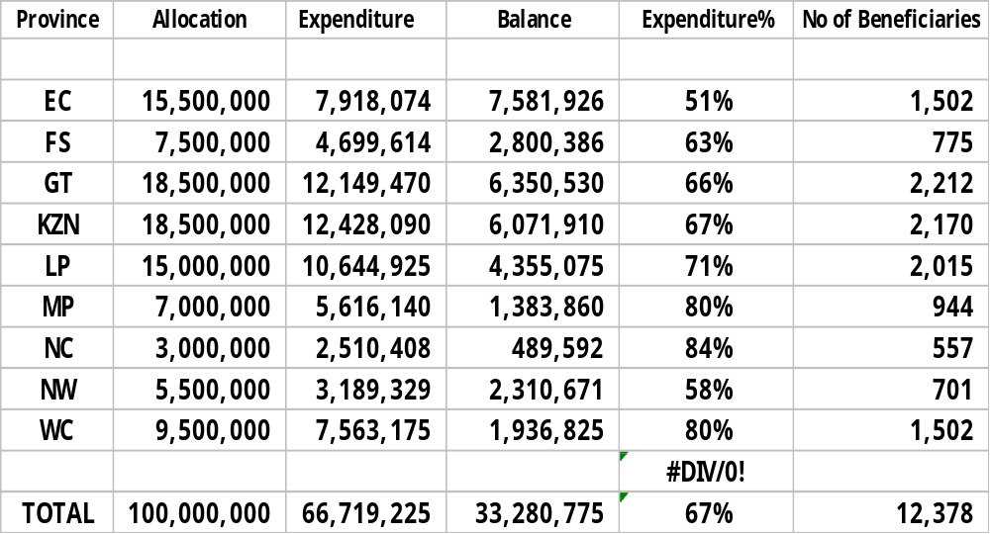

- In 2007, 25,073 students enrolled for NC(V) Level 2 and 12,378 (50%) students were awarded bursaries. According to the latest NSFAS Report issued on 28 of January 2008, of the 61 320 students enrolled on the NC(V) Levels 2 and 3, 36 791 (60%) students benefited from the FET College bursary scheme. The final 2008 figures from NSFAS are due at the end of February 2009.

- The following Table shows the 2008 allocation and payment to colleges per province

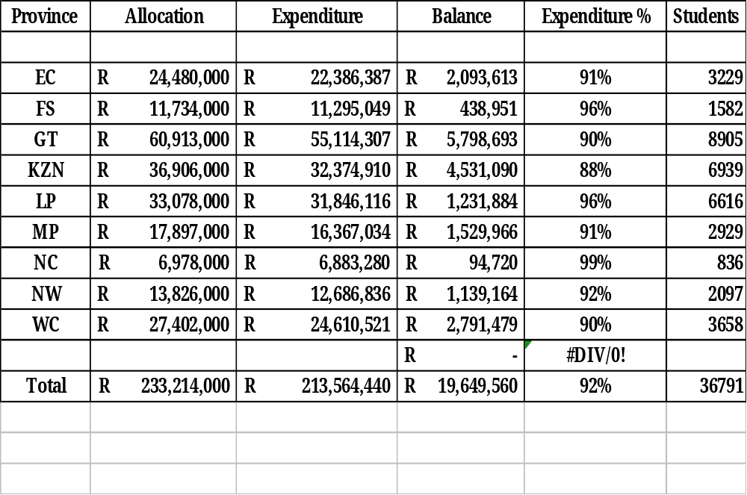
- Besides determining bursary allocations, the role of the Department includes:

- Monitoring and support to colleges
- Training student support services managers/officers of colleges on the application process and the Means Test Administration.
- Identifying individual colleges that experience difficulties with claiming and support them to process students claims
- Writing letters to the SGs of provinces where colleges are lagging behind in the claiming process.

D. RESKILLING OF COLLEGE LECTURERS
- The Department of Education implemented a three-year lecturer training plan towards the implementation of the new National Certificate (Vocational) (NC(V) qualifications which were offered in Further Education & Training (FET) Colleges from January 2007. Training was conducted in 2006 (level 2), 2007 (level 3) and 2008 (level 4).

- The lecturer training was designed to orientate lecturers to the teaching and assessment methodologies that would facilitate the delivery of the NC(V) curriculum. It also focussed on high level knowledge and skills required by the new NC(V) qualification, which marked a shift from earlier qualifications offered in FET Colleges.

The purpose of lecturer training
- Training providers were required to deliver the following outcomes in the training:
  - Familiarise lecturers with the NC(V) curriculum content, per programme, on Levels 2,3 and 4.
  - Assist lecturers to plan and conduct teaching and assessment tasks
  - Assist lecturers in developing the minimum assessment requirements in each subject.
  - Provide guidance on the compilation of ICASS marks
  - Help with the analysis of exemplar question papers and Integrated Summative Assessment Tasks (ISATs)

Roll-out of the training

- In the first year of training (2006), the main focus was on teaching and assessment methodologies and mastering of the content of the Compulsory and Fundamental subjects on NC(V) Level 2.

- In the second and third years, the emphasis was heavily in favour of curriculum content, the ISATs, and preparation for the level 4 examination.

- Level 2 training in 2006 was co-ordinated and funded by the DoE, but the subsequent L3 and L4 training was funded by colleges, through their Recapitalisation allocations.

- Each year training was offered in the four Fundamental subjects, i.e. Mathematics, Mathematical Literacy, English First Additional Language and Life Orientation on the three NQF levels.
- In 2006 and 2007 training was offered in the first eleven NC(V) programmes, i.e. Management, Marketing, Information Technology & Computer Science, Finance, Economics & Accounting, Office Administration, Electrical Infrastructure Construction, Civil Engineering & Building Construction, Engineering & Related Design, Primary Agriculture, Hospitality and Tourism.
- A twelfth programme (Safety in Society) was added in 2008 and in 2009 two more programmes are added, namely Education & Development and Mechatronics.
- A total of 5 750 lecturers were trained over the three-year period from 2006 to 2008 in the different programmes on levels 2, 3 and 4 respectively (Annexure A).
- The DoE monitored the delivery of training in all 3 years and officials were available to answer questions posed by lecturers.

Remedial and intervention training
- Following the Level 2 examination results in November 2007, some subjects were identified to be need of intervention. Remedial teaching training sessions were therefore arranged in Mathematics, Mathematical Literacy, Computer Programming, Electronic Control & Digital Electronics and Electronics.

- In total 220 lecturers received training in the abovementioned subjects.

Service Providers
- Service providers were selected on the basis of their particular expertise in the various programme specialisations. A further and important consideration was providers’ experience and reputation in education and training.

- Service providers constituted a mix of higher education institutions, professional consultants and subject experts.

- For purposes of consistency the same training providers were used over the three years. However where deficiencies were identified, changes were made with immediate effect.

Units of training delivered to date

- In 2006, forty training sessions were hosted on Level 2 and involved 1 861 lecturers. In 2007, 1 608 lecturers were involved in forty three Level 3 training sessions. In 2008, 220 lecturers received remedial training in specific subjects, while 2 061 lecturers were involved in forty three sessions of Level 4 training. Further details on the training are indicated in Annexure A.

.

ANNEXURE A: Breakdown of lecturers trained: 2006-2008
Total number of lecturers trained for NC(V) implementation (2006-2008)
 | Programme/ subject | Training Provider | 2006 | 2007 | 2008 | 2008 | Total per programme
 | Fundamental Subjects |  | Level 2 | Level 3 | Remedial | Level 4
1 | English First Additional Language | SAIDE | 155 | 162 |  | 198 | 515
2 | Mathematics | RADMASTE | 144 | 176 | 41 | 139 | 500
3 | Mathematical Literacy | Brombacher & Associates | 132 | 112 | 41 | 142 | 427
4 | Life Orientation | THSBS | 164 | 241 |  | 203 | 608
 | Programmes |  | Level 2 | Level 3 | Remedial | Level 4
1 | Tourism | THSBS | 103 | 69 |  | 72 | 244
2 | Hospitality | THSBS | 124 | 76 |  | 103 | 303
3 | IT & Computers | TUT | 123 | 95 | 89 | 85 | 392
4 | Office Admin | Adrienne Berkowitz | 171 | 117 |  | 256 | 544
5 | Management | Lynne Addison | 123 | 68 |  | 95 | 286
6 | Primary Agriculture | UNISA | 15 | 28 |  | 31 | 74
7 | Civil Engineering & Building Construction | Wits School of Education | 119 | 95 |  | 100 | 314
8 | Engineering & Related Design | Wits School of Education | 115 | 123 |  | 204 | 442
9 | Electrical Infrastructure Construction | Wits School of Education | 119 | 107 | 49 | 173 | 448
10 | Finance, Economics & Accounting | Wits Enterprise | 150 | 96 |  | 147 | 393
11 | Marketing | Wits Enterprise | 104 | 43 |  | 78 | 225
12 | Safety in Society Levels 2 & 3 | SAPS | 17 | 18 |  |  | 35
Total number of lecturers trained for NC(V) implementation (2006-2008) |  |  | 1861 | 1608 | 220 | 2061 | 5750

ANNEXURE B: 2009 Student enrolments in scarce skills

FET COLLEGE NC(V) PROJECTED ENROLMENTS PER PROVINCE FOR 2009: LEVELS 2, 3 & 4
 | Level 2 |  | Level 3 |  | Level 4 |  | TOTAL PER PROVINCE
Eastern Cape | 9,765 |  | 2,814 |  | 486 |  | 13,065
Free State | 3,448 |  | 1,350 |  | 601 |  | 5,399
Gauteng | 19,934 |  | 7,816 |  | 2,227 |  | 29,977
Kwa Zulu Natal | 15,857 |  | 5,681 |  | 827 |  | 22,365
Limpopo | 9,356 |  | 6,117 |  | 1,033 |  | 16,506
Mpumalanga | 4,559 |  | 2,416 |  | 601 |  | 7,576
Northen Cape | 2,185 |  | 1,007 |  | 154 |  | 3,346
North West | 6,580 |  | 2,431 |  | 1,018 |  | 10,029
Western Cape | 7,360 |  | 3,618 |  | 990 |  | 11,968
TOTALS PER LEVEL | 79,044 |  | 33,250 |  | 7,937 |  | 120,231
FET COLLEGE NC(V) ENROLMENTS PER PROGRAMME FOR 2009: LEVELS 2, 3 & 4
 | Level 2 |  | Level 3 |  | Level 4 |  | TOTAL PER PROGRAMME
Civil Engineering & Building Construction | 6,972 |  | 2,924 |  | 789 |  | 10,685
Electrical Infrastructure Construction | 11,628 |  | 5,799 |  | 1,169 |  | 18,596
Engineering & Related Design | 12,700 |  | 6,110 |  | 1,659 |  | 20,469
Mechatronics | 480 |  | 0 |  | 0 |  | 480
Marketing | 3,925 |  | 1,421 |  | 401 |  | 5,747
Finance, Economics & Accounting | 7,069 |  | 2,455 |  | 665 |  | 10,189
Management | 4,762 |  | 1,707 |  | 324 |  | 6,793
Office Administration | 11,842 |  | 5,639 |  | 1,579 |  | 19,060
Tourism | 4,165 |  | 1,329 |  | 264 |  | 5,758
Hospitality | 4,935 |  | 1,555 |  | 355 |  | 6,845
Information Technology & Computer Science | 6,487 |  | 3,084 |  | 580 |  | 10,151
Primary Agriculture | 1,880 |  | 835 |  | 152 |  | 2,867
Safety in Society | 1,179 |  | 392 |  | 0 |  | 1,571
Education and Development | 1,020 |  | 0 |  | 0 |  | 1,020
TOTALS PER LEVEL | 79,044 |  | 33,250 |  | 7,937 |  | 120,230

