PUBLIC SERVICE

PROPOSED NEW INDUCTION PROGRAMME OUTLINE

CONTENTS:

COURSE 1: INDUCTION FOR SUPPORT STAFF – LEVEL 1-5

COURSE 2: INDUCTION FOR JUNIOR AND MIDDLE MANAGEMENT – LEVEL 6-12

COURSE 3: INDUCTION FOR SMS MEMBERS – LEVEL 13-16

DRAFT 2: 11 June 2007

PROGRAMME DESIGN

Background

The urgency of transformation within the public service has been communicated at various levels over the past few years. Of particular significance is the February 2004 State of the Nation Address in which President Mbeki commended the cadre of public sector managers and leaders who continue to work hard and “stand tall even among their counterparts elsewhere in the world”. Yet, the President had another stern message:

We must be impatient with those in the public service who see themselves as pen-pushers and guardians of rubber stamps, thieves intent on self-enrichment, bureaucrats who think they have a right to ignore the vision of Batho Pele, who come to work as late as possible, work as little as possible and knock off as early as possible.

In response to this challenge, the Minister for Public Service and Administration, Minister Geraldine Fraser-Moleketi, made explicit the need for a compulsory programme in her Budget Vote in June 2004:

The next phase of public service and administration in South Africa will require that skills sets and approaches be valued and applied in all components of the public service. One of the mechanisms that will spearhead this is the compulsory induction programme that we have agreed to during the most recent Cabinet Lekgotla. Every serving public servant will be exposed to this as a matter of urgency and every new recruit that joins the public service will go on an appropriate level of induction soon after being employed.

As the custodian for capacity building programmes in the public service, the SAMDI introduced the Induction and Re-orientation Programme as a module within the Presidential Strategic Leadership Development Programme (PSLDP) in 2005. Thus, by mid-2007, SAMDI had rolled out a short course that enables Senior Management Service (SMS) members to:

- demonstrate and apply knowledge of the roles and responsibilities of the provincial and national government in South Africa, and
- demonstrate an understanding of employment relations in an organisation.

In addition five short induction and re-orientation courses were developed in 2006 for various target groups including officials responsible for the management of induction programmes in their department. Although these courses were implemented in an attempt to respond to the Cabinet resolution mentioned above, implementation has been at pilot scale and did not have high intake levels to make the desired impact.

A need for a new approach to enlist the participation of departments at required scale became an urgent necessity

Massification of the Induction Programme

The limitation of the current Induction and Re-orientation Programme is that it is not designed according to specific categories of various employees in the public service but arbitrarily between two major groups of public servants that is, SMS and non-SMS. For every serving public servant to benefit from this programme, it has to be expanded and provided across the senior (SMS), junior and middle management (JMMS) categories, as well as support staff. Such expansion requires not only more human and material resource allocation, but also adjustments to the curriculum design.

The massification of the induction programme will however, focus mainly on the new entrants into the public service across the categories stated above especially the JMMS category. The SMS induction will be designed differently to allow for various methodological approaches in terms of delivery. These will include but not limited to e-learning, breakfast seminars etc.

Curriculum Design

The Induction Programme is premised on the ethos of Batho Pele, which is articulated in the belief set: ‘We belong, We care, We serve.’ The programme provides a broad introduction to the vision, role and work of the Public Service, and introduces participants to their rights, responsibilities and requisite competencies.

Unlike other formal unit standard based courses, the Induction Programme is unique in the following ways:
- It is compulsory for all employees in the Public Service
- Its curriculum is designed wholly around the core purpose and mission of public service delivery in the South African context
- It seeks more to engender appreciation and ownership of a people- and service-oriented value system than knowledge and skills that can be assessed
- It is non-credit bearing and is not linked to a qualification

However, as a quality assured offering of the SAMDI, the Induction Programme is outcomes based and interactive. It is also designed according to the new SAMDI Learning Framework that differentiates course provision according to the type of target group, competency mix, and the associated level of instructional complexity. This Learning Framework was accepted as a design tool by provinces that participated in the provincial consultative workshops. A simplified representation of the Learning Framework is given below:

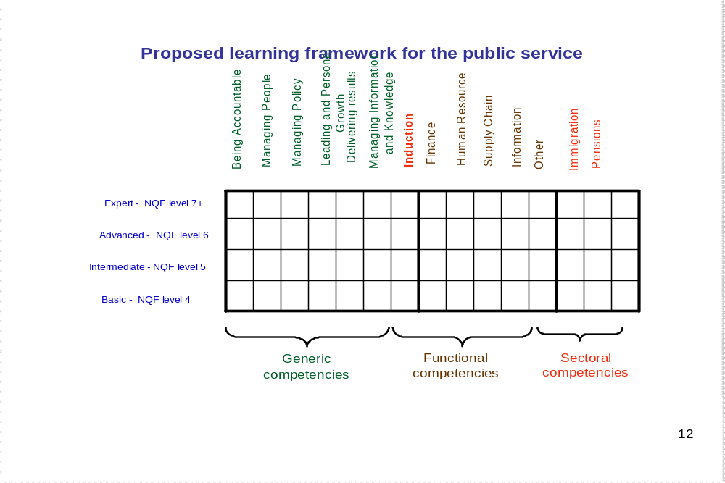

The Induction Programme will be offered mainly as generic courses but will afford opportunities for customisation through role play, in-built presentations by designated officials in departments and adaptable exercises. Three courses have been designed to match the needs of support staff, JMMS and SMS staff. The courses expose participants to the big public service picture and how all the important components – laws, policies, structures and procedures – fit together. Content for staff at lower employment levels is less complex and the course will be at a slower pace. At middle and senior management levels, sessions are quite short and participants will be given extensive further reading and resources.

All three courses will be organised with the following outcomes in mind:
- Understanding of the Public Service within the context of the developmental South African state.
- Understanding of the role of a public servant as a social transformation agent.

Delivery Approach

Course delivery will begin at two pilot provinces in November 2007. the course will be delivered through partnerships (collaboratively) with:
- Provincial academies
- Private providers
- FET Colleges
- Provincial trainers and Higher Education Institutions (HEIs) where necessary

Training of facilitators will commence soon after the completion of the design and material development. The trainers will be subjected to a less formal SAMDI intiated assessment with regard to understanding of content and facilitation capability. Only those trainers that have the required skills will be recruited to partner with SAMDI in the implementation of the induction courses. Where necessary, a development intervention might be undertaken to ensure that those with potential to facilitate the courses are considered for selection.

The assessment will guide the decision making process regarding which facilitators will be deployed for which induction courses. the rationale is that of ensuring that for example, the most capable facilitators are deployed for courses with a higher degree of complexity namely, the JMMS induction.

Facilitators will be able to guide how customisation will be effected in the courses during training.

COURSE 1
INDUCTION FOR SUPPORT STAFF: LEVEL 1-5 (TWO DAYS)

Module Outline | Time | Training Methods
Introduction and getting to know each other | 45 min  8.30 – 9.15am | Welcome. Programme aims and overview.  Word wheel exercise on set of questions to stimulate thinking.  Individual introductions
Module 1:The work of government:  - The problems we face as a country  - How government addresses these problems  - The budget: income and expenditure  - The need for economic growth | 105 min  9.15 -11.00am | Group task.  Plenary reports and discussion.  Short inputs in form of  Q and A discussion.
Module 2: Introduction to structures of government  - The Constitution and Bill of Rights  - The Executive and Legislatures  - The three spheres of government  - The Public Service | 90 min  11.30-1pm | Exercise Bill of Rights.  Input on Constitution and government.  Exercise on 3 spheres.  Brief intro to PS.
Module 3: Building a better Public Service  - Current problems  - Role of public servants  - Batho Pele: building a service culture | 120 min  2-4pm | Group task and dramatic presentations.  Plenary discussion on BP.  Putting BP into practice – case study
Recap of previous day | 30 min  8.30-9am
Module 4: Relationship and communication with public and colleagues | 90 min  9 – 10.30am | 3 role play exercises:
Module 5: Corruption and ethics | 120 min  11-1pm | Case studies and debates
Module 6: Rights and responsibilities as a public servant:  - What is expected from you  - Work ethics  - Discipline  - Your rights as an employee –  - Right to organise  - Basic Conditions  - Working hours and Leave  - Training and development  - Deductions, Medical aid and Pensions | 60 min  2-3pm | Input and questions
Wrap-up and Evaluation | 30 min | Summary and Go around
TOTAL | 2 days  (11 hours training)

COURSE 2
INDUCTION FOR JUNIOR AND MIDDLE MANAGEMENT: LEVEL 6-12 (TWO DAYS)

Module Outline | Time | Training Methods
Introduction and getting to know each other | 45 min  8.30 – 9.15am | Welcome  Programme aims and overview  Word wheel exercise on set of questions to stimulate thinking.  Individual introductions
Module 1: SA challenges and the developmental state:  - The legacy of Apartheid and challenges for development  - The RDP and the developmental state  - The budget priorities: income and expenditure | 100 min  9.20 -11am | Group task.  Plenary reports and discussion.  Short inputs in form of  Q and A and debates on priorities and increasing income.
Module 2: Understanding economic development  - Structure of SA economy, SA within global economy and the need for economic growth  - ASGISA and JIPSA | 90 min  11.30-1pm | Input and exercise on economy
Module 3: Introduction to structures of government  - The Constitution and Bill of Rights  - The Executive and Legislatures  - The three spheres of government  - Understanding local government  - The Public Service  - Relationship between Executive, Legislature and Public Service management  - Inter-governmental relations  - Partnerships for development  - Public participation | 120 min  2-4pm | Exercise on Bill of Rights.  Input on Constitution and government.  Exercise on 3 spheres  Brief Q and Q intro to PS.  Debate on case studies on relationship between PS and Exec and Legislature.  Input or IGR  Exercise on partnerships and participation
Module 4: Building a better Public Service  - Current problems  - Role of public servants  - Batho Pele: Building a service culture  - Changing the culture: Relationship and communication with public and colleagues  - Role of PS managers <and managing staff>  - Changing the environment  - Competencies | 120 min  8.30-10.30pm | Group task and drama.  Plenary discussion on role of public service and Batho Pele  Putting BP into practice – role play exercises:  - Communication with member of public  - Helping a colleague  Case studies on staff management and improving systems  Discussion competencies

Module 5: Ethics and corruption | 60 min  11am-12pm | Input and case study discussion
Module 6: Managing for effective implementation:  - Planning  - Budgeting, spending, procurement, accounting, oversight.  - M and E.  - Performance management | 60 min  12-1pm | Inputs in integrated parts with discussion in between  (more detail in resource material)
Module 7: Rights and responsibilities as a public servant:  - What is expected from you  - Work ethics  - Discipline  - Management of staff and resources  - Your rights as an employee –  - Right to organise  - Working hours and Leave  - Training and development  - Deductions, Medical aid and Pensions  - Basic Conditions | 90 min  2pm-3.30pm | Group task.  Reports and summary inputs.  Input and discussion.
Wrap-up and Evaluation | 30 min  3.30-4pm | Summary and wrap  Go around
TOTAL | 2 days  (12 training hours)

COURSE 3
INDUCTION FOR SMS MEMBERS: LEVEL 13-16 (TWO DAYS)

Module Outline | Time | Training Methods
Introduction and getting to know each other | 40 min  8.30 – 9.10am | Welcome  Programme aims and overview  Word wheel exercise on set of questions to stimulate thinking.  Individual introductions: background, main concerns.
Module 1: SA challenges and the developmental state:  - The legacy of Apartheid and challenges for development  - The RDP – vision for development  - The developmental state: challenges and approaches | 50 min  9.10 –10.00am | Group task.  Plenary reports and discussion.  Debate on developmental state
Module 2: The fiscus and the economy  - The budget priorities: income and expenditure  - Structure of SA economy, SA within global economy and the need for economic growth  - ASGISA and JIPSA | 50 min  10.00-10.50am | Budget and revenue: Short inputs in form of  Q and A and debates on priorities and increasing income.  Input and exercise on economy and assessment of ASGISA.
Module 3:Introduction to structures of government  - The Constitution and Bill of Rights  - The Executive and Legislatures  - Access to information and Administrative Justice  - The three spheres of government  - Policy and law-making process | 50 min  11.10-12.00pm | Input on Bill of Rights and Constitution  Case study on progressive realisation of rights and access to info.  Exercise on 3 spheres.  Input on policy
Module 4: Basic understanding of local government  - Competencies  - Structures  - IDP  - Finance | 60 min  12-1pm | Input and discussion
Module 5: The Public Service  - Role and Structures  - Relationship between Executive, Legislature and Public Service management  - Inter-governmental relations  - Partnerships for development  - Public participation | 50 min  2.00- 2.50pm | Brief Q and Q intro to PS.  Debate on case studies on relationship between PS and Exec and Legisl.  Input or IGR.  Group discussion on partnerships and participation

Module 6: Understanding our province  - Key challenges and statistics  - PGDS  - NSDP and PSDF  - Other key strategic programmes and main budget items | 70 min  2.50-4pm | Presentations and discussion
Module 7: Building a better Public Service  - Current problems and challenges: service culture, effective implementation, corruption and ethics  - Role of public service and SMS  - SMS competencies and role of PS managers  - Batho Pele: building a service culture and improving systems | 80 min  8.30-9.50am | Group discussion, plenary presentations.  Plenary discussion on role of public service and SMS competencies  Putting BP into practice – case study exercises:
Module 8: Overview of planning, budgeting, M and E | 50 min  9.50-10.40am | Overview input in parts with discussion in between
Module 9: Overview of PFMA and spending, procurement, accounting, reporting and oversight systems | 60 min  11.00-12.00pm | Overview input in parts with discussion in between
Module 10: Management for improved performance  - Implementation management  - Performance management  - Coaching and mentoring | 60 min  12-1pm | Exercise, discussion and input  (more detail in resource material)
Module 11: Ethics and corruption | 60 min  2-3pm | Input and case study discussion
Module 12: Rights and responsibilities as a public servant:  - What is expected from you  - Management of staff and resources  - Your rights as an employee – | 40 min  3-3.40pm | Input and discussion.
Wrap-up and Evaluation | 20 min  3.40-4pm | Summary and wrap  Go around
TOTAL | 2 days  ( 12 hours 20 min training time)
.

