

STRATEGIC PLANS & BUDGET 2008/9

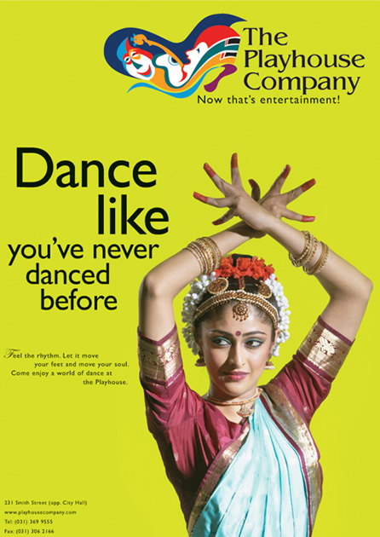
CONTENTSPAGE NUMBER

Introduction5 - 6

2.Strategic Plan7 - 22

3.Annual Performance Plan23 - 27

4.Budget for 2008/928 - 37

1. INTRODUCTION BY THE CHIEF EXECUTIVE AND ARTISTIC DIRECTOR

1.1 OVERVIEW

The Playhouse Company is a Cultural Institution promulgated under the Cultural Institutions Act 119 of 1998.

Its primary mandate is to facilitate and manage the staging and promoting of artistic works that are representative of the diverse South African artistic and cultural heritage.

In pursuit of a highly representative and balanced artistic calendar, The Playhouse Company has an artistic programme that focuses primarily, but not exclusively on the following:

- promoting Arts Education and Arts Development Initiatives
- presenting artistic works at the highest possible level of excellence in dance, drama and music
- collaborating with External Productions/Events, Individual Companies and Institutions in promoting the
performing arts
- facilitating the access and optimal usage of all our theatres as venues for hire

The artistic programmes are primarily geared to target the following categories within the performing arts sector:

- women and youth
- the physically challenged
- professional productions
- promotion of traditional artforms
- development of new South African theatrical works
- a balance in demographics and racial groups

The Playhouse Company’s vision is to be “Africa’s premiere theatre of excellence”

We will achieve our vision through:

- Commitment to artistic integrity and excellence in our productions and corresponding ancillary functions
- Presenting productions that cater for multi-cultural & diverse audiences
- Facilitating the development and preservation of varied and representative artforms
- Effective corporate governance and sound financial controls as well as best practices in service delivery

The Institutional values of the Playhouse Company include:

- Integrity – artistic excellence, personal attitude and behaviour which is open, honest and reliable
- Professionalism – to produce work of highest standards in all facets of the organization
- Accountability – to one another, funders and the artistic community, making equitable and optimal use
of resources
- Customer care – providing value for our clients
- Freedom of expression – where differences are nurtured and welcomed with understanding, respect and tolerance

The Playhouse Company has become widely recognized throughout South Africa for its leadership in the transformation and further development of the performing arts. This entity is committed to promoting artistic excellence and in enriching the lives of all South African through music, drama and dance productions and other related events.
Our facilities have undergone renovations as well as technological and infrastructural upgrade thus giving our theatres a competitive advantage. We provide world-class standards in entertainment while engaging in a comprehensive education and development arts programme that provides a professional platform to entry-level artists, artistic communities and artforms that have been marginalized in the past.

In conclusion, this institute is making inroads in complying with best governance practices in financial management, human resources and overall arts administration.

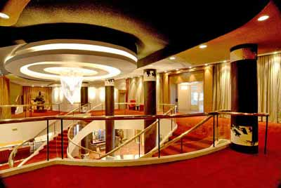
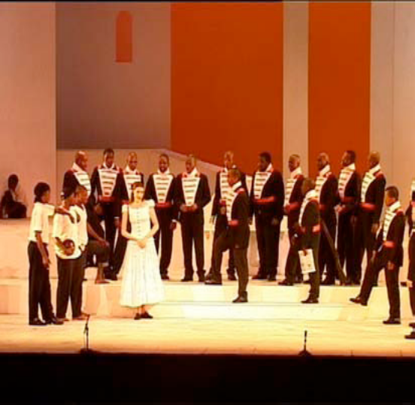
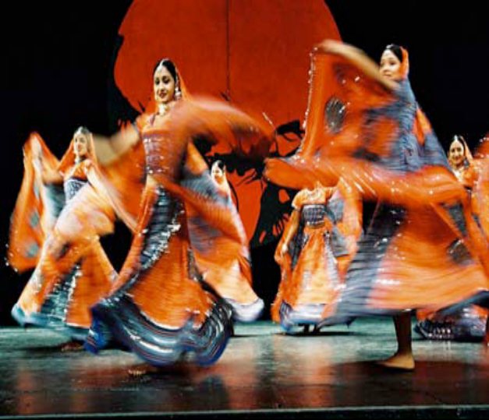
2. Strategic plan

2.1 STRATEGIC ISSUES AND OBJECTIVES FOR 2008/09 – 2009/2010

The issues highlighted in the next two pages seek to improve on matters addressed during the previous strategic planning sessions. The operational plans will integrate the departmental activities raised during the strategy review process on the 14-16 September 2007 for 2008/09-2009/10 financial years.

PERSPECTIVE | STRATEGIC THEME/ISSUE | STRATEGIC OBJECTIVE | KEY PERFORMANCE AREA | RISK FACTOR AND MITIGATION | KEY PERFORMANCE INDICATOR | KEY PERFORMANCE TARGETS
Internal customer | Human resource development and an internal customer focused environment  Organisational wellness | To create a work environment that develops the skills, potential, spiritual and emotional upliftment | To develop institutional capacity especially human resources department that can handle all HR related issues including training, occupational health and safety, skills retention and organisational wellness | Negative perceptions about Playhouse work environment by its staff  Loss of skills and experience and high staff turn over within the HR department | Appointment of HR personnel and development of HR development policies | Ongoing
Council | Fundraising activities and strategy | To play an active part in fundraising strategies, activities and solicitation of funds | Fundraising strategy and programme activities | If there is no funding all the identified capital projects will not be implemented | Meetings and lobbying activities with potential funders  Pledges and receipt of funds for the upgrade of Playhouse building, integrated parking etc | Ongoing

PERSPECTIVE | STRATEGIC THEME/ISSUE | STRATEGIC OBJECTIVE | KEY PERFORMANCE AREA | RISK FACTOR AND MITIGATION | KEY PERFORMANCE INDICATOR | KEY PERFORMANCE TARGETS
Internal and external customers | Safety issues around The Playhouse Company | To promote a safe environment for both staff and customers of The Playhouse Company | Safety and security | Increase crime incidence around The Playhouse Company  Mitigation  - Intensification of visible policing around the Playhouse Company building  - Partnership with EThekwini Metro, KZN Tourism, and Business in the area | - Elimination or reduction of criminal activities around Playhouse  - Secure & safe environment resulting in increasing audience numbers attending Playhouse shows | Short term (3months) but ongoing
Internal and External customer | Parking facilities for The Playhouse Company | To develop a Playhouse Parking Improvement Plan that integrates parking space with Playhouse facilities | Safe, accessible and convenient parking space for Playhouse customers | Currently, the parking used by The Playhouse Company is not safe, accessible and not convenient, during rainy and cold seasons it is unfriendly and unpleasant to customers | An integrated Parking Plan that meets the requirements of The Playhouse Company | By May 2008
Internal and external customer perspective | The Playhouse Company Building is in serious need of repairs | To upgrade and conserve the Playhouse Building | Upgrade and conservation of the Playhouse Building | Building is old and is posing danger to both staff and customers | Approval of plans and funding | Re - Submission of all approved plans to the DAC by May 2008  Renovation completion by December 2009
Internal and external customer | Air-condition system is 23 years and is showing signs of stress and dysfunctionality | To install a new air-conditioning system | Source funding for the purchase of the new air-condition | Loss of clients and health hazard as a result unbearable heat | New effective and durable air-condition systems | Before ISPA , May 2008

no | Name of Project, Production or Festival | Strategic Objective | Target | Key Performance Indicator | TARGET
1 | TRADITIONAL ARTS FESTIVAL: A ground-breaker on the South African national arts roster, The Playhouse Company’s Traditional Arts Festival enables communities of different cultures to reach out and touch others through the performance of their individual creative expression. The Festival has various elements: a traditional Zulu Dance Competition, a Gala Concert, a choral festival and a national isicathamiya festival. These critical platforms have a key role to play, both as a host for the indigenous art forms and as a major draw card in the national and global arenas of cultural tourism. | To showcase the diverse the diverse cultural spectrum that is present in KwaZulu-Natal and South Africa as a whole  To offer a unique space for the promotion of indigenous arts  To elevate the position of indigenous art forms | Artists: performers of indigenous music  Practitioners: specialists of indigenous knowledge systems, folk dance forms, music and storytelling specialists, praise poets etc.  Audience: local and cultural tourist markets/ audiences | A balanced programme that showcases a diverse range of indigenous artforms | Indigenous knowledge systems would be more widely known  Cultural difference will be shared thereby tolerance would have been promoted and our national cultural heritage would be preserved
2 | SOUTH AFRICAN (SA) WOMEN’S ARTS FESTIVAL: This is a platform to showcase artistic work that highlights women’s strength, vulnerabilities, passions, fears, dignity and their contribution to society. | To promote the vital expressions of women and their roles as artists, directors, choreographers/ set/ lighting/ costume designers  To advocate for the rights of women through the media via the arts  To provoke debate & discourse about artistic productions by women | Artists: both men and women, though a preference for young girls and women will be given  Audiences: broad spectrum of the public, gender activists and lobbying groups, etc. | Over 60% of the productions will be performed by women | The status of women as invaluable contributors to the arts industry will be elevated  This Festival creates a vital platform for the creation of job opportunities for a marginalized sector in our community
3 | TEST DRIVING THE ARTS: this weekly programme creates a platform for entry level out-of-town musicians, poets and actors, to perform for city lunch hour audiences. This platform creates a sharp learning curve experience for artists and offers them exposures to cosmopolitan audiences and talent scouts, thus serving as a spring-board for employment opportunities. | To provide a accessible performance platform  To promote entry level artists  To assist in network opportunities  To provide opportunity for local talent to showcase South African development works in the tourist market | Artists: entry level artists  Audience: primarily inner city workers and tourist market | Enrolment to be part of the annual season which will be in excess of 60% | A unique job creation opportunity for artists within KwaZulu-Natal  Entry level artists will have meaningful experiences of the professional theatre environment  Artists receive publicity and powerful association with The Playhouse Company brand which serves as a reference for future employment
4 | NEW COMMISSIONED WORKS: the commissioned works focus primarily on developing new South African work within the various arts genres by providing funds and technical assistance to specific individuals or organizations who promote the previously marginalised performing arts and culture of KwaZulu-Natal. | To encourage the creative development of untold stories or themes in the public consciousness | Professional and semi professional artists | 40% of the review of all works will be ground breaking work or innovation | New works will recorded in script or score which will be accessed by future artists and audiences - a proudly South African legacy will be born  Work will be critically acclaimed and invites for tours and partnerships
5 | THE PLAYHOUSE MOBILE THEATRE (TRUCK) The Playhouse-Transnet truck with its stage facilities is widely utilized internally for showcasing of art forms from within KwaZulu-Natal , and also by many corporate and government departments to help “get the message across” to communities situated in outlying areas of the province. | To provide a basic “theatre” infra structure or performance platform via its fold out’ stage, outdoor sound equipment and own generator within the context of impoverished rural areas that are remote or inaccessible | Corporate and government departments | Reach in excess of  350 000 per annum | Disadvantaged communities gain an opportunity to expose art forms that have been marginalized  Wider and more knowledgeable communities become supportive of these art forms
6 | SCHOOLS PROGRAMME: The Playhouse Company mounts two very successful annual schools programmes targeting senior primary schools and high schools. The focus is on making dramatic works which young learners usually associate with old and confusing texts as vibrant, readily accessible performance. In dance, the exposure of the diversity within this arts form is skilfully presented. | To offer primarily matric learners a live performance experience that is interactive. Set works eg. Shakespeare’s King Lear has been adapted for these vivid stage presentations  To instil at primary school level a holistic concept of Dance as potent a tool of artistic expression form various cultures and a positive vehicle for developing respect for a healthy body | Age ranges : 10 – 20yrs | 80% audience capacity | Dramatic works will be understood as live plays within the context of literature  Dance would be seen as more than entertainment value

2.2 Marketing

NO | Perspective | Strategic Theme | Strategic Objective | Key Performance Indicators | TARGET
1 | Production marketing | Ensure maximum exposure of all productions/ festivals/ events presented by and in association with The Playhouse Company  Use a variety of new marketing strategies that will complement current strategies used | Retain current and include more surprise and effective marketing tools  Investigate the use of below-the- line to support above- the- line approaches | Production marketing plans and budgets to be redrafted | Ensure at the very minimum one unique marketing initiative to every single production marketing campaign  Deadline: 4 weeks before production opening
1 |  | Joint ventures | Diversify target and niche markets according to new markets that need penetrating | Secure 5 joint ventures for the financial year and ensure each of them have a Memorandum of Understanding | July 2008
1 |  | Advertising | Arts and entertainment advertising: ensure maximum exposure of productions via trade publications, aim for publicity and where not possible secure advertising space | Traditional Arts Festival: ensure no less than R200 000 worth of publicity  SA Women’s Arts Festival: ensure no less than R400 000 worth of publicity | Secure deals no less than one month prior to the Festival/ event
1 |  | Publicity | Greater emphasis to be placed on national media both print and electronic  Map publicity according to productions on offer, aim for one national focus profile piece every second month | Secure strategic media alliances with:  Top Billing, Rootz: & 3 Talk | Secure deals no less than one month prior to the Festival/ event
2 | Research/ review of efforts. | Research our potential and/or actual competitors.  Conduct post mortem of all activities. | Growth of audience members. | Create business strategic alliances with:  - ALL Municipalities.  - Twenty big corporates. | Identify and determine ideal starting dates of productions to meet target dates.
3 | Telesales | Consolidating customer data and information from a variety of sources and systems and ensure that the data collected is accurate and in a consistent framework | Examine alternative strategies to database marketing. | Achieve 50% in advance sales  Exploit all opportunities available to us via Computicket, use stats and patron data | Six weeks before curtain up of all in-house productions
4 | Brand Awareness | Increase brand awareness in cost effective ways | Position the brand within its publics by being seen in all public spheres such as outdoor events | The Playhouse Company must have been present and well branded at no less than six major outdoor events | Confirmation for participation from host to be received one month prior to the activity
5 | Public Relations | Raise staff morale  which will result in competent and motivated staff and in turn develop & retain staff | Organize staff outings in partnership with Human Resources  Present staff with cards for birthdays & religious holidays | Increase in staff performance and decrease in negative comments about The Playhouse from staff members in the Playhouse suggestion box  Issue a questionnaire via HR to determine level of staff satisfaction. | May 2008
5 |  | VIP Invitation List: use invitations to opening nights to lobby support for The Playhouse Company.  Identify key decision-makers by role in companies/ organizations & specify interest-generating benefits for each one, this will help encourage preplanning for all marketing initiatives | Create interest in The Playhouse Company from key stakeholders | Attendance by key stakeholders at opening nights, lists to be drawn up in consultation with co-ordinators.  May 2008 25% increase in the corporate database | Monthly updating
6 | Advertising  Sponsorship and Fundraising | Grow revenue by increasing income via  advertising and sponsorship initiatives | Sell advertising space in our marketing material | Develop a chart indicating roles, responsibilities and targets | Quarterly
6 | Advertising  Sponsorship and Fundraising | Improve donor process | Enhance donor management | Number of proposals sent versus the number of proposals accepted | Quarterly review
6 | Advertising  Sponsorship and Fundraising | Improve Donor satisfaction. | Keep donors informed - timeous reporting | Maintain contact through telephone, letters  Interim and final reports on funding. | As per contracts, review bi-monthly

2.3 Arts & Marketing SERVICE DELIVERY IMPROVEMENT

NO | Perspective | Strategic Theme | Strategic Objective | Key Performance Indicators | TARGET
1 | Performance management - training and development. | Empower Staff  Ensure staff are 95% productive | Provide skills training that will empower staff | Improve skills and productivity within the department  Identify courses/workshops/  seminars which are relevant to the department  Encourage staff to be more involved in their personal development plans. | Bi-annually as this  coincides with performance management
2 | Compliance with the relevant legislation | Will ensure operational excellence | Enhance standard operational procedures and systems | Improve efficiency and effectiveness.  Safeguarding of assets and compliance with SCM | Ongoing
3 | Operational excellence | Enhance standard operational procedures and systems | Increase financial reporting. More regular budget reporting; setting of reporting deadlines; stricter policy on project execution and completion | Variances/ deviations to be fully explained and motivated this will ensure financial discipline and collective ownership of budgets | Monthly

2.4 Functions

NO | PERSPECTIVE | STRATEGIC THEME | STRATEGIC OBJECTIVES | KEY PERFORMANCE INDICATORS | TARGET
1 | Marketing | Increase in the hire of venues  Profitable use of venues | To ensure that Playhouse venues are at the forefront of users minds  Solicit business by initiating sales and not only from incoming calls/ walk-ins  Profile of function venues in the Playhouse News  Advertise in Trade Publications  Update Playhouse website with pictures of venues with variable settings | Advertise venues in the Playhouse News very two months  Quarterly advertise in Trade Publications  Update Playhouse website every two months on different set-ups  Advertise quarterly in Trade Publications | Ongoing
2 | Stakeholders | Win stakeholder confidence  Retain current and build new stakeholders | Provide high quality service and keep a provisional level at all times  Increase efficiency and service delivery.  Build a data base of all clients who utilize venues | Create a questionnaire form for clients to give feedback on their events
3 | Internal Processes | Operational excellence | Enhance standard operational procedures and systems  Improve efficiency and effectiveness by adhering strictly to all company procedures, rules and regulations as set out by Management | Attend all meetings relating to company procedures to be more knowledgeable | Ongoing
4 | Financial | Financial discipline | Responsible use of resources.  Consult budgets constantly | Consult with Finance department regularly | Ongoing
5 | Maintenance | Venues efficiency | To ensure that venues and fixed assets are of the highest operational level | Repairs and Maintenance is done timeously | Weekly/Monthly

2.5 Stage Management

no | Perspective | Strategic Theme | Strategic Objectives | Key Performance Indicators | TARGET
1 | Internal Processes | Operational Excellence | Enhance organizational structure  Regular internal meetings  Employee satisfaction | Regular attendance of all staff at meetings relating to procedures within the organisation | Ongoing
2 | Training & Development/Staff Morale | Staffing | Motivate and retain staff  Increasing staff morale  Ensure that workload is spread fairly | Identified training courses with HR that relevant staff need to attend  Schedules of staffing different show are adhered to at all times | Ongoing
3 | Maintenance and Repairs | Monitoring and fault reporting thereby enhancing productivity | Timeous repairs and maintenance of equipment | Turnaround time sorting problems and complaints from users | Ongoing
4 | Communication | Ensuring efficient communication levels | Timeous relevant information to reach staff | Additional computer equipment | April
5 | Maintenance | Efficiently run venues | To ensure that theatres and fixed assets are of the highest operational level  Weekly checks of all theatre venues and monthly checks on assets | A smoothly run theatre | Weekly/monthly

2.6 Sound

no | Perspective | Strategic Theme | Strategic Objectives | Key Performance Indicators | TARGET
1 | Sound Department | Operational excellence | - Maintenance and repairs  - Fast equipment maintenance and repair turnaround time | Have in-house staff that can do the repairs to sound equipment  Institute a repair schedule which indicates turnaround time | Ongoing
1 | Sound Department | Operational excellence. | - Training and development  - Motivate and retain qualified staff | - Conduct skills audit to determine competence of personnel  - Send technicians on necessary training programs to improve their skills | Ongoing.
1 | Sound Department | Operational excellence | Ensuring efficient communication levels  Timeous relevant information to reach staff | All technicians are kept up to date on developments within the department through daily communication, verbal, notice boards and e-mail | Ongoing
1 | Sound Department | Operational excellence | - Highest standard of audio systems in theatres to ensure that we stay competitive in the market  - Up-grading equipment in the theatres on an ongoing basis to keep  abreast of industry standards | - Happy clients, ensuring repeat business in a saturated market | Ongoing

2.7 Lighting

no | Perspective | Strategic Theme | Strategic Objectives | Key performance Indicators | TARGET
1 | Internal Processes | Operational Excellence  Motivate Staff | Organizational structure is place and adhered to  Retain staff | Regular communication with staff members  Employee satisfaction | Ongoing
2 | Maintenance and repairs | Monitoring all equipment and maintaining equipment | Timeous repairs to equipment | Turnaround time in sorting out problems from users | Ongoing
3 | Financial | Financial Discipline | Constant monitoring of budget for department (a) | Safe guarding of company assets (b) | Ongoing
4 | Communication | Ensure efficient communication levels | Relevant information to reach staff timeously | Staff is kept up to date on developments within department and the company | Ongoing

2.8 STRATEGIC PLAN FOR Maintenance & Wardrobe 2008/2009

NO | Perspective | Strategic Theme | Strategic objectives | Key performance Indicators | TARGET
1 | Maintenance and Repairs | Monitoring and fault reporting | Repairs to equipment done timeously  Enhance productivity and client satisfaction | Equipment that is well maintained during productions | Ongoing
2 | Internal processes | Staffing | Motivate and retain staff/ morale  Employ additional staff to cope with additional shows | Staff is not over worked | Ongoing
3 | Communication | Ensuring proper communication levels | Staff to be informed timeously  Ensure staff is kept abreast of developments within the department and the company | Staff is well informed at all times | Ongoing
4 | Financial | Financial discipline | Monitoring of budget for department  Safeguarding of company assets | SCM is adhered to continuously  Department is running smoothly | Ongoing

2.9 Finance

The Finance Department strategic goals been developed to ensure efficient and effective use of resources to compliment other Departments in achieving the strategic goals of the Playhouse Company. Added emphasis has been placed in ensuring that the Playhouse Company has and maintains internal controls (systems and procedures) as per best practices and there is compliance with all relative legislation.

NO | PERSPECTIVE | STRATEGIC OBJECTIVE | KPI | TARGET
1 | Stakeholders | Unqualified Audit Report | Number of qualifications in Audit Report | No qualifications.  Stakeholder confidence.
2 | Stakeholders | Less than five items under Reporting Issues | Number of items raised as Reporting Issues in Audit Report | Less than five items raised as Reporting Issues.
3 | Internal Processes | Compliance with relevant legislation – Public Finance Management Act, Treasury Regulations etc | 1.Compliance Reports by Internal Audit  2. Compliance Reports  by Department of Finance | 95% compliance
4 | Internal Processes | Compilation and Implementation of policies in line with legislation and best practices | Number of policies approved and implemented | 90% of required policies
5 | Internal Processes | Recovery of outstanding debt | Outstanding debt at year end | 95% Recovery of outstanding debt
6 | Internal Processes | Provide physical facilities and training for staff | Competent and motivated staff | At least three training sessions for all staff
7 | Internal Processes | Accurate and timeous compilation and distribution of monthly management accounts | Management feedback | 95 % accuracy  95% deadlines met
8 | Internal Processes | Ensuring that unauthorized, irregular and fruitless and wasteful expenditure is prevented | Expenditure within budget  Compliance with all Supply Chain Management policies | Explanations of all variances of more than 5%  100% compliance with all procurement policies
9 | Internal Processes | Ensuring that maximum possible revenue received from all sources | Timeous invoicing when services have been completed  Prompt reconciliations of all accounts | Invoicing within seven days  90 % Tenancy occupancy rate
10 | Internal Processes | Improvement and development of internal control systems and procedures according to best practice | Number of queries raised by Internal Audit | 90% compliant

The above will greatly enhance stakeholder confidence in the financial management of the Playhouse Company, which is vital to its continued operations and future growth.

2.10 Human Resources

NO | Perspective | Strategic Themes | Strategic Objectives | Key Performance Indicator | TARGET
1 | Stakeholder | Empower Staff | Implement Performance Management and Development System | Signing of Performance Agreements by all Managers and Line Managers | 30 June 2008
2 | Internal Process | Improve H R Administration | Ensure effective and efficient human resource administrative function  Develop and implement salary and overtime payment control measures | Timeous salary, computation and related activities  Overtime policy and standardized procedural document | Accuracy of payment, weekly and monthly  30 April 2008
3 | Training & Development | Empower staff  Staffing | Conduct skills audit for all employees | Workplace Skills Plan and a Training Plan and implementation of these plans | 75% of employees trained by 31st March 2009  30 June 2008
4 | Filling of positions | Skilled manpower provisioning | Effective implementation of the recruitment and selection policy | All vacant posts filled by suitably qualified employees | Turn around time not exceeding 3 months
5 | Staff orientation | Know your company | Develop and implement the Induction Programme  Make employee understand the mission and the vision of the company  Entrench the culture of organization to employees  Awareness of policies, practices and procedures | Effective implementation of the Induction Programme  Conduct workshops on all approved policies | 31 March 2009  30 April 2008
6 | Trade Unionism | Collective Bargaining | Develop and maintain sound relations between Council, Management, Trade Union SACCAWU | Quarterly Union/Management Meetings; Implement participative decision making in all levels of management;  Conduct quarterly stakeholder analysis;  Implement two way communication system;  Implement early warning system to detect oncoming trouble; and Monitor, evaluate, adjust, review, and implement policies, agreements, and proposals timeously | Revive monthly union meetings  (dispute resolve within the stipulated time frame in the grievance procedure)  Conclude wage negotiations by 31 July 2008
7 | Legislation | Mandates | Review all policies to ensure compliance with legislation | All policies compliant to:  The Constitution of the RSA 1996.  The Cultural Institutions Act.  Public Finance Management Act.  Basic Conditions of Employment Act.  Labour Relations Act.  Employment Equity Act.  Skills Development Act.  Skills Development levies Act.  Occupational Health & Safety Act. | 31 July 2008
8 | Internal and External Audit | Governance & Compliance | Implement recommendations emanating from internal audit as well as Auditor General’s management letter | Zero external audit qualifications  Address audit queries | Immediate
9 | Risk | Risk Management | Formalise risk management process within department and make it more structured and comprehensive;  Identification and assessment of the significant risks facing the department;  Develop a risk profile of the department | HR Risks are engaged in an informed manner throughout the organization;  Management of risks is proactive and effective;  Big surprises or big mistakes are avoided; and Risk management strategies are in place and are operating effectively in order reducing residual risk within the department risk appetite | September 2008  Ongoing

2.11 Other Ancilliary Services

NO | PERSPECTIVE | Strategic Themes | Strategic Objectives | Key Performance Indicator | TARGET
1 | Buildings | Maintenance audit & repairs | - Ensure that buildings meet the standards of a professional theatre  - Comply with legislation and regulations governing the theatre industry  Commence renovations of three (3) complexes beginning September 2007 and completing not later than 2010 | - Assessment by stakeholders  - Stakeholder satisfaction  - Buildings free of roof leaks  - General appearance of halls | Ongoing  Secure financial resources to meet the objectives
2 | Cost effectiveness and efficiency | Responsible use of resources and elimination of waste through effective budget management | Provision of services to the three; The Playhouse Company complexes viz. Mayville, Head Office & Playhouse Theatre Complex | Elimination of over-expenditure of allocated budget | Healthy budget with no variances
3 | Hygiene | Tidiness and cleanliness of our premises | Ensuring that the service provider as well as our employees keep and maintain our premises to acceptable standards of hygiene.  Regularly appraise delivery of contracted service providers | Tidy & clean surroundings.  Public comments.  Faulty free ablutions.  Areas for disposal of waste.  General appearance of premises & personnel.  Absence of pests such as mice, cockroaches, etc. | Ongoing
4 | Fumigation | Borer control in affected area, yearly | Periodic fumigation of areas where structures and wood products are infested | Limitation of the spread of the borer pest | Once in 3 years
5 | Productions | Construction of sets |  | Timeous delivery of goods  Quality of goods / workmanship  Costs  Demand of our products  Comments from production directors and audience | Yearly projects

6 | Internal Processes | Ensure governance  compliance  Operational excellence | Compliance with key legislation  Put in place standard operational  procedures & systems | Planning, monitoring & reporting.  Compliance with relevant legislation:  - B C E A.  - Occupational Health & Safety (OHSAct).  - Safety, Health & Environment Act (SHE Act).  - Labour Relations Act.  - Skills Development Act.  - Employment Equity Act..  - P F M A.  - C I A.  - Compliance with Supply Services and PPPFA.  - Develop policies & procedure manuals to facilitate sound administration, monitoring & control | 100% compliance
7 | Maintenance | Policies & Procedures | Write a comprehensive and tailor-made maintenance policy and procedures that informs the yearly maintenance plan | Reduction of maintenance costs  Stock levels  Space requirements  Repair maintenance  Preventive maintenance  Management  Technicians | Ongoing
8 | Air-Conditioning Plant | Assessment of the state of equipment  Cost associated with maintenance | To way the maintenance cost against replacement | Report by a competent Engineer of the state of the plant | Procure services and complete exercise by end of March 2008
9 | Security | Crime Prevention & Safety in and around The Playhouse Complexes | Maintain a climate of safety and security | Effective security presence  No. of incidents reported or observed Safety of patrons and general public | Daily  Monthly reports
10 | Training – Basic Fire Technology | Equip employees with modern techniques for fire fighting | To have trained a maximum of twelve (12) fire marshals | Qualified fire marshals from an accredited service provider i.e. eThekwini Municipality fire brigade | 30 September 2007 and yearly thereafter
11 | Tenants | Profitable usage of spaces | Recruit tenants to rent unused offices for office, mini factories purposes | No of vacant or occupied space  No of enquiries for rental space  Turnover rate | 100-occupancy rate

NO | PERSPECTIVE | Strategic Themes | Strategic Objectives | Key Performance Indicator | TARGET
12 | Transportation | Maintenance of vehicles | Ensure periodic servicing of vehicles based on KM travelled  or time period | Less traffic fines or potential litigation  Availability of vehicles  Frequency of breakdowns | Monthly checks  Inspections
13 | Internal Process | Skills Development  Recruit and Replace | Provide skills training through accredited providers  Mechanical/Electrical Engineers | No of training courses  No of workshop  No of participants  Ensure continuity  Maintain maintenance standards.  Ensure equipment and building receive the necessary expert attention  Statutory provisions regulating building and equipment are observed and maintained | Ongoing  Not less than 5 Artisans  Find a suitable replacement with the requisite competencies, skills and qualification three months before the existing engineer retires ± June 2008
14 | Mayville: Costume Hire & Props Hire | Periodic inventory and tagging of costumes | - Costume and Props to be marked and taking into consideration the value of the item  - To keep a record of all the items  - Computerize the inventory of costumes  - Consideration must be given for replacement of badly torn costume | Effective controls | - Accountability for stocks  - Efficient and speedy service delivery to client
15 | Asset Disposal of old and obsolete Asset | Identify assets for disposal purposes guided by SCM policy and procedures | Create more storage space | More availability of space for future storage | 31 March 2008

3. Annual Performance Plan


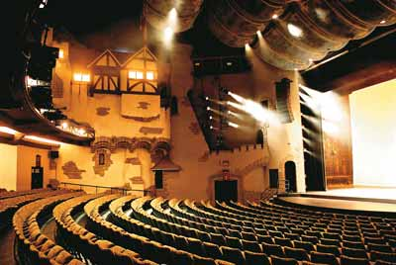
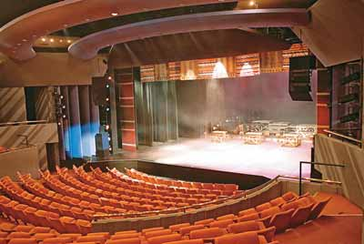

Planned Productions
3.1 MOBILE THEATRE
A year long programme where various users, such as corporate companies, arts groups and municipalities hire and make use of The Playhouse Company’s mobile stage facilities to mount medium scale productions/events e.g. product launches, concerts, awareness campaigns etc. The mobile stage offers immediate, accessible sound equipment and technical services especially in the rural and townships setting. Rentals are kept to minimum making it an affordable option for its many users.

MOBILE STAGE
This programme offers entry-level artists the opportunity of working in a professional theatre environment and offers exposure to the rudimentary processes of artists management. These free lunch hour concerts, with a total number of approximately 600 artists take place between the months of February through to December each year.

TEST DRIVE
This is a platform to showcase new South African theatre works. The primary focus is on the development of works that reflect contemporary South Africa’s artistic and diverse heritage. Artists that are making a transition from amateur to professional status are accorded performance opportunities. In addition, infrastructural support such as sets, props, costumes, stage and technical services as well as marketing of productions is given to each production. Approximately eight productions in Dance, Drama and Music genres are selected following an extensive peer review process.
NEW STAGES

ANNUAL PERFORMANCE PLAN

Central to the Playhouse Company’s arts plan are critical government imperatives such as:
- poverty alleviation & job creation
- social cohesion programmes
- promotion of historically marginalized artforms and artists.

The Playhouse Company’s primary objectives remain staging productions, festivals and concerts of the highest attainable standards as well as to use the performing arts as a tool for social change in order to impact positively on the quality of people’s lives.

Particular attention is given to arts development of historically disadvantaged communities who were systematically marginalized from the main theatre stages in the past.


The Playhouse Company’s mobile stage maintains a national profile featuring at the National Arts Festival in Grahamstown. The ten-day tour provides a platform to showcase the talents of both KwaZulu Natal artists as well as Grahamstown based artists and audiences with a technically equipped free stage. More than 300 artists have an opportunity to perform on the mobile stage.

GRAHAMSTOWN TOURS

A quarterly network forum for the arts community to engage in discussion and debates around the development of the arts. Key areas include the exchange of information on performance opportunities in other related areas as well as a series of workshops on proposal and script-writing, budgeting, best audition practices, copyright issues etc

ARTS NETWORK FORUM

Over 25 000 learners come to the theatre to witness live the specific schools programmes in dance, music and or drama that are undertaken to augment school curricular. The primary focus is on providing accessible presentations of examination set works in English and in IsiZulu for matric learners. Edu-dance programmes for primary schools have a focus on tolerance, awareness of multiculturalism and respect.
SCHOOLS PROGRAMME
This programme focuses on skills transfer in areas of script writing, choreography, and Directing and production development. Such programmes result in a fully-fledged staged production on our theatres as well as tours in schools around the Kwa Zulu Natal province.
RESIDENCY PROGRAMME

This Youth Festival is held during the celebration of our national Youth Day. The Playhouse Company’s Hip Kulcha programme is designed to create a platform for artistic and cultural expression about issues that are important to the youth.

HIP KULCHA
New artistic works that focus on South African life experiences are developed from conceptual to fully fledged staged productions. A record high of between 6 and 8 productions are produced in our theatres and are given the necessary professional and technical support.
NEW COMMISSIONS
As one of South Africa’s leading performing arts institution and the premiere theatre complex in KwaZulu-Natal, The Playhouse Company plays a significant role in the artistic and cultural life the province. The Playhouse Company produces a large-scale live entertainment with effective audience appeal that richly complements the overall entertainment package of the city and province.
FESTIVE SEASON PRODUCTION
Children’s theatre is promoted. Through these productions The Playhouse Company also supports the development of a unique blend of indigenous oral traditions in story telling and praise poetry with other types of folklore.
CHILDREN’S PRODUCTION
Indigenous artforms are the main focus of this festival which promotes and celebrates the mosaic traditions of Arts, Culture and Heritage of our country. The primary focus is on music, dance and storytelling. Collaborations with various countries in Europe and India have produced outstanding results.
INTERNATIONAL TRADITIONAL ARTS FESTIVAL
This is an annual festival that features artistic works that highlight contributions made by women in society. The festival features various prominent and upcoming female artists in music, dance and drama. The festival also features craft and beadwork, as well as various art exhibitions.
THE SOUTH AFRICAN WOMEN’S ARTS FESTIVAL
These are fully-fledged professional productions that showcase the best in South African theatre.
PROFESSIONAL PRODUCTIONS
3.2 IN-HOUSE PRODUCTIONS
The Playhouse Company uses every opportunity to collaborate with various arts companies and producers. This acts as another stream of income generated at box office in addition to grants received from various levels of government.
IN-ASSOCIATION PRODUCTIONS
3.3 PARTNERSHIPS
The Playhouse Company offers its theatre venues for hire at very competitive rates. As part of the venues hire lease agreement the expertise of technical staff is offered.
EXTERNAL
PRODUCTIONS
3.4 OUTSIDE HIRE PRODUCTIONS
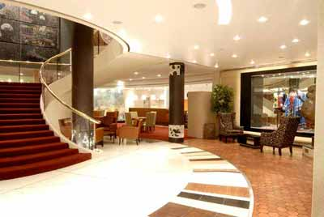
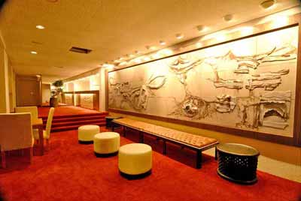
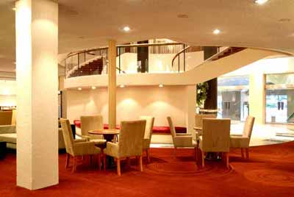
4. Budget for 2008/9


