

AUDITOR-GENERAL

POLICY, STANDARDS AND GUIDELINES

MARCH 2008

INVESTIGATIONS

Table of contents
Chapter Content | Page
1. INTRODUCTION | 1
2. FUNCTIONS OF THE AUDITOR-GENERAL | 2
3. LEGAL FRAMEWORK FOR INVESTIGATIONS | 3
4. STANDARDS FOR INVESTIGATIONS | 5
5. RESPONSIBILITY WITH REGARD TO FRAUD AND ERROR | 9
6. CODE OF PROFESSIONAL CONDUCT AND ETHICS | 10
7. THE INVESTIGATING PROCESS | 11
8. PRE-PLANNING PHASE | 13
9. PLANNING PHASE | 16
10. EXECUTION PHASE | 18
11. REPORTING PHASE | 20
12. FOLLOW-UP PHASE | 22
13. QUALITY CONTROL AND TRACKING | 23
BIBLIOGRAPHY | 24
Annexure 1 Framework and Guideline: Access to and Disclosure and Protection of Information as contemplated in Sections 15 – 18 of the Public Audit Act, 2004 (Act No. 25 of 2004)

Kindly take note that copyright in this guideline vests with the Auditor-General. Consequently, in terms of the Copyright Act No. 98 of 1978, no part of such documentation may be reproduced or transmitted in any form or by any means, electronic or mechanical, including photocopying, recording or any information storage and retrieval system, for purposes other than for work done on behalf of the Auditor-General, without permission in writing from the Auditor-General. Any party breaching this stipulation will be in contravention of the above-mentioned act and will be liable to the Auditor-General for all damages suffered as a result of such breach.

Chapter 1
INTRODUCTION

1. PURPOSE

The purpose of this document is to structure the process, promote uniform working methods and explain the modus operandi of investigations, and to serve as a guide for all authorised auditors conducting investigations on behalf of the Auditor-General (AG). This document repeals all previous guidelines on forensic audit investigations and special investigations. This guideline is in addition to the International Standards on Auditing (ISA).

DEFINITIONS

In this document, unless the context indicates otherwise -

- “Allegation” means a statement of wrongdoing made without proof.

- “Affirmation” means a solemn undertaking to speak the truth.

- “Evidence” means evidence obtained in whatever form, which is used to support findings and conclusions emanating from an investigation.

- “Economic crime” includes, inter alia, crimes against the public welfare, for example corruption and bribery and crimes against property, for example theft, fraud, forgery and uttering.

- “Investigation” as contemplated in section 5(1)(d) of the Public Audit Act, 2004 (Act No. 25 of 2004) (PAA) is defined as an independent and objective process where procedures are performed in accordance with guidelines issued by the AG to facilitate the investigation of financial misconduct, maladministration and impropriety, which may result in legal proceedings for adjudication, and ensure probity in the accounts, financial statements and financial management of an institution referred to in section 4(1) and section 4(3) of the PAA, and which may result in legal proceedings for adjudication. An investigation may be performed where the AG –
- considers it to be in the public interest
- receives a complaint relating to such institution or its affairs, or
- receives a request relating to such institution or its affairs, and
- deems it appropriate. This will result in a report (as contemplated in section 20 of the PAA) or a special report (as contemplated in section 29 of the PAA).

- “Legal forum” means a forum that provides a medium for the adjudication of matters relating to substantive issues of disagreement or legal action between two parties.

- "Sworn affidavit" refers to evidence obtained under oath.

Section 1 of the Public Audit Manual (PAM) contains additional definitions that may be applicable to this guideline.

IMPLEMENTATION DATE

This document will be effective for all investigations commencing on or after 1 April 2008.

Chapter 2

FUNCTIONS OF THE AUDITOR-GENERAL

FUNCTIONS OF THE AUDITOR-GENERAL

This section sets out the functions of the AG as per section 188 of the Constitution and the PAA, with the sole purpose of providing clarity to all relevant stakeholders.

The functions of the AG differ from those of auditors in private practice to the extent that the AG is mandated to provide only auditing and other prescribed functions. In terms of the PAA, the functions of the AG can be categorised as follows:

Constitutional functions:

- Mandatory audits (sections 4(1) and 4(2))
- Discretionary audits (sections 4(3) and 5(3))
- Discretionary reporting (sections 20(3) and 29(3))

Other functions (discretionary):

- Audit-related services (section 5(1)(a))
- Advice and support to any legislature or any of its committees (section 5(1)(b))
- Comments in a report on responses by an auditee (section 5(1)(c))
- An appropriate investigation of a section 4(1) or 4(3) auditee (section 5(1)(d))
- An appropriate special audit of a section 4(1) or 4(3) auditee (section 5(1)(d))
- Cooperate with persons, institutions and associations, nationally and internationally (section 5(2)(a))
- The appointment of advisory and other structures outside the AG’s administration for specialised advice to the AG (section 5(2)(b))
- Anything that is necessary to effectively fulfil the AG’s role (section 5(2)(c))

For the purpose of this document it is important to clearly define and understand the differences between the following functions of the AG:

- Auditing (refer to section 1 of PAM)
- Audit-related services (refer to the “Audit-related services” policy and guideline approved on 28 February 2006)
- Investigations (addressed in this guideline)
- Special audits (refer to the “Special audits” policy and guideline)

Chapter 3
LEGAL FRAMEWORK FOR INVESTIGATIONS

BACKGROUND

The PAA was enacted on 1 April 2004 and repealed the following legislation pertaining to the AG:

- The Auditor-General Act, 1995 (Act No. 12 of 1995)
- The Audit Arrangements Act, 1992 (Act No. 122 of 1992)
- Sections 58 to 62 of the Public Finance Management Act, 1999 (Act No. 1 of 1999) (PFMA)

In addition to the powers and duties retained from the Auditor-General Act, the PAA imposed certain new powers and duties on the AG. These new powers and duties relate mainly to “investigations” and “special audits” as contemplated in sections 5(1)(d) and 29 of the PAA.

CONSTITUTIONAL REQUIREMENTS AND PUBLIC AUDIT ACT REQUIREMENTS

Section 188(3) of the Constitution of South Africa, 1996 (Constitution) requires the AG to submit audit reports to any legislature that has a direct interest in the audit and to any other authority prescribed by national legislation.

Section 5(1)(d) of the PAA mentions investigation in a particular context and as a particular type of audit or investigation. An investigation has the following characteristics:

- The AG may charge a fee for an investigation.
- The AG may not compromise his role as an independent auditor.
- An investigation as contemplated in the PAA is limited to being carried out at an institution mentioned in sections 4(1) and 4(3).
- The AG can determine the nature and extent of an investigation to be carried out and can decide what procedures are appropriate under the circumstances.
- At least one of three requirements must be satisfied before an investigation is carried out:
- the AG must consider it in the public interest
- the AG received a request to do so, or
- the AG received a complaint.

Section 29(1) of the PAA provides for the AG to designate an authorised auditor to carry out an investigation in terms of section 5(1)(d). In doing so, the authorised auditor acts in terms of the provisions contained in chapter 3, part 1 of the PAA, which includes the powers conferred upon the AG when performing an audit.

Section 29(3) of the PAA gives the AG the discretion to issue a special report on an investigation. If the AG issues a special report, it must simultaneously be submitted to:
- the auditee subjected to the investigation
- if applicable, the auditee’s executive authority in terms of the PFMA
- the National Treasury or the appropriate provincial treasury
- the relevant legislature, for tabling.

Section 29(3) of the PAA gives the AG the power to issue a special report on an investigation. Even if a special report is issued by the AG, he/she will still be obliged to issue a report on the findings of the investigation in terms of section 20(1) of the PAA.

3. TERMINOLOGY

For reasons of efficacy and consistency the terminology used by the AG and authorised auditors should be limited to that used in the PAA.

The following terms will from the date of approval of this document be referred to as investigations:

- Forensic audit
- Forensic investigation
- Forensic audit investigation
- Special investigation

Chapter 4

STANDARDS FOR INVESTIGATIONS

STANDARDS APPLICABLE TO INVESTIGATIONS
The AG as auditor of the public sector of South Africa has adopted the International Standards on Auditing, issued by the International Auditing and Assurance Standards Board (IAASB) of the International Federation of Accountants (IFAC). These standards do not provide for investigations as referred to in section 5(1)(d) of the PAA. The AG deemed it necessary to compile policy, standards and guidelines for investigations conducted by or on behalf of the AG. During the development of the policy, standards and guidelines for investigations conducted by or on behalf of the AG, existing guidelines and reference material were researched. Investigations performed by the AG will be performed in terms of this document, taking into account the requirements of PAM, section 2, chapter 35: Quality assurance on review of audit files and applicable ISAs.

CODE OF STANDARDS

Since compliance with the ISAs is not always relevant and appropriate to the nature of a particular investigation, the following standards should at least be complied with:

  - Standards of conduct

2.1.1 Integrity and objectivity

Staff should conduct themselves with integrity. Staff shall sacrifice neither their own nor the AG’s integrity to serve the auditee, management of the auditee or the public interest.

Prior to accepting an engagement, the investigating team should determine if the investigation would cause any conflict of interest that could impair professional judgement or objectivity. The investigating team members should disclose any potential conflicts of interest and where actual conflict of interest exists, recuse themselves from the investigation. Where applicable, auditing staff may perform an investigation, or assist with the performance of an investigation. This will not result in a conflict of interest. The inclusion of a member of the regularity audit in the investigating team will not be deemed a conflict of interest.

The investigating team members should maintain an objective state of mind in discharging their responsibilities.

Knowledge, experience and skills

The investigating team should have the knowledge, experience and skills required to perform the investigation. The investigating team need to have a thorough understanding of the entity. The skills required by investigators should include but not be limited to auditing, internal control, and financial reporting, accounting, taxation, information technology, etc. Where required the skills of a specialist may be used.

    - Due care

The investigating team members should exercise due care in the execution of their duties. Due care requires diligence, critical analysis and scepticism in executing their duties.

Conclusions should be supported with evidence that is relevant, reliable and sufficient.

Investigations should be adequately planned. Planning consists of establishing specific objectives, determining the various steps to be taken, and defining the work in order to control the execution of the investigation with reference to time and cost constraints and the information and other resources available. The facts and circumstances of each investigation are unique and should be carefully reviewed to develop a suitable action plan that sets out the objectives of the investigation and the methods to be used to attain them. Given the nature of investigations, an inductive approach to planning is usually adopted. This means that the planning is done on a continuous basis to accommodate changes in the circumstances of an investigation as new facts are brought to light through the work of the manager and as events unfold. The investigating team should therefore be continually informed of any new facts that emerge and of changes in the nature and execution of the work.

Work performed by team members shall be adequately supervised by the manager in charge of the investigation. The extent of supervision required will be determined at the planning stage. The extent of supervision will vary depending on the experience of the team members performing the investigation and the complexity of the tasks assigned to them. The work will remain under the manager’s supervision and control.

Understanding the objectives of the investigation and the terms of the engagement

Everybody involved in the investigation should understand the nature of the actual dispute or contemplated legal action, the objective of the assignment and the role they are to fulfil.

The terms of the engagement should be verified in order to ensure the investigation is conducted accordingly. Identify any restriction that might be imposed on the performance of the investigation, as well as the time frames and deadlines, the availability of resource persons and the billing and payment arrangements.

The context in which an investigation is performed may change as new facts come to light. It is therefore important to regularly clarify the objective of the assignment with the auditee.

    - Risk assessment

A risk assessment should be performed to determine the engagement risk and identify mitigating strategies.

    - Communication with the auditee

The manager in charge of the investigation should communicate significant findings made during the investigation to the auditee.

    - Confidentiality

Investigating team members shall not disclose confidential or privileged information obtained during the course of the investigation without the written consent of the auditee, or an instruction by the legislature, or a court of law during a criminal proceeding.

    - Engagement letter

The terms of the engagement between the AG and the auditee should be documented in a letter of engagement. The letter of engagement should clearly establish the nature and terms of the engagement, set out the roles and responsibilities of the parties involved and include the following information: the facts, the nature of the contemplated or actual dispute or legal action, the objective of the engagement, the type of communication requested and, if applicable, the intended purpose of the report, the staff allocation, a tentative work schedule and a fee estimate. Any subsequent change in the nature and terms of the engagement should be appropriately reflected in an amendment to the letter of engagement.

  - Standards of execution

    - Execution

Investigations shall be conducted in a professional and thorough manner. The investigating team’s objective should be to obtain complete, reliable and relevant evidence and information.

The investigating team should establish predication and scope priorities at the outset of the investigation and continuously re-evaluate them as the investigation proceeds. The investigating team should strive for efficiency in its examination.

The investigating team should be alert to the possibility of conjecture, unsubstantiated findings and bias of witnesses and others.

    - Evidence

Information and evidence that substantiate the findings contained in the report and other supporting evidence should be obtained during the investigation. To assess the sufficiency and appropriateness of the evidence, consider whether such evidence is sufficiently persuasive to support the findings contained in the report. To determine whether the evidence is sufficiently persuasive, consideration should be given to the quality and quantity of evidence, as well as the chain of events.

All work performed should be documented. The documentation usually includes working papers explaining the methods used, the analyses made, all relevant facts, the data collected, the evidence gathered in support of the factual findings and management comments, conclusions and recommendations.

  - Standards of reporting

    - Reports

After an investigation has been completed, a process will be followed in terms of which the findings will be identified, corroborated and made public. This process will involve issuing different types of reports that will contain from detailed findings for specific role players, to more generic findings for general reporting. The different types of reports are:

- Management report
- Report to the legislature
- Special report, if required

The nature, content and form of the reports may vary depending on the nature of the assignment and the objective and intended purpose of the report.

All reports issued should:

  - describe the mandate
  - specify the restrictions on the use of the report
  - specify the limitations of the findings
  - provide the information needed to understand the subject matter and environment specific to the investigation
  - specify the nature and scope of the work performed and the evidence gathered
  - describe the approaches taken and methods applied
  - describe the facts relating to the purpose of the investigation
  - communicate the factual findings of the investigation
  - draw conclusions on the facts obtained during the investigation
  - include recommendations on the way forward, for instance possible actions (litigation, disciplinary actions), follow-up procedures, etc. (except for a special report)
  - where relevant, present charts, schedules, the document brief and other useful information
  - list the documents and information sources relied upon in forming the findings (except for a report to the legislature and a special report)
  - state the date of the report
  - be signed off by the delegated signatory.

All reports should be clear and concise, understandable, well organised and consistent, and the findings should be explicit and detailed. The report should communicate the results of the work in a clear, concise and consistent manner in relation to the purpose of the investigation and the analyses performed. In conclusion, the report should not express an audit opinion or an opinion on the legal effect of the facts set out in the report. In conducting investigations no opinion should be expressed regarding the guilt or innocence of any person(s) or party, as it is a factual report highlighting the facts obtained during the investigation.

Every report should disclose its intended use and specify that it should not be used for any other purpose. The limitations of the report should be indicated, particularly the fact that the findings are based on the information obtained during the investigation. It should also specify that the conclusions could differ if additional information was made available that might contradict evidence in the possession of the AG.

In terms of section 29(2) read with section 21(3) of the PAA, the AG is required to table an investigation report to the relevant legislature on every investigation performed. If an investigation report cannot be issued to the relevant legislature a special report should be tabled.

Prior to issuing a report that contains any legal interpretation/s the legal department of the AG should evaluate the report to verify that the findings and conclusions are legally substantiated and reported correctly.

In terms of the pre-issuance review policy of the AG each management report and report to legislature should be subjected to a pre-issuance report.

2.3.2 The management report

The purpose of a management report will be to communicate the findings of and conclusions on the investigation to management of the auditee in order for them to supply further information that may affect the investigation findings and conclusions, and supply comments on the investigation findings.

Reasonable time should be given to management to evaluate the findings made and conclusions reached after completion of the investigation, and where applicable supply additional information and management comments. Management comments should be considered and where appropriate included in the report to legislature.

2.3.4 The report to the legislature

The purpose of a report to the legislature is to communicate the findings of the investigation without naming specific individuals, institutions, or entities that were implicated by the information gathered during the investigation.

2.3.5 A special report

The purpose of a special report will only be to inform the legislature that a specific investigation has been finalised, but that the details regarding the findings are sub judice and can for the interim not be divulged in a report to the legislature.

Chapter 5

RESPONSIBILITY WITH REGARD TO FRAUD AND ERROR

PREVENTION AND DETECTION OF FRAUD AND ERROR

  - The primary responsibility for the prevention and detection of fraud and error rests with both those charged with the governance and the management of an entity. Management, with the oversight of those charged with governance, needs to set the proper tone, create and maintain a culture of honesty and high ethics, and establish appropriate controls to prevent and detect fraud and error within the entity.

  - It is the responsibility of those charged with the governance of an entity to ensure, through the oversight of management, the integrity of an entity’s accounting and financial reporting systems and that appropriate controls are in place, including those for monitoring risk, financial control and compliance with the law.

  - It is the responsibility of the management of an entity to establish a control environment and maintain policies and procedures to assist in achieving the objective of ensuring, as far as possible, the orderly and efficient conduct of the entity’s business. This responsibility includes implementing and ensuring the continued operation of accounting and internal control systems which are designed to prevent and detect fraud and error. Such systems reduce but do not eliminate the risk of misstatements. Accordingly, management assumes responsibility for any remaining risk.

  - Two types of intentional misstatements are relevant in the auditor’s consideration of fraud:

  - Misstatements resulting from financial reporting
  - Misstatements resulting from the misappropriation of assets

    - Fraudulent financial reporting involves intentional misstatements or omissions of amounts or disclosures in financial statements aimed at deceiving financial statement users. Fraudulent financial reporting may involve the following:

- Deception such as manipulation, falsification or alteration of the accounting records or supporting documents upon which financial statements are based.
- Misrepresentation in, or intentional omission from the financial statements of events, transactions or other significant information.
- Intentional misapplication of accounting practices relating to measurement, recognition, classification, presentation or disclosure.

    - Misappropriation of assets is a different form of intentional deception and entails the theft of an entity’s assets. Misappropriation of assets can be accomplished in a variety of ways (including embezzling receipts, stealing physical or intangible assets, or causing an entity to pay for goods and services not received). It is often accompanied by false or misleading records or documents of which the purpose is to conceal the fact that the assets are missing.

  - The fact that public funds are involved tends to impose a higher profile on issues related to fraud, since auditors may have to be responsive to public expectations regarding the detection of fraud. Public expectations regarding the use of public funds place the onus on the public sector auditor to consider what action to take in relation to an act of fraud, even though the fraud may not be material to the financial statements or affect the auditor’s report on the financial statements.

  - Given the implications of the increasing levels of economic crime for the public accountability process, the aims of investigations are to facilitate the proper and timely identification, investigation and prosecution of cases of misuse of financial resources.

Chapter 6

CODE OF PROFESSIONAL CONDUCT AND ETHICS

In addition to adhering to the AG’s Code of Professional Conduct and Ethics, investigators are also required to adhere to the code of professional conduct and ethics contained in this document.

It is compulsory for every investigator, auditor or specialist conducting investigations to sign and abide by the code of professional conduct and ethics. All investigators must have a thorough working knowledge of the standards and guideline for planning, executing, reporting and follow-up of investigations. The code of professional conduct and ethics includes the following:

    - An investigator shall, at all times, demonstrate a commitment to professionalism and diligence in the performance of his or her duties.
    - An investigator shall strive to safeguard the interests of the general public, AG and fellow team members.
    - An investigator shall not engage in any illegal or unethical conduct, or any activity which would constitute a conflict of interest.
    - An investigator shall, at all times, exhibit the highest level of integrity in the performance of all professional assignments and will accept only assignments for which there is reasonable expectation that the assignment will be completed with professional competence.
    - An investigator will not accept any assignment that could impair his or her objectivity and judgement in any way.
    - An investigator will comply with lawful orders of the courts and will testify to matters truthfully and without bias or prejudice.
    - An investigator, in conducting investigations, will obtain evidence or other documentation to support the factual findings and conclusions contained in the investigation reports, in order to provide a substantiated and balanced report.
    - An investigator shall not express an opinion regarding the guilt or innocence of any person or party.
    - An investigator shall not reveal any confidential information obtained during an investigation, unless specifically, in writing, authorised to do so by the Auditor-General.
    - An investigator will reveal all matters discovered during the course of an investigation which, if omitted, could cause a distortion of the facts.
    - An investigator shall acquire all the evidence and documentation required to substantiate the report within the legal mandate afforded to the Auditor-General.
    - An investigator shall continually strive to increase the competence and effectiveness of professional services performed under his or her direction.

If an investigation is conducted in an environment where a security clearance is required, all investigators shall, without delay and prior to the start of the investigation, apply for the required security clearance. Only after the required application has been submitted will an investigator participate in the investigation. If the security clearance is denied, for whatever reason, the investigator will immediately distance himself or herself from the investigation. Should circumstances arise or information become available that could impact negatively on the investigator’s independence, impartiality or objectivity, the investigator will without delay disclose the circumstances or information to those affected and distance himself or herself from the investigation if so required.
Chapter 7

THE INVESTIGATING PROCESS

1. INVESTIGATING PROCESS

A structured approach should be followed when investigations are planned, executed, reported on and followed up. All investigations conducted by the AG should be conducted in terms of these standards and guideline and documented using the format provided in the TeamMate software adopted for investigations. The modus operandi adopted when performing investigations consists of the following phases:

- Pre-planning phase
- Planning phase
- Execution phase
- Reporting phase
- Follow-up phase

This is schematically presented as set out below:

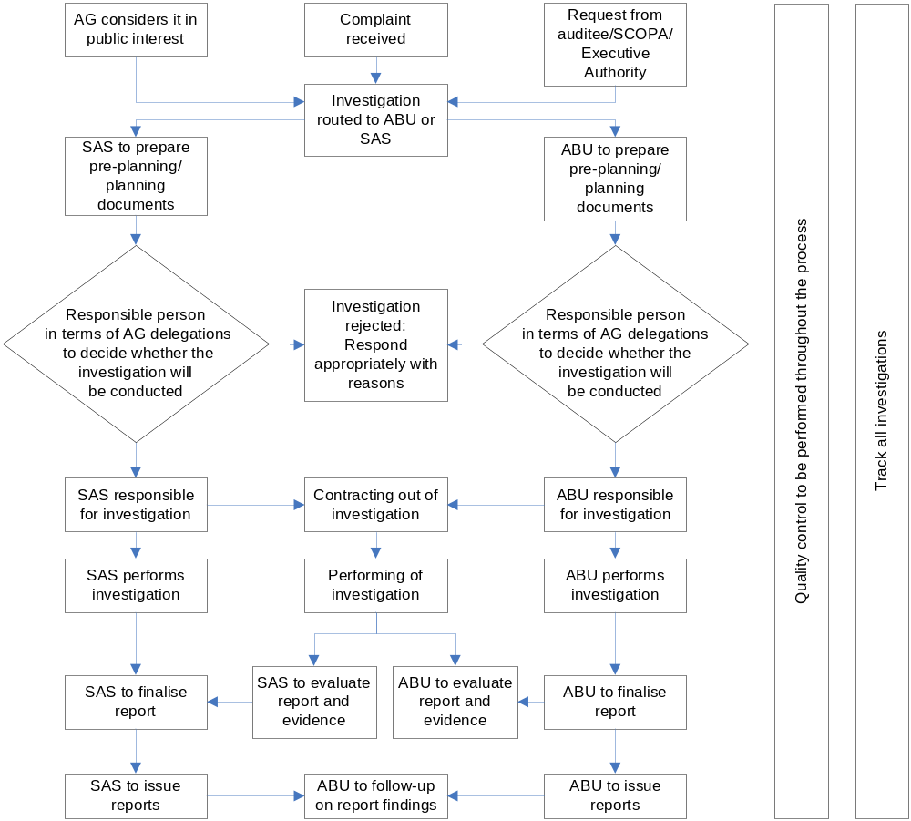
*ABU = Audit business unit
*SAS = Specialised Audit Services business unit
2. DECISION TO PERFORM AN INVESTIGATION

If the AG decides to perform the investigation, the AG or the person delegated with the responsibility will without delay inform the auditee of the AG’s decision to perform the investigation.

It is recommended that the consideration of each factor be documented as evidence that the AG applied his/her mind to the matter at hand. It should be noted that the AG’s value judgement, which is demonstrated to be based on a set of objective, measurable criteria, would in all likelihood be viewed by the courts as a reasonable exercise of the AG’s discretion and would be difficult to dispute, should the decision or action be judicially considered.

Compliance with these standards and guidelines is compulsory when an investigation is conducted by or on behalf of the AG.

3. SERVICE LEVEL AGREEMENTS

Service level agreements (SLA) should be concluded between the Business Unit: Specialised Audit Services (SAS) and the various functional audit business units. The SLA sets out the support responsibilities and service expectations between the respective business units.

4. SERVICE LEVEL CHECKLIST

A service level checklist needs to be distributed to the auditee to inform the AG of the results achieved with the investigation, as well as identify problem areas that need to be addressed by future investigations.

Chapter 8

PRE-PLANNING PHASE

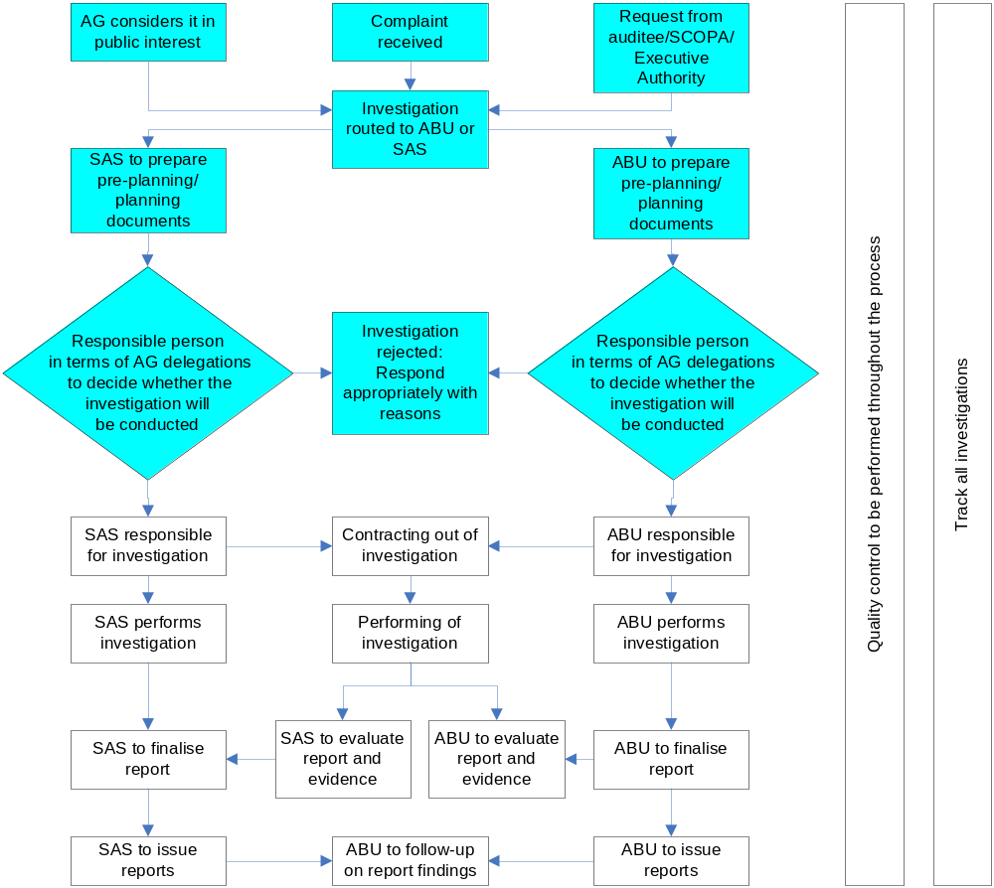

PRE-PLANNING PHASE

- Request for an investigation

Any request for an investigation should be properly documented. The following minimum information should be provided:

- Details of the person/institution requesting the investigation or reasons as to why this information is not provided. An affidavit or other evidence to substantiate the request should be submitted.
- Details of the institution at which the investigation is requested.
- A summary of the allegations of misconduct and/or irregularities that led to a reasonable suspicion that public funds have been misused for private gain.
- The names of contact persons and other investigative agencies that may already be involved in the investigation of these allegations.
- Financial arrangements, such as who should be responsible for the cost of the investigation, the budget available and other financial limitations.

- Risk assessment guidelines and worksheet

No investigation is to be entered into without the risk related to such an engagement having been evaluated and the engagement having been approved at the appropriate level. The following aspects should be considered during the risk assessment:

- Current or expected level of litigation
- Quality of preliminary information and evidence
- Nature of the skills required
- Availability of staff/effect of the loss of key personnel
- Availability, reliability and admissibility of information
- Safety of staff
- Financial risk
- Expectations and restrictions put on the AG
- Independence of the AG and the investigating team
- Level of involvement of subsequent legal proceedings
- Factual correctness of the investigation reports
- Involvement of other investigative agencies
- Any other risk that might influence the AG’s decision to undertake the investigation

- Letter of engagement

No investigation should commence until such time as the terms of the engagement have been formally agreed to in writing. The letter of engagement should be signed at the same level, at least, as that at which the investigation risk assessment was approved and should contain at least the following details:

- Name of the auditee
- Mandate of the investigating team containing the objectives of the investigation
- Composition of the investigating team
- Broad framework of the scope and nature of the investigation
- Products to be delivered and the limitations thereof
- Any restrictions placed on the assignment and products to be delivered
- Purpose for which the products will be used
- “Standard” disclaimers
- Billing arrangements, including rates, budgets and provisional time frames

- Official file

An official file should be opened for each investigation, in accordance with the filing system of the AG. All official correspondence, approvals and contact information of other investigating bodies involved should be placed on the file, which should be kept by the business unit responsible for the investigation. In terms of confidentiality provisions the file should have the same classification as the document with the highest classification on the file. The official file should be kept on TeamMate with a manual file for evidence obtained.

- Contracting out of investigation

Investigations can be contracted out to authorised auditors or specialists under the following conditions:
  - Where the audit business unit does not have the capacity to perform the investigation and SAS cannot assist the audit business unit, and/or
  - Where the issue/s at hand is/are of a specialised nature and SAS cannot assist the audit business unit.

The AG guideline on contracting out of audits needs to be adhered to when an investigation is contracted out to a authorised auditor or specialist. Special tailored working papers will be made available in PAM for investigations that are contracted out.

The requirements set out in this document need to be adhered to by all authorised auditors and specialists that perform investigations on behalf of the Auditor-General.

- Registering of the investigation on PeopleSoft

All investigations should, in terms of the AG’s policies and guidelines in this regard, be registered on PeopleSoft.

Chapter 9

PLANNING PHASE

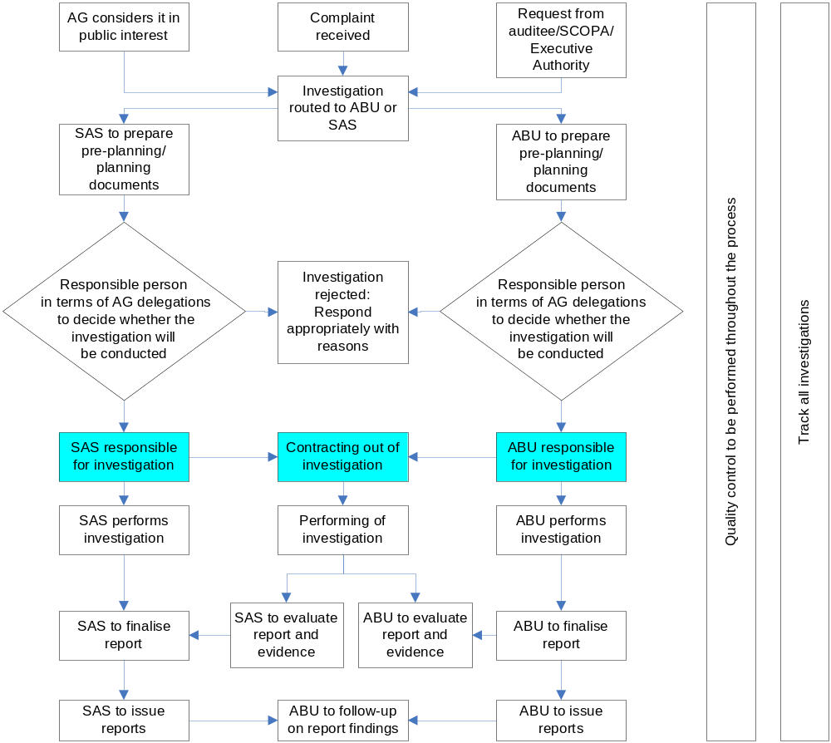

1. PLANNING PHASE

During the planning phase a general strategy and a detailed approach should be developed regarding the expected nature, timing and extent of the investigation. The extent of planning will vary according to the magnitude of the investigation and the risks involved. The planning should focus the efforts of the team and should cover all aspects of the investigation and risk assessment. Sufficient attention should be devoted to important areas of the investigation, potential problem areas, the proper assignment of work and the coordination of work submitted to the SAS business unit.

2. THE INVESTIGATION PLAN

The investigation plan should contain at least the following information:

- Background on the institution being investigated
- Initiator of the investigation
- Allegations that must be investigated
- Objectives of the investigation
- Focus, scope and approach to the investigation
- Consideration of laws, rules and regulations applicable to the investigation
- Investigating procedures that need to be performed
- Nature of evidence required to verify the allegations
- Reporting requirements for the investigation
- Skills required to perform the investigation
- Staff required to perform the investigation
- Need for assistance by experts or specialists
- Time frame of the investigation
- Budget available for the investigation
- Quality control requirements for the investigation
- Nature and role of the AG in case of litigation

The investigation plan should be reviewed and approved at the appropriate level of management, based on the level of risk identified with the risk assessment.

3. CODE OF PROFESSIONAL CONDUCT AND ETHICS

Every individual involved in any phase of an investigation should consider, agree to and sign the code of professional conduct and ethics as proof of accepting the additional requirements indicated in this code. The same applies to investigations conducted by authorised auditors and specialists.

Chapter 10

Execution Phase
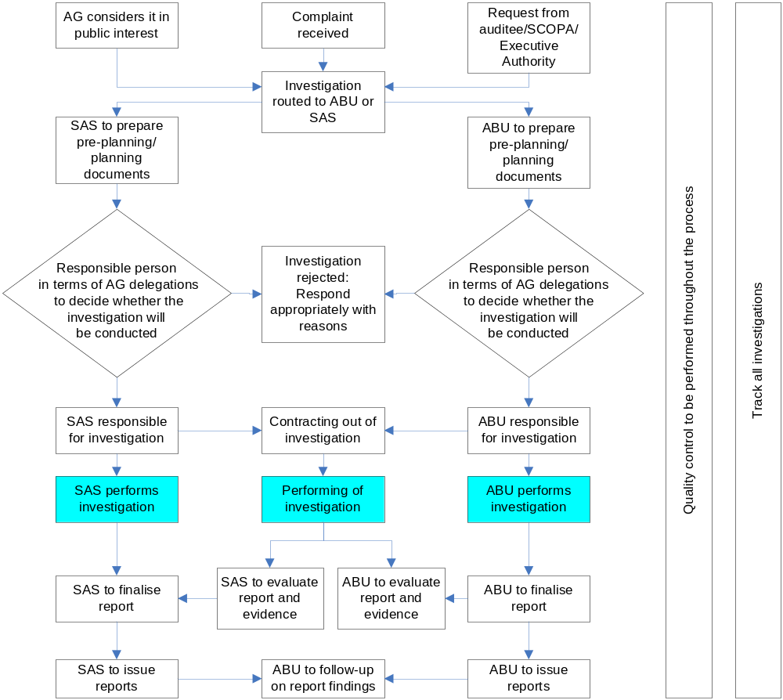

EXECUTION PHASE

During the execution phase, the procedures developed during the planning phase should be executed and documented to ensure that the objectives of the investigation are achieved.

Sufficient, complete, relevant, appropriate and reasonable evidence should be obtained to substantiate findings and conclusions and should be comprehensively documented in working papers.

All documents should be completed and filed in accordance with the layout prescribed in the standard audit file for investigations (electronically or in manual file format).

If, during the performance of an investigation, the investigating team:
- is in any way restricted from access to documentation or information, or
- has evidence that documentation, information or anything else has been removed from the premises where the investigation is being conducted,

the investigating team should follow the process prescribed in the AG’s guideline “Access to and Disclosure and Protection of Information as contemplated in Sections 15 – 18 of the Public Audit Act, 2004 (Act No. 25 of 2004)” approved by the AG on 2 March 2006.

The PAA gives the investigating team search and seizure powers to obtain access to premises where information, documentation or anything else that might be of importance to the investigation may be found.

The right to search and seizure is only to be used if all avenues have already been exhausted to obtain the required information, documentation or anything else that might be of importance to the investigation.

The said guideline is attached to this guideline as annexure I.

Chapter 11

REPORTING PHASE

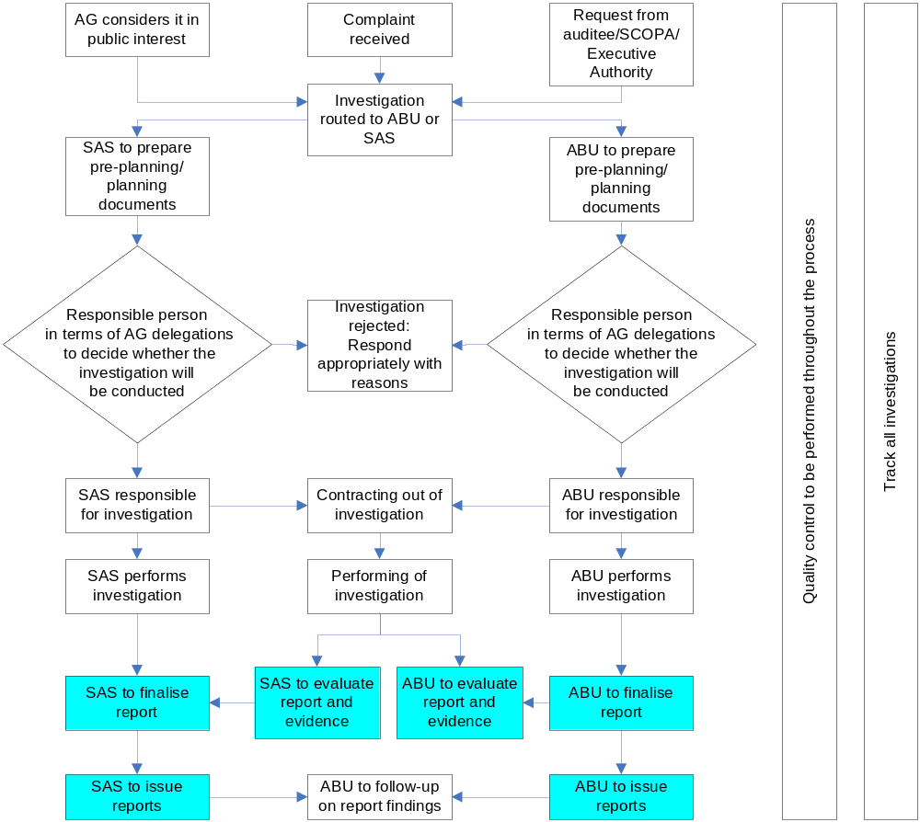

REPORTING PHASE

During the reporting phase, the investigating team communicates the result of its work in writing. In addition to the requirements of the reporting standard (refer par. 2.3 of chapter 4), it should also be ensured that the report complies with the following requirements:

- The factual correctness of the report and the interpretation of the facts must be cleared at the most appropriate level and proof of clarification must be filed on the official file.
- It must be clear, concise, complete, objective, timely, logically sequenced and structured, readable and accurate.
- It must contain specific and properly substantiated facts.
- It must contain clear and precise language and terminology to obviate misunderstanding, ambiguity and false perceptions being created.
- All reports must be language edited.
- Terms and phrases must be used consistently. General abbreviations must be avoided as far as possible.
- Graphs, charts and tabulations must be suitable and relevant and must only be used to visually illustrate and explain written information.
- Contents must be relevant to the scope and nature of the investigation.
- The report should identify possible areas for improvement, which may serve as a guide for action to be taken by the auditee.

The report should be dated with the date the report is signed. The date of the report is important because it informs the reader that the conclusion is based on information available up to that date. The conclusion could change if new information subsequently comes to the attention of the manager. The report should therefore specify that the conclusion is based on the information available as at the date of the report and could change if new information were to invalidate the information obtained.

Before the report is issued, the risk assessment should be reviewed to ensure that all risks emanating from the report have been appropriately identified and assessed and that the mitigating strategies are in fact in place. This must be documented on the risk assessment.

The investigation report should at least contain the following:

- Clear and concise title
- Addressee
- Recipients of final and draft copies
- Table of contents
- List of abbreviations (if any are used)
- Mandate of the AG
- Purpose and limitations of the report
- Background to the report
- Relevant role players involved
- Purpose, objectives and approach of the investigation
- Scope of the assignment
- Sources of information
- Procedures performed
- Overview of the entity
- Regulatory environment
- Executive summary
- Background, detailed findings, and recommendations on each allegation investigated
- Appreciation for any assistance rendered
- Signature of the AG or his designate
- Place of signing of report
- Date of the report
- List of exhibits and annexes to the report
- Other matters that came to the attention of the investigating team

Chapter 12

FOLLOW-UP PHASE
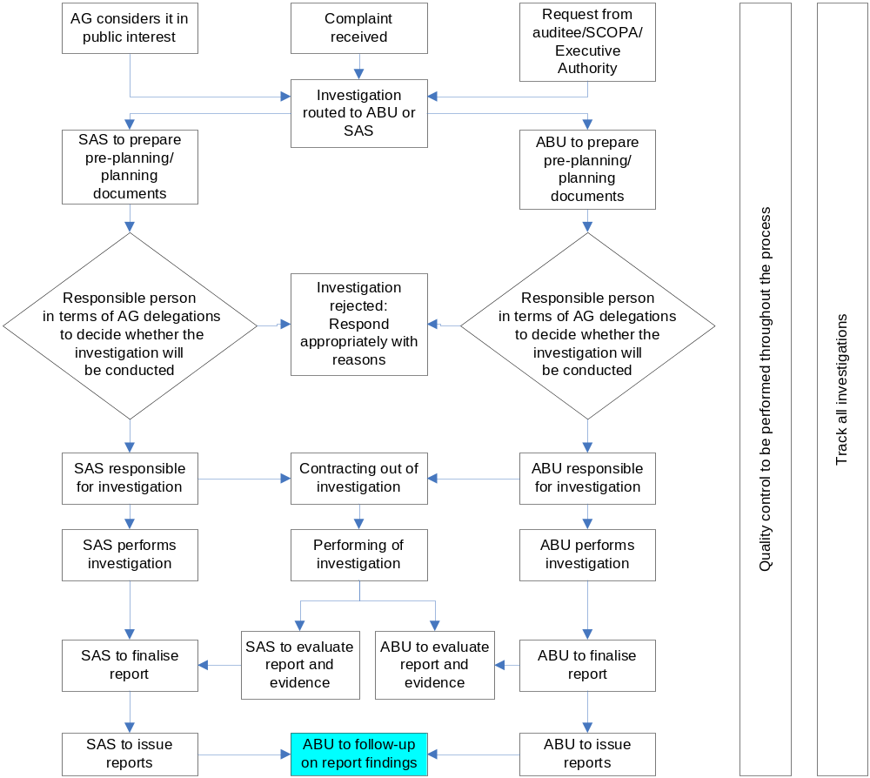

FOLLOW-UP PHASE

Where an investigation has been or is being conducted the audit business unit must take into consideration the impact or findings of the investigation and its possible effect on the regularity audit.

During the follow-up phase the AG should meet further obligations in terms of the engagement and also monitor the auditee with regard to compliance with the relevant legislation prescribing its responsibilities in respect of material irregularities and misconduct.

The follow-up of investigations is the responsibility of the audit business unit responsible for the audit of the specific institution. Where the AG does not perform the audit, the audit business unit responsible for the audit of the national department, the provincial department or the local authority to which the institution reports, will perform the follow-up work on the recommendations.

Chapter 13
QUALITY CONTROL AND TRACKING

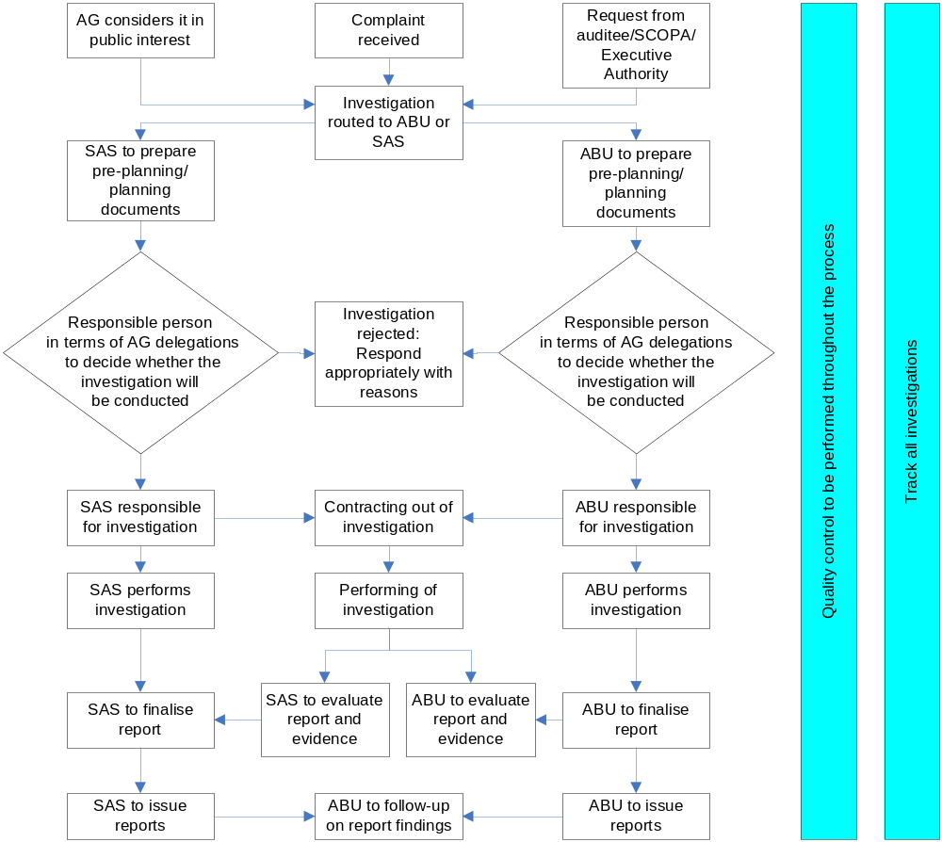

1. QUALITY CONTROL

All investigations should be subjected to a quality control process as per the quality control strategy of the AG prior to the issuance of any report. Quality control of each investigation should be performed at the business unit that conducted the investigation. This quality control is in addition to the quality control performed by the Governance business unit of the AG.

2. TRACKING

All requests received, complaints received, or where the AG deems it to be in the public interest to perform investigations, should be tracked centrally in each business unit, whether an investigation needs to be performed or not, as well as the progress made on the investigation. This requirement will enable the AG to report on all investigations performed or declined as part of the AG’s annual report.
BIBLIOGRAPHY

- Framework and Guideline: Access to and Disclosure and Protection of Information as contemplated in Sections 15 – 18 of the Public Audit Act, 2004 (Act No. 25 of 2004).
- Framework and Guidance: Investigations and Special Audits as contemplated in Section 29 of the Public Audit Act, 2004 (Act No. 25 of 2004).
- Audit-Related Services: Policy and Guideline.
- Guidelines for the Planning, Execution, Reporting and Follow-up of Forensic Audits.
- Specialised Audit Services Engagement Quality Control Review Policy.
- ISQC 1: Quality Control For Firms That Perform Audits And Reviews Of Historical Financial Information, And Other Assurance And Related Services Engagements (Effective as of June 15, 2005).
- The Process Flow For Case Files.
- Investigation Manual: Fraud and Corruption Control Unit.
- Quality Control Strategy: Financial year 2004/2006.
- Fraud Examiners Manual: Association of Certified Fraud Examiners.
- Forensic Auditing; Chatterji A. N.; SAI – India.
- ISA 240R: The Auditor’s Responsibility To Consider Fraud In An Audit Of Financial Statements (Revised) (Effective for audits of financial statements for periods starting on or after December 15, 2004).
- Legal Interpretation of section 29 of the Public Audit Act, No. 25 of 2004.

Annexure 1

Policy and Guidelines:

Access to and Disclosure and

Protection of Information

as contemplated in

Sections 15 – 18 of the

Public Audit Act 2004 (Act No. 25 of 2004)

Approved by the Auditor-General

2 March 2006

Index
Number | Content | Page Nr
 | GENERAL INTRODUCTION | 1
 | PART A | 4
1. | The law relating to search and seizure in South Africa: An overview | 4
2. | The powers of the Auditor-General | 15
 | PART B | 21
3. | The Promotion of Access to Information Act | 21
4. | Responsibilities to third parties in terms of PAIA | 26
5. | Section 18 of the PA Act | 28
 | SCHEDULE 1: ANNEXURE TO PART A | 32
1. | Introduction | 32
2. | Reasons for the application of a warrant | 33
3. | The procedures to be followed for the application of a warrant | 34
4. | Preparation for the execution of the warrant | 36
5. | The execution of the warrant | 39
6. | The management of seized Articles | 45
 | SCHEDULE 2: ANNEXURE TO PART B | 47
“A” | Step by step checklist for Information Officer | 47
“B” | Notes to checklist for managing requests | 54
“C” | Control sheet for managing requests | 65
“D” | Templates | 68
1. | Letter to be addressed to the Deputy Auditor-General | 68
2. | Letter to be addressed to the employee/s of the Auditor-General to be appointed as Deputy Information Officer(s) | 71
3. | Awareness letter to be addressed to all employees of the Auditor-General | 74
 | Overview of the Promotion of Access to Information Act | 76
4 | Awareness letter to be addressed by the Deputy Auditor-General to line Business Executives of the Auditor-General | 79

General Introduction
i The Public Audit Act, 2004 (Act No. 25 of 2004) (“the Act”; “the PA Act”) was published in the Government Gazette on 20 December 2004, with effect from 1 April 2004. This Act repeals:
- the Auditor-General Act, 1995 (Act No. 12 of 1995);
- the Audit Arrangements Act, 1992 (Act No. 122 of 1992);
- sections 58, 59, 60, 61 and 62 of the Public Finance Management Act, 1999 (Act No. 1 of 1999) (“the PFMA”).

ii Chapter 3 Part 1 of the Act, inter alia, deals with access to information and the protection and disclosure thereof. The relevant provisions are contained in sections 15, 16, 17 and 18 of the Act. In addition to certain powers that were contained in the now repealed Auditor-General Act, 1995, certain new powers and duties are imposed on the Auditor-General (“AG”). The inclusion of search and seizure powers serves as one of these additional powers and duties.

iii In view of these legislative changes, the AG, authorised auditors and assistants need policies and procedures on the following:
- general access to information when conducting and audit;
- search and seizure;
- protection of information; and
- disclosure of information.

iv In addition, the AG must obtain an indication as to the capacity needed in the organisation to meet these legislative requirements.

v The purpose of this policy framework and guidelines document is to:
- set out the procedures for obtaining the different types of information or documentation available to the AG;
- summarise the law and procedure generally applicable to search and seizure in the context of South African law;
- compare the exercise of search and seizure powers by various organs of state, for example, the Financial Services Board, SARS, the Public Protector, the Commission on Gender Equality, etc;
- advise on the difference, if any, between search and seizure in the private and public domain;
- advise on the extent to which the AG should guard against the disclosure of information and, more specifically, what type of information is protected by section 18;
- provide a comprehensive policy derived from the research results above; and
- determine the skills and qualifications of staff needed for the performance of search and seizure.

vi Section 15 of the Act provides for the “General auditing powers” of the AG “when performing an audit referred to in section 11” of the Act. Section 11 refers to the audits that the AG must perform as contemplated in sections 4(1) and 4(2), and those the AG opts to perform in terms of section 4(3). Section 4(1) refers to:
- all national state departments and administrations;
- all provincial state departments and administrations;
- all constitutional institutions;
- the administration of Parliament;
- the administration of provincial legislatures;
- all municipalities;
- all municipal entities;
- any other national or provincial institution or accounting entity that the AG must audit by law.

vii Section 4(2) refers to the audit of the consolidated financial statements of the National Government and all Provincial Governments (required respectively by sections 8 and 19 of the PFMA), and a parent municipality with all municipalities under its “sole or effective” control, as required by section 122(2) of the Municipal Finance Management Act, 2003 (Act No. 56 of 2003) (“the MFMA”).

viii Section 4(3) provides that the AG may audit the following:
- any public entity listed in the PFMA;
- any other institution not mentioned in section 4(1), but that is funded from the National Revenue Fund, or a Provincial Fund, or by a municipality;
- any other institution not mentioned in section 4(1) that is authorised in terms of legislation to receive money for a public purpose.

ix Section 15 sets out the powers the AG would exercise over auditees, i.e. all institutions or accounting entities referred to in section 4 and audited in terms of the Act. The powers are those necessary to perform the AG’s duties and responsibilities at every institution or accounting entity that falls within the ambit of the AG’s jurisdiction. The section provides for the AG to search, without a warrant, the property, premises or vehicles under the control of an auditee.

x The heading of section 16 of the Act is “Searches of property, premises, vehicles and persons”. It is an added tool in the AG’s enforcement arsenal when performing an audit and contains more far-reaching powers than section 15, in that the AG may, under authority of a warrant, enter and search any property, premises or vehicle on suspicion that information or an asset of an auditee is kept or hidden there, and may seize such information or asset.

xi Part A of this document, Access to Information, deals with the exercise of the powers in sections 15 and 16.

xii Section 17 provides that when exercising the powers in sections 15 and 16, the AG or an authorised auditor may be “accompanied by such assistants and other persons as are reasonably required for the exercise of those powers”.

xiii Section 18 provides for the protection and disclosure of information obtained during the course of the AG’s official duties. Part B of this document, Protection and Disclosure of Information, deals with the provisions of section 18.

Part A: Access to Information

- The Law relating to Search and Seizure in South Africa: An Overview

  - Introduction and background
1.1.1 The power of search and seizure is not new to our law, and is historically most commonly exercised by the police in terms of the Criminal Procedure Act, 1977 (Act No. 51 of 1977). However, there are a number of Acts vesting the power of search and seizure in organs of state similar to the AG (see paragraph 1.4.5 below). As in the Public Audit Act, these Acts generally provide for:
- procedures that include search and seizure without the use of a warrant;
- search and seizure on the strength of a warrant.

1.1.2 It is accepted in our law that search and seizure may constitute a violation of the constitutional rights of individuals, notably the right to privacy as contained in section 14 of the Constitution of the Republic of South Africa, 1996 (Act No. 108 of 1996) (“the Constitution”). It is also accepted that search and seizure may constitute a justifiable limitation to the right to privacy. It is nevertheless a power that should be used with circumspection, and it cannot be properly discussed without reference to the right to privacy.

1.1.3 It is recognised in our law that the right to privacy in the workplace constitutes a particular problem, due to the possibility of employees’ private information being kept there. For the person participating in a search and seizure, it is important to take note of this issue and to understand where justifiable action stops and a violation of the right to privacy starts.

1.1.4 With regard to the Act, it should be noted that:
- the legislature has placed a powerful discretionary investigative tool in the hands of the AG;
- the legislature went to some lengths to see that constitutional values are respected, so as to prevent abuse of the power. In this regard, section 16 provides for certain procedures to be followed and makes special reference to decency, order and the affected person’s constitutional rights.

1.1.5 This section of the document:
- discusses the right to privacy in the workplace (as related to search and seizure);
- discusses access to an employee’s private information;
- provides an overview of the powers of search and seizure in South African law, as it relates to organs of state similar to the AG (it does not deal in detail with search and seizure as it relates to criminal law and procedure).

  - The right to privacy at the workplace
1.2.1 The right to privacy can be found in Chapter 2 of the Constitution, which provides that:
“Everyone has a right to privacy which includes the right not to have -
(a) their person or home searched;
(b) their property searched;
(c) their possessions seized; or
(d) the privacy of their communications infringed.”

1.2.2 Like most fundamental rights, the right to privacy is not absolute and can be limited by invoking the general limitation clause appearing at section 36 of the Constitution, which provides that:
“The rights in the Bill of Rights may be limited only in terms of a law of general application to the extent that the limitation is reasonable and justifiable in an open and democratic society based on human dignity, equality and freedom, taking into account all relevant factors, including -
(a) the nature of the right;
(b) the importance of the purpose of the limitation;
(c) the nature and extent of the limitation;
(d) the relation between the limitation and its purpose; and
(e) less restrictive means to achieve the purpose.”

1.2.3 The right to privacy is not new to our law. Our common law has long recognised a person’s right to be left alone. It has also recognised that this right is not absolute and can be limited in certain instances. Indeed, our common law has recognised that the extent of this right diminishes in the workplace.

1.2.4 As stated by Cameron JA in the matter between OM Powell and 10 Others and The Honourable WJ van der Merwe and 4 Others:
“Our law has a long history of scrutinising search warrants with rigour and exactitude – indeed, with sometimes technical rigour and exactitude. The common law rights so protected are now enshrined, subject to reasonable limitation, in s 14 of the Constitution:….”

1.2.5 The nature and scope of search warrants are discussed in great detail in the Powell matter, particularly in relation to the potential for misuse and need for strict limits. This serves to highlight the considerable safeguards deemed necessary in order to protect an individual’s right to privacy.

1.2.6 In Mistry v Interim Medical and Dental Council of South Africa and Others, it was held, as to the nature of the right to privacy, that the existence of safeguards to regulate the way in which State officials might enter the private domains of ordinary citizens was one of the features that distinguished a constitutional democracy from a police state.

1.2.7 In Investigating Directorate: Serious Economic Offences and Others v Hyundai Motor Distributors (Pty) Ltd and Others; In Re Hyundai Motor Distributors (Pty) Ltd and Others v Smit NO and Others, it was held that the right to privacy in section 14 of the Constitution did not relate solely to the individual within his or her intimate space. When persons moved beyond this established ‘intimate core’, they still retained a right to privacy in the social capacities in which they acted. Thus, when people were in their offices, in their cars or on mobile telephones, they still retained a right to be left alone by the State unless certain conditions were satisfied. Wherever a person had the ability to decide what he or she wished to disclose to the public and the expectation that such a decision would be respected, was reasonable, the right to privacy would come into play.

1.2.8 An example where the right to privacy was outweighed by the right of the public to be informed of malpractices is to be found in MEC for Health, Mpumalanga v M-Net and Another. It was held that although the MEC for Health and her officials had the right to control access to the hospital and the staff to practice their profession without undue interference, the public which was served by the hospital and whose taxes funded it, was prima facie entitled to be informed of practices that would constitute an invasion of patients’ rights and a serious dereliction of duty on the part of the medical professions.

1.2.9 It was further held that weighing up the right to privacy of the hospital staff against the right of the public to be informed of untoward goings-on at public hospitals, the right of the public and the obligation of the media to inform the public of these outweighed the interest of the medical staff at the hospital not to be disturbed in the exercise of their duties.

1.2.10 In Fedics Group (Pty) Ltd and Another v Matus and Others, documents were seized during the search of a private office from which one of the respondents was conducting business for the applicant and, at the same time, financing a competing business entity. It was held that although it was accepted for the purposes of the case that the search of the respondent’s office had constituted a violation of her constitutional rights to dignity and privacy, the documents should be allowed as evidence, inter alia because the documents had been found in an office from which the applicant conducted its business and not in the respondent’s private home.

1.2.11 An employee has a reasonable expectation of privacy, but the extent thereof depends on the nature of the workplace and the object of the search.

1.2.12 Comments made in the US Supreme Court case of O’Connor and Others v Ortago regarding the definition of “workplace” are helpful in approaching the issue of warrantless searches. “Workplace” was held to include “those areas and items that are related to work and are generally within the employee’s control.” This would include such areas as offices, desks, filing cabinets, computers and government vehicles.

However, “not everything that passes through the confines of the business address can be considered part of the workplace context.” As a general rule, a government employee would continue to have an expectation of privacy about his/her personal belongings which have been brought into the workplace environment. This is the same expectation of privacy a private individual would have about his/her personal belongings at his/her private dwelling. Thus, “the appropriate standard for a workplace search does not necessarily apply to a piece of closed personal luggage, a handbag, or a briefcase that happens to be within the employer’s business address.”

1.2.13 That is not to say that a public employee’s personal property can never be included within the workplace context. While “a court is more apt to find an employee has standing to challenge the seizure of personal items or the search of an area where personal items are stored than the search or seizure of work-related documents or materials,” a public employee’s private property may still, in certain rare circumstances, fall within the scope of a workplace search. This generally occurs where the employee is put on notice that his/her property can be searched as part of the workplace environment, or in situations where the employee is using the personally-owned property as part of the workplace. The employee’s expectation of privacy would be limited by his/her knowledge that it was departmental policy to search employees’ belongings to deter crimes such as theft.

1.2.14 A reasonable expectation of privacy can be said to exist when:
- an individual exhibits an actual expectation of privacy, and
- that expectation is one which society is prepared to recognise as reasonable.

1.2.15 An “expectation of privacy in commercial premises …. is different from, and indeed less than, a similar expectation in an individual’s home.” A government employee’s expectation of privacy is limited by the “operational realities of the workplace,” and “whether an employee has a reasonable expectation of privacy must be addressed on a case-by-case basis.”

1.2.16 Courts will often look to the openness and accessibility of a workspace to determine whether an expectation of privacy can be sustained.

1.2.17 Courts will consider both the position occupied by the employee and the surrounding work environment when determining whether a reasonable expectation of privacy exists. For example, “when an individual enters into an employment situation with high security requirements, it becomes less reasonable for her to assume that her conduct on the job will be treated as private.”

  - Access to an employee’s private information
1.3.1 Consideration of this aspect of the law is relevant given the possibility that the AG may:
- wish to gain access to electronic information kept by an employee of the auditee during the course of the exercise of the AG’s powers under section 15;
- come into contact with the private information or property of a person during a search and seizure carried out under section 16.

1.3.2 Privacy has been referred to in our law as the right to be left alone. It has been described by the Constitutional Court as:
“… an individual condition of life characterised by seclusion from the public and publicity. This implies an absence of acquaintance with the individual or his personal affairs.”

1.3.3 Section 15 (1)(a) inter alia gives the AG “full and unrestricted access” to any “electronic record or information” of the auditee. Most likely, problems in respect of private information at the workplace will arise during a search for (and of) such electronically stored records or information. The introduction of technology and electronic communication tools (e-mail and Internet) into the workplace has irreversibly changed the way business is conducted. Nowadays, it is a commonplace occurrence to find private information on computers at the workplace. In the case of search and seizure, this may obviously pose a threat to the employee’s right to privacy, but the border between an employee’s right to privacy and the interests of an employer (or the AG, for that matter) is decidedly blurry.

1.3.4 The right to privacy in the workplace extends to and protects not only the right to physical privacy, but also the right to privacy in respect of personal data to which the employer may have access as a result of the employment relationship. The issue which requires consideration is the extent to which access to an employee’s private information can be gained.

1.3.5 It is clear that privacy is not an absolute right nor is it a paramount value. It is, however, closely linked with the paramount value of human dignity and exists where there is a reasonable expectation of privacy, the workplace being one such arena. One must balance employer and employee interests in dealing with the issue, and in determining whether an independent institution such as the AG has the right to invade this privacy during the course of an investigation.

1.3.6 An employer’s e-mail, Internet and computer network are normally used as a business tool and data in its computer system is accordingly neither confidential nor private. An employer is entitled to access information which has been stored on its computer system, provided the access of such information relates to the employer’s legitimate and lawful business activities.

1.3.7 It is not inconceivable that the records and information contemplated in section 15(1) of the PA Act may be stored on computers worked on by employees of the auditee, next to private e-mails and other information of a personal nature. However, “full and unrestricted access” as contemplated in section 15 does not provide a licence to the AG to violate such employee’s right to privacy.

1.3.8 The AG’s task would be facilitated by contracts of employment or Internet user policies stating that the auditee may access e-mail communications and Internet communications that are made on its Internet/intranet computer system. Internet user policies usually prohibit, inter alia, illegal usage, accessing of sites which are unrelated to the objectives of the department, unauthorised distribution of employer data and information, and the dissemination of confidential information.

1.3.9 In the absence of such contracts or policies that would facilitate the AG’s task to a large extent, a search and seizure which involves gaining access to an auditee employee’s (or other person’s) private information would be dealt with in the manner described in respect of searches and seizures in general. This would require a balance between the interests pursued by the AG and the intrusion of the individual’s right to privacy in the process.

  - Search and seizure by other organs of state
1.4.1 Several organs of state have search and seizure powers bestowed upon them by Acts pertaining to their particular areas of jurisdiction. These powers are thus created and regulated by statute. The situation is different from that of a private individual or entity seeking similar relief. The private party has to rely on the common law and apply for a so-called “Anton Piller”, which entails an application comprising a Notice of Motion, with supporting affidavit, lodged at the High Court. The primary purpose of an Anton Piller application is to obtain and secure evidential material with probable value which a litigant requires, and which would be destroyed by the party against whom the relief is sought, should such party become aware that the applicant is in need of the material. (The search and seizure in this case is carried out by the sheriff on behalf of the applicant.)

1.4.2 Sections 15 and 16 of the PA Act distinguish between:
- a situation where the AG can search for information and other material without obtaining a search warrant (as contemplated in section 15); and
- a situation where the AG needs to obtain a warrant to search and seize (as contemplated in section 16).

1.4.3 The powers in sections 15 and 16 relate to an audit and, in terms of section 29(2), a special audit and an investigation. The wording in section 15 is somewhat ambiguous as to which “person” is subject to the powers in section 15, and whether it includes a person other than those related to the work of an auditee (persons related to the work of the auditee would be employees, contract workers, service providers, agents, etc). There is no ambiguity with regard to the “person” that may be searched in terms of section 16(1)(b), though, this refers to any person on the premises at the time of the search, including “third parties” (persons who normally have nothing to do with the work of the auditee).

    - It is suggested that the most likely interpretation is for section 15 to refer to persons employed by, or representing, or working for or on behalf of an auditee. The person must, in other words, have some connection to the auditee, and not merely be a coincidental bystander on the scene. (If section 15 was interpreted to include such bystanders or private individuals, section 16 would have been superfluous.) This interpretation would be in line with other legislation of a similar nature, such as the Inspection of Financial Institutions Act, 1998 (Act No. 80 of 1998). Legislation that regulates a particular sphere of activity – such as financial institutions – usually distinguish between the individuals or entities directly subject to its provisions, and “third parties” not normally subject to its provisions. In the case of its subjects, warrantless searches are sanctioned; in the case of the third parties, a search warrant must be obtained. On the other hand, legislation generally applicable to all entities and individuals – such as legislation relating to tax, corruption, and the criminal law in general – always necessitates a search warrant issued by an independent judicial authority (unless specific and exceptional circumstances dictate otherwise).
1.4.5 The table below demonstrates this distinction and also compares the search and seizure powers of the AG to similar powers of other organs of state:

Organ of State | Act of Parliament | Search and seizure power | Procedure
Auditor-General | Public Audit Act, 2004 (Act No. 25 of 2004) | Section 15(1) read with 15(2) empowers the Auditor-General to enter premises of auditee, for purposes of conducting an audit, without a warrant.  Section 16(1) empowers the Auditor-General to enter and search private dwellings and/or persons, which action must be sanctioned by a warrant issued by judge or magistrate. A reasonable suspicion must exist that material is kept or hidden on the premises. | - Auditor-General ex officio authorised to enter and search premises of auditee for purpose to conduct audit.  - Warrant not a pre-requisite.  - Action must be sanctioned by warrant issued by judge or magistrate.  Information in form of affidavit on oath or affirmation to establish reasonable suspicion that material is in possession or under control of a person or on the premises.

Organ of State | Act of Parliament | Search and seizure power | Procedure
Financial Services Board | Inspection of Financial Institutions Act, 1998 (Act No. 80 of 1998) | For purpose of inspection of institution an appointed inspector may at any time enter and search premises occupied by institution.  (Searches are limited to premises occupied by the institution )  The enter and search of private persons or premises not occupied by an institution is only possible on the authority of a warrant.  An inspector may proceed without a warrant, if a person in control of the premises consents to the entry and search of the premises. | - An appointed inspector ex officio authorised to enter and search any premises occupied by institution and seize material related to the affairs of the institution.  - Warrant may be issued on application by magistrate or judge.  - Information in form of affidavit on oath or affirmation to establish reasonable belief that material related to affairs of institution is kept on premises.
South African Revenue Services | Revenue Laws Amendment Act, 1996 (Act No. 46 of 1996) | Section 57D empowers a Commissioner , on application and only when authorised by a warrant, issued by a judge, to enter and search any premises and search any person present on the premises. | An application to a judge which consists of a Notice of Motion and founding affidavit on oath or solemn declaration to establish reasonable grounds that an offence has been committed or to establish non-compliance of a person’s obligations.
Special Investigations Unit | Special Investigating Units and Special Tribunals Act, 1996 (Act No. 74 of 1996) | A member of the Special Investigation Unit, for purpose of performing functions, under authority of a warrant, issued by a judge or magistrate, may enter and search any premises. A member of the unit can without a warrant enter and search any premises for material if a competent person consent thereto or if the member believes on reasonable grounds that a warrant will be issued on application, but the delay in obtaining a warrant would defeat the object of the search.  (Member of unit has a discretion). | - Warrant may be issued by a judge or magistrate  Information in the form of an affidavit on oath or affirmation to establish reasonable grounds that material is in possession or under control of any person on any premises.

Organ of State | Act of Parliament | Search and seizure power | Procedure
Medicine Control Council | Medicines and Related Substances Control Act, 1965 (Act No. 101 of 1965) | An appointed inspector has very wide powers to enter and search any premises on which described medicine are present in terms of section 28 of the Act.  A private dwelling can only be entered and searched by an appointed inspector under authority of a warrant. | Warrant may be issued by magistrate on information on oath or affirmation.  - Information before a magistrate in the form of affidavit on oath or affirmation to establish reasonable grounds.
Competition Commission | Competition Act, 1998 (Act No. 89 of 1998) | Section 46(1) of the Act makes provision for a warrant to search and enter any premises, issued by a judge or magistrate from information on oath or affirmation.  Section 47 of the Act provides for entry and search of certain premises without a warrant, if person in control consent or if the inspector has reasonable grounds for believing that a warrant would be granted, but delay in obtaining it would defeat the object of the entry and search. | Warrant may be issued on application by a magistrate or judge.  Information in form of affidavit on oath or affirmation to establish reasonable grounds that a prohibited practice has taken place.
National Prosecuting Authority | National Prosecuting Authority Act, 1998 (Act No. 32 of 1998) | Sections 29(5) read with sections 28(13) and (14) of the Act provide for entry and search of a premises on reasonable suspicion that a specific offence had been committed or objects in relation to investigation of specific offence, could be found on the premises. | - An application to judge which consists of Notice of Motion and founding affidavit on oath or affirmation.  Information must establish reasonable suspicion that an offence had been committed, or the object in relation to an offence is possibly on the premises.

- The powers of the AG
  - Introduction
2.1.1 This section deals with:
- the general auditing powers of the AG and authorised auditors in section 15 of the Act (for ease of reading, only “AG” is used below;
- the searches of property, premises, vehicles and persons contemplated in section 16 of the Act;
- the meaning of terminology used with regard to the powers of the AG.

  - The general auditing powers of the AG (section 15)
2.2.1 Section 15 provides for the general auditing powers of the AG, and includes the warrantless search of property, premises or vehicles belonging to or under the control of an auditee.

2.2.2 Section 15(1)(a) gives the AG “full and unrestricted access” to any “document, book or written or electronic record or information” of the auditee, or “which reflects or may elucidate” the audit (“the business, financial results, financial position or performance of the auditee”). The AG also has such unrestricted access to assets “of or under the control” of an auditee, and to staff members and representatives of the auditee. In view of the AG’s duties and responsibilities in terms of the Act, it appears that the legislature intended the meaning of this introductory subsection to be all-encompassing, to include all information and material relevant to the performance of the audit. The phrase “full and unrestricted access” implies that persons requested to do so are compelled to provide the information (or asset, or staff member/representative) to the AG. The AG’s powers to so compel is set out in section 15(2) and (if the need arises for a search and seizure) section 16.

2.2.3 What does the AG have access to?

The meaning of “document, book or written… record or information” does not provide difficulty; generally speaking, in South African law anything that contains writing may qualify as a document. The phrase is wide enough to include computer printouts. For practical purposes, although the AG may under section 15(1)(a) access any information “of the auditee”, it is suggested that within the context of the Act this should be interpreted as any information relevant to the performance of the audit. Furthermore, the AG may access any information that “reflects or may elucidate” the business, financial results and position, or performance of the auditee, whether this information is kept by the auditee or not. (If necessary, the AG may use the powers in section 16 to obtain such information.) The wording is intentionally wide; in both instances, it is up to the person conducting the audit to decide what he/she should access or not.

The meaning of “electronic record or information” needs some clarification, as the Act does not provide a definition. Neither the Electronic Communications and Transactions Act, 2002 (Act No. 25 of 2002) (“ECT Act”) nor the Computer Evidence Act, 1983 (Act No. 57 of 1983; as amended by the Computer Evidence Amendment Act No 5 of 1992) is helpful in this regard. The Computer Evidence Act defines “information” in fairly archaic terms, while the ECT Act does not define either “electronic” or “information”.

It is suggested that the legislature intended any information or record that is stored in electronic format (i.e. in computers and any other electronic data storage equipment). Such information may be stored on the hard disk drive of a computer used by the auditee, or on the auditee’s server, or on computer tapes (used in some large information systems), or on compact disks, or in “memory sticks”, or portable hard disk drives, or stiffies, or cellphones, or so-called “PDAs” – anything used to store electronic information. This means that the physical mode of storage – such as the hard disk drive of a computer – is capable of being searched (under sections 15 and 16) and seized (under section 16).

2.2.4 The AG has a wide discretion in exercising the powers in section 15(2). Although this discretion should be exercised with circumspection, it is in the public interest that the AG’s powers are unfettered in carrying out the duties and responsibilities of the AG. Having regard to the main function and purpose of the AG, namely to act as external auditor for all national and provincial state departments and municipalities, a procedure which would require the AG to obtain a warrant each time prior to searching the auditee’s office for work or audit-related purposes, would seriously disrupt routine conduct of business and impose an undue burden on the AG.

2.2.5 The term “search and seizure” is not used in section 15. It may be that the legislature decided that no such reference was necessary in view of the AG’s “full and unrestricted access” to the information, assets and staff of the auditee (as contemplated in section 15(1)), but on careful reading of the section it appears that any reference to seizure is studiously avoided. In terms of section 15(2) of the Act, the AG has the authority, without a warrant and for purposes of an audit, to enter any property, premises or vehicle belonging to, or under control of an auditee, where information is kept or where a staff member of the auditee performs his duties (and where the AG would then have “full and unrestricted access” to such information and staff member, the mention of “search” would probably be superfluous).

2.2.6 In terms of section 15(2), the AG may also -
- direct a person to produce or deliver information or an asset as specified by the AG;
- inspect, and question any person about, information or an asset;
- make copies/extracts thereof or remove same to be copied/extracted;
- direct any person to disclose information relevant to the audit;
- direct the recordal of information or answers;
- direct that information or answers be disclosed in writing or under oath or affirmation.

It appears that the only reason why the AG may remove material from the premises of the auditee in terms of section 15, is to make copies or extracts.

2.2.7 Section 15(3) is dealt with in Part B Section 1 below, as this refers to the protection and disclosure of information.

  - The AG’s powers of search and seizure (section 16)
2.3.1 Section 16 of the Act deals with the authority to enter, search and seize under a warrant, and gives the AG the discretion to search any property, premises, vehicle, or person under certain circumstances, and to seize material to complete the audit. (Where the AG is referred to below, please note that the powers also apply to an authorised auditor.) The property, premises or vehicle concerned may therefore be any private party’s, or it may be a property, premises or vehicle contemplated in section 15(2)(a).

2.3.2 It should be noted that the AG’s power to search and seize is a limited power. The AG may only exercise the powers in section 16 and enter property, premises or a vehicle:
- on a reasonable suspicion that a “document, book or written electronic record or information” or an asset referred to in section 15(1) and (2) is kept or hidden there, and
- needs to be inspected for the audit.

If one of these requirements is absent, the AG cannot rely on section 16 and exercise its powers.

In addition, section 16(1)(c) limits the purpose for which an article or information may be seized to “the purpose of completing the audit”. This is another way of saying that the seizure must be necessary for the completion of the audit; the AG may not seize something simply because it is convenient to do so, or for any other reason.

2.3.3 Section 16(2) places a statutory duty on the person conducting the search to provide the person in charge of the property being searched with:
- proof of identity; and
- a copy of the warrant.

It stands to reason that the AG’s staff should properly identify themselves and divulge the authority under which they are operating. Should this not be possible (i.e. should there not be a person at the property), the warrant must be affixed to “the property, premises or vehicle” at a prominent place.

2.3.4 Section 16(3) provides that the AG may request the assistance of law enforcement agencies or investigating authorities to enforce the provisions of the section. This may be necessary where the AG fails to, or is prevented from, gaining entry to the property concerned, or where the environment is hostile, or where there is a possibility of physical danger to the staff members concerned.

2.3.5 Section 16 (4) deals with the manner in which an entry and search is to be conducted. As mentioned above, the legislature showed an awareness that power may be abused and went to great lengths to ensure that constitutional values are respected. The Act clearly exhibits a concern for the constitutional rights of persons subjected to the search and seizure provisions; hence in the first instance the prerequisite of a warrant before the search is carried out.

2.3.6 In view of the careful wording of the section, it is clear that the legislature intended the AG to be circumspect in exercising the powers of search and seizure. It is suggested:
- that even if the prerequisites discussed in paragraph 2.3.2 above are present, these powers only be used as a last resort to obtain the required article or information;
- that if it is reasonably possible to attain the purpose of the search with the co-operation of the auditee/person concerned and without going the route of a warrant, this should be done;
- that if the decision is taken to exercise the powers, a competent and experienced team be used to conduct the operation;
- that a person qualified in law and representing the AG be present at the scene of the operation for its duration.

2.3.7 Section 16 inter alia provides for entering and searching private dwellings, and for searching private persons (i.e. persons that are not related to or connected to the official business of the auditee). For any search of private dwellings and private persons in terms of section 16 to be procedurally fair and legitimate, there must be objective, reasonable grounds for the search and concomitant intrusion of privacy. The legislature showed an awareness that power may be abused and so went to some lengths to see that constitutional values are respected. In this regard, special reference is made in section 16(4) to decency, order and the affected person’s constitutional rights, which include an individual’s right to privacy.

2.3.8 What should the AG consider in determining a reasonable suspicion? The expression “reasonable suspicion” has been considered by our courts in numerous cases. It is clear that the courts require that the suspicion be based on reasonable facts.

In Minister of Law and Order v Kader, the following was stated at 50H:

“Suspicion in it’s ordinary meaning is a state of conjecture or surmise where proof is lacking: ”I suspect but I can not proof”. Suspicion arises at or near the starting point of an investigation of which obtaining of prima facie proof is the end.”

A reasonable suspicion is an impression formed on the basis of diverse factors, including facts and pieces of information falling short of fact, such as allegation or rumour. It is the total picture that is relevant to establish a reasonable suspicion to be able to adequately and objectively justify the issue of a warrant. This is applicable in respect of matters where a search warrant is sought by law enforcement authorities, and it also holds true in circumstances where the AG has to conduct searches and seizures of private persons and private dwellings.

2.3.9 What is considered in evaluating the suspicion? In evaluating section 16 of the Act, a reasonable person would bear in mind that the violation of privacy contemplated in the section authorises drastic action. The following should therefore be considered:
- The information at the disposal of the AG should be analysed and assessed critically when applying for a warrant. Such information should not be merely accepted without further ado, and should be substantiated or corroborated where possible.
- As with any potential violation of a constitutional right, there should be no other, less drastic manner to achieve the same result brought about by the search.
- The section requires suspicion and not certainty. However, the suspicion must be based on solid grounds, otherwise it will be flighty or arbitrary, and not a reasonable suspicion..

Part B: Protection and disclosure of information

- The Promotion of Access to Information Act

  - Introduction and background
3.1.1 The Promotion of Access to Information Act, 2000 (Act No. 2 of 2000) (the “Act” or “PAIA”) was enacted in order to give effect to the constitutional right to access information held by the State or by another person, which is required for the exercise or protection of any right. Where a request is made in terms of the Act, the public or private body to whom the request is made is obliged to release the information, except where the Act expressly provides that the information need not be released. The Act sets out the procedural requirements for the requesting and release of information.

3.1.2 The person tasked with the administration of the Act is called the Information Officer, and is the Deputy Auditor-General (DAG). The focus of the Information Officer’s role is to balance the constitutional right of access to information with the need for the protection of certain information categories, like confidential information, for example.

3.1.3 This part of the document is intended as a practical guideline to the Act. Its various procedural requirements for the Information Officer have been set out in the Annexures hereto for the sake of convenience.

3.1.4 As a starting point to understand the principles behind access to information, note must be taken that the Act is premised on the following:
- An appreciation that the system of government in South Africa prior to 27 April 1994, amongst others, resulted in a secretive and unresponsive culture in public and private bodies, which often led to an abuse of power and human rights violations.
- Section 8 of the Constitution, which provides for the horisontal application of the rights in the Bill of Rights contained in Chapter 2 of the Constitution (the “Bill of Rights”) to juristic persons, to the extent required by the nature of the rights and the nature of those juristic persons.
- Section 32 of the Constitution, which provides that:
“(1) Everyone has the right of access to –
  - any information held by the state; and
  - any information that is held by another person and that is required for the exercise or protection of any rights.
- National legislation must be enacted to give effect to this right, and may provide for reasonable measures to alleviate the administrative and financial burden on the state.”
- The obligation of the State to respect, protect, promote and fulfil at least all the fundamental rights set out in the Bill of Rights, which is the cornerstone of democracy in South Africa.
- The right of access to any information held by a public or private body being appropriately limited to the extent that the limitations are reasonable and justifiable in an open and democratic society based on human dignity, equality and freedom, as contemplated in Section 36 of the Constitution.

3.1.5 The objects of PAIA are set out in Section 9 of the Act and include:
- to give effect to the constitutional rights of access to information held by both the public and private sectors:
- subject to justifiable limitations, including, but not limited to, limitations aimed at the reasonable protection of privacy, commercial confidentiality and effective, efficient good governance; and
- in a manner which balances that right with any other rights, including the rights in the Bill of Rights;
- to give effect to the constitutional obligations of the State of promoting a human rights culture and social justice, by allowing public bodies to access information from private bodies, upon compliance with the requirements contained in the Act, which includes an additional obligation for certain public bodies in certain instances to act in the public interest;
- to establish voluntary and mandatory mechanisms or procedures to give effect to the rights set out above in a manner which enables persons to obtain access to records of public and private bodies as swiftly, inexpensively and effortlessly as reasonably possible; and
- generally, to promote transparency, accountability and effective governance of all public and private bodies by empowering and educating persons to understand their rights in terms of the Act in order to exercise their rights in relation to public and private bodies; to understand the functions and operations of public bodies; and to effectively scrutinise and participate in decision-making by public bodies that affects their rights.

  - Records, Information and Severance
3.2.1 Despite its title, PAIA provides for access to “records” rather than to “information”. This means, amongst others, that if the information being sought by a requester from the AG is not captured in an organisational record, then the AG is under no obligation to provide the information under PAIA. The Act does not require the creation of a record in order to satisfy a request.

3.2.2 At the same time, PAIA provides for the separation of information within a particular record (see Section 28 of the Act). This “severance” provision means, amongst others, that access to a record cannot be refused simply because it contains information which must be protected. In such cases, the protected information must be severed (in practical terms, masked or deleted). The AG must explain information so severed to the requester when the record is made available.

  - Other Legislation Providing for Access
3.3.1 All other legislation providing for access to records is subordinate to PAIA (see Section 5 of the Act). This means, amongst others, that any refusal of access to a record must be justifiable in terms of PAIA. Nevertheless, access to records can and should continue to be managed under other legislation where the latter:
- is applicable to the records under consideration;
- provides for access under less onerous conditions than PAIA; and
- does not conflict with the principles of access in PAIA.

3.3.2 It is imperative therefore that the Information Officer be conversant with all legislation on application for access to records under his/her purview.

  - Voluntary Disclosure
3.4.1 PAIA establishes the presumption that all public body records are publicly available unless good reason exists (in terms of the grounds for refusal set out by PAIA) for denying access. This places the onus on the Information Officer to justify all refusals.

3.4.2 Furthermore, under Section 15 of PAIA, Information Officers are encouraged to proactively identify records which can be made available (the so-called “voluntary disclosure” mechanism) without the need for requesters to go through PAIA access procedures. The broader the reach of voluntary disclosure on the part of the AG, the less onerous the access process becomes for both the Information Officer and potential requesters.

  - Assisting Requesters
3.5.1 It is important that the Information Officer not regard (and treat) requesters as either nuisances or potential enemies. Indeed, Section 19 of PAIA obliges the AG to ensure that requesters are given every assistance in enabling them to utilise PAIA effectively.

3.5.2 It is incumbent on the Information Officer to ensure that an adequate support infrastructure is in place at the AG.

  - Documenting Requests
3.6.1 In the interests of accountability, good management, consistent decision-making, and capacity for accurate and comprehensive reporting, it is imperative that requests for records (and the process around requests) be effectively documented by the Information Officer. In this regard the Information Officer is referred to Annexure A, which sets out the procedure for managing request, as well as Annexure B, which contains the explanatory notes relating to the step-by-step checklist referred to in Annexure A.

3.6.2 This implies an appropriate filing system and database applications as are set out in Annexure C. This annexure will assist the Information Officer to accurately document the request procedures and detail on a control sheet. It also implies the implementation of a formal organisational procedure (including a work flow instrument) to support and direct the handling of PAIA requests. Annexure D supports the whole request management procedure by providing template documentation to assist the Information Officer to inter alia appoint Deputy Information Officers and inform staff of PAIA.

  - Records Management
3.7.1 Good record management is fundamental to the right of access to information. Records which cannot be found by the AG, take a long time to find, or have been lost or destroyed without proper authorisation, impede the public’s right of access. They are also an impediment to the conscientious Information Officer and the AG’s inability to provide such records will have to be explained to a requester.

3.7.2 Conversely, well-managed records put the Information Officer in a strong position to fulfil his/her obligations in terms of PAIA and reduce the possibility of embarrassment and costly delays.

3.7.3 Sound, consistent and timeous decision-making is promoted by good record management. In the public sector, good record management is achievable through compliance with the requirements of the National Archives of South Africa Act, 1996 (Act No. 43 of 1996) and equivalent provincial archival legislation.

- Responsibilities to third parties in terms of PAIA

  - Definition of Third Parties in relation to the AG
PAIA defines third parties (in relation to public bodies) as any person other than the requester concerned and the public body. A third party (except for the purposes of Section 34 of PAIA, which refers to natural persons only) can also include a government of a foreign state, an international organisation or an organ of that government or international organisation.

  - Mandatory protection of Third Parties
4.2.1 PAIA provides for mandatory protection of third parties in terms of:
- the privacy of a third party who is a natural person (see Section 34);
- commercial information (see Section 36);
- certain confidential information (see Section 37);
- research information (see Section 43).

4.2.2 In all the above categories there are grounds for refusal of access to information as well as conditions under which access cannot be refused by the Information Officer. In the case of confidential information, there are also grounds on which access may be refused.

  - Third Party notification and intervention
4.3.1 The Information Officer must inform the third party of the request for information (including whether s/he thinks the disclosure will be in the public interest), within 21 days of the receipt of the request and by the fastest means possible.

4.3.2 The third party may, within 21 days after receiving notice, make representations to the Information Officer on why access should be refused, or give written consent to the disclosure of the record to the requester.

4.3.3. If a third party has refused to consent to access, the Information Officer must, within 30 days after the third party has been informed, decide whether or not to grant the request, considering the following:
- The possibility that the third party may lay a claim for damages against the AG for breach of duty.
- The level of personal privacy of the information and the value its confidentiality has for the third party.
- Any privilege attached to the document.
- The nature and extent of the third party’s right to be protected.
- The purpose for which the requester wishes to use the information.
- Whether any confidential information may be severed from the record, whilst the document retains its utility for the requester.

4.3.4 The Information Officer must notify the third party of the decision to grant or refuse access. If access is granted, notification must include the provisions of PAIA relied upon.

4.3.5 If the third party was not informed of the request for any reason, any decision by the Information Officer concerning the disclosure of that information must be made with due regard to the fact that the third party did not have the opportunity to make representations.

- Section 18 of the PA Act

  - The right to demand disclosure in terms of section 15
5.1.1 It stands to reason that in the performance of the AG’s duties, staff members of the AG will access confidential, secret or classified information. Section 15(2)(e) provides for the disclosure of such information to the AG if it is relevant to the audit.

5.1.2 Section 15(3)(a) provides that even if a person is required in terms of other legislation to maintain secrecy or confidentiality, or not to disclose information, the AG may still require disclosure. The person concerned must disclose such information, even if he/she would otherwise be in breach of the aforesaid statutory duty.

5.1.3 An indemnity is however expressly provided in terms of section 15(3)b, which states that such a person would not be in breach of any legislation imposing secrecy or confidentiality if the disclosure of information was made in compliance with section 15.

5.1.4 Section 15(2)(e) provides that the AG may “direct a person to disclose” confidential, secret or classified information. The AG may further “question any person about such information”. Although the use of “person” in the remainder of section 15 is ambiguous, it appears that the intention of the legislature was for any person, and not only persons connected to the auditee, to be subject to the provisions of section 15(2)(e).

  - The duties of the AG in terms of section 18
5.2.1 The fact that the AG comes into possession of secret or classified information, does not mean that the information ceases to be secret or classified. In terms of section 18(1), the AG has an obligation (and no discretion in the matter) to take “precautionary steps to guard against the disclosure of secret or classified information” where such information has been obtained in terms of:
- Section 15(1), which provides for the “full and unrestricted access” of the AG to information, assets, staff members and representatives of the auditee;
- Section 15(2), as discussed in paragraph 3.1 above; or
- Section 16, which provides for search and seizure by the AG.

5.2.2 What would constitute such precautionary steps? The use of the word “precautionary” implies that the AG has to take measures before coming into possession of the information. A standard policy or operating procedure is thus called for, and should include measures relating to:
- the physical safeguarding of the information;
- the reporting line when such information is located;
- the person or persons responsible for guarding the information;
- audits, special audits or investigations where circumstances dictate additional measures to keep staff members, authorised auditors and assistants from disclosing information (such as signing additional secrecy undertakings).

5.2.3 It is interesting to note that there is no direct sanction if the AG does not take precautionary steps as contemplated in section 18(1). The Act is silent on what should happen if this is not done. However, section 50 imposes a duty of confidentiality on all AG staff members and authorised auditors with regard to “information obtained in the course of an audit or the carrying out of duties in terms of this Act otherwise than in an audit report or in accordance with section 18(4)” without the permission of the AG. (Section 18(4) is discussed below.) A contravention of section 50 is an offence in terms of section 51(1)(d).

5.2.4 Section 18(2) states that the precautionary steps envisaged in subsection (1), may not prevent the disclosure of any audit finding by the AG or an authorised auditor, where it relates to:
- unauthorised expenditure, irregular expenditure, or fruitless and wasteful expenditure within the meaning of the PFMA or the MFMA
- any other legislation applicable to the auditee which is the subject of the audit;
- any other irregular conduct relating to the financial affairs of an auditee; or
- any criminal conduct relating to the financial affairs of an auditee.

The intention of this section is to promote transparency and ensure good corporate governance. This serves to protect the independence of the AG, and addresses possible abuse of section 18(1).

5.2.5 However, care should be taken by the AG or authorised auditor when disclosing such information, as disclosure may not include facts that would “harm the national interest”. What constitutes the national interest and what would harm it is not defined, and this will depend on the circumstances. The section gives the AG a discretion to make this determination. Obvious examples of facts that should not be disclosed in accordance with this section are:
- facts that may damage South Africa’s relations with a foreign country;
- facts relating to the movement of strategic assets, such as oil;
- facts relating to the strength of the armed forces;
- facts relating to intelligence or armed forces operations.

5.2.6 A competent but not compellable witness (section 18(3)). Section 18(3) provides that the AG, an authorised auditor, an assistant or other person required to exercise the AG’s powers during an audit are competent witnesses before:
- a court in a civil matter; or
- any other body or institution established in terms of legislation,

but may not be compelled to disclose any information obtained in the course of official duties in proceedings in which the AG is not a party. Effectively, the section gives a discretion to the AG with regard to the disclosure of information before these fora. The “body or institution” referred to means any statutory body or institution, and may include a commission of enquiry established for a particular purpose. The use of the words “before” and “proceedings” (and the reference to a civil court) clearly implies that some form of adjudication, or formal process of adjudication, was intended. It appears that the body or institution cannot rely on this section unless such proceedings are involved.

The decision to disclose information or not should not be taken lightly, as the AG must be seen to be independent (and independent-minded). Whether to disclose or not will depend on the circumstances; the public interest, the national interest, and the interests of persons affected by the disclosure would play a role in the decision. It is however recommended that it is advisable for the AG to avoid disclosure of information before a civil court or such statutory body as far as possible.

5.2.7 Competent and compellable witness (section 18(4)). Section 18(4) states that subsection (3) does not apply to any proceedings before:
- a legislature or an internal committee of a legislature; or
- a court in a criminal matter.

The use of “a legislature” (as opposed to “the” legislature) indicates that the AG is a competent and compellable witness before the national legislature, provincial legislatures, and municipal councils. Like any normal citizen, the AG is also a competent and compellable witness in a criminal court. It is in the public interest that this be so.

Unlike provided in section 18(3), the AG has no discretion at all in section 18(4). It thus appears that there may be conflict between this provision and subsections (1) and (2) – the AG has to guard against disclosing secrets and classified information, and harming the national interest, yet is a compellable witness before a legislature or a criminal court. The conflict is probably resolved by the provisions calling for in camera proceedings in a criminal court and similar provisions before a legislature. As the duty not to disclose is on the AG, it must be the AG that institutes the necessary procedures to safeguard the information when the conflict arises. The AG should therefore request the prosecutor to bring an application to the court for his/her evidence to be heard in camera (“in camera” means that members of the public and media will not be allowed in court i.e. the proceedings are held behind closed doors).

5.2.8 The Act does not define secret or classified information. It is clear that the intention of the legislature was to refer to information classified by the state according to its level of confidentiality. In other words, the term “secret or classified information” refers to any information classified as confidential, strictly confidential, secret, top secret, etc. It is not clear whether the legislature also intended private secret information to be included under the provisions of section 18. An example would be market sensitive information or business or trade secrets (such as impending major acquisition) which, if it is known in the public domain, may cause irreparable damage to the reputation of the private party concerned. This may lead to lawsuits against the AG. It is recommended that should the disclosure of information obtained from private parties be classified or regarded as sensitive or secret by such parties, it be dealt with in similar fashion as classified state information.

Schedule 1: Annexure to Part A

- Introduction

In terms of section 16 of the Public Audit Act, 2004 (Act No. 25 of 2004) (“the Act”), the Auditor-General (“the AG”) and authorised auditors may exercise the power of search and seizure under authority of a warrant. The Act is silent on the procedures:
- to be followed for application of the warrant;
- to be followed during execution of the warrant.

This document is intended to serve as a practical guideline for the staff of the AG and authorised auditors on:
- reasons for the application for a warrant;
- the procedures followed for such application;
- preparation for execution of the warrant;
- the search and seizure team’s composition;
- the execution of the warrant; including
  - the first steps to be taken at the scene;
  - legal representatives and handling legal challenges;
  - the search and seizure of IT equipment;
  - searches of persons;
- the management of seized articles;
- the safeguarding of secret or classified information.

- Reasons for the application of a warrant

  - When should a warrant be applied for?
The person in charge of the audit must decide, in consultation with the Senior Manager: Legal Services, whether a warrant should be applied for. A warrant may only be applied for under the following circumstances:
- during the performance of an audit;
- it is necessary to inspect a document, book, or written or electronic record or information (collectively termed hereunder “the information”), or an asset, for the audit; of which:
  - the information either belongs to the auditee or is relevant to the business, financial results, financial position or performance of the auditee;
  - the asset belongs to or is under the control of the auditee;
- it is necessary to obtain the information or asset for the completion of the audit;
- the information or asset cannot be found; or the auditee’s staff members are:
  - evasive about, or
  - hostile when questioned about, or
  - refuses to disclose
the location of the information or asset;
- there is a reasonable suspicion that the information or asset is hidden or kept at certain property, premises, or in a vehicle;
- the location of the property, premises or vehicle is known;
- the information or asset cannot be obtained in terms of the AG’s general audit powers in Section 15;
- the information or asset cannot be obtained in any other manner than with a warrant for search and seizure.

- The procedures to be followed for the application of a warrant

  - What are the first steps?
- The Senior Manager: Legal Services must be satisfied that the application for a warrant under the circumstances is justified. This entails consultations with the appropriate persons, including the person in charge of the audit.
- The Senior Manager: Legal Services should decide whether the application must be brought before a Judge or a Magistrate. It is recommended that the application only be brought before a Judge in exceptional circumstances, such as where it is a high profile matter or where legal challenges to the issue of a warrant is likely.
- The person in charge of the audit must draft an affidavit setting out the reasons for the necessity of the warrant. The affidavit should at least contain information on the following:
  - the nature of the audit in question and particulars of the auditee;
  - particulars of the persons (including authorised auditors and assistants) conducting the audit;
  - the information (or facts) giving rise to the reasonable suspicion that the documentation, information or asset is kept or hidden at the property/premises, or that it is in possession or under control of a person;
  - the nature of such information or asset;
  - that the documentation or information is that of the auditee, or reflects or may elucidate the business, financial results, financial position or performance of the auditee, or that the asset is that of the auditee or is controlled by the auditee;
  - the location of the documentation, information or asset according to the available information;
  - that there is a need to inspect the documentation, information or asset for the audit (and the reasons for this need);
  - the reasons why a warrant is necessary to obtain the information or asset;
  - whether the documentation, information or asset can be obtained in any other way or manner.
- The Senior Manager: Legal Services must be satisfied that the affidavit discloses a proper basis for the application of a warrant.
- The affidavit should be commissioned by a Commissioner of Oaths, who is preferably not in the employ of the AG.
- The Senior Manager: Legal Services must complete the warrant for the signature of the Judge or Magistrate. The template to be used is attached to this Annexure and contains the minimum information to be included.
- The Senior Manager: Legal Services must draft a short memorandum to the AG, setting out the circumstances and reasons for the application. The memorandum must include a recommendation as to whether the application should be heard by a Judge or a Magistrate.
- The AG must consider the application objectively and exercise his/her discretion whether to use the powers of section 16 of the Act.
- The AG’s decision must be documented.
- The affidavit must be signed by the AG, even if an authorised auditor is the person in charge of the audit. It is recommended that although section 16 gives an authorised auditor the authority to search and seize, the application process be centralised in the administration of the AG.

  - How is a warrant applied for?
- If the AG decides that the application should proceed, the Senior Manager: Legal Services should take responsibility for the application process.
- The Senior Manager: Legal Services decides whether, under the circumstances, an independent Legal representative is necessary to make the application. It is recommended that should the application be brought before a Judge, such legal representation be obtained. It is further recommended that such a Legal representative be appointed in complex matters, or where it is a high profile matter, or where legal challenges to the issue of a warrant are likely. The decision should be left for the discretion of the Senior Manager: Legal Services.
- The Senior Manager: Legal Services must take the necessary steps to arrange with the Clerk of the Court or the High Court Registrar, as the case may be, to bring the application before a Magistrate or Judge in chambers. It is incumbent on the Senior Manager: Legal Services to determine the correct area of jurisdiction (i.e. Magistrate’s District or High Court Division) where the search will take place;
- The Senior Manager: Legal Services should approach the Judge or Magistrate with the person in charge of the audit and, if applicable, with the Legal representative appointed by the AG. It is recommended that no more than these three persons be present when the Judge or Magistrate considers the application. The Senior Manager: Legal Services and person in charge of the audit should be prepared and ready to answer any queries by the Judge or Magistrate.

- Preparation for the execution of the warrant

  - What should be considered during the planning of the search and seizure?
- A task team must be assembled for the operation. It is recommended that at least the Senior Manager: Legal Services, the person in charge of the audit and a person of the Specialised Audit Services business unit be part of this team.
- The task team should consider the following:
  - the number of teams necessary to conduct the search and seizure (in other words, whether one or more premises are to be searched);
  - the resources necessary to conduct the search and seizure, including and the number of persons;
  - the logistics necessary to conduct the search and seizure, such as the transport of voluminous documentation from the scene;
  - the logistics and timing involved in case of a number of searches to be performed at the same time;
  - other time-critical factors, such as the possibility of information being destroyed or lost;
  - the composition of the search and seizure team(s);
  - whether a law enforcement agency should be requested to assist;
  - whether the environment at the property or premises is likely to be hostile;
  - whether physical danger to the members of the team is a possibility;
  - whether experts in the search and seizure of computers should form part of the team, or at least be consulted;
  - in the case of high profile matters, whether a media management plan should be considered and implemented;
  - whether the search and seizure should be carried out in its entirety by an independent third party;
  - whether a forensic accountant should be briefed (if one is not already involved in the matter).
- It is recommended that the local South African Police Service (“SAPS”) branch be informed of a pending operation at all times, if this is feasible. Even if the presence of SAPS members is not required during an operation, it is prudent that they be made aware of the operation occurring within their area of jurisdiction.

  - What should be the composition of the search and seizure team?
The composition and size of the search and seizure team will depend entirely on the circumstances. The suggestions below should be seen as optimum requirements, but may be adapted as circumstances dictate. Obviously, the skills and qualifications below may be sourced from the AG’s own staff, or from authorised auditors or assistants appointed in terms of the PA Act.

The following persons, or persons with the following skills, should be considered for a search and seizure team:
- Members of both sexes. This is necessary in the event of men and woman to be searched at the property or premises (see paragraph 5.7 below).
- Experts in searching, extracting and seizing electronic information. See in this regard paragraph 5.6 below.
- At least one forensic accountant who is properly informed on the matter.
- The person in charge of the audit, or his/her deputy from the audit team. This person must have firsthand knowledge of the nature of the information or assets required.
- Persons (whether employees of the AG or not) that are experienced in conducting searches and seizures. Such persons are usually found amongst the ranks of former police officers or investigators.
- The leader of the team should preferably be a senior person with a legal qualification or legal knowledge. Ideally, it is essential that this person have demonstrated the ability in the past:
  - to make judgment calls and value judgments;
  - to think on his/her feet;
  - not to shy away from conflict;
  - to be resilient in the face of hostility.
- Representatives from the South African Police Service (or the Directorate: Special Operations, or another investigative agency, as the case may be). It is prudent to have members of an authority independent from the AG at the scene, and Police Officials are experienced at handling uncomfortable situations that may arise as a result of the operation.
- At least one person who’s only task is to take (copious) notes of everything that occurs during the operation. These notes should be typed up in an affidavit as soon after the operation as possible and should serve as a record of the operation. Before finalisation of the affidavit, all members of the team should be given the opportunity to provide input.
- If possible, a person operating a video camera to record the events. After the operation the video cassette must be sealed in the presence of the person in charge of the property or premises.
- At least two persons whose only responsibility is to compile a record of each and every article seized at the property or premises. The record should be signed on each page by the two persons and the person in charge of the property or premises.
- If necessary, the Sheriff of the Court may be requested to assist in search and to provide logistical support.

- The execution of the warrant

  - When should the warrant be executed?
- The warrant should be executed as soon as it is practically possible after it has been authorised.
- The Act is silent on when the warrant may be executed. It is recommended that the warrant only be executed in day-time. Depending on the circumstances, this could be at dawn or at the onset of business hours.
- It is recommended that a warrant not be executed late in the day, unless circumstances dictate this. The course of the search is an unknown quantity, and for this reason the team should give themselves us much time as possible to conduct the search.

  - What should be done on arrival at the property or premises?
- The person in charge of the property or premises must be identified. If there is no-one at the property or premises, the warrant must be affixed to a prominent place at the property or premises, and the team is entitled to use reasonable force to gain access to the property or premises. What is “reasonable” will be determined by the circumstances (and may involve a locksmith or a sledgehammer), but it is recommended that a member of the SAPS be present when use of force is necessary.
- A copy of the warrant must be given to the person in charge of the property or premises. In addition, the team leader must provide proof of identity to the said person; if the team leader is not the person mentioned in the warrant, the latter should also provide proof of identity.
- It is recommended that the person in charge of the property or premises be informed of the operation by using words along the following lines:
“We are from the Auditor General and are here to search this property/premises, and if necessary vehicles and persons on this property/premises, in terms of a warrant for search and seizure issued by a Judge/Magistrate. You are entitled to a copy of the warrant. In terms of the warrant, we are entitled to search and seize the articles mentioned in the warrant. Do you understand?
You are entitled to legal representation during this search. Your legal representative may look after your interests, but neither you nor your legal representative may interfere with the search and seizure. Do you understand? Would you like to exercise this option and contact your legal representative?
You are requested to communicate only with me during the course of operation, and not to communicate with the other team members. Furthermore, apart from yourself and your legal representative, we will have sole discretion in deciding which persons to allow on this property/premises during the operation. We will appreciate your co-operation in this regard.”
- If possible, the co-operation of the person in charge of the property/premises must be obtained and he/she should be requested to provide the articles in the search warrant. This will ensure that the search and seizure is conducted quickly and efficiently, with minimum disruption to any business carried out at the property/premises.
- The team leader must decide which persons should remain at the property/premises, and which persons should be permitted to leave. Depending on the circumstances it may be possible that everybody on the premises must be searched, or that everybody should be separated from their computers. It is important that this call be made as soon as possible after gaining access to the property/premises.

  - What should be done if the person decides on legal representation?
- It must be remembered that the person in charge of the property/premises being searched is entitled to legal representation. For this reason, he/she should be given a reasonable opportunity to contact his/her legal representative, and allow for a reasonable time for the legal representative to arrive at the property. It is recommended that the team leader uses his/her own cellphone to make this call.
- Under no circumstances should the team members leave the premises, prior to the arrival of the legal representative.
- Under no circumstances should the search be conducted prior to the arrival of the legal representative.
- When the person in charge of the property/premises initiates contact to his/her legal representative, the team leader should insists on talking to the legal representative and explaining the circumstances to him/her. It should be made clear to the legal representative that he/she will be given a reasonable time to arrive at the property/premises, the team would not wait indefinitely before starting before the search and seizure.
- When the legal representative arrives, the circumstances should be explained to him/her in accordance of paragraph 5.2 above. In particular, it should be made clear that the legal representative would not be allowed to interfere with the operation, but may communicate complaints and concerns to the team leader.

  - How should legal challenges to the search and seizure be handled?
- It is not uncommon for the legal representative to threaten the person conducting the search and seizure with urgent legal proceedings to stop the operation. Challenges of this kind must be handled as follows:
  - The team leader must inform the legal representative that the search and seizure will not stop without a court order to that effect.
  - Under no circumstances should the team leader leave the premises in the face of threats of this kind.
  - The team leader must immediately inform the Senior Manager: Legal Services and/or the AG’s legal representative of the possible challenge to the search and seizure.
  - If the legal representative proceeds with an urgent application, the team leader may decide to seal the seized articles at the property/premises.
  - If the application is pending, such sealed articles may be handed in at the Registrar of the High Court, where it is safe from interference.
- If the challenge to the search and seizure is successful, the team leader must ensure that any articles seized to that point are safeguarded. It is important that the team leader insists on a copy of the court order, and avail himself/herself of what he/she is required to do. If the court order instructs him/her to return all seized articles, this should be complied with.
- In general, the team leader and Senior Manager: Legal Services should take steps to ensure that the AG is represented at any court application.

  - How should the search and seizure be conducted?
- It is essential for each person taking part in the operation to be properly briefed and to know exactly what his/her role(s) and responsibilities are during the operation.
- The search and seizure should be conducted with strict regard to decency, order and any affected person’s constitutional rights. The team leader should be sensitive to special circumstances, such as a person’s religious beliefs and, where reasonably possible, accommodate any requirements in this regard.
- If the search and seizure is conducted at a private dwelling, special care should be taken that any infringement of a person’s privacy is handled with circumspection and sensitivity. It is not always possible to draw a clear border between what is related to the audit and what constitutes material of a private nature (the person conducting the search may not know beforehand what is contained in, say, a file).
- Although the search and seizure should be as thorough as possible, the team should endeavour to complete it as soon as possible.
- A complete inventory should be compiled of articles seized at the property/premises. The person in charge of the property/premises should be requested to sign each page of the inventory together with the persons responsible for the compilation.
- If possible, events should be recorded with a video camera. After the operation the video cassette should be sealed in the presence of the person in charge of the property/premises.
- As stated in paragraph 4.2, at least one person should be tasked to observe and take notes of all events during the operation. These notes should be typed up into an affidavit as soon after the operation as possible and should serve as a written record of the operation. Before finalisation of the affidavit all team members should be given the opportunity to provide input. If possible, the approval of the person in charge of the property/premises of this record should be obtained at the property/premises concerned.
- If it is necessary to interview persons at the property/premises, this should be done by at least two persons.
- Team members should preferably communicate with persons at the property/premises via the team leader. The reason for this is that arguments may erupt or hostile situations may escalate if there is not a clearly established channel of communication. For the same reason, any persons at the property/premises should be directed to communicate via the team leader.
- The team is entitled to take reasonable measures to access information or assets mentioned in the search warrant. This for example would entail retaining the services of a locksmith to open strongrooms or safes or vehicles where the keys are not available, or the persons at the property/premises refuse to provide access.
- The search should be conducted with due consideration to the layout of the premises concerned.
- It is a criminal offence to hinder or interfere with any person exercising a power or carrying out a duty in terms of the PA Act. Should such hindrance or interference occur during the search, the SAPS should be requested to deal with the matter. The team member concerned must make an affidavit setting out the circumstances as soon as possible.
- Recalcitrant and aggressive persons should be escorted from the premises, preferably by members of the SAPS.
- Should any illegal substances or objects be found during the search (or during offsite inspection of the information or asset), this should be reported to the SAPS without delay, together with an affidavit setting out the circumstances of the find. Examples of such substances or objects include illegal narcotics, unlicensed firearms, child pornography, unwrought precious metals, suspected stolen goods, and foreign currency.
- In general team members should act reasonably under all circumstances.

  - How should information technology equipment and electronic information be searched and seized?
- In most instances, the information sought by the AG will be in electronic format and kept in computers, computer systems, or other devices capable of storing data. It is therefore recommended that at least one expert in the search, extraction and seizure of electronic information be part of the team.
- It is of the utmost importance that laypersons not be given the responsibility of searching and/or seizing electronic information from electronic data storage devices (including computers). The search and seizure of electronic information is almost always a complex issue, and the process should therefore be handled with circumspection. Special procedures are necessary to extract or safeguard electronic information, otherwise the information may be rendered inadmissible in later proceedings. In addition, if the correct technical procedures are not followed, information may be inadvertently destroyed, corrupted or rendered useless.
- The team must have regard for the fact that electronic information is not necessarily only kept on computer hard disk drives. It may also be kept on a server, compact disk, digital versatile disk (DVD), memory stick, stiffy drive, portable hard disk drive, hand-held devices like “PDAs”, and a cellphone, to give some examples. It is vital that the expert determine the nature of the computer systems and data storage devices at the property/premises as soon as possible. The team leader should render all assistance requested by the expert in this regard.
- It may be necessary to remove electronic equipment from the premises. This possibility should be taken into account during the logistical planning of the operation.
- It may be possible to “mirror” computers’ hard disk drives at the property/premises, which negates the necessity of seizing the physical equipment. However, if the possibility exists that a crime or irregularity will continue to be committed if the equipment is left at the property/premises, the equipment should be seized.

  - How should persons be searched?
- Persons should only be searched when it is absolutely necessary. The team leader should take responsibility for this decision.
- Before the search takes place, the person should be given the opportunity to provide the articles searched of his/her own accord.
- Men should search men and woman should search woman. No deviation from this rule must be allowed. During the searches, the conduct of the person performing the search must be above reproach.
- It is recommended that at least two team members should be present during the search of a person. The dignity and decency requirements of the person concerned must be taken into account. This entails that the person is not searched in the presence of the rest of the team or other persons at the property/premises, but should be searched in a private place.
- It is recommended that such searches be carried out only by experienced persons.

6 The management of seized articles

6.1 How should seized articles be stored?
- As stated in paragraph 5.5 above, an inventory should be made of all seized articles. The inventory should identify the article, and also indicate its origin (i.e. where exactly it was found).
- Although the seized articles may remain in the possession of the AG for the purpose of completing the audit, it should be borne in mind that it may have to be returned. For this reason care should be taken in ensuring that the articles are not damaged or destroyed.
- If the seized articles contain classified information, the AG must have due regard to the requirements of section 18 of the PA Act.
- Should the seized articles be required as evidence in legal proceedings, care must be taken to ensure that it is at all times clear where the articles were found, and that they were not tampered with from the time of seizure to the time of the proceedings (this is called “the chain of evidence”).
- Articles seized at a particular property/premises should be stored together, separate from other articles, at all times, and should preferably be behind lock and key.

6.2 How should secret or classified information be safeguarded?
In terms of section 18(1) of the PA Act, the AG must take precautionary steps to guard against the disclosure of secret or classified information that were inter alia obtained during a search and seizure. Such steps should be taken with regard to the following:
- The physical safeguarding of the information. This entails:
  - that the secret or classified information be kept under lock and key, preferably in a strongroom or safe;
  - that a limited number of persons have access to the safe/strongroom;
  - that access to the safe/strongroom be strictly controlled at all times;
  - that access to the keys to the safe/strongroom, or its code, be strictly controlled at all times;
  - that a register be kept of persons obtaining the key or code;
  - that a register be kept of persons accessing the information.
- A senior person with appropriate security clearance should be made responsible for managing all secret and classified information obtained by the AG in the course of exercise of AG’s duties and responsibilities. The persons in charge of an audit, or a team leader during a search and seizure must report the obtaining of secret or classified information to the responsible person without delay, and must ensure that it is safeguarded at the scene of the search.
- In certain circumstances, it will be known beforehand that secret or classified information will probably be accessed during the course of an audit or search and seizure. It is recommended that additional measures be adopted (if appropriate) to prevent the disclosure of such information.

These measures may entail:
  - That staff members or authorised auditors carrying out the duties be required to have a minimum level of security clearance.
  - That staff members be required to sign additional secrecy undertakings (that is, additional to the normal confidentiality requirement in terms of section 50 of the PA Act).

Schedule 2: Annexure to Part B

Annexure “A”

Step by Step Checklist for Information Officer

Request no. _______/20___

Details of Requester:

NAME CAPACITY
Address:

Telephone: Fax:
Email: Reference:
Contact person:

STEP 1
Request received on [date]
Due date (not more than 30 days from date of receipt):
[date]
Make entry on Control Item 1(a): Go to STEP 2

STEP 2
Can the request be proceeded within 30 days? (Section 25(1)) See Note 1.
(a) Yes – Go to STEP 3.
(b) No – Notify requester of extension [Form 1] if it can be processed within 60 days, alternatively agree on due date with requester.
Due date extended to (section 26) [date]
Make entry on Control Item 1(b) Go to STEP 3.

STEP 3
(a) Procedural requirements (Section 11 and 18).
(b) Has the request been made on the required form and does it contain the required information? (Section 11(1)(a)).
(i) If Yes to all – Go to Step 3(c).
(ii) No – Notify the requester [Name] and [Capacity] explain the deficiencies or request further information. Deny the request for the time being. [Form 2] On compliance go to Step 3(c). Treat the request as a new request.
(c) Is a request fee and/or deposit payable? (Sections 22) See Note 3.
(i) Yes – Determine the amount of the request fee and/or deposit and notify requester [Form 3]. Make entry on Control Item 2.
(ii) Request fee and deposit paid. On compliance – Go to STEP 4.
(iii) No – Go to STEP 4.

STEP 4
Does the record exist? (Section 23) See Note 4.
(a) Yes – Go to STEP 5.
(b) No – Refuse the request, execute an Affidavit or Affirmation and notify the requester [Form 4/Form 5 Affidavit]. Make entry on Control Item 3 and go to Control Item 14.

STEP 5
Is the record part of automatically available records? (Section 15) See Note 5.
(a) Yes – Notify requester [Form 8] and provide access. Make entry on Control Item 4.
(b) No – Go to STEP 6.

STEP 6
Steps 6, 7, 8 and 9 should be considered as a whole before access is granted or refused. If more than one ground for the mandatory or discretionary refusal of access exists, they should be addressed simultaneously in the notice to the requester. See Note 6.
(a) Does the record contain:
(i) Personal Information of a third party, who is a natural person and would the disclosure involve an unreasonable disclosure of personal information about the third party? (Section 1 “personal information” and Section 34) See Note 7.
(ii) Trade secrets of a third party? (Section 36(1)(a)) See Note 8.
(iii) Financial, commercial scientific or technical information of a third party which is likely to cause harm to the commercial or financial interests of that party? (Section 36(1)(b)) See Note 9.
(iv) Information supplied in confidence by a third party and which could reasonably be expected to disadvantage the third party in any negotiations, contractual or otherwise? (Section 36(1)(c)) See Note 10.
(v) Information which, if disclosed, would be an actionable breach of confidence owed to a third party? (Section 37(1)(a)) See Note 11.
(vi) Information, the disclosure of which could reasonably be expected to endanger the life or physical safety of an individual? (Section 38(1)(a)) See Note 12.
(vii) Information which is privileged from production in legal proceedings? (Section 40) See Note 13.
(viii) Information about research being conducted by or for a third party, the disclosure of which would likely expose the third party, the person for whom the research is being conducted or the subject matter of the research to serious disadvantage? (Section 43(1)) See Note 14.
(b) If Yes to any one or more of the above – Inform the relevant third party of such request. [Form 10] (Section 47) See Note 15. Make entry on Control Item 6(a).
(i) The third party must be afforded 21 days within which to make representations (Section 48) See Note 15. When received – Make entry on Control Item 6(b).
(ii) 30 days after notice to the third party the Information Officer of the AG must decide whether to grant or refuse access (whether the third party has made representations or not). Go to STEP 7.
(c) If No to all of the above – Consider whether mandatory disclosure in the public interest is required (Section 46).
(i) If Yes – Notify the third party [Form 11] (Section 46 and 49) See Note 17. Go to STEP 9.
(ii) If No – Go to STEP 8.

STEP 7
Having considered all the information as well as the representations by the third party (if any), does the information fall within one or more of the categories under 6(a) to 6(b).

(a) If Yes access must be refused, unless:
(i) The third party has consented to disclosure in writing to the particular requester provided that there are no other reasons to object to access. Go to STEP 8.
(ii) Part of the record can be reasonably severed from the other parts containing such information as described above. Access may be granted to such part provided there is no other reason to object to access (Section 28). See STEP 8 and STEP 9 below. See Note 16. Notify the third party [Form 10]. Make entry on the Control Item 7.
(iii) Mandatory disclosure in the public interest is required. Notify the third party [Form 11] (Section 46). See Note 17. Go to STEP 9.
(iv) If access is refused in total – Notify requester [Form 12] and the third party [Form 10]. Make entry on Control Item 8. Go to STEP 8.
[Consider the exceptions to each of the above rules discussed in the Notes, but especially in respect of Note 7]

(b) If No to all of the above – Notify the third party. [Form 11] (Section 71). Go to STEP 8.

STEP 8
(a) Does the record contain:
(i) information which would impair the security of buildings, structures and systems such as computer systems, means of transport or any other property? (Section 38(b)(i)) See Note 18.
(ii) information on methods, plans, procedures or systems for the protection of a person in a witness protection scheme, the safety of the public or the security of property? (Section 38(b)(ii)).
(iii) trade secrets of the AG? (Section 42(1)(a)) See Note 8.
(iv) financial, commercial, scientific or technical information, other than trade secrets, of the AG, the disclosure of which would be likely to cause harm to the commercial or financial interests of the AG? (Section 42(3)(b)) See Note 9.
(v) information, the disclosure of which could reasonably be expected to put the AG at a disadvantage in contractual or other negotiations or to prejudice the AG in commercial competition? (Section 42(3)(c)) See Note 10.
(vi) a computer program, as defined in section 1(1) of the Copyright Act, 1978 (Act No. 98 of 1978), owned by the AG except insofar as it is required to give access to a record to which access is granted in terms of this Act? (Section 42(3)(d)) See Note 19.
(vii) information about research being or to be carried out by or on behalf of the AG the disclosure of which would be likely to expose the AG, a person that is or will be carrying out the research on behalf of the AG or the subject matter of the research, to serious disadvantage? (Section 43) See Note 14.
(b) If Yes to any on or more of the above access may be refused. This is a discretion that must be exercised cautiously by the Information Officer. See Note 6. If refused – Notify requester [Form 12]. Make entry on Control Item 9. Go to STEP 10.
If part of the record can be reasonably severed from the other parts containing such information as described above, access may be granted to such part provided there is no other reason to object to access (Section 28). See Note 16. Notify the requester [Form 11]. Make entry on Control Item 7. Go to STEP 9.
(c) If No to all of the above – Go to STEP 9.

STEP 9
Does the record relate to a record provided by a health practitioner about the physical or mental health or well being of the requester or person on whose behalf the request is made.
(i) If No – Grant access to the record. Make entry on Control Item 11. Go to STEP 10.
(ii) If Yes – Consider whether disclosure may cause serious harm to the person’s physical or mental health (Section 30) See Note 20.
(iii) If Yes – request the nomination of a health practitioner from the requester [Form 14]. Make entry on Control Item 10(a) and upon receipt of nomination at Control Item 10(b). Consult with the health practitioner nominated by the requester.
(iv) If the health practitioner considers such disclosure potentially harmful – Notify requester that access will only be provided on condition that adequate provision for counselling has been made [Form 15]. Make entry on Control Item 10(c) and (d).
(v) If No – Go to STEP 10.

STEP 10
Double check whether the request should not be refused or deferred under the grounds set out in STEP 6, STEP 7. STEP 8 or STEP 9.
(a) If Yes – Refuse or defer under the appropriate section or sections and send the required notification to the requester [Form 9].
(b) If No – Grant access and Notify the requester, stipulating the conditions for access [Form 13]. See Note 16. Make entry on Control Item 11. Go to STEP 11.

STEP 11
(a) Determine the form of access required by the requester and prepare the record for access.
(b) Determine whether access fee has been paid. If paid – Make entry on Control Item 12. When access has been given – Go to STEP 12.
(i) Personal inspection of record
(ii) Copy of written or printed materials
(iii) Viewing of images
(iv) Listening to recordings
(v) Copy of recording
(vi) Transcript of recording
(vii) Stiffy disk
(viii) Compact disk
(ix) Language preference

STEP 12
Sign off the control sheet notifying date(s) on which access was provided and the form of the access provided. Go to Control Item 13.

Annexure “B”

Notes to checklist for Managing Requests

NOTE 1
The Information Officer of the AG must as soon as is reasonably possible make a decision in accordance with the Act to grant or refuse a request. Normally this must be done within 30 days of the date of receipt of the request (See Section 25).
However, if the request is:
- for a large number of records or requires a search through a large body of records that would unreasonably interfere with the activities of the AG; or
- for records that are kept in another office of the AG in another town or city than the one in which the Information Officer of the AG works; or
- for records that necessitate consultations with other divisions of the AG and compliance with the initial period is not reasonably possible,
the Information Officer of the AG may extend the original period once for another period of 30 days (see Section 26).

It is also possible to make such extension with the written consent of the requester. The Information Officer of the AG must inform the requester of the extension given as well as adequate reasons for the extension, the period of the extension and inform the requester of his/her right to approach a court for review against such extension.

NOTE 2
Unlike the position with public bodies where the motives for asking the information is irrelevant in terms of the Act (frivolous and vexatious requests being the exception) a person is not entitled to request information from a private body unless that person requires such information for:
- the exercise of a right; or
- the protection of a right (see Section 50(1)).

This must be kept in mind if the AG intends to bring a request for access to information to a private body. This includes a request for access to records containing personal information about the requester or the person on whose behalf the request is made. Although section 50 does not clearly state that the requester must have a personal interest in the request, it will usually have to be the case. The requester will have to at least prove that it has a legal interest in the protection or exercise of the right relied on. The term required conveys an element of need. The information does not have to be essential but it must be more than merely useful. Required means “reasonably required” and not simply “needs” or “desires”.

There is uncertainty about the scope of the meaning of the term “rights”. It may be broadly interpreted to include all rights, including contractual rights, or it may be more restrictively interpreted to mean only fundamental rights and rights derived therefrom, like delictual rights.

In addition if the AG requests the information in terms of this Act it must also prove that it is acting in the public interest (section 50(2)). Of course if the information is sought in terms of another act, the requirements of that other act need to be met.

Unlike public bodies, there is no obligation on private bodies to assist the requester if the request is formally or materially deficient. Therefore, if the AG brings a request for access to information of a private body and that request is materially deficient, then the request can simply be refused by the private body stating the reasons relied on. The AG as the requester must then bring a new request, provided the requirements can be met.

NOTE 3
There are two types of fees that are prescribed, namely a request fee and an access fee. The level of the fees is prescribed by regulation and may change from time to time.

The Information Officer of the AG must require the requester to pay the prescribed request fee before further processing the request (section 22). This does not apply to natural persons requiring access to a record containing personal information about the requester.

Personal information is defined as:
- information relating to the race, gender, sex, pregnancy, marital status, nationality, ethnic or social origin, colour, sexual orientation, age, physical or mental health, well-being, disability, religion, conscience, belief, culture, language and birth date of the individual;
- information relating to the education, medical, criminal or employment history of the individual;
- information on the financial transactions of the individual;
- identifying number, symbol, address, fingerprints or blood type of the individual;
- personal opinions, views or preferences of the individual;
- private or confidential correspondence sent by the individual;
- views or opinions of another individual about the requester, where this has bearing on a proposal for a grant, award or prize where the name of the other individual must be withheld; but
- excludes information about an individual who has been dead for more than 20 years .

If, in the opinion of the Information Officer of the AG, the preparation of the record for disclosure will exceed the prescribed number of hours, namely six (6) hours, one third (1/3) of the access fee is payable as a deposit before the request is processed.

Access fees are also payable in respect of request for personal information. If the request is refused the deposit is refundable. (section 22(2))

NOTE 4
All reasonable steps must be taken to find the record requested. If the record cannot be found or does not exist, the Information Officer of the AG must notify the requester by affidavit or affirmation that it is not possible to give access to the record. The affidavit must give a full account of all steps taken to find the record or determine whether it exists. This is deemed to be a refusal in terms of the Act. If the record is later found, the requester must be notified of this fact and a decision in respect of access must be taken by the Information Officer of the AG.

NOTE 5
The Information Officer of the AG must regularly, but at least once a year, submit to the Minister a description of the categories of records of the AG that are automatically available without someone having to request access in terms of the Act.

The notice must include:
- Categories available for inspection in terms of other legislation;
- For purchase or copying; and
- Records that are available free of charge.

The description must also set out the manner in which access to these records may be obtained.

NOTE 6
In terms of the Act the refusal to access of certain records is mandatory. If the records fall within the categories described in these sections of the Act access must be refused, except if the exceptions in those sections apply. Step 6 and 7 deals with such mandatory refusals and their exceptions.

In certain other instances the Information Officer of the AG has a discretion to refuse access to records. This is a discretion that must be exercised according to the requirements of natural justice. Primarily this means that the Information Officer of the AG must:
- inform himself or herself of all the relevant facts that may have a bearing on the decision; and
- carefully weigh the carious interests concerned against each other.

Step 10 deals with refusals in respect of health records that may affect the physical or mental health or well being, if they are disclosed to the requester or the person on whose behalf such request for access is made.

NOTE 7

For the definition of “personal information” see Note 2 above.

The Information Officer of the AG must refuse a request for access to a record of the AG if its disclosure would involve the unreasonable disclosure of personal information about a third party, including a deceased individual. The record requested must be evaluated. If it potentially contains personal information as defined, the third party must be notified before granting or refusing access to the record. In the case of a deceased person (dead less than 20 years), the next of kin (see below) must be notified. The third party must be given an opportunity to consent to the access or make representations about the nature of the information and about access, ie. consent to restricted access or refusal of access.

“Individual’s next of kin” is defined in section 1 as:
- an individual to whom the individual was married immediately before the individual’s death;
- an individual with whom the individual lived as if they were married immediately before the individual’s death;
- a parent, child, brother or sister of the individual; or
- if there is no next of kin as above, or the requester concerned took all reasonable steps to locate such next of kin but was unsuccessful, an individual who is related to the individual in the second degree of affinity or consanguinity.

Exceptions to mandatory refusal in this case:
- If the third party consents to access, access may be granted provided there are no other impediments to granting access under Steps 6 to 9.
- A record may not be refused in terms of section 34 insofar as it consists of information:
  - about an individual who has consented in terms of the Act (section 48) or otherwise in writing to its disclosure to the requester concerned;
  - that was given to the AG by the individual to whom it relates and the individual was informed by the AG, before it was given, that the information belongs to a class of information that would or might be made available to the public;
  - already publicly available;
  - about an individual’s physical or mental health, or well-being, who is under the care of the requester and who is under the age of 18 years or incapable of understanding the nature of the request, and if giving access would be in the individual’s best interests;
  - about an individual who is deceased and the requester is the individual’s next of kin or making the request with the written consent of the individual’s next of kin;
  - about an individual who is or was an official of the AG and which relates to the position or functions of the individual, including, but not limited to the fact that the individual is or was an official of the AG; the title, work address, work phone number and other similar particulars of the individual; the classification, salary scale, remuneration and responsibilities of the person held or services performed by the individual; and the name of the individual on a record prepared by the individual in the course of employment.

NOTE 8
Trade secrets are generally regarded in common law as a type of confidential information that can be protected by restraint of trade agreements or by the law of delict. Some cases treat the terms as synonymous – confidential information is a trade secret.

Trade secrets have the following characteristics
- it is confidential, that is, it is limited to certain people or is something which is not public property or public knowledge;
- it must have economic value; in assessing the confidentiality of information, four factors may assist, namely:
  - the information must be information, the release of which the owner believes would be injurious to him/her or of advantage to his/ her rivals or others.
  - The owner must believe the information is confidential or secret, that is, not already in the public domain.
  - The owner’s belief under the previous two heads must be reasonable;
  - The information must be judged in the light of the usages and practices of the particular industry concerned.

Any type of knowledge meeting with these requirements may qualify as a trade secret and is protected as the intellectual property of the owner thereof.

Practically speaking, if any information is or may be regarded as confidential it should be refused under this or the next heading after the representations of the third party has been considered.

Exceptions to mandatory refusal in this case:
Access may not be refused on this ground if the information is:
- already publicly available;
- about or owned by a third party who has consented in writing to its disclosure either to the Information Officer or to the requester concerned; or
- about the results of any product or environmental testing or other investigation supplied by or carried out by a third party and its disclosure would reveal a serious public safety or environmental risk.

The results of any product or environmental testing or other investigation do not include the results of preliminary testing or other investigation conducted for the purpose of developing methods of testing or other investigation.

NOTE 9
It may be difficult to distinguish between this category and the previous one, although this category may only refer to a certain kind of confidential information. See the previous note for the relevant principles that are applicable. If there is any doubt, refuse access on this and the previous ground.

NOTE 10
It may be difficult to distinguish between this category and the previous ones, although this category may only refer to confidential information. See the previous note for the relevant principles that are applicable. If there is any doubt, refuse access on this and the previous grounds.

NOTE 11
An actionable breach of confidence may have its origin either in contract or delict. Where there is a contractual undertaking to keep information confidential, such information may not be disclosed without the consent of the other contractual party. A duty of confidence may also be owed in terms of the common law (for example a legal representative to his/her client; a hospital, psychiatrist or doctor to its/his/her patient) or in terms of legislation (for example the Commissioner of the South African Revenue Services and his/her staff in respect of information disclosed in tax returns). Although the section refers only to actionable breach in respect of contractual undertakings, access should also be refused in respect of other actionable breaches.

Exceptions to mandatory refusal:
The record may not be refused on this ground if:
- the information is already public knowledge; or
- the third party has consented to disclosure in writing.

NOTE 12
Where there is a reasonable suspicion that the disclosure of the information may lead to physical danger or harm to an individual, access must be refused. For instance, particulars about the processes for the protection of witnesses under a witness protection program or their identities could be refused under this heading.

NOTE 13
The following information is privileged from production in legal proceedings:
- statements made without prejudice;
- incriminating evidence given in circumstances where the person giving the information will be able to rely on the privilege against self incrimination; i.e. information disclosed in liquidation proceedings by a director which may incriminate that director;
- confidential communications between husband and wife;
- information provided and communications in confidence between a legal adviser in his professional capacity and client for the purpose of obtaining legal advice;
- confidential communications between legal adviser and third parties in contemplation of legal proceedings. A legal advisor includes a salaried employee where such employee provides advice equivalent to an independent adviser's advice.

NOTE 14
This section may overlap with previous sections which deals with trade secrets and confidential information above, but its scope is wider in that it protects information on the research of a third party which may harm the third party in other ways than patrimonially. In principle research is usually unique and confidential, and disclosure before it is published by the third party, may result in serious disadvantages in the reputation or standing of the third party or may seriously impair the conclusion of the research. Very often, however, such disclosure will also cause monetary damage.

NOTE 15
The Information Officer of the AG considering a request for access to a record that might be a record mentioned in Step 6 must take all reasonable steps to inform a third party to whom the record relates of the request.

The Information Officer of the AG must inform a third party as soon as reasonably possible, but in any event, within 21 days after that request is received or transferred and by the fastest means reasonably possible (probably telephone, fax or e-mail if available).

When informing a third party the Information Officer of the AG must state that:
- he or she is considering a request for access to a record that might affect the third party and describe the content of the record;
- furnish the name of the requester;
- describe the provisions of the relevant section potentially applicable;
- where the information may have to be disclosed in the public interest (section 47), inform the third party of this fact and of the reasons why;
- state that the third party may, within 21 days after the third party is informed make written or oral representations to the Information Officer of the AG why the request for access should be refused; or give written consent for the disclosure of the record to the requester.

If a third party is not informed orally of a request for access, the Information Officer of the AG must give a written notice to the third party stating the matters referred to above.

NOTE 16
Section 28 provides that where a request for access is made to a record of a public body containing information which may or must be refused in terms of any provision of Part 2 Chapter 4 of the Act (Step 6-8), every part of the record which does not contain such information and which can reasonably be severed from the objectionable parts, may be disclosed.

Consider whether meaningful parts of the information can reasonably be excised from the full record, and provide access thereto provided no other impediment in terms of the Act exists. Therefore, complete the entire evaluation process and determine all possible objections, before deciding whether a record can be cut down to an unobjectionable state. For instance, the obliteration of a name may in many instances be enough, if the identity of the person cannot be inferred from the information, to protect confidentiality.

NOTE 17
Despite any other provision of Chapter 4 of the Act, the Information Officer of the AG must grant a request for access to a record of the AG contemplated in any of the sections relating to mandatory or discretionary disclosure, if the disclosure of the record:
- would reveal evidence of a substantial contravention of, or failure to comply with, the law; or
- an imminent and serious public safety or environmental risk; and
- the public interest in the disclosure of the record clearly outweighs the harm contemplated in the provision in question.
- This provision should be very carefully considered before access is given on this ground as it is far reaching. The dictates of public policy and the preservation of constitutional values other than access to information, should be carefully considered and weighed. The benefit to the public interest must clearly outweigh the harm that may result as a consequence of the rights or interests of others.

NOTE 18
This will for example relate to plans on the security systems in such buildings, computer systems or means of transport. Similarly access to reports on weaknesses in a security system of a computer system would be refused on this ground.

NOTE 19
This exclusion is aimed specifically at protecting the proprietary rights in computer programs. What is protected is the program itself, but not any information or records that are the result of its operation. Sometimes access to a copy of the program will be necessary to provide access to the records created with that program.

NOTE 20
The object of this provision is to ensure that a person does not receive alarming news about his or her physical or mental health without proper medical intervention or counselling to soften the blow. The mere fact that such information is first referred to a health practitioner will of course already be alarming to the individual concerned. These provisions provide a ground for deferral and not refusal.

Annexure “C”

Control Sheet For Managing Requests

Request no: _________/20____
Control Item 1
Due date:
(a) Date received _________________ plus 30 days ____________ [date]
(b) Extended date (plus 60 days or agreed date) ____________ [date]
Control Item 2
Deposit:
(a) Deposit to be paid: R _________ [amount]
(b) Paid: Amount R ______ [date] ________[receipt no] on ____________ [date]
Control Item 3
(a) Record does not exist. Established on: ____________ [date]
(b) Affidavit/affirmation executed on: ____________ [date]
(c) Requester notified on: ____________ [date]
Control Item 4
(a) Records are part of automatically accessible records.
Access granted: ____________ [date]
(b) Requester notified on: ____________ [date]
Control Item 5
(a) Records due to be published on: ____________ [date]
(b) Access deferred. Requester notified on: ____________ [date]
Control Item 6
(a) Third party informed of request on: ____________ [date]
(b) Third party response due by ________ (21 days): ____________ [date]
(c) Third party response not received / received on: ____________ [date]
Control Item 7
(a) Access can be granted to part of the record with only due restrictions.
(b) Requester notified on: ____________ [date]
Control Item 8
(a) Access to record refused due to mandatory reasons in terms of section number ________ on: ____________ [date]
(b) Requester notified on: ____________ [date]
Control Item 9
(a) Access to record refused due to mandatory reasons in terms of section number ________ on: ____________ [date]
(b) Requester notified on: ____________ [date]
Control Item 10
(a) Record pertains to health or mental well-being. Requester
notified to nominate health practitioner on: ____________ [date]
(b) Nomination received on: ____________ [date]
(c) Health practitioner consulted on: ____________ [date]
(d) Requester notified of conditions on: ____________ [date]
Control Item 11
Access granted on: ____________ [date]
Control Item 12
Access fee paid on: ____________ [date]
Control Item 13
Access was provided as follows, on: ____________ [date]
- Personal access ____________ [date]
- Copies of the record was sent to the requester by
- Hand ____________ [date]
- Registered post ____________ [date]
- E-mail ____________ [date]
- Fax ____________ [date]

Control Item 14

Request herewith signed off.

___________________________________

Information Officer of Public Body/Nominee

Refusal of Requests: The Rights of a Requester
If a request for access to information is refused by the AG requested to give access to information, the requester may make an application to court against such refusal of the request.

The Information Officer must ensure that specific grounds in terms of the Act are used to refuse access to information. Specific sections of the Act must be referred to.

In the as yet unreported case of Davis v Clutcho (Pty) Ltd, the applicant argued that the respondent is not entitled during court proceedings to refer to new grounds for refusal which were not referred to in the initial reply to the request for access.

Application to Court
Application may be made to court on a decision of the Information Officer of the AG. The Act does not make provision for an internal appeal process for the AG.

A requester aggrieved by the decision of the Information Officer of the AG with regards to the refusal of a request for access to information or a decision taken in terms of access fees, extension of a time period or where the access was requested in a certain form, may by way of an application to court, within 30 days, apply for the appropriate relief.

A third party, aggrieved by the decision of the Information Officer of the AG to grant a request for access to information, may by way of an application to court, within 30 days, apply for the appropriate relief.

Annexure “D”

Templates

TEMPLATE 1

LETTER TO BE ADDRESSED TO THE DEPUTY AUDITOR-GENERAL

Dear [ ]

APPOINTMENT AS INFORMATION OFFICER OF [ ]

We confirm your appointment as Information Officer in terms of the Promotion of Access to Information Act, Act no 2 of 2000 (“the Act”).

As this appointment is automatic in terms of the Act, no additional remuneration will be payable as a result thereof.

Your appointment will result in you undertaking certain additional duties, in accordance with the Act, which are set out below. You may delegate one or more of these duties to one or more Deputy Information Officer(s), provided that you shall remain obliged to supervise such Deputy Information Officer(s). In addition, we advise that the legal advice that we have obtained indicates that delegation of your duties to one or more Deputy Information Officer(s) does not absolve you of your duties and obligations (liabilities) as Information Officer in terms of the Act.

As Information Officer, your duties shall include ensuring compliance with the Act as well as those responsibilities set out or implicit in the Act. In particular you shall:
- compile An Information Manual for the Auditor-General in terms of Section 14 of the Act and update it annually;
- report to the South African Human Rights Commission as required in terms of the Act;
- communicate with all requesters of information, in terms of the Act;
- assess requests for records received in terms of the Act;
- grant or refuse access to a record in terms of the grounds set out in the Act;

- obtain the prescribed request fee before processing a request for information;
- ensure that the form for a request complies with the requirements in terms of the Act before processing it;
- depose to all affidavits in terms of the Act, in particular in respect of records that cannot be found or do not exist;
- decide whether to grant or refuse a request within the time period set out in the Act or any extended time period;
- consider and refuse requests on the basis set out in the Act, including –
  - privacy of a third party who is a natural person;
  - protection of commercial information of a third party;
  - protection of certain confidential information of a third party;
  - protection of safety of individuals and protection of property;
  - protection of records privileged in legal proceedings;
  - commercial information relating to a public body; and
  - protection of research information of a third party and protection of research information of the AG;
- take appropriate steps in opposing and/or defending any action instituted in a court of law in respect of a refusal to grant access to information;
- attend to the updating and reviewing of the manual with information at regular intervals;
- introduce a policy on information with specific reference to information retention, the form of retention, document retention in terms of applicable legislation and information destruction; and
- liaise with legal advisers as and when required.

This appointment constitutes a variation to your existing contract of employment, to which you consent. As indicated, your appointment is automatic, yet we would nevertheless appreciate you confirming your acceptance of such appointment in writing. Kindly do so by signing in the space provided below.

Your appointment is with retrospective effect from [the earlier of the date of his/her appointment as DAG or the date on which the Act was promulgated].

Yours faithfully
[ ]

I, _______, confirm my appointment as Information Officer of the Auditor-General with retrospective effect from [ ]
_________________
Name:
Date:

TEMPLATE 2

LETTER TO BE ADDRESSED TO THE EMPLOYEE/S OF THE AUDITOR-GENERAL TO BE APPOINTED AS DEPUTY INFORMATION OFFICER(S)

Dear [ ]

APPOINTMENT AS A DEPUTY INFORMATION OFFICER OF THE AUDITOR-GENERAL

We refer to the above and confirm that in terms of the Promotion of Access to Information Act, Act no 2 of 2000 (“the Act”) we have offered to appoint you as a Deputy Information Officer in accordance with Section 17 of the Act. You have accepted such appointment on the terms contained in this letter, which constitutes a variation of your existing contract of employment, to which you have consented.
Your appointment is with effect from [ ]. This appointment will result in the following changes in your role at [ ] and remuneration: [describe in detail or delete if no change in remuneration and role]

As Deputy Information Officer, the Auditor-General’s Information Officer (currently [ ]) will delegate certain of his/her [delete as necessary] powers and duties in terms of the Act to you. You will perform your duties as Deputy Information Officer under the direction and control of the Information Officer. In addition, the Information Officer may prescribe conditions relating to the performance of your duties as the Information Officer considers necessary. Notwithstanding such delegation, the Information Officer may exercise the power or perform the duty him/herself and may withdraw or amend such delegation at any time in accordance with the Act.

As Information Officer, I have decided to delegate the following powers and/or duties to you: [Delete as necessary]
- compile an Information Manual in terms of Section 14 of the Act and update it annually;
- report to the South African Human Rights Commission as required by the Act;
- communicate with all requesters, in terms of the Act;
- assess requests for records received in terms of the Act;
- grant or refuse access to a request of a record in terms of the grounds set out in the Act;
- obtain the prescribed request fee before processing a request for information;
- ensure that the form of the request complies with the requirements in the Act before processing it;
- depose to all affidavits in terms of the Act, in particular in respect of records that cannot be found or do not exist;
- decide whether to grant or refuse a request within the time period set out in the Act or any extended time period;
- consider and refuse requests on the basis set out in the Act, including:
  - privacy of a third party who is a natural person;
  - protection of commercial information of a third party;
  - protection of certain confidential information of a third party;
  - protection of safety of individuals and protection of property;
  - protection of records privileged in legal proceedings;
  - commercial information of public body; and
  - protection of research information of the third party and protection of research information of public body;
- take appropriate steps in opposing any action instituted in a court of law in respect of a refusal to grant access to information;
- attend to updating and reviewing the manual of information at regular intervals;
- introduce a policy on information with specific reference to information retention, form of retention, document retention in terms of applicable legislation and information destruction;
- report to the Information Officer in respect of the powers and duties delegated; and
- liaise with legal advisers as and when required.

Kindly confirm your agreement with the provisions contained herein by signing in the space provided below. In addition, we require your confirmation that you have read and understood the provisions of Section 17 of the Act, a copy of which is attached.

Yours faithfully

DEPUTY AUDITOR-GENERAL
[ ]

I, _______, confirm my appointment as Deputy Information Officer of the Auditor-General with effect from [ ] and that I have read and understood the provisions of Section 17 of the Act.

_________________
Name:
Date:

TEMPLATE 3

AWARENESS LETTER TO BE ADDRESSED TO ALL EMPLOYEES OF THE AUDITOR-GENERAL

Dear all

PROMOTION OF ACCESS TO INFORMATION ACT
The Promotion of Access to Information Act, Act no 2 of 2000 (“the Act”) provides that everyone has the right to access any information held by the State or any other person, where such information is required for the exercise or the protection of any rights. A general overview of the Act is [attached to this memo]/[available on our intranet].

The objective of this memorandum is to inform you of our responsibilities as an organisation in dealing with requests for information (“Requests”) received in terms of the Act.

I am our organisation’s Information Officer who is tasked with administering all Requests received. I have appointed [Name(s)] as Deputy Information Officer(s) to assist me. Therefore any and all Requests which you happen to come across must be sent to [me or name of Deputy Information Officer(s)] directly and without delay. Under no circumstances are you or anyone else to reply to, or communicate with the requester.

Note that a written Request should expressly refer to the fact that it is a Request in terms of the Act. However, not all Requests may indicate this expressly and before sending such documents to [me or name of Deputy Information Officer(s)], you should consult your [manager/business unit/ service line leader].

Everyone must assist me and my Deputy Information Officer(s) whenever we require assistance as the Act sets strict deadlines within which we have to deal with Requests. Failure to give full, timeous support when so requested may therefore expose our organisation to litigation and could lead to disciplinary action.

No one is permitted to send a Request for information in terms of the Act on behalf of our organisation without having consulted [our legal department] me [or name of Deputy Information Officer(s)].

Finally, I appeal to everyone to implement proper measures to manage business records to enable us to identify and access such records more efficiently.

Yours faithfully

DEPUTY AUDITOR-GENERAL

Information Officer

Overview of the Promotion of Access to Information Act

OBJECTIVE

The Promotion of Access of Information Act, Act no 2 of 2000 (the Act) gives effect to section 32 of the Constitution, which provides that everyone has the right to access any information held by the State or any information that is held by another person, where such information is required for the exercise or the protection of any rights.

The Act creates mechanisms to facilitate access to records held by public and private bodies irrespective of their size and the nature of their business.

To facilitate this access, the Act sets out various procedures to be followed by persons requesting information (called requesters) and the Information Officer’s of public bodies. Any person may request access, including an employee, the public, government or competitors.

APPOINTMENT OF AN INFORMATION OFFICER
In a public body, the person responsible for dealing with requests for information and facilitating such requests on behalf of that public body is the head of the public body, but such responsibility may be delegated to Deputy Information Officers.
The Act defines the head of a public body to include the Chief Executive Officer of a juristic person or any other person “duly authorised” by that person.

PUBLICATION OF A MANUAL
The public body must send a Manual in terms of section 14 to the South African Human Rights Commission that contains, amongst other requirements:
- details about the public body and Information Officer;
- a description of the subjects on which the public body holds records and the categories of records held on each subject, with sufficient detail to facilitate a request for access to a record; and
- a description of the records of the body, which are available in accordance with any other legislation.

ACCESS TO RECORDS
A request for access to records must be made by a requester in the prescribed form. Access must be granted if :
- the procedural requirements of the Act have been fulfilled by the requester; and
- the public body is not entitled to refuse access on any grounds for refusal set out in the Act.

GROUNDS FOR REFUSAL
Grounds on which access to a record must be refused are:
- where it would amount to an unreasonable disclosure of personal information;
- where it is likely to harm the commercial interests of a third party;
- where the public body has entered into an agreement with a third party and disclosure would result in a breach of duty of confidence owed to the third party in terms of that agreement;
- if it would endanger the safety of an individual or the security of a building or a system;
- where it is a record which is privileged from production in legal proceedings;
- where it constitutes research information of a third party.

The Act provides for notifying relevant third parties of the request and allows such third parties to intervene.

Access to a record may be refused where the information is confidential and such disclosure is likely to cause harm.

Notwithstanding the above grounds of refusal, the Act provides that if the information is of such a nature that it would be in the public interest that the information be disclosed, and access to the information outweighs the harm that would arise as a result of granting access to the information, it must be disclosed.
Once a requester has exhausted all avenues of internal remedy within the organisation it may approach the courts for an order to compel disclosure.

NON-COMPLIANCE WITH THE ACT
No criminal or civil liability exists for anything done in good faith in the exercise or the performance of any power or duty in terms of the Act. However, the Act contains penal provisions for the intentional and fraudulent concealment or falsification of records and provides that a person acting in such a manner is guilty of an offence and liable for a fine or imprisonment for a period not exceeding two years.

TEMPLATE 4

AWARENESS LETTER TO BE ADDRESSED BY THE DEPUTY AUDITOR-GENERAL TO LINE BUSINESS EXECUTIVES OF THE AUDITOR-GENERAL

Dear all

PROMOTION OF ACCESS TO INFORMATION ACT

The Promotion of Access to Information Act, Act no 2 of 2000 (“the Act”) provides that everyone has the right to access any information held by the State or any other person, where such information is required for the exercise or the protection of any rights.

The objective of this memorandum is to inform you of our responsibilities as an organisation in dealing with requests for information (“Requests”) received in terms of the Act.

I am our organisation’s Information Officer who is tasked with administering all Requests received. I have appointed [Name(s)] as Deputy Information Officer(s) to assist me. Therefore any and all Requests which you or anyone in your [division/unit] happen to come across must be sent to us directly and without delay. Under no circumstances are you or anyone else to reply to, or communicate with the Requester.

Note that a written Request should expressly refer to the fact that it is a request in terms of the Act. However, not all Requests may indicate this expressly and before we as Information Officers are inundated with every suspicious document, please consider carefully whether it is in fact a Request in terms of the Act.

Please assist us whenever we require assistance as the Act sets strict deadlines within which we have to deal with Requests. Failure to give full, timeous support when so requested may therefore expose our organisation to litigation and could lead to disciplinary action.

No one is permitted to send a Request for information in terms of the Act on behalf of our organisation without having consulted [our legal department]/[us].

Finally, I appeal to everyone to implement proper measures to manage business records to enable us to identify and access such records more efficiently.
Contact me or my Deputy Information Officer(s) if you require more information on the Act.

Yours faithfully
DEPUTY AUDITOR-GENERAL

Not yet issued
This code of professional conduct and ethics for investigators is based on the “Code of Professional Ethics” issued by the South African Chapter of the Association of Certified Fraud Examiners dated 2005.
Section 14 of the Constitution
Section 14(a) of the Constitution
Section 14(b) of the Constitution
Section 14(c) of the Constitution
Section 14(d) of the Constitution
Section 36(1) of the Constitution
Case no. 503/2002 SCA dated 1 April 2004 at p. 34
1998(4) SA 1127 (CC) at p.1142E-1143A
2001(1) SA 545 (CC) at p.545 para 52
At p. 557A/B – C
2002(6) SA 714 (T)
At p. 718I-719B
At p. 722G/H-I/J
1998(2) SA 617 (C)
At p.641-642
Steytler N., Constitutional Criminal Procedure: Commentary on the Constitution of South Africa, 1998 Butterworths on p.100
482 US 709 (1987) at p.710 - 720
At p.716 of O’Connor supra
Bear in mind that private individuals are not subject to the search and seizure powers of the AG without the authority of a warrant – see Section 1.4 below.
At p.716 of O’Connor supra
United States v Anderson, 154 F. 3d 1225 at p.1231 (10th Cir. 1998)
See, e.g. United States v Broadus, 7 F.3d 460 at p.463 (6th Cir. 1993) (upholding search of employee’s jacket placed in locker where notice provided locker was “subject to inspection at any time by authorised personnel”)
Katz v United States, 389 U.S. 347 at p.361 (1967) (J. Harlan, concurring)
New York v Burger, 482 U.S 691 at p.700 (1987)
At p.717 of O’Connor supra
At p.718 of O’Connor supra
See People v Holland, 591 N.Y.S. 2d 744 at p.747 (1992) (noting “a person’s legitimate expectation of privacy in a work area will vary depending on an evaluation of the ‘surrounding circumstances’ including the function of the workplace and the person’s efforts to protect his area from intrusion. … A receptionist in a hospital emergency room waiting area could not reasonably expect that his or her desk top would not be perused by those who seek to avail themselves of the hospital’s services but could legitimately expect that the drawers of that desk would not be invaded”)
Cowles v State, 23 P. 3d 1168 at 1173 (Alaska 2001)
Bernstein & Others v Bester & Others 1996(4) BCLR 449 (CC)
For a discussion on the meaning of these, see paragraph 2.2.2 below
Khumalo et al v Holomisa Case CCT 53/01 at para 27 where O’Regan J points out that there is a close link between human dignity, a paramount value, and privacy in our constitutional order. The case is available at www:<http:www.concourt.gov.za/judgements/2002/khumalo.pdf
“’information’ includes any information expressed in or conveyed by letters, figures, characters, symbols, marks, perforations, patterns, pictures, diagrams, sounds or any other visible, audible or perceptible signals;…”
A search or seizure of any of these is a complex operation and should be conducted with circumspection. Please refer to Annexure A: Guideline for Procedures: Search and Seizures in Schedule 1 attached hereto.
Please refer to Annexure A: Search and Seizure under Section 16 of the Public Audit Act, 2004 (Act No. 25 of 2004): Policy Guidelines and Procedures in Schedule 1.
Please refer to Annexure A.
Please refer to Annexure A.
S v Roberts 1999 (2) SACR 243 (SCA) at 250-253, Howie J; Council of Review, South African Defence Force, and Others v Monnig and Others 1992 (3) SA 482 (A) at 490C-G; BTR Industries South Africa (Pty) Ltd and Others v Metal and Allied Workers Union and Another 1992 (3) SA 673 (A) at 693I – J
1991(1) SA 41 (A)
See Mabona and Another v Minister of Law and Order 1988(2) SA 654 (SE) at p.658 F-H
See Annexure A in Schedule 1
See Currie & Klaaren’s The Promotion of Access to Information Act Commentary para 5.12.
See Davis v Clutcho (Pty) Ltd an as yet unreported Cape Provincial Division Case No 1289/03 dated 10 June 2003 for an application of these principles. See also Cape Metropolitan Council v Metro Inspection Services (Western Cape) CC 2001 SA 1013 (SCA) and Shabalala v Attorney General Transvaal 1995 1 SA 608 (T); Currie and Klaaren 5.9 – 5.14.
(Naude S J & Neethling in LAWSA Vol 2 1st Reissue para 401. See also Townsend Productions (Pty) Ltd v Leech 2001 (4) SA 33 (C) 53 – 55; Triomed (Pty) Ltd v Beecham Group plc 2001 (2) SA 522 (T):
The unreported Cape Provincial Division Case No 1289/03 dated 10 June 2003
Rights are not defined and may include rights founded in the constitution, contract, delict or statute.
A “record” includes all records held by a private body irrespective of how or when the record came into existence and regardless of the form of the record. Records also include records which are in the possession of an official of a body or a contractor employed by the body.
State departments and organs of state.
Defined as a natural person, which carries or has carried on any trade, business or profession but only in such capacity, a partnership which carries or has carried on any trade, business or profession or any former or existing juristic person, but excludes a public body.

