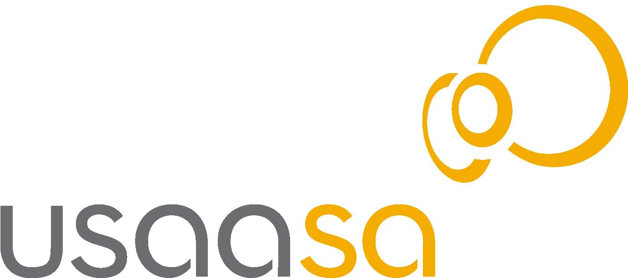

T A B L E OF C O N T E N T S
 | Page
- Glossary | 3
SECTION ONE
- Foreword by the Chairperson | 4
- Board Structure | 5
- Executive Summary by the CEO | 6
- USAASA Executive structure | 8
- Mission | 9
- Vision | 9
- Core values | 10
- Strategic objectives | 10
SECTION TWO
- Corporate Scorecard | 11

- GLOSSARY

ASGISA Accelerated and Shared Growth Initiative for South Africa
CEO Chief Executive Officer
ECA Electronic Communications Act No 36 of 2005
FET Further Education and Training
HR Human Resources
ICT Information Communication Technologies
IA Internal Audit
JIPSA Joint Initiative on Priority Skills Acquisition
PFMA Public Finance Management Act
PUSANO Provincial Under Serviced Area Network Operator
PIAC Presidential International Advisory Council
RDP Reconstruction and Development Programme
USAASA Universal Service and Access Agency of South Africa
USAF Universal Service and Access Fund
USAL Under-Serviced Area Licensee

SECTION ONE

- FOREWORD BY THE CHAIRPERSON
 CASSANDRA GABRIEL - Chairperson

After spending some time intensely reviewing our mandate as outlined in the ECA, our track-record as the Agency and engaging our stakeholders, the Board has come to realise that for the Agency to remain relevant in the sector and fulfil its mandate from our shareholder and meet the expectations from Parliament and the broader public, it must revise its strategy and embark on a business unusual approach to connecting the poor. The Board has appointed a Chief Executive Officer who has the key responsibility of turning around the Agency and building a winning team that is focused, capable and willing and anxious to deliver our mandate. The Board has confidence that the CEO and the management team are steadily addressing the challenges facing USAASA, the most critical challenges being the shortage of operational funding, the lack of access to the USAF funds collected and the need to attract and retain more skilled employees to effectively manage USAASA. Our stakeholders have thus far been very supportive of the winds of change blowing through USAASA and there seems to be a genuine commitment to building a more effective Agency. This three-year corporate strategic plan is meant to inform our stakeholders of our priorities of priorities, but we also would like this to be a basis of our partnership with our stakeholders in bringing digital inclusion to all our people for a better life.

- BOARD STRUCTURE
USAASA BOARD
Cassandra Gabriel (Chairperson)
Andy Mooke
Zingisa Mzaidume
Bheki Maduna
Berenice Francis
Maredi Mphahlele
HR & REMUNERATION SUB-COMMITTEE

Zingisa Mzaidume
(Chairperson)
Bheki Maduna
Andy Mooke
AUDIT & RISK MANAGEMENT SUB-COMMITTEE
Hopewell Mpungose (Independent Chairperson)
Bheki Maduna
Berenice Francis
Maredi Mphahlele
George Finger (Independent member)
USAF PROJECTS
SUB-COMMITTEE

Andy Mooke (Chairperson)
Maredi Mphahlele
Berenice Francis

- EXECUTIVE SUMMARY BY THE CHIEF EXECUTIVE OFFICER
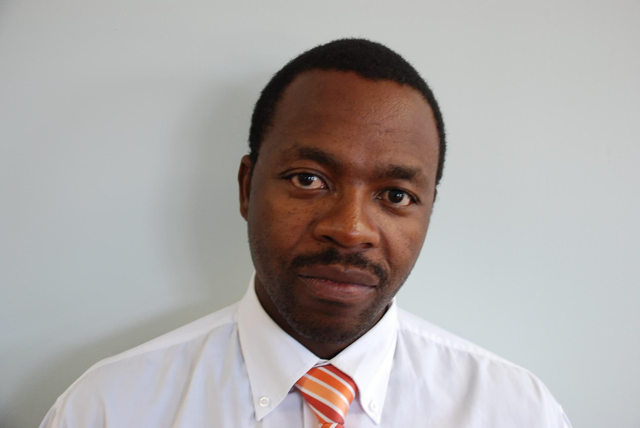 JAMES THELEDI - CEO
The past few months have indeed baptised us at the Agency. We are more passionate about the vision of digital inclusion realising an information society in our lifetime for the present and coming generations. The challenges of universal service and access to electronic communications services and networks in South Africa remain daunting and continue to compete with universal access to water, electricity, transport, housing, education and other services. Over the last 11 years, the Agency has been struggling to graduate from its narrow focus on being a telecentre organisation to a more strategic facilitator that provides insightful advise, research and guidance on universal service and access to ICTs to Government as a policy maker, the Regulator, the ICT industry, Parliament, Communities, the Non-Governmental Organisations, the Small Medium Micro Enterprises (SMMEs) and the broader public.
With the guidance from our Board, we have put together a three-year strategic plan that seeks to address the challenges of universal service and access in the Republic of South Africa, our mandate as outlined in the ECA, and change the negative perceptions associated with Agency’s past role as the implementer, delivering ICT infrastructure in schools and community access centres in an uncoordinated and unsustainable manner. The changes at senior management level and 5-year contracts for employees at the Agency have resulted in low morale and a lack of strategic focus in line with the Mandate. As a result key stakeholders lost confidence in the Agency due to: weaknesses in internal processes, lack of capacity to spend yielding surpluses in the Universal Service and Access Fund (USAF), lack of proper planning on the sustainability of telecentres, cyberlabs, digital hubs and sub-optimal funding subsidies for the Under-Serviced Areas Licensees (USALs), and the general lack of evaluation and monitoring and reporting on the projects, programmes and the general progress the country was making on the goal of universal service and universal access to ICTs in the country. Government through the National Treasury and the Department of Communications, has indicated its desire to see a credible business plan from the Agency before further resources can be provided, including the monies contributed by the operators for the USAFund but still within the National Treasury.
In this strategic plan, we have taken into account the above issues and have ensured that this is not the same old strategy presented by different people at different times. We have scanned the environment both national and internationally, looked at our mandate in the ECA and the available and required resources, consulted our external stakeholders, engaged our employees and completed a skills analysis, identified gaps and training and development interventions, reviewed our internal systems, policies, and developed a risk register to be monitored continuously and to report to the Board on how we manage risk and embed the culture of risk management in our work.
Our focus is to deliver on our core business, establish value-adding partnerships and play a facilitating role in the delivery of universal service and universal access to electronic communications services and networks to all South Africans to achieve a better life. Our core business is to become a champion and the declared facilitator and advisor on universal service and access to electronic communications services and networks. We do this through our research programme, our funding, our campaigns on promoting usage and uptake of ICTs infrastructure and services, our training and capacity building programmes, and most importantly our people at USAASA.

- USAASA EXECUTIVE STRUCTURE

CEO

Head:
USAF Projects
Head:
Legal & Regulatory
Head:
Corporate Affairs
CFO
Chief Audit Executive
Board Secretary
Office Manager
Head:
Research &
Strategy
PA
Head:
HR

6. VISION

Achieving digital inclusion by accelerating affordable access and promoting the use of Information & Communication Technology Services by all in South Africa for socio-economic development

7. MISSION

- Preserve and facilitate universal service and access to ICT services to all South Africans in partnership with other

stakeholders to achieve an inclusive information society
- Monitor and evaluate universal access and service to ICTs by all South Africans
- Manage the USAF to promote universal service and access
- Advise on definitions of universal service and access
- Harness the talent and capability of all employees in pursuit of delivering universal service and access in ICTs.

8. CORE VALUES

- Batho Pele - We believe in provision of excellent service to all our customers and stakeholders
- Ubuntu - We promote an environment of humanness, caring and support
- Integrity - We uphold high standards of trust, honesty and respect in our interaction with all stakeholders
- Innovation - We support employee creativity in delivering all our services
- Transparency - We encourage openness in all our activities
- Accountability - We foster employee ownership and responsibility in ensuring quality service
- Teamwork - We endeavor to create a harmonious work environment where all employee views and contributions are respected

9. STRATEGIC OBJECTIVES

- To reposition the Agency as a champion of universal service and access in South Africa
- To reach every South African excluded from universal service and access to ICT and Broadcasting facilities and services
- To effectively and efficiently manage the USAF
- To collaborate with the ICT industry in making ICTs available, accessible and affordable to all South Africans
- To provide rigorous and continuous research regarding universal service and access

SECTION TWO

CORPORATE SCORECARD FOR 2008 - 2011

The Annual Business Plan format below is as per Treasury Regulation 30.1.3(b) and (d)
2

Strategic objective | Key Performance Area (KPA) | Outcomes | 2008/9 | 2009/10 |  | 2010/11
To reposition the Agency as a champion of universal service and access in South Africa | Sound Corporate Governance  Legal compliance and Regulatory and Policy formulation. | Revised Internal Policies and Procedures  - SCM Policy  - Investment Policy  - Risk Management Policy  Standardised Service Level Agreements and Memorandum of Understanding | June 08  Annual review | Annual review  Annual review |  | Annual review  Annual review
 | Improved Stakeholder Management  Improved corporate image and content management | Develop Stakeholder Engagement Plan  Improve Marketing & Communications plan  New Corporate Identity launch/Website | June 2008  May 2008  March 2008 | Annual review  Annual review  Annual review |  | Annual review  Annual review  Annual review
 | Conduct Public Awareness Campaigns on benefits of ICT’s | Support stakeholder events & initiatives based on mandate | Ongoing | Ongoing |  | Ongoing
Strategic objective | Key Performance Area (KPA) | Outcome | 2008/9 | 2009/10 |  | 2010/11
 | Human Capital Development | Training on the basis of Workskills Plan  Succession Planning  Mentorship and Coaching  Leadership Development Programme  Performance Management Policy | June 2008 | Annual review |  | Annual review
To reach every South African excluded from universal service and access to ICT’s. | Implement projects for disabled | Rehabilitate 6 access centres and 9 school cyberlas for the disabled | April 08 – December 08 | Annual review |  | Annual review
 | Implement e-learning programme | Pilot project on content with Mindset Programme  Support school cyberlabs programme (provide e-mails, internet connectivity)  Connect FET colleges | 15 schools  Currently 89 schools connected (internet)  18 colleges | 498 Cyber labs  2209 e-Rate subsidies  Nil  36 colleges |  | Nil  Nil  50 colleges
 | Implement community access centres programme | Rehabilitate access centres according to sustainability plan  Complete connectivity in access centres  Training/Capacity building | 102 Access centres  All Access centres connected  1 000 Learners | Nil  All Access centres connected  1 000 Learners |  | Nil  All Access centres connected  1 000 Learners
Strategic objective | Key Performance Area (KPA) | Outcome | 2008/9 | 2009/10 |  | 2010/11
 | Support PUSANO’s | Develop subsidy framework in consultation with ICASA and DoC. | 31 October 08 | Annual review |  | Annual review
To effectively and efficiently manage the USAF. | Produce operational manual for the Fund | Production of optimal subsidy document.  Final USAF Operating Manual | 31 October 2008 | Annual review | Annual review
To collaborate with the ICT industry in making ICTs available, accessible and affordable to all South Africans. | Identify training needs within the communities and implement training programme | Collaborate with key stakeholders by entering into MoU with the following stakeholders e-Skills Council, ISETT SETA, Meraka Institute, DoE, MDDA, | September 2008 | Annual review | Annual review
To provide rigorous and continuous research regarding universal service and access | Definitions of Universal service, Universal Access, Needy People, and an Under-Serviced Area  Review of universal service obligations of operators | Recommendations to the Minister of Communications and Authority on definitions and any other matter relating to universal service and access  - Draft Discussion paper  - Provincial Summits  - National Summit.  Final report to Minister  Draft report  Final report | April 2008  April – June 2008  September 2008  November 2008  1 April 2008  30 June 2008 | Annual review  Annual review | Annual review  Annual review
Strategic objective | Key Performance Area (KPA) | Outcome | 2008/9 | 2009/10 | 2010/11
 | Report on best practice of universal service and universal access | Continuous research on best practices on universal service and universal access  Collaboration with Meraka on ICT applications to address community needs | Annual review | Annual review | Annual review
 | Monitoring & Evaluation Framework | Web Portal  Geographical Information System (GIS)  Position Papers and impact assessments | Annual review  Ongoing  Ongoing | Annual review  Annual review  Annual review | Annual review  Annual review  Annual review

