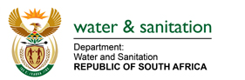
______________________________________________________________________

RESPONSES TO QUESTIONS RAISED DURING THE SCOA BRIEFING ON THE ADJUSTMENT APPROPRIATION BILL IN VOTE 41 (DEPARTMENT OF WATER AND SANITATION) CONVENED ON 01 DECEMBER 2021

- What is the status of infrastructure projects such as the Vaal Gamagara and Giyani Water Project?

Reply

  - The Giyani Water Services Project includes replacement of approximately 325km of pipeline through the Nandoni-Nsami Pipeline, which will deliver water to 55 villages around Giyani in the Mopani District.

The project is currently at 50% progress and anticipated to be completed and commissioned by March 2023. The pipelines will be commissioned progressively, ensuring access of water to communities between March 2022 and March 2023.

1.2 The purpose of the project is for the functional replacement of the existing steel pipeline with a new pipeline to provide assurance of current and future demands by all users. The main water users in the area include the various mines, municipalities, agricultural sector, and Transnet. Progress on site has reached 88% based on the revised program.
Budget approval was received to re-allocate R345,777 million to the Vaal Gamagara Project, that will be monitored on a monthly basis. It is anticipated that the project will be completed by the end May 2022.
- How will the R582.2 million rollover be spent by the department on the Vaal River Remediation Project?

Reply:

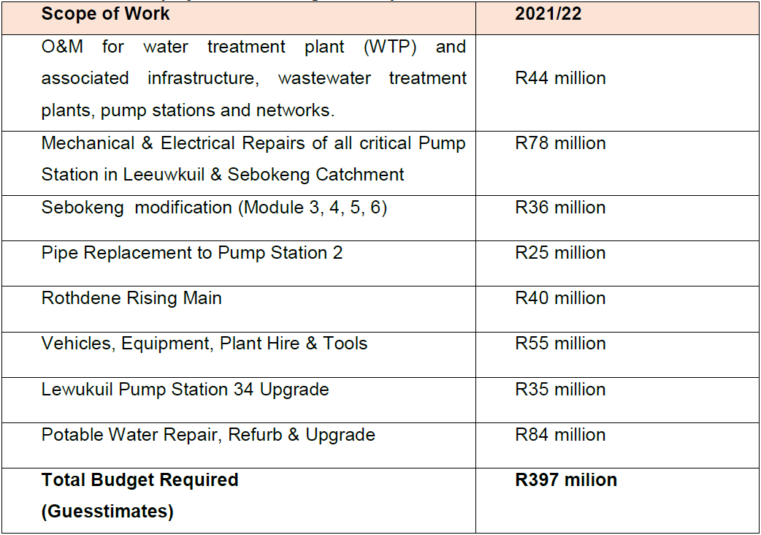

The National Treasury has approved the amount of R582.2 million as roll-over in the regional bulk infrastructure grant to fund the integrated Vaal River System (VRS) pollution remediation intervention project operational expenditure related to labour, purification, security, transportation and management of bio-solids, operations and maintenance of infrastructure and consumables, in Emfuleni Local Municipality.

The department of Water and Sanitation (DWS) has appointed ten (10) unblocking and eight (8) bio-solids contractors. The contractors are doing unblocking of sewer main lines and cleaning of wastewater treatment works. Subsequently, sewer is being removed from communities and channeled to wastewater treatment works which has resulted in increased volumes of inflows into the Sebokeng, Leeuwkuil and Rietspruit Wastewater Treatment Works.

The estimated total cost for the department’s Section 63 Intervention is R7.6 billion and the department appointed Rand Water and allocated R397 million for this financial year. R397 million budget breakdown is indicated in the table below:
  - Who are the main stakeholders in the project?

Reply:
The main stakeholders in the Vaal River System Remediation project are:
- Community of Emfuleni Local Municipality,
- Emfuleni Local Municipality,
- Sedibeng District,
- Gauteng Provincial Department of Cooperative Governance and Traditional Affairs,
- National Department of Cooperative Governance and Traditional Affairs
  - Whether Rand Water has the capacity to implement the project?
Reply:
Yes, Rand Water has both the technical capability and capacity to implement section 63 successfully. Rand Water has managed various projects valued above R1 billion such as the Sedibeng Regional Sanitation Scheme which was valued above R7 billion.
- DWS to submit detailed plan for the implementation of the Vaal River System Remediation Project
Reply:
Please refer to Annexure A which includes implementation plan details for the project
- Implementation plan for reticulation in Umkhanyakude District Municipality
Reply:
The department is in the process of appointing Umhlathuze Water as an Implementing Agent to implement the water reticulation project in the Umkhanyakude District Municipality. It is anticipated that the project will commence in 2022.
- The department should provide implementation plan of internal controls and the Financial Recovery Plan
Reply:
Please refer to Annexure A which includes implementation plan details for the project
- How much does the department owe municipalities for municipal services??
Reply:
The Department of Public Works and Infrastructure (DPWI) is responsible for payment of rates and services on behalf of the Department of Water and Sanitation (DWS). Upon settling the municipal debt, the DPW invoices the DWS. In terms of records of invoices submitted by DPWI for reimbursement, R34 223 662 was settled for municipal services from January 2021 to October 2021.
- Status of the War on Leaks Project and the beneficiaries of the project?
Reply:
The Department is in the process of drafting an exit report to wind down the War on Leaks Project. All training will be concluded by March 2022
- What is being done about the role of the private sector in the pollution of the Vaal River System?
Reply:
Reported cases of pollution by private sector *since April 2017 to date
Sector | Registered and Investigated Cases | NWA Notices Issued | NWA Directives Issued | Criminal Cases | Active cases | Closed cases
Agriculture | 322 | 47 | 179 | 5 | 116 | 34
Mining | 85 | 6 | 8 | 3 | 45 | 2
Industries | 71 | 21 | 4 | 2 | 16 | 1
Tourism | 14 | 6 | 0 | 0 | 1 | 1
Commercial | 15 | 5 | 2 | 0 | 1 | 1

- What is the department doing to assist emerging farmers to access Water Use Licences?

Reply:
The Department prioritises applications from emerging farmers in line with Section 2 (b) and (c) and Section 27 (1) (b) of the National Water Act, Act no. 36 of 1998. The Water Use License application process has been automated through the introduction of the online system (Electronic Water Use License Application and Authorisation System (E-WULAAS). The Department assists emerging farmers to access the electronic system by uploading applications on their behalf and providing guidance throughout the application process. When processing the applications from emerging farmers in catchments that are water stressed the Department takes measures to identify other sources of water to cater for emerging farmers. For example, in the Northern Cape the Department used a portion of water reversed for discretionary releases to cater for emerging farmers.
It should be noted that the Department is currently undergoing organizational restructuring and is intending to establish a component that will focus on Historically Disadvantaged Individual support within water use authorisation establishment. The component, which is expected to be in operation by April 2022, will ensure dedicated support to emerging farmers with regard to Water Use License applications, including post authorisation support.
The Department has also embarked on nationwide Water Use Authorisation Information Sessions targeting the black emerging businesspeople, including black emerging farmers who want to apply for water use license applications. These information sessions have already been conducted in Free State, Limpopo and Northern Cape. On the 07 and 08 December 2021 the information sessions will be held in Eastern Cape, whilst the rest of the work sessions for remaining Provinces are planned for January to March 2022.
- What is the status of the legal action taken against farmers that are redirecting water from rivers into their private dams? What is the department doing about that?
Reply:
The table below depicts number of reported and investigated since April 2017. The type of contraventions detected includes amongst others, suspected unauthorised water use and non-compliance to Dam Safety Regulations. The table also shows administrative and criminal measures the department has taken to rectify the contraventions committed by dam owners.

Enforcement activities and actions taken within Agricultural Sector from April 2017 to date
Regional Office | Number of reported non-compliance cases investigated | Non- Compliance Letters Issued | NWA Notices Issued | NWA Directives Issued | Criminal Cases | Water Tribunal | Active Cases | Closed Cases
Eastern Cape | 134 | 10 | 14 | 2 | 0 | 0 | 127 | 7
Free State | 85 | 1 | 23 | 3 | 0 | 0 | 71 | 14
Gauteng | 138 | 0 | 61 | 9 | 0 | 0 | 130 | 8
KwaZulu Natal | 141 | 3 | 25 | 8 | 1 | 4 | 130 | 11
Limpopo | 137 | 0 | 31 | 1 | 1 | 0 | 87 | 50
Mpumalanga | 111 | 0 | 6 | 1 | 0 | 0 | 96 | 15
North West | 72 | 0 | 37 | 4 | 0 | 1 | 69 | 3
Northern Cape | 73 | 1 | 28 | 6 | 0 | 0 | 69 | 4
Western Cape | 121 |  | 79 | 6 | 1 | 0 | 110 | 11
Total | 1012 | 15 | 304 | 40 | 3 | 5 | 889 | 123
- What is the status in terms of the filling the vacant senior management position, especially the positions of the Acting Director General and the Chief Financial Officer?

Reply:

A total of 19 Senior Management positions have been filled since the start of the current financial year. The status on the selection process is as follows:
- Director General’s post: Advertised on 17 September 2021 (closing date: 4 October 2021). Interviews were held on 22 November 2021 and awaiting Cabinet approval.
- Chief Financial Officer post: To be advertised 3 December 2021
- The following posts were advertised:
  - Deputy Director General: Regulation, Compliance and Enforcement (readvertised on 26 November 2021).
  - Deputy Director General: Water and Sanitation Services Management (closed 26 November 2021).
- Deputy Director General: Corporate Support Services (filled internally through matching and placement).

