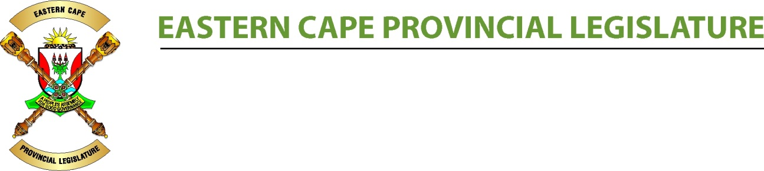
Weekly diary 2021
Monday, 15 February to Sunday, 21 February

THE LEGISLATURE HAS IMPLEMENTED PREVENTATIVE MEASURES TO CURB THE SPREAD OF COVID-19 AND IN LINE WITH THE NATIONAL STATE OF DISASTER REGULATIONS: ALL PROGRAMMES OF THE LEGISLATURE THAT INVOLVE THE PUBLIC HAVE BEEN SUSPENDED UNTIL FURTHER NOTICE. THE LEGISLATURE IS ALSO CLOSED TO THE PUBLIC FOR THIS PERIOD. THE EASTERN CAPE PROVINCIAL LEGISLATURE URGES THE PUBLIC TO ADHERE TO THE NATIONAL LOCKDOWN DIRECTIVES. #StayHomeSA #StaySafe

During the lockdown, the Legislature will continue to serve as a people’s assembly by conducting all its meetings via a virtual platform until stated otherwise by the Executive of the Legislature.

DATE | ACTIVITY | TIME | VENUE |  | GOVERNMENT/NCOP/HOTL
MON  15/02 | Political/Constituency Day  SCHOOLS VISITS |  | Ms Teams Virtual |  | Government Business  NCOP  -  House of Traditional Leaders  -
TUES  16/02 | SCHOOLS VISITS |  | Ms Teams Virtual |  | Government Business  EXCO LEKGOTLA  NCOP  - Briefing by Briefing by the Department of Agriculture, Land Reform and Rural Development on the Upgrading of Land Tenure Rights A/B [B 6B - 2020] (sec 76)  - Briefing by the Department of Cooperative Governance and Traditional Affairs on the objects of the Local Government: Municipal System Amendment Bill (B2B-2019) section 76 @ 12:00  - DEBATE ON THE STATE OF THE NATION ADDRESS  House of Traditional Leaders  _
WED  17/02 | SCHOOLS VISITS |  | Ms Teams Virtual |  | Government Business  G&A & BUDGET CABINET COMMITTEES  NCOP  - Presentation by National Treasury on third quarter Agricultural Sector provincial conditional grant expenditure for 2020/21 financial year @ 09:00 – 12:00  - Committee on Security and Justice  Deliberation and  consideration of the  Electoral Laws  Amendment Bill,  Adoption of minutes  and reports  - DEBATE ON THE STATE OF THE NATION ADDRESS @ 14:00  House of Traditional Leaders  -
THURS  18/02 | SCHOOLS VISITS |  | Ms Teams Virtual |  | Government Business  EXCO LEKGOTLA  NCOP  REPLY ON STATE OF THE NATION ADDRESS @ 14:00  House of Traditional Leaders
FRI  19/02 | SCHOOLS VISITS |  | Ms Teams Virtual | Government Business  DSD & EDCON PROJECT GRADUATION - NMM  NCOP  Women’s Charter Review Sessions  House of Traditional Leaders
SUN  21/02 | Fortnightly briefing by Premier on COVID-19 to Leaders of Political Parties | 14:00 | Ms Teams Virtual

