2. REPORT OF THE SELECT COMMITTEE ON TRANSPORT, PUBLIC SERVICES AND ADMINISTRATION, PUBLIC WORKS AND INFRASTRUCTURE ON THE ADJUSTED ALLOCATIONS OF BUDGET VOTE 7: NATIONAL SCHOOL OF GOVERNMENT, DATED 17 JULY 2020

The Select Committee on Transport, Public Service and Administration, Public Works and Infrastructure (hereinafter referred to as the Select Committee), having considered the directive of the National Council of Provinces (the Council) to consider and report on the adjustment allocation of Budget Vote 7: National School of Goverment, reports as follows:

- INTRODUCTION
South Africa is among countries worldwide seized with managing the outbreak of the Coronavirus 2019 (hereafter referred to as COVID-19) which has been declared a global pandemic by the World Health Organisation. The emergence of the COVID-19 pandemic has had a devastating effect on the health, economic and social systems of most countries around the globe. In South Africa contexts, its impact is already observable in the resources of government and has put a strain in its delivery capacity and the country’s ability to meet its NDP priorities. In April 2020, the President announced a R500 billion fiscal support in response to COVID-19 and revised priorities.

Based on the above, the Public Finance Management Act of 1999 and the Money Bills Act Amendment Procedure and Related Matters Act of 2009 empowers the Minister of Finance to table an adjusted budget whenever necessary to Parliament. On 24th June 2020, the Minister of Finance tabled special adjustments budget from the initial budget tabled in February 2020 to Parliament to fund government activities relating to COVID-19 pandemic. According to Section 5 of the Money Bills Act, Committees are therefore required to review strategic plans, annual performance plans and budgets of government departments to be in line with supplementary/or adjustments budget as tabled by the Minister of Finance in Parliament.

In considering adjusted strategic, annual performance plan and special budget, the Committee ensured that the National School Goverment plan and budget allocations are in line with Medium Term Strategic Plan 2019/24.
The Select Committee on Transport, Public Service and Administration considered the adjustments budget of the National School Goverment on 8 July 2020 in a joint meeting with the Portfolio Committee on Public Service and Administration considered a presentation on the adjusted Strategic Plan and Annual Performance Plan and budget allocation of the National School of Government. This report summarises presentation received from the National School of Government, focusing on the 2019/24 adjusted Strategic Plan and 2020/21 Annual Performance Plan and special adjustment Budget.

- THE IMPLICATIONS OF THE COVID-19 PANDEMIC ON THE MANDATE OF THE DEPARTMENT
The National School of Government draws its mandate from the Constitution, and with particular reference to 195(1) (h), which stipulates that: “good human resource management and career-development practices, to maximise human potential, must be cultivated”. The applicability of this, and the other values and principles to the three spheres of government, organs of state and public enterprises indicates the requisite depth and the reach of the National School Goverment in order to fulfil this constitutional mandate. The mandate of the National School Goverment was not implicated as a result of COVID-19 pandemic.

- ANALYSIS OF THE REVISED BUDGET ON EACH PROGRAMME
3.1 Adjusted Budget
The main allocation to the Entity in February 2020 for 2020/21 financial year was R206.6 million. The supplementary budget of June 2020 revises this allocation downward to R190.5 million. This represents a downward revision by R16 million (approximately 8 per cent) in nominal terms, which translates into a reduction of approximately 12 per cent in real terms.
The budget of the School is divided into two programmes, namely Programme 1: Administration and Programme 2: Public Sector Organisational and Staff Development. Whilst the main budget allocation in February split the budget 55 per cent and 45 per cent between Programme 1 (R112.9 million) and Programme 2 (R93.7 million), respectively, the downward revision in allocation narrowed this split to 51 per cent (R96.8 million) and 49 per cent ((R93.7 million, unchanged), respectively. This is because only the allocation to Programme 1 was revised downward, whilst the allocation to Programme 2 remains unchanged.
The budget cut was made from Goods and Services under Programme 1: Administration, which involved the suspension of subsistence and travelling, as well as venues and facilities funding. There were no virements made.
Table 1: Revised budget
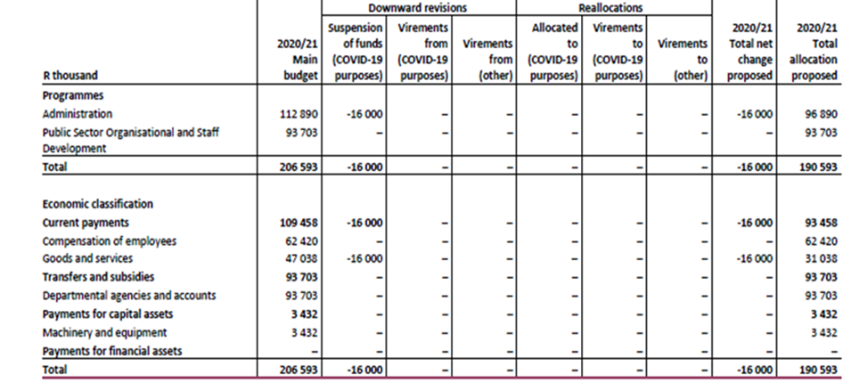
Source: National Treasury (2020)
3.2 Performance Programmes
The National School of Government has two programmes, which are as follows:

    - Programme 1: Administration
The purpose of this programme is to provide strategic leadership, management and support services to the School. The budget for Programme 1 was revised downward from R112.9 million in February 2020/21 to R96.9 million in June 2020/21. This represents a downward revision by R16 million in rand terms in the budget of 2020/21. The programme is one of the two major cost drivers under this Vote, consuming 51 per cent of the overall allocation. The main cost drivers are the Corporate Services and Management sub-programmes.
The School reduced the average number of days for debt collection to 60 days. All disciplinary cases were resolved within 60 days from the date of receiving the case. The School facilitated three agreements supporting international exchanges and capacity building initiatives. It is envisaged that the Entity will have to cut down on many of its targets that were pre-planned before the pandemic. This means a lot of cutting down on facilitation of learning programmes and less travelling due to suspension of venue and travelling funding, which speaks to the core of the Entity’s mandate. The activities are in line with the National Development 2030’s Sub–Outcome 3: Efficient and effective management and operations system.

    - Programme 2: Public Sector Organisational and Staff Development
The Public Sector Organisational and Staff Development (Programme 2) is responsible for facilitating transfer payments to the Training Trading Account, which provides education, development and training to public sector employees.
The budget allocation for Programme 2 increased from R79.8 million in 2019/20 to R93.7 million in 2020/21. The allocation to the Programme was not revised by the Supplementary budget of June 2020. In real terms the budget allocation of Programme 2 increased by 11.7 per cent between 2019/20 and 2020/21. This programme consumes 49 per cent of the overall revised budget, which is allocated to the National School of Government Training Trading Account sub-programme, which provides education, development and training to public sector employees. The School introduced the use of the e-Learning modality that enables it to offer 22 e-Learning courses and to establish communities of practice, as well as open online courses. The School undertook ten training needs analyses with public sector institutions. The School completed six research projects to inform training needs and opportunities. The Programme activities are in line with the National Development 2030’s Sub–outcome 2: A public service that is a career of choice, which ensures that the public service recruits graduates and mentors them through learnerships, internships and apprenticeships; as well as Sub-Outcome 5: Increased responsiveness of public servants and accountability to citizens.

- OBSERVATIONS AND FINDINGS
The Committee identified the following matters in relation to the special adjustment budget for the Budget Vote 7, which are as follows:
  - The Committee noted and welcomed the presentation of the National School of Government on the Strategic Plan and Annual Performance Plan and revised budget for 2020/21 financial year. The Committee noted the budget cuts of R16 million from the actual budget. Budget cuts derived mainly from the budget for goods and services. The School assured the Committee that the Strategic Plan and Annual Performance Plans would remain the same under dire implications of COVID-19.

  - The Committee was concerned about the School being negatively affected regarding its source of revenue due to the COVID-19 pandemic and budget cuts as a result of the special adjustment budget. Eighty per cent of the budget of the National School of Government derives from the Trading Training Account wherein the School used to conduct face-to-face training. Since the COVID-19 pandemic and the implementation of the lockdown, the School budget has been severely impacted and has lost revenue estimated at R10.5 million monthly on training fees.

  - The School brought to the attention of the Committee that providing training through a virtual platform is not always feasible as the majority of the clients at lower levels do not have tools of trade to be able to attend online training. In offices the employer provides internet and desktop computers. This is the risk the School is confronted with in attaining most of the set targets and will ultimately result in a budget shortfall in the Trading Training Account.

  - Due to financial constraints, the School has no option but to approach the National Treasury to use savings realised from government departments paying in advance for training fees in respect of officials who did not turn up for training. Migrating all courses to online training has major financial implications for government departments, and the School has to invest in the IT infrastructure, which will still be near impossible with a revised budget.

  - The Committee welcomed the announcement by the School that it intended to offer diplomas to its learners/students including Members of Parliament and legislatures.

  - The School has made a commitment to achieve a clean audit for the 2020/21 financial year, however most of the targets might be negatively impacted by the COVID-19 pandemic.

- RECOMMENDATIONS
The Committee recommends that the Minister gives attention to the following:
  - The Minister should request National Treasury to grant the National School of Goverment permission to utilise savings from the Trading Training Account, having considered their business case, for government officials who could not attend training to fund its priorities for the 2020/21 financial year.

  - The National School of Goverment together with the National Treasury should find a common funding solution to ensure the School’s activities funded through Trading Training Account are not impacted under these tough economic conditions caused by the COVID-19 pandemic.

  - The National School of Goverment should embrace the e-learning training format as part of digital transformation in the Fourth Industrial Revolution in the public service. In the long term, the e-learning format will save government money to initiate other programmes.

- CONCLUSION
The Committee noted the financial constraints confronting the National School of Government due to the impact of the COVID-19 pandemic. Since the advent of COVID-19, the National School of Goverment was not able to conduct face–to-face training with learners as a result of some of the measures to save lives.

The Committee recommends that the Council approves Budget Vote 7: National School of Government, in the special adjustment budget.
[The DA reserved its position on the Report and abstained. The EFF objected to the Report.]

Report to be considered.

