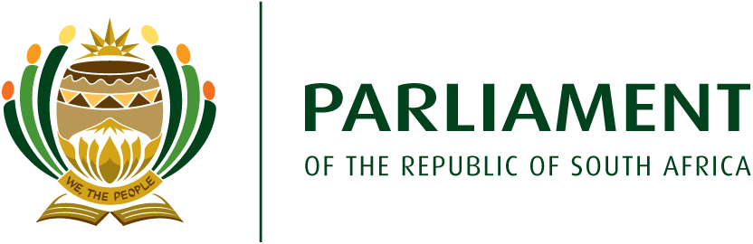
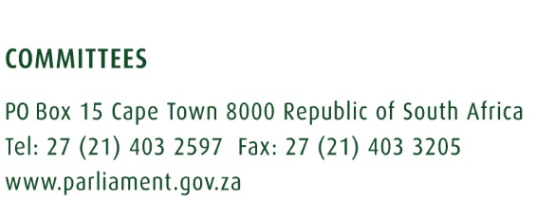

15 February 2022
Revised Draft Programme for Provincial Public hearings on the Electoral Amendment Bill [B 1 – 2022]
Groups | Group A (In-Land Provinces |  | Group B (Coastal Provinces)
Delegation | Mr MS Chabane  Mr AC Roos  Adv. BT Bongo  Ms MA Molekwa  Mr M Lekota |  | Ms M Modise – Leader of the delegation  Ms TA Khanyile  Ms TI Legwase  Mr KB Pillay  Ms LF Tito  Ms LL Van der Merwe
Staff | Mr P Hlungwani - Researcher  Mr E Mathonsi – Committee Secretary  Mr V Ramaano – Committee Secretary  Mr Ben Lwazi – Committee Assistant |  | Mr A Salmon - Content  Mr Z Rento – Committee Secretary  Ms Nandipha Maxhegwana – Committee Secretary  Mr Pilate Gwebu – Committee Secretary
Province | Limpopo Province |  | Kwazulu-Natal Province
Date | Town | Venue | Town | Venue
Sunday, 6 March 2022 | Travel to Thohoyandou |  | Travel to Richards Bay
Monday, 7 March 2022 | 10:00 – 13:00 –Thohoyandou | TBC | 10:00 – 13:00 -Richards Bay. Drive to Pietermaritzburg after public hearings. | TBC
Tuesday, 8 March 2022 | 10:00 – 13:00: Nkowankowa | TBC | 10:00 – 13:00 – Pietermaritzburg. Drive to Ladysmith after public hearings | TBC
Wednesday, 9 March 2022 | 10:00 – 13:00 – Groblersdal. Drive to Mpumalanga | TBC | 10:00 – 13:00 – Ladysmith. Drive to Johannesburg after public hearings and sleepover. | TBC
 | Mpumalanga Province |  | Northern Cape Province
Date | Town | Venue | Town | Venue
Thursday, 10 March 2022 | 10:00 – 13:00- Mbombela – drive to Ermelo after public hearings | TBC | 11:00 - 14:00 Upington  Drive to Kuruman after public hearings. | TBC
Friday, 11 March 2022 | 10:00 – 13:00: Ermelo  Drive to Middleburg after public hearings | TBC | 10:00 – 13:00 - Kuruman  Drive to Kimberley after public hearings | TBC
Saturday, 12 March 2022 | 10:00 – 13:00 – Middleburg  Drive to Johannesburg after public hearings |  | 10:00 – 13:00 – Kimberley. Drive to Bloemfontein | TBC
Sunday, 13 March 2022 | Rest in Johannesburg |  | Rest in Bloemfontein
 | Gauteng Province |  | Free State Province
Date | Town | Venue | Town | Venue
Monday, 14 March 2022 | 10:00 -13:00: Randfontein | TBC | 10:00 - 13:00 -Bloemfontein.  Drive to Senekal after public hearings
Tuesday, 15 March 2022 | 10:00 – 13:00 Germiston |  | 10:00 – 13:00 – Senekal. Drive to Kroonstad
Wednesady, 16 March 2022 | 10:00 – 13:00 – Hammanskraal. Drive to Mahikeng |  | 10:00 - 13:00 -Kroonstad  Drive to Johannesburg after public hearings and fly to Eastern Cape | TBC
 | North West Province |  | Eastern Cape Province
Date | Town | Venue | Town | Venue
Thursday, 17 March 2022 | 10:00 - 13:00: Mahikeng. Drive to Schweizer Reneke after public hearings. |  | 10:00 – 13:00 Qonce. Drive to Qonce (King Williams Town) after public hearings | TBC
Friday, 18 March 2022 | 10:00 – 13:00 – Schweizer-Reneke. Drive to Potchefstroom |  | 10:00 – 13:00 –. Cradock ve to Queenstown after public hearings.
Saturday, 19 March 2022 | 10:00 – 13:00 – Potchefstroom and drive to Johannesburg and their constituencies. |  | 10:00 – 13:00 – Gqeberha
 | Western Cape Province |  | Western Cape Province
 | Town | Venue | Town | Venue
Monday, 22 March 2022 | Fly or drive to Mossel Bay | N/A | 10:00 – 13: Khayelitsha. Drive to Cistrudal after the public hearings | TBC
Tuesday, 23 March 2022 | 10:00 – 13:00 – Mossel Bay and drive or fly to Cape Town |  | 10:00 – 13:00 – Citrusdal and drive to Cape Town after the public hearings.

