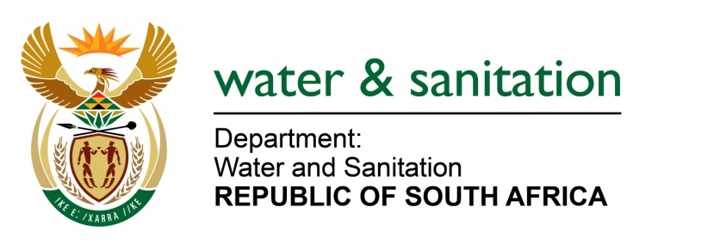

NATIONAL ASSEMBLY

FOR WRITTEN REPLY

QUESTION NO 999

DATE OF PUBLICATION IN INTERNAL QUESTION PAPER: 5 MAY 2017
(INTERNAL QUESTION PAPER NO. 15)

999. Mr L J Basson (DA) to ask the Minister of Water and Sanitation:
(1) Whether her department has put any operational plans in place to address the infestation of hyacinth plants at the Roodeplaat Dam; if not, why not; if so, what (a) are the full details of the operational plans and (b) is the timeframe for cleaning and prevention of hyacinth;
(2) whether any monitoring mechanisms have been put in place to monitor the incidence of any other invasive species at the specified dam; if not, why not; if so, what are the relevant details;
(3) whether her department issued any legal mandates to keep dams and waterways clean and devoid of invasive species; if not, what is the position in each case; if so, in each case, what are the relevant details? NW1127E
---00O00---
REPLY:
(1) Working for Water: Department of Environmental Affairs (WfW: DEA) has been actively involved with the controlling and eradicating invasive weeds in Roodeplaat Dam and has developed a plan to realise this. From 2007 to 2010, the level of weeds has been reduced from 100% to about 5% through their interventions. Working for Water has spent more than R4 million towards this. Furthermore, Working for Water is providing herbicides to land owners through Department of Public Works office on site to control invasive species. Refer to Annexure A for the Strategic Plan.
(2) Monitoring is done by the project manager for Working for Water in the Department of Environmental Affairs.
(3) My Department has developed Resource Management Plans for management of Access and Use of State Dams. As part of the plan it is proposed that for each dam, that has boating recreational use, the Department should build a washbay to wash the boats from other dams to controls and contain invasive weeds. Moreover my Department is currently finalising Regulations for Access and the Use of State Dams.
Furthermore, land owners are mandated by NEMBA (National Environmental Management Biodiversity Act 10 of 2004) together with the Alien and Invasive Species Regulations that came to effect on 1 October 2014, which both give the responsibility to the land owners to develop management plans to control and eradicate invasive species including the budget to realise the above. To this effect, there is a Memorandum of Understanding (MoU) signed between the Department of Environmental Affairs and my Department to map out how this should be achieved. Continuing engagements are in place to this effect. Refer to Annexure B for the signed MoU.
---00O00---

