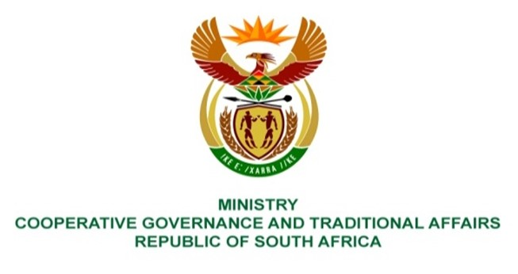

NATIONAL ASSEMBLY
QUESTIONS FOR WRITTEN REPLY

QUESTION NUMBER 998
DATE OF PUBLICATION: 17 March 2023

998. Ms. B Mathulelwa (EFF) to ask the Minister of Cooperative Governance and Traditional Affairs:

Whether she has been informed that the residents of the Ugu District Municipality have been without clean water for a period of over five years; if not, what is the position in this regard; if so, which interventions will she take in this regard? NW1126E
REPLY:

No, the Minister of Cooperative Governance and Traditional Affairs has not been informed that the residents of the Ugu District Municipality (UDM) have been without clean water for a period of over five years. The Minister is aware of intermittent supply of water to certain areas every now and then, but not for the entire Ugu District municipal area not to have clean water for a period of over five years.

The following interventions have been taken to support Ugu District Municipality to attend to intermittent water supply to communities:

- A Municipal Infrastructure Support Intervention Plan (MSIP) for UDM was developed after Cabinet considered a State of Local Government (SOLG) report in 2021 that highlighted that UDM was deemed dysfunctional. The implementation of the MSIP, and monitoring thereof led by DCOG, has led to improvement of water supply and service delivery protests have been minimized.
- KZN COGTA seconded a Project Management Unit (PMU) comprising of Engineers and Project Managers in May 2022 to support and strengthen UDM to fast-track implementation of grant funded projects. KZN CoGTA also availed funding for strategic infrastructure projects related to provision of basic services to accelerated water provision, and for repairs and maintenance of aged infrastructure through the Accelerated Infrastructure Renewal Programme in the 2022/23 financial year.
- UDM developed a turnaround plan in June 2022 for addressing water challenges and established a Water War Room that sits every fortnight to monitor the implementation of the Water Services Turnaround Plan. The multi stakeholder Water War Room includes representatives from DCOG through the Municipal Infrastructure Support Agent (MISA), the Department of Water and Sanitation (DWS), the provincial Department of Cooperative Governance and Traditional Affairs (KZN COGTA).
- MISA funded and drilled 2 boreholes completing the project in March 2023 in the uMdoni Local Municipality area benefitting 44 households. MISA has also deployed a professionally registered Civil Engineer as well as two Civil Engineering Young Graduates to support and strengthen UDM.
End.

