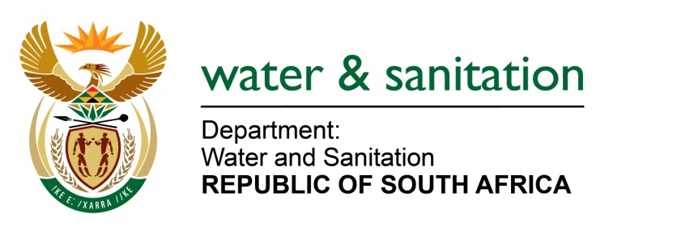

NATIONAL ASSEMBLY

FOR WRITTEN REPLY

QUESTION NO 997

DATE OF PUBLICATION IN INTERNAL QUESTION PAPER: 18 MARCH 2022
(INTERNAL QUESTION PAPER NO. 11)

997 Mr L J Basson (DA) to ask the Minister of Water and Sanitation:
(1) What (a) is the current progress of the project to expand the Madibeng Water Treatment Plant that has been delayed for years and (b) is the (i) projected and (ii) budgeted cost of the project;
(2) (a) on what date is it envisaged that the current phase of the project of 20ML will be completed and (b) what will happen to the second phase of 20ML of the project?
NW1240E
---00O00---
MINISTER OF WATER AND SANITATION
1(a) The current progress on the upgrade of the Madibeng Water Treatment Works is at 73% towards completion.

b (i) The project cost for the project is R750 million.
(ii) The allocated cost for the financial year 2022/23, is R103 million.

2 (a) The project is being implemented in a phased approach. It is anticipated that phase 2 of the upgrade of the Water treatment Plant will be completed by April 2023.

(b) The current phase of the project is still under construction and is anticipated to be completed by April 2023. The next phase of the project is under planning and will be implemented in partnership with the Sibanye Stillwater Mine. It is anticipated that phase 3 of the project commence in May 2023 and be completed by May 2024.

---00O00---

