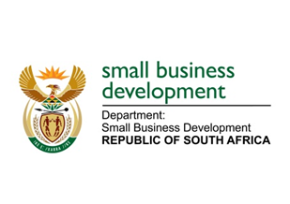

NATIONAL ASSEMBLY

QUESTION FOR WRITTEN REPLY

“995. Ms C King (DA) to ask the Minister of Small Business Development:

How much land does (a) her department and (b) the entities reporting to her (i) own, (ii) have exclusive rights to and/or (iii) lease from the State to (aa) use and/or (bb) occupy?”

NW1088E

REPLY:

- The Department of Small Business Development (DSBD)
- The DSBD does not own any land;
- The DSBD does not have any exclusive rights to any land; and
- The Department also does not lease any land from the State:
(aa)&(bb) Not applicable since the Department does not own any land nor lease land.

- The Small Enterprise Development Agency (SEDA)
- SEDA does not own land;
- SEDA does not have any exclusive rights to any land; and
- SEDA does not lease from the State:
(aa)&(bb) Not applicable.

- The Small Enterprise Finance Agency (SEFA)
- 367 713 m²
- 367 713 m²
- 5 054 m² - North West Development Corporation SOC Ltd:
(aa) SEFA letting to SMMEs / tenants.
(bb) Occupied by tenants only.

