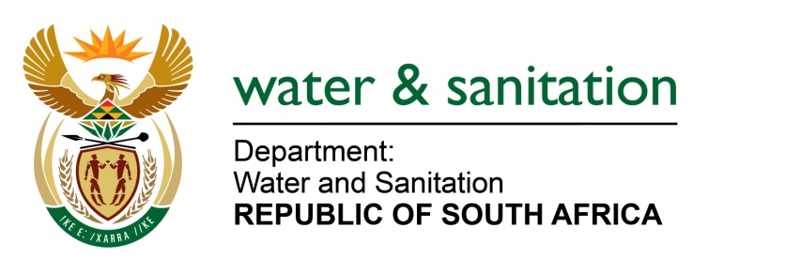

NATIONAL ASSEMBLY

FOR WRITTEN REPLY

QUESTION NO 994

DATE OF PUBLICATION IN INTERNAL QUESTION PAPER: 17 MARCH 2023
(INTERNAL QUESTION PAPER NO. 10)

994. Mrs M R Mohlala (EFF) to ask the Minister of Water and Sanitation:
Which measures of intervention have been taken regarding the ageing infrastructure, burst pipes, leaks and unmetered connections causing financial losses in the Matjhabeng Local Municipality?
NW1118E
---00O00---
MINISTER OF WATER AND SANITATION

The Matjhabeng Local Municipality (LM) has challenges of aged and dilapidated infrastructure leading to frequent pipe bursts which contribute to high water losses and reduced pressure in the reticulation system. The municipality is estimated to be losing more than 56% of clean water due to the frequent pipe bursts and aged infrastructure. The municipality is further challenged by a high percentage of non-revenue water which contributes to financial losses for the municipality.

To deal with the challenges indicated above, the Matjhabeng LM has compiled a business plan for replacement of old asbestos and old galvanized pipes with an estimated cost of R1,4billion. The plan was submitted to the Infrastructure South Africa (ISA). However, the municipality was also advised to submit a business plan to the Department of Water and Sanitation for implementation of water conservation and water demand management while awaiting the response from ISA. Should funding for the business plan be secured, implementation of this business plan would reduce the high water losses and improve water supply to the consumers.
To further remedy the challenges relating to water losses and non-revenue water the following interventions are being implemented by the municipality:
- Procurement of over six thousand (6,000) water meters in the 2022/2023 FY to start addressing the issue of unmetered consumers and to improve on revenue collection.
- Appointment of qualified Civil Engineers, Technologists, Technicians and thirty (30) qualified artisan plumbers and
- Purchasing of four (4) new heavy equipment vehicles (TLBs) to assist in water network maintenance and pipe bursts.
- In the 2023/2024 FY, the technical service will run the following water business programmes:
  - Pressure management to reduce pipe bursts and water losses
  - Non-Revenue Water Management to reduce water loses and improve revenue collection
  - Installation of the SCADA System to measure and monitor water losses in the reticulation system
  - Active leak detections to locate invisible pipe bursts
- The municipality will also appoint a suitable Professional Services Provider (PSP) to develop a Water Demand and Water Conservation Management (WDWCM) Strategy as a fundamental step in promoting water use efficiency and to be compliant with both the Water Services Act and the National Water Act, Act 36 0f 1998, which together emphasizes effective management of water resources and supply services.
---00O00---

