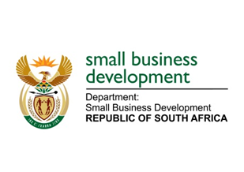
NATIONAL ASSEMBLY
QUESTION FOR WRITTEN REPLY
DUE TO PARLIAMENT: FRIDAY, 31 MARCH 2023

“922. Mr H C C Krüger (DA) to ask the Minister of Small Business Development:
Whether there is a masterplan on co-operative development; if not, why not; if so, will she furnish Mr H C C Krüger with a copy of the masterplan?” NW1028E

REPLY: I have been advised by the department as follows:

There is no masterplan solely dedicated for co-operatives. Co-operatives support is incorporated as part of the National Integrated Small Enterprise Development Strategic (NISED) Framework and any matter and support that is dedicated to small enterprises include the co-operatives development support, as articulated on section 13 of the Cooperatives Policy. The NISED Strategic Framework provides for the promotion of Micro Small and Medium Enterprises (MSME) development through a specific focus on four Pillars that will drive small business development in the country. The proper implementation of the Pillars will bring out positive outcomes that will propel MSMEs, including co-operatives, to the forefront economic development. The Pillars are (1) well informed SA on MSMEs with continuous monitoring, evaluation, and learning (better data), (2) policy, laws and regulations reformed to enable MSME growth and efficient governance, (3) effective support and services delivered for MSME growth (financial and non-financial), and (4) Coordinated government with strengthened private sector partnerships for MSME growth.

Moreover, the sector focused masterplans that have implications for SMMEs have also made provision for support of MSMEs, including co-operatives. Amongst others, the masterplans have made a clear intention to transform the various sectors of the economy through the improved participation of MSMEs. Such participation will be facilitated via supplier development interventions – which should bring about increased pool of competitive small enterprises and more market access opportunities.
The Department has already taken a strategic decision to move our co-operatives support intervention from sefa to Seda to be modeled on the Technology Transfer Assistance Programme, e.g. 90% grant and 10% own contribution. A transfer to Seda would ensure a seamless process between the business development support provided by the agency.

STELLA NDABENI-ABRAHAMS
MINISTER: SMALL BUSINESS DEVELOPMENT

