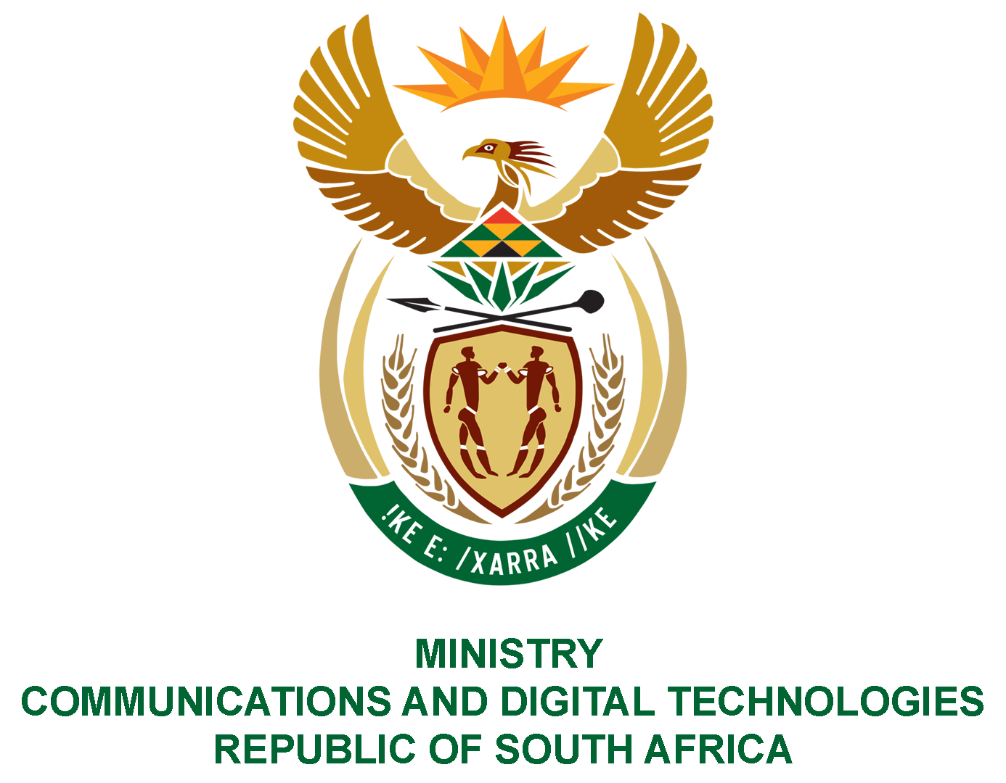

PARLIAMENT OF THE REPUBLIC OF SOUTH AFRICA

NATIONAL ASSEMBLY

WRITTEN REPLY

QUESTION: 986

DATE OF PUBLICATION: 25 MARCH 2022
QUESTION PAPER NO: 12

Mr M S Malatsi (DA) to ask the Minister of Communications and Digital Technologies:

- What amount did (a) her department, (b) the SA Post Office, (c) the National Electronic Media Institute of South Africa, (d) the SA Broadcasting Corporation, (e) the State Information Technology Agency and (f) Broadband Infraco spend on (i) settlements and (ii) salaries to suspended employees in the past eight financial years;

(2) what were the reasons for each suspension?

NW1229E
REPLY:

I have been advised by the Department and SOEs as follows:

DEPARTMENT:

(1)(a)(i) R329,384-00 was paid on settlements.

(1)(a)(ii) R2 024 276,50.

- The response is provided in annexure A.

SOEs:
- (b-f)
SOEs | - Settlements | (ii) Salaries to suspended employees
SAPO | R23, 023,132. 69 | R69, 631,178. 13
Nemisa | R 30 000.00 | R653 332.77
SABC | R66 390 764.35 | R26 787 242.38
SITA | R 9 438 136.08 | R 46 882 565.68
BBI | R 1 971 372.00 | R 2 083 164.00

- The responses are provided in the annexures. Annexure B for SAPO and annexure C for the other entities in question.

Authorised for submission by

MS. NONKQUBELA JORDAN-DYANI
DIRECTOR-GENERAL (ACTING)
DATE:

Recommended/not recommended

__________________________
HON. PHILLY MAPULANE, MP
DEPUTY MINISTER OF COMMUNICATIONS AND DIGITAL TECHNOLOGIES
DATE:

Approved/ not approved

________________________________
HON. KHUMBUDZO NTSHAVHENI, MP
MINISTER OF COMMUNICATIONS AND DIGITAL TECHNOLOGIES
DATE:

