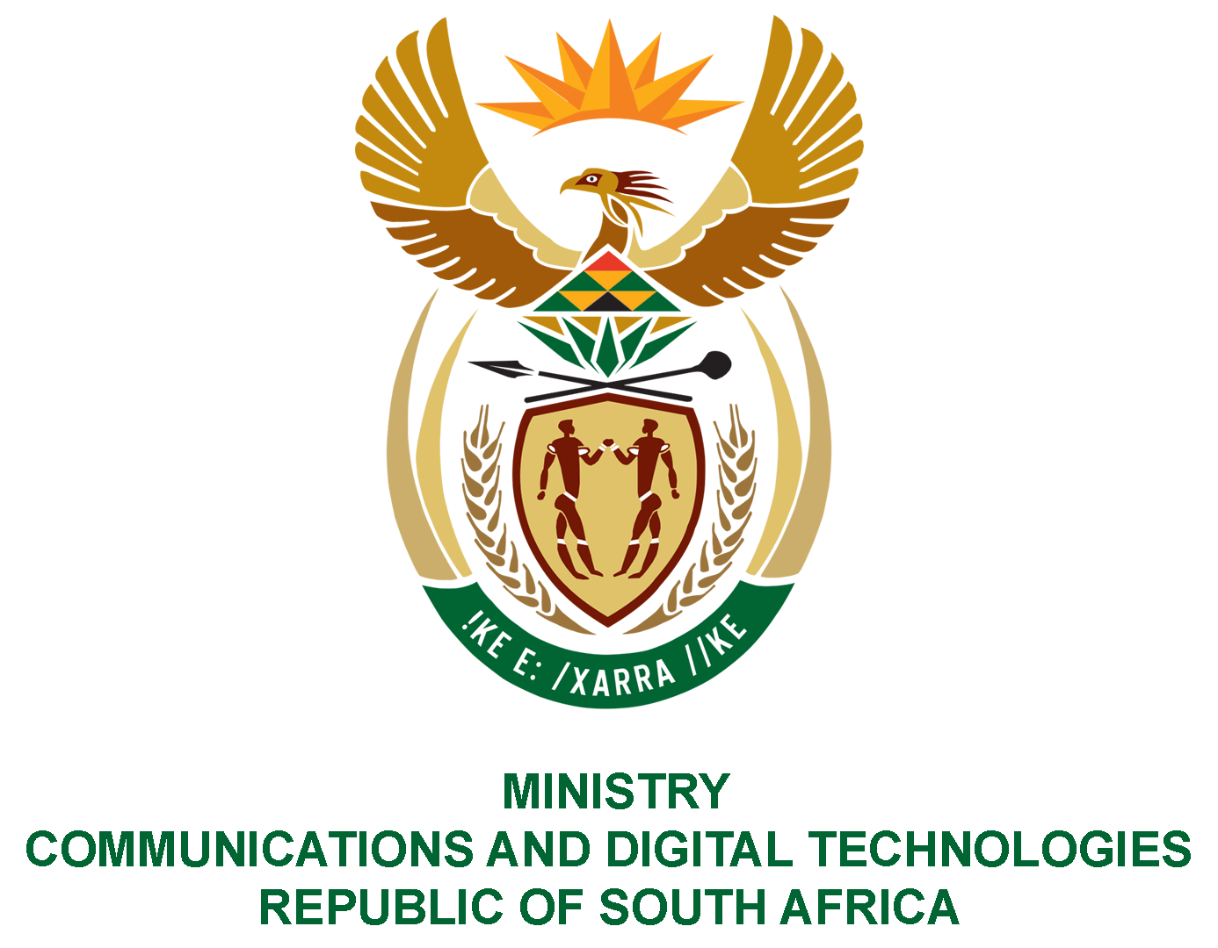

PARLIAMENT OF THE REPUBLIC OF SOUTH AFRICA

NATIONAL ASSEMBLY

WRITTEN REPLY

QUESTION: 985

DATE OF PUBLICATION: 18 MARCH 2022
QUESTION PAPER NO: 11

Mr M S Malatsi (DA) to ask the Minister of Communications and Digital Technologies:

What amount does (a) her department, (b) the SA Post Office, (c) the National Electronic Media Institute of South Africa and (d) the SA Broadcasting Corporation, owe the (i) Tshwane Metropolitan Municipality, (ii) Johannesburg Metropolitan Municipality and (iii) Ekurhuleni Metropolitan Municipality for (aa) water, (bb) rates and (cc) electricity as at 7 March 2022?
NW1228E

REPLY

I have been advised by the Department and SOEs as follows:
I have been advised by the SOEs as follows:

- Department:

- Tshwane Metropolitan Municipality:
(aa) Water R0.00
(bb) Rates R0.00
(cc) Electricity R0.00

- Johannesburg Metropolitan Municipality:
(aa) Water R0.00
(bb) Rates R0.00
(cc) Electricity R0.00

- Ekurhuleni Metropolitan Municipality:
(aa) Water R0.00
(bb) Rates R0.00
(cc) Electricity R0.00

(b-d) SOEs:
- SAPO has indicated that no amount is owed to any of the mentioned municipalities as at 07 March 2022. All utilities, rates and taxes accounts are paid in full.
- Nemisa indicated that municipal rates and taxes accounts are up to date
- SABC responded that the accounts at the municipalities mentioned were up to date as at 07 March 2022.

Authorised for submission by

MS. NONKQUBELA JORDAN-DYANI
DIRECTOR-GENERAL (ACTING)
DATE:

Recommended/not recommended

__________________________
HON. PHILLY MAPULANE, MP
DEPUTY MINISTER OF COMMUNICATIONS AND DIGITAL TECHNOLOGIES
DATE:

Approved/ not approved

________________________________
HON. KHUMBUDZO NTSHAVHENI, MP
MINISTER OF COMMUNICATIONS AND DIGITAL TECHNOLOGIES
DATE:

