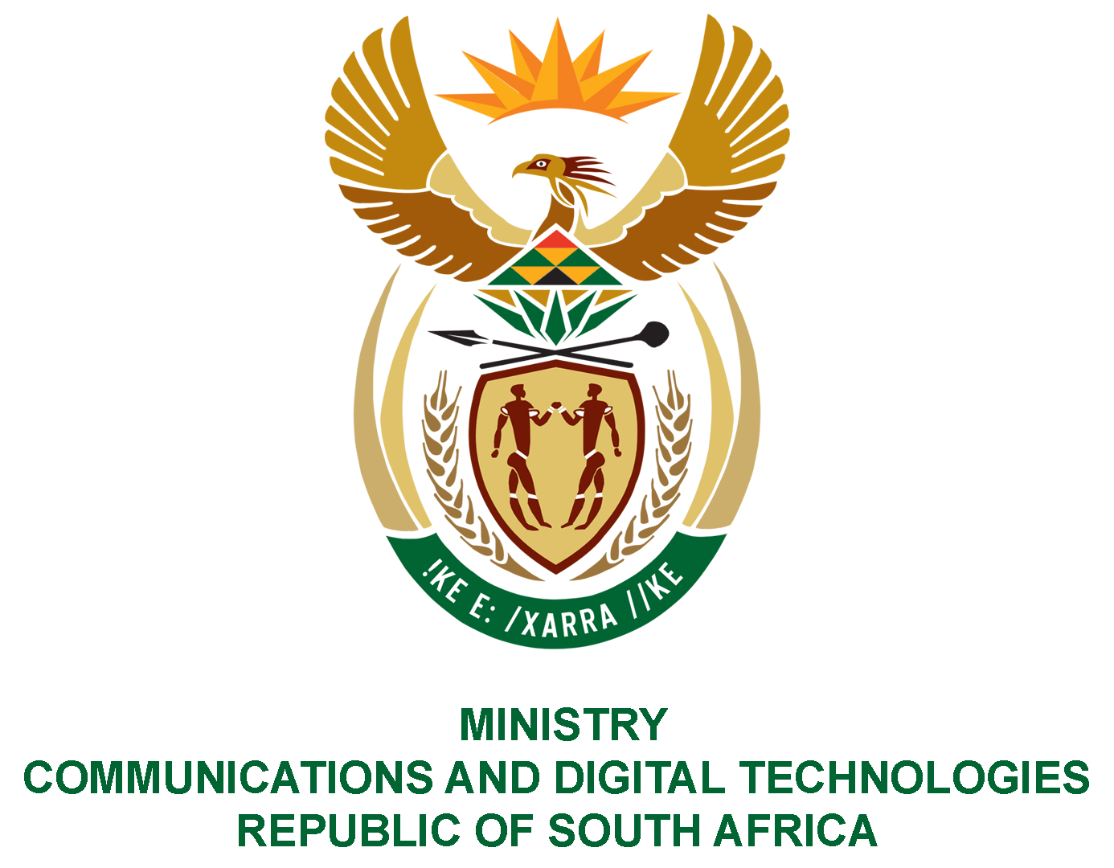

PARLIAMENT OF THE REPUBLIC OF SOUTH AFRICA

NATIONAL ASSEMBLY

WRITTEN REPLY

QUESTION: 984

DATE OF PUBLICATION: 18 MARCH 2022
QUESTION PAPER NO: 11

Mr M S Malatsi (DA) to ask the Minister of Communications and Digital Technologies:

What amount has (a) her department, (b) the SA Post Office, (c) the National Electronic Media Institute of South Africa, (d) the SA Broadcasting Corporation, (e) the State Information Technology Agency and (f) the Broadband Infraco spent on (i) flowers, (ii) cards, (iii) wreaths and (iv) gifts in the past eight financial years?
NW1227E

REPLY

I have been advised by the Department and SOEs as follows:
- Department

Department | - Flowers | (ii) Cards | (iii) Wreaths | (iv) Gifts
 | R47 363, 00 | 0 | Included (i) due to BAS SCOA classification | R691, 00

(b-f)
SOEs | - Flowers | (ii) Cards | (iii) Wreaths | (iv) Gifts
SAPO | - | - | - | -
NEMISA | R3 549.90 | - | - | -
SABC | R96 329.00 | - | R4 463.00 | R 116 181.00
SITA | R21 463.00 | - | - | -
BBI | R69 156.00 | - | - | R24 075.00

SAPO indicated that no money was spend for flowers, cards, wreaths and gifts in the last eight (8) years.

Authorised for submission by

MS. NONKQUBELA JORDAN-DYANI
DIRECTOR-GENERAL (ACTING)
DATE:

Recommended/not recommended

__________________________
HON. PHILLY MAPULANE, MP
DEPUTY MINISTER OF COMMUNICATIONS AND DIGITAL TECHNOLOGIES
DATE:

Approved/ not approved

________________________________
HON. KHUMBUDZO NTSHAVHENI, MP
MINISTER OF COMMUNICATIONS AND DIGITAL TECHNOLOGIES
DATE:

