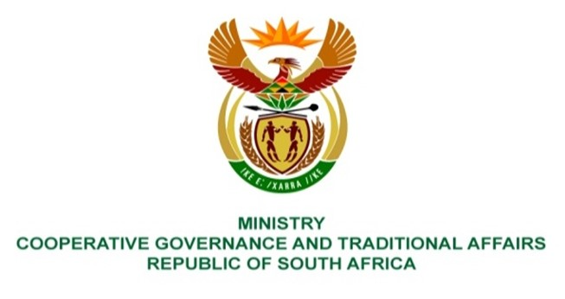

NATIONAL ASSEMBLY
QUESTIONS FOR WRITTEN REPLY

QUESTION NUMBER 2021/978

978. Mr C Brink (DA) to ask the Minister of Cooperative Governance and Traditional Affairs:
(1) What is the time frame for the establishment of each district hub that is being established in terms of the District Development Model;
(2) Whether each and/or any one of the hubs have the ability to provide shared services to local or district municipalities; if not, what is the position in this regard; if so, what is the expected capability of each or any of the hubs to render shared services with regard to (a) financial management, (b) project management, (c) engineering services, (d) town and regional planning and (e) enterprise resource management systems;
(3) (a) what are the estimated capital expenses related to the establishment of each of the hubs and (b) where will the money be sourced? NW1145E

REPLY:

- District Hubs have been established in the Waterberg and OR Tambo Districts and in eThekwini Metro. In the Financial Year for 2021/22, the Department plans to establish District Hubs in the 21 District Municipalities who are water services authorities. The remaining 28 District Hubs will be established during the 2022/23 Financial Year, provided funding is made available.
- It is not the responsibility of District and Metropolitan Municipalities nor Provincial CoGTAs to set up Hubs. It is a national CoGTA function to ensure that the DDM is effectively implemented with a government-wide focus. Existing institutional arrangements and practices in different provinces will inform the setting up of Hubs and their operations. The Hubs are not municipal structures falling under municipal administration. They may be physically located at district or metropolitan level but not within the municipality. They are accountable to national CoGTA but have to be inclusive and collaborative thus steered by intergovernmental district/metropolitan level steering committees having participation of respective municipalities, provincial CoGTAs and key national and/or provincial departments. The Hubs are aimed primarily at facilitating intergovernmental joint planning and as needed and in a differentiated way will support Local Government capacity building and coordinate capacity building programmes. Shared Services functions will not be performed by the Hubs as these need to be done through direct agreements between respective municipalities. The Hubs may support these processes as may be appropriate or necessary.A DDM Hub is conceived as a functional network of support and a facilitation system for Intergovernmental Planning in relation to a specific district or metropolitan space or a combination of district spaces or metropolitan spaces.
- The District Hub itself does not necessarily physically constitute the full range of people and resources required to be effective but enables a platform for networking, linking and connecting with various resources and processes located at various levels of government and outside of government. A minimum resource requirement would be a DDM Hub Manager as a senior, strategic person that can build the necessary networks and partnerships around successful facilitation of the One Plan. (b) The money will be allocated through the MTEF. CoGTA continues to mobilise support and capacity building opportunities through partnerships with private sector partners.

