FOR WRITTEN REPLY
QUESTION 974

NATIONAL ASSEMBLY
36/1/4/1(201900232) "

DATE OF PUBLICATION IN INTERNAL QUESTION PAPER: 20 SEPTEMBER 2019 (INTERNAL QUESTION PAPER NO 17-2019)

974. Dr P J Groenewald (FF Plus) to ask the Minister of Police:

- Whether he has taken any steps against a certain officer (nama and details furnished) of the SA Police Service whose firearm was left in the vehicle and then stolen while the specified person was away from the vehicle; if not, why not; if so, what steps;

- Whether he will make a statement on the matter?
NW2126E
REPLY:

- The matter has been brought to the attention of the National Commissioner of the South African Police Service (SAPS). The National Commissioner has initiated steps to verify the authenticity of the officer’s report, with regard to the incident. The final report and decision thereof will be furnished to the Minister of Police, regarding the disposal of the matter.

- The issuing of a statement on the matter at hand will depend on the outcome of the process in paragraph (1) above.

Reply to question 974 recommended

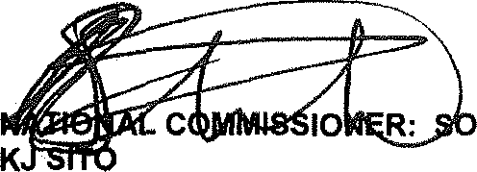GENERAL UTH AFRICAN POLICE SERVICE

LE (SOEG)

Date: ]g15 J?g- 1

2

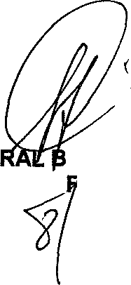Reply to question 974 approved/not approved

GENE H CELE (MP) MINISTER Q ' PO ICE

Date:

NASIONALE VERGADERING

VRAAG VIR SKRIFTELIKE BEANTWOORDING

Dr. PJ Groenewald (VF Plus) vra die Minister van Polisie:

  - Of enige stappe geneem is teen die provinsiale kommissaris van Polisie in Noord-Kaap (It-gent. R Ship/tJn) wat sy vuurwapen in sy voertuig gelaat het en wat toe gesteel is terwyl hy weg van sy voertuig was, indien wet, watter stappe, indien nie, hoekom nie;
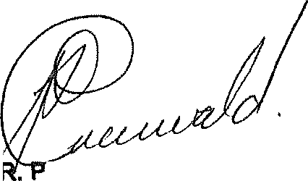
  - of hy ‘n Verklaring oor die aangeleentheid sal doen?

D J GROENEWALD (LP)
12 September 2019

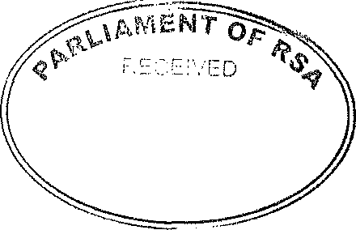

! I SEP 2019

VG P) us Hoofkanto or VF Plu« Parle ment
rariement, Kaapstad, 4oo\

Unrepresented Nations and Peoples Organization

INFORMATION NOTE

To: The Minister of Police

ROBBERY OF OFFICIAL FIREARM: LIEUTENANT GENERAL SHIVURI, PROVINCIAL COMMISSIONER: NORTHERN CAPE

- In a letter dated 2019-09-10 from Lieutenant General Shivuri, the Provincial Commissioner of Northern Cape and addressed to the National Commissioner, Lieutenant General Shivuri reported the robbery of his official firearm.

- In the factual report it is mentioned that on 2019-09-08 Lieutenant General Shivuri was frequenting an informal car wash in the Kimberley CBD in order to have his car washed. He further alludes to the fact that two boys started to wash the vehicle whilst he was still inside the vehicle busy putting loose items (including his official firearm) in a brown carry bag. One of the boys grabbed the brown carry bag and ran away. The firearm was later recovered and three suspects were arrested on account of the robbery.

- In a subsequent question in Parliament, dr. Groenewald of the FF Plus asked the Minister of Police whether any steps have been taken ”apa/nsf a certain officer whose firearm was left in the vehicle and then stolen while the specified person was away from the vehicle.”

- The version put forward by Lieutenant General Shivuri does not prima facie constitute misconduct as the firearm was still under his control when it was robbed. According to the information in the question asked by dr. Groenewald, the firearm was stolen whilst the person was away from the vehicle. If the last mentioned allegation is found to be factually correct, Lieutenant General Shivuri i a facie contra\/ened the provisions of the Firearms Control Act, 2000 which also constitutes misconduct.

- In order for the National Commissioner to decide whether any steps should be instituted against Lieutenant General Shivuri, copies of the statements filed in Kimberley CAS196/09/09 were requested in order to consider whether any disciplinary steps in terms of the provisions of section 9 of the SA Police Service Act, 1995 should be instituted against Lieutenant General Shivuri.

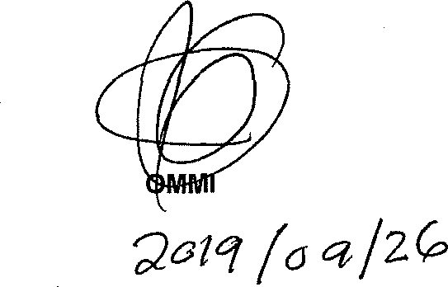
- Once the statements filed in the said case docket haVe been perused, an informed decision will be taken as to whether to institute a board of Inquiry as provided for in section 9 of the SA Police Service Act, 1995.

LIEUTENANT GENERAL DIVISIONAL C SSIONER: LEGAL AND POLICY SERVICES A KHAN
Date:

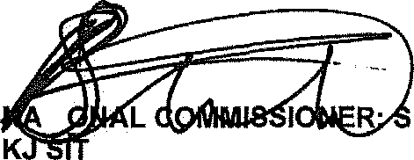
Noted

TI
OLE (SOEG)
GENERAL OUTH AFRICAN POLICE SERVICE

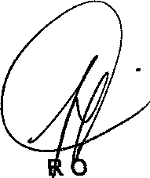
Noted

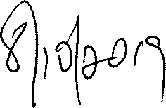
MINISTE F POLICE BK CELE , MP

Date: D

Information Note compiled by Telephone number
Date
Infonnation Note verified by Telephone number
Date
Brigadier D Odendaal
012 3937026
2018-09-26

Major General P Mnisi 012 3937011
201B-09-26

