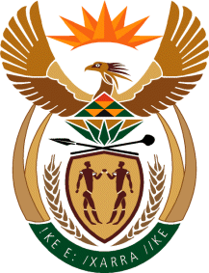

MINISTER IN THE PRESIDENCY: REPUBLIC OF SOUTH AFRICA
Private Bag X1000, Pretoria, 0001, Union Buildings, Government Avenue, PRETORIA
Tel: (012) 300 5200, Website: www.thepresidency.gov.za

NATIONAL ASSEMBLY
WRITTEN QUESTION FOR WRITTEN REPLY

QUESTION NUMBER: 971
DATE OF PUBLICATIONS: 19 March 2021

971. Mr M S Malatsi (DA) to ask the Minister in The Presidency:
With reference to (a) each of the past seven financial years and (b) the 2021-22 financial year, what (i) are the names of the brand agencies contracted to Brand South Africa, (ii) was the total value of each contract in respect of each project and (iii) was the (aa) name and (bb) duration of each project? NW1138E

REPLY:

- The spreadsheet is herewith attached detailing the requested information.

Thank you.

