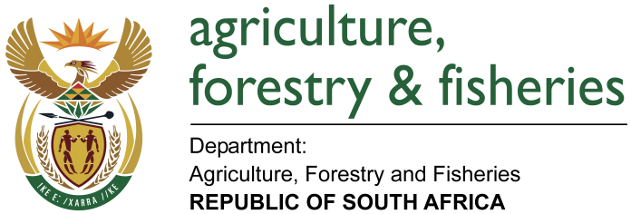
NATIONAL ASSEMBLY

WRITTEN REPLY

QUESTION 971 / NW1064E

MINISTER OF AGRICULTURE, FORESTRY AND FISHERIES:
Ms T M Mbabama (DA) to ask the Minister of Agriculture, Forestry and Fisheries:

QUESTION:
How much land does (a) his department and (b) the entities reporting to him (i) own, (ii) have exclusive rights to and/or (iii) lease from the State to (aa) use and/or (bb) occupy? NW1064E

REPLY:

- (i) The Department of Agriculture, Forestry and Fisheries (DAFF) does not own land.
(ii) DAFF administers land on behalf of the Department of Public Works to preserve the land’s agricultural potential. The land administered are in all the 9 provinces.

GAUTENG - (6488.8419ha)
KWAZULU NATAL – (6794.6304ha)
MPUMALANGA – (4058.6147ha)
LIMPOPO – (3967.2156ha)
NORTHERN CAPE - (11715.7721ha)
EASTERN CAPE – (4415.2687ha)
NORTH WEST – (9788.393 ha)
FREE STATE – (6521.4947ha)
WESTERN CAPE - (19481.9748ha)
Each land has its size and all combined is 73232.1959 hectares for all the 9 provinces.

(iii) DAFF leases the properties mainly for agricultural activities such as livestock grazing and some for planting of crops.

(b) (i) The Agricultural Research Centre which is an entity reporting to the Minister for Agriculture, Forestry and Fisheries owns 16 755.5119 hectares.

(ii) The ARC has no exclusive rights on land.

(iii) The ARC does not lease land from the state.

