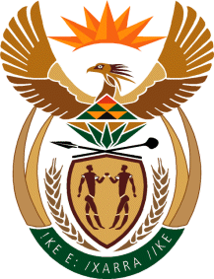

MINISTER IN THE PRESIDENCY: REPUBLIC OF SOUTH AFRICA
Private Bag X1000, Pretoria, 0001, Union Buildings, Government Avenue, PRETORIA
Tel: (012) 300 5200, Website: www.thepresidency.gov.za

NATIONAL ASSEMBLY
WRITTEN QUESTION FOR WRITTEN REPLY

QUESTION NUMBER: 970
DATE OF PUBLICATIONS: 19 March 2021

970. Mr M S Malatsi (DA) to ask the Minister in The Presidency:
What total amount was spent on public service announcements at (a) eNCA, (b) SABC 2, (c) SABC 3 and (d)(i) print and (ii) digital media platforms for COVID-19 awareness campaigns in the period 1 March 2020 and 1 March 2021?

NW1137E

REPLY:

The GCIS did not spend any funds for the flighting of PSA’s. The Public Service Announcements were flighted by all major media houses free of charge both on TV and on Radio.
- ENCA flighted 11 spots and the total value of the PSA’s was R125 250.00
- SABC 1, 2 & 3 flighted a total of 14 spots and the value of the PSA’s was R300 750.00. The cost breakdown per station is not available.
- Same as above.
- (i) No PSA’s were placed

(ii) Digital media platforms

The GCIS received ad grants from Facebook, Twitter as well as Google for use in COVID-19 awareness campaigns. This was a global campaign from the platform owners to assist Governments across the world in sharing COVID-19 information

Facebook: 4 ad grants totalling US$ 88 031 or roughly R1,3 million to use on GovernmentZA page. Spent to date: R680 000

Twitter: received ad grants from Twitter totalling R381 000 - Spent to date: R381 000

Google: Initial grant for the search campaign totalled US$5,5 million that was set to expire on 31 December 2020. This was extended until 31 December 2021. An addition grant of US$2,5 million was received in March 2021. Total grant: US$7,5 million or roughly R115 million. Spent to date: R77 000 000
Thank you.

