NATIONAL ASSEMBLY

QUESTION FOR WRITTEN REPLY
QUESTION NUMBER: 961 [NO1089E]

DATE OF PUBLICATION: 5 MAY 2017

961. Mr B R Topham (DA) to ask the Minister of Finance:
(1) With reference to the resignation and dismissal of staff members of the SA Revenue Service (SARS) in the period 1 September 2014 to 30 April 2017, what are the (a) names, (b) academic qualifications and (c) job details in terms of job title, grade and brief job description, of each staff member;
(2) With reference to each staff member who was subsequently appointed to vacant positions within SARS in the specified period, (a) what are their (i) names and (ii) academic qualifications and (b) what is their (i) length of service at SARS and (ii) work record outside of SARS? NW1089E
REPLY:

- Due to the confidential nature of some of the information requested and our legislative obligation to the protection of personal information governed by the Protection of Personal Information Act, SARS is prohibited from disclosing any employee specific information that may include names of individuals, qualifications, job specific information, length of service, work record, etc.

The following summarised information can however be made available:
1227 employees resigned during the period 1 September 2014 to 30 April 2017 and 82 employees were dismissed during the same period.

- Due to the confidential nature of some of the information requested and our legislative obligation to the protection of personal information governed by the Protection of Personal Information Act, SARS is prohibited from disclosing any employee specific information that may include names of individuals, qualifications, job specific information, length of service, work record, etc.

The following summarised information can however be made available:
The attrition rate for SARS remained stable over a period of 7 years. There is in actual fact a significant decline in the rate between 2013/14 and 2016/17 financial year.
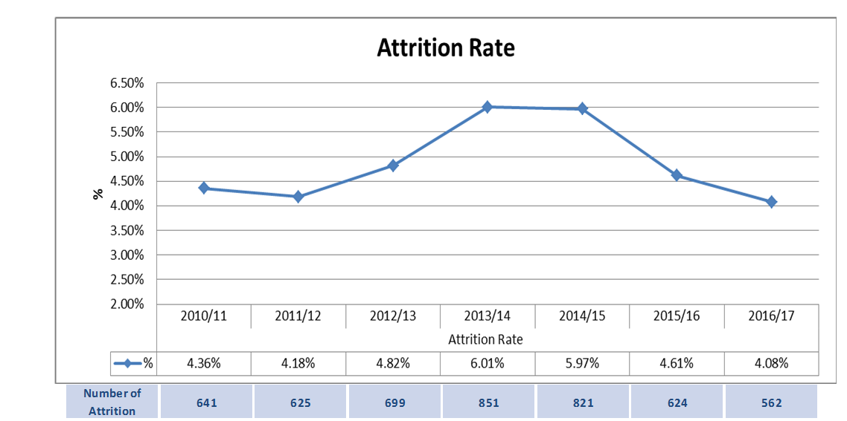
913 External applicants were recruited during the period 1 September 2014 and 30 April 2017.
2674 Internal applicants were appointed during the period 1 September 2014 and 30 September 2017.
Internal appointments as a percentage of external appointments are reflected in the table below:
External Recruitment | Internal Appointments | Total | % Internal Appointments
913 | 2674 | 3587 | 74.55%

All recruitment is based on the requirements of the job that is necessary in terms of years of service and experience and demanded by the job to be performed.

