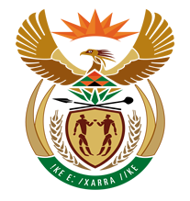

NATIONAL ASSEMBLY

QUESTION FOR WRITTEN REPLY
QUESTION NUMBER: 960 [NO1088E]

DATE OF PUBLICATION: 5 MAY 2017

960. Mr R A Lees (DA) to ask the Minister of Finance:
(1) What is the total number of staff members of the SA Revenue Service who (a) have resigned, (b) were dismissed and (c) are on (i) full pay and (ii) unpaid suspension in the period 1 September 2014 to 30 April 2017;
(2) (a) what is the total number of persons that were recruited to fill vacancies created by the departure of staff members and (b) what was the annual attrition rate over the specified period?
NW1088E
REPLY:

(1)(a) The total number of staff members of the SA Revenue Service who have resigned during the period 1 September 2014 to 30 April 2017 is 1277.

(b) 82 Employees were dismissed during the period 1 September 2014 to 30 April 2017.

(c)(i) 166 Employees were suspended with full pay during the period 1 September 2014 to 30 April 2017.

(c)(ii) 43 Employees were suspended without pay during the period 1 September 2014 to 30 April 2017.

(2)(a) 913 External applicants were recruited during the period 1 September 2014 and 30 April 2017 to fill funded vacancies.

(b) The annual attrition rate is reflected in the table below per financial year:
