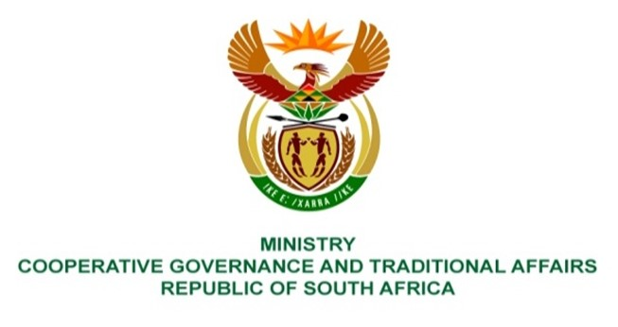

NATIONAL ASSEMBLY
QUESTIONS FOR WRITTEN REPLY

QUESTION NUMBER 959
DATE OF PUBLICATION: 17 March 2023

959. Ms S A Buthelezi (IFP) to ask the Minister of Cooperative Governance and Traditional Affairs:

What (a) is the role of her department in situations where local governments are unable to provide basic services like water and sanitation, as is the case in the Theewaterskloof Local Municipality that is unable to provide the services to the increasing number of persons occupying land in the Khoisan settlement of Knoflokskraal on land that is earmarked for forestry plantations and not human settlement and (b) plans does her department have in place to cooperate with other governmental departments who own the land of traditional settlements but fail to provide essential municipal services? NW1066E
REPLY:

- The role of the Department of Cooperative Governance (DCOG), like all other provincial and national departments, is to support and strengthen municipalities to perform their functions in accordance with section 154 of the Constitution. In situations where municipalities fail to perform their functions, despite the support mentioned above, the provincial executive in local government may intervene by taking any appropriate steps in terms of section 139 of the Constitution. If a provincial executive does not adequately perform the functions, the national executive must intervene in terms of section 139 (7) of the Constitution.

The Theewaterskloof Local Municipality (TLM) will only start planning for the sustainable provision of basic services to the communities occupying land on Knoflokskraal, that is earmarked for forestry plantations and not human settlement, after a response expected by 19 May 2023 by the Department of Public Works and Infrastructure (DPWI) on whether continued occupation will be allowed. The commitment by DPWI to provide the response emanated from a community meeting that was held on 25 March 2023 on the occupied land on Knoflokskraal.

- DCOG is leading on the implementation of the District Development Model (DDM) to ensure alignment of all of government plans, budgeting and implementation of programmes and projects. The DDM ensures that the planning undertaken by a municipality for provision of municipal services, among other issues, is aligned with the development plans of other organs of state as provided for on Section 24(1) of the Municipal Systems Act, No. 32 of 2000 and to give effect to the principles of co-operative government contained in section 41 of the Constitution.
End.

