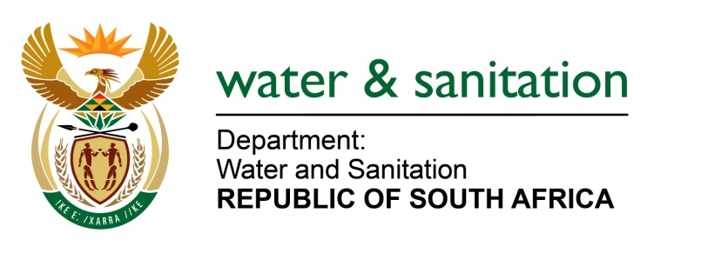

NATIONAL ASSEMBLY

FOR WRITTEN REPLY

QUESTION NO 957

DATE OF PUBLICATION IN INTERNAL QUESTION PAPER: 17 MARCH 2023
(INTERNAL QUESTION PAPER NO. 10)

957. Ms S A Buthelezi (IFP) to ask the Minister of Water and Sanitation:
(1) With reference to the microbial contamination from faecal pollutants in most of the rivers and dams of the Republic, what steps has his department taken to rigorously improve the wastewater treatment plants in the Republic;
(2) whether there will be any consequence management measures taken against the persons found to be responsible to ensure that accountability practices for oversight are met; if not, why not; if so, what are the relevant details? NW1064E
---00O00---

MINISTER OF WATER AND SANITATION
(1) The Department of Water and Sanitation’s (DWS) 2022 Green Drop Report provided a detailed overview of the state of wastewater management in the country. The findings of the report presented a concerning trend across the country which showed that wastewater management has deteriorated notably since 2014.

Water Service Authorities responsible for wastewater collection and treatment systems that achieved less than 30% during Green Drop Assessment were issued with non-compliance letters and instructed to submit corrective action plans. Implementation of the corrective measures will be monitored through a dashboard developed as part of the Water Services Improvement Programme (WSIP). The Department has also collaborated with the South African Local Government Association (SALGA) and Municipal Infrastructure Support Agent (MISA) to assist municipalities on the development of these action plans, to ensure improvement in the management of wastewater treatment plants. The DWS and SALGA have also rolled out the water and sanitation councillor induction across the country on wastewater quality management and drinking water management.

The DWS, in collaboration with the SALGA, has also taken steps to support Water Service Authorities through:
- Capacitating the Water and Sanitation portfolio-based councillors throughout their term of office.
- Training of Process Controllers to augment wastewater operations and maintenance capacity. Energy and Water Sector Training Authority (EWSETA) will facilitate the training so that it complies with Wastewater Quality Management regulations.
- Ensuring that all wastewater management environmental hazards are mapped and mitigated

(2) The Department ensures protection of water resources by serving suspected transgressors or polluters with notices and directives in accordance with the provisions of the National Water Act (Act 36 of 1998) (NWA). These notices and directives instruct the identified transgressors to make representations, which may take the form of action plans in other instances. The representations are then submitted to the Department to assess and advise on the implementation thereof. The Department then monitors implementation of the action plans and adherence to the timeframes committed to control the causes of pollution and remedy effects thereof.

The Department may also lay criminal charges against polluters liable for offenses stipulated under Section 151 of the NWA, where the outcome is a fine imposed against an offender or institute civil action by applying for a court interdicts against polluters. The court may, upon examining the application, issue an order the polluter to take remedial action.

Since January 2020, the Department has taken administrative enforcement action by issuing 374 notices and directives under sections 19, 20, and 53 of the National Water Act (NWA).

The Department has also pursued criminal action against 13 water users found to have caused pollution of water resources. To date, 9 case dockets were finalized and handed to the NPA for a decision to prosecute whereas 2 plea sentencing agreements were reached where the court-imposed fines against the municipalities. Additionally, the Department initiated 3 court interdict applications against water users found to have caused pollution of water resources, and 1 court order was granted in this regard.

---00O00---

