36/1/4/1(201900225)
NATIONAL ASSEMBLY

FOR WRITTEN REPLY

QUESTION 957

DATE OF PUBLICATION IN INTERNAL QUESTION PAPER: 13 SEPTEMBER 2019 (INTERNAL QUESTION PAPER NO 16-2019)

957. Mrs M O Clarke (DA) to ask the Minister of Police:

- What number of (a) vehicles are allocated to the Leondale Police Station for visible policing and (b)(i) policing sectors are within the specified police station and (ii) vehicles are allocated to each sector;

what are the details of the crime statistics linked to the specified police station in the three financial years;

- what number of (a) arrests have been made in terms of the crimes that occur and (b) convictions have been secured in terms of each crime committed†
NW2111E
REPLY:

(1)(a)(b)(i)(ii) There is no police station/satellite or service point called “Leondale Police Station", in South Africa. It would be appreciated if the Honourable Member could clarify the name of the police station in question.

(2) Not applicable.

(3)(a)(b) Not applicable.

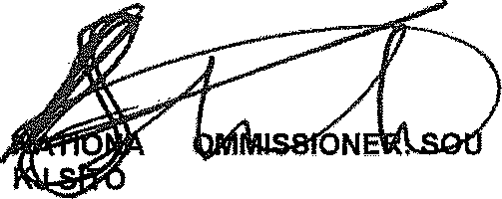
Reply to question 957 recommended/not recommended

L C
LE (SOEG)
GENERAL TH AFRICAN POLICE SERVICE

Reply to question 957 approved/move
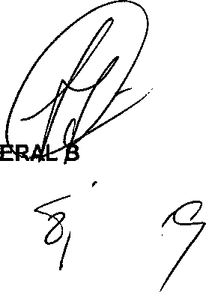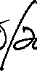
GEN
H CELE (MP)
MINISTER OF POLICE

