36/1/4/1(201900224)
NATIONAL ASSEMBLY

FOR WRITTEN REPLY QUESTION 946
DATE OF PUBLICATION IN INTERNAL QUESTION PAPER: 13 SEPTEMBER 2019 (INTERNAL QUEGTION PAPER NO 16-2019)
946. Mr T C R Walters (DA) to ask the Minister of Police:
Whether there are any plans to reopen the Kocksoord Police Station in the Rand West City Local Municipality; if not, why not; if so, what are the relevant details?
NW2100E
REPLY:

The Provincial Commissioner: Gauteng has received a request, in this regard and is in the process of conducting a feasibility study, pertaining to the re-opening of the Kocksoord Satellite Police Station.

Reply to question 946 recommended/

Date: iF1? -It t r
GENERAL
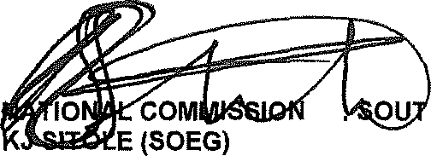
ER H AFRICAN POLICE SERVICE

Reply to question 946 approved/not approved

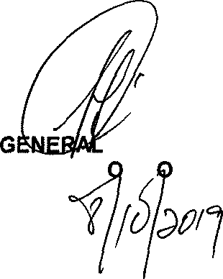

BH CELE (MP) MINISTER F IN LICE

Date: @

