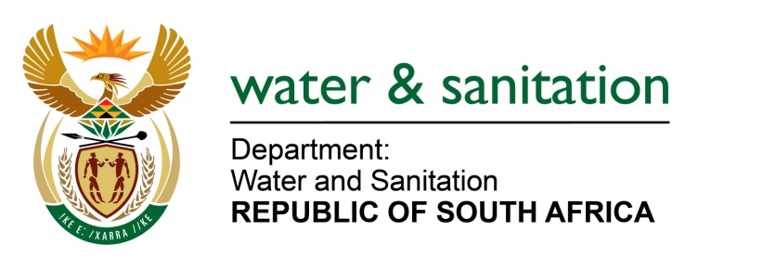

NATIONAL ASSEMBLY

FOR WRITTEN REPLY

QUESTION NO 944

DATE OF PUBLICATION IN INTERNAL QUESTION PAPER: 31 MARCH 2017
(INTERNAL QUESTION PAPER NO. 12)

944. Ms T M Mbabama (DA) to ask the Minister of Water and Sanitation:

(1) Whether there is any position of (a) chief executive officer, (b) chief financial officer and/or (c) chief operating officer that is currently vacant in each entity reporting to her; if so, (i) how long has each specified position been vacant and (ii) what is the reason for each vacancy;

(2) have the vacancies been advertised; if so, (a) were interviews done and (b) on what date will the vacancies be filled;

(3) (a) what is the total number of persons who are currently employed in the specified positions in an acting capacity, (b) for what period has each person been acting in each position and (c) has any of the specified persons applied for the positions? NW1013E
---00O00---

REPLY:

Refer to Annexure A for positions currently vacant in each entity.

---00O00---

Annexure A

Entity | (1)(a) | (1)(b) | (1)(c) | (1)(i) | (1)(ii) | (2)(a) | (2)(b) | (3)(a) | (3)(b) | (3)(c)
Amatola Water | No | No | No | Not applicable | Not applicable | Not applicable | Not applicable | Not applicable | Not applicable | Not applicable
Bloem Water | No | No | No | Not applicable | Not applicable | Not applicable | Not applicable | Not applicable | Not applicable | Not applicable
Lepelle Water | No | No | Yes | Position was created in 2015 | Position is earmarked for future expansion (as Regional Water Utility) | No | No | No | No | No
Magalies Water | Yes | No | No | 19 months | Term of CEO expired and contract was not renewed | Position has been advertised internally and externally; the interviews are scheduled for April 2017 | The recruitment process is expected to be completed in May 2017 | Two Executives are appointed on acting capacity, COO acting for CEO, and GM: Engineering for COO | The GM: Corporate Services acted as CEO for 12 months; The COO is currently acting as CEO now for 7months | Information not known. Information is with the Recruitment Agency
Mhlathuze Water | Yes | Yes | No | CE Suspended since November 2015 pending disciplinary enquiry, | Not applicable | No. It's a secondment to Mhlathuze Water from Cogta since June 2016. | Not applicable | 1 | June 2016. | N/A
 |  |  | Yes | COO Incumbent resigned in October 2016 | Incumbent resigned in October 2016. Restructuring of the Engineering and Operations Departments | The Chief Operations Officer position has not been advertised as the Engineering and Operations department is being restructured. | Pending restructuring of the Engineering and Operations departments | 1 | October 2016. | N/A
Overberg Water | Yes | No | No | 2 years | The incumbent left the position | Yes | Not known | One | 1 year and 10 months | No
Rand Water | No | No | No | Not applicable | Not applicable | Not applicable | Not applicable | Not applicable | Not applicable | Not applicable
Sedibeng Water | No | No | No | Not applicable | Not applicable | Not applicable | Not applicable | Not applicable | Not applicable | Not applicable
Umgeni Water | No | No | No | Not applicable | Not applicable | Not applicable | Not applicable | Not applicable | Not applicable | Not applicable
TCTA | No | Yes | No | 5 months for CE  7 Months for COO | Automatic contract expiry | No | To be filled by November 2017 | 1 | 5 months | Recruitment process has not been activated
WRC | No | No | No | Not applicable | Not applicable | Not applicable | Not applicable | Not applicable | Not applicable | Not applicable
Inkomati CMA | No | No | No | Not applicable | Not applicable | Not applicable | Not applicable | Not applicable | Not applicable | Not applicable
Breede-Gouritz CMA | No | No | No | Not applicable | Not applicable | Not applicable | Not applicable | Not applicable | Not applicable | Not applicable
---00O00---

